VISTA Seminar

Seminar 103

February 25, 2026
10:00 am – 11:30 am EST Buffalo / 3:00 – 4:30 pm GMT London / 4:00 pm – 5:30 pm CET Paris / 11 pm – 12:30 pm CST Beijing

TOC:

1. Presenter 1: Prof. Laura M. P. Gonzalez, Universita di Pisa, Italy...….…...page 2
2. Presenter 2: Mr. Joao Pimentel, University of California Irvine, USA…....page 3
3. How to connect………………………………………………………..….. page 4

What controls excitation energy transfer in xanthophyll-binding microbial rhodopsins? Structural and spectroscopic insights from multiscale modeling
Laura Pedraza-González
¹Dipartimento di Chimica e Chimica Industriale, Università di Pisa
Via G. Moruzzi 13, 56124 Pisa, Italy.
E-mail: laura.pedraza@unipi.it
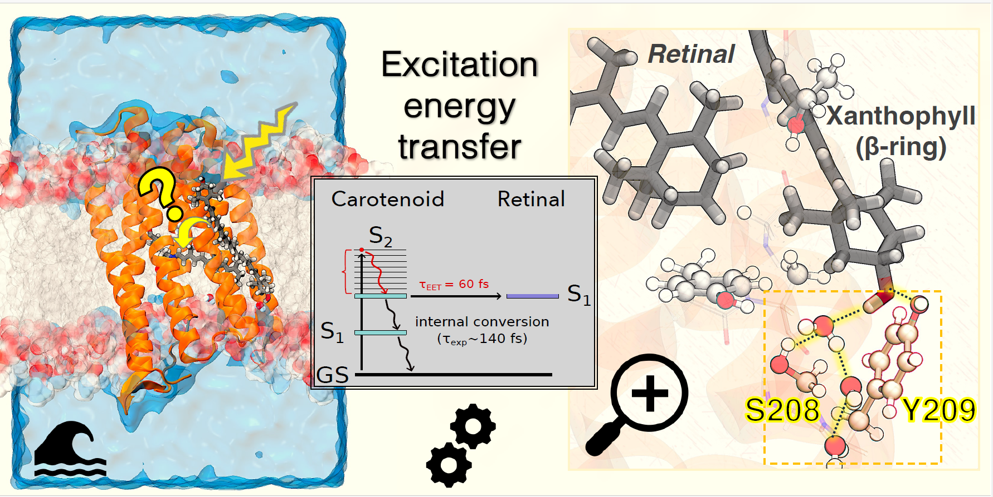
Light harvesting in biology relies on pigment–protein assemblies that control the flow of electronic excitation with remarkable efficiency. Among these systems, a small subset of microbial rhodopsins extends retinal-based photoreception by recruiting carotenoids as auxiliary antenna pigments, enabling carotenoid-to-retinal excitation energy transfer (EET). Recent experiments revealed a striking functional asymmetry in the newly discovered Kin4B8 xanthorhodopsin: hydroxylated xanthophylls bind to the protein and act as efficient light-harvesting antennas, whereas 4-keto xanthophylls can also bind but fail to transfer energy to retinal.[1,2] In this talk, I will present a multiscale computational study that resolves the molecular origin of this behavior and provides a unified framework for understanding both enhanced and suppressed EET within the same protein scaffold.[3] By integrating molecular docking, molecular dynamics, polarizable quantum/classical simulations, and excitonic modeling, we establish spectroscopically consistent structural models that reproduce experimental absorption and circular dichroism spectra, as well as excitation energy transfer efficiencies. We show that efficient energy transfer requires more than stable pigment binding and sizable electronic coupling. Instead, EET emerges from a delicate interplay between protein-guided binding geometry, excited-state energetics, and vibronic relaxation, which together determine whether energy flow between chromophores is promoted or quenched. These results refine the structure–function paradigm for carotenoid-assisted rhodopsins and define the limits of protein-mediated control over biological light harvesting.
References:
[1] Béjà, O., and coworkers. Phototrophy by antenna-containing rhodopsin pumps in aquatic environments. Nature, 2023, 615, 535–540.
[2] Sheves, M., and coworkers. Selective Choice of the Efficient Carotenoid Antenna by a Xanthorhodopsin: Controlling Factors for Binding and Excitation Energy Transfer. JACS Au, 2025, 5, 7, 3070–3081
[3] Pedraza-González, L., and coworkers. Structural and spectroscopic basis of excitation energy transfer in microbial rhodopsins binding xanthophylls. Chem. Sci., 2025, 16, 18423-18437.
Thermodynamically Consistent Coarse-Graining of Molecular Systems: Beyond Rigid-Monomer Models
João Pimentel
¹Department of Chemistry, University of California Irvine
E-mail: joaop@uci.edu

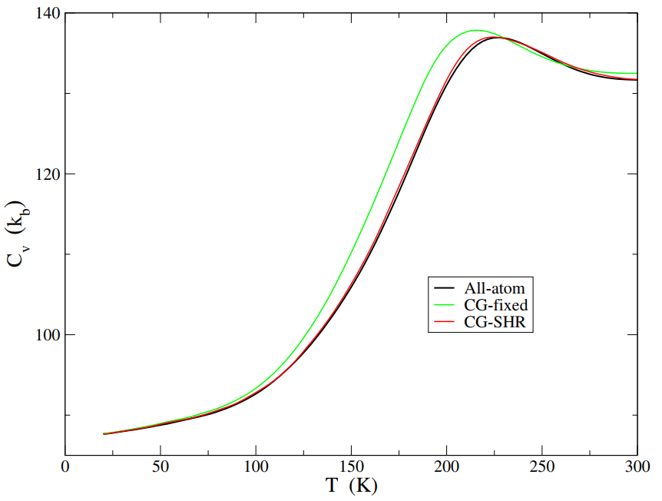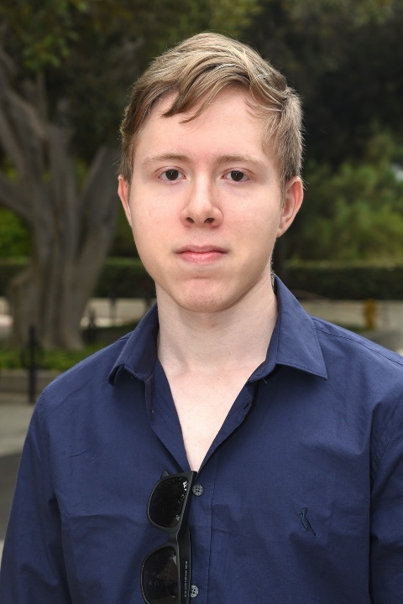

We present a framework for coarse-graining molecular systems that selectively groups atoms that belong to relatively rigid subunits (e.g., entire molecular monomers or segments of larger molecules) and directly constructs a Free Energy Function (FEF) depending on the centers and orientations of these subunits, i.e., the coarse-grained (CG) coordinates. Unlike conventional rigid-body approaches, the internal configurations of the subunits are not fixed. Starting with an all-atom potential, the configuration space is partitioned into the slow (CG) and fast subspaces. The fast degrees of freedom are averaged out using a local harmonic approximation, producing a temperature-dependent CG FEF that has the option of including nuclear quantum effects in the fast subspace. Despite its conceptual simplicity, the approach yields remarkably accurate equilibrium properties for water and ammonia clusters. The CG simulations achieve statistical convergence with fewer sampling steps, and the cost of a single FEF evaluation remains comparable to that of the original all-atom potential.

How to connect

Alexey Akimov is inviting you to a scheduled Zoom meeting.

Topic: VISTA, Seminar 103
Time: Feb 25, 2026 10:00 AM Eastern Time (US and Canada)
Join Zoom Meeting
https://buffalo.zoom.us/j/96132363031?pwd=xtlPCpSGUlbIau8wL738ICrR8yUbWh.1

Meeting ID: 961 3236 3031
Passcode: 443552

How to stay updated

A. VISTA Mailing list:

- Follow the link:
https://listserv.buffalo.edu/scripts/wa.exe?A0=CHE-VISTA-LIST&X=OA41BBB2DC6071987DF&Y=alexeyak%40buffalo.edu
- Click the menu icon in the upper right part of the list (yellow highlight in the picture below)
- Click the “Subscribe or Unsubscribe” option (purple highlight below) – it will bring you to the next window where you’ll be asked for your email/name (I think it the name is optional to provide). This way, you can subscribe to the mailing list to stay tuned or unsubscribe if you find the seminars irrelevant to you or just get too much emails to deal with.
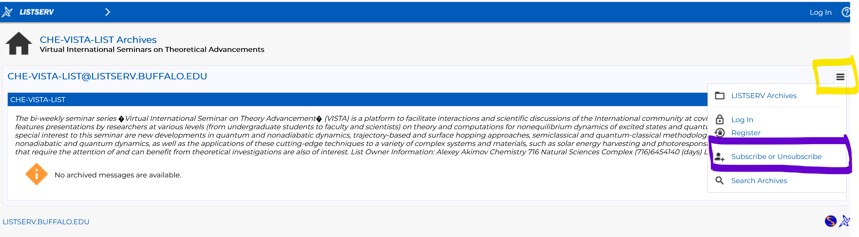

B. Slack Workspaces:

- VISTA workspace: https://join.slack.com/t/vista-atk8254/shared_invite/zt-mdlteo5v-P1Hc7XVupkwMbnGhNG4KIw
- Quantum Dynamics Hub workspace: https://join.slack.com/t/quantumdynamicshub/shared_invite/zt-mjbhjssx-GGhsbYHxeBMvhmumK_j7LA

