VISTA Seminar

Seminar 109

May 20, 2026
10:00 am – 11:30 am EDT Buffalo / 3:00 – 4:30 pm BST London / 4:00 pm – 5:30 pm CEST Paris / 10 pm – 11:30 pm CST Beijing

TOC:

1. Presenter 1: Prof. Thomas L. C. Jansen, University of Groningen, Netherlands………………………………………………………………..….page 2
2. Presenter 2: Dr. Chaoqun Zhang, Yale University, USA……………......…page 3
3. How to connect………………………………………………………..….. page 4

Energy Transfer with a Twist: An Investigation of Chlorosome Lamella

Yieon Park, Gijsbert A. H. ten Hoven, Thomas L. C. Jansen
University of Groningen, Zernike Institute for Advanced Materials,
Nijenborgh 3, 9747 AG Groningen, The Netherlands
E-mail: t.l.c.jansen@rug.nl

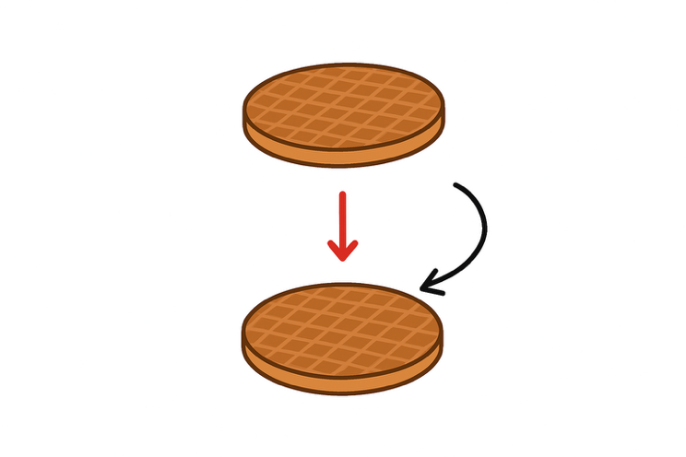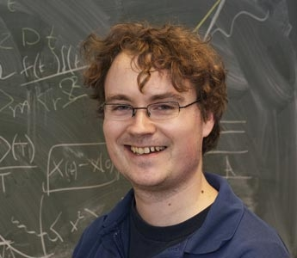

Photosynthetic chlorosomes—products of exceptional evolutionary optimization—are among the most efficient light-harvesting architectures in nature [1]. Yet the impact of the relative twist between their two-dimensional lamellar sheets on exciton transport has remained an open question. Using a recently developed time-dependent multi-chromophoric fluorescence energy-transfer approach [2], together with a chlorosomestructure with the molecular packing based on NMR experiments [3], we quantify how the inter-sheet angle modulates energy transfer. We find a marked enhancement of exciton transfer for the antiparallel stacking [4]. Analysis of eigenstates in a reduced model reveals that this behaviour arises from interference between multiple transfer pathways linking delocalized exciton states [5] of different symmetry. Beyond chlorosomes, these results suggest that angular-dependent transport should be expected in other stacked two-dimensional excitonic materials, offering a promising direction for future exploration.

References:
[1] Blankenship, R. E. Molecular Mechanisms of Photosynthesis, Third Edition.; Wiley: Oxfort, U.K., 2021.
[2] Zhong, K.; Nguyen, H. L.; Do, T. N.; Tan, H.-S.; Knoester, J.; Jansen, T. L. C. An Efficient Time-Domain Implementation of the Multichromophoric Förster Resonant Energy Transfer Method. J. Chem. Phys. 2023, 158, 064103. https://doi.org/10.1063/5.0136652.
[3] Ganapathy, S.; Oostergetel, G. T.; Wawrzyniak, P. K.; Reus, M.; Gomez Maqueo Chew, A.; Buda, F.; Boekema, E. J.; Bryant, D. A.; Holzwarth, A. R.; de Groot, H. J. M. Alternating Syn-Anti Bacteriochlorophylls Form Concentric Helical Nanotubes in Chlorosomes. Proc. Nat. Acad. Sci. 2009, 106, 8525–8530. https://doi.org/10.1073/pnas.0903534106.
[4] Park, Y.; Ten Hoven, G. A. H.; Jansen, T. L. C. Energy Transfer between Two-Dimensional Sheets: An Investigation of Chlorosome Lamella. J. Phys. Chem. Lett. 2025, 12507–12513. https://doi.org/10.1021/acs.jpclett.5c02725.
[5] Jansen, T. L. C. The Manhattan Exciton Size: A Physically Tractable Delocalization Measure. J. Chem. Phys. 2025, 162, 074113. https://doi.org/10.1063/5.0253831.
Deep learning electron-phonon couplings beyond mean-field level

Chaoqun Zhang

Department of Chemistry, Yale University
Email: chaoqun.zhang@yale.edu

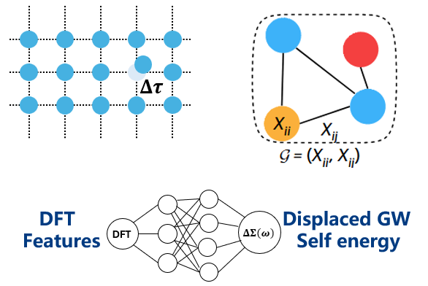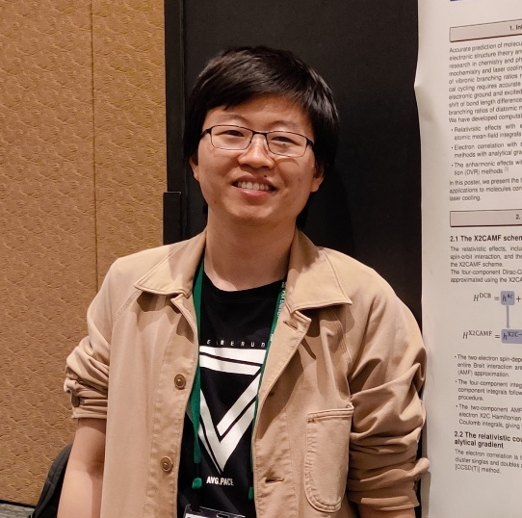

The coupled dynamics of nuclei and electrons are central to many phenomena in chemical physics, condensed matter physics, and quantum information science, including spin relaxation, carrier transport, and superconductivity. Although electron correlation effects can strongly change the magnitude of electron–phonon (e–ph) interactions and thus the phonon scattering behavior, applications of theoretical methods calculating e–ph coupling beyond the mean-field level remain limited due to their high computational cost. To address this challenge, I have developed data-driven machine learning (ML) framework for e-ph coupling at GW level by combining the ML Green’s functions method, developed in Professor Zhu’s group, and the GW perturbation theory (GWPT). Predicted band gap renormalization and transportation properties from machine learned e-ph couplings agree well with those from ab initio calculations. The ML tools expand the applicability of GWPT to more complicated materials. This framework can also be easily extended to other Green’s function-based embedding methods, opening future possibilities to further improve e-ph couplings for strongly correlated materials

How to connect
Alexey Akimov is inviting you to a scheduled Zoom meeting.

Topic: VISTA, Seminar 109
Time: May 20, 2026 10:00 AM Eastern Time (US and Canada)
Join Zoom Meeting
https://buffalo.zoom.us/j/92169932880?pwd=sjrynjy9qEvh9NdPgYFoQ7wF3D4yfj.1

Meeting ID: 921 6993 2880
Passcode: 906921

How to stay updated

A. VISTA Mailing list:
- Follow the link: https://listserv.buffalo.edu/scripts/wa.exe?A0=CHE-VISTA-LIST&X=OA41BBB2DC6071987DF&Y=alexeyak%40buffalo.edu
- Click the menu icon in the upper right part of the list (yellow highlight in the picture below)
- Click the “Subscribe or Unsubscribe” option (purple highlight below) – it will bring you to the next window where you’ll be asked for your email/name (I think it the name is optional to provide). This way, you can subscribe to the mailing list to stay tuned or unsubscribe if you find the seminars irrelevant to you or just get too much emails to deal with.
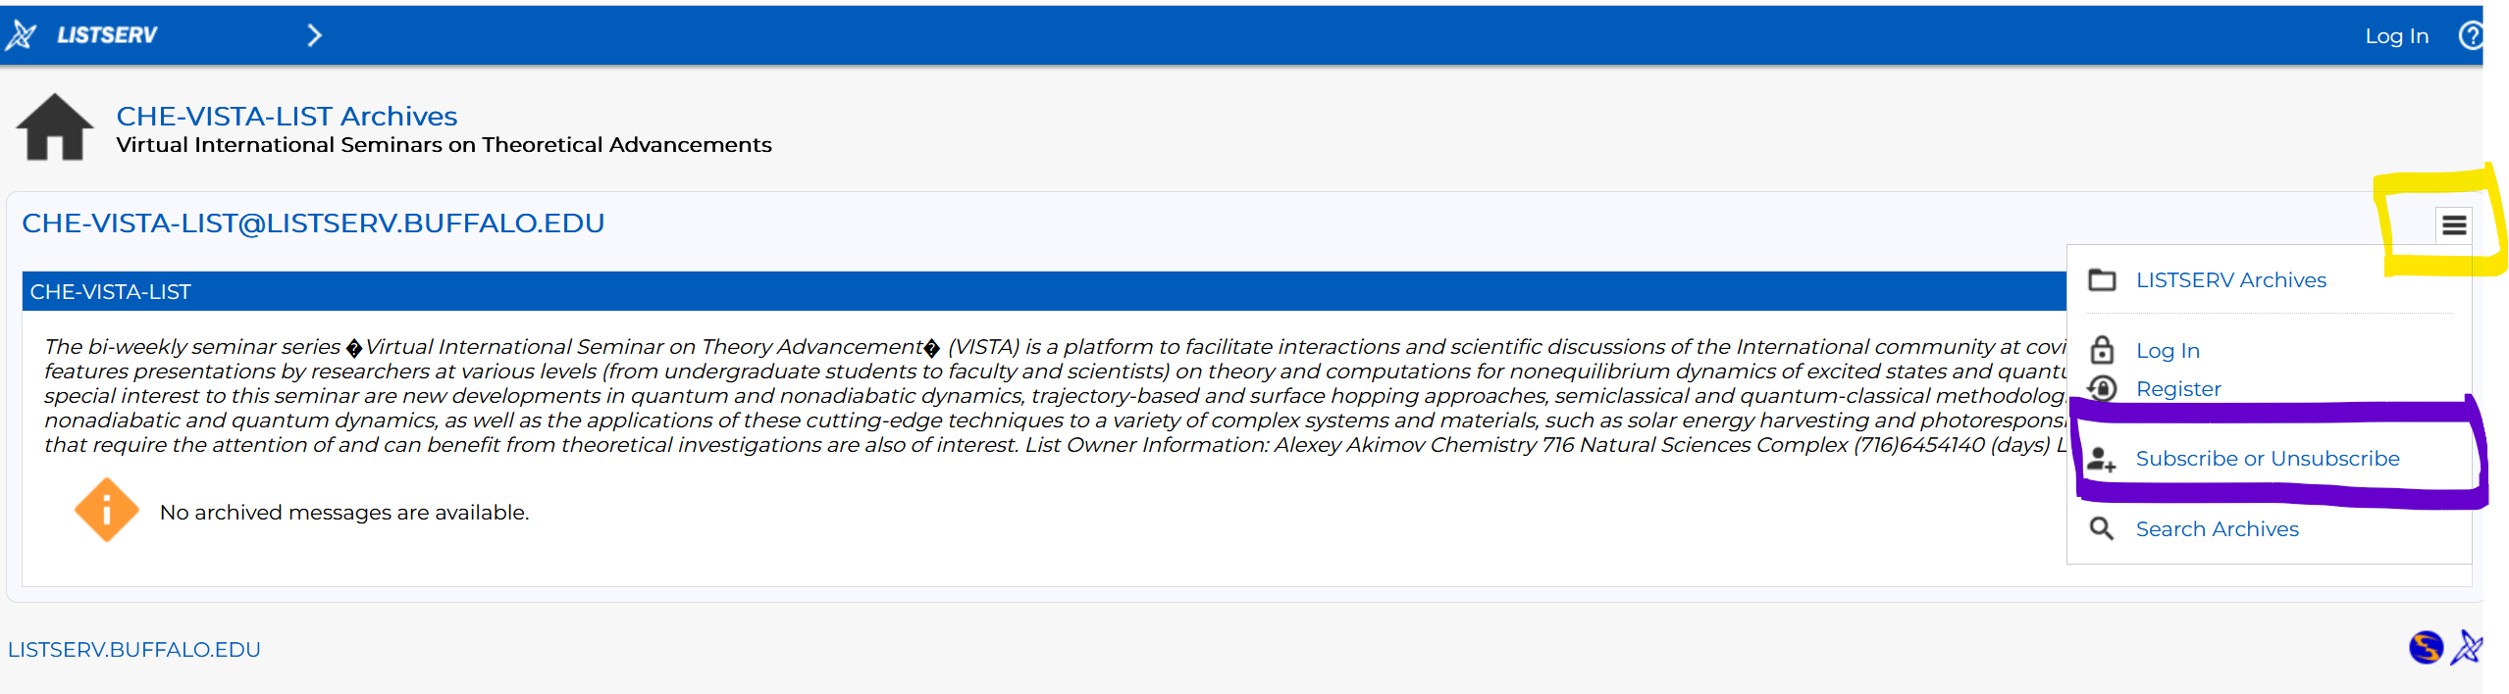

B. Slack Workspaces:
- VISTA workspace: https://join.slack.com/t/vista-atk8254/shared_invite/zt-mdlteo5v-P1Hc7XVupkwMbnGhNG4KIw
- Quantum Dynamics Hub workspace: https://join.slack.com/t/quantumdynamicshub/shared_invite/zt-mjbhjssx-GGhsbYHxeBMvhmumK_j7LA

C. Gmail calendar: https://calendar.google.com/calendar/u/4?cid=Y19jMjhjZjc3YmQxZWY1MWFkMzAwNjQ2MDVkZmQ1YjY3OGMyZmMxMGJmYjZhZmUyOGViZjg0MzA0NzVhMmY5NDAyQGdyb3VwLmNhbGVuZGFyLmdvb2dsZS5jb20

