VISTA Seminar

Seminar 108

May 6, 2026
10:00 am – 11:30 am EDT Buffalo / 3:00 – 4:30 pm BST London / 4:00 pm – 5:30 pm CEST Paris / 10 pm – 11:30 pm CST Beijing

TOC:

1. Presenter 1: Prof. Chenyang Li, Beijing Normal University, China.…...….page 2
2. Presenter 2: Dr. Mohd Shavez, University of Hyderabad, India…..….....…page 3
3. How to connect………………………………………………………..….. page 4

Towards quantitative computations of exchange coupling constants in transition-metal complexes via multireference driven similarity renormalization group
Ziyu Hu and Chenyang Li*
College of Chemistry, Beijing Normal University, Beijing, China
E-mail: chenyang.li@bnu.edu.cn
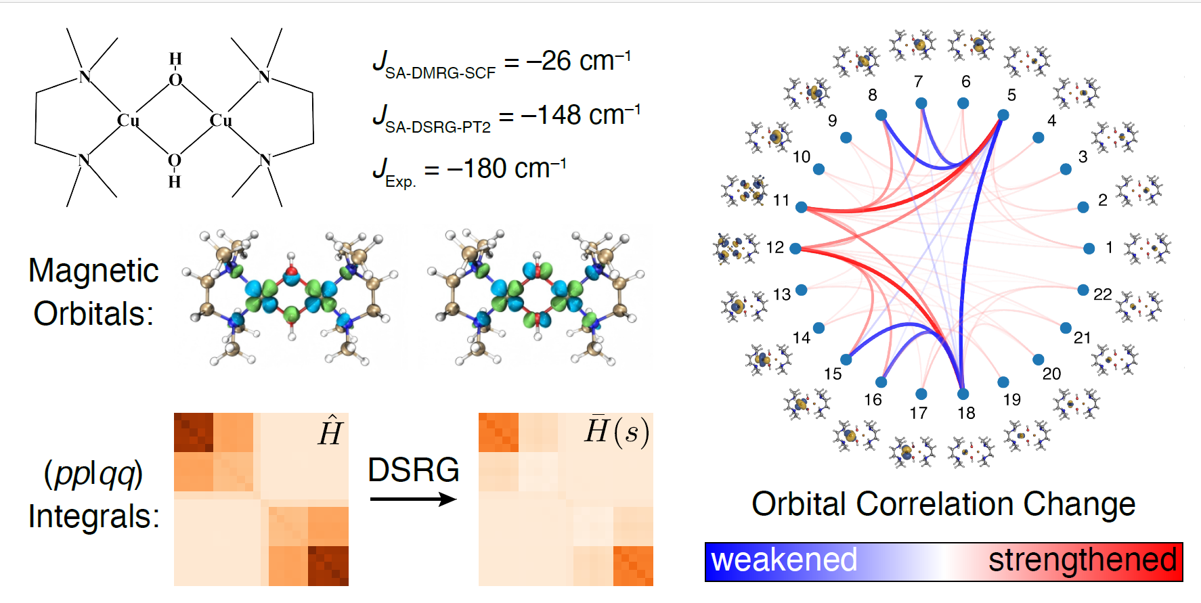

Accurately predicting magnetic exchange coupling constants ($J$) in transition-metal complexes remains a major challenge for electronic structure theory. In this talk, I will present our recent work showing that the state-averaged driven similarity renormalization group second-order perturbation theory, combined with the density matrix renormalization group, can provide quantitative predictions of $J$values for a set of 21 bimetallic 3d complexes, with particular emphasis on dicopper systems. Active orbitals are systematically selected using the atomic valence active space approach, ensuring the consistent inclusion of metal 3d and 4d shells together with ligand orbitals involved in superexchange pathways. Analyses of the effective Hamiltonians indicate that dynamical correlation significantly reduces the effective on-site Coulomb repulsion, which is a key factor in improving the predicted magnetic couplings. In addition, we utilize orbital mutual correlation plots as an intuitive visualization tool for identifying magnetic exchange pathways.

Reference
[1] Z. Hu and C. Li, Inorg. Chem. 2026 (in press).

Designing benzodithiophene-based donor-acceptor oligomers and small molecules for photovoltaic applications: Insights from computational studies

Mohd Shavez

School of Chemistry, University of Hyderabad, Hyderabad, 500046, India
E-mail: mohddshavezz@gmail.com

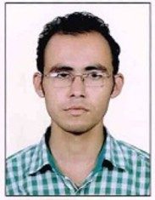

Over the past two decades, the field of organic photovoltaics has grown rapidly to develop newer materials for improving the efficiency of solar cells. Bulk heterojunction architecture-based organic solar cells (OSCs) have been rapidly promoted in recent times due to various advantages such as a wide range of materials selection, simple preparation procedure, light-weightiness, low-cost, transparency, and mechanical flexibility. In this work, structural, optoelectronic, charge transport, and charge transfer properties of benzo[1,2-b,4,5-b’]dithiophene (BDT) based conjugated oligomers were explored using density functional theory (DFT) and time-dependent (TDDFT) methods. BDT is a widely used donor system, and various structural modifications of this unit has provided a better understanding of the structure-property relationships. Non-fullerene acceptor is used in our studies. Our studies figure out many essential relationships that will help to design the active layers with more probabilities of obtaining better efficiencies.

How to connect
Alexey Akimov is inviting you to a scheduled Zoom meeting.

Topic: VISTA, Seminar 108
Time: May 6, 2026 10:00 AM Eastern Time (US and Canada)
Join Zoom Meeting
https://buffalo.zoom.us/j/91789007369?pwd=wIeA6bBkMLEQpvSnyfbyQAm8l5EZgO.1

Meeting ID: 917 8900 7369
Passcode: 091637

How to stay updated

A. VISTA Mailing list:
- Follow the link: https://listserv.buffalo.edu/scripts/wa.exe?A0=CHE-VISTA-LIST&X=OA41BBB2DC6071987DF&Y=alexeyak%40buffalo.edu
- Click the menu icon in the upper right part of the list (yellow highlight in the picture below)
- Click the “Subscribe or Unsubscribe” option (purple highlight below) – it will bring you to the next window where you’ll be asked for your email/name (I think it the name is optional to provide). This way, you can subscribe to the mailing list to stay tuned or unsubscribe if you find the seminars irrelevant to you or just get too much emails to deal with.
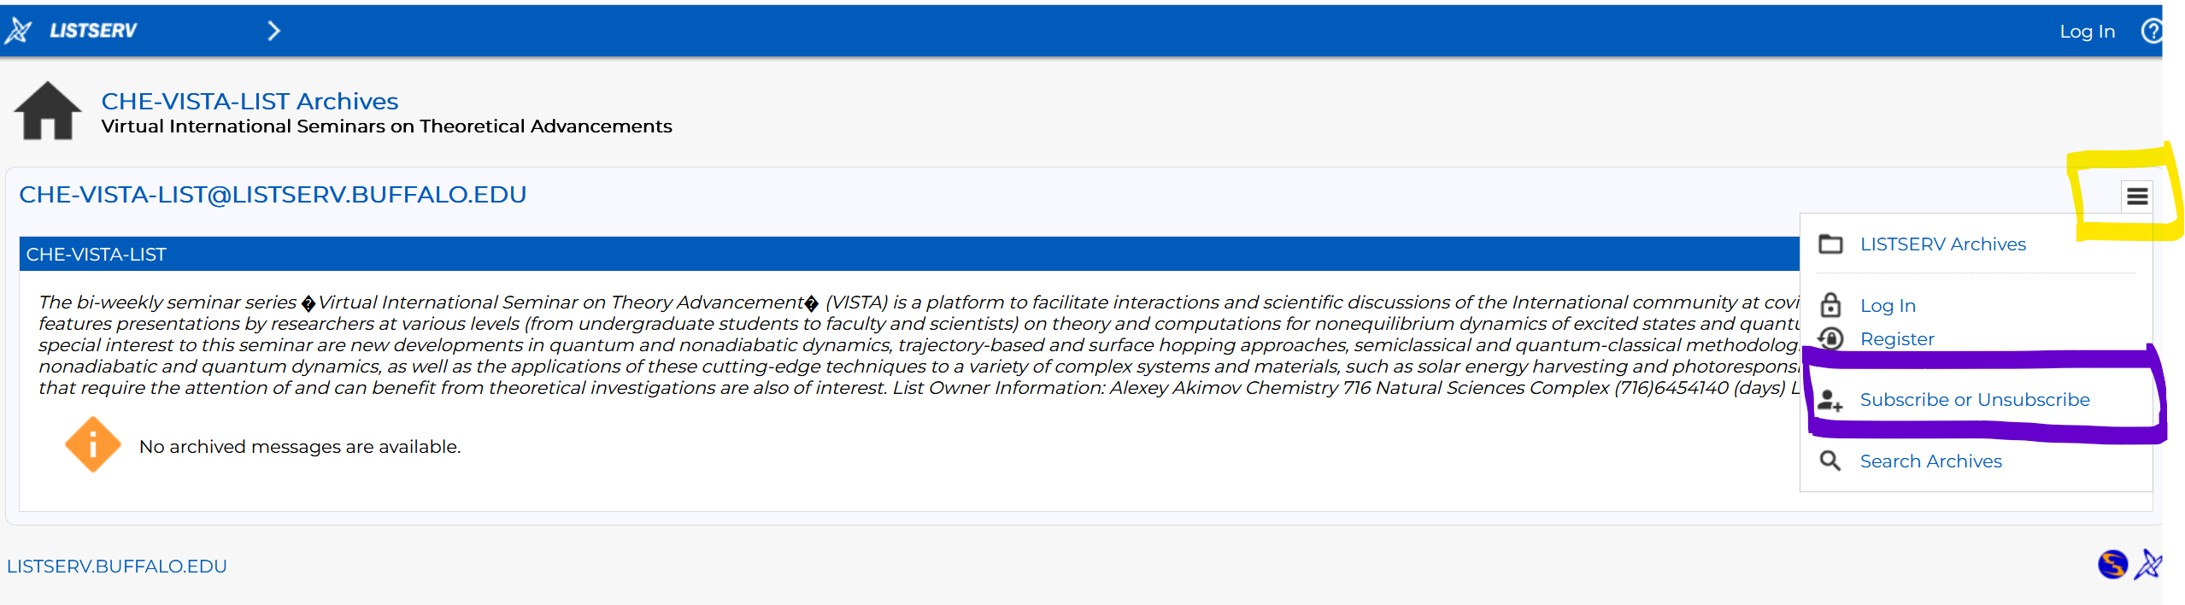

B. Slack Workspaces:
- VISTA workspace: https://join.slack.com/t/vista-atk8254/shared_invite/zt-mdlteo5v-P1Hc7XVupkwMbnGhNG4KIw
- Quantum Dynamics Hub workspace: https://join.slack.com/t/quantumdynamicshub/shared_invite/zt-mjbhjssx-GGhsbYHxeBMvhmumK_j7LA

C. Gmail calendar: https://calendar.google.com/calendar/u/4?cid=Y19jMjhjZjc3YmQxZWY1MWFkMzAwNjQ2MDVkZmQ1YjY3OGMyZmMxMGJmYjZhZmUyOGViZjg0MzA0NzVhMmY5NDAyQGdyb3VwLmNhbGVuZGFyLmdvb2dsZS5jb20

