VISTA Seminar

Seminar 87

Apil 9, 2025
10:00 am – 11:30 am EDT Buffalo / 3:00 – 4:30 pm BST London / 4:00 pm – 5:30 pm CEST Paris / 10 pm – 11:30 pm CST Beijing

TOC:

1. Presenter 1: Prof. Richard Lombardini, St Mary’s University, USA..……..page 2
2. Presenter 2: Mr. Davide Moscato, Universita degli Study di Milano, Italy..page 3
3. How to connect………………………………………………………..….. page 4

Interacting Quantum Trajectories and Dwell Times for Particles with Spin 1/2

Richard Lombardini¹ and Bill Poirier²

- St. Mary’s University (San Antonio, TX), Department of Physics (Associate Professor).
Email: rlombardini@stmarytx.edu
- University of Vermont, Department of Chemistry (Chair).
Email: bill.poirier@uvm.edu
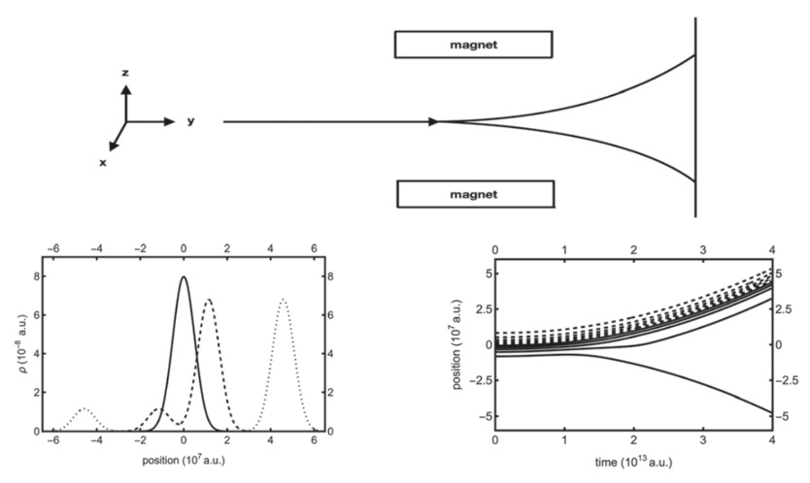

Time propagation of non-relativistic quantum systems of spin 1/2, traditionally modeled by spinor wavefunctions obeying Pauli equation, will be examined within the context of quantum trajectory methods (QTMs). First, a new variation of QTMs, known as the interacting quantum trajectory (IQT) method, which has been developed for non-relativistic spin-free particles,¹ will be presented for both a free-particle system called the ‘quantum spin flipper’ and the Stern-Gerlach experiment. This method replaces the wavefunction or ‘pilot wave’ in the de Broglie-Bohm (dBB) theory with an ensemble of trajectories where the quantum effects manifest as interactions between the trajectories. The 1D cases will be presented where three real-valued field quantities, one particle position and two angles designating orientation of spin, each depending on time and a trajectory labeling coordinate, are guided by three non-linear coupled PDEs. Novel numerical techniques will be introduced in the propagation in order demonstrate stable dynamics. Second, quantum dwell times and dwell time distributions in the context of dBB QTMs, will be presented for a benchmark 3D spin-1/2 particle system which was analyzed in an earlier study using QTM-based arrival time distributions.² Recent work has established a connection between QTMs and dwell times,^{3,4} but only in the context of time-independent stationary scattering applications. This present analysis extends these concepts to more general multi-dimensional and time-dependent cases. In addition, dwell time formulation in terms of bipolar quantum trajectories⁵ will be presented which offers another possible theoretical candidate for comparison to experimental quantum time measurements.

References:
[1] B. Poirier, Chemical Physics 370, 4-14 (2010).
[2] S. Das, M. N$\ddot{o}$th, D. D$\ddot{u}$rr, Physical Review A 99, 052124 (2019).
[3] L. Dupuy, G. Parlant, B. Poirier, Y. Scribano, Physical Letters A 456, 128548 (2022).
[4] L. Dupuy, G. Parlant, B. Poirier, Y. Scribano, Chemical Physics 572, 111952 (2023).
[5] B. Poirier, Journal of Chemical Physics 121, 4501-4515 (2004).
Semiclassical Initial Value Representation: From large molecular systems to nonadiabatic dynamics

Davide Moscato, Michele Gandolfi, Giacomo Mandelli, Riccardo Conte, Michele Ceotto

Universita degli Studi di Milano, Italy
Email: davide.moscato@unimi.it

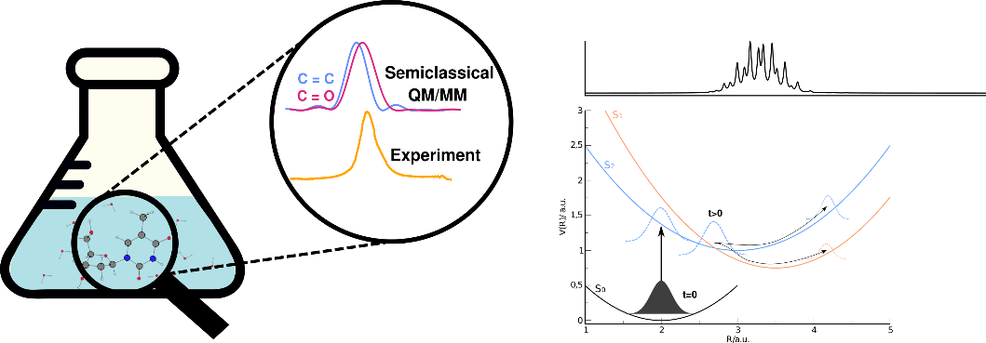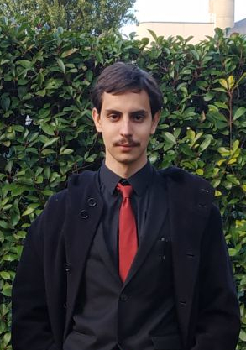

Since the early stages of the development of semiclassical theories, it has been pointed out how they can include nuclear quantum effects in standard molecular dynamics.[1] Thanks to recent developments, [2,3] it is possible to apply those methods to full-atomistic systems featuring thousands of vibrational degrees of freedom. As a proof of concept that our full-atomistic semiclassical approach is already applicable to tackle practical problems, we introduce a quantum mechanics/molecular mechanics semiclassical method for studying the solvation process of molecules in water.[4] We employ it for vibrational spectroscopy calculations since such a tool is very sensitive to the molecular environment. Specifically, we look at the vibrational spectroscopy of thymidine in liquid water. Here we can show that our results feature experimental accuracy and also allow to give new physical insights on the system under investigation. Moreover, in the last and final part of the talk, we will also explore the possibility of using the Semiclassical Initial Value Representation (SCIVR) to compute vibronic spectra in a nonadiabatic framework.[5] More specifically, by combining the mapped Hamiltonian and the SCIVR formalism we introduce a time-averaged semiclassical method for the calculation of the absorption spectrum that is also able to account for nonadiabatic effects in vibronic spectroscopy. To benchmark this approach, we consider some simple model systems against exact quantum mechanical results. Finally, we test our method on the four-mode model of pyrazine, a fundamental benchmark in the field of nonadiabatic vibronic spectroscopy for understanding the potentiality and the limitations of our semiclassical approach.

References:
[1] W.H. Miller; J. Phys. Chem. A 2001, 105, 13, 2942–2955
[2] M. Ceotto, G. F. Tantardini, A. Aspuru-Guzik; J. Chem. Phys. 135, 214108 (2011)
[3] M. Ceotto, G. Di Liberto, R. Conte; Phys. Rev. Lett. 119, 010401
[4] D. Moscato, G. Mandelli, M. Bondanza, F. Lipparini, R. Conte, B. Mennucci, M. Ceotto; J. Am. Chem. Soc. 2024, 146, 12, 8179–8188
[5] D. Moscato, M. Gandolfi, M. Ceotto; paper submitted

How to connect

Alexey Akimov is inviting you to a scheduled Zoom meeting.

Topic: VISTA, Seminar 87
Time: Apr 9, 2025 10:00 AM Eastern Time (US and Canada)
Join Zoom Meeting
https://buffalo.zoom.us/j/96683048322?pwd=fAntHatA7T601Egn1dAAuz83NU42vY.1

Meeting ID: 966 8304 8322
Passcode: 770986

