VISTA Seminar

Seminar 112

September 16, 2026
10:00 am – 11:30 am EDT Buffalo / 3:00 – 4:30 pm BST London / 4:00 pm – 5:30 pm CEST Paris / 10 pm – 11:30 pm CST Beijing

TOC:

1. Presenter 1: Prof. Linjun Wang, Zhejiang University, China…………...….page 2
2. Presenter 2: Mr. Meseret Simachew Bazabih, Bowling Green State University, USA…………………………………………………………………………...page 3
3. How to connect………………………………………………………..….. page 4

Detailed Complementary Consistency for Mixed Quantum-Classical Nonadiabatic Dynamics

Linjun Wang*
Department of Chemistry, Zhejiang University, Hangzhou 310058, China
*Email: ljwang@zju.edu.cn

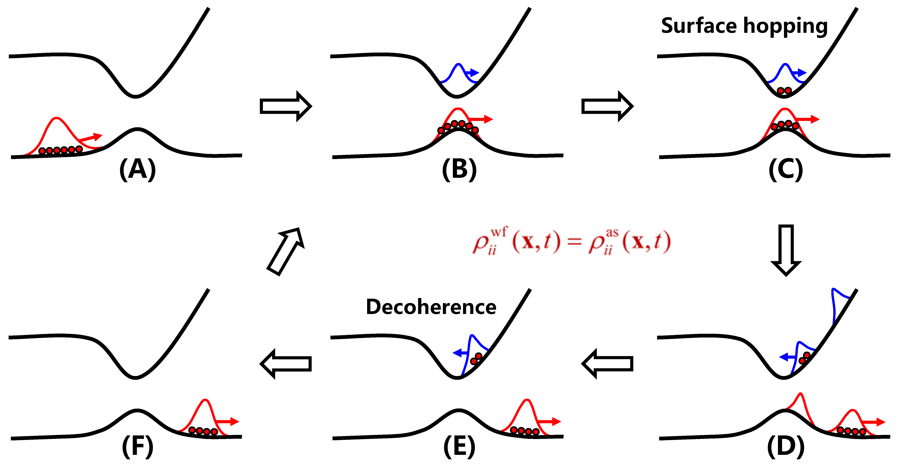

Nonadiabatic dynamics processes are ubiquitous across chemistry, physics, biology and materials science. While a fully quantum description inherently suffers from the “curse of dimensionality”, the mixed quantum-classical descriptions offer a promising pathway for studying complex systems, but a robust theoretical framework is strongly required. Suppose we describe the total system in terms of a mixed quantum-classical trajectory ensemble, and each trajectory is characterized by “classical” coordinates and momenta, along with a wave function and an active state for the “quantum” degrees of freedom. By analogy to the Born interpretation in quantum mechanics, the wave function should give the probability density that the trajectory can be found at a particular spatial place in a particular state at the ensemble level. On the basis of this basic principle for mixed quantum-classical dynamics, we have developed the detailed complementary consistency method, where wave function tells particle how to hop and particle tells wave function how to collapse. We reveal that surface hopping and quantum decoherence are actually two sides of the same coin. As benchmarked against a variety of scattering and bound-state models, the method yields highly reliable time dependence and spatial distribution for both state populations and quantum coherence. A consistent theoretical framework for mixed quantum-classical nonadiabatic dynamics has thus been established.

References:
1. L. Huang, Z. Shi, and L. Wang. Detailed Complementary Consistency: Wave Function Tells Particle How to Hop, Particle Tells Wave Function How to Collapse. J. Phys. Chem. Lett. 15, 6771–6781 (2024).
2. J. Xu, Z. Shi, and L. Wang. Consistent Construction of the Density Matrix from Surface Hopping Trajectories. J. Chem. Theory Comput. 20, 2349–2361 (2024).
3. R. Xie, Z. Shi, and L. Wang. Coupled-Trajectory Surface Hopping with Sign Consistency. J. Chem. Phys. 162, 164103 (2025).

Strain-driven photochemical reactivity of a small molecule

Meseret Simachew Bazabih,† Filippo Sacchetta,‡ Alejandro Blanco-Gonzalez,† and Massimo Olivucci†,‡,*

†Department of Chemistry, Bowling Green State University, Bowling Green, Ohio 43403, United States
‡Dipartimento di Biotechnologie, Chimica e Farmacia, Università di Siena, I-53100, Siena, Italy
Email: mbezabi@bgsu.edu


Strained olefins are a special type of alkene known for their exceptional reactivity, contributing to high-performance materials due to their unique geometry, ring strain, and electronic properties. They are primarily used in organic synthesis, drug discovery, building large molecules (i.e., polymers), and energy storage. In this work, we investigated the electronically excited state dynamics of norborn-1-ene using a multistate-multiconfigurational quantum mechanical/molecular mechanics (QM/MM) approach in solution to account for solvent effects, starting with the computation of its absorption spectrum, λ_{max} of 320 nm. Our QM/MM quantum-classical excited state molecular dynamics simulations revealed a unique zwitterionic conical intersection structure with a non-classical and homoaromatic cation formed via anchimeric assistance. Its singlet excited state lifetime was calculated to be 75 fs, indicating that norborn-1-ene undergoes an ultrafast relaxation process. We believe this work provides insight into the photophysical and photochemical properties of such a highly strained olefin and the stereochemistry of its photoreaction.

How to connect

Alexey Akimov is inviting you to a scheduled Zoom meeting.

Topic: Seminar #112: Linjun Wang and Meseret Simachew Bazabih
Time: Sep 16, 2026 10:00 AM Eastern Time (US and Canada)
Join Zoom Meeting
https://buffalo.zoom.us/j/91080141922?pwd=Ns1yh51zRCgF4YYmvrs3XSHaHEZ42k.1

Meeting ID: 910 8014 1922
Passcode: 542966

How to stay updated

A. VISTA Mailing list:
- Follow the link: https://listserv.buffalo.edu/scripts/wa.exe?A0=CHE-VISTA-LIST&X=OA41BBB2DC6071987DF&Y=alexeyak%40buffalo.edu
- Click the menu icon in the upper right part of the list (yellow highlight in the picture below)
- Click the “Subscribe or Unsubscribe” option (purple highlight below) – it will bring you to the next window where you’ll be asked for your email/name (I think it the name is optional to provide). This way, you can subscribe to the mailing list to stay tuned or unsubscribe if you find the seminars irrelevant to you or just get too much emails to deal with.
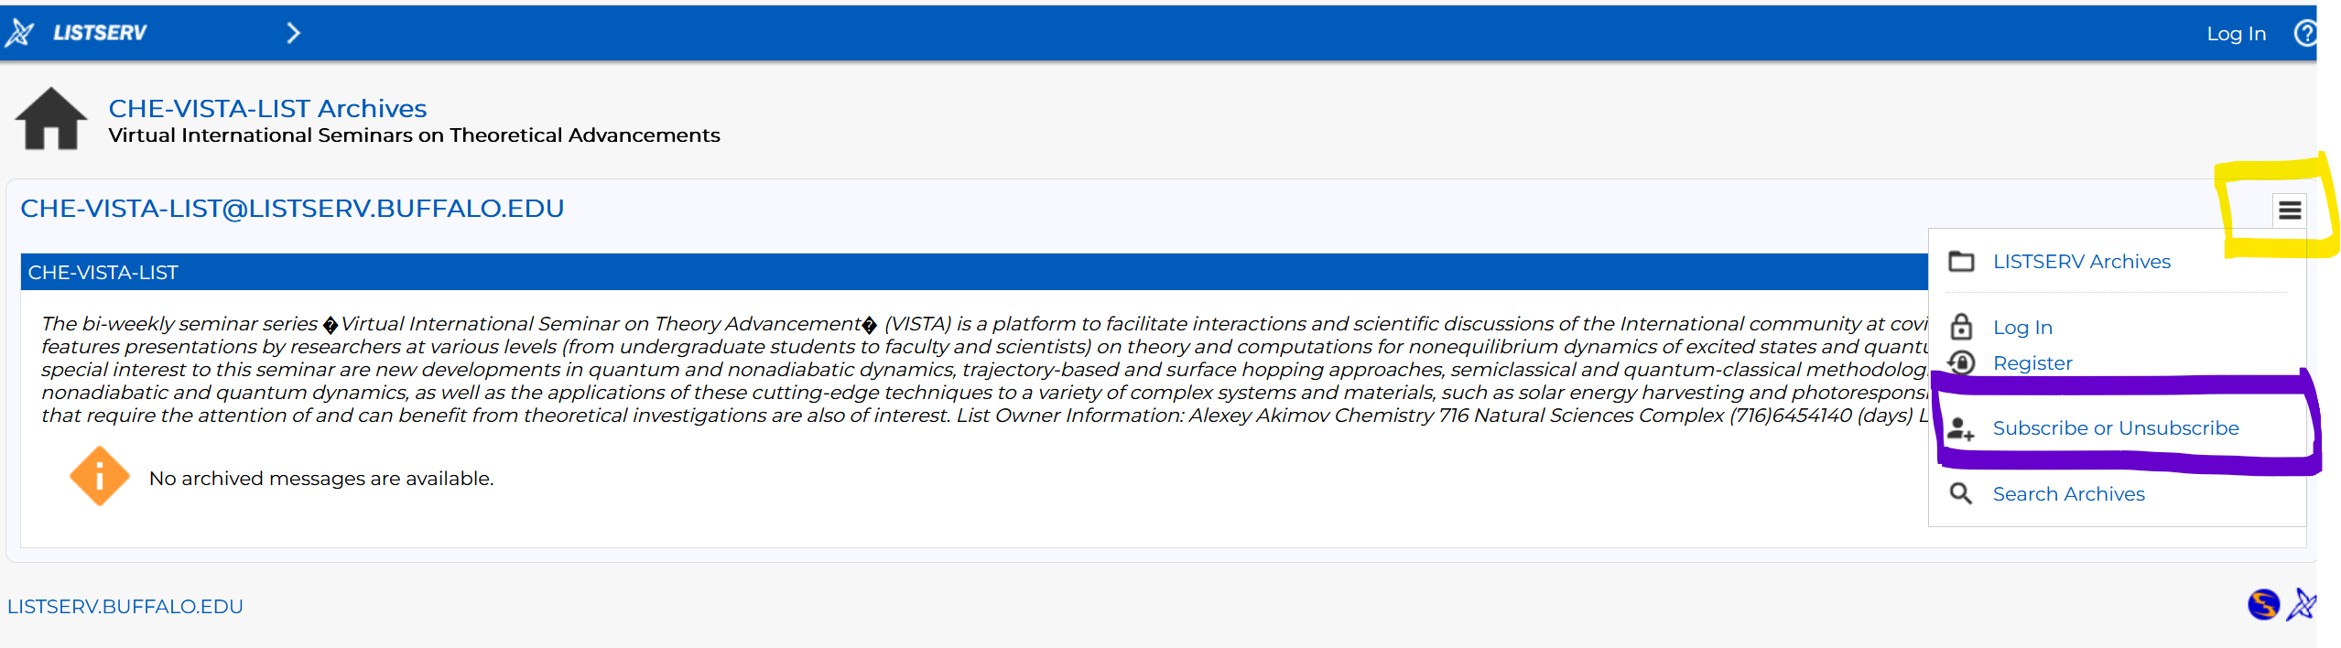

B. Slack Workspaces:
- VISTA workspace: https://join.slack.com/t/vista-atk8254/shared_invite/zt-mdlteo5v-P1Hc7XVupkwMbnGhNG4KIw
- Quantum Dynamics Hub workspace: https://join.slack.com/t/quantumdynamicshub/shared_invite/zt-mjbhjssx-GGhsbYHxeBMvhmumK_j7LA

C. Gmail calendar: https://calendar.google.com/calendar/u/4?cid=Y19jMjhjZjc3YmQxZWY1MWFkMzAwNjQ2MDVkZmQ1YjY3OGMyZmMxMGJmYjZhZmUyOGViZjg0MzA0NzVhMmY5NDAyQGdyb3VwLmNhbGVuZGFyLmdvb2dsZS5jb20

