VISTA Seminar

Seminar 85

March 12, 2025
10:00 am – 11:30 am EST Buffalo / 3:00 – 4:30 pm GMT London / 4:00 pm – 5:30 pm CET Paris / 11 pm – 12:30 am CST Beijing

TOC:

1. Presenter 1: Prof. Farnaz Shakib, New Jersey Institute of Technology, USA…………………………………………………………………………..page 2
2. Presenter 2: Dr. Muhammad Hasyim, New York University, USA………..page 3
3. How to connect………………………………………………………..….. page 4

Development of methods and software for non-adiabatic quantum dynamics simulations subject to nuclear quantum effects

Farnaz A. Shakib

Department of Chemistry and Environmental Science, New Jersey Institute of Technology, Newark, NJ 07102
Email: shakib@njit.edu

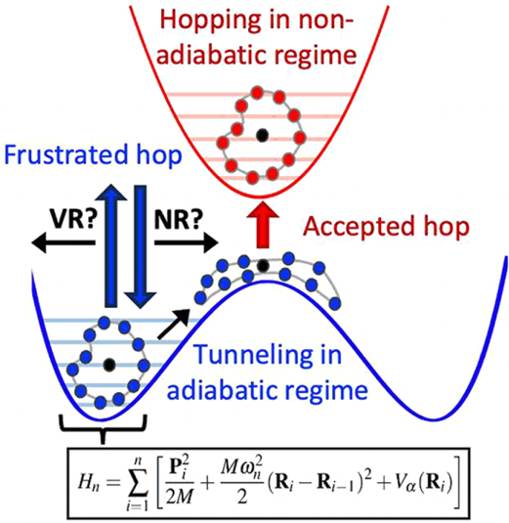

Classical molecular dynamics (MD) neglects nuclear quantum effects (NQEs) associated with atomic motions, including proton tunneling and zero-point energy. The isomorphism between Feynman’s path integral formulation of quantum mechanics and a classical ring polymer of n beads has been exploited extensively for calculating statistical and dynamical properties subject to NQEs. Here, I will discuss our recent method and software developments in the context of the ring polymer surface hopping (RPSH) methodology where the non-adiabatic electronic transitions are described through Tully’s fewest-switches surface hopping algorithm and the motion of the nuclei is quantized through the ring polymer Hamiltonian in the extended phase space. Specifically, I will address the fundamental questions related to the conservation of energy and detailed balance arising from the surface hopping ansatz within RPSH. I will show that proper treatment of frustrated hops is key to the accurate description of real-time dynamics as well as reproducing the correct quantum Boltzmann populations. I will also introduce Zhu-Nakamura (ZN) RPSH for efficient simulations of non-adiabatic dynamics subject to NQEs in condensed phases. ZN formalism allows bypassing the expensive calculations of derivative couplings as opposed to the original RPSH, or any other surface hopping algorithm for that matter. Furthermore, it inherently addresses the issue of frustrated hops. By calculating the probability of non-adiabatic transition based on the shape and slope of potential energy surfaces, ZN-RPSH can reduce the computational cost drastically which is essential for efficient simulations of non-adiabatic dynamics subject to NQEs in complex molecular and material systems.

Understanding Cavity-Mediated Dynamics in Vibrational Polaritonic Chemistry

Muhammad R. Hasyim

Simons Center for Computational Physical Chemistry, New York University, New York, NY 10003, USA
E-mail: mh7373@nyu.edu

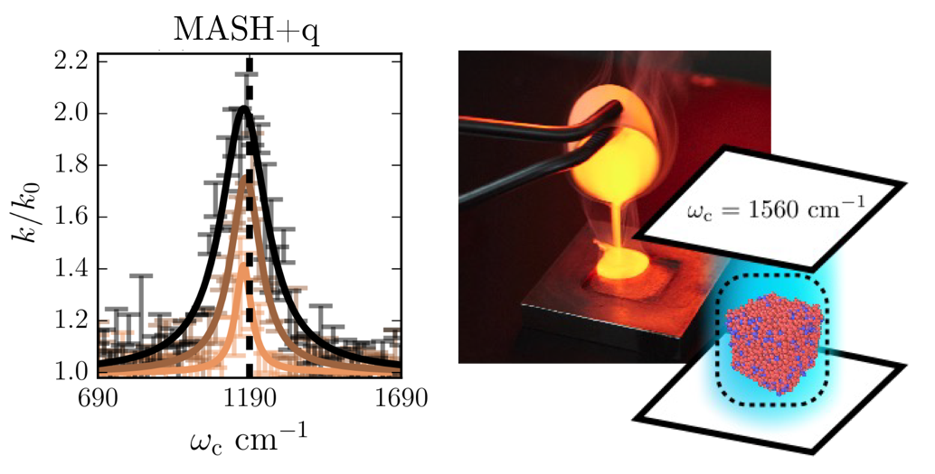

Recent experiments have demonstrated how optical microcavities—devices that selectively trap light at specific frequencies—can modify reaction kinetics. In the strong coupling regime, where the optical mode frequency matches a molecular transition, hybrid light-matter states called polaritons form, leading to either suppression or enhancement of reaction rates.
This talk presents two complementary studies examining polaritonic chemistry across different length scales. First, we explore light-matter interactions using mixed quantum-classical (MQC) methods on a single-molecule model [1]. We improve quantitative accuracy by implementing the mapping approach to surface hopping (MASH) as an alternative to mean-field and trajectory hopping methods, while incorporating quantum treatment of the cavity mode. Our results show that combining MASH with a quantum cavity mode yields the most accurate rates. Second, we investigate how optical cavities modify the properties of supercooled liquids—a metastable form of a liquid below freezing [2]. Using cavity molecular dynamics, which treats both the cavity mode and molecular system classically, we study relaxation dynamics in such systems with many molecules ($N≫100$). Our results reveal that collective relaxation achieves maximum modification at an optimal coupling strength, highlighting an intriguing phenomenon where vibrational polaritons can mediate collective relaxation dynamics at much longer timescales. I conclude this talk with future directions on modeling collective phenomena in vibrational polaritonic chemistry.

References

[1] Muhammad R. Hasyim, Arkajit Mandal, and David R. Reichman. arXiv:2502.04570 (2025).
[2] Muhammad R. Hasyim, Arianna Damiani, Norah M. Hoffmann, in preparation (2025).

How to connect

Alexey Akimov is inviting you to a scheduled Zoom meeting.

Topic: VISTA, Seminar 85
Time: Mar 12, 2025 10:00 AM Eastern Time (US and Canada)
Join Zoom Meeting
https://buffalo.zoom.us/j/98636796729?pwd=jmG1slp7pmAfiqfiWw2iWIEUK2ieDX.1

Meeting ID: 986 3679 6729
Passcode: 004330

