VISTA Seminar

Seminar 98

November 26, 2025
10:00 am – 11:30 am EST Buffalo / 3:00 – 4:30 pm GMT London / 4:00 pm – 5:30 pm CET Paris / 11 pm – 12:30 pm CST Beijing

TOC:

1. Presenter 1: Prof. Hongli Guo, Zhejiang University, China……...……......page 2
2. Presenter 2: Dr. Xinju (Spancer) Dong, Oak Ridge National Laboratory, USA…………………………………………………………………………..page 3
3. How to connect………………………………………………………..….. page 4

First-Principles Calculations of Moiré Excitons in Twisted Two-Dimensional Materials

Hongli Guo^{1,2}, Xu Zhang², Gang Lu²

¹School of Physics, Zhejiang University, Hangzhou 310058, P. R. China
²Department of Physics and Astronomy, California State University Northridge, Northridge, California 91330-8268, United States
Email: hongliguo@zju.edu.cn

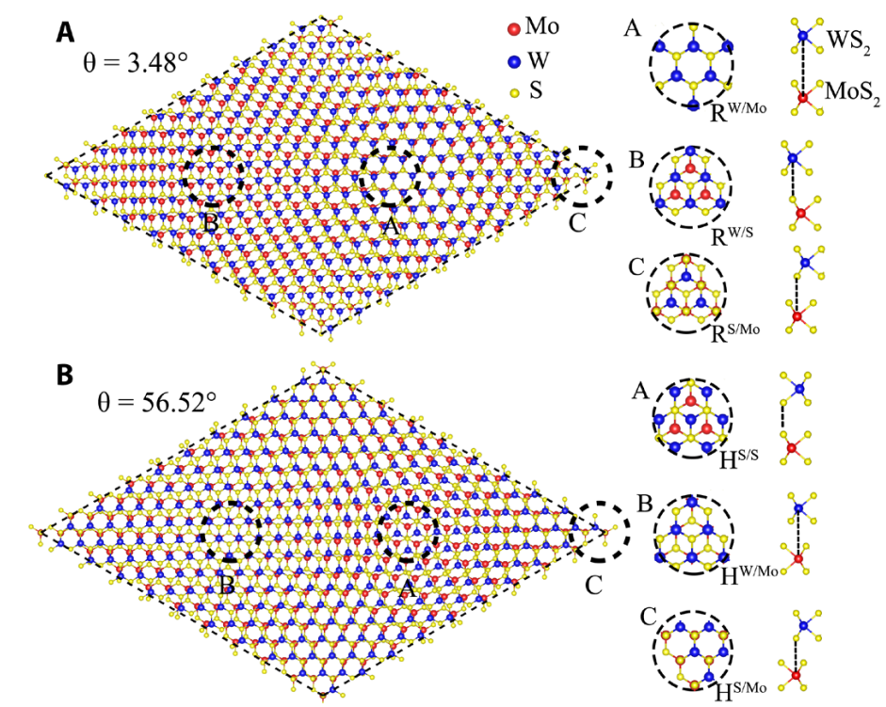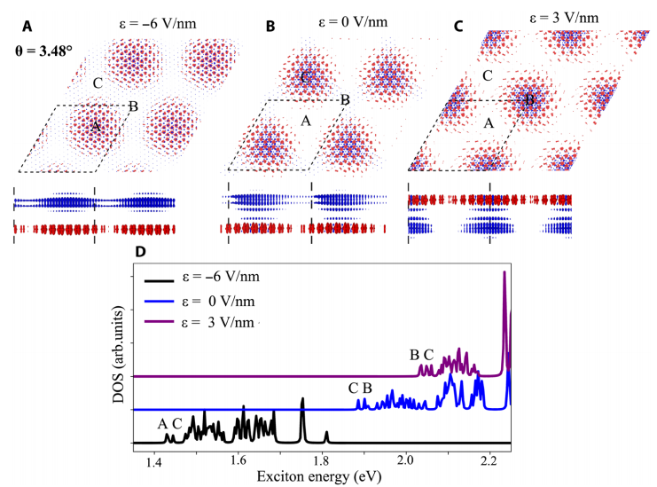

By combining linear-response time-dependent density-functional theory (LR-TDDFT) with range separated hybrid functional, we overcome the difficulty of accurately treating excitonic effects at large scales and successfully compute the key properties of moiré excitons in twisted materials containing more than 2,000 atoms. These properties include exciton energy, dispersion, spatial localization, polarity, and optical absorption, as well as their tunability through external and structural control. Our theoretical analysis also predicts a variety of mechanisms for manipulating moiré exciton states, offering useful design guidelines for optoelectronic and quantum-photonic devices.We further propose a mechanism to realize high-temperature intralayer exciton Bose–Einstein condensation (BEC) using chemical doping. Our results reveal the essential roles of the moiré potential and exciton interactions in exciton condensation and provide key physical parameters and phase diagrams that can guide the search for optimal materials. To capture ultrafast dynamics, we integrate LR-TDDFT with nonadiabatic molecular dynamics, allowing us to include many-body effects while maintaining computational feasibility for large systems. For moiré excitons in black phosphorus, we obtain time- and space-resolved exciton dynamics, revealing charge and energy transfer processes involved in bright–dark exciton conversion. We determine exciton transfer times and lifetimes and uncover the significant effects of electron–hole interactions and exciton–phonon coupling on exciton transport and relaxation.
References :
[1] Guo et al., Science Advances 6, eabc5638 (2020).
[2] Guo et al., PNAS 118 (32), e2105468118 (2021).
[3] Guo et al., Science Advances 8 (40), eabp9757 (2022).
[4] Guo et al., Science Advances 9 (29), eadi5404 (2023).

Inter(Intra)molecular Singlet Fission Study Using GronOR Non-Orthogonal Configuration Interaction Method
Xinju (Spancer) Dong,¹ Coen de Graaf,^{2,3} Ria Broer,⁴ Carmen Sousa,⁵ Jordi Ribas,⁵ Xavier López,² Tjerk Straatsma^{1,6}
1). Oak Ridge National Laboratory, Oak Ridge, TN, USA. 2) Universitat Rovira i Virgili, Tarragona, Spain 3) ICREA, Barecelona, Spain. 4) University of
Groningen, Groningen, the Netherlands. 5). Universitat de Barcelona, Barcelona, Spain, 6). University of Alabama, Tuscaloosa, AB
Email: spancerdong86@gmail.com
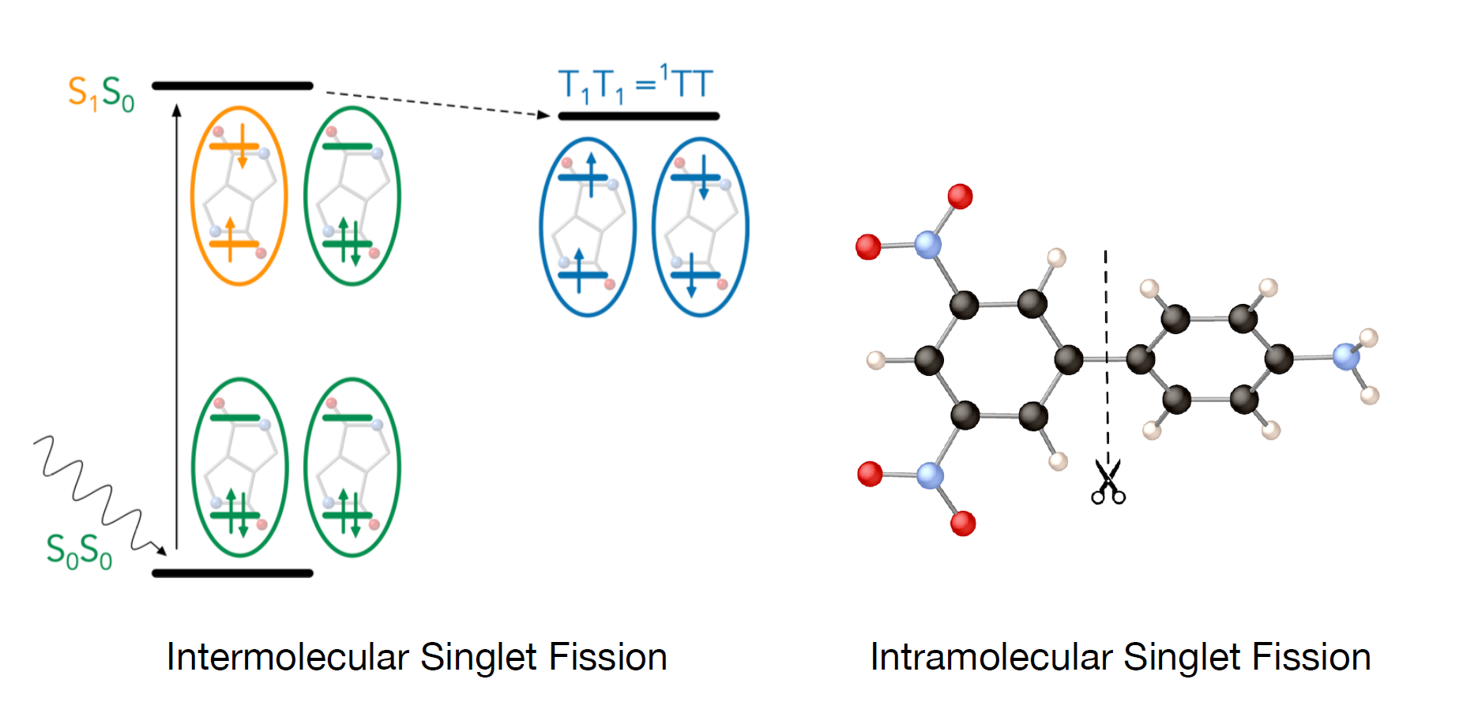
The couplings among electronic states provide essential clues to reveal details of the electron transfer mechanism within photochemistry processes, such as singlet fission. Singlet fission processes play a significant role in the design of more efficient photoharvesting solar cells. The GronOR^{1,2} software package renders a computational description of couplings to enable theoretical insight into the singlet fission process, which cannot be obtained directly from experiments. The core methodology of GronOR is non-orthogonal configuration interaction using fragment wave functions (NOCI-F) and allows an intuitive way of interpreting wavefunctions in terms of individually optimized diabatic states. Based on an advanced worker-master execution model, GronOR computes the Hamiltonian matrix (the computationally most demanding step) in parallel, and scales linearly on the largest modern HPC systems. In this talk, examples in inter-³ and intra-⁴ molecular singlet fission and performance of GronOR on HPCs will be illustrated.

References:
1). Straatsma, T. P., Broer, R., Faraji, S., Havenith, R. W. A., Suarez, L. E., Kathir, R. K., ... & De Graaf, C. (2020). GronOR: Massively parallel and GPUaccelerated non-orthogonal configuration interaction for large molecular systems. The Journal of Chemical Physics, 152(6).
2). Straatsma, T. P., Broer, R., Sánchez-Mansilla, A., Sousa, C., & De Graaf, C. (2022). GronOR: Scalable and accelerated nonorthogonal configuration interaction for molecular fragment wave functions. Journal of Chemical Theory and Computation, 18(6), 3549-3565.
3). Sousa, C., Lopez, X., Dong, X., Broer, R., Straatsma, T. P., & de Graaf, C. (2025). Nonorthogonal Configuration Interaction for Singlet Fission: Beyond the Dimer. The Journal of Physical Chemistry C, 129(8), 4290-4302.
4). Sousa, C., Dong, X., Broer, R., Straatsma, T. P., & de Graaf, C. (2025). The overlapping fragment approach for Non-orthogonal Configuration Interaction with fragments. Physical Chemistry Chemical Physics.
How to connect

Alexey Akimov is inviting you to a scheduled Zoom meeting.

Topic: VISTA, Seminar 98
Time: Nov 26, 2025 10:00 AM Eastern Time (US and Canada)
Join Zoom Meeting
https://buffalo.zoom.us/j/92091092386?pwd=MXP0jAnpQrKMKtQ23nfsZN57RLSgw5.1

Meeting ID: 920 9109 2386
Passcode: 503287

How to stay updated

A. VISTA Mailing list:

- Follow the link:
https://listserv.buffalo.edu/scripts/wa.exe?A0=CHE-VISTA-LIST&X=OA41BBB2DC6071987DF&Y=alexeyak%40buffalo.edu
- Click the menu icon in the upper right part of the list (yellow highlight in the picture below)
- Click the “Subscribe or Unsubscribe” option (purple highlight below) – it will bring you to the next window where you’ll be asked for your email/name (I think it the name is optional to provide). This way, you can subscribe to the mailing list to stay tuned or unsubscribe if you find the seminars irrelevant to you or just get too much emails to deal with.
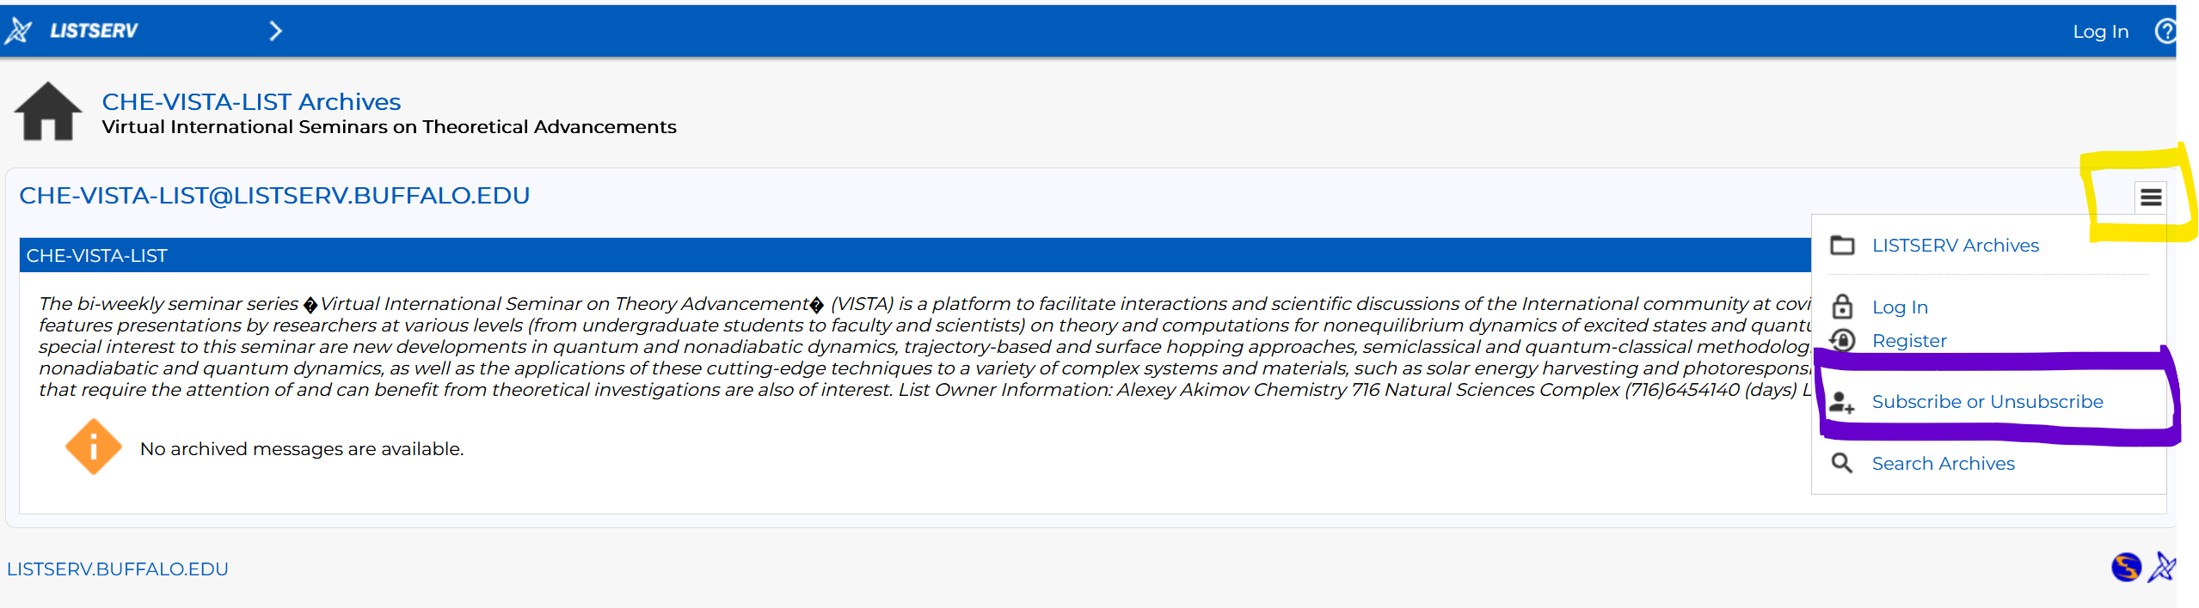

B. Slack Workspaces:

- VISTA workspace: https://join.slack.com/t/vista-atk8254/shared_invite/zt-mdlteo5v-P1Hc7XVupkwMbnGhNG4KIw
- Quantum Dynamics Hub workspace: https://join.slack.com/t/quantumdynamicshub/shared_invite/zt-mjbhjssx-GGhsbYHxeBMvhmumK_j7LA

