VISTA Seminar

Seminar 110

June 3, 2026
10:00 am – 11:30 am EDT Buffalo / 3:00 – 4:30 pm BST London / 4:00 pm – 5:30 pm CEST Paris / 10 pm – 11:30 pm CST Beijing

TOC:

1. Presenter 1: Prof. Anna Hehn, Christian-Albrechts-University Kiel, Germany…………………………………………………………………..….page 2
2. Presenter 2: Ms. Livia Correa McCormack, The University of Utah, USA,page 3
3. How to connect………………………………………………………..….. page 4

Describing excited states in solids:
from static excited-state properties to trajectory surface hopping
Anna Hehn
Physical Chemistry Institute, Christian-Albrechts-University Kiel, Germany;
Kiel Nano, Surface and Interface Science, Kiel, Germany.
Email: hehn@pctc.uni-kiel.de

The plethora of photochemical processes that need to be unraveled when aiming for a comprehensive description of excited states in solids becomes apparent when considering the process of upconversion: Converting two low energy photons to a high energy one is of vital importance for both catalytical as well as bio-medical applications, holding the promise to enhance both sensing, phototherapy, and theranostics as well as photocatalysis under low solar irradiance. The challenge of overcoming the systematically too low quantum yields demands an atomistic understanding of the full range of relevant photochemical mechanisms, emphasizing the need for an advanced quantum-mechanical tool set for the description of excited states within time-dependent density functional theory implying periodic boundary conditions. This presentation summarizes first steps towards establishing such a tool set within the electronic structure code CP2K and the mixed quantum classical dynamics code Newton-X, with recent developments ranging from semi-empirical and approximate hybrid density functional kernels for static absorption and emission spectroscopy [1], the extension of the Gaussian and plane wave ansatz to the Gaussian and augmented plane wave ansatz[2], the inclusion of perturbative spin-orbit coupling [3], to establishing an interface between CP2K and Newton-X, enabling surface hopping dynamics for extended systems implying periodic boundary conditions [5, 6].

References:
[1] A. Hehn, B. Sertcan, F. Belleflamme, S. K. Chulkov, M. B. Watkins, J. Hutter, J. Chem. Theory Comput. 18, 4186 (2022).
[2] B. Sertcan Gökmen, J. Hutter, A. Hehn, J. Chem. Theory Comput. 20, 8494 (2024).
[3] J.-R. Vogt, J. Wilhelm, A. Hehn, J. Chem. Phys. 162, 082502 (2025).
[4] The CP2K program package (https://www.cp2k.org); M. Iannuzzi et al. J. Phys. Chem. B 130, 1237 (2026).
[5] J.-R. Vogt, M. Schulz, R. Souza Mattos, M. Barbatti, M. Persico, G. Granucci, J. Hutter, A. Hehn, J. Chem. Theory Comput. 21, 10474 (2025).
[6] The Newton-X program package (https://newtonx.org); M. Barbatti et al., to be submitted.
Thermal electromagnetic transport mediated by coupled surface phonon-polaritons in nanostructures

Lívia Corrêa McCormack

Department of Mechanical Engineering, The University of Utah
Email: livia.correa@utah.edu

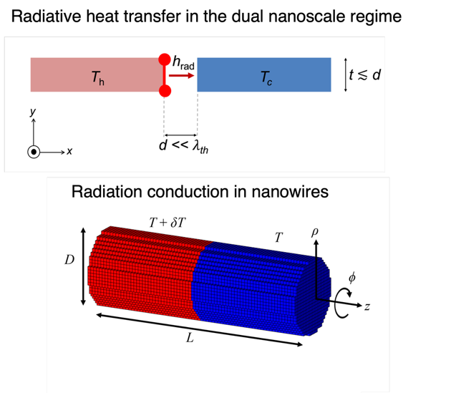

Nanostructures supporting surface phonon polaritons can engineer thermal electromagnetic transport, enabling non-contact heat transfer at the nanoscale and improved thermal management in miniaturized devices. In this talk, the discrete system Green’s function (DSGF) method, a fluctuational-electrodynamics-based framework, is applied to investigate thermal electromagnetic transport in nanostructures. First, contrasting trends reported in the dual nanoscale regime of near-field radiative heat transfer [1,2] have left unclear why near-field radiative heat transfer between subwavelength membranes does not always surpass that between infinite layers. Using DSGF predictions and modal analysis, we show that electromagnetic corner and edge modes can either enhance or attenuate heat transfer depending on material losses, leading to a 5.1-fold enhancement for SiC and a 2.1-fold attenuation for SiO₂. Second, the DSGF is used for the first time to predict radiative conductivity in SiO₂ nanowires and assess the validity of kinetic theory, which is widely employed to estimate radiative conductivity despite ongoing the lack of consensus regarding its accuracy. The results show that the kinetic theory systematically overpredicts radiative conductivity because the commonly used mean free path neglects size effects. A modified kinetic theory incorporating an effective mean free path improves agreement with DSGF predictions for total radiative conductivity.

References:

[1] L. Tang, L. M. Corrêa, M. Francoeur, and C. Dames, Corner-and edge-mode enhancement of near-field radiative heat transfer, Nature, 629, 67 (2024).
[2] X. Luo et al., Observation of near-field thermal radiation between coplanar nanodevices with subwavelength dimensions, Nano Letters, 20, 1502 (2024).

How to connect

Topic: VISTA, Seminar 110
Time: Jun 3, 2026 10:00 AM Eastern Time (US and Canada)
Join Zoom Meeting
https://buffalo.zoom.us/j/94308184918?pwd=ilCMOmU6Wzu5QZSsGmvX4WIKTF7yrl.1

Meeting ID: 943 0818 4918
Passcode: 650634

How to stay updated

A. VISTA Mailing list:
- Follow the link: https://listserv.buffalo.edu/scripts/wa.exe?A0=CHE-VISTA-LIST&X=OA41BBB2DC6071987DF&Y=alexeyak%40buffalo.edu
- Click the menu icon in the upper right part of the list (yellow highlight in the picture below)
- Click the “Subscribe or Unsubscribe” option (purple highlight below) – it will bring you to the next window where you’ll be asked for your email/name (I think it the name is optional to provide). This way, you can subscribe to the mailing list to stay tuned or unsubscribe if you find the seminars irrelevant to you or just get too much emails to deal with.
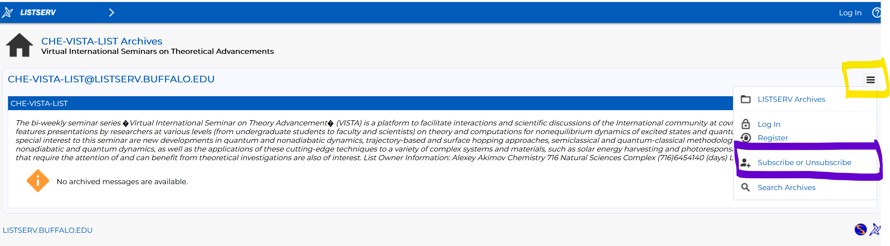

B. Slack Workspaces:
- VISTA workspace: https://join.slack.com/t/vista-atk8254/shared_invite/zt-mdlteo5v-P1Hc7XVupkwMbnGhNG4KIw
- Quantum Dynamics Hub workspace: https://join.slack.com/t/quantumdynamicshub/shared_invite/zt-mjbhjssx-GGhsbYHxeBMvhmumK_j7LA

C. Gmail calendar: https://calendar.google.com/calendar/u/4?cid=Y19jMjhjZjc3YmQxZWY1MWFkMzAwNjQ2MDVkZmQ1YjY3OGMyZmMxMGJmYjZhZmUyOGViZjg0MzA0NzVhMmY5NDAyQGdyb3VwLmNhbGVuZGFyLmdvb2dsZS5jb20

