VISTA Seminar

Seminar 82

January 29, 2025
10:00 am – 11:30 am EST Buffalo / 3:00 – 4:30 pm GMT London / 4:00 pm – 5:30 pm CET Paris / 11 pm – 12:30 am CST Beijing

TOC:

1. Presenter 1: Dr. Lea-Maria Ibele, Institute de Chimie Radicalaire, CNRS/Aix-Marseille Université, France …………………………………………………page 2
2. Presenter 2: Mr. Alessandro Loreti, University of Bologna, Italy……..…..page 3
3. How to connect………………………………………………………..….. page 4

Progressing nonadiabatic molecular dynamics: User-friendly development and community-driven benchmarks

Lea M. Ibele
Institut de Chimie Radicalaire, CNRS/Aix-Marseille Université, France
Email: lea-maria.ibele@univ-amu.fr

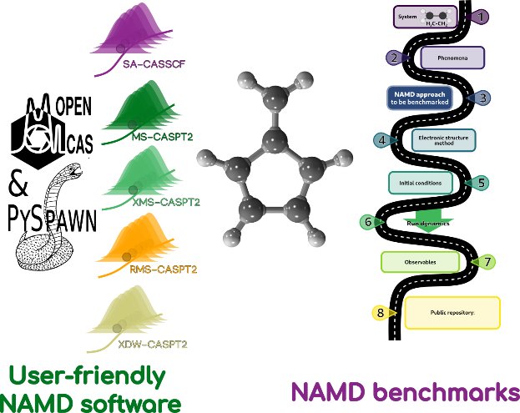

Nonadiabatic dynamics has become an indispensable tool for unravelling the photochemistry and photophysics of molecules. Despite the rapid grow of the field, it often still remains a tool reserved to experts and closed communities. The reasons for that are manifold, one being only a subset of methodologies offering user-friendly and freely available software, another being the uncertainty which of the plethora of nonadiabatic dynamics methodologies is suitable to tackle a certain photochemical problem.
In this talk, I first will introduce our recently developed interface between PySpawn and OpenMolcas [1]. This combination of user-friendly and fully open-source software allows for the first time running ab initio multiple spawning calculations with different multistate CASPT2 formulations, combining state-of-the-art dynamics and electronic structure calculations. I will introduce the structure and capabilities of the interface and plans for future development.
In addition, I want to overview recent efforts towards a common benchmark of nonadiabatic dynamics methodologies. After the introduction of the molecular Tully models in 2020 [2], there have been continued examples towards a comparison of nonadiabatic molecular dynamics. Emblematic ones are the cyclobutanone challenge [3] and a community effort of creating a roadmap of the steps towards a first communal benchmark set for nonadiabatic dynamics [4].

References:
[1] L.M. Ibele, A. Memhood, B.G. Levine, D. Avagliano, J. Chem. Theory Comput. 2024, 20, 18, 8140–8151
[2] L.M. Ibele, B.F.E. Curchod, Phys. Chem. Chem. Phys. 2020, 22, 15183-15196
[3] “Prediction Challenge: Cyclobutanone Photochemistry”, 2024, https://pubs.aip.org/collection/16531/Prediction-Challenge-Cyclobutanone-Photochemistry
[4] “CECAM workshop: Standardizing nonadiabatic dynamics: towards common benchmarks,” https://www.cecam.org/workshop-details/standardizing-nonadiabatic-dynamics-towards- common-benchmarks-1304 (May 2024)
WFOT: a WaveFunction Overlap Tool Between Single- and Multi-Reference Electronic Structure Methods for Spectroscopy Simulation

Alessandro Loreti^{1*}, Victor Manuel Freixas², Davide Avagliano^{1,3}, Francesco Segatta¹, Huajin Song⁴, Sergei Tretiak⁴, Shaul Mukamel², Marco Garavelli¹, Niranjan Govind^{5,6}, Artur Nenov¹

¹Dipartimento di Chimica Industriale “Toso Montanari”, University of Bologna, Bologna, Italy
²Department of Chemistry and Department of Physics and Astronomy, University of California, Irvine, USA
³Institute of Chemistry for Life and Health Sciences Chimie Paristech, Paris, France
⁴Physics and Chemistry of Materials, Theoretical Division, Los Alamos, USA
⁵Physical and Computational Sciences Directorate, Pacific Northwest National Laboratory, Richland, USA
⁶Department of Chemistry, University of Washington, Seattle, USA
Email:alessandro.loreti5@unibo.it
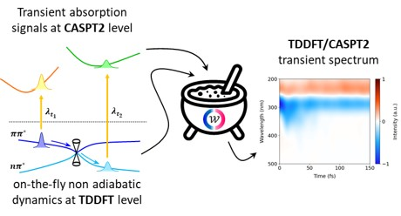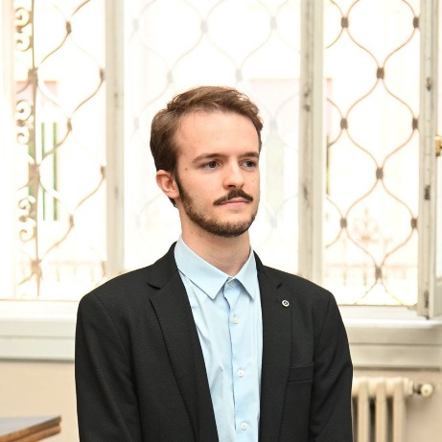

We report the development of a novel diagnostic tool, named WFOT[1], which is designed to evaluate the overlap between wavefunctions computed at single-reference (e.g., TDDFT) and multi-reference (e.g., CASPT2) levels of theory allowing to quantitatively compare the performance of these two families of methods for solving the electronic structure. The tool works by truncating the wavefunction of both methods to CIS-like expansions spanning the same configurational space and maximizes the overlap between molecular orbitals through a pseudo-unitary transformation. To validate its functionality, we performed on-the-fly non-adiabatic dynamics of Acetylacetone at the TD-DFT level of theory and mapped the photo-active state onto the CASPT2 manifold. The single- to multi-reference mapping was used to compute the transient absorption spectrum with multi-reference quality and completeness.
The WFOT tool has been interfaced with the COBRAMM[2] package, allowing access to software such as NWChem, Gaussian, and OpenMolcas.

References
[1] Loreti, A.; Freixas, V. M.; Avagliano, D.; Segatta, F.; Song, H.; Tretiak S.; Mukamel, S.; Garavelli, M.; Govind, N.; Nenov, A. WFOT: A Wave Function Overlap Tool between Single- and Multi-Reference Electronic Structure Methods for Spectroscopy Simulation. JCTC 2024 20 (11), 4804-4819
[2] Weingart, O.; Nenov, A.; Altoè, P.; Rivalta, I.; Segarra-Martí, J.; Dokukina, I.;
Garavelli, M. COBRAMM 2.0 — A software interface for tailoring molecular
electronic structure calculations and running nanoscale (QM/MM) simulations.
J Mol Model 2018, 24.

How to connect

Alexey Akimov is inviting you to a scheduled Zoom meeting.

Topic: VISTA, Seminar 82
Time: Jan 29, 2025 10:00 AM Eastern Time (US and Canada)
Join Zoom Meeting
https://buffalo.zoom.us/j/95878305055?pwd=e8CNVegG9XRMkubb8iFa5EBBSMdjph.1

Meeting ID: 958 7830 5055
Passcode: 201964

