VISTA Seminar

Seminar 104

March 11, 2026
10:00 am – 11:30 am EDT Buffalo / 2:00 – 3:30 pm GMT London / 3:00 pm – 4:30 pm CET Paris / 10 pm – 11:30 pm CST Beijing

TOC:

1. Presenter 1: Prof. Henrik R. Larsson, UC Merced, USA………………….page 2
2. Presenter 2: Dr. Eirik F. Kjønstad, Caltech, USA……………………..…...page 3
3. How to connect………………………………………………………..….. page 4

Correlated real-time electronic charge migration dynamics using the density matrix renormalization group
Henrik R. Larsson

Department of Chemistry and Biochemistry at
University of California Merced, USA
Email: larsson@ucmerced.edu

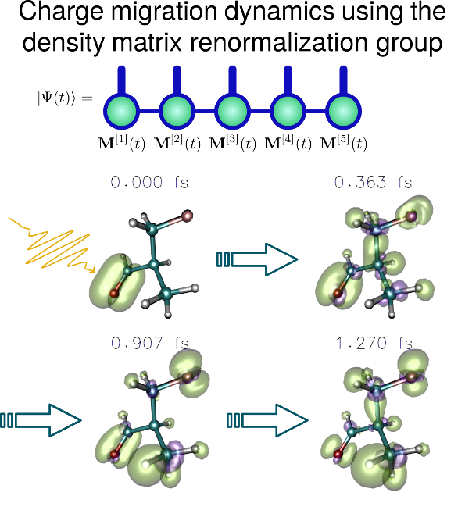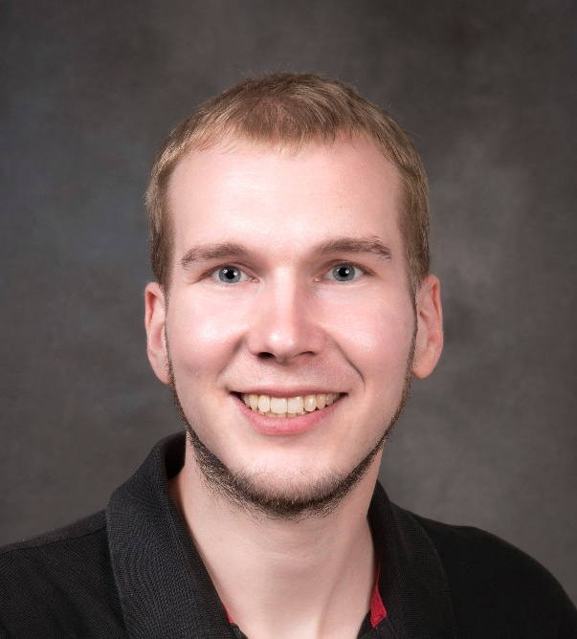

Charge migration is a key process in attochemistry, where, after ionization the electronic hole, i.e., the positive, localized charge, rapidly migrates in a molecule. Despite its relevance for e.g. understanding radiation damage and the possibility for using it to control chemical reactions, a systematic understanding of how the chemical environment such as functional groups affect charge migration is missing. Real-time molecular electron dynamics simulations can elucidate charge migration, but the sensitivity of charge migration to electronic correlation effects renders these simulations extremely challenging. Here, using the time-dependent density matrix renormalization group (TDDMRG), we present an efficient framework for simulating charge migration that takes static electron correlation effects into account. By a careful optimization of the TDDMRG workflow, we are able to simulate real-time dynamics of 45 fully correlated electrons in 50 spatial orbitals. Further, we present a new way to understand charge migration by mapping it to localized orbitals. This allows us to unravel complicated charge migration dynamics in nontrivial molecules such as phenylacetaldehyde and isobutyraldehyde in terms of chemical concepts such as through-space orbital interactions and curly arrows. This paves the way toward qualitative understanding of charge migration using chemical concepts.

Status and future of nonadiabatic dynamics with similarity-constrained coupled cluster theory

Eirik F. Kjønstad

California Institute of Technology, Pasadena, USA
Email: ekjoen@caltech.edu
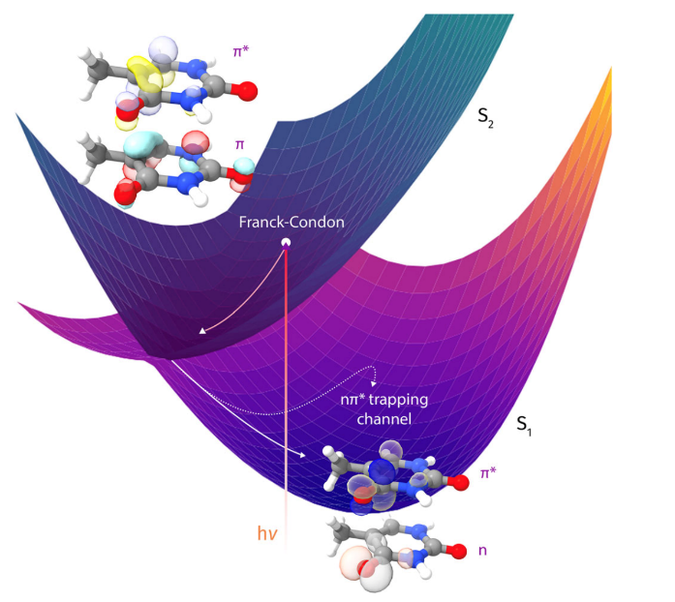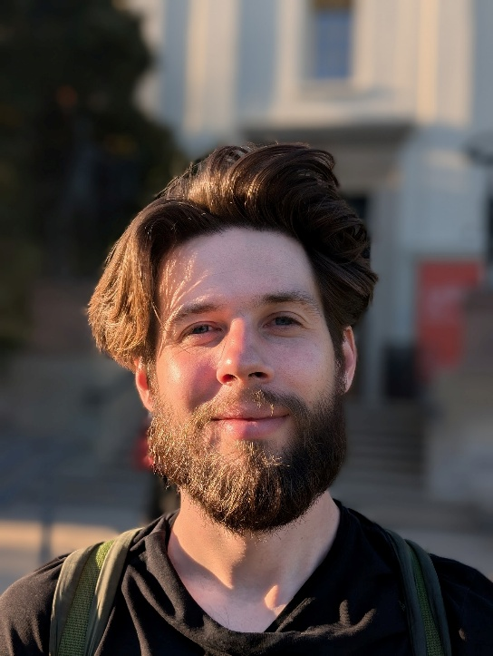

Coupled cluster theory is a highly accurate electronic-structure method, but it describes conical intersections correctly only if its working equations are modified to guarantee that the associated non-Hermitian Hamiltonian matrix remains diagonalizable. Similarity constrained coupled cluster (SCC) theory [1] enforces this property, and - aided by recent efficient implementations of analytical gradients and derivative-coupling elements [2] - is now beginning to be applied to simulations of photophysics in medium-sized systems at the singles and doubles level (similarity-constrained EOM-CCSD) [3]. We present the status of the similarity constrained coupled cluster method and discuss future prospects for applying the approach in nonadiabatic dynamics simulations.

References:

[1] E. F. Kjønstad, H. Koch. Phys. Chem. Lett. 2017, 8, 19, 4801–4807
[2] E. F. Kjønstad, S. Angelico, H. Koch. J. Chem. Theory Comput. 2024, 20, 16, 7080–
7092
[3] E. F. Kjønstad, O. J. Fajen, A. C. Paul, S. Angelico, D. Mayer, M. Gühr, T. J. A. Wolf,
T. J. Martínez, H. Koch. Nat. Commun. 2024, 15, 10128

How to connect

Alexey Akimov is inviting you to a scheduled Zoom meeting.

Topic: VISTA, Seminar 104
Time: Mar 11, 2026 10:00 AM Eastern Time (US and Canada)
Join Zoom Meeting
https://buffalo.zoom.us/j/97712375193?pwd=ysMoy3KJS4NaC9bEKvnCCPHd8jI96O.1

Meeting ID: 977 1237 5193
Passcode: 620131

How to stay updated

A. VISTA Mailing list:

- Follow the link:
https://listserv.buffalo.edu/scripts/wa.exe?A0=CHE-VISTA-LIST&X=OA41BBB2DC6071987DF&Y=alexeyak%40buffalo.edu
- Click the menu icon in the upper right part of the list (yellow highlight in the picture below)
- Click the “Subscribe or Unsubscribe” option (purple highlight below) – it will bring you to the next window where you’ll be asked for your email/name (I think it the name is optional to provide). This way, you can subscribe to the mailing list to stay tuned or unsubscribe if you find the seminars irrelevant to you or just get too much emails to deal with.
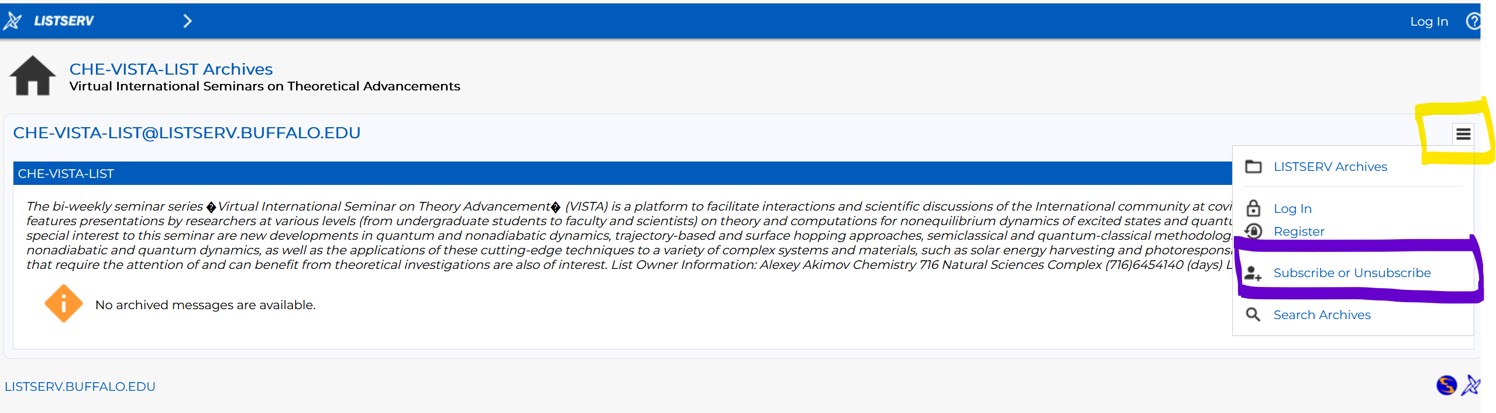

B. Slack Workspaces:

- VISTA workspace: https://join.slack.com/t/vista-atk8254/shared_invite/zt-mdlteo5v-P1Hc7XVupkwMbnGhNG4KIw
- Quantum Dynamics Hub workspace: https://join.slack.com/t/quantumdynamicshub/shared_invite/zt-mjbhjssx-GGhsbYHxeBMvhmumK_j7LA

