VISTA Seminar

Seminar 102

February 11, 2026
10:00 am – 11:30 am EST Buffalo / 3:00 – 4:30 pm GMT London / 4:00 pm – 5:30 pm CET Paris / 11 pm – 12:30 pm CST Beijing

TOC:

1. Presenter 1: Prof. Ignacio Franco, University of Rochester, USA…….…...page 2
2. Presenter 2: Mr. Julian Stetzler, University of South Carolina, USA……...page 3
3. How to connect………………………………………………………..….. page 4

Tree Tensor Network Decomposition of Open Quantum Dynamics for Efficient Simulation of Next Generation Quantum Systems

Ignacio Franco

University of Rochester
Email: Ignacio.Franco@rochester.edu

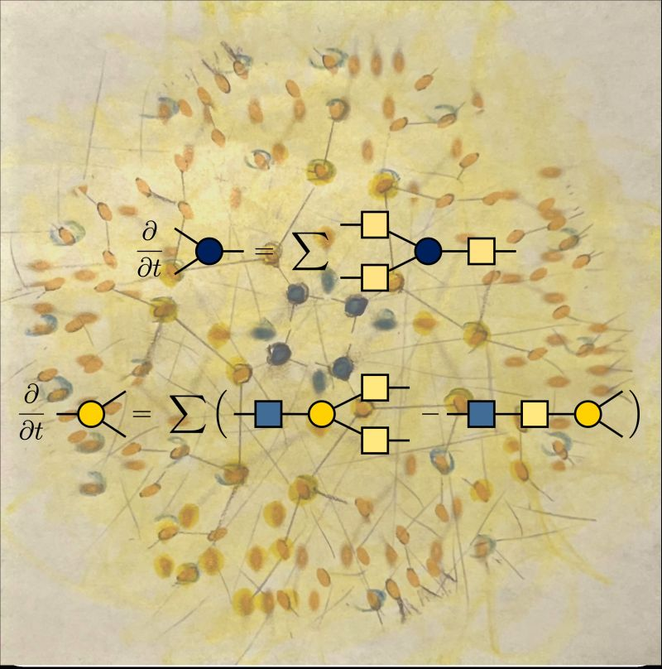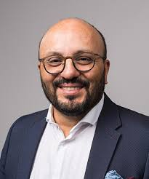

To unlock the sophistication of chemistry in building complex molecular architectures to develop next-generation quantum technologies, there is a critical need to identify robust molecular design principles that can be used to generate quantum subspaces with protected or controllable coherences[1]. Systematic progress requires developing experimental and theoretical methods to quantify and manipulate quantum coherences and understanding how the decoherence (or quantum noise) introduced by the environment influences the system’s dynamics.
In this talk, I will summarize recent efforts in my group to advance the theory, simulation and interpretation of quantum decoherence in chemistry. Specifically, I will introduce the TTN-HEOM [2], a numerically exact method for open quantum dynamics that makes the powerful but memory-hungry hierarchical equations of motion (HEOM) practical for real-world simulations by using tree tensor networks (TTN) to compress and organize the equations. The TTN-HEOM is based on our recent bexcitonic generalization of the HEOM [3] which unifies HEOM variants and exposes their common mathematical structure. The method now enables simulations of driven quantum system interacting with highly structured environments typical of chemistry and quantum information science, as needed to finally establish the basic chemical principles of quantum decoherence phenomena.

References:
[1] G. D. Scholes, A. Olaya-Castro, S. Mukamel, A. Kirrander and K.K. Ni, G. J. Hedley, N. L. Frank, J. Phys. Chem. Lett. 16, 1376 (2025)
[2] X. Chen and I. Franco J. Chem. Phys. 163, 104109 (2025)
[3] X. Chen and I. Franco, J. Chem. Phys. 160, 204116 (2024)

Factorized Electron Nuclear Dynamics: Theory Development and Implementation

Julian Stetzler

Department of Chemistry and Biochemistry, University of South Carolina, Columbia, SC 29208
Email: JULIANPS@email.sc.edu

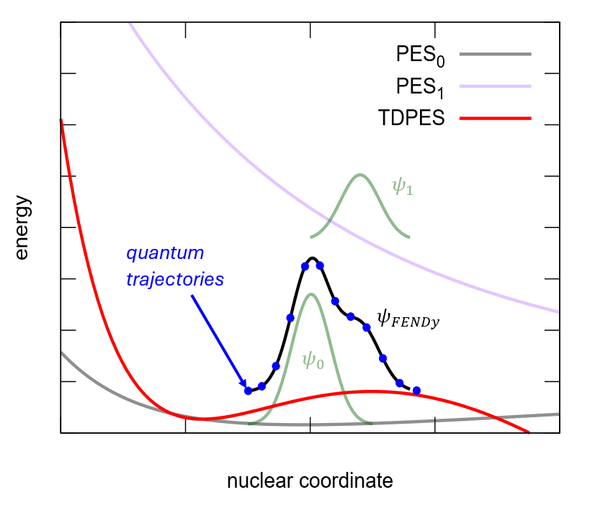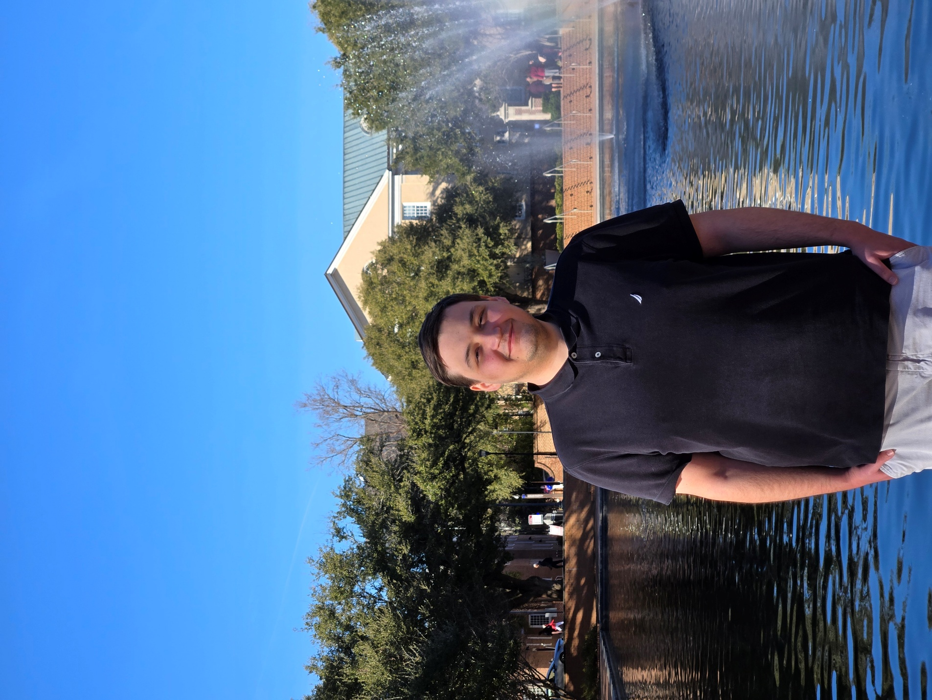

Conventional theoretical and computational approaches to fully coupled quantum molecular dynamics, i.e. when both the electrons and nuclei are treated as quantum-mechanical particles, are impractical for all but the smallest chemical systems. In this talk I will describe the formalism and implementation of the Factorized Electron Nuclear Dynamics (FENDy) with effective complex potential [J. Chem. Theory Comput. 19 (2023), pp 1393-1408], to model the photodissociation of H₂⁺ beyond the established framework of the Born-Oppenheimer approximation or Born-Huang expansion of the molecular wavefunction. This method is based on the exact factorization of the molecular wavefunction, with the nuclei evolving under a complex time-dependent potential which captures the key features of dynamics in the nuclear subspace. The imaginary part of the potential ensures that the electronic component satisfies the partial normalization condition. The electronic wavefunction is represented within the standard electronic structure basis sets without referencing the electronic eigenstates. The nuclear wavefunction is represented as a quantum-trajectory ensemble, which in principle circumvents the exponential scaling of the numerical cost with the system size. The challenging evaluation of the gradients on unstructured grids is performed by projection on auxiliary bases. I will further discuss the limitations of this method for studying photodissociation.

How to connect

Alexey Akimov is inviting you to a scheduled Zoom meeting.

Topic: VISTA, Seminar 102
Time: Feb 11, 2026 10:00 AM Eastern Time (US and Canada)
Join Zoom Meeting
https://buffalo.zoom.us/j/91368530634?pwd=kPRAVeanL5tuWSTJlHRmTubRGx7wxn.1

Meeting ID: 913 6853 0634
Passcode: 404017

How to stay updated

A. VISTA Mailing list:

- Follow the link:
https://listserv.buffalo.edu/scripts/wa.exe?A0=CHE-VISTA-LIST&X=OA41BBB2DC6071987DF&Y=alexeyak%40buffalo.edu
- Click the menu icon in the upper right part of the list (yellow highlight in the picture below)
- Click the “Subscribe or Unsubscribe” option (purple highlight below) – it will bring you to the next window where you’ll be asked for your email/name (I think it the name is optional to provide). This way, you can subscribe to the mailing list to stay tuned or unsubscribe if you find the seminars irrelevant to you or just get too much emails to deal with.
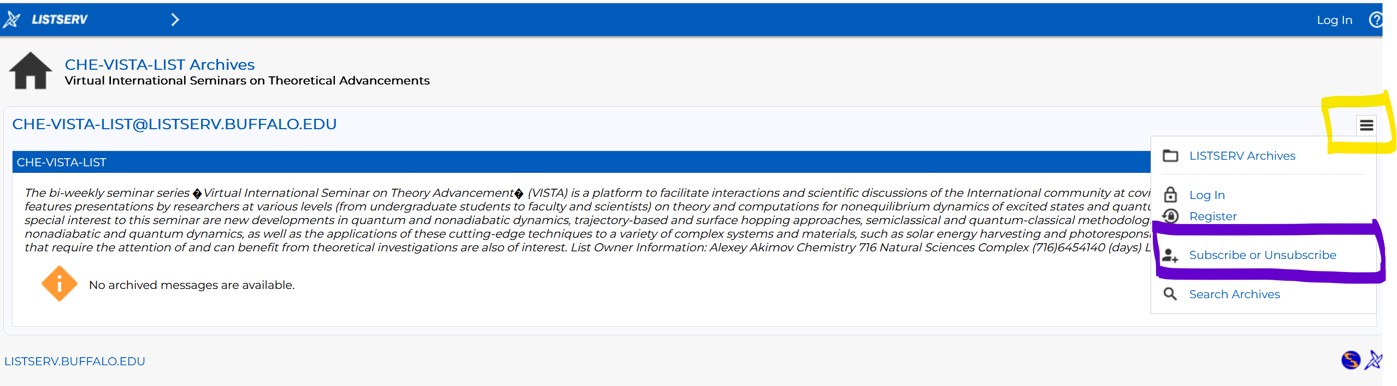

B. Slack Workspaces:

- VISTA workspace: https://join.slack.com/t/vista-atk8254/shared_invite/zt-mdlteo5v-P1Hc7XVupkwMbnGhNG4KIw
- Quantum Dynamics Hub workspace: https://join.slack.com/t/quantumdynamicshub/shared_invite/zt-mjbhjssx-GGhsbYHxeBMvhmumK_j7LA

