VISTA Seminar

Seminar 84

February 26, 2025
10:00 am – 11:30 am EST Buffalo / 3:00 – 4:30 pm GMT London / 4:00 pm – 5:30 pm CET Paris / 11 pm – 12:30 am CST Beijing

TOC:

1. Presenter 1: Prof. Justin Talbot, Clemson University, USA…………….…page 2
2. Presenter 2: Ms. Elizabeth Stippell, University of Southern California, USA…………………………………………………………………………..page 3
3. How to connect………………………………………………………..….. page 4

Addressing Challenges and Artifacts on Excited State Potential Energy Surfaces: Insights from Quantum Chemistry and Quasi-Classical Dynamics

Justin J. Talbot

Department of Chemistry, Clemson University, Clemson, SC 29631, USA.
Email: jjtalbo@clemson.edu



Elucidating the important role that nonadiabatic transitions play in renewable energy catalysis, biological systems, and atmospheric chemistry is a current challenge for computational chemistry. Key difficulties include building a sufficiently accurate representation of the excited-state potential energy surfaces and their couplings. To address these challenges, we have incorporated an ab initio treatment of electronic structure theory—including the analytical evaluation of non-adiabatic couplings—with the symmetric quasi-classical Meyer-Miller model, which treats electronic and nuclear motions on an equal footing using classical mechanics. In this talk, I will discuss the benefits and pitfalls of such an approach and illustrate, using small gas-phase molecules as examples, how it might be employed to understand and predict the complex dynamics relevant to solar energy catalysis, photoinduced isomerization, and energy flow within molecules.
Additionally, I will discuss how some predicted minimum energy excited state configurations can be unphysical—existing only within the construct of the Born-Oppenheimer approximation. Using ab initio calculations and Landau-Zener dynamics, I will present some examples of these “fantastical” minimum energy configurations, show how they correspond to unphysically high harmonic frequencies, and demonstrate how they collapse within femtoseconds to lower-energy electronic states.

Enhancing Interlayer Charge Transport of Two-Dimensional Perovskites by Structural Stabilization via Fluorine Substitution

Elizabeth Stippell

University of Southern California, USA; Email: stippell@usc.edu

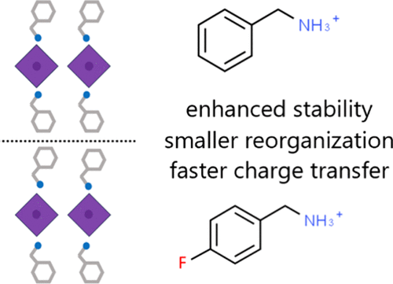

Two-dimensional lead-halide perovskites provide a more robust alternative to three-dimensional perovskites in solar energy and optoelectronic applications due to increased chemical stability afforded by interlayer ligands. At the same time, the ligands create barriers for interlayer charge transport, reducing device performance. Using a recently developed ab initio simulation methodology, we demonstrate that ligand fluorination can enhance both hole and electron mobility by 1–2 orders of magnitude. The simulations show that the enhancement arises primarily from improved structural order and reduced thermal atomic fluctuations in the system rather than increased interlayer electronic coupling. Arising from stronger hydrogen bonding and dipolar interactions, the higher structural stability decreases the reorganization energy that enters the Marcus formula and increases the charge transfer rate. The detailed atomistic insights into the electron and hole transfer in layered perovskites indicate that the use of interlayer ligands that make the overall structure more robust is beneficial simultaneously for chemical stability and charge transport, providing an important guideline for the design of new, efficient materials.

How to connect

Alexey Akimov is inviting you to a scheduled Zoom meeting.

Topic: VISTA, Seminar 84
Time: Feb 26, 2025 10:00 AM Eastern Time (US and Canada)
Join Zoom Meeting
https://buffalo.zoom.us/j/92336724757?pwd=eEWXXcFT0kYOwb1GgjRXZbVXxceR8d.1

Meeting ID: 923 3672 4757
Passcode: 469045

