VISTA Seminar

Seminar 100

January 14, 2026
10:00 am – 11:30 am EST Buffalo / 3:00 – 4:30 pm GMT London / 4:00 pm – 5:30 pm CET Paris / 11 pm – 12:30 pm CST Beijing

TOC:

1. Presenter 1: Prof. John Tully, Yale University, USA……………………... page 2
2. How to connect………………………………………………………..….. page 3

Adventures with Surface Hopping

John C. Tully

Yale University
New Haven, CT 06520 USA
Email: john.tully@yale.edu

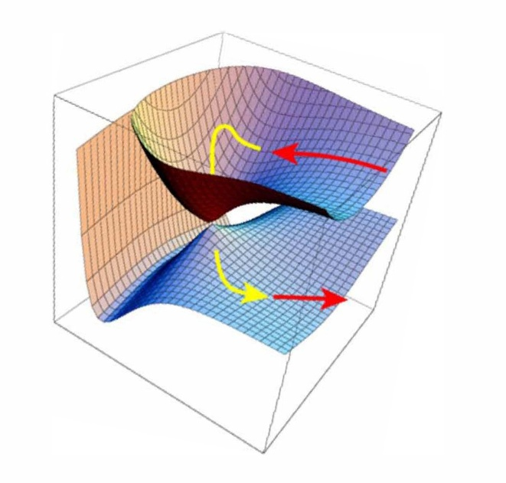

Surface Hopping, a method for introducing nonadiabatic quantum mechanical transitions in otherwise classical mechanical molecular dynamics simulations, has been developed and applied over many years. The evolution of the surface hopping method since its initiation in preliminary form in 1971 will be outlined, somewhat biased by the speaker’s personal fascination with nonadiabatic dynamics. The origins and justifications of features of the surface hopping algorithm such as “fewest switches”, the “Pechukas force”, decoherence, and frustrated hops will be given. Extensions to systems exhibiting quantized nuclear motion and electronic continua at metal surfaces will be discussed, as well as issues involving detailed balance, conical intersections, and conservation of total translational and rotational energy. Avenues for possible future research may also be suggested.

How to connect

Alexey Akimov is inviting you to a scheduled Zoom meeting.

Topic: VISTA, Seminar 100
Time: Jan 14, 2026 10:00 AM Eastern Time (US and Canada)
Join Zoom Meeting
https://buffalo.zoom.us/j/97135579838?pwd=9rObocLNwpA08ebiMj5i8KJiR1s5j4.1

Meeting ID: 971 3557 9838
Passcode: 812235

How to stay updated

A. VISTA Mailing list:

- Follow the link:
https://listserv.buffalo.edu/scripts/wa.exe?A0=CHE-VISTA-LIST&X=OA41BBB2DC6071987DF&Y=alexeyak%40buffalo.edu
- Click the menu icon in the upper right part of the list (yellow highlight in the picture below)
- Click the “Subscribe or Unsubscribe” option (purple highlight below) – it will bring you to the next window where you’ll be asked for your email/name (I think it the name is optional to provide). This way, you can subscribe to the mailing list to stay tuned or unsubscribe if you find the seminars irrelevant to you or just get too much emails to deal with.
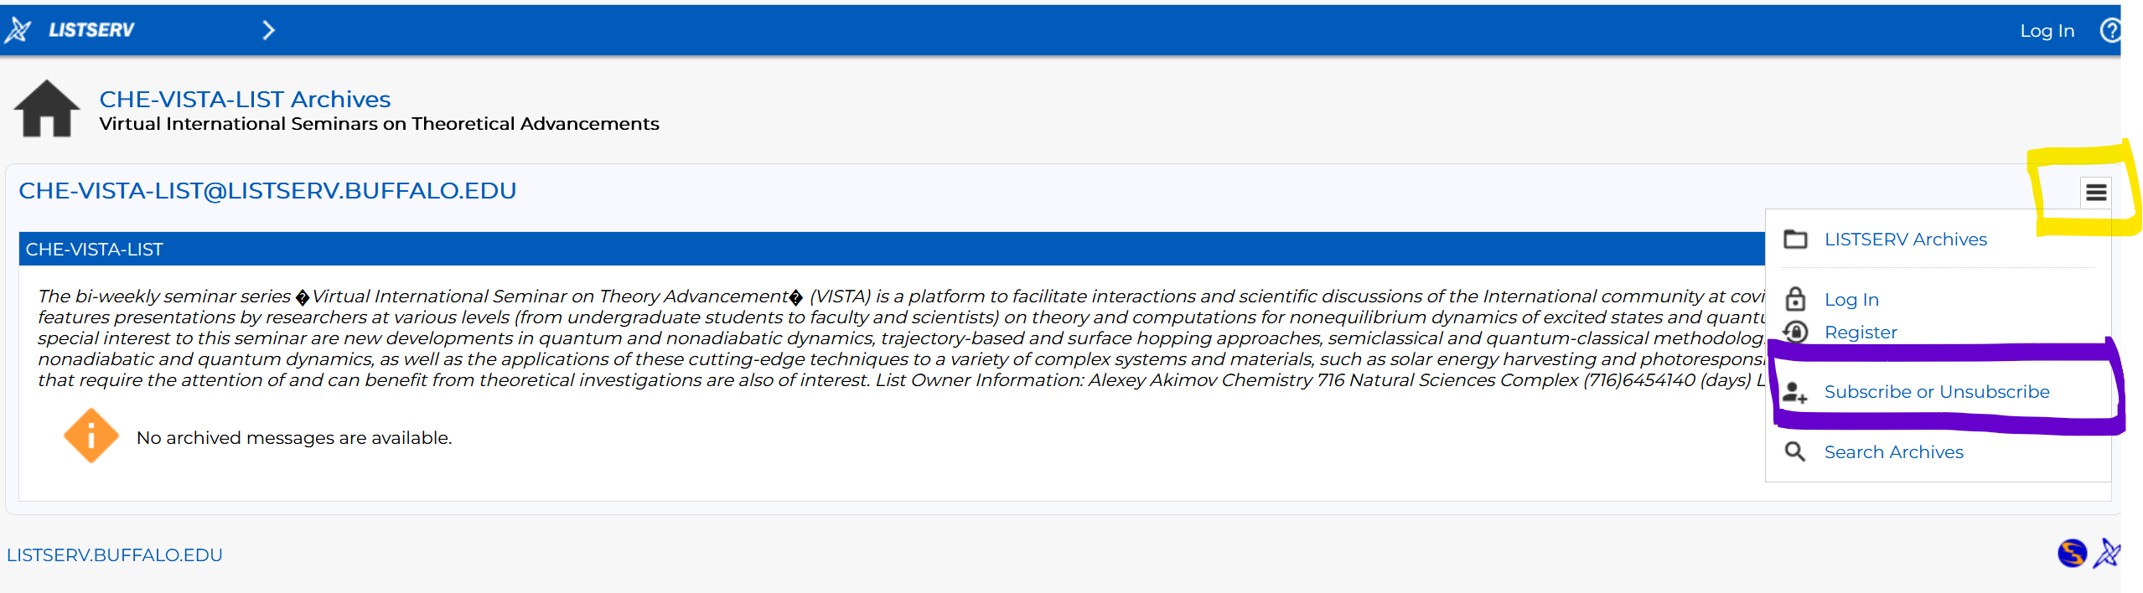

B. Slack Workspaces:

- VISTA workspace: https://join.slack.com/t/vista-atk8254/shared_invite/zt-mdlteo5v-P1Hc7XVupkwMbnGhNG4KIw
- Quantum Dynamics Hub workspace: https://join.slack.com/t/quantumdynamicshub/shared_invite/zt-mjbhjssx-GGhsbYHxeBMvhmumK_j7LA

