VISTA Seminar

Seminar 88

Apil 23, 2025
10:00 am – 11:30 am EDT Buffalo / 3:00 – 4:30 pm BST London / 4:00 pm – 5:30 pm CEST Paris / 10 pm – 11:30 pm CST Beijing

TOC:

1. Presenter 1: Prof. Sergey I. Bokarev, Technical University of Munich, Germany……………………………………………………………………....page 2
2. Presenter 2: Dr. Saeed Rahmanian Koshkaki, Texas A&M University, USA…………………………………………………………………………...page 3
3. How to connect………………………………………………………..….. page 4

Spectroscopy and dynamics of molecules in highly-excited states

Sergey I. Bokarev
Chemistry Department, School of Natural Sciences, Technical University of Munich, Lichtenbergstr. 4, Garching 85748, Germany
Institute of Physics, Rostock University, Albert-Einstein-Str. 23-24, 18059 Rostock, Germany
E-mail: sergey.bokarev@tum.de

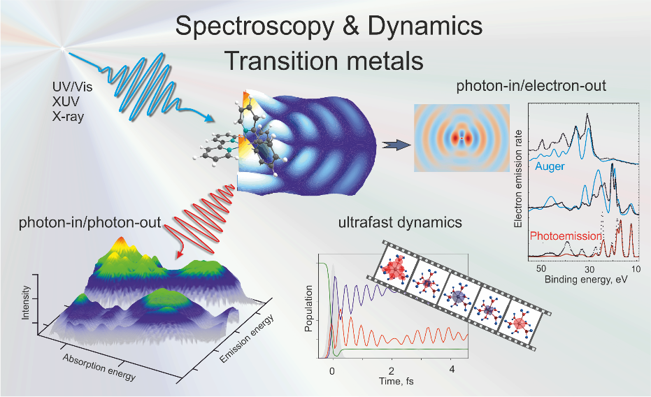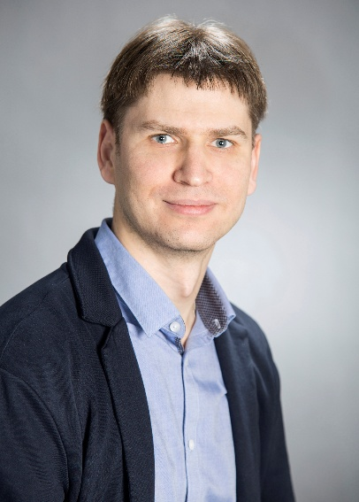

The past decade heralds the gradual change of the ultrafast paradigm in physics and chemistry from the femtosecond to subfemtosecond and even a few tens of attoseconds domain. The fascinating growth in the number of ultrafast phenomena studies is due to the establishment of new sources, such as X-ray free-electron lasers and high harmonic generation setups that give access to dynamics at electronic time scales. To keep pace with experiments, accurate and efficient theoretical methods need to be developed [1].
In my talk, I will discuss several computational protocols to address different kinds of X-ray photon-in/photon-out and photon-in/electron-out spectroscopic observables based on the multi-reference electronic structure theory. For instance, I will describe approaches to compute valence and core photoionization and Auger decay in molecules employing different flavors of the central-potential method [2,3] and beyond it [4]. Further, I will present developments of the density-matrix-based time-dependent restricted active space configuration interaction method (ρ-TD-RASCI) to compute the ultrafast electron dynamics [5]. The applications of these theoretical protocols will be exemplified by the simulations of the linear X-ray spectra, high harmonic generation, ultrafast charge migration, and spin-flip dynamics in molecules and transition metal complexes excited by extreme ultraviolet and soft X-ray light.

References:

1. S.I. Bokarev, O. Kühn, WIREs Comp. Mol. Sci. 10 (2020), e1433.
2. G. Grell, S.I. Bokarev J. Chem. Phys. 152 (2020) 074108.
3. B. Tenorio et al. JCTC 18 (2022) 4387.
4. T. Marx, S.I. Bokarev PRA 106 (2022) 032806.
5. V. Kochetov, S.I. Bokarev JCTC 18 (2022) 46.
Controlling Exciton-Polariton Transport in Multilayered Materials

Saeed Rahmanian Koshkaki
Department of Chemistry, Texas A & M University, College Station, Texas
77842, USA Email: rahmanian@tamu.edu

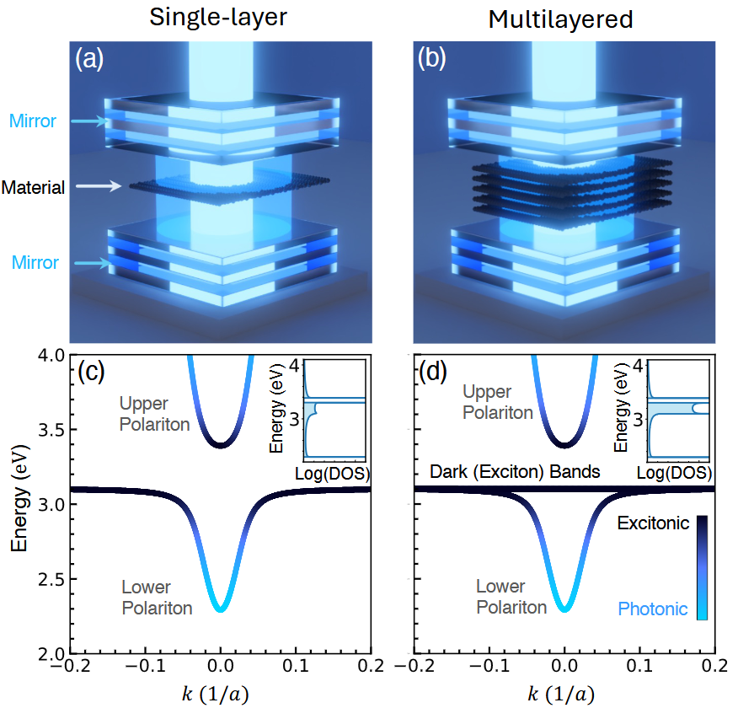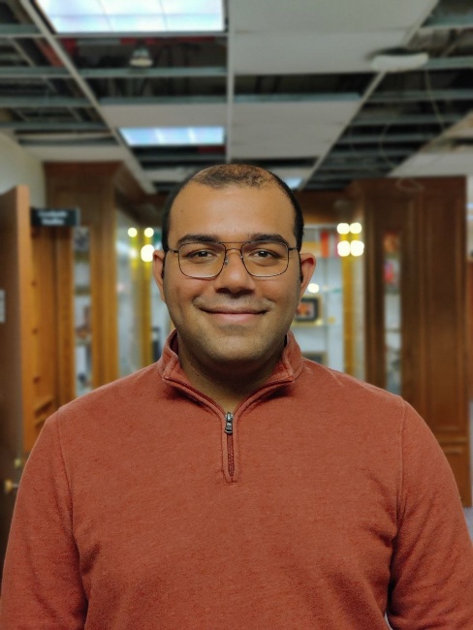
Exciton-polariton quasiparticles in optical cavities and semiconductor devices are promising quantum systems, which provide extended control on transport and coherence of quantum excitations. In these systems, material excitations (excitons) interact with cavity excitations (photons), giving rise to exciton-polaritons that embody characteristics of both excitons and photons. Recent groundbreaking discoveries have significantly expanded our knowledge of exciton-polariton dynamics, such as Bose-Einstein Condensation (BEC), enhanced group velocity, and topological properties. However, the numerical study of these systems remains largely constrained to setups where a single-layer material is placed within an optical cavity. This approach overlooks the spatial variations of the quantized field present in multilayered materials and experimental platforms, limiting the performance of numerical studies.
In this study, we present our latest findings on the modification of exciton-polariton transport in multilayered materials. To achieve these results, we developed a novel exact method that overcomes the limitations of single-layer setups, enabling the numerical study of exciton-polaritons in multilayered materials using cutting-edge computational hardware. Our findings reveal that exciton-polarity transport in multilayered materials is different from single-layered materials, with more coherent transport and higher group velocity. We show this enhancement is originated from an effect we term phonon synchronization. Our findings suggest that exciton-polariton materials in multilayered materials are more promising candidates for applications in technologies such as quantum information science.

References
[1] Koshkaki, Saeed Rahmanian, Arshath Manjalingal, Logan Blackham, and Arkajit Mandal. ”Exciton-Polariton Dynamics in Multilayered Materials.” arXiv:2502.12933 (2025).
[2] Blackham, Logan, Arshath Manjalingal, Saeed Rahmanian Koshkaki, and Arkajit Mandal. ”Microscopic Theory of Polaron-Polariton Dispersion and Propagation.” arXiv:2501.16622 (2025).
How to connect

Alexey Akimov is inviting you to a scheduled Zoom meeting.

Topic: VISTA, Seminar 88
Time: Apr 23, 2025 10:00 AM Eastern Time (US and Canada)
Join Zoom Meeting
https://buffalo.zoom.us/j/96529858399?pwd=LHKjChnYhHM2pOEvghZnav6ofPKIVb.1

Meeting ID: 965 2985 8399
Passcode: 377886

