VISTA Seminar

Seminar 94

October 1, 2025
10:00 am – 11:30 am EDT Buffalo / 3:00 – 4:30 pm BST London / 4:00 pm – 5:30 pm CEST Paris / 10 pm – 11:30 pm CST Beijing

TOC:

1. Presenter 1: Prof. Arindam Chakraborthy, Syracuse University, NY, USA..page 2
2. Presenter 2: Ms. Anna Baranova, Rutgers University, NJ, USA………......page 3
3. How to connect………………………………………………………..….. page 4

Development of Stratified Stochastic Tensor Contraction Method for Applications in Electronic Structure Theory

Arindam Chakraborty

Department of Chemistry, Syracuse University
4-008 Center for Science and Technology (CST), Syracuse, New York 13244
Email: archakra@syr.edu

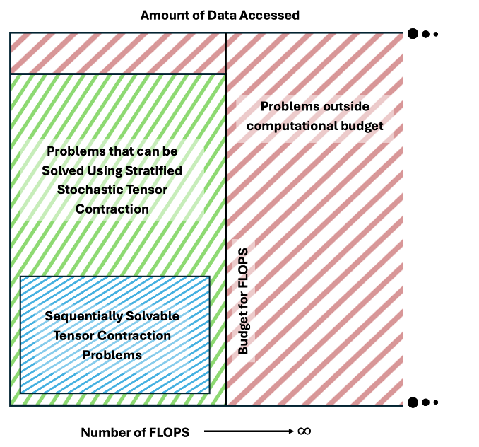

This presentation showcases the development of a stratified stochastic tensor contraction (SSTC)method for efficient implementation of the multicomponent Coupled Cluster (mc-CC) method at the singles and doubles level, denoted as SSTC-mcCCSD. In contrast to the sequential tensor contraction in the mc-CCSD equations, the SSTC implements a stochastic tensor contraction strategy. By partitioning the total trace into non-overlapping segments, partial sums are calculated through stochastic enumeration within the SSTC framework. Computational efficiency is achieved by assigning the sample points for each segment in proportion to the variance specific to that segment. The methodology was applied to the calculation of exciton and biexciton binding energies in semiconductor quantum dots (specifically PbS and CdS), and the results were used to analyze the scaling behavior of biexciton binding energies as a function of quantum dot size. The presentation will cover the derivation of the SSTC-mcCCSD method and a comparison of the results with the second-order many-body perturbation theory. The effectiveness and accuracy of the presented approach will be highlighted, showcasing its potential in the study of semiconductor nanoparticles.

When Adiabatic TDDFT Breaks Down: New Routes to Nonperturbative Dynamics
Anna Baranova

Department of Physics, Rutgers University
Email: ab2567@scarletmail.rutgers.edu

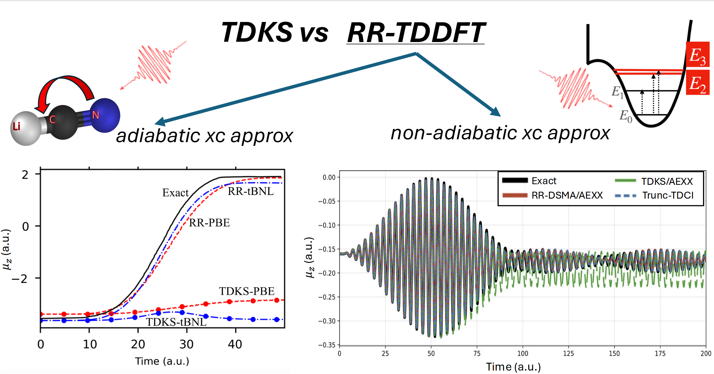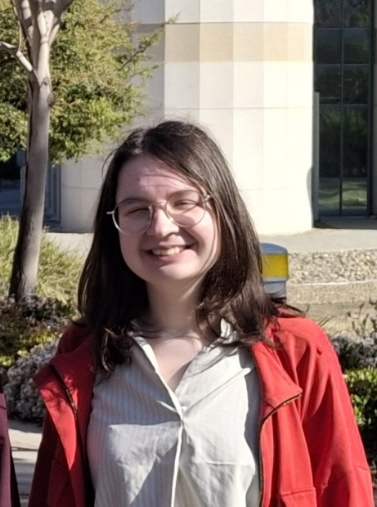
For many large electronic structure calculations, Time-Dependent Density Functional Theory (TDDFT) provides a good balance between accuracy and computational cost, but is almost entirely restricted to an adiabatic exchange-correlation potential. This may provide a reasonably accurate real-time dynamics of many processes, but it fails when the system is driven far from any ground state [1]. We show that the Response-Reformulated TDDFT (RR-TDDFT)[2] enables an adiabatic approximation to accurately predict the excited-state dynamics, provided the approximation is accurate enough in the response regime. When states of double excitation character become populated, the theory requires a non-adiabatic frequency-dependent exchange-correlation kernel. We show how recent approximations [3,4] incorporated in RR-TDDFT lead to an accurate dynamics in a model system.

References:
[1] L. Lacombe and N. T. Maitra, Non-adiabatic approximations in time-dependent density functional theory: progress and prospects, Npj Comput Mater 9, 124 (2023).
[2] D. B. Dar, A. Baranova, and N. T. Maitra, Reformulation of Time-Dependent Density Functional Theory for Nonperturbative Dynamics: The Rabi Oscillation Problem Resolved, Phys. Rev. Lett. 133, 096401 (2024).
[3] D. B. Dar and N. T. Maitra, Oscillator strengths and excited-state couplings for double excitations in time-dependent density functional theory, The Journal of Chemical Physics 159, 211104 (2023).
[4] A. Baranova and N. T. Maitra, Excited State Densities from Time-Dependent Density Functional Response Theory, arXiv:2506.05082.
How to connect

Alexey Akimov is inviting you to a scheduled Zoom meeting.

Topic: VISTA, Seminar 94
Time: Oct 1, 2025 10:00 AM Eastern Time (US and Canada)
Join Zoom Meeting
https://buffalo.zoom.us/j/99418912618?pwd=C5J3LGv6dp8tKRLr7bXFyzIP0XkAzL.1

Meeting ID: 994 1891 2618
Passcode: 184637

How to stay updated

A. VISTA Mailing list:

- Follow the link:
https://listserv.buffalo.edu/scripts/wa.exe?A0=CHE-VISTA-LIST&X=OA41BBB2DC6071987DF&Y=alexeyak%40buffalo.edu
- Click the menu icon in the upper right part of the list (yellow highlight in the picture below)
- Click the “Subscribe or Unsubscribe” option (purple highlight below) – it will bring you to the next window where you’ll be asked for your email/name (I think it the name is optional to provide). This way, you can subscribe to the mailing list to stay tuned or unsubscribe if you find the seminars irrelevant to you or just get too much emails to deal with.
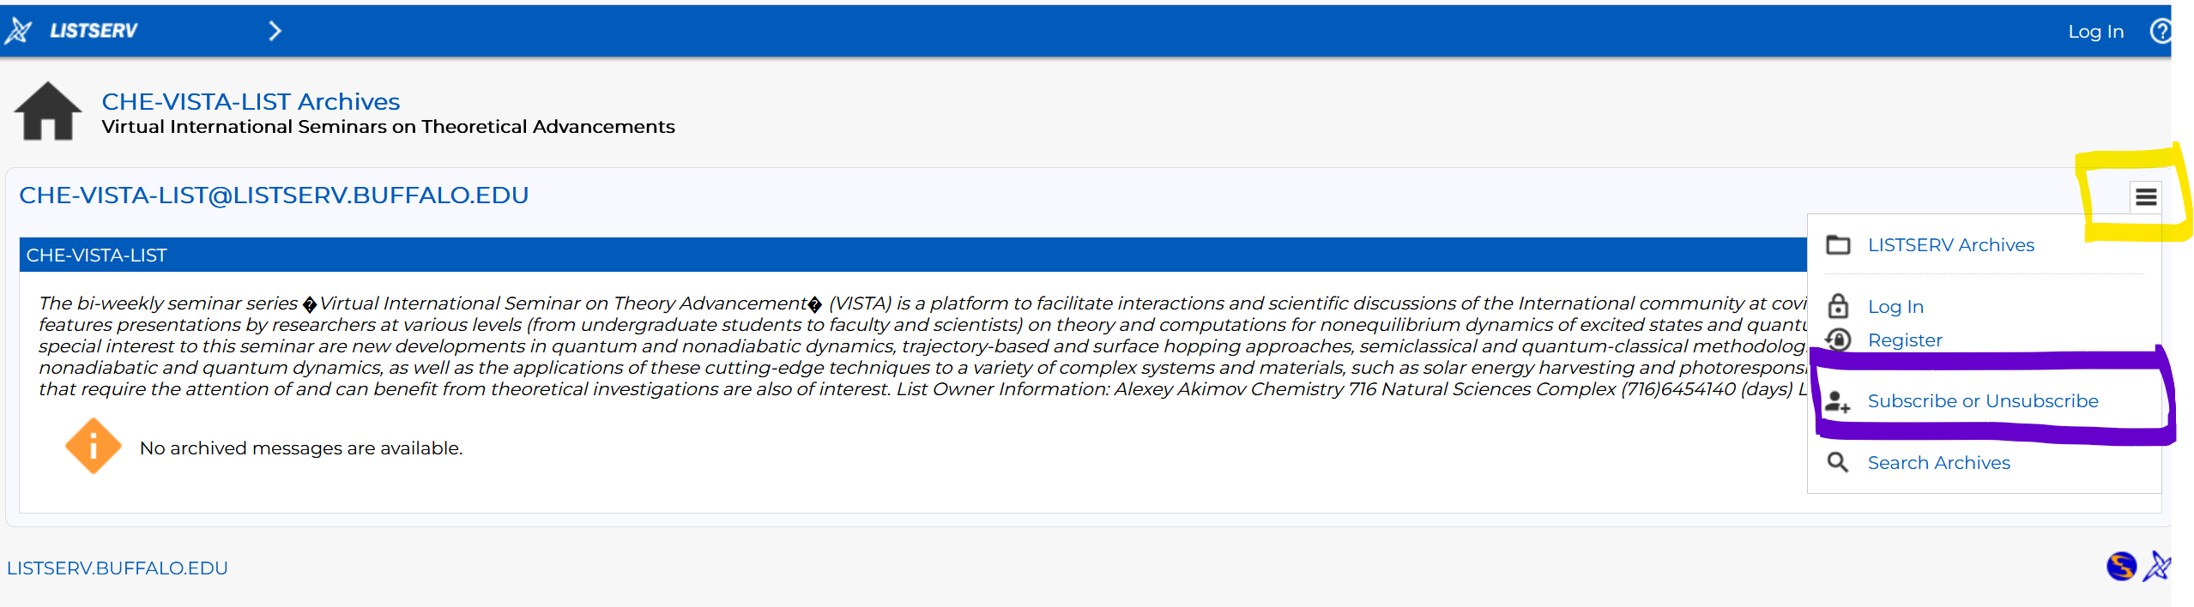

B. Slack Workspaces:

- VISTA workspace: https://join.slack.com/t/vista-atk8254/shared_invite/zt-mdlteo5v-P1Hc7XVupkwMbnGhNG4KIw
- Quantum Dynamics Hub workspace: https://join.slack.com/t/quantumdynamicshub/shared_invite/zt-mjbhjssx-GGhsbYHxeBMvhmumK_j7LA

