VISTA Seminar

Seminar 90

May 21, 2025
10:00 am – 11:30 am EDT Buffalo / 3:00 – 4:30 pm BST London / 4:00 pm – 5:30 pm CEST Paris / 10 pm – 11:30 pm CST Beijing

TOC:

1. Presenter 1: Prof. Julia Westermayr, Leipzig University, Germany…….….page 2
2. Presenter 2: Dr. Peter Schürger, Universite Paris-Saclay, France...……......page 3
3. How to connect………………………………………………………..….. page 4

Machine Learning for Excited States: Towards larger systems and transferability

Julia Westermayr, Rhyan Barrett, Sophia Wesely, Christoph Ortner, Johannes Dietschreit

University of Leipzig, Germany
Email: julia.westermayr@uni-leipzig.de

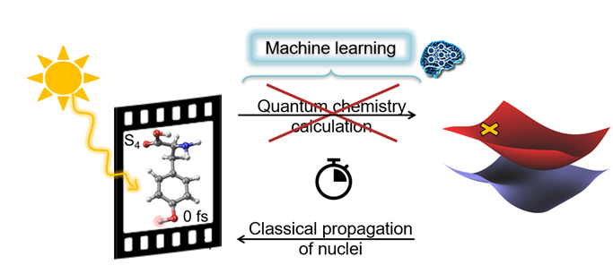

Machine learning is revolutionizing molecular and chemical sciences, especially in ground-state studies where numerous foundational models have already been established. Yet, applying machine learning to reactions that are affected by perturbations, such as light excitation or external electric fields, remains a significant challenge due to issues with model transferability. In this presentation, I will investigate how machine learning can be expanded to encompass simulations that incorporate excited states and external fields.¹⁻³ I will also illustrate how insights gained from ground-state simulations can be adapted and how knowledge can be translated to excited-state systems by leveraging X-MACE, the excited-state version of the message-passing atomic cluster expansion (MACE) framework,⁴ potentially paving the way towards universal excited-state machine learning models.

References:

1 Tiefenbacher, M. X. et al. Excited-state nonadiabatic dynamics in explicit solvent using machine learned interatomic potentials. arXiv preprint arXiv:2501.16974 (2025).
2 Barrett, R., Dietschreit, J. C. & Westermayr, J. Incorporating Long-Range Interactions via the Multipole Expansion into Ground and Excited-State Molecular Simulations. arXiv preprint arXiv:2502.21045 (2025).
3 Mausenberger, S. et al. SpaiNN: equivariant message passing for excited-state nonadiabatic molecular dynamics. Chem. Sci. 15, 15880-15890, doi:10.1039/D4SC04164J (2024).
4 Barrett, R., Ortner, C. & Westermayr, J. Transferable Machine Learning Potential X-MACE for Excited States using Integrated DeepSets. arXiv preprint arXiv:2502.12870 (2025).

A New Perspective on the Exact Factorization of the Molecular Wavefunction

Peter Schürgerª, Y. Lassmann^{b}, B. Curchod^{b}, L. Ibele^{c}, D. Lauvergnatª, F. Agostiniª
ª Université Paris-Saclay, CNRS, Institut de Chimie Physique
^{b} University of Bristol, School of Chemistry
^{c} Aix Marseille Université, CNRS, Equipe de Chimie Théorique - Institut de Chimie Radicalaire
Email: peter.schuerger@universite-paris-saclay.fr


The interest in non-adiabatic dynamics continues to give rise to numerous approaches to solve the molecular time-dependent Schrödinger equation [1], among them are the methods based on the Exact Factorization (EF). With this formalism, the molecular wavefunction is decomposed into an exact product of a marginal nuclear and a conditional electronic wavefunction. This seems conceptually different from the standard treatments of the molecular wavefunction, which express it in the adiabatic and diabatic electronic bases. In this contribution, I will present a new perspective on the EF [2], highlighting the connection to the adiabatic and diabatic electronic basis. Specifically, we find that (1) there are unitary transformations that transform among the three representations, i.e., EF, adiabatic and diabatic, and that (2) are defined by the diagonalization of respective operators (Fig. 1, left). Properties of EF, as the U(1) gauge freedom and the partial normalization condition emerge naturally in this picture. When acting on the time-dependent Schrödinger equation, the unitaries generate the electronic and the nuclear evolution equations.
I will conclude with some recent applications of the coupled-trajectory methods to simulate the ultrafast dynamics of fulvene and 4-(dimethylamino)benzonitrile (DMABN) (Fig. 1, right) [3] whose electronic structure is represented using linear vibronic coupling models [4].

References:
[1] L. González, R. Lindh, John Wiley & Sons, Chichester, ISBN: 978-1-119-41775-0 (2020)
[2] P. Schürger, Y. Lassmann, F. Agostini, B. Curchod chemrxiv-2024-1819d-v2 (2024).
[3] P. Schürger, L. Ibele , D. Lauvergnat, F. Agostini, J. Chem. Phys., 162, 104117 (2025).
[4[ S. Gómez, E. Spinlove, G. Worth, Phys. Chem. Chem. Phys., 26, 1829-1844 (2024)

How to connect

Alexey Akimov is inviting you to a scheduled Zoom meeting.

Topic: VISTA, Seminar 90
Time: May 21, 2025 10:00 AM Eastern Time (US and Canada)
Join Zoom Meeting
https://buffalo.zoom.us/j/98271613442?pwd=NyOWjWRh18nw2ixZlJdVnYFEctx8bC.1

Meeting ID: 982 7161 3442
Passcode: 796441

