VISTA Seminar

Seminar 97

November 12, 2025
10:00 am – 11:30 am EST Buffalo / 3:00 – 4:30 pm GMT London / 4:00 pm – 5:30 pm CET Paris / 11 pm – 12:30 pm CST Beijing

TOC:

1. Presenter 1: Prof. Scott G. Sayres, Arizona State University, USA……......page 2
2. Presenter 2: Dr. Miguel Recio-Poo, Universitat de Barcelona, Spain……..page 3
3. How to connect………………………………………………………..….. page 4

Tuning the Ultrafast Energy Flow in Molecular Scale Materials

Scott G. Sayres

Arizona State University, Tempe AZ, 85282, United States

Email: ssayres@asu.edu Webpage: https://sites.google.com/asu.edu/sayreslab/
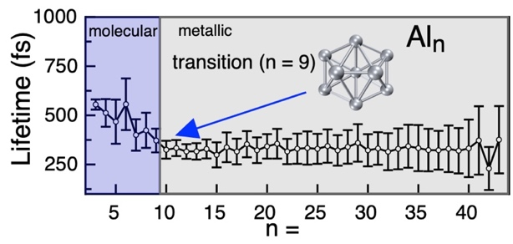
Clusters and related (sub)-nanoscale systems are promising alternatives to traditional bulk materials as they often exhibit novel properties, stemming from their quantized sizes, that can be developed for energy conversion applications. I will present our recent ultrafast spectroscopy measurements that demonstrate the exquisite tunability of their physical and chemical properties through systematic adjustment of their atomic composition. We calculate the structures and spin configurations of neutral clusters using density functional theory to identify features that facilitate relaxation, drive carrier localization/separation and polaron formation.¹ In combination with cutting-edge non-adiabatic molecular dynamics (NAMD) calculations, our femtosecond time-resolved mass spectrometry measurements conclusively disentangle femtosecond excited state relaxation from the slower charge-carrier recombination (ps) in (TiO₂)_{n} clusters and reveal new relaxation phenomena.² I will also show strong evidence that ferromagnetic coupling drives the relaxation behavior of copper oxide clusters.^{3–5} Their total spin magnetic moments increment upon removal of each Cu atom from the (Cu₂O)_{n} stoichiometry, aligning with a nearly linear decrease of ∼40 fs per Cu in their measured excited-state lifetimes. Formation of μ₄-O structures breaks this trend and are associated with terminal Cu atoms that are found to be important for the production of Rydberg excitons in (Cu₂O)_{n} clusters. The electronic relaxation properties are strongly dependent on both size and local structure, enabling sub-nanometer clusters to exhibit metallic or semiconducting properties, and even transition between the two at the molecular level in relation with calculated excited state topological properties. Our combined experimental/theoretical approach has proven powerful for identifying the onset of metallic behavior in pure (Al)_{n} clusters at n = 9.⁶
References
(1) Garcia, J.M.; Heald, L.F.; Shaffer, R.E.; Sayres, S.G. Oscillation in Excited State Lifetimes with Size of Sub-Nanometer Neutral (TiO₂)_{n} Clusters Observed with Ultrafast Pump-Probe Spectroscopy. J. Phys. Chem. Lett. 2021, 12, 4098–4103.
(2) Recio-Poo, M.; Rotteger, C. H.; Illas, F.; Bromley, S. T.; Morales-García, Á.; Sayres, S. G.; Akimov, A. V. Revealing Recombination and Ultrafast Relaxation Mechanisms in Atomically Precise Titania Nanoclusters. J. Am. Chem. Soc. 2025, 147, 40900–40909.
(3) Rotteger, C. H.; Jarman, C. K.; Rucker, H. G.; Sobol, M. M.; Sayres, S. G. Effect of μ₄ -O Sites on the Ultrafast Dynamics of Neutral Magnetic Copper Oxide Clusters. J. Phys. Chem. Lett. 2025, 16 (27), 7107–7114.
(4) Rotteger, C. H.; Rucker, H. G.; Sobol, M. M.; Sayres, S. G. Calculated Magnetic and Geometric Structures of Neutral Copper Oxide Clusters. J. Phys. Chem. A 2025, 129, 39, 8982.
(5) Rotteger, C. H.; Jarman, C. K.; Sobol, M. M.; Sutton, S. F.; Sayres, S. G. Sub-Picosecond Dynamics of Rydberg Excitons Produced from Ultraviolet Excitation of Neutral Cuprite (Cu₂O)_{n} Clusters, n < 13. J. Phys. Chem. A 2024, 128, 8466–8472.
(6) Rotteger, C. H.; Jarman, C. K.; Sutton, S. F.; Sayres, S. G. Size Onset of Metallic Behavior in Neutral Aluminum Clusters. Nanoscale 2024, 16 (28), 13516–13524.
Mechanisms and Methodologies for Excited-State Dynamics in Bare and Hydrated Atomically Precise TiO₂ Nanoclusters
Miguel Recio-Poo
Universitat de Barcelona, Spain
Email: miguelrecio@ub.edu
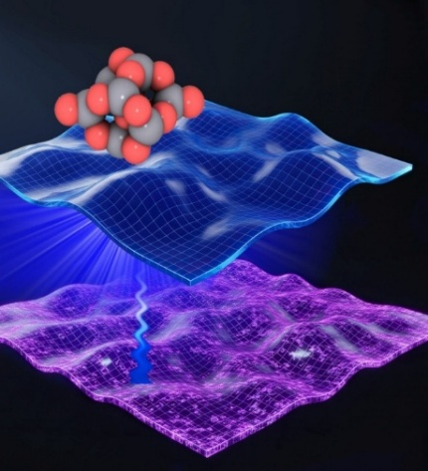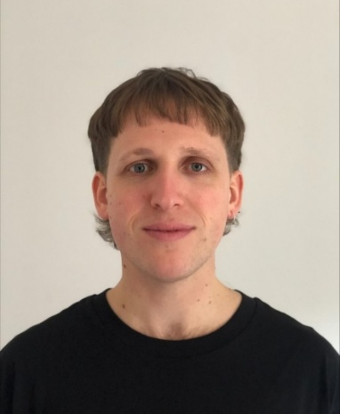
Titanium dioxide (TiO₂), or titania, is a prototypical photoactive model oxide central to photocatalysis, solar-energy conversion, and environmental remediation.[1-3]. Yet, its performance remains constrained by ultrafast excited-state relaxation and electron–hole recombination, processes that are challenging to resolve in extended solids where defects, surfaces, and disorder obscure intrinsic behaviour. Atomically precise TiO₂ nanoclusters provide a molecularly defined platform to disentangle these fundamental mechanisms and to benchmark theoretical approaches for describing photoinduced dynamics.[4, 5]
Using nonadiabatic molecular dynamics (NA-MD), we systematically examine how the interplay of electronic structure, nuclear dynamics, and environmental effects governs excited-state relaxation and recombination in titania nanoclusters. We evaluate how specific methodological choices—such as trajectory generation, exchange–correlation functional, and decoherence correction—affect the computed recombination times. Within this framework, we also explore the influence of hydration, finding that adsorbed water modifies the electronic structure and enhances nonadiabatic couplings, which leads to faster radiative and nonradiative recombination.
We integrate these insights with femtosecond pump–probe spectroscopy on size-selected neutral TiO₂ nanoclusters, achieving quantitative agreement between computed and measured lifetimes. The combined results reveal two distinct regimes—sub-picosecond relaxation among high in energy excited states and slower charge-carrier recombination—arising from the interplay of electronic gaps, state densities, and nonadiabatic couplings. Together, this unified experimental–computational perspective establishes a predictive and mechanistic understanding of ultrafast energy flow in bare and hydrated TiO₂ nanoclusters, bridging model precision and real-world complexity to give key insights into excited state properties of metal oxide clusters.
References:
[1] X. Chen; S. S. Mao, Chem. Rev. 2007, 7, 2891-2959
[2] J. Schneider; M. Matsuoka; M. Takeuchi; J. Zhang; Y. Horiuchi; M. Anpo; D. W. Bahnemann; Chem. Rev. 2014, 114, 9919–9986.
[3] Y. Nosaka and A. Y. Nosaka, Chem. Rev. 2017, 117, 11302–11336.
[4] Y. Nam; L. Li; J. Y. Lee; O. V. Prezhdo. J. Phys. Chem. C 2018, 122, 5201−5208.
[5] M. Recio-Poo; M. Shakiba; F. Illas; S. T. Bromley; A. V. Akimov; Á. Morales-García; J. Phys. Chem. C 2025, 129(3), 1806–1823.
How to connect

Alexey Akimov is inviting you to a scheduled Zoom meeting.

Topic: VISTA, Seminar 97
Time: Nov 12, 2025 10:00 AM Eastern Time (US and Canada)
Join Zoom Meeting
https://buffalo.zoom.us/j/97338119357?pwd=7WbTfUB6DHJk00wl4c782R0ImU99ss.1

Meeting ID: 973 3811 9357
Passcode: 402708

How to stay updated

A. VISTA Mailing list:

- Follow the link:
https://listserv.buffalo.edu/scripts/wa.exe?A0=CHE-VISTA-LIST&X=OA41BBB2DC6071987DF&Y=alexeyak%40buffalo.edu
- Click the menu icon in the upper right part of the list (yellow highlight in the picture below)
- Click the “Subscribe or Unsubscribe” option (purple highlight below) – it will bring you to the next window where you’ll be asked for your email/name (I think it the name is optional to provide). This way, you can subscribe to the mailing list to stay tuned or unsubscribe if you find the seminars irrelevant to you or just get too much emails to deal with.
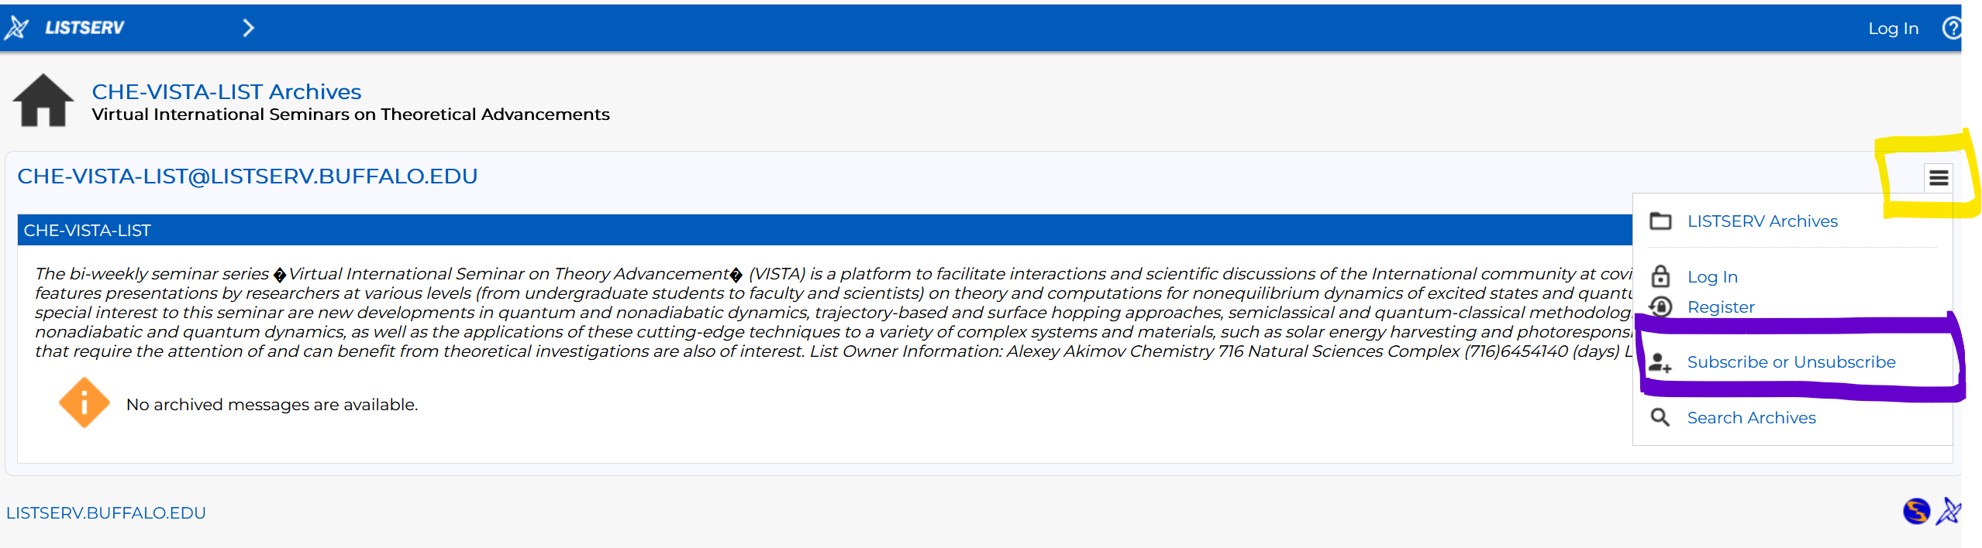

B. Slack Workspaces:

- VISTA workspace: https://join.slack.com/t/vista-atk8254/shared_invite/zt-mdlteo5v-P1Hc7XVupkwMbnGhNG4KIw
- Quantum Dynamics Hub workspace: https://join.slack.com/t/quantumdynamicshub/shared_invite/zt-mjbhjssx-GGhsbYHxeBMvhmumK_j7LA

