VISTA Seminar

Seminar 81

January 15, 2025
10:00 am – 11:30 am EST Buffalo / 3:00 – 4:30 pm GMT London / 4:00 pm – 5:30 pm CET Paris / 11 pm – 12:30 am CST Beijing

TOC:

1. Presenter 1: Dr. Andrei Piryatinski, Los Alamos National Laboratory, USA…………………………………………………………………………..page 2
2. Presenter 2: Dr. Sameernandan Upadhyayula, Weitzmann Institute of Science, Israel……………………………………………………………………...…..page 3
3. How to connect………………………………………………………..….. page 4

Hybrid Semiconductor and Plasmonic Nanostructures for Quantum and Coherent Multi-Photon Generation and Control

Andrei Piryatinski
Theoretical Division, Los Alamos National Lab, USA
Email: apiryat@lanl.gov

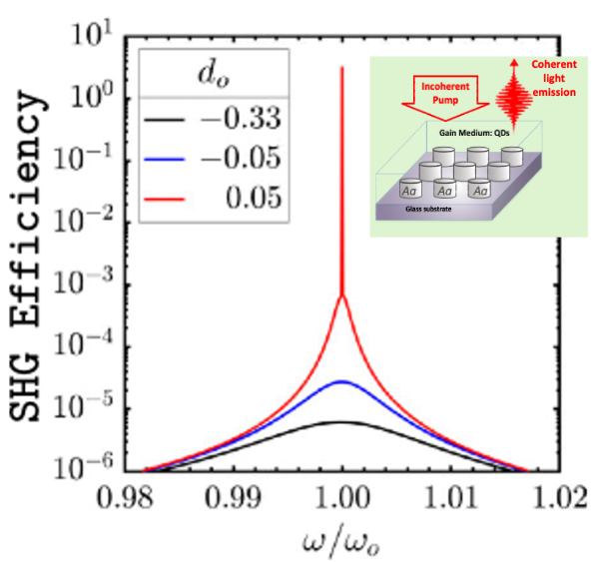

Current nanofabrication technologies enable the precise integration of semiconductor quantum emitters, such as quantum dots or nanoplatelets, with metal nanoparticles exhibiting tunable surface plasmon resonances. This integration allows for control over interaction pathways between quantum emitters and plasmonic modes, leading to new functionalities essential for on-chip optoelectronic devices. A well-studied phenomenon in these hybrid materials is the acceleration of spontaneous light emission due to enhancing the photon density of states by surface plasmons, known as the plasmonic Purcell effect. This talk presents theoretical studies and simulation results of optical phenomena in hybrid semiconductor-metal materials beyond the Purcell effect. Specifically, it discusses metal nanopillar arrays forming a plasmonic cavity where quantum dots experience strong coupling with collective surface lattice resonances, forming exciton-plasmon polariton states. The model calculations, supported by FDTD simulations, predict significant enhancement of second harmonic generation and second harmonic lasing above a certain exciton-plasmon coupling threshold. Furthermore, the study explores parametric amplification and spontaneous parametric downconversion (SPDC) in arrays of metal nanoparticles with C2v symmetry, showing that single-layer arrays of L-shaped nanoparticles can yield quantum photon production compatible with standard SPDC sources.

$ℏ^{2}$ corrections to semiclassical transmission probabilities

Sameernandan Upadhyayula and Eli Pollak

Department of Chemical and Biological Physics Weizmann Institute of Science, Rehovot, Israel
Email: sameernandan.upadhyayula@weizmann.ac.il

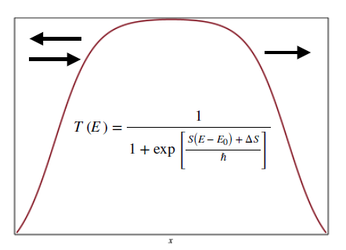

Kemble’s expression for the energy dependent transmission coefficient [1,2] is the best semiclassical estimate for calculation of thermal transmission coefficients and thermal rates. However, there remains a difficulty even within the uniform semiclassical approximation of Kemble. It predicts that the half-point, defined as the energy at which the energy dependent transmission probability equals 0.5 occurs always when the energy equals the barrier height. This is incorrect as exemplified for an Eckart barrier. This may be corrected by modifying the Kemble form [3] , either by shifting the energy or by adding a constant term to the Euclidean action, such that the resulting thermal transmission coefficient gives the correct leading order term in as derived by Pollak and Cao [4,5]. Shifting the energy is equivalent to a modified vibrational perturbation theory (mVPT2) semiclassical estimate for the rate, significantly improving it especially for asymmetric systems. Shifting the action generalizes a similar correction introduced by Eckart [6] and later used by Yasumori and Fueki [7], specifically for the Eckart barrier, to general barrier potentials (mYF) . Both improvements are exemplified by applications to the Eckart barriers, a Gaussian barrier and tanh barriers. The mVPT2 and mYF theories have been generalized to multidimensional systems and have been applied to compute thermal rates of collinear and reactions [8] .

References:
[1] E. C. Kemble, Phys. Rev. 48,549 (1935)
[2] S. Upadhyayula and E. Pollak, J. Phys. Chem. Lett. 14,9892 (2023)
[3] S. Upadhyayula and E. Pollak , J. Phys. Chem. A 128,3434 (2024)
[4] E. Pollak , J. Chem. Phys. 159,224107 (2023)
[5] E. Pollak and J. Cao., J. Chem. Phys. 157,074109 (2022)
[6] C. Eckart., Phys. Rev. 35,1303 (1930)
[7] I. Yasumori and K. Fueki, J. Chem. Phys. 88,922 (1954)
[8] S. Upadhyayula, M. Ceotto and E. Pollak, (manuscript under preparation)

How to connect

Alexey Akimov is inviting you to a scheduled Zoom meeting.

Topic: VISTA, Seminar 81
Time: Jan 15, 2025 10:00 AM Eastern Time (US and Canada)
Join Zoom Meeting
https://buffalo.zoom.us/j/94058680337?pwd=29NOLip4OdGrGb8Ea3C8arcC3CdXq5.1

Meeting ID: 940 5868 0337
Passcode: 050772

