VISTA Seminar

Seminar 95

October 15, 2025
10:00 am – 11:30 am EDT Buffalo / 3:00 – 4:30 pm BST London / 4:00 pm – 5:30 pm CEST Paris / 10 pm – 11:30 pm CST Beijing

TOC:

1. Presenter 1: Prof. Maksim F. Gelin, Hangzhou Dianzi University, China...page 2
2. Presenter 2: Mr. Zengkui Liu, NYU Shanghai, China…………………......page 3
3. How to connect………………………………………………………..….. page 4

How to turn your on-the-fly dynamics code into a simulator of nonlinear spectroscopic signals via doorway-window method

Maksim F. Gelin

School of Science, Hangzhou Dianzi University, China
Email: maxim@hdu.edu.cn
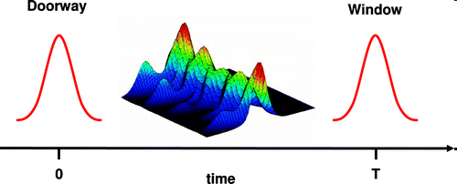

I will give a brief overview of the recently developed ab initio theoretical framework and protocol for the on-the-fly simulation of femtosecond time-resolved spectroscopic signals (transient-absorption pump-probe, electronic 2D, 2D-FLEX, visible pump – X-ray probe spectra, etc.) with quasi-classical trajectories [1]. Recently, the protocol has been extended to simulate pump-probe signals beyond the weak-field limit [2].
The simulation protocol is based on the quasi-classical approximation to the doorway-window representation of four-wave-mixing signals and accounts for the finite duration and spectral shape of the laser pulses involved. With the doorway-window simulation protocol, we just need (time-dependent) adiabatic electronic energies and transition dipole moments along trajectories to calculate any nonlinear electronic spectroscopic signal. The numerical effort is thus comparable to that for the calculation of purely dynamical observables, like electronic populations, bond lengths/angles, etc.

References:

[1] M. F. Gelin, Z. Lan, N. Doslic, W. Domcke, WIREs 2025, Doi:10.1002/wcms.70012
[2] H. Guan, K. Sun, L. Vasquez, L. Chen, S. V. Pios, Z. Lan, M.F. Gelin. J. Comput. Theor. Chem. 2025, Doi: 10.1021/acs.jctc.5c00515

Title: Direct all-atom nonadiabatic simulation of absorption spectroscopy in liquid phase

Zengkui Liu

New York University Shanghai (NYU Shanghai)
567 West Yangsi Road, Room E617, Pudong New Area, Shanghai, 200124, China
Email: zengkui.liu@nyu.edu

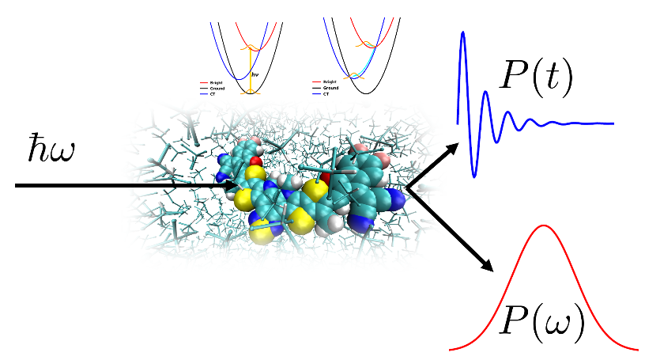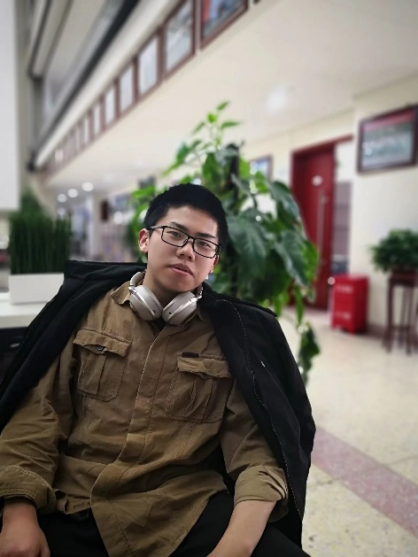

We report a computational approach for linear absorption spectroscopy of organic photovoltaic non-fullerene acceptor Y6’s chloroform solution simulated using nonadiabatic dynamics within the perturbative and nonperturbative approaches with atomistic details. Population and coherence dynamics during and after the light-matter interaction period can be obtained via all-atom nonadiabatic semiclassical and mixed quantum-classical dynamics. The simulated spectra can well reproduce the absorption peak positions and lineshapes corresponding to transitions from the ground state to S1, S2, and S6 excited states. The time-dependent radial distribution functions provide the atomistic information about the solvent reorganization in response to the photoinduced intramolecular charge transfer due to the photoexcitation. These calculations provide molecular insight into the photoinduced charge transfer dynamics in Y6 and offers a consistent computational framework for condensed-phase electronic spectroscopy.

How to connect

Alexey Akimov is inviting you to a scheduled Zoom meeting.

Topic: VISTA, Seminar 95
Time: Oct 15, 2025 10:00 AM Eastern Time (US and Canada)
Join Zoom Meeting
https://buffalo.zoom.us/j/91504288811?pwd=PCq96EznAWVa2RfjyAqxogjpotM82M.1

Meeting ID: 915 0428 8811
Passcode: 948483

How to stay updated

A. VISTA Mailing list:

- Follow the link:
https://listserv.buffalo.edu/scripts/wa.exe?A0=CHE-VISTA-LIST&X=OA41BBB2DC6071987DF&Y=alexeyak%40buffalo.edu
- Click the menu icon in the upper right part of the list (yellow highlight in the picture below)
- Click the “Subscribe or Unsubscribe” option (purple highlight below) – it will bring you to the next window where you’ll be asked for your email/name (I think it the name is optional to provide). This way, you can subscribe to the mailing list to stay tuned or unsubscribe if you find the seminars irrelevant to you or just get too much emails to deal with.
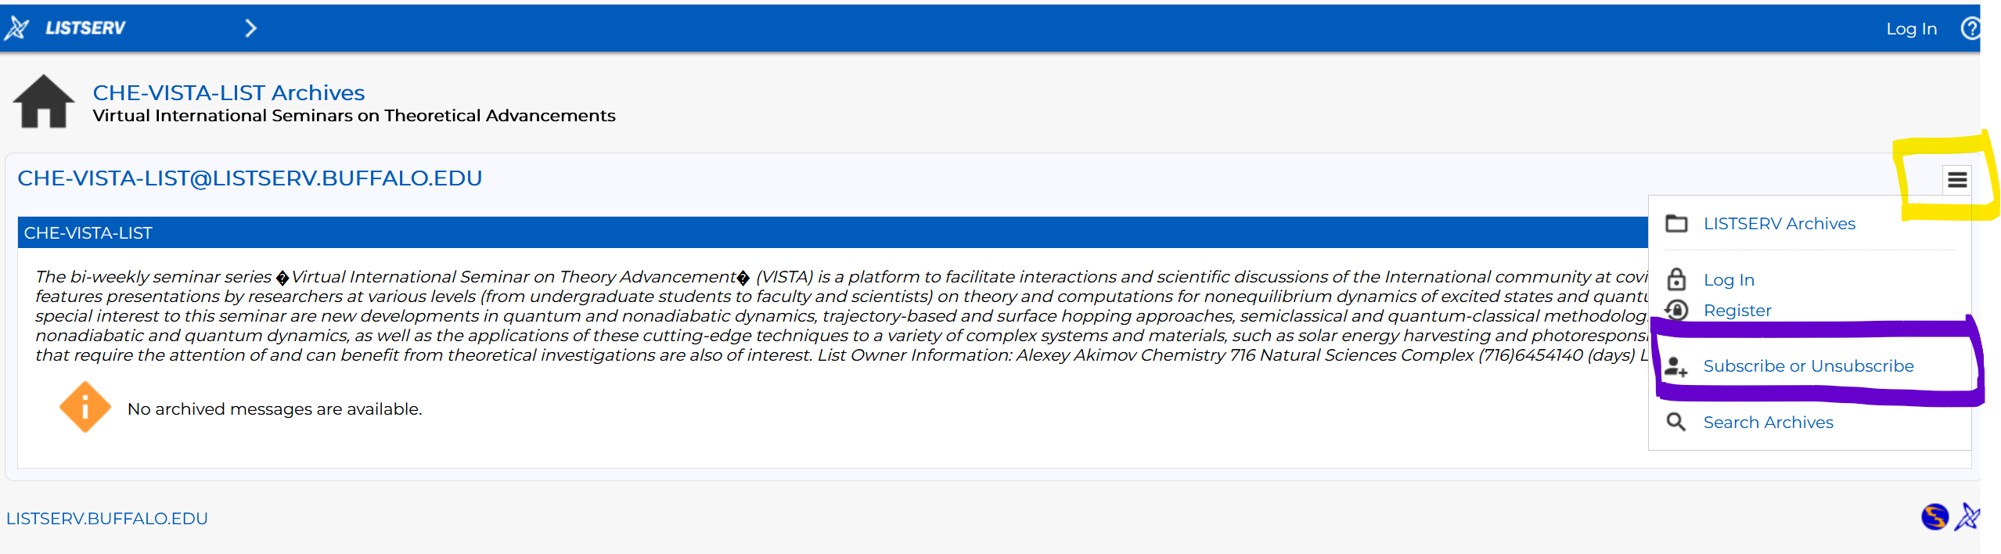

B. Slack Workspaces:

- VISTA workspace: https://join.slack.com/t/vista-atk8254/shared_invite/zt-mdlteo5v-P1Hc7XVupkwMbnGhNG4KIw
- Quantum Dynamics Hub workspace: https://join.slack.com/t/quantumdynamicshub/shared_invite/zt-mjbhjssx-GGhsbYHxeBMvhmumK_j7LA

