VISTA Seminar

Seminar 111

September 2, 2026
10:00 am – 11:30 am EDT Buffalo / 3:00 – 4:30 pm BST London / 4:00 pm – 5:30 pm CEST Paris / 10 pm – 11:30 pm CST Beijing

TOC:

1. Presenter 1: Prof. Amber Jain, IIT Bombay, India….…………………..….page 2
2. Presenter 2: Dr. Sachith Wickramasinghe, Texas A&M University, USA….page 3
3. How to connect………………………………………………………..….. page 4

Deep inverted Marcus regime: quantum nuclear effects vs. resonance

Manas Nagda, Priyam K. De, and Amber Jain

Department of Chemistry, IIT Bombay
Email: amberj@iitb.ac.in

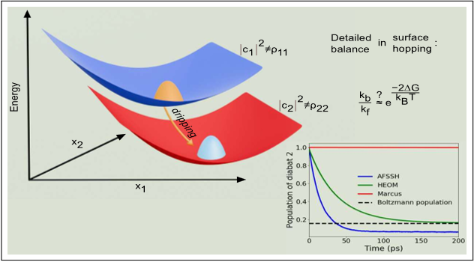

At low reorganization energies, Marcus rate constants can be orders or magnitude wrong compared to Fermi’s golden rule results. The difference has long been attributed to quantum nuclear effects. In this work, we compute the rate constants in the deep Marcus inverted regime from surface hopping simulations (decoherence corrected) as well as from analytical theory. Neither of these computed rate constants include quantum nuclear effects, but agree well with the Fermi’s golden rule results. We interpret the results arising from resonance of the electronic states with nucleus acting as an external field. We further show that in this deep inverted regime, surface hopping results can violate detailed balance significantly and provide an analytical justification of the same.

References:

¹ M. Nagda, P. K. De, and A. Jain, J. Phys. Chem. Lett. 17, 39, 2026

Controlling Mode-Selective Energy Transport in Cavity-Coupled Water

Sachith Wickramasinghe

Texas A&M University, College Station, TX, USA
Email: sachithpw@tamu.edu

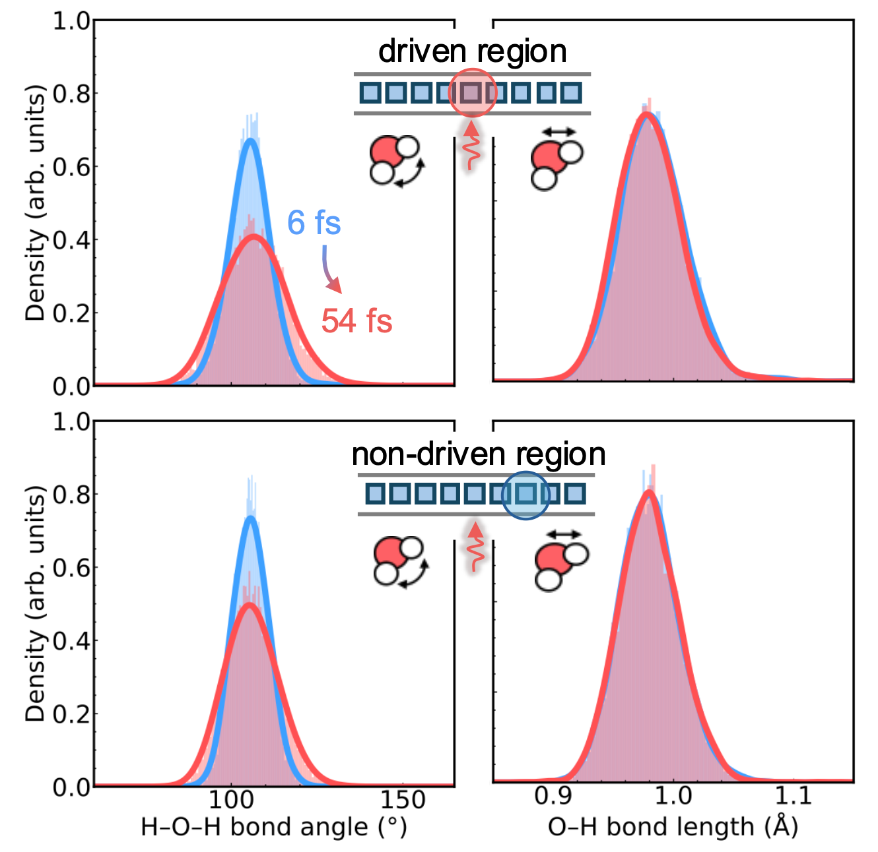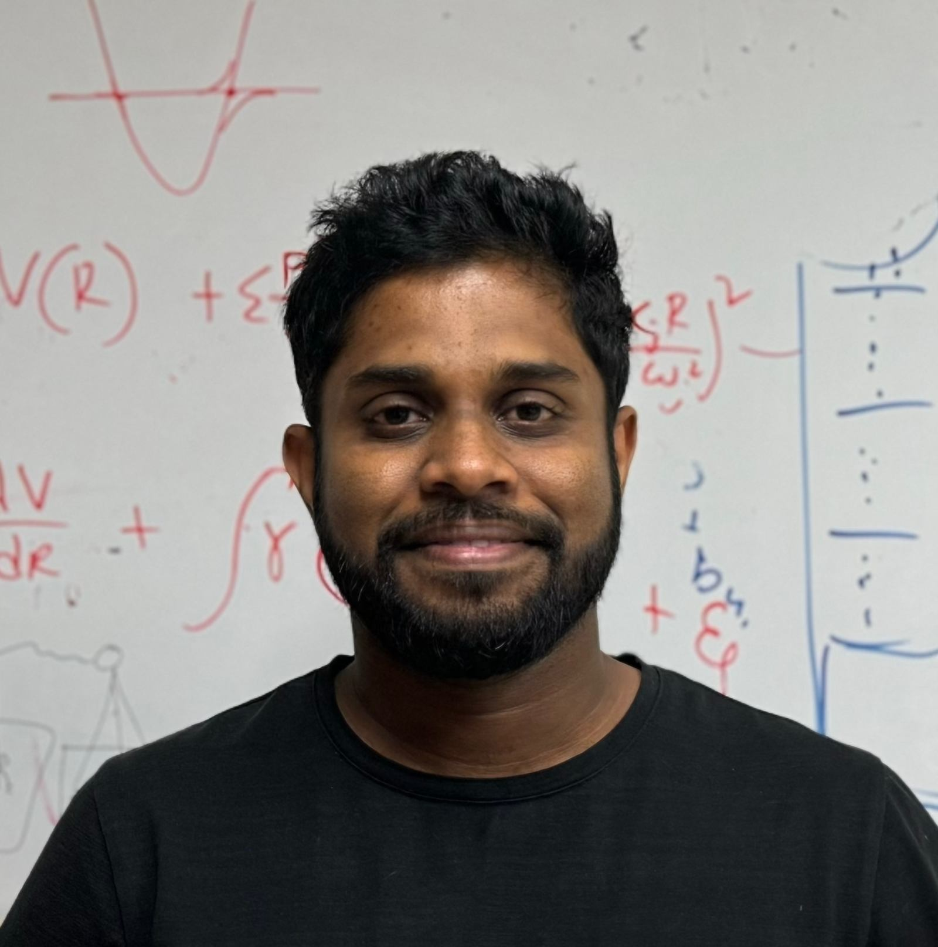
Recent experiments demonstrate the modification of chemical dynamics via cavity-enhanced vibrational energy transport. Here, we provide a microscopic account of both photonic and mode-selective energy transport using direct mesoscale on-the-fly simulations and provide the mechanistic principles of cavity-modified transport under vibrational strong coupling. Our approach combines density functional tight-binding (DFTB) with a light-matter Hamiltonian beyond the long-wavelength approximation to propagate the dynamics of vibrational polaritons By exploiting the sparse nature of light-matter interactions in the real-space representation, we employ a parallelized propagation scheme with lightweight inter-CPU communication that enables direct mesoscale simulations.¹ We find that molecular anharmonicity plays a crucial role in dictating photonic transport, and driving-dependent photonic localization occurs when coupling cavity modes to a highly anharmonic mode of the molecular system. We confirm our understanding using a simple model system by reproducing the photonic transport and its localization. We also demonstrate that the diffusion of mode-selective temperature, quantified via the variance of the H-O-H bond angle or of the O-H bond length, is highly dependent on the cavity photon frequency. We show that the cavity photon frequency can be used as a tuning knob to achieve and control mode-selective energy transport. Our results highlight the rich dynamical interplay of molecular and photonic degrees of freedom that persist in real atomistic systems.²

References:

1. Wickramasinghe, Sachith, Amirhosein Amini, and Arkajit Mandal. "On-the-fly cavity–molecular dynamics of vibrational polaritons." Physical Chemistry Chemical Physics 28, no. 13 (2026): 7840-7849.
2. Wickramasinghe, Sachith, Michael Fowler, Gerrit Groenhof, and Arkajit Mandal. "Mode-Selective and Anharmonicity-Controlled Energy Transport in Cavity-Coupled Water." arXiv preprint arXiv:2607.28782 (2026).

How to connect

Topic: Seminar #111: Amber Jain and Sachith Wickramasinghe
Time: Sep 2, 2026 10:00 AM Eastern Time (US and Canada)
Join Zoom Meeting
https://buffalo.zoom.us/j/95085266296?pwd=FXUTaPCpAUDOIk5QtQ5bLAyffcb03o.1

Meeting ID: 950 8526 6296
Passcode: 288833

How to stay updated

A. VISTA Mailing list:
- Follow the link: https://listserv.buffalo.edu/scripts/wa.exe?A0=CHE-VISTA-LIST&X=OA41BBB2DC6071987DF&Y=alexeyak%40buffalo.edu
- Click the menu icon in the upper right part of the list (yellow highlight in the picture below)
- Click the “Subscribe or Unsubscribe” option (purple highlight below) – it will bring you to the next window where you’ll be asked for your email/name (I think it the name is optional to provide). This way, you can subscribe to the mailing list to stay tuned or unsubscribe if you find the seminars irrelevant to you or just get too much emails to deal with.
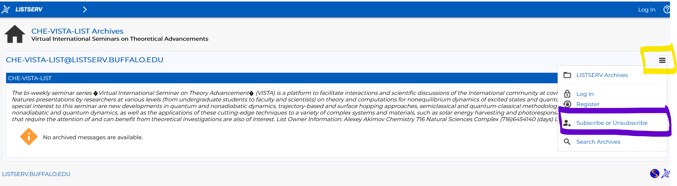

B. Slack Workspaces:
- VISTA workspace: https://join.slack.com/t/vista-atk8254/shared_invite/zt-mdlteo5v-P1Hc7XVupkwMbnGhNG4KIw
- Quantum Dynamics Hub workspace: https://join.slack.com/t/quantumdynamicshub/shared_invite/zt-mjbhjssx-GGhsbYHxeBMvhmumK_j7LA

C. Gmail calendar: https://calendar.google.com/calendar/u/4?cid=Y19jMjhjZjc3YmQxZWY1MWFkMzAwNjQ2MDVkZmQ1YjY3OGMyZmMxMGJmYjZhZmUyOGViZjg0MzA0NzVhMmY5NDAyQGdyb3VwLmNhbGVuZGFyLmdvb2dsZS5jb20

