VISTA Seminar

Seminar 83

February 12, 2025
10:00 am – 11:30 am EST Buffalo / 3:00 – 4:30 pm GMT London / 4:00 pm – 5:30 pm CET Paris / 11 pm – 12:30 am CST Beijing

TOC:

1. Presenter 1: Prof. Norah Hoffmann, New York University, USA…………page 2
2. Presenter 2: Dr. Yeonsig Nam, Argonne National Laboratory, USA…..…..page 3
3. How to connect………………………………………………………..….. page 4

Exploring the Complexity of Polaritonics: From Single-Molecule Strong Coupling to Twin Polaritons

Norah Hoffmann
Department of Chemistry & Department of Physics, New York University, New York, New York 10003, USA
Simons Center for Computational Physical Chemistry at New York University, New York, New York 10003, USA
Email: nmh6061@nyu.edu
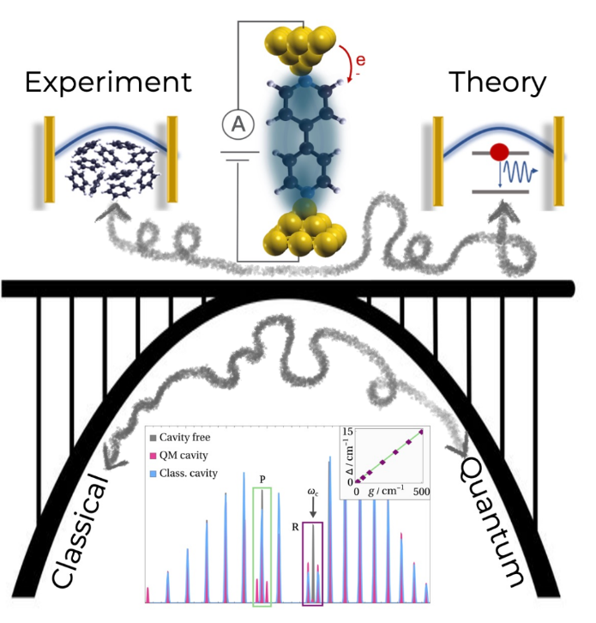
Light-matter interactions are essential to fundamental biological processes and modern sustainable energy applications, making their control crucial. Polaritonics, a nascent light-matter field that exploits strong light-matter coupling in optical or plasmonic cavities, offers new ways to control and modify material properties and chemical reactions. However, a gap remains between large-scale experiments and theoretical models, leading to conflicting findings and highlighting the need for further experimental and theoretical understanding.
In this talk, I will address two key challenges. First, I will discuss the gap between experiments, which require millions of molecules to achieve the strong coupling limit, and theoretical models, which struggle with such large-scale simulations. I will explore how we can bridge this gap by using Scanning Tunneling Microscope Break Junctions (STM-BJ) as plasmonic cavities. Here, I will highlight the potential of STM-BJs and demonstrate how electric field-induced long exciton lifetimes allows us to induce strong light-matter features in just a single molecule.
Second, I will explore the quantum-classical divide in polaritonic phenomena. By analyzing classical and quantum treatments of light in rovibrational spectra, we identify the twin polariton, a secondary splitting beyond the primary resonance due to light-matter entanglement. I will show that the twin polariton persists in many-molecule cases and follows the same linear dependence on coupling strength, offering a novel way to tune quantum features via classical control.
Monitoring Conical Intersection Dynamics with Quantum Dynamics and X-ray Spectroscopy

Yeonsig Nam
Chemical Sciences and Engineering Division, Argonne National Laboratory, Lemont, IL, 60439, USA; Email: nam@anl.gov

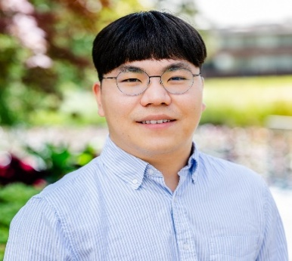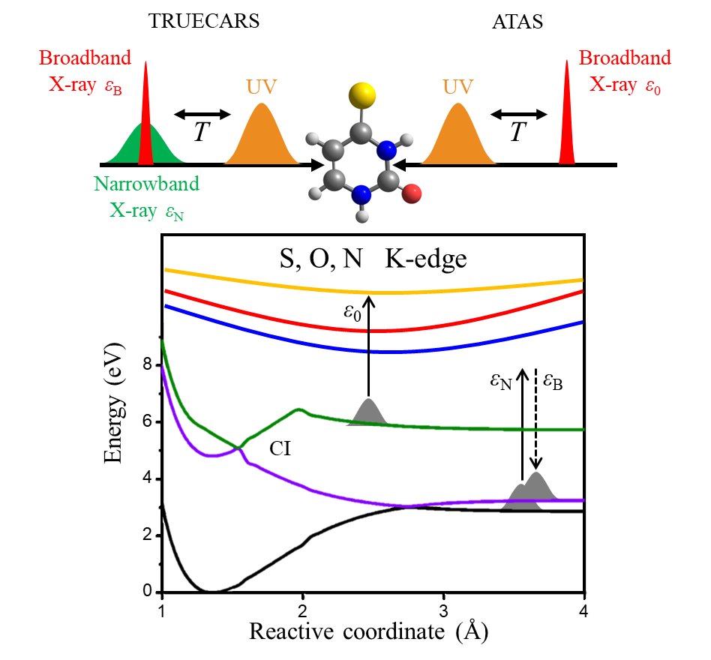

Probing conical intersection dynamics is crucial for unraveling the rates and outcomes of many photophysical and photochemical processes. The advent of X-ray free-electron lasers (XFELs), with their unparalleled brightness, coherence, and femtosecond time resolution, has opened new frontiers in the direct observation of ultrafast molecular dynamics. In this talk, I present how combining quantum nuclear wavepacket dynamics and computational spectroscopy simulations offers unprecedented insights into the timing of conical intersection passages and the subsequent energetic evolution of electronic states.
In the first part, I showcase how three complementary XFEL-based techniques—transient X-ray absorption spectroscopy, stimulated X-ray Raman spectroscopy, and X-ray diffraction—reveal different aspects of the internal conversion dynamics of gas-phase 4-thiouracil through a conical intersection, with particular emphasis on the evolution of population and vibronic coherence [1, 2].
In the second part, I discuss the photo-relaxation dynamics of thymine, a nucleobase with an unusually long excited-state lifetime compared to other nucleobases—a long-standing puzzle in ultrafast spectroscopy. By simulating time-, energy-, and angle-resolved photoelectron spectroscopy on top of quantum nuclear dynamics, I provide new insights into excited-state thymine, consistent with recent experimental findings.[3]

References:
[1] Y. Nam, F. Montorsi, D. Keefer, S. M. Cavaletto, J. Y. Lee, A. Nenov, M. Garavelli, and S. Mukamel, “Time-Resolved Optical Pump-Resonant X-ray Probe Spectroscopy of 4-Thiouracil: A Simulation Study”, J. Chem. Theory Comput., 2022, 18(5), 3075-3088
[2] Y. Nam, D. Keefer, A. Nenov, I. Conti, F. Aleotti, F. Segatta, J. Y. Lee, M. Garavelli, and S. Mukamel, “Conical Intersection Passages of Molecules Probed by X-ray Diffraction and Stimulated Raman Spectroscopy”, J. Phys. Chem. Lett., 2021, 12(51), 12300-12309
[3] M. D. J. Waters, Y. Nam, V. K. Jaiswal, I. Conti, D. Keefer, S. M. Cavaletto, C. Wang, M. Garavelli, S. Mukamel, and H. J. Wörner, “Monitoring conical intersection dynamics by imaging molecular electronic coherences”, (Nat. Commun., Under Major Revision)
How to connect

Alexey Akimov is inviting you to a scheduled Zoom meeting.

Topic: VISTA, Seminar 83
Time: Feb 12, 2025 10:00 AM Eastern Time (US and Canada)
Join Zoom Meeting
https://buffalo.zoom.us/j/97685672834?pwd=RUK0XsMSqxv2K20cH1c47HSSO2TFyN.1

Meeting ID: 976 8567 2834
Passcode: 374899

