VISTA Seminar

Seminar 114

October 14, 2026
10:00 am – 11:30 am EDT Buffalo / 3:00 – 4:30 pm BST London / 4:00 pm – 5:30 pm CEST Paris / 10 pm – 11:30 pm CST Beijing

TOC:

1. Presenter 1: Prof. Dmitry Shalashilin, University of Leeds, UK..……...….page 2
2. Presenter 2: Dr. Jiří Janoš, Sorbonne University, France…………....……..page 3
3. How to connect………………………………………………………..….. page 4

Electrophore model for dissociation of molecules after electron impact in plasma
Ryan Brook,^{1,2} Dmitry Makhov,¹ Alfred Stonelake,¹ Gregory Armstrong,² Anna Nelson,²
Jonathan Tennyson,^{2,3} and Dmitrii V. Shalashilin^{1*}
¹School of Chemistry, University of Leeds, Leeds LS2 9JT, United Kingdom
²Quantemol Ltd., 320 City Road, The Angel, London EC1V 2NZ, United Kingdom
³Department of Physics and Astronomy, University College London, London WC1E 6BT, United Kingdom
*Email: d.shalashilin@leeds.ac.uk
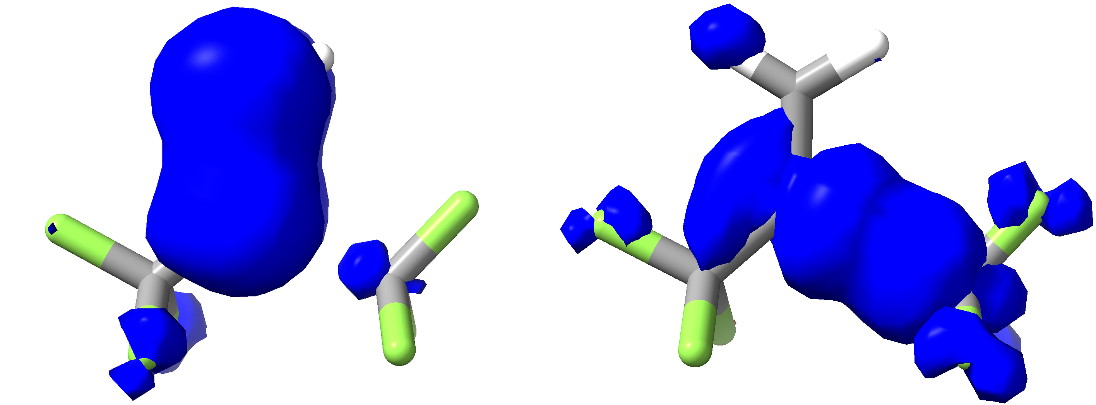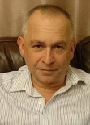
Chemical processes in low-temperature plasmas typically involve molecules excited by electron impact. Unlike photoexcitation, electron impact on closed shell species primarily produces molecules in triplet states, as triplet states are lower in energy. However, similar to excitation of singlet states by a photon, triplet excitation is localized in a small part of the molecule, which we called electrophore, by analogy with chromophore in photochemistry.
The electrophore model suggested by us [1,2] describes well the dynamics of dissociation in plasma. We have shown that nonadiabatic dynamics of energy transfer between different triplet states can be modeled using theories and codes developed previously for the dynamics of energy transfer between chromophores in photochemistry. We find that molecules in triplet states created by electron impact relax very quickly to the lowest triplet state and the dynamics of dissociation simplifies. Therefore, Ab initio molecular dynamics on the lowest triplet Potential Energy Surface is often sufficient for understanding the reaction. Plasma chemistry is crucial for plasma technologies in microelectronics manufacturing, and it has been a subject of many experimental studies. In particular, industry is looking for new environmentally friendly molecules to replace fluorocarbons currently used in plasma etching and plasma deposition. See for example [3,4]. Almost no theory of dissociation after electron impact has been reported previously. We hope that this work initiates a new direction of research for the nonadiabatic dynamics community and will help to find new molecules for the use in industry.

References
[1] Makhov, D.V., Armstrong, G., Chuang, H.H., Ambalampitiya, H., Lemishko, K., Mohr, S., Nelson, A., Tennyson, J., and Shalashilin, D.V. Journal of Physical Chemistry Letters, 2024 15, 3404–3411.
[2] Brook, R., Bramley, O., Makhov, D.V., Nelson, A., Armstrong, G., Yong, J., Saunders, E., de Viggiani, J., Tennyson, J., Shalashilin, D.V. Journal of Vacuum Science and Technology 2025 A43, 043003.
[3] Lee, H.J., Tak, H.W., Kim, S.B., Kim, S.K., Park, T.H., Kim, J.Y., Sung, D., Lee, W., Lee, S.B., Kim, K., Cho, B.O., Kim, Y.L., Lee, K.C., Kim, D.W., and Yeom, G.Y. Applied surface science. 2023 639, 158190.
[4] Kim, J., Kang, H., Kim, Y., Jeon, M., and Chae, H. Plasma processes and polymers. 2024 21, 5.

ON THE INTERPRETATION OF MOLECULAR PHOTOEXCITATION WITH LONG AND ULTRASHORT LASER PULSES

Jiří Janoš,^{1,*} Federica Agostini,¹ Petr Slavíček,³ Basile F. E. Curchod²

¹Sorbonne Université, CNRS, LCT UMR 7616, Paris 75005, France
²School of Chemistry, University of Bristol, Bristol BS8 1TS, United Kingdom
³ University of Chemistry and Technology, Technická 5, Prague 6, 166 28, Czech Republic
Corresponding author: jiri.janos@sorbonne-universite.fr

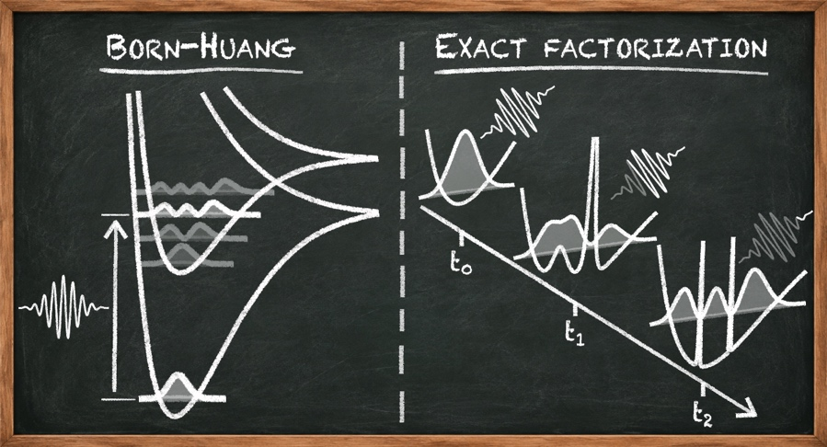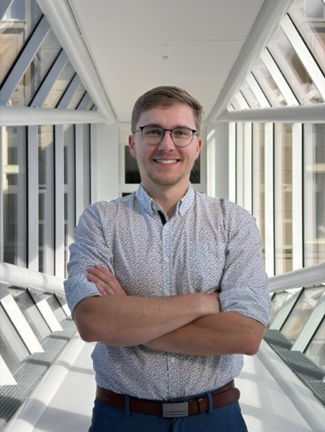

Photoexcitation is an inherent part of any photochemical or spectroscopic experiment, yet its role in excited-state dynamics is often overlooked. In practice, however, it is the photoexcited molecular state, built upon photoexcitation and shaped by the characteristics of the light source, that ultimately determines the fate of the excited molecule and its subsequent photochemical behavior. In this talk, I will discuss how different laser pulses build excited molecular states, using two complementary representations of the molecular wave function: the Born–Huang expansion and exact factorization. I will consider two limiting cases: the preparation of a stationary molecular state by a long 100-fs laser pulse and the generation of an electronic wave packet by an ultrashort (attosecond) pulse. I will further show that standard concepts such as population transfer between electronic states, resonance conditions, and sudden vertical excitation—concepts naturally associated with the Born–Huang representation and widely used in chemical thinking about photoexcitation—are fundamentally challenged when viewed through the framework of exact factorization. Finally, I will comment on suitable strategies for modelling photoexcitation in both femto- and attochemistry based on the presented results.

How to connect

Alexey Akimov is inviting you to a scheduled Zoom meeting.

Topic: Seminar #114: Dmitry Shalashilin and Jiri Janos
Time: Oct 14, 2026 10:00 AM Eastern Time (US and Canada)
Join Zoom Meeting
https://buffalo.zoom.us/j/94252964712?pwd=YLJ0rkx8naBvge59N9aTWZIu5w7MMJ.1

Meeting ID: 942 5296 4712
Passcode: 004303

How to stay updated

A. VISTA Mailing list:
- Follow the link: https://listserv.buffalo.edu/scripts/wa.exe?A0=CHE-VISTA-LIST&X=OA41BBB2DC6071987DF&Y=alexeyak%40buffalo.edu
- Click the menu icon in the upper right part of the list (yellow highlight in the picture below)
- Click the “Subscribe or Unsubscribe” option (purple highlight below) – it will bring you to the next window where you’ll be asked for your email/name (I think it the name is optional to provide). This way, you can subscribe to the mailing list to stay tuned or unsubscribe if you find the seminars irrelevant to you or just get too much emails to deal with.
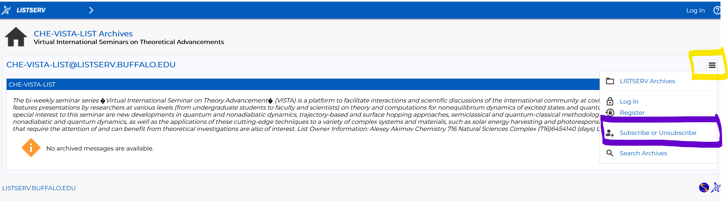

B. Slack Workspaces:
- VISTA workspace: https://join.slack.com/t/vista-atk8254/shared_invite/zt-mdlteo5v-P1Hc7XVupkwMbnGhNG4KIw
- Quantum Dynamics Hub workspace: https://join.slack.com/t/quantumdynamicshub/shared_invite/zt-mjbhjssx-GGhsbYHxeBMvhmumK_j7LA

C. Gmail calendar: https://calendar.google.com/calendar/u/4?cid=Y19jMjhjZjc3YmQxZWY1MWFkMzAwNjQ2MDVkZmQ1YjY3OGMyZmMxMGJmYjZhZmUyOGViZjg0MzA0NzVhMmY5NDAyQGdyb3VwLmNhbGVuZGFyLmdvb2dsZS5jb20

