VISTA Seminar

Seminar 93

September 17, 2025
10:00 am – 11:30 am EDT Buffalo / 3:00 – 4:30 pm BST London / 4:00 pm – 5:30 pm CEST Paris / 10 pm – 11:30 pm CST Beijing

TOC:

1. Presenter 1: Prof. Daniel Nascimento, University of Memphis, TN, USA..page 2
2. Presenter 2: Dr. Dean Lahana, RWTH Aachen University, Germany…......page 3
3. How to connect………………………………………………………..….. page 4

Exploring quasi-relativistic density functional theory approaches in the simulation of resonant inelastic x-ray scattering maps

Daniel Nascimento
Department of Chemistry at the University of Memphis
Email: Daniel.Nascimento@memphis.edu

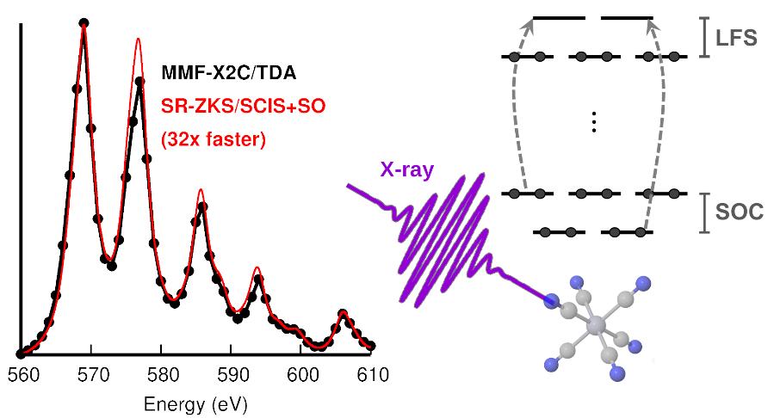

Experimental advancements are pushing the boundaries of core-level spectroscopy. Modern light sources can now produce unprecedented ultrafast x-ray laser beams that can be used to probe chemical processes occurring on the femtosecond timescale with extraordinary resolution. These technologies allow us to gather valuable time-resolved information about the electronic structure of atoms and molecules. However, the theoretical tools commonly used to interpret and analyze the wealth of data produced by light source facilities are heavily reliant on model Hamiltonians, thus lacking predictive ability. While high-level, predictive quantum chemistry techniques, such as coupled-cluster theory would be highly desirable in this context, these techniques remain too computationally expensive for routine use on systems larger than a few dozen atoms. An attractive alternative is to employ density functional theory (DFT) and its variants, as they have been shown to perform reasonably well for a large number of systems at an affordable computational cost.
In this talk, I will present our ongoing efforts to develop and apply DFT-based methods for simulating near-edge x-ray fine structure (NEXAFS) and resonant inelastic x-ray scattering (RIXS) in transition metal complexes. I will focus on how quasi-relativistic approximations based on the zeroth-order regular approximation can be constructed to efficiently incorporate scalar-relativistic and spin-orbit effects, and how these strategies can be extended to simulate multi-dimensional core-level spectra.

o-Nitrophenol and the Dark Side of Photochemistry

Dean Lahana

Institute of Physical Chemistry, RWTH Aachen University
Email: deanlahana@gmail.com

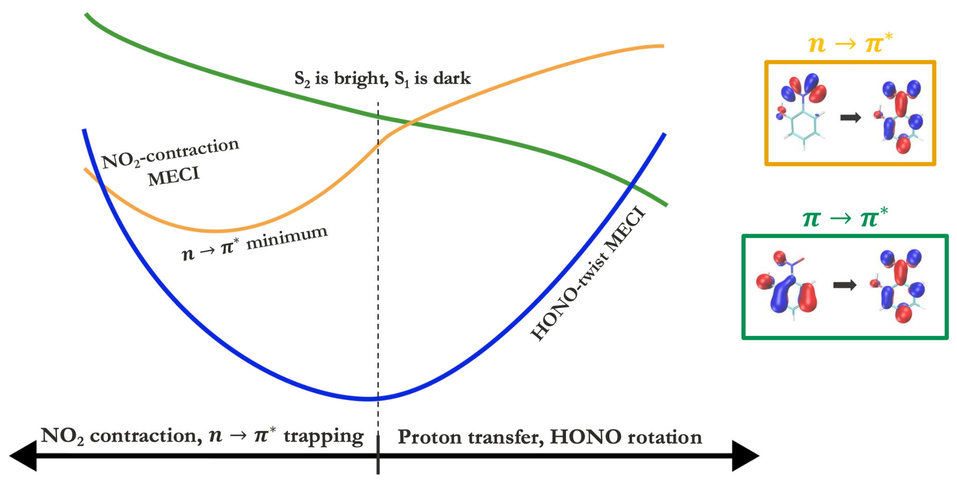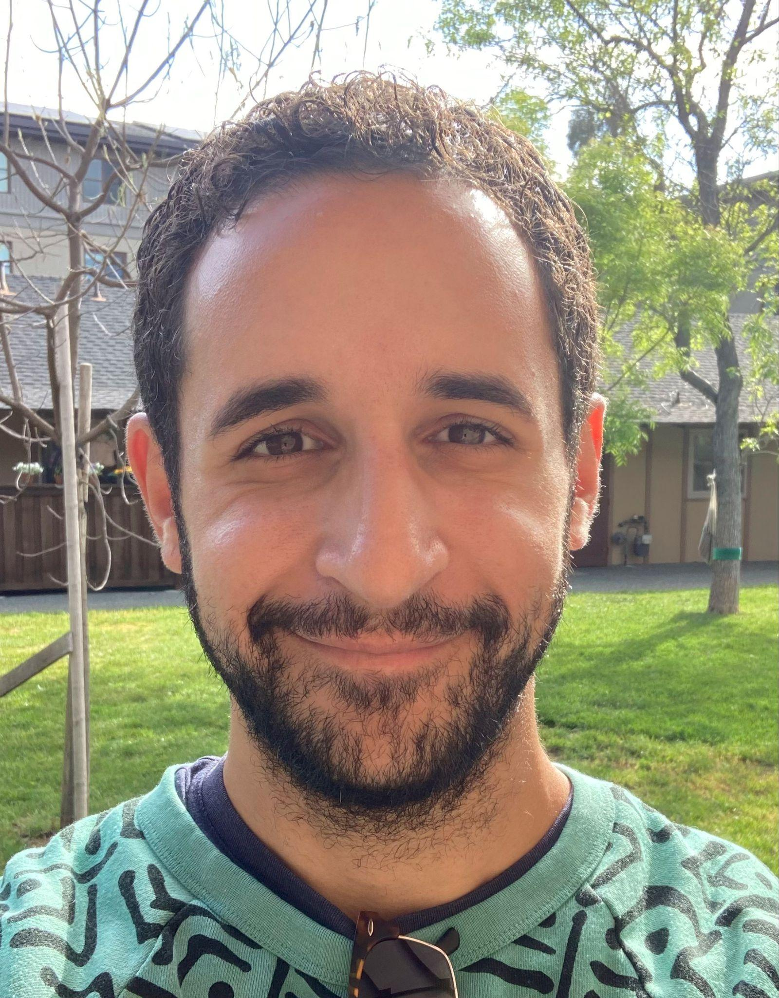

Computational chemistry has many times been asked to prove its value in elucidating the underlying atomic-level details that give rise to experimental observables. Here, we consider o-nitrophenol, which has long held the interest of the photochemical community due to its potential implications for atmospheric chemistry and because its simplicity enables its chemical motifs (intramolecular hydrogen bonding, push-pull substituents) to be studied without an assortment of confounding variables. Equation-of-motion coupled cluster singles and doubles (EOM-CCSD) electronic structure calculations reveal a low-lying dark n→𝜋* state which results in population trapping, impeding internal conversion and possibly the generation of nitrous acid (HONO). Hole-hole Tamm-Dancoff approximation (hh-TDA) non-adiabatic dynamics simulations predict only ~20% internal conversion to the ground electronic state within 1 ps, as opposed to ~85% for simulations without the n→𝜋* state. We also find no evidence of HONO dissociation on either the singlet or triplet manifold, suggesting that o-nitrophenol might be of limited consequence for atmospheric chemistry.

How to connect

Alexey Akimov is inviting you to a scheduled Zoom meeting.

Topic: VISTA, Seminar 93
Time: Sep 17, 2025 10:00 AM Eastern Time (US and Canada)
Join Zoom Meeting
https://buffalo.zoom.us/j/95147384088?pwd=NVi90BnxbkBfpy3RarJZ5ra3CWKEwB.1

Meeting ID: 951 4738 4088
Passcode: 704453

How to stay updated

A. VISTA Mailing list:

- Follow the link:
https://listserv.buffalo.edu/scripts/wa.exe?A0=CHE-VISTA-LIST&X=OA41BBB2DC6071987DF&Y=alexeyak%40buffalo.edu
- Click the menu icon in the upper right part of the list (yellow highlight in the picture below)
- Click the “Subscribe or Unsubscribe” option (purple highlight below) – it will bring you to the next window where you’ll be asked for your email/name (I think it the name is optional to provide). This way, you can subscribe to the mailing list to stay tuned or unsubscribe if you find the seminars irrelevant to you or just get too much emails to deal with.
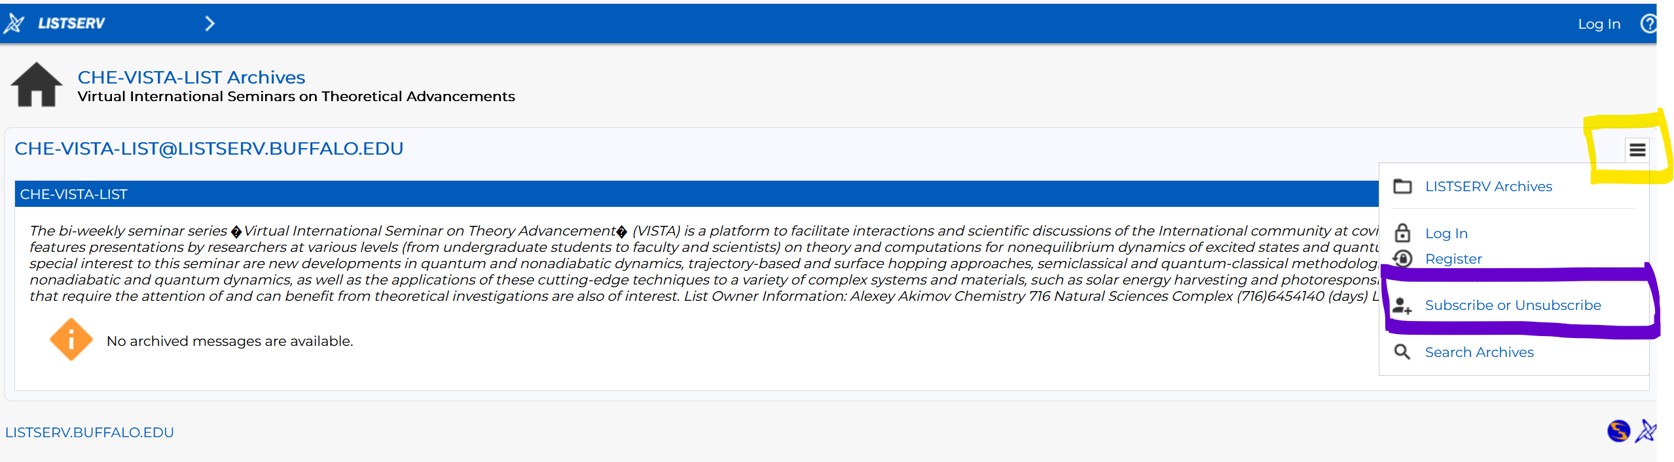

B. Slack Workspaces:

- VISTA workspace: https://join.slack.com/t/vista-atk8254/shared_invite/zt-mdlteo5v-P1Hc7XVupkwMbnGhNG4KIw
- Quantum Dynamics Hub workspace: https://join.slack.com/t/quantumdynamicshub/shared_invite/zt-mjbhjssx-GGhsbYHxeBMvhmumK_j7LA

