We construct the iterative scheme:
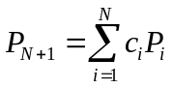

such that the coefficients minimize the error:
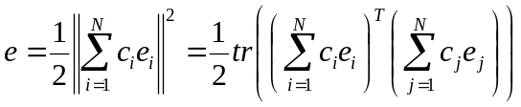,
so:
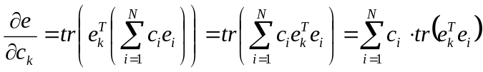

and that
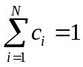
but in addition to the above properties we require that the extrapolated matrix is always idempotent:
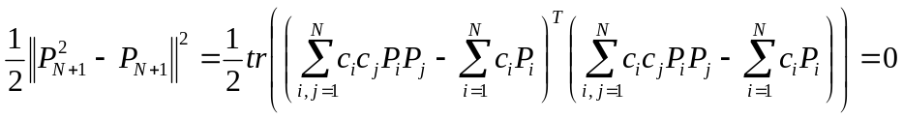
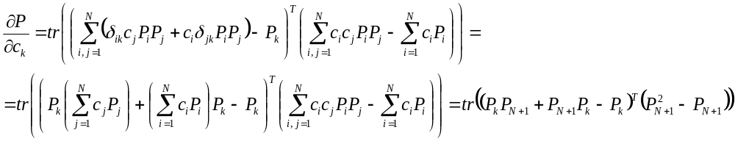(contains polynomials up to 3 order in coefficients), so the scheme is going to be iterative anyways, but in c for given set of error and density matrix pair, so it can be faster. Alternatively, a CG or gradient optimization can be applied to coefficients directly. Iterations do not involve Fock matrix formation, so are relatively cheap.

Most importantly this approach does not require determination of the eigenvalue spectrum, Fock matrix preconditioning (shift and scale). It does not rely of choice of iterative function.

At least 2 guess points should be given for the method to start. The guess densities do not have to be idempotent. If they are Hermitian, the following iterates are also Hermitian, being linear combinations of the first two.

Hmm… it seem like the phase space of density matrices will not actually evolve, it will be 2-D. This is not good – that is why in DIIS we add to history only new iterates, not the extrapolated matrices.

The Lagrangian for these conditions will be:
