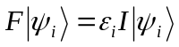
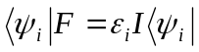

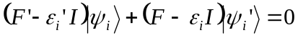
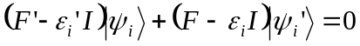

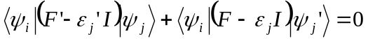

if eigenvalue 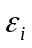is K-fold degenerate: 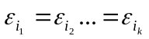

For simplicity – 2-fold degeneracy:
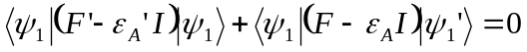

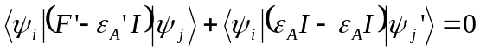
so:
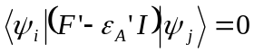 where 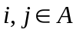- a set of eigenvectors corresponding to a given eigenvalue 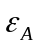.
Since any linear combination of the eigenvectors corresponding to a repeated eigenvalue is also an eigenvector, the eigenvectors 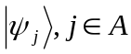form a linear (right) space.
Denoting
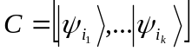
and
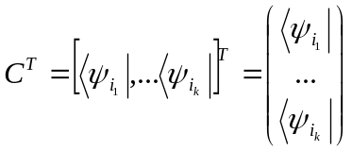

The above equations will take the form:
