Electrostatic in EHT
To understand how one can construct EHT Hamiltonian such that it will preserve rotational invariance, we start with the energy expression.
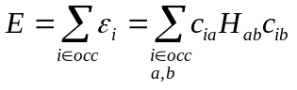,
where 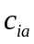and 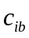are the coefficients of the AO functions a and b in expansion of the MO i, which diagonalize the Hamiltonian H.
The matrix elements of the Hamiltonian in AO basis can be expressed:
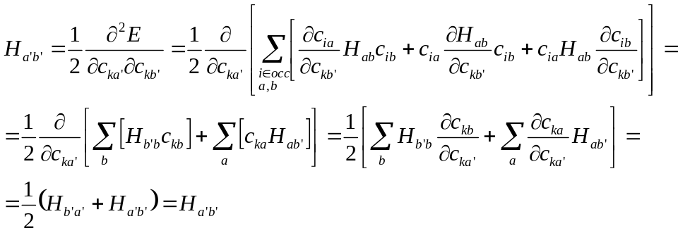
Here we obtained the fact that 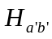is independent of the MO indexes k. One of the prerequisites for this to be true, which we used quietly, was the assumption that the derivative of the matrix element of the Hamiltonian in AO basis with respect to orbital coefficients is zero: 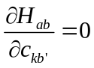 for any k, a, and b. This is certainly satisfied for original EHT Hamiltonian in which case 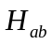depends only on the AO overlap, but not on the AO weights.
Now, if one is interested in incorporating electrostatic interactions within the framework of the EHT, the matrix elements must be made dependent on the MO-LCAO orbital coefficients. There are 2 possible approaches of doing this:
- one in which depends on 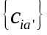, but still 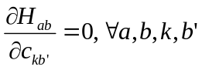
- a more general constraint on the form of , which can be derived from 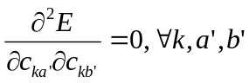.
There are many possibilities of defining such forms – e.g. most of the semiempirical and HF methods construct such a form of the Hamiltonian.

We now derive the general constraint:
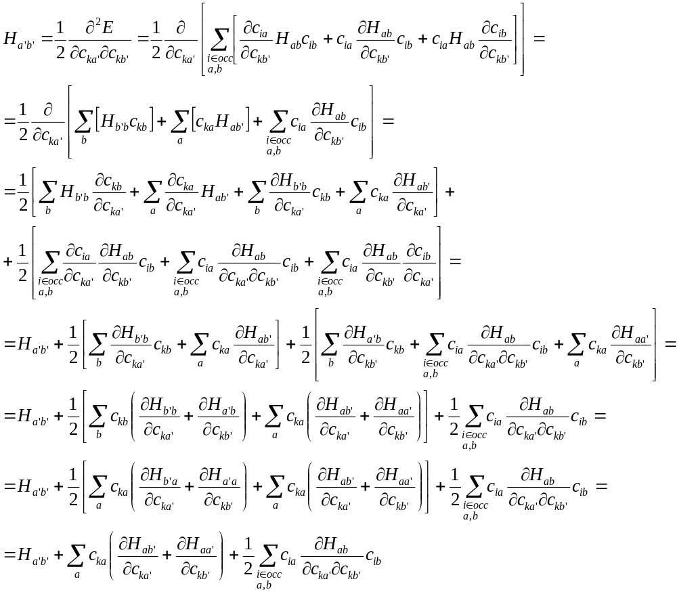This quantity must be independent on orbital index k.

Note that is not enough to make H dependent on some quantities which are sums over all k indices (so k-independent), because the derivatives will still depend on index k via 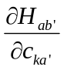.

In fact, it is not exactly k-independence we are imposing on 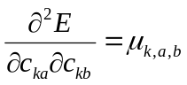,but rather equality of 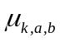for all k for fixed a and b:
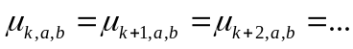

Lets assume that 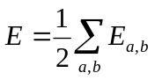,
with
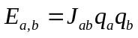,
where
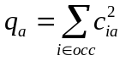and 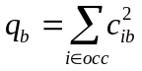
We find that
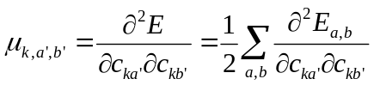
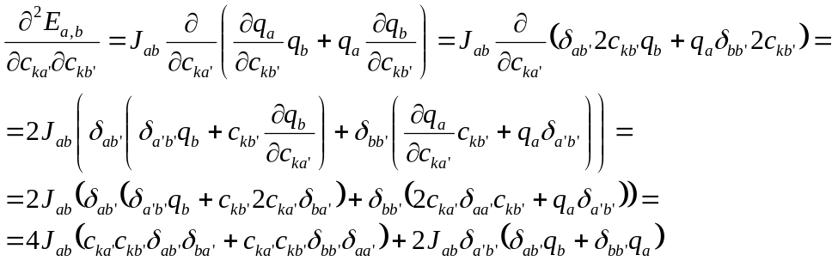
So:
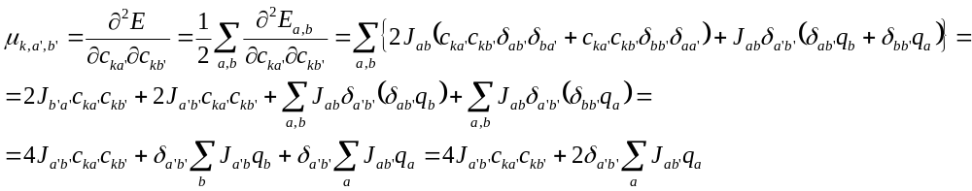
Now, construct new (corrected) energy functional:

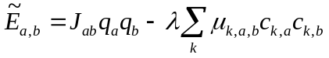
Then

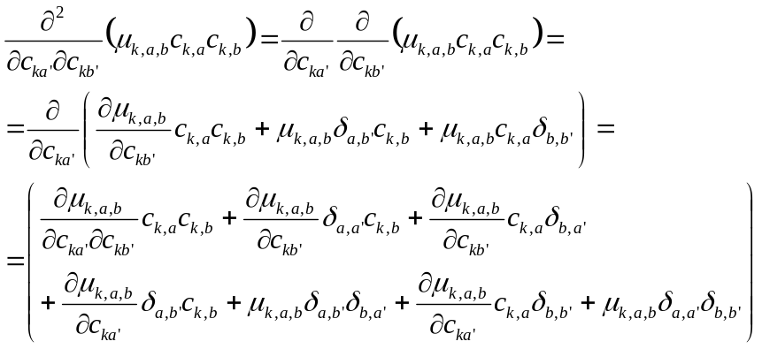

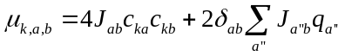, so:
similarly
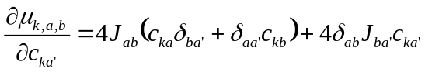
So:

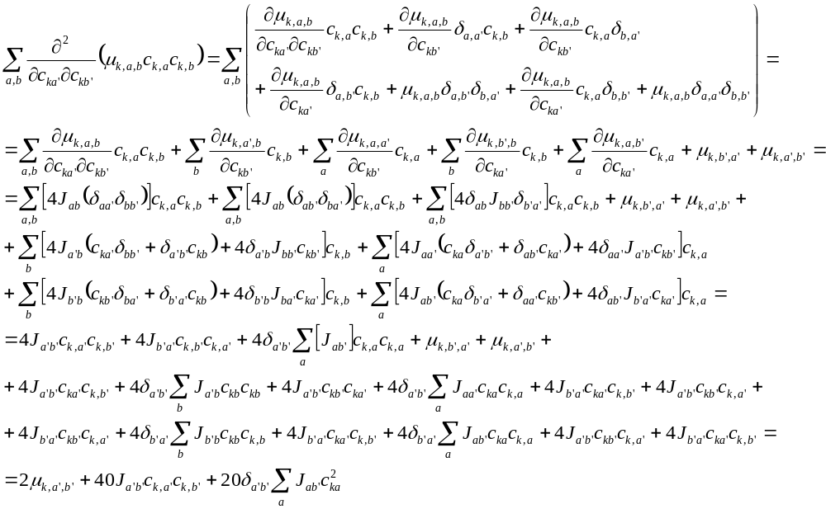
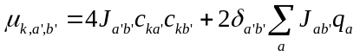

quite close, but…

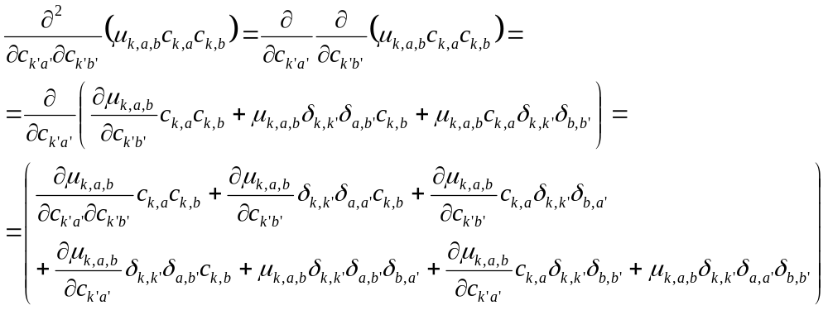

, so:
similarly
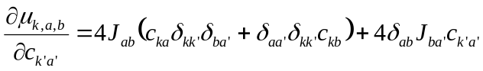
So:
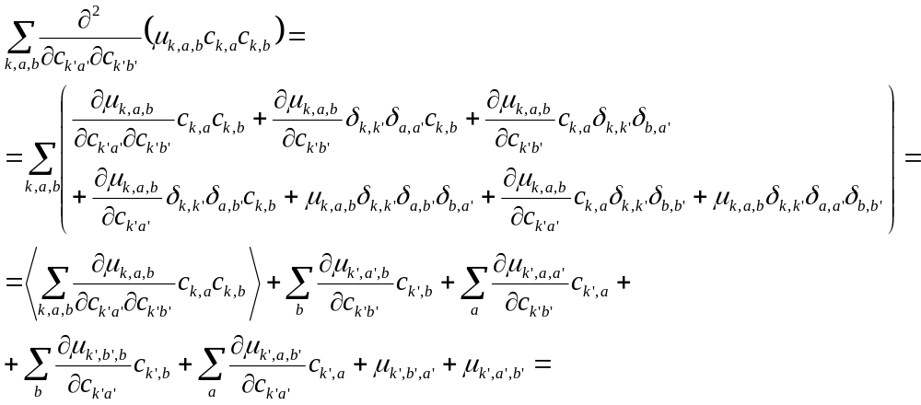

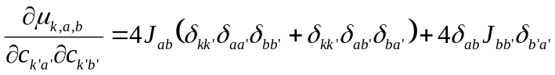

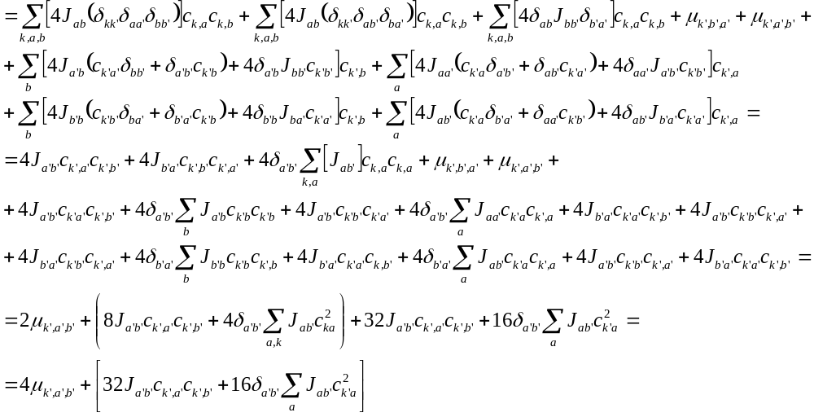

So:
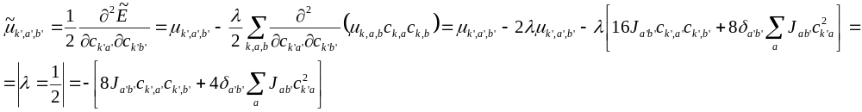or:
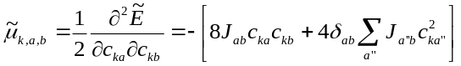
This quantity is still different for different k.
Introduce one more correction
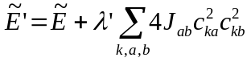
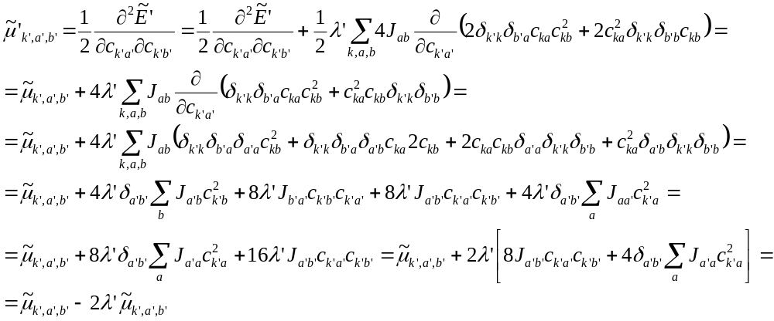
Thus, if we set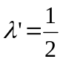, we get: 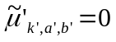, so it is the same for all k indices.
Therefore the proper form of the electrostatic energy is:
