Stage 1:

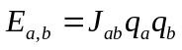,
where
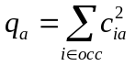and 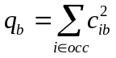
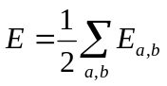,
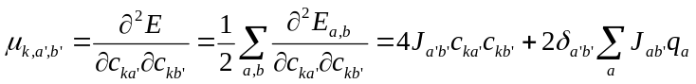

Stage 2:
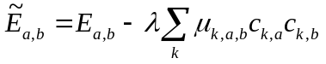
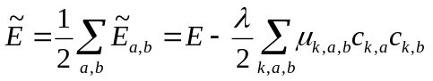

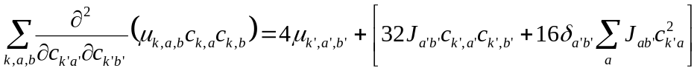
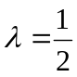
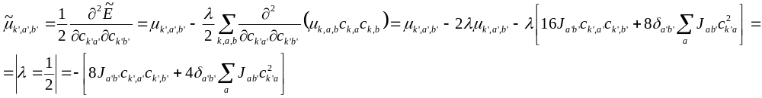

Stage 3:
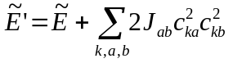
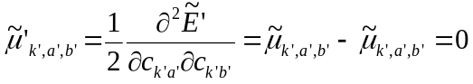

Stage 4 (Composing):
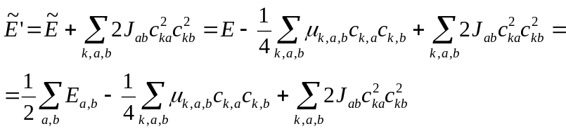
with
and
So in total:
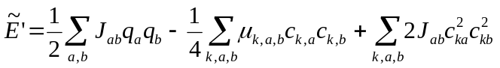
with
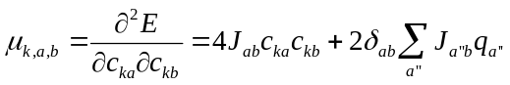,
so:
