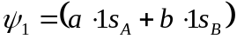
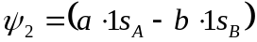

Then,

Keeping in mind that(simply because of the symmetry):
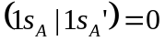,
we get:
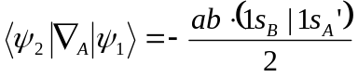
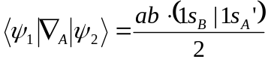

So:
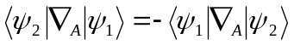

But lets see this:

so it is non-zero.

