Part 1. Hartree-Fock method – the root of semiempirical techniques

Index notation:
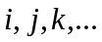- for general running indexes in summations and vector(matrix)-vector(matrix) products
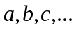- for molecular and atomic orbitals
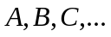- for atomic species
Sometimes this will have a convenient property that MO or AO a will be sitting on atom A.

Wavefunction representation:
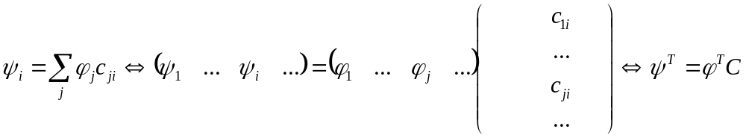, (1.1)
i-th column of the matrix C, gives the coefficients of the expansion of i-th MO in terms of AOs.

Roothaan equation:

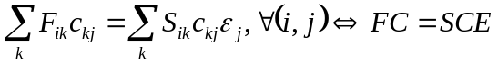, (1.2)
where  – is a Fock matrix in AO basis, - is an overlap matrix in AO basis:
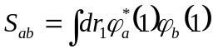. (1.3)

Fock matrix:

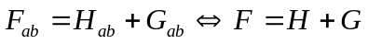, (1.4)
where  and - are the one-electron (core) and two-electron (Coulomb and exchange) Hamiltonians, respectively:
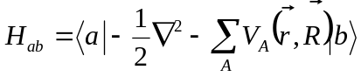, (1.5)
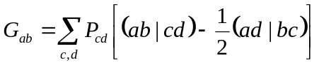, (1.6)
with effective core potential and 2-electron integrals in AO basis given by:
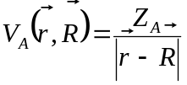, (1.7)
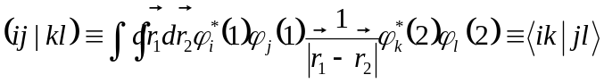. (1.8)
The density matrix is given by:
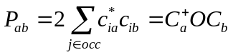, (1.9)
where 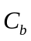is b-th column-vector of the matrix , 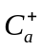is a Hermitian conjugate of the a-th column-vector of the matrix - so it is a row-vector with the elements complex-conjugate to those in a-th column of the matrix . The matrix is the occupation matrix – a diagonal matrix with the first Nocc diagonal elements equal to 2 (closed-shell case), Nocc – is a number of occupied orbitals:
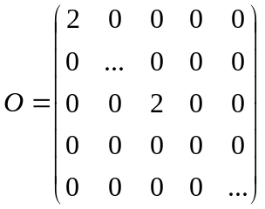. (1.10)
For the open-shell model the density matrix is a sum of two spin-components:
, (1.11)
now with
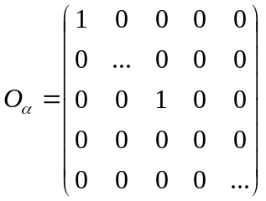and 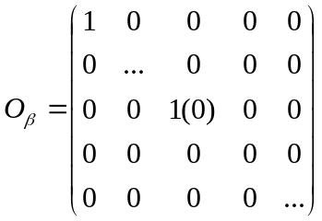. (1.12)
So in close-shell case:
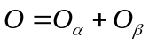. (1.13)

Energy:
Electronic energy:
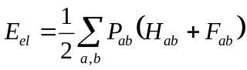. (1.14)
Nuclear energy:
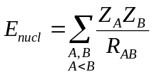, (1.15)
where 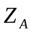- are the nuclear charges (in HF method – total charges, but in CNDO/INDO – also total (not just effective core!) charges).

Total energy:
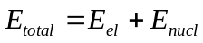. (1.16)

Part 2. CNDO method

Approximations.

General (main) approximation:

- Neglect of differential overlap:
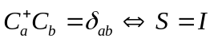. (2.1)
This means some Hamiltonian matrix elements will become zero (see next), but also that the generalized eigenvalue problem, Eq. (1.2), becomes a standard eigenvalue problem:
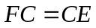. (2.2)

Approximations regarding 2-electron integrals:

- Because of (2.1), all 2-electron integrals 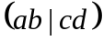 are zero, unless a=b and c=d:
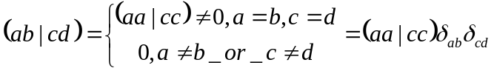, (2.3)
- Non-zero 2-electron integrals do not depend on orbital type – to preserve rotational invariance of the Hamiltonian:
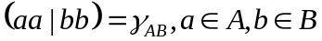, (2.4)
where, of course, A can be the same and B. Practically, the integral is evaluated in STO (or in STO-nGTO) using s-orbitals of the valence shell.

Approximations regarding 1-electron integrals:

- Diagonal elements of the core Hamiltonian. Because of (2.1), the 1-electron integrals 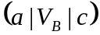will be non-zero only if :
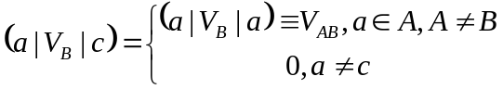. (2.5)
Note, that element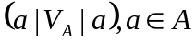is implicitly included in parameterization of the core Hamiltonian.
- Off-diagonal matrix elements of the core Hamiltonian are proportional to the AO overlaps:
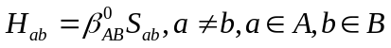. (2.6)

Explicit expression for Fock matrix elements

Using the approximation above, the Fock matrix elements can be written as:
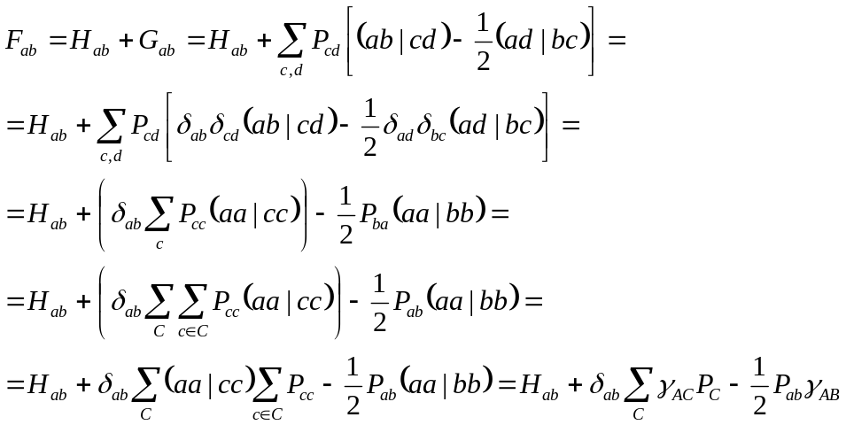. (2.7)
Or, with the change of indexing:
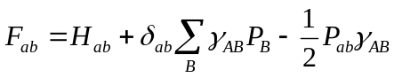, (2.8)
where
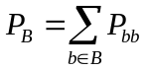, (2.9)
is a total electron density on atom B.
Equation 2.8 can be further elaborated:
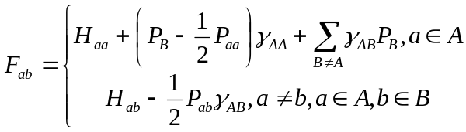. (2.10)

Explicit expression for core Hamiltonian matrix elements

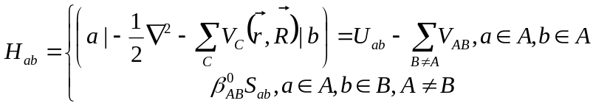, (2.11)
where
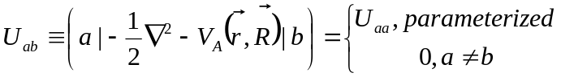. (2.12)
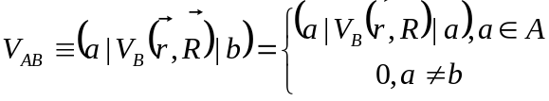. (2.13)

Technicalities and pitfalls:

1) The electron repulsion integrals (ERI) of type 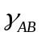 are computed explicitly, using s orbitals of the valence shell given by STOs with parameterized exponents:
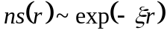, (2.14)
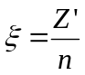. (2.15)
GTO representation of the STO, but with the same exponents is also possible (this is the way I’m doing it). n – is a principal quantum number of the valence shell, 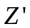- are parameters
So:
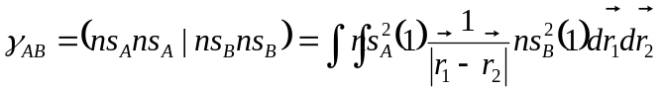. (2.16)

2) Nuclear attraction integrals (NAI) of type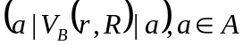are also evaluated explicitly, using valence s-orbitals, like in Eq. (2.16):
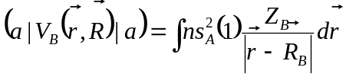. (2.17)

3) 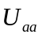- is parameterized from the IP and EA energies and ERIs, Eq. 2.16:
For the 2s^{m}2p^{n} configuration:
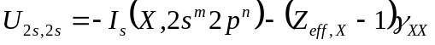, (2.18a)
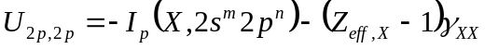. (2.18b)

Quantities 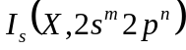and 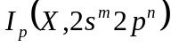are the parameters (from atomic data).

4) Quantities 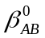are the average of single-atom-type parameters 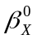:
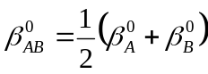. (2.19)

5)
Note that so far we have introduced 3 types of Z:
a) - is the nuclear charge. Used in NAI, Eq. (2.17), and nuclear energy, Eq. (1.15), calculations;
b) 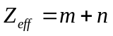- is a number of valence electrons in the 2s^{m}2p^{n} configuration. This is kinda effective core charge (but very crude, not the one obtained from the Slater rules). Used in core parameter evaluation, Eq. (2.18);
c) - is an effective core charge, more closely related to Slater rules and screening. Solving hydrogen-like problem with this effective charge gives the exponent of the resulting STOs. Used in NAI and ERI evaluation as a parameter of the AO exponents.

Part 3. CNDO/2 method

Approximations:
- Neglect of “penetration” term.
Originates from:
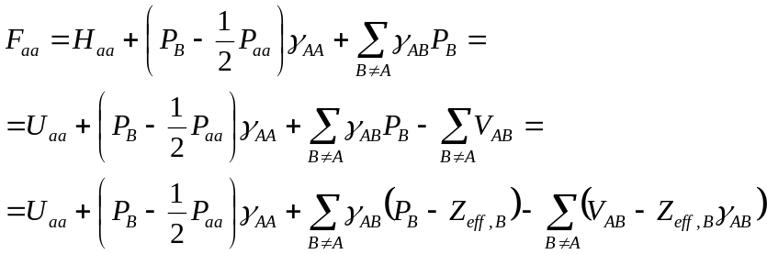. (3.1)
The last sum 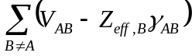has the meaning of “penetration” energy, although there is no strict justification. According to this approximation this term is neglected. Effectively the approximation means:
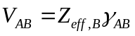. (3.2)

- Different core Hamiltonian parameterization strategy – using both IP and EA:

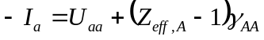, (3.3)
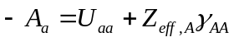, (3.4)
so
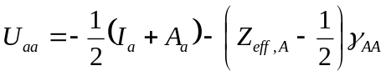. (3.5)

Part 4. INDO method

Approximations:

- Main: All one-center exchange integrals are retained

So the Fock matrix is:

if 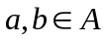:
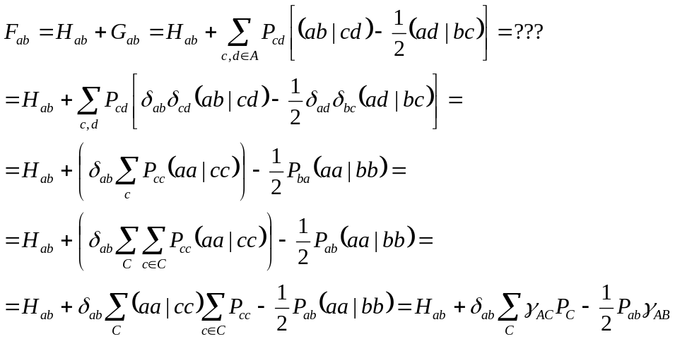

- A slightly different way of parameterization of core matrix elements

