Derivation of the EHT method:
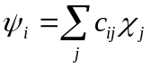
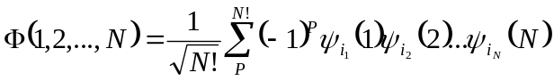
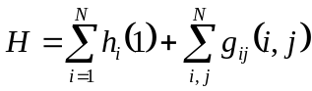
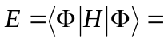

Ok. To make long story short, we eventually arrive at:
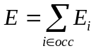
The derivatives of the eigenvalues can be computed as follows:
Each 1-electron molecular orbital is given by:
,
then
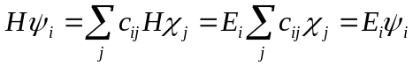
Projecting on the same orbital, and using the fact that: 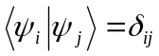we arrive at:
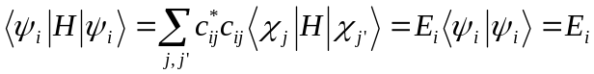
Taking derivatives of the RHS and LHS w.r.t. some coordinate 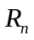, we get:
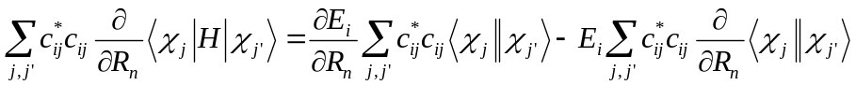
Or:
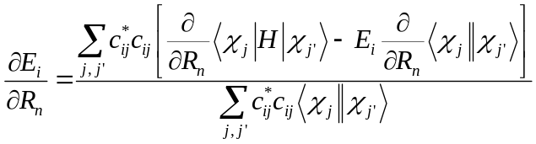
Because 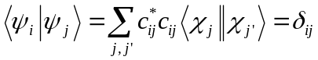, we finally get:
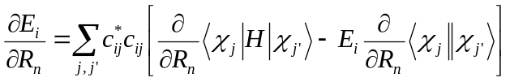

And the total force acting on the atoms in the system that is in a given electronic state is:
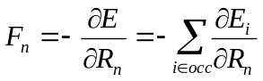
Because in EHT the Hamiltonian matrix elements in atomic basis are given by:
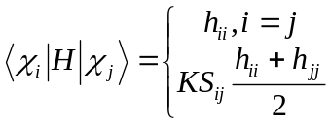,
we have:
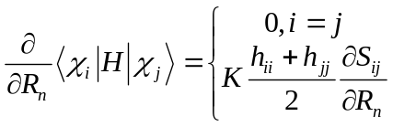

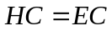
If we start from:

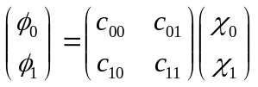 or 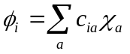

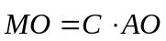

and we have:
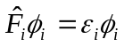
then:

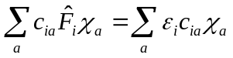 => 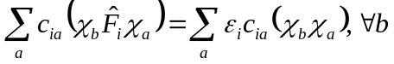
We then have:

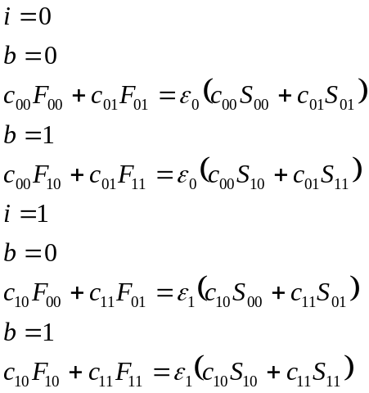

This is equivalent to:

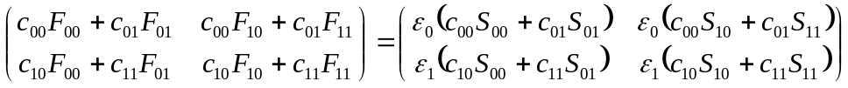

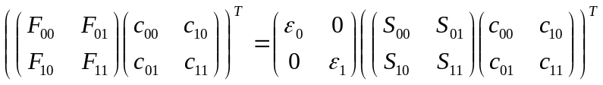

Transpose both sides we obtain:

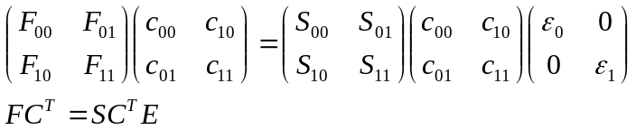

Developer Manual

double OVERLAP_INTEGRAL(PrimitiveG& GA,PrimitiveG& GB,int is_normalize)

Compute the overlap integral between two Gaussian primitives:
,
,
where
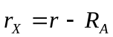

See more details in Valeev¹ and Taketa²

Aux_Function1(double s, double x)

computes lower incomplete gamma-function divided by some power function:
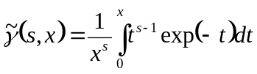,
The actual lower incomplete gamma-function (mathematical definition) is:
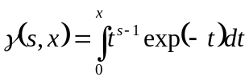
Relation: 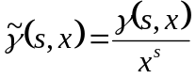

method: using series expansion:
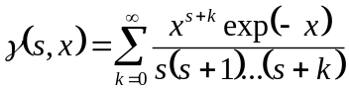
So:
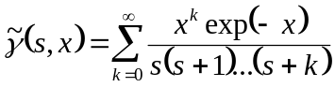

Aux_Function2(int n, double t)

computes incomplete gamma-function:
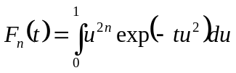
method: via relation to the lower incomplete gamma-functions
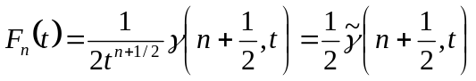
Note: - is what actually computed by Aux_Function1, it includes division by 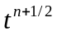implicitly (no explicit division) – to avoid division by zero problem.

Proof:
,so
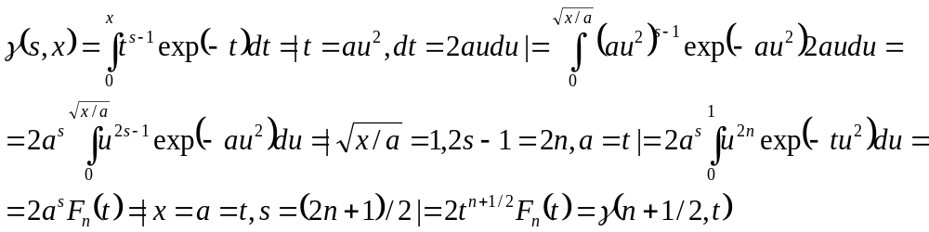
Then,
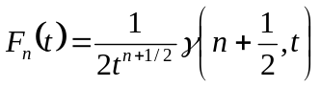
EOF

derivative:
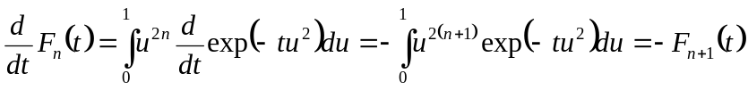

Aux_Function3(int n1, int n2, double x1, double x2, vector<double>& f)

computes coefficients in expansion:
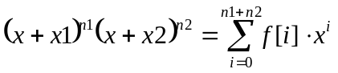

method:
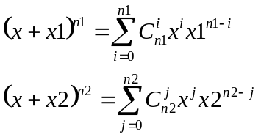
so
and so
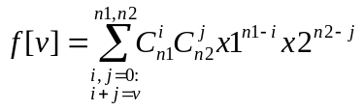

a bit of optimization – explicit expression for lower powers:

sum = 0 (s+s)

1)
n1 = 0, n2 = 0:
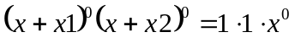
f[0] = 1

sum = 1 (s+p)

2) n1 = 1, n2 = 0:
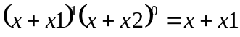
f[0] = x1, f[1] = 1

3) n1 = 0, n2 = 1:
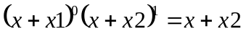
f[0] = x2, f[1] = 1

sum = 2 (d+s,p+p)

4) n1 = n2 = 1
f[0] = x1*x2, f[1] = x1+x2, f[2] = 1

5) n1 = 2, n2 = 0
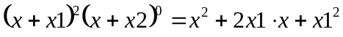
f[0] = x1^2, f[1] = 2*x1, f[2] = 1

6) n1 = 0, n2 = 2
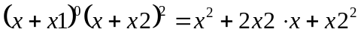
f[0] = x2^2, f[1] = 2*x2, f[2] = 1

sum = 3 (f+s,d+p)

7) n1 = 3, n2 = 0
f[0] = x1^3, f[1] = 3*x1^2, f[2] = 3*x1, f[3] = 1

8) n1 = 0, n2 = 3
f[0] = x2^3, f[1] = 3*x2^2, f[2] = 3*x2, f[3] = 1

9) n1 = 2, n1 = 1
f[0] = x1^2 * x2, f[1] = (2*x1*x2 + x1^2), f[2] = (2*x1 + x2), f[3] = 1

10) n1 = 1, n1 = 2
similar to 9.

Aux_Function4(int n1, int n2, double PA, double PB, double PC, double gamma, vector<double>& G)

computes G functions:
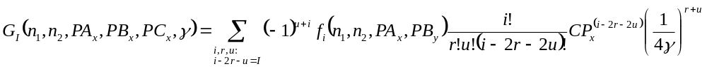
for all possible I values: 0<=I<=n1+n2

The summation limits more explicitly:
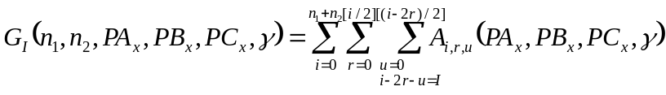
with

Lets list G explicitly:
n1+n2 = 0
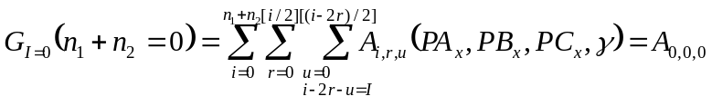
n1+n2 = 1
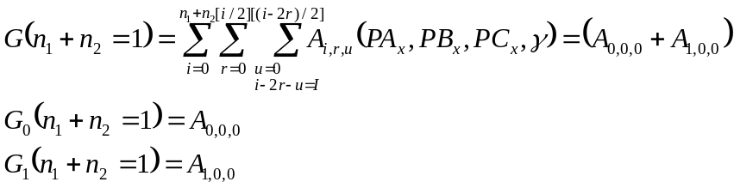

n1 + n2 = 2
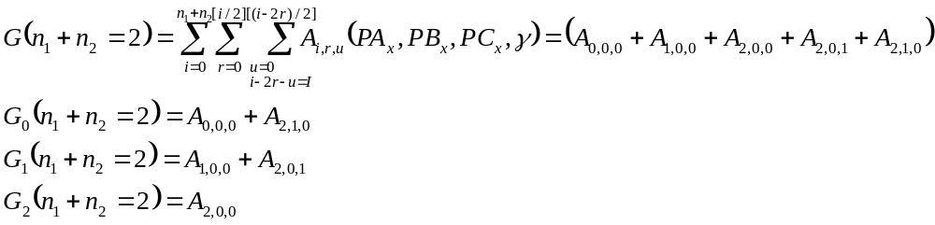

n1 + n2 = 3
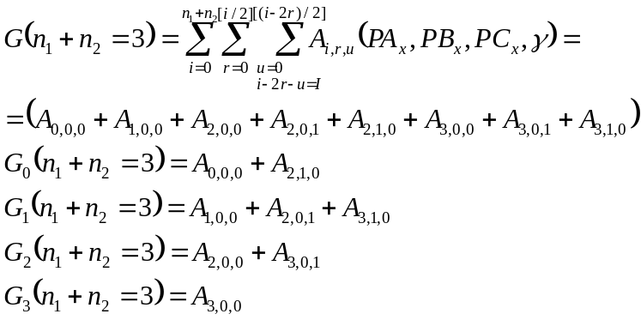

n1 + n2 = 4
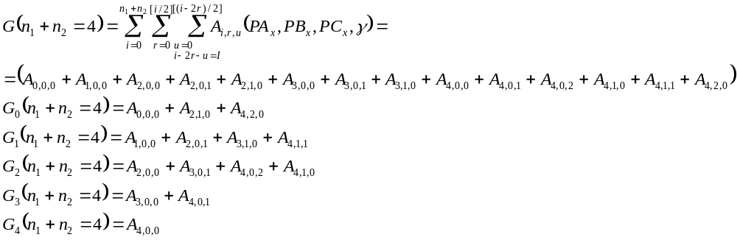

Lets evaluate A:
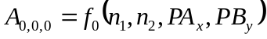

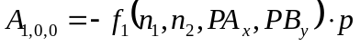
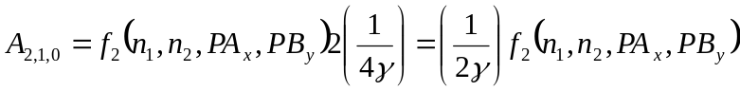
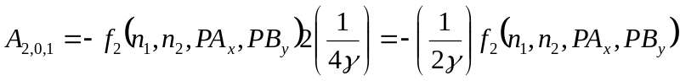
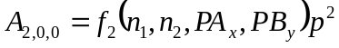
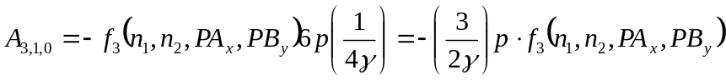
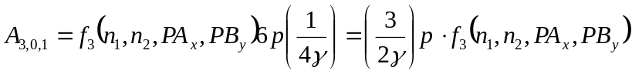

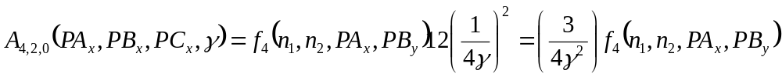
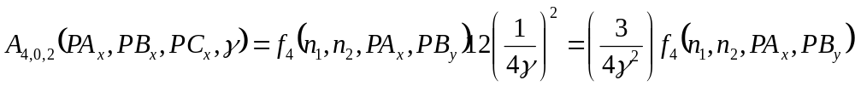

To summarize:

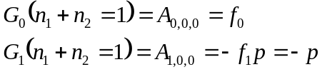

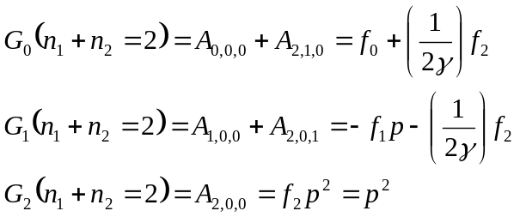
Note, expressions for G₀(n1+n2=2) and G₁(n1+n2=2) contain f1/2gamma terms in Taketa, which is wrong.

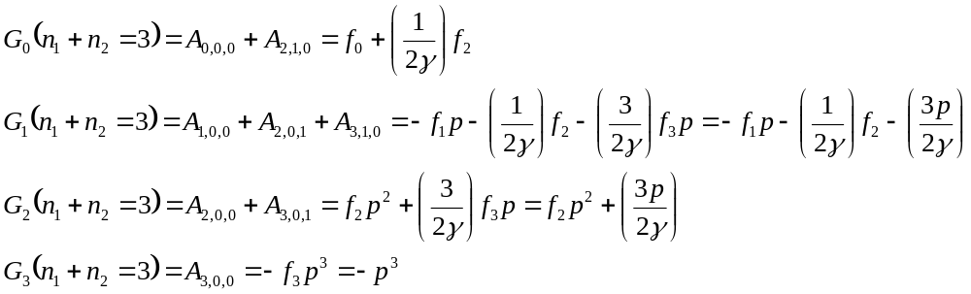

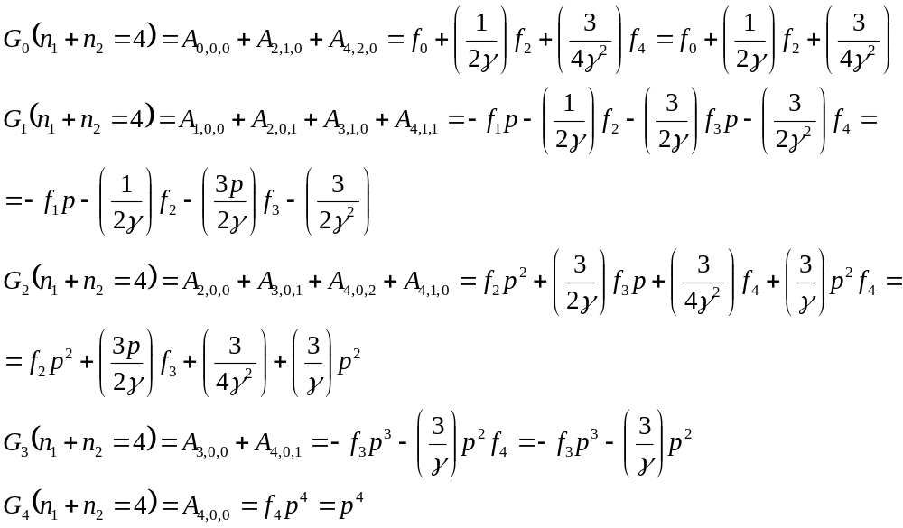
Note in Taketa they have in G1: 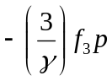, which is incorrect. Must be 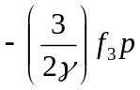 .

void Aux_Function5(int l1,int l2,double a,double b,double gamma,vector<double>& H)

computes H functions:
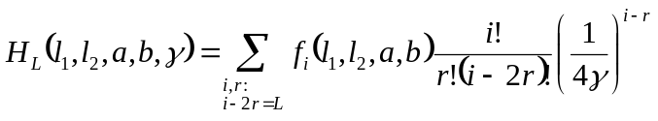
for all possible I values: 0<=L<=l1+l2

The summation limits more explicitly:
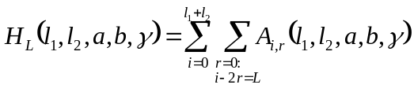
with
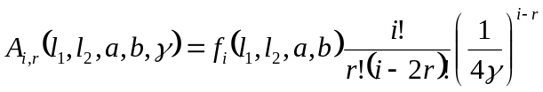

Lets list H explicitly:

l1+l2 = 0
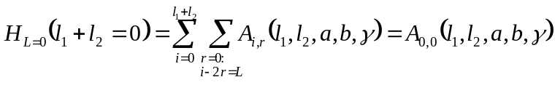

l1+l2 = 1
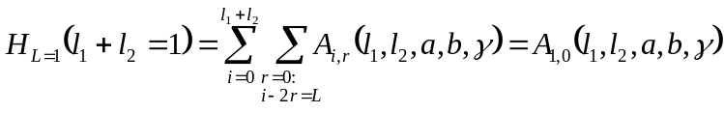
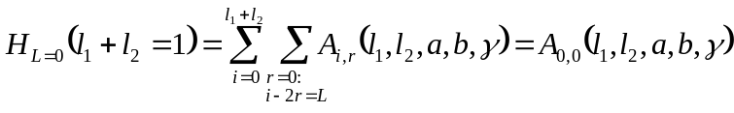

l1+l2 = 2
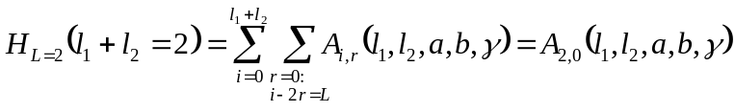
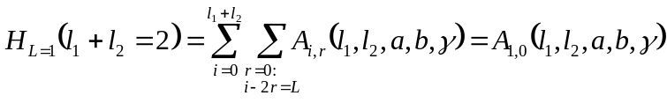
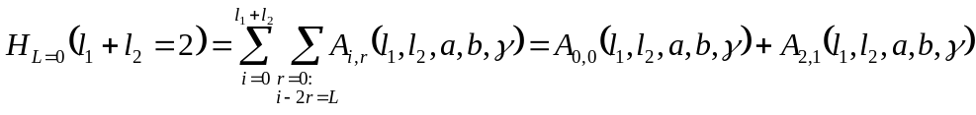

l1+l2 = 3
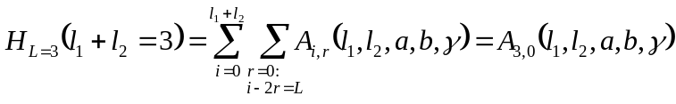
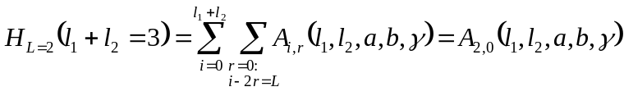
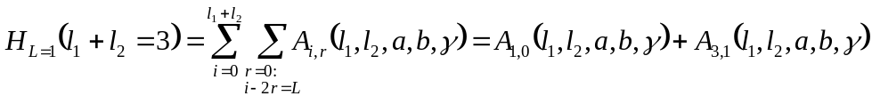
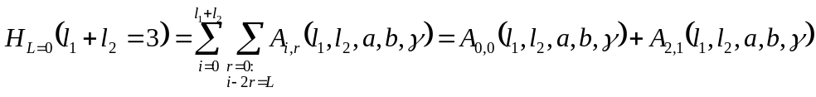

l1+l2 = 4
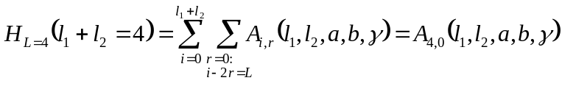
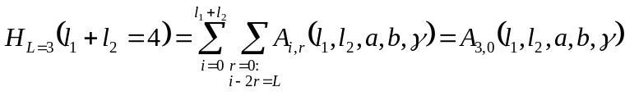
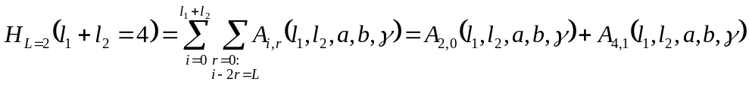
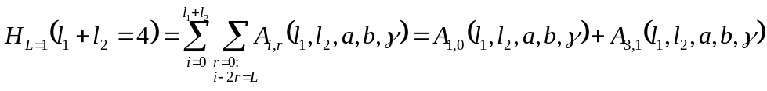

Lets evaluate A:

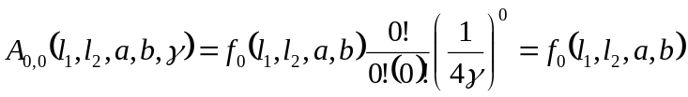
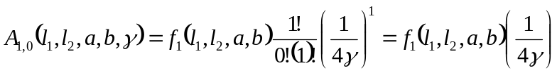
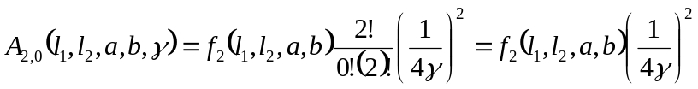
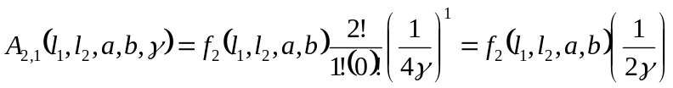
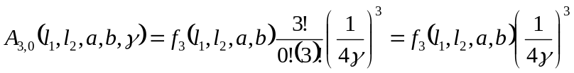
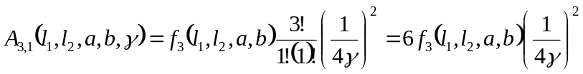
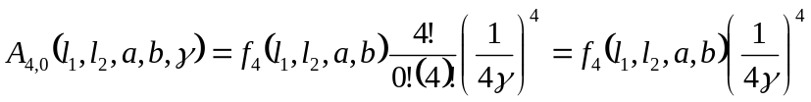
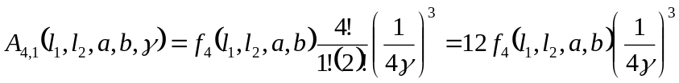
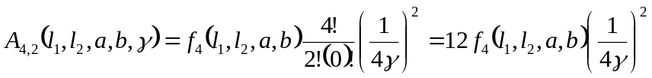

To summarize:
l1+l2 = 0

l1+l2 = 1

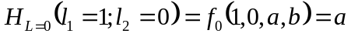
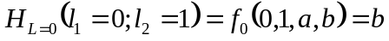
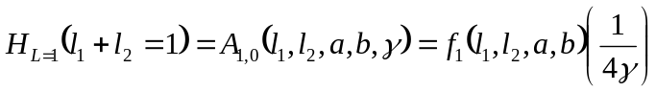
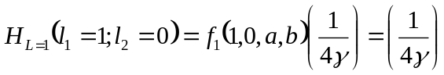
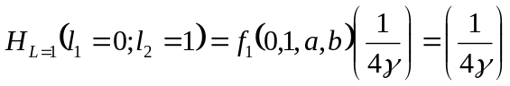

l1+l2 = 2

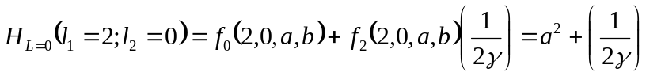
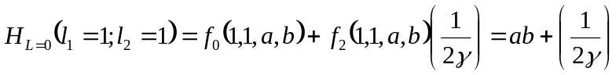
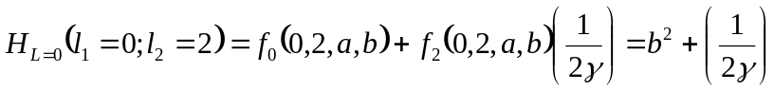

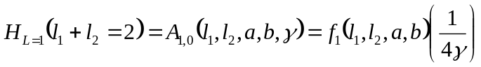
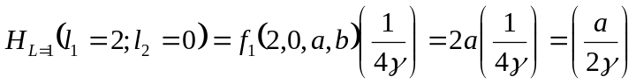
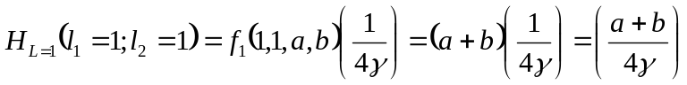
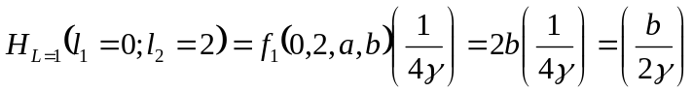

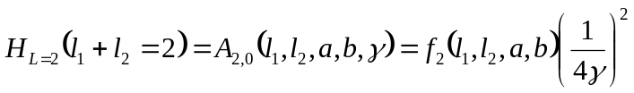
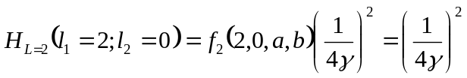
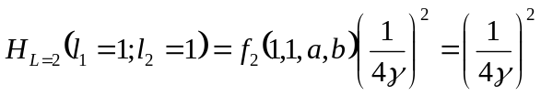
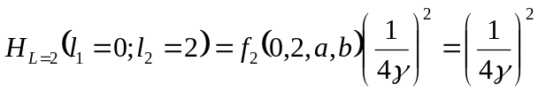

l1+l2 = 3

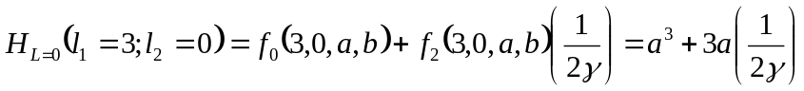

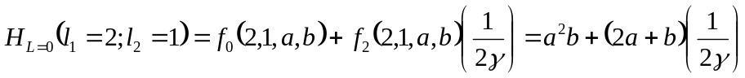
…

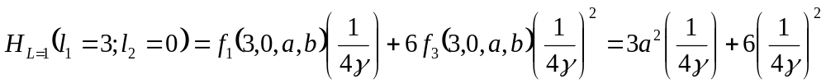
…

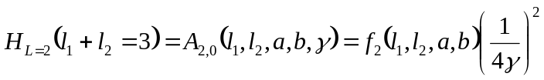
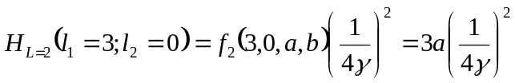
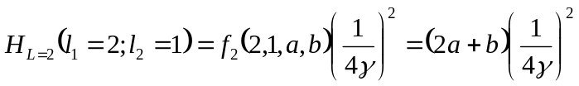
…

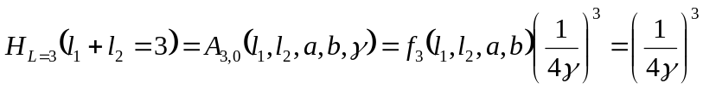

void Aux_Function6(int l1,int l2,int l3,int l4,double PA,double PB,double QC,double QD,double p,double gamma1,double gamma2, vector<double>& G)

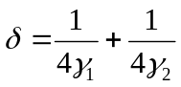

DOS:

“Normalized” Gaussian:
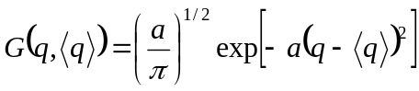,
that is:
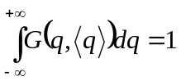
Remember the equality:
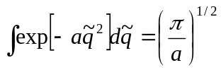

So the function
double dos(double e,double sigma);

computes this:
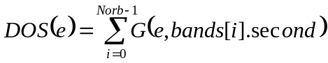,
with 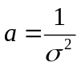

Function void fermi_integrals(double ef (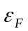),double sigma (),double& Idn,double& Iup);

computes the two sums:
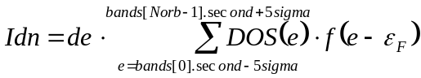
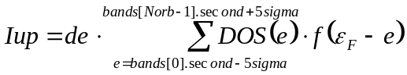
here 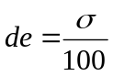- grid spacing

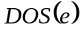 - is described above
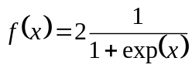 - Fermi distribution, double occupation
- is a guess for the Fermi energy

double System::population(int i,double ef (),double sigma () )

compute the population (occupation number) of orbital i:
Mathematical:
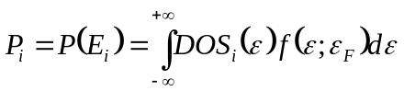
where 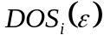- is a density of states due to orbital i (DOS, projected onto orbital i).

Implementation:
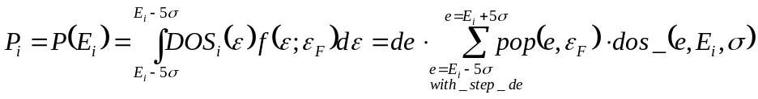,
where
,


