Density matrix in AO basis:

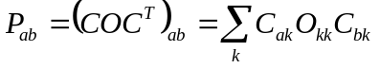

Charge density matrix (population):

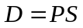

The diagonal elements of D, 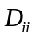, give the population on orbital i – this population comes from states of different energy.
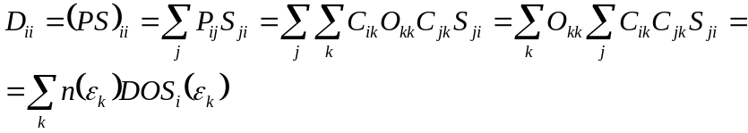

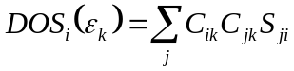 - is the contribution of AO i to the density of states at energy 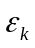. This is an orbital-resolved DOS.

From the additivity of the charge density matrix, we can derive that:

a) for orbitals of given type (type-resolved DOS):

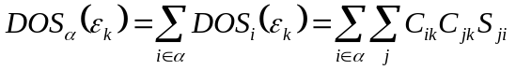

b) for orbitals on given atom A (atomic-resolved DOS):
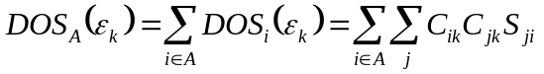

c) for orbitals of given type centered on given atom A (type-and-atomic-resolved DOS):
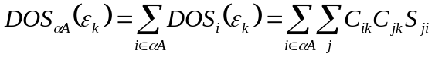

Some additivity rules:
1) 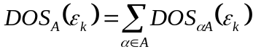 sum of DOS of states of all type with states centered on a given atom gives the atomic-resolved DOS for given atom
2) 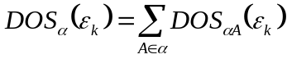 sum of type-and-atomic-resolved DOSs over all atoms gives DOS resolved in the state type
3) total DOS via DOSs of different resolution type

Form 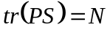 we also get:

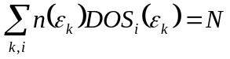total number of electrons, also this can be applied to resolve number of electrons of given type (type of orbital, atom localization, both).

