So, the total energy in HF and semi-empirical methods is given by:
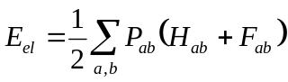

The forces acting on some arbitrary atom is then:
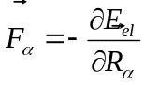.
For simplicity we will omit index in further derivations.
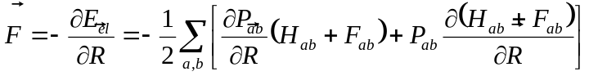
The analytic form of core and Fock matrices is known, so the calculation of the 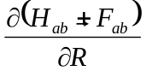term is straightforward. A bit more difficult is a calculation of the 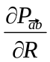term.
Using AO to MO transformation
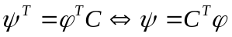

and orthonormality of converged MOs
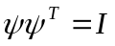,
we obtain:
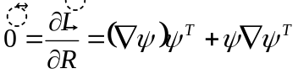,
so:
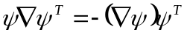
Introducing the definition:
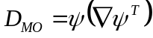,
we get known property:

Introducing
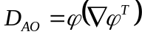 - a matrix of derivative couplings in AO basis
and
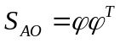- an overlap matrix in AO basis, we obtain:

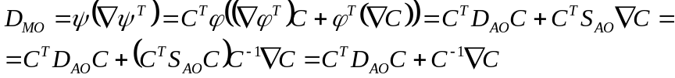

Hartree-Fock-Roothan equations:
Note: although is diagonal, it does not commute with general matrix, so:
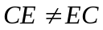
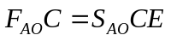

So:

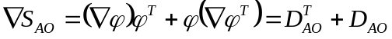,
note that unlike in MO basis, 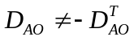

Then:

In the regions far away from surface crossings the quantity 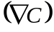is negligible, so the simpler result will hold:
which is practically a Hellmann-Feynmann theorem.

However, for the regions close to the seam, the terms are essential. Without them, the force (for each surface) will be discontinuous.

So we need to know , to evaluate both NAC and gradients.

Differentiating the orthonormality condition in MO basis:
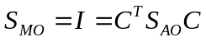

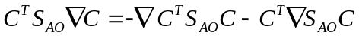
or
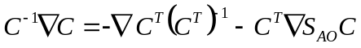

We can see that the equations above are of form:
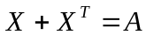,
where 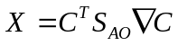- is not-necessarily symmetric, 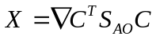 - is also not-necessarily symmetric, but 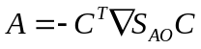is symmetric.
Assuming that 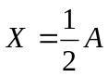,then 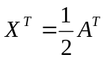, the identity still can be obtained, so 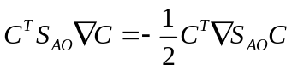is a possible solution
Or, finally:

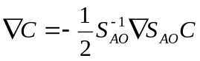
In the case when 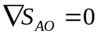this solution leads to 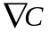,while any anti-symmetric matrix will also be solution for ,such that:
, although zero matrix will also be valid solution.

Also,
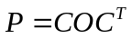
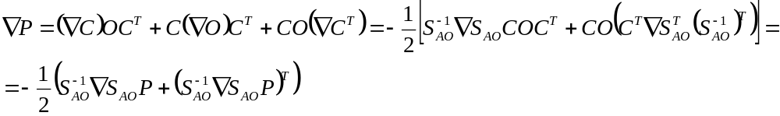
is a symmetric matrix – it is easy to see. Further:

Then:
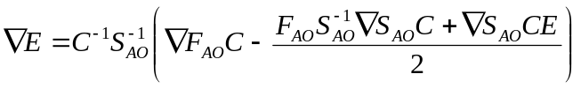
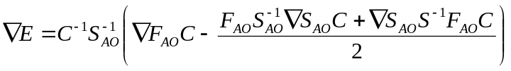
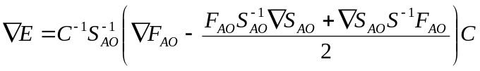
Because of the NDO approximation, the coefficients are determined from the standard (not generalized) Hartree-Fock equation, in which 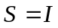.

Then
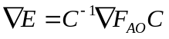

In addition, 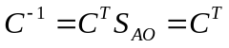.

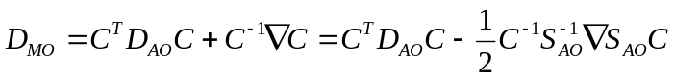
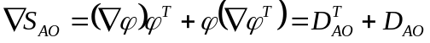

Then:
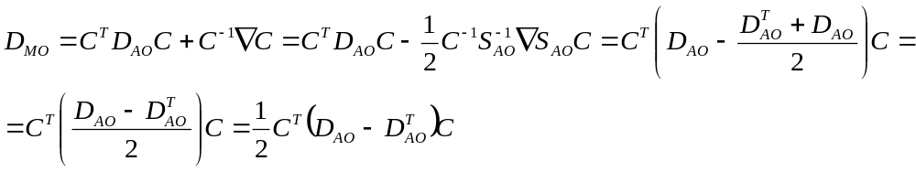

The symmetry of this result becomes obvious
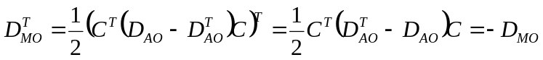

Other formulations of the NAC (DC)¹:
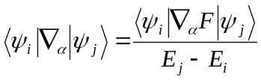

References:
(1) Groenhof, G.; Boggio-Pasqua, M.; Shafer, L. V.; Robb, M. A. Adv. Quantum Chem. 2010, 59, 181–212.

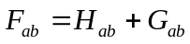
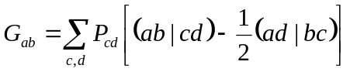
so:
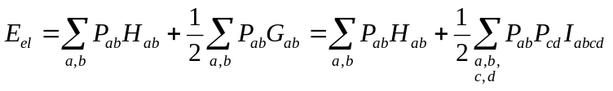
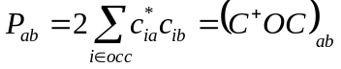

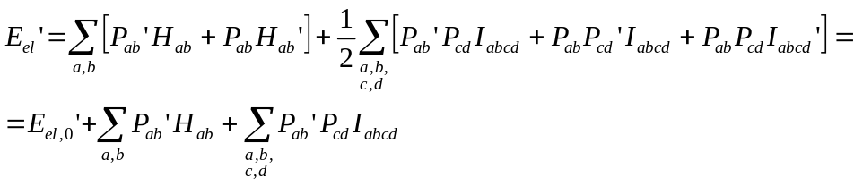
with
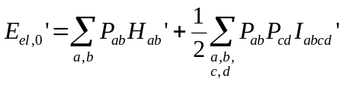
Need to evaluate:

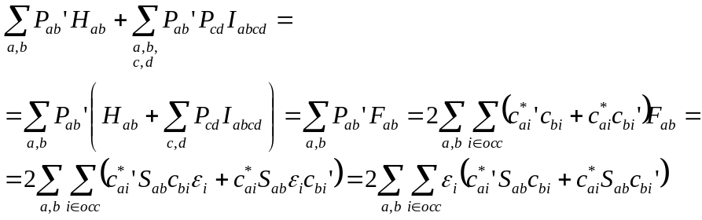

Hmmm… it looks like the correct definition of the density matrix is:

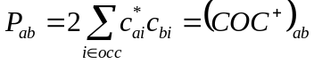

and
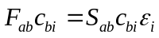

Now we use orthonormality condition:
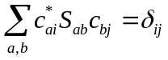, so
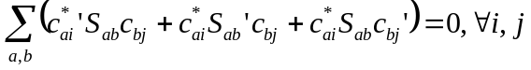

So now:
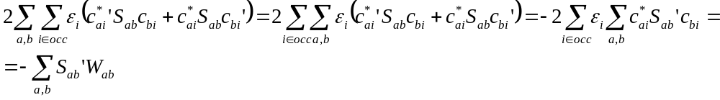
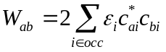

Now specifically for INDO:

For EHT
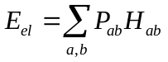
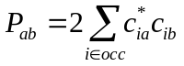
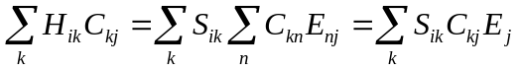
or
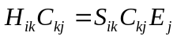 (one of the ways)
