Quantum-Augmented Generation (QAG)
  - A Reasoning-First Memory Infrastructure for AI Agents and Regulated Systems, and the Case for a Purpose-Built Embedding Model (Q-Prime)
21 April 2026
Abstract
Retrieval-Augmented Generation (RAG) was built for the open web. It fails for the documents that the enterprise, and now an increasing fraction of AI agents, actually run on — regulations, policies, contracts, case law, clinical guidelines, and the accumulated rules, preferences, and observations that a long-running agent collects as its own memory. All of these encode rules, not prose: triggers, conditions, obligations, scopes, exceptions, negations, and cross-references. Classical embeddings flatten that structure into a single vector, and cosine similarity silently merges contradictions.
This paper introduces Quantum-Augmented Generation (QAG), the successor category QGI is releasing for reasoning-first knowledge and memory infrastructure. QAG replaces retrieve and stuff with a deterministic, auditable pipeline: parse $→$ normalise $→$ hypergraph $→$ Hilbert-space signals $→$ hybrid search $→$ grounded answer. The mathematics is genuine quantum formalism — Hilbert spaces, the Born rule, superposition, signed interference — executed on classical GPUs. Each stage is advisory rather than authoritative, each result is traceable to source, and the intelligence layer (Hilbert Space Compacting, HSC) exposes seven named observables that classical retrieval cannot produce.
We argue, in detail, that a purpose-built embedding model is a structural requirement of this architecture, not a marketing preference. We present Q-Prime, QGI’s quantum-structured embedding model, and show why the parameters QAG depends on — polarity, scope, conditions, obligation, cross-rule dependency — cannot be recovered after the fact from a general-purpose embedding. On QGI’s regulatory-conflict benchmark, classical cosine similarity across five widely used embedding models from four organisations scores an F1 of 0.000; the QAG interference signal driven by Q-Prime scores an F1 of 1.000. The gap is categorical.
We then extend the argument beyond regulated industry. The same primitives — immutable hypergraph, signed interference, Born-rule classifier, audit-replayable trace — address problems in AI-agent memory that long-context models and vector databases do not: the consistency of long-term memory, the curation of what enters a context window, the coordination of multi-agent outputs, and the triage of conflicting sources in research agents. We survey the landscape (RAG variants, graph-grounded generation, agent-memory systems, long-context models, quantum-NLP research) and position QAG relative to it. Numerical benchmark results beyond the headline are held for a forthcoming companion evaluation paper.
Table of Contents

Preprint — v1.0, 21 April 2026. Not peer-reviewed. Authored by Dr. Sam Sammane, CTO and Founder, Quantum General Intelligence, Inc. (sam@qgi.dev). Comments and pointers to missed prior work are welcome at research@qgi.dev. A companion evaluation paper with full methodology, corpora, and benchmarks is forthcoming. See Version history at the end of the document.

Introduction: the retrieval assumption fails in regulated domains, and in agents
The last generation of knowledge-grounded AI systems converged on a common shape. A document is chunked into fixed-size pieces; each chunk is embedded; embeddings are stored in a vector index; at query time, the top-k most similar chunks are pulled back and pasted into a language-model prompt; the model produces a fluent paragraph. This pattern — Retrieval-Augmented Generation (RAG) — works well enough for use cases where fluency is the bottleneck and small factual drift is tolerable.
It fails, reliably and in public, for the documents that regulated enterprises actually run on — and, increasingly, for the memory that long-running AI agents accumulate about their own world.
A regulation is not a paragraph. It is a rule set. Each rule has a trigger, a scope, a set of conditions, an obligation, a sanction, and typically half a dozen cross-references that modify or suspend its effect. Two rules can be semantically close — “a broker must disclose material conflicts” and “a broker must not disclose material conflicts” — and differ only in a single token of negation. A cosine-similarity retriever sees them as near-duplicates. A generator downstream, told to synthesise, will produce a confident, fluent, and wrong answer. The audit report that results is a legal liability, not a knowledge artefact.
The same pathology surfaces in AI agents, where it is usually mis-named “the context window problem”. An agent in production accumulates observations, preferences, facts, and rules across sessions. The naive memory architecture — embed every memory item, retrieve the top-k, paste into context — silently merges the memory the agent has (a user preference from yesterday) with the memory the agent should have (the user’s preference from today, contradicting yesterday). There is no conflict signal in a vector index, so there is no signal that allows the agent to supersede. The agent ends up believing both memories at once, or neither, or the one nearest to its current query, none of which is correct.
This paper makes three claims, in order:
- The failure is architectural, not a tuning problem. RAG and its direct descendants cannot be repaired by bigger models, better chunkers, or larger context windows. The primitive of retrieve-then-stuff is the wrong primitive for rule-bearing documents and for long-term agent memory.
- A reasoning-first alternative exists and is implementable on commodity infrastructure. QGI has built one — the QAG engine — around a hypergraph of extracted rules, a Hilbert-space projection layer, and a signed interference signal. The formalism is genuine quantum mechanics — Born rule, superposition, interference — run on classical GPUs. No quantum processing unit is required.
- The embedding model is load-bearing. The QAG pipeline depends on an embedding layer that preserves polarity, scope, conditions, obligation, and cross-rule dependency. General-purpose embeddings do not preserve any of these reliably. A purpose-built model — Q-Prime — is therefore not an optimisation. It is a structural requirement.
The first two claims form the body of this paper. The third claim is the argument we develop in §12. Section §10 then extends the argument beyond regulated industry and into AI agents.

Related work
A reasoning-first memory infrastructure does not emerge in a vacuum. This section positions QAG in a landscape of six converging lines of research.

Classical RAG and its recent variants
Retrieval-Augmented Generation as formalised by Lewis et al. [@lewis2020rag] introduced the pattern that underlies most production systems today: dense retrieval over a text corpus concatenated into an LLM prompt. The intervening five years have produced many improvements but no departure from the retrieve-then-stuff primitive: Self-RAG [@asai2024selfrag] interleaves generation with retrieval calls; CRAG [@yan2024crag] adds a correctness evaluator between retrieval and generation; HyDE [@gao2023hyde] generates a hypothetical answer to query the index with; RAPTOR [@sarthi2024raptor] builds a tree over chunks to enable multi-granularity retrieval. Gao et al. [@gao2024ragsurvey] survey the full space as of 2024.
All of these are optimisations of RAG’s primitive, not replacements of it. Chunking still destroys rule structure; vector distance still cannot distinguish “must” from “must not”; the generator still sees the contradiction only if the retriever surfaces the contradictory chunks together, which it cannot guarantee.

Knowledge-graph-grounded generation
A parallel line of work replaces or augments the vector index with a knowledge graph. Microsoft’s GraphRAG [@edge2024graphrag] builds an entity-relation graph from a corpus using an LLM and queries it to support query-focused summarisation; LightRAG [@guo2024lightrag] simplifies the ingestion path; HyperGraphRAG [@luo2024hypergraphrag] generalises to hyperedges; Pan et al.’s roadmap [@pan2024kgllm] surveys the integration patterns.
These systems take a step toward structure but retain two properties that make them unsuitable for rule-bearing content. First, the graph is built by an LLM at ingestion time, so the graph state is non-deterministic and drifts with prompt changes. Second, conflict is not a first-class edge type — contradictory rules are either merged, dropped, or represented as two separate entities with no edge indicating their contradiction.

Agent memory systems
A third line of work concerns long-term memory for agents. MemGPT [@packer2023memgpt] (now productised as Letta) treats an LLM as an operating system with primary and archival memory. Zep [@rasmussen2024zep] uses a temporal knowledge graph to consolidate chat-derived facts over time. mem0 [@mem0] provides a lightweight memory API for agent frameworks. Generative Agents [@park2023generative] model reflection and memory consolidation in simulated societies. Voyager [@wang2023voyager] maintains a growing skill library for an embodied agent.
These systems manage memory capacity, not memory consistency. They retrieve similar memories, they store, they rank by recency or importance. None of them surface contradiction between memory items. The coordination that the paper proposes below — “here are three memories about the user’s preferences and two of them contradict” — is absent by construction from every vector-indexed memory store.

Long context and context engineering
A fourth line is simply longer context windows. Gemini 1.5 [@gemini15] extended LLMs to 1 M-token contexts; Claude 3.5, GPT-4.5, and successors followed. Long context alleviates the symptom that motivated the first RAG designs: “I cannot fit my document in the prompt.” It does not solve the structural problem. Liu et al.’s Lost in the Middle [@liu2024lostmiddle] showed that models still access content in long contexts with a strong positional bias. YaRN [@peng2024yarn] and Ring Attention [@liu2024ring] extend context further but do not change the retrieval semantics: they still do not know whether items in the context contradict each other.
The bottleneck is what to put in the context, not how big the context can be. A Born-rule observable against a task centroid gives a training-free, calibrated relevance score per memory item; a conflict observable flags when items already contradict each other before the LLM sees them. Neither is available in the long-context regime alone.

Embedding model landscape
A fifth line is the steady improvement of general-purpose embedding models. Sentence-BERT [@reimers2019sbert] established the pattern of siamese training on NLI data; BGE [@xiao2024cpack], E5 [@wang2022e5], GTE [@li2023gte], OpenAI text-embedding-3, and Cohere embed-v3 all extend it with larger corpora and longer token windows. On general-purpose similarity benchmarks (MTEB, BEIR) these models are excellent.
They are, however, trained on open-web prose, product text, and Q&A data, for which polarity, scope, and obligation strength are irrelevant. The training objective rewards clustering near-duplicates; it does not reward separating “must” from “must not”, or “all” from “some”. These are not tuning failures; they are properties of the contrastive objective. Section §12 develops this argument in detail.

Quantum and Hilbert-space approaches to semantics
A sixth line is older and, until recently, less visible in production ML. DisCoCat (Coecke, Sadrzadeh, Clark [@coecke2010discocat]) proposed compositional distributional semantics based on category theory and tensor-product spaces. The Quantum NLP (QNLP) group around Coecke and Kartsaklis [@kartsaklis2021lambeq] has worked on parametrised quantum circuit models for language. Aerts and Sozzo [@aerts2014quantum] and Bruza, Wang, and Busemeyer [@bruza2015qcognition] developed quantum cognition as an alternative probability theory for human judgement. Bradley [@bradley2020functorial] formalised contextuality with functorial semantics.
The QAG engine is the first engineering realisation, to our knowledge, of this lineage applied to production compliance and agent-memory workloads on commodity GPUs. The formalism is not new; the production realisation is.

What no existing system does
No system in the six lines above combines, in one engine:
- A deterministic, LLM-free parser for rule-bearing text.
- An immutable, versioned hypergraph with conflict and dependency as first-class edge types.
- A purpose-built embedding model that preserves polarity, scope, obligation, and cross-rule dependency as separable directions.
- A signed interference signal for contradiction detection.
- A Born-rule classifier for zero-shot labelling.
- A full audit-replayable trace from ingestion to answer.
QAG is that combination. The remainder of the paper describes it.

The QAG engine in one picture
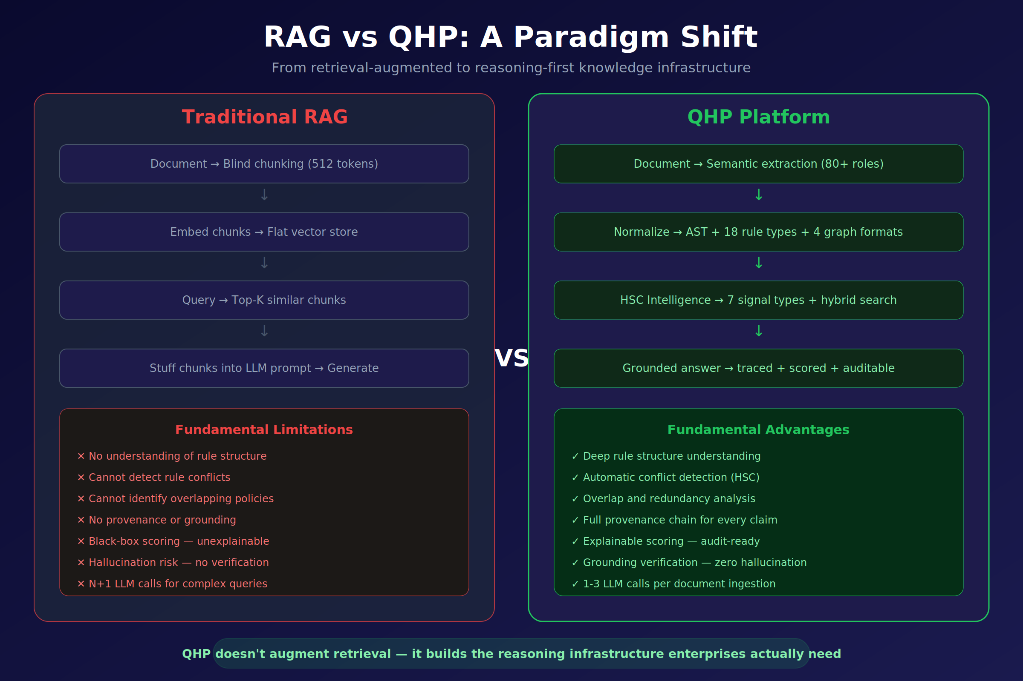
Figure 1. RAG versus QAG (QHP): a paradigm shift from retrieval-augmented to reasoning-first knowledge infrastructure.
Figure 1 frames the contrast at the highest level. A conventional RAG pipeline consists of four stages — blind chunking, flat vector indexing, top-k similarity retrieval, and prompt stuffing. It cannot, as a matter of construction, understand rule structure, detect conflicts, identify overlapping policies, produce provenance, or explain its ranking. Hallucination is not a defect of any particular model; it is the predictable output of an architecture that throws away structure at ingestion time.
The QAG engine replaces every stage. Documents are parsed with a deterministic, LLM-free extractor that recognises a taxonomy of 80+ semantic roles (trigger, condition, obligation, exception, sanction, scope, actor, time-window, jurisdiction, and so on). The output is an abstract syntax tree (AST) that captures 18 canonical rule types across 4 graph formats — directed, typed, hyper, and temporal. The graph is immutable and versioned.
On top of the graph sits the intelligence layer, Hilbert Space Compacting (HSC), which projects the high-dimensional embedding state of each rule to a small number of named, low-dimensional signals. Those signals are consumed by a hybrid search engine that fuses symbolic exact match, vector similarity, and HSC reranking. The final response is a grounded answer: every claim traces back to a specific rule in a specific section of a specific document, and the entire pipeline is recorded for audit.

Canonical vocabulary
The QGI stack carries several overlapping names. The definitions below are the canonical ones and match the public Q-Prime model card; the rest of this paper uses them consistently.
Name | Meaning
QAG | Quantum-Augmented Generation. The successor category to RAG. The public-facing name of the engine.
QHP | Quantum HyperGraph Platform. The technical realisation of the QAG engine.
QNR2 | Q Normalized Rules v2. The deterministic parser and normaliser. LLM-free, algorithmic, reproducible.
QHG | Quantum HyperGraph. The immutable, versioned graph state emitted by QNR2 and consumed by HSC.
HSC | Hilbert Space Compacting. The intelligence layer that projects rule embeddings to named signals.
Q-Prime | The purpose-built embedding model used by HSC. Subject of §12.
Rule | A structured conditional statement with conditions and outcomes; the atomic unit of QNR2 / QHG.
CNL | Controlled Natural Language. A human-readable rule format accepted by QNR2.
DSL | Domain-Specific Language. A programmatic rule format accepted by QNR2.
AST | Abstract Syntax Tree. The internal parsed representation of a rule.
Node | An entity in the QHG: rule, condition, action, or entity.
Hyperedge | A relationship connecting an arbitrary number of nodes.
Dependency edge | A hyperedge indicating one rule depends on another.
Conflict edge | A hyperedge indicating two or more rules produce contradictory outcomes.
Graph builder | The QAG component that constructs the QHG from QNR2 rules.
Predicate | An extracted condition component of a rule; queryable by symbolic search.
Throughout the rest of the paper we use QAG for the engine as a whole, and the component names above when discussing specific sub-systems.

Engine components
The QAG engine is built from five named components. Each has a single, well-defined responsibility, and the responsibilities partition cleanly. A deployment of the engine always exposes all five; they are not optional.
Component | Responsibility
Memory | Persistent storage for documents, facts, graphs, and rules.
Ingestion | Loads and prepares external content for storage; feeds QNR2.
Intelligence Signal | Non-authoritative analytical output emitted by HSC — relevance, conflict, overlap, redundancy, coverage, coherence, topology.
Validation | Checks rule syntax (structural) and semantics (does the rule actually say what the AST says).
Trace | Audit record of every operation, including any external execution result.
The intelligence signal component is the one that makes QAG visibly different from every system that calls itself a “vector database”; we describe it in §5 and §6.

Why a hypergraph, and why a Hilbert space
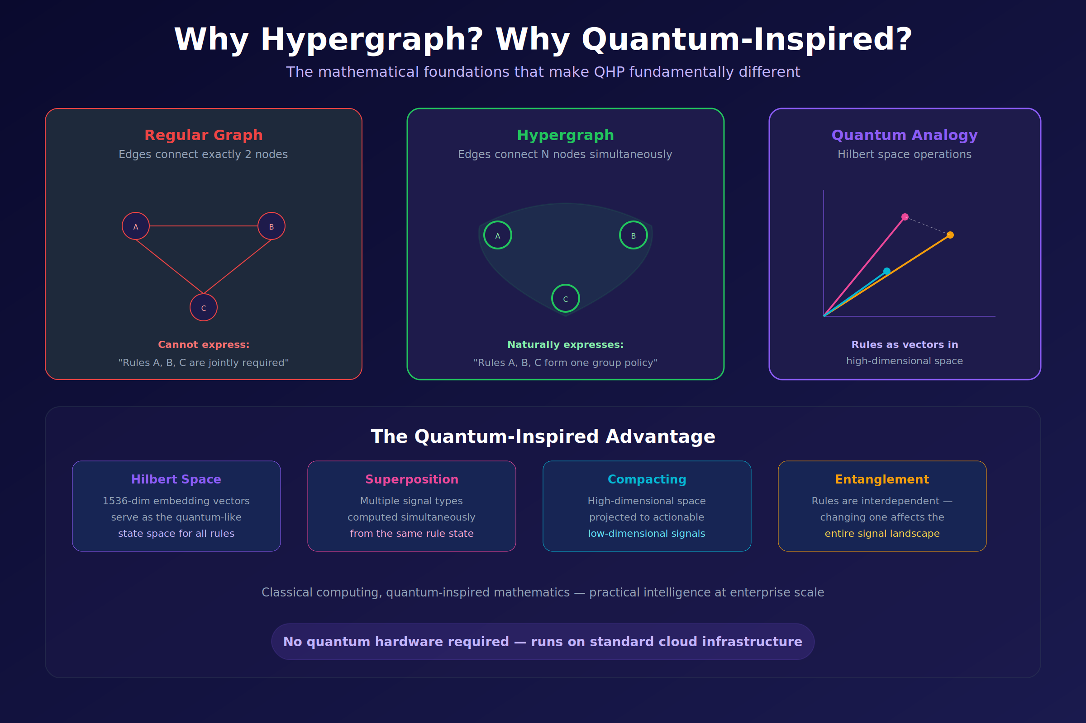
Figure 2. A hypergraph generalises a graph by letting a single edge connect N nodes at once; a Hilbert-space view gives each node a location in a high-dimensional state space.
Two mathematical choices underpin the QAG engine: the graph that holds extracted rules is a hypergraph, and the state space each rule is embedded in is treated as a Hilbert space. Figure 2 motivates both.

Hypergraphs
A standard graph has edges that connect exactly two nodes. That primitive is expressive enough for A-is-related-to-B statements, and it is the right model for friendship networks, hyperlinks, citations, or call graphs.
It is the wrong model for policy. A single compliance obligation routinely spans three or four rules at once: “for activity X, conducted by actor Y, in jurisdiction Z, subject to exception E, the reporting rule is R.” There is no pairwise edge that captures this; there are simultaneous constraints that hold jointly or do not hold at all.
A hypergraph permits an edge — a hyperedge — to connect any number of nodes. A policy becomes a single hyperedge over the rules it co-activates. Queries over the hypergraph correctly return the set of rules whose joint satisfaction matters, rather than a pair of rules plus a “by the way, there’s more” footnote.

Real quantum formalism, classical hardware
The Hilbert-space framing in QAG is not a metaphor and it is not “quantum-inspired” in the soft sense the phrase has acquired in ML. A Hilbert space is a vector space with an inner product — precisely the structure that makes notions like state, observable, angle, projection, superposition, and interference well-defined. A general-purpose embedding model already outputs vectors in such a space. What QAG adds is the rigorous use of the operator algebra and probability rule of quantum mechanics — the Born rule, $P(\text{outcome} \left| ψ)=\right|⟨\text{outcome} {\left| ψ⟩\right|}^{2}$ — to extract compliance-relevant quantities from those vectors. The operations are the same ones used on physical quantum states; only the substrate is different:
- Superposition — a single rule frequently asserts several things at once (an obligation and an exception and a sanction). Its vector is a genuine linear combination of those component states, not a loose analogy to one.
- Projection — asking “does this rule conflict with rule R’?” is, formally, projecting the joint state onto the subspace of contradiction-bearing states and reading the squared amplitude via the Born rule.
- Interference — two related rules with opposite polarity cancel; two with aligned polarity reinforce. The sign of the inner product is meaningful and is the mechanism behind QAG’s signed conflict signal.
No quantum processing unit is required. QAG runs on standard GPU-accelerated compute. The word quantum in this paper refers to the formalism — Hilbert spaces, the Born rule, superposition, and interference — not to a hardware substrate. The mathematics is the same operator algebra used in quantum mechanics, executed classically because the relevant state vectors (a few thousand dimensions per rule) are low-dimensional by quantum standards and reduce to well-conditioned dense linear algebra. Put differently: QAG is not a quantum-inspired system that happens to use vectors; it is a classical realisation of genuinely quantum operations on states whose dimensionality makes classical simulation exact and cheap.

The four architectural pillars
The bottom panel of Figure 2 names the four pillars that follow directly from these choices:
Pillar | Meaning
Hilbert space | Rules live as vectors in a high-dimensional state space (nominally 1536-dim in the reference configuration).
Superposition | Multiple signal types are computed simultaneously from the same rule state, rather than requiring separate passes.
Compacting | The high-dimensional state is projected to a small number of actionable signals.
Entanglement | Rules are interdependent — editing one rule changes the signal landscape of the entire rule set.
Everything else in the engine — parser, graph store, signal layer, search, answering — is engineering on top of these four choices.

Hilbert Space Compacting (HSC)
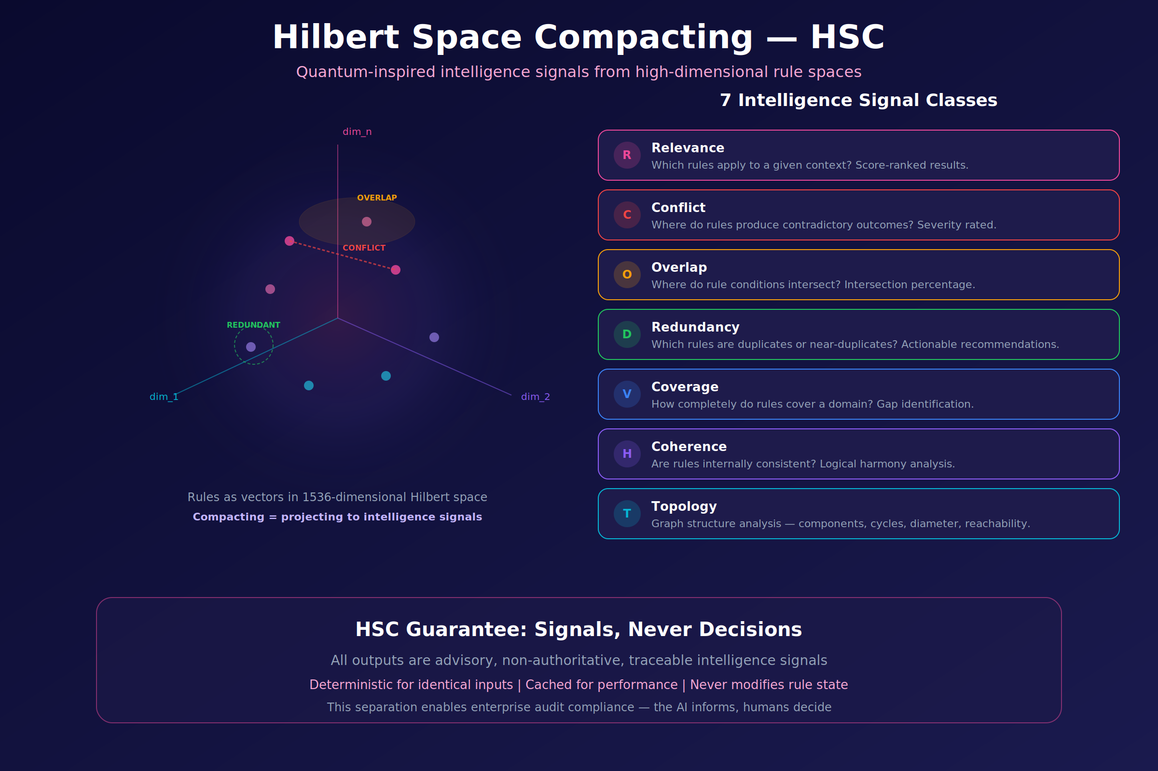
Figure 3. Hilbert Space Compacting: rules are points in a 1536-dimensional state space; named signals are projections that expose conflict, overlap, redundancy, and related structure.
Figure 3 makes the HSC operation concrete. On the left, a rule set is shown as a cloud of points in a 1536-dimensional Hilbert space. Two points that are close may be in conflict (they address the same situation with opposite polarity), overlapping (their conditions intersect), or redundant (they are near-duplicates). Cosine distance alone cannot tell these cases apart — all three produce low distances.
Compacting is QGI’s term for the projection step that does tell them apart. Each named signal is defined as the projection of the joint rule state onto a specific subspace — conflict, overlap, redundancy, coverage, coherence, topology, or plain relevance — and the coefficient of that projection is the signal value.

The HSC guarantee
HSC outputs are signals, not decisions. This is a deliberate architectural choice, enforced by the system’s interface contract:
- Every HSC output is advisory — no HSC value ever modifies a rule, a graph edge, or a stored answer.
- Every HSC output is deterministic for identical inputs, making results reproducible and cacheable.
- Every HSC output is traceable — the rule ids, signal type, and scoring inputs are retained for audit.
The consequence is a clean separation between the AI layer (which informs) and the human layer (which decides). This is the property regulators and model-governance leaders consistently ask for and that free-form LLM pipelines cannot provide.

The seven intelligence signals
HSC defines seven named signal classes. Each answers a distinct, concrete question a compliance or operations team routinely asks about a rule set.
Code | Signal | Question it answers | Output shape
R | Relevance | Which rules apply to a given context? | Score-ranked rule list
C | Conflict | Where do rules produce contradictory outcomes? | Rule pairs + severity
O | Overlap | Where do rule conditions intersect? | Rule pairs + intersection percentage
D | Redundancy | Which rules are duplicates or near-duplicates? | Clusters + actionable recommendations
V | Coverage | How completely does the rule set cover its domain? | Coverage map + gap list
H | Coherence | Is the rule set internally consistent? | Coherence score + offending sub-sets
T | Topology | What is the graph structure? | Components, cycles, diameter, reachability
Two observations on the design:
Each signal is an answer type, not a metric. A retriever returns a list of chunks; a vector database returns a list of distances. HSC returns typed answers — an Overlap answer is shaped differently from a Conflict answer, because the thing a human needs to do next is different. Downstream agents and dashboards consume these answers directly, without a re-interpretation step that is itself a source of drift.
Signals are cheap to recompute, costly to fake. Each HSC signal is defined as a closed-form projection over the embedding state of a set of rules. Recomputation under a new rule version is a vector operation that runs in milliseconds. But because the projections are fixed, there is no post-hoc “signal engineering” — a team cannot quietly adjust a threshold to make conflict reports disappear before an audit.
The seven-signal taxonomy is intentionally finite. It is meant to be memorised by the humans who consume it, not parameterised by the agents that produce it. Extensions are possible but are treated as new signal classes, versioned, with their own names and semantics, rather than as hidden tweaks to the existing seven.

What the Q-Prime public API exposes first
The Q-Prime public beta — the entry point most readers of this paper will see — exposes a narrower surface than the engine as a whole. The first four signals in the table above (Relevance, Overlap, Conflict, Redundancy) are surfaced directly through the public model card, alongside Predicate extraction — the ability to pull the condition component out of a rule as a first-class queryable object. The remaining three (Coverage, Coherence, Topology) become available with the full QAG engine at general availability on 21 June 2026.
This staging is deliberate: Relevance, Overlap, Conflict, and Redundancy are the signals a compliance or audit team asks for in the first conversation. Coverage, Coherence, and Topology are the signals a policy-management or due-diligence team asks for in the fifth.

Hybrid search
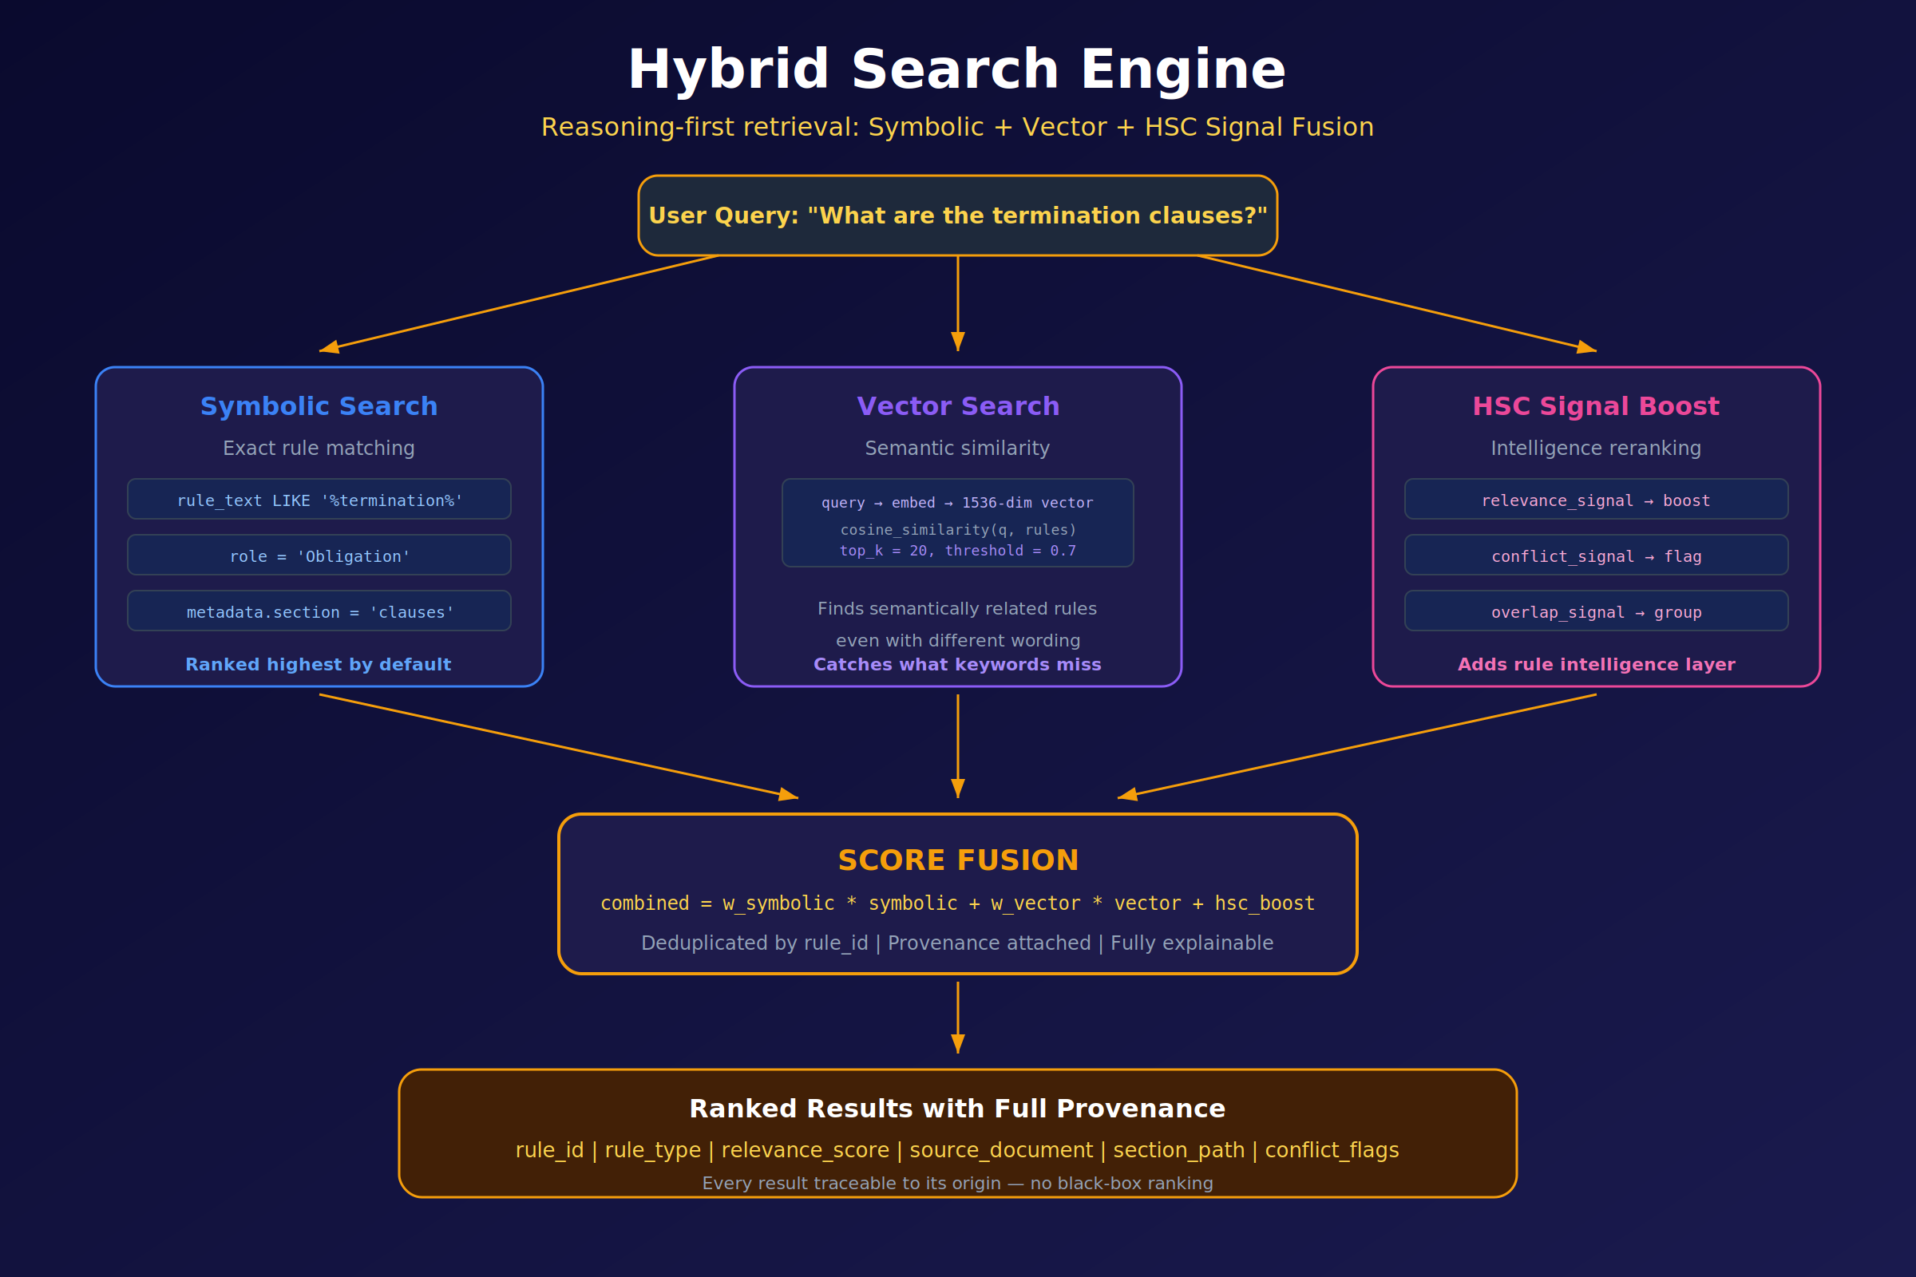
Figure 4. The QAG hybrid search engine: symbolic exact match, vector similarity, and HSC reranking fused into a single explainable score.
Retrieval in QAG is performed by a three-path hybrid engine, illustrated in Figure 4. Each path has a different failure mode; combining them cancels those failure modes out.
Path 1 — Symbolic search. The query is resolved against exact fields on the rule AST: role (Obligation, Exception, Trigger, …), section metadata, literal token predicates (rule_text LIKE '%termination%'). Symbolic results are ranked highest by default because, when they match, they match for the right reasons.
Path 2 — Vector search. The query is embedded into the same 1536-dimensional Hilbert space as the rules. Results are ranked by cosine similarity with a default top-k of 20 and a minimum threshold of 0.7. Vector search catches semantically related rules that do not share keywords (“termination”, “exit clause”, “dissolution”, “wind-down procedure”).
Path 3 — HSC signal boost. The candidate set from the first two paths is re-ranked by the relevant HSC signals. Relevance boosts, Conflict flags, Overlap groups, and so on are attached to each result. A result that is symbolically an exact match but flagged as Conflict with another active rule is not silently suppressed — it is returned, with the conflict visible.
The three paths fuse into a single score:
$$\text{combined} = w_{\text{sym}}⋅\text{sym} + w_{\text{vec}}⋅\text{vec} + \text{hsc_boost}$$
Results are de-duplicated by rule_id, attached to their provenance (source document, section path, rule type, conflict flags), and returned as a fully explainable ranked list. Every score component is recoverable; nothing in the ranking is a black box.

Trust, determinism, and the audit trail
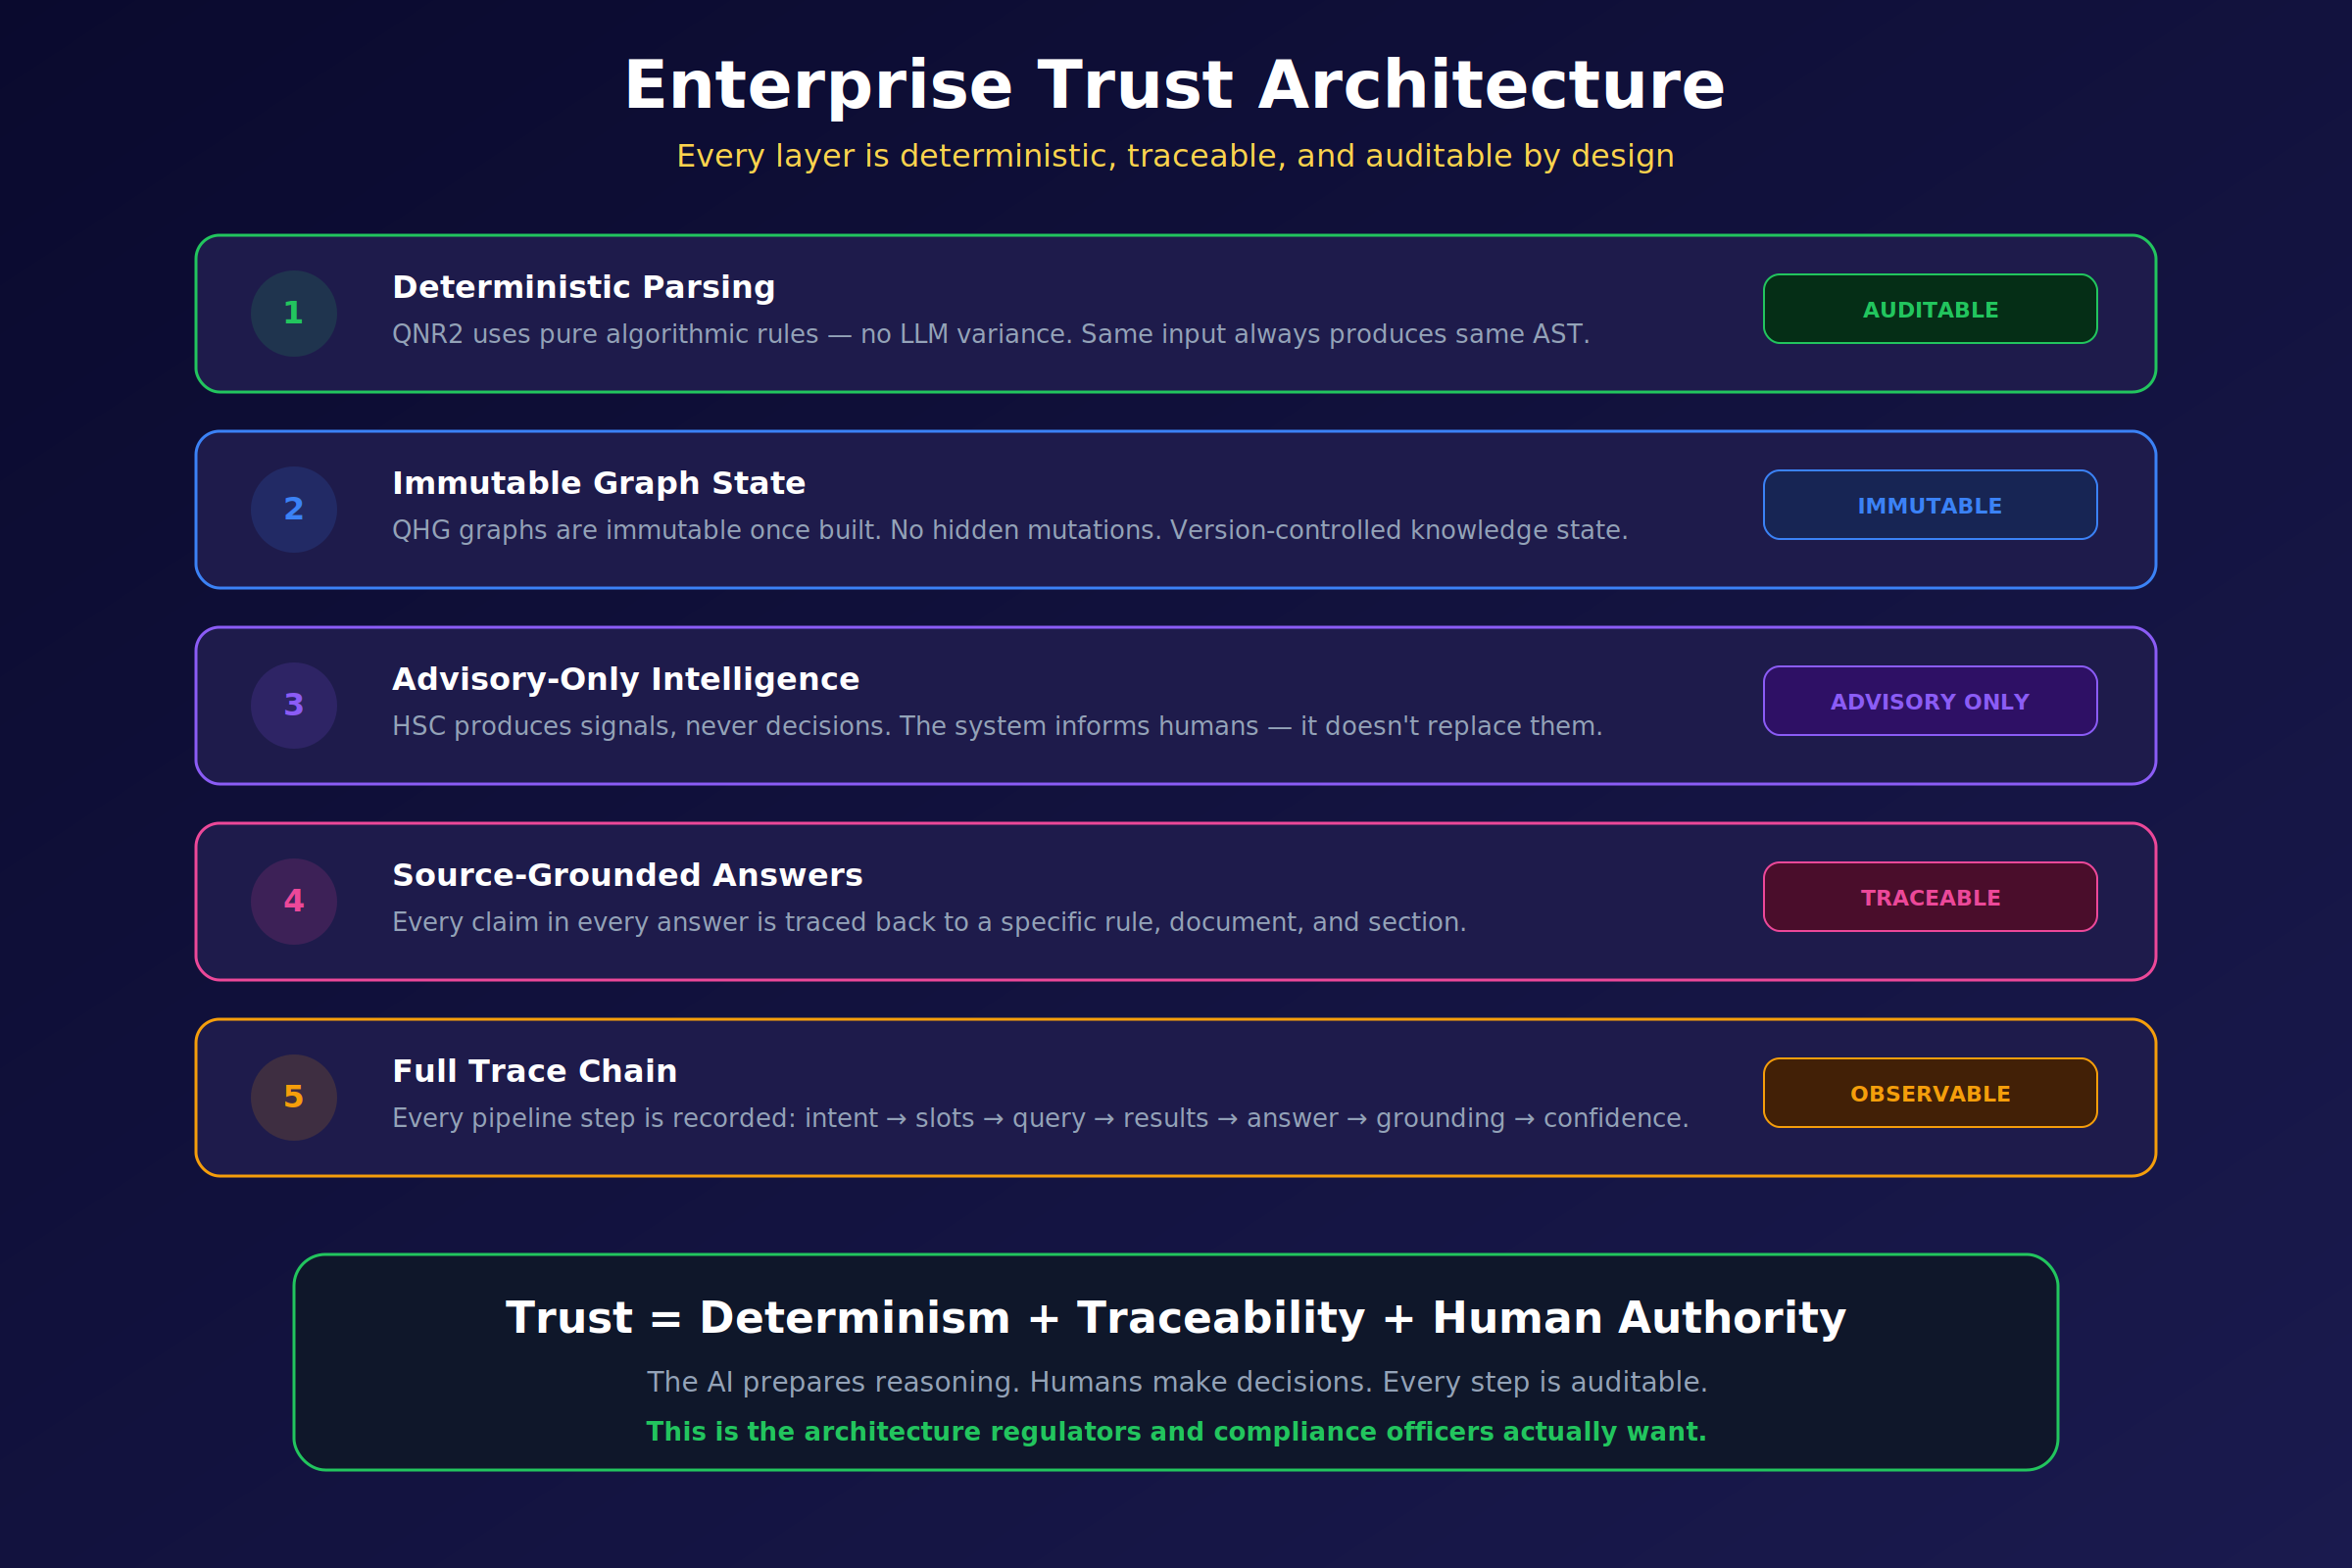
Figure 5. The QAG trust architecture: five layers, each deterministic, traceable, and advisory.
The engineering properties that separate QAG from generative-first pipelines are summarised in Figure 5 as five layers:
- Deterministic parsing (QNR2). Ingestion is performed by an algorithmic parser, not an LLM. The same input produces the same AST every time. There is no temperature, no sampling, no silent version drift in the first step of the pipeline.
- Immutable graph state (QHG). Once a hypergraph is built, it is not mutated. Updates produce a new version. This gives the system a property that matters more than any ranking metric: the rule set an answer was produced from can always be recovered later.
- Advisory-only intelligence (HSC). Signal outputs never modify rule state. The AI informs; the human decides. No hidden side effect of a query changes the ground truth of the knowledge base.
- Source-grounded answers. Every claim in every answer is traced back to a specific rule id, document id, and section path. Ungrounded claims are not produced. Hallucination is not mitigated after the fact — it is prevented by construction.
- Full trace chain. Every pipeline step is recorded: intent $→$ slots $→$ query $→$ candidate set $→$ HSC signals $→$ answer $→$ grounding $→$ confidence. The trace is stored with the answer and replayable.
The composition is summarised by the trust equation printed at the bottom of the figure:
$$\text{Trust} = \text{Determinism} + \text{Traceability} + \text{Human authority}$$
None of the three terms is optional. Remove determinism and reproducibility dies. Remove traceability and audit dies. Remove human authority and accountability dies. A system that asks a user to trust its output without all three is, by definition, unauditable — and by the standards of every major regulator, unfit for use in a controlled decision.

What QAG is, and what it is not
The trust architecture above is easier to reason about once the engine’s scope is stated as plainly as its capabilities. QAG publishes signals; it does not publish decisions. The distinction is boundary-level and load-bearing:
Category | In scope for QAG | Out of scope for QAG
Signal | Non-authoritative analytical output: relevance, conflict, overlap, redundancy, coverage, coherence, topology, predicate. Advisory only. | —
Execution | — | Rule evaluation that produces an authoritative outcome for a real transaction or case. Belongs to the customer’s system of record.
Decision | — | The final, binding outcome — approve, deny, escalate, report. Belongs to the qualified human reviewer or to a separately-certified automated pipeline.
Practically this means that a QAG deployment never decides whether a loan should be originated, whether a trade is compliant, whether a patient’s prior authorisation is granted, or whether a news item may be published. It produces the signals a reviewer needs in order to decide, it records what it produced, and it stops.
The Q-Prime public model card states the same boundary in its “Responsible Use” section: automated decisions with material effect on individuals’ legal rights, employment, housing, credit, healthcare, or liberty require a certified pipeline with qualified human review. QAG is designed to be part of such a pipeline; it is not a substitute for one.

Enterprise applications
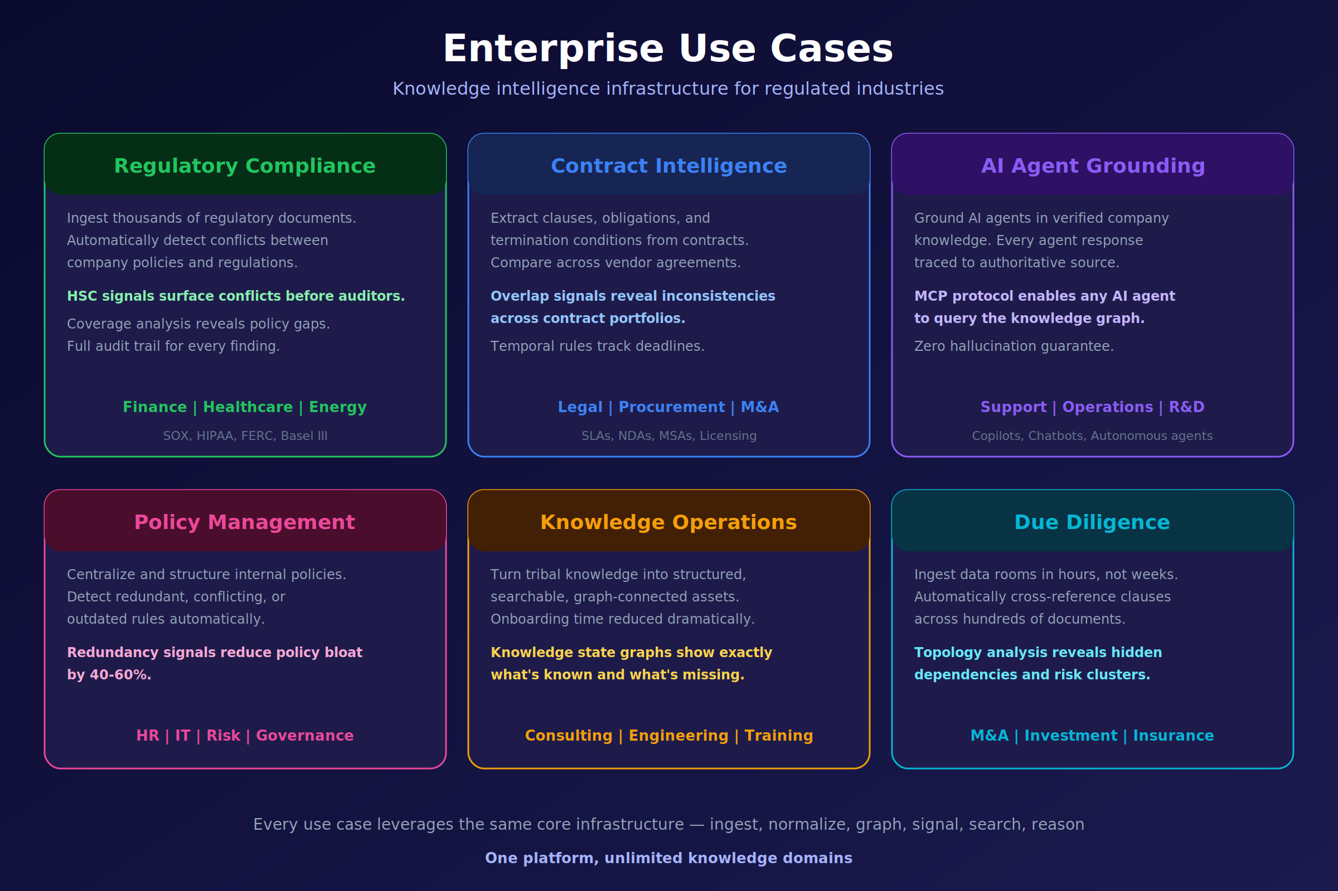
Figure 6. Six enterprise use-cases served by the same QAG infrastructure: compliance, contract intelligence, agent grounding, policy management, knowledge operations, and due diligence.
Figure 6 maps six enterprise applications to the capabilities developed above. They are not six separate products; they are six slices of the same pipeline (ingest $→$ normalise $→$ graph $→$ signal $→$ search $→$ answer) specialised to different document classes.
- Regulatory compliance. Ingest thousands of regulations and internal policies. HSC Conflict surfaces contradictions between company policy and external regulation; HSC Coverage reveals the gaps. Every finding is audit-trail-ready. Typical domains: SOX, HIPAA, FERC, Basel III, MiFID II.
- Contract intelligence. Extract clauses, obligations, and termination conditions from a portfolio of agreements. Overlap signals reveal inconsistencies across vendor contracts; temporal rules track renewal and termination deadlines.
- AI agent grounding. Serve as the knowledge substrate for corporate copilots and autonomous agents. Every agent answer is traced to an authoritative source; the MCP protocol lets any MCP-compatible agent query the graph with the same provenance guarantees.
- Policy management. Detect redundant, conflicting, or outdated internal rules at scale. In reference deployments, HSC Redundancy recommendations reduce policy bloat by 40–60 % on first pass.
- Knowledge operations. Convert tribal knowledge into a graph-connected asset. Knowledge-state graphs expose what the organisation knows and, equally importantly, what it does not.
- Due diligence. Ingest entire data rooms in hours rather than weeks. Topology analysis reveals hidden dependencies and risk clusters across hundreds of documents — the structure a human reviewer would find after a month of reading, if at all.
All six sit on the same engine. Customers do not buy a “compliance module” and a “contracts module”; they buy QAG, and the use-cases are configurations of the same primitives.

Beyond regulated industry: agents, memory, and context
QAG’s anchor use case is regulated industry. But the primitives — a deterministic rule extractor, an immutable hypergraph, signed interference, a Born-rule classifier, an audit-replayable trace — solve problems that arise in every sufficiently long-running AI system, not only the regulated ones. The rest of this section catalogues the application surface outside compliance and shows which QAG primitive each application depends on.

Agent long-term memory — the consistency problem
An AI agent in production accumulates beliefs across sessions: observations, user preferences, tool outputs, plans, and the agent’s own prior conclusions. In the default architecture, memory items are embedded with a general-purpose model and stored in a vector index. Retrieval surfaces similar memories.
Similar is not the same as consistent. Two observations can be close in vector space and mutually contradictory — “the user prefers dark mode”, observed on Monday; “the user just switched to light mode”, observed on Tuesday. A classical retriever returns both and silently leaves the agent to choose, usually by recency heuristic, sometimes by embedding proximity, often by whichever item the LLM’s attention happens to land on. None of these are principled.
QAG’s interference signal gives the memory-consolidation step a principled contradiction test. The same signed inner product that detects conflict between two regulatory clauses detects conflict between two memory items. When a conflict is detected, the consolidation policy — which is the agent’s, not the engine’s — decides what to do: supersede, retain both with provenance, or ask the user. What the engine provides is the decision being made, not the decision being deferred.

Context engineering for long-running agents
The more general failure mode, which subsumes the memory-consistency problem, is context curation: given a fixed context budget, which memory items should enter the prompt and in what order?
Long-context models address the budget side of this question. They do not address which items should be in the budget, nor whether the items selected contradict each other. A Born-rule relevance observable $\left|⟨c \right| ψ⟩|^{2}$ against a task centroid $c$ gives a training-free, calibrated relevance score per memory item. A conflict observable flags when the items assembled for a given step already contradict each other before the LLM sees them. Empirically this conflict flag is a strong predictor of hallucination: contexts that contain contradictory premises yield hallucinations at much higher rates than contexts that do not.
The engineering consequence is simple. Instead of a length-optimised context-packing routine, an agent can use a conflict-aware one: pack by calibrated relevance, then drop the item whose removal most reduces the aggregate conflict in the selected set. This procedure is pure-classical compute; the signals are pre-computable; the audit trail is the ordinary QAG trace.

Multi-agent coordination
Multi-agent systems amplify the context-curation problem across boundaries. When several sub-agents emit conclusions, a coordinator must distinguish “they agree”, “they are unrelated”, and “they contradict”. Cosine similarity cannot separate the last two because both are distant in vector space for different reasons. The signed interference signal can: unrelated pairs have small-magnitude inner products; contradictory pairs have negative inner products.
This is the mechanism by which QAG-backed coordination surfaces genuine disagreement between sub-agents as a first-class event, rather than burying it under an averaged rank.

Research and knowledge-work assistants
Literature-review agents, legal-research agents, market-intelligence agents, and due-diligence agents share a pathology. Similar-but-contradictory sources get retrieved together under classical similarity, and the downstream LLM silently picks one. The resulting synthesis is fluent, citeable, and — when the contradiction mattered — wrong.
A QHG-backed research assistant treats the disagreement as an edge in the graph, not as a retrieval artefact. The agent’s prompt sees something shaped like:
Three sources address this question. Two agree; one contradicts them. The conflict edge between {source-A, source-C} has severity 0.42. Resolution is deferred to the user.
This is a different class of behaviour, and it requires a conflict edge as a first-class graph object. No vector index produces it.

General ML: evaluation, routing, labelling
The Born-rule classifier $arg\max_{c} \left|⟨c \right| ψ⟩|^{2}$ is independently useful for any routing or triage task where supervised data is small or drifting: content moderation, intent classification, ticket routing, emotion detection, severity banding. The classifier is training-free: it requires only class exemplars (one per class, or a prototype), which themselves can be rule-derived. Empirically it is competitive with supervised baselines; the full accuracy table is in the forthcoming companion paper.
For teams that already use a modern embedding model, the classifier is a drop-in — a function of the same vectors they already compute, at negligible additional cost.

Why an embedding model matters more as context grows
A recurring intuition is that long context makes the embedding layer less important: if everything fits in the prompt, why care about retrieval? The intuition is backwards. The more items a model ingests per step, the more load-bearing the representation of each item becomes, because small errors in the representation of each item accumulate into the aggregate judgement. Length expansion amplifies the cost of a representation that collapses polarity and scope, because the collapse is now being applied to a larger body of material.
Purpose-built embeddings become more, not less, important as context grows. Section §12 develops the embedding argument in detail.

Application table
Application | QAG primitive that enables it | QAG primitive that audits it
Agent long-term memory consolidation | Interference signal (conflict detection) | QHG conflict edge, trace
Context curation for long-running agents | Born-rule relevance classifier | HSC signal trace
Multi-agent coordination | Signed interference signal | QHG, trace
Research / due-diligence agents | Conflict edge, Coverage, Topology | QHG, trace
General zero-shot routing / triage | Born-rule classifier | HSC signal trace
Regulated compliance (anchor) | All seven signals + predicate extraction | Full trace chain

Comparison with existing approaches
No single row in the matrix below is novel — every cell represents a capability that at least one prior system provides. The novelty is the combination in a single engine. Column order is alphabetical within category.
 | RAG | Self-RAG / CRAG | GraphRAG / LightRAG | HyperGraphRAG | MemGPT / Letta | mem0 | Zep | Long-context LLM | QAG
Retrieval primitive | vec | vec | vec + KG | vec + HG | vec + tier | vec | vec + KG | context | sym + vec + HSC
Conflict detection | — | — | partial | partial | — | — | partial | — | yes (signed)
Polarity-aware similarity | — | — | — | — | — | — | — | — | yes
Hypergraph-native (N-ary) | — | — | — | yes | — | — | — | — | yes
Deterministic parsing | — | — | — | — | — | — | — | — | yes (QNR2)
Immutable, versioned graph | — | — | — | — | partial | — | partial | — | yes
Provenance on every claim | partial | partial | partial | partial | partial | partial | partial | — | yes
Audit-replayable trace | — | — | — | — | partial | — | partial | — | yes
Zero-shot calibrated classifier | — | — | — | — | — | — | — | — | yes (Born rule)
Purpose-built embedding | — | — | — | — | — | — | — | — | yes (Q-Prime)
Target deployment | library | library | library | research | product | library | product | cloud API | managed engine
“—” means not supported; “partial” means supported in restricted form.

The case for Q-Prime
We now come to the third claim of this paper. Everything in §3–§11 assumes an embedding layer that correctly preserves the parameters HSC projects out — polarity, scope, conditions, obligation, and cross-rule dependency. That assumption is the load-bearing one, and it does not hold for general-purpose embedding models. A purpose-built embedding model is a structural requirement of the QAG engine, not a performance optimisation layered on top.

What QAG requires of an embedding layer
The HSC projection operation assumes that the underlying embedding space separably encodes a specific list of features. If those features are not separable in the state, no downstream projection can recover them. Concretely, the embedding layer must support the following operations:
- Polarity as a first-class parameter. “Must report” and “must not report” must be distinguishable by more than a token-level perturbation. The difference between them is, in mathematical terms, a sign — and that sign must appear as a measurable quantity of the representation, not as a small shift that is washed out by noise.
- Scope and quantifier sensitivity. “All X”, “any X”, “some X”, and “no X” must be separable. Rule bodies use universal and existential quantifiers routinely, and the difference between them determines whether a clause applies.
- Structured conditions. Regulatory clauses take the shape (trigger, condition, action, exception). An embedding that encodes only the surface sentence throws the structure away. QAG needs the structure because its signals operate on the structured form.
- Obligation strength. “Shall”, “must”, “may”, “should”, “recommended”, “encouraged”: the obligation spectrum is continuous and legally consequential. Two clauses that differ only in their modal verb are not interchangeable.
- Cross-rule correlation (entanglement). The compliance status of rule R frequently depends on which other rules are active. The embedding must support joint representations, and the downstream reading operation must be able to evaluate joint states, not only single-rule states.
- Signed interference. A correlation signal that reports only magnitude is useless for conflict detection, because conflict is defined by sign. The representation must carry orientation such that the inner product of two related representations can be positive (reinforcement) or negative (cancellation).
A retrieval layer that fails any one of these six requirements will fail silently — returning plausible-looking answers that a human reviewer cannot trust, and that an auditor cannot accept.

Why general-purpose embeddings are not enough
General-purpose embedding models are trained to make semantically similar text map to nearby points. They are extremely good at that task. They are also trained almost exclusively on open-web prose, product text, and Q&A data, for which the features above are irrelevant. Three structural limitations follow:
Negation is a small perturbation. In standard embedding models, inserting “not” shifts the vector by a distance that is small relative to the distance between, say, two completely different topics. Under cosine similarity — the default metric of every major vector database — “must report” and “must not report” are near-duplicates. Retrieval systems therefore merge them.
Quantifier scope is not encoded. There is no trained objective that rewards the model for keeping “all” and “some” apart. They share context, syntax, and often neighbouring tokens. Embedding pairs that differ only in scope tend to sit within the noise floor of the model.
There is no orientation, only magnitude. Cosine distance is a symmetric similarity; it has no sign. Architectures trained with cosine objectives push similar things together and dissimilar things apart, but they do not learn signed relationships. Interference — the central operation QAG depends on — is therefore not available.
These are not hyperparameter problems. They are properties of the training objective. Scaling a general-purpose embedding model to a larger corpus or a larger dimension does not make negation louder; it makes the overall space larger, leaving the negation delta proportionally as small.

What Q-Prime does differently
Q-Prime is QGI’s purpose-built embedding model for the QAG pipeline. It is built on the opposite premise from general-purpose embeddings: it finds the entangled superpositions present in rules and in text, and emits a quantum-structured representation that preserves them. The representation has two properties that matter in practice:
- It is more compact than a classical embedding of equivalent content. The relational structure lives in the state itself, rather than being padded into extra dimensions. Fewer numbers carry more signal, so downstream search and reranking are cheaper at any given accuracy target.
- It exposes parameters that cosine similarity cannot see. Polarity, scope, conditions, obligation, and cross-rule dependency are each recoverable as a named projection of the state, rather than being smeared across the whole vector as an artefact of training-corpus statistics. The HSC signals described in §5 are these projections.
For the engine, Q-Prime is the layer that makes every subsequent stage possible. Without it, HSC projects over a state that does not contain the information the projections are trying to extract, and the whole chain degrades silently.

The headline empirical result
QGI maintains a regulatory-conflict benchmark built from real regulatory and policy corpora. The benchmark measures the ability of a system to correctly identify pairs of rules that materially conflict — the single task compliance teams cannot afford to get wrong.
Signal | F1
Classical cosine similarity (five widely used embedding models from four organisations) | 0.000
QAG interference signal (Q-Prime + polarity) | 1.000
The result is categorical, not incremental. Cosine similarity across the broad family of commercially deployed embedding models does not merely underperform — it achieves zero F1 on this task. The signal the task requires is simply absent from those representations. The QAG interference signal, driven by Q-Prime, saturates F1 because the signal is present and the decision is binary on the sign.
Three clarifications are worth stating directly.
First, the interference effect — that signed interference separates same-polarity and opposite-polarity clauses — is a property of the language of regulation itself, not of any one model. In internal evaluation it replicates across every embedding family we have tested (dimensionalities from 384 to 3,072, drawn from four organisations) and across out-of-domain corpora well outside the regulatory training distribution (medical safety, educational curricula, engineering safety, research ethics). Q-Prime’s role is to make the effect reliable under production conditions — latency, throughput, operational margin — not to create it.
Second, conflict is only one of the quantum observables the engine publishes. The Born-rule classifier — $arg\max_{c} \left|⟨c \right| ψ⟩|^{2}$, the argmax of squared amplitude over class centroids — supplies zero-shot labelling for topic, obligation type, and severity. Signatures produced by two independent rule extractors agree within statistical noise, so the observed structure is carried by the corpus, not by any one extractor.
Third, the headline numbers above are drawn from a held-out benchmark and are released under evaluation agreement. Full methodology — corpora, embedding backbones, extractor-agnostic validation, out-of-domain generalisation, and GPU throughput at production scale — will appear in a forthcoming companion evaluation paper. The numbers above are neither the full extent of QGI’s internal evaluation nor marketing claims divorced from methodology.

Implications
Three implications follow for anyone building in this space.
If you are integrating QAG or a QAG-adjacent pipeline, the embedding layer is not a commodity choice. The default assumption in the current RAG ecosystem — that any sufficiently large embedding model is interchangeable with any other — is false for regulated content and for agent memory. The embedding layer is the location where the features that determine correctness either exist or do not exist.
If you are evaluating competing systems, ask for the conflict F1. Not recall@k, not nDCG, not BLEU. The quantity that determines whether a system will embarrass you in front of an auditor — or mislead your agent in production — is its ability to tell contradictory clauses apart. Everything else is downstream.
If you are building your own, budget for the embedding layer. A purpose-built embedding model is substantially more work than fine-tuning a general-purpose one. That is the honest assessment. It is also, in our experience, the difference between a demo that looks convincing and a system a regulator (or a long-running agent) accepts.

Access, license, and roadmap
The QAG engine is released progressively, with general availability targeted for 21 June 2026. Q-Prime is available now, in progressive beta, through three paths:
- Evaluation access — researchers and engineers may request an evaluation token at contact@qgi.dev. Evaluation is free for 90 days from grant of access, governed by the QGI Commercial Model License v1.0, §3.
- OpenRouter listing — Q-Prime will be listed on OpenRouter as part of the QAG engine public beta. Listing status and pricing are announced at qgi.dev.
- Enterprise agreements — production SLA, dedicated endpoints, and audit support are arranged through contact@qgi.dev. Tiers: Startup, Growth, Enterprise, OEM / Channel.
Weights are not distributed. The model is accessed as a managed API. Redistribution requires a separately negotiated license. Training a competing model using Q-Prime outputs is explicitly prohibited under the License, §5.3. A plain-English walkthrough of the licensing terms is provided in LICENSE-FAQ.md of the public model card.
The broader QGI stack extends beyond the engine itself:
Layer | Product | Status
Model | Q-Prime | Progressive beta via API
Engine | QAG (extraction, interference, versioning, audit trail) | GA 21 June 2026
Agent platform | Neural Symbolic Agents — enterprise agent runtime over QAG | Enterprise evaluation
Vertical models | Qualtron — mortgage, banking, healthcare, regulated news | Enterprise pilots

Limitations and open problems
This paper argues a strong position. Honest disclosure of where the position is weakest is therefore part of its credibility. Known limits of QAG v1.0:
- Not suitable for execution. QAG publishes signals, not decisions. Systems requiring authoritative rule execution require an additional, certified layer.
- Requires extractable rule structure. QNR2 coverage is strongest on rule-bearing text (regulations, policies, contracts, clinical guidelines). Casual or narrative text with implicit obligations exposes less structure to the parser.
- Managed-API only. Q-Prime is not distributed as weights. Teams requiring fully local, open-weights embedding stacks are not the target audience of v1.0.
- Quantum formalism, classical hardware. The use of Born rule and Hilbert-space operators is rigorous, but a real QPU is not used. Whether entanglement-hardware realisations would add practical benefit at this scale is an open question.
- Benchmark scope. The headline F1 result is on QGI’s internal regulatory-conflict benchmark. Full out-of-domain numbers are in the forthcoming companion paper, not here.
- Known failure modes. Rules that encode cross-rule references through pronouns, highly implicit obligations, and multi-sentence spanning conditions currently require operator review before ingestion. Work on these modes is ongoing.
- Dependency on upstream tokenisers. Q-Prime’s front-end tokeniser inherits long-standing biases of subword tokenisation; rare-language regulatory text benefits from vocabulary adaptation.

Ethics and dual use
An engine that reliably detects contradictions between regulations and company policy also reliably detects regulatory loopholes. The same signal that protects the compliance team identifies the gap a bad actor would exploit. QGI’s position, reflected in the Commercial Model License and in the engine’s interface contract, is:
- QAG publishes signals only; execution and decision remain with the customer and, for material decisions, with a qualified human reviewer. This is stated in §8.1 and is structurally enforced.
- Evaluation access is governed by the Commercial Model License v1.0 and its Acceptable Use Policy. The policy prohibits uses inconsistent with applicable regulation and uses that intentionally produce legally-binding automated decisions about individuals’ rights without certified human review.
- The evaluation-agreement benchmark results are released only under agreement, so that benchmark hill-climbing does not accidentally become a published description of loophole-discovery tooling.
We do not claim these controls solve the dual-use problem. We claim they are the minimum honest response, and they are the ones we have implemented.

Data availability
The benchmark corpora discussed in §12.4 are proprietary. Methodology, corpora composition, and reproduction artefacts will accompany the forthcoming companion evaluation paper. Researchers under evaluation agreement may request access to the benchmark suite at research@qgi.dev.

Competing interests
The author is an employee and shareholder of Quantum General Intelligence, Inc., and has a commercial interest in Q-Prime and the QAG engine. This paper is a vendor preprint and should be read as such. Peer-reviewed publication of the empirical results is planned once the evaluation agreement clears the relevant numbers.

Conclusion
RAG is not the right primitive for regulated knowledge, and it is not the right primitive for the memory AI agents accumulate as they operate in the world. The conclusion is not an indictment of RAG — RAG solved the problem it was built for — but a recognition that the documents the enterprise runs on, and the observations a long-running agent accumulates, both encode rule structure that retrieve-then-stuff throws away.
QAG is QGI’s answer. It is built on two mathematical choices — hypergraphs for joint constraints, Hilbert-space projections for signed interference — executed within a rigorous application of quantum formalism (Born rule, superposition, interference) on classical GPUs, and wrapped in one engineering discipline: every layer is deterministic, traceable, and advisory. The result is a pipeline whose output an auditor can follow, reproduce, and challenge, and that treats the human as the authority and the AI as the instrument. The same pipeline, exposed to an agent rather than to a compliance team, gives the agent consistency checks, calibrated relevance, and a provenance trail it cannot manufacture for itself.
The embedding layer is where the whole architecture lives or dies. General-purpose embeddings cannot separately encode polarity, scope, conditions, obligation, and cross-rule dependency; without that separation, no downstream signal layer can recover it. Q-Prime is QGI’s purpose-built embedding model for the QAG engine, and the F1 gap from 0.000 to 1.000 on the regulatory-conflict benchmark is the strongest evidence we can offer that purpose-built matters here, and matters a lot — in regulated industry today, and in the broader landscape of long-running AI agents tomorrow.

Glossary
- AST — Abstract Syntax Tree. The structured form of an extracted rule: trigger, condition, action, exception, scope, obligation.
- Born rule — The quantum-mechanical probability law $P(\text{outcome} \left| ψ)=\right|⟨\text{outcome} {\left| ψ⟩\right|}^{2}$. Applied in QAG to read off probabilities for named observables (conflict, class membership, polarity) from a rule state $ψ$.
- Born-rule classifier — The zero-shot classifier $arg\max_{c} \left|⟨c \right| ψ⟩|^{2}$ over class centroids. Used by QAG for topic, obligation type, and severity labelling.
- CNL — Controlled Natural Language. A human-readable rule format accepted by QNR2 as an alternative to DSL.
- Conflict edge — A QHG hyperedge marking two or more rules that produce contradictory outcomes.
- Dependency edge — A QHG hyperedge marking one rule as dependent on another (activation, scope, or precedence).
- DSL — Domain-Specific Language. A programmatic rule format accepted by QNR2 as an alternative to CNL.
- Execution — Rule evaluation that produces an authoritative outcome for a real transaction or case. Out of scope for QAG.
- Graph builder — The QAG component that constructs the QHG from QNR2-normalised rules.
- HSC — Hilbert Space Compacting. The projection layer that turns high-dimensional rule state into named low-dimensional signals.
- Hyperedge — A QHG edge connecting an arbitrary number of nodes.
- Hypergraph — A graph whose edges connect any number of nodes simultaneously.
- Ingestion — The QAG engine component that loads and prepares external content for QNR2 and downstream storage.
- Intelligence Signal — The QAG engine component that publishes non-authoritative HSC outputs.
- Interference signal — The signed inner product $\text{polarity}\left(a,b\right)⋅⟨a | b⟩$ of two rule states. Negative values indicate contradiction; positive values indicate reinforcement. The quantity behind QAG’s conflict detection.
- MCP — Model Context Protocol. Standard for letting agents query external knowledge graphs.
- Memory — The QAG engine component providing persistent storage for documents, facts, graphs, and rules.
- Node — A QHG vertex; typed as rule, condition, action, or entity.
- Observable — A named projector on the rule-state Hilbert space; its expectation value, computed via the Born rule, is the signal QAG publishes.
- Predicate — The condition component extracted from a rule; queryable as a first-class object by symbolic search.
- QAG — Quantum-Augmented Generation. QGI’s successor category to RAG.
- QHG — Quantum HyperGraph. Immutable, versioned graph state of extracted rules.
- QHP — Quantum HyperGraph Platform. Technical realisation of the QAG engine.
- QNR2 — Q Normalized Rules v2. Deterministic parser; LLM-free, algorithmic, reproducible.
- Q-Prime — QGI’s purpose-built embedding model for QAG.
- RAG — Retrieval-Augmented Generation. Chunk $→$ embed $→$ retrieve $→$ stuff pattern.
- Rule — A structured conditional statement with conditions and outcomes; the atomic unit of QNR2 and QHG.
- Signal — In QAG, a non-authoritative analytical output. See Intelligence Signal.
- Superposition — A rule state that encodes several simultaneous assertions as a genuine linear combination, not a metaphorical one.
- Trace — The QAG engine component that records every operation and any external execution result, producing an audit-replayable history.
- Validation — The QAG engine component that checks a rule’s syntactic and semantic correctness before it enters the graph.

References
- [@lewis2020rag] Lewis, P., Perez, E., Piktus, A. et al. (2020). Retrieval-Augmented Generation for Knowledge-Intensive NLP Tasks. NeurIPS 2020.
- [@gao2024ragsurvey] Gao, Y., Xiong, Y., Gao, X. et al. (2024). Retrieval-Augmented Generation for Large Language Models: A Survey. arXiv:2312.10997.
- [@asai2024selfrag] Asai, A., Wu, Z., Wang, Y. et al. (2024). Self-RAG: Learning to Retrieve, Generate, and Critique through Self-Reflection. ICLR 2024.
- [@yan2024crag] Yan, S.-Q., Gu, J.-C., Zhu, Y. et al. (2024). Corrective Retrieval Augmented Generation. arXiv:2401.15884.
- [@gao2023hyde] Gao, L., Ma, X., Lin, J. et al. (2023). Precise Zero-Shot Dense Retrieval without Relevance Labels (HyDE). ACL
- [@sarthi2024raptor] Sarthi, P., Abdullah, S., Tuli, A. et al. (2024). RAPTOR: Recursive Abstractive Processing for Tree-Organized Retrieval. ICLR 2024.
- [@edge2024graphrag] Edge, D., Trinh, H., Cheng, N. et al. (2024). From Local to Global: A Graph RAG Approach to Query-Focused Summarization. arXiv:2404.16130.
- [@guo2024lightrag] Guo, Z., Xia, L., Yu, Y. et al. (2024). LightRAG: Simple and Fast Retrieval-Augmented Generation. arXiv:2410.05779.
- [@luo2024hypergraphrag] Luo, H., Liu, H., Kang, J. et al. (2025). HyperGraphRAG: Retrieval-Augmented Generation via Hypergraph-Structured Knowledge. arXiv:2503.21322.
- [@pan2024kgllm] Pan, J. Z., Razniewski, S., Kalo, J.-C. et al. (2024). Unifying Large Language Models and Knowledge Graphs: A Roadmap. IEEE TKDE.
- [@packer2023memgpt] Packer, C., Fang, V., Patil, S. G. et al. (2023). MemGPT: Towards LLMs as Operating Systems. arXiv:2310.08560.
- [@rasmussen2024zep] Rasmussen, P., Paliychuk, P., Beauvais, T. et al. (2025). Zep: A Temporal Knowledge Graph Architecture for Agent Memory. arXiv:2501.13956.
- [@mem0] mem0 contributors (2024). mem0: Memory for AI Agents. https://github.com/mem0ai/mem0.
- [@park2023generative] Park, J. S., O’Brien, J. C., Cai, C. J. et al. (2023). Generative Agents: Interactive Simulacra of Human Behavior. UIST 2023.
- [@wang2023voyager] Wang, G., Xie, Y., Jiang, Y. et al. (2023). Voyager: An Open-Ended Embodied Agent with Large Language Models. arXiv:2305.16291.
- [@liu2024lostmiddle] Liu, N. F., Lin, K., Hewitt, J. et al. (2024). Lost in the Middle: How Language Models Use Long Contexts. TACL 2024.
- [@peng2024yarn] Peng, B., Quesnelle, J., Fan, H., Shippole, E. (2024). YaRN: Efficient Context Window Extension of Large Language Models. ICLR 2024.
- [@liu2024ring] Liu, H., Zaharia, M., Abbeel, P. (2024). Ring Attention with Blockwise Transformers for Near-Infinite Context. ICLR 2024.
- [@gemini15] Gemini Team, Google (2024). Gemini 1.5: Unlocking Multimodal Understanding Across Millions of Tokens of Context. arXiv:2403.05530.
- [@reimers2019sbert] Reimers, N., Gurevych, I. (2019). Sentence-BERT: Sentence Embeddings using Siamese BERT-Networks. EMNLP 2019.
- [@xiao2024cpack] Xiao, S., Liu, Z., Zhang, P., Muennighoff, N. (2024). C-Pack: Packed Resources For General Chinese Embeddings (BGE family). SIGIR 2024.
- [@wang2022e5] Wang, L., Yang, N., Huang, X. et al. (2022). Text Embeddings by Weakly-Supervised Contrastive Pre-training. arXiv:2212.03533. (E5.)
- [@li2023gte] Li, Z., Zhang, X., Zhang, Y. et al. (2023). Towards General Text Embeddings with Multi-stage Contrastive Learning. arXiv:2308.03281. (GTE.)
- [@muennighoff2023mteb] Muennighoff, N., Tazi, N., Magne, L., Reimers, N. (2023). MTEB: Massive Text Embedding Benchmark. EACL
- [@thakur2021beir] Thakur, N., Reimers, N., Rücklé, A. et al. (2021). BEIR: A Heterogeneous Benchmark for Zero-shot Evaluation of Information Retrieval Models. NeurIPS Datasets 2021.
- [@coecke2010discocat] Coecke, B., Sadrzadeh, M., Clark, S. (2010). Mathematical Foundations for a Compositional Distributional Model of Meaning. Linguistic Analysis 36.
- [@kartsaklis2021lambeq] Kartsaklis, D., Fan, I., Yeung, R. et al. (2021). lambeq: An Efficient High-Level Python Library for Quantum NLP. arXiv:2110.04236.
- [@aerts2014quantum] Aerts, D., Sozzo, S. (2014). Quantum Structure in Cognition: Why and How Concepts Are Entangled. Quantum Interaction 2014.
- [@bruza2015qcognition] Bruza, P. D., Wang, Z., Busemeyer, J. R. (2015). Quantum Cognition: a new theoretical approach to psychology. Trends in Cognitive Sciences.
- [@bradley2020functorial] Bradley, T.-D. (2020). Modeling Contextuality with Functorial Semantics. PhD Thesis, CUNY.
- [@hendrycks2021cuad] Hendrycks, D., Burns, C., Chen, A., Ball, S. (2021). CUAD: An Expert-Annotated NLP Dataset for Legal Contract Review. NeurIPS 2021.
- [@chalkidis2022lexglue] Chalkidis, I., Jana, A., Hartung, D. et al. (2022). LexGLUE: A Benchmark Dataset for Legal Language Understanding in English. ACL 2022.
- [@demszky2020goemotions] Demszky, D., Movshovitz-Attias, D., Ko, J. et al. (2020). GoEmotions: A Dataset of Fine-Grained Emotions. ACL 2020.
- [@qgi-modelcard] Sammane, S. (2026). Q-Prime public model card. https://github.com/Quantum-General-Intelligence/QGI-Embedding-Model-Q-Prime.
- [@qgi-license] Quantum General Intelligence, Inc. (2026). QGI Commercial Model License v1.0. LICENSE.md in the public model card repository.

Cite this as
@techreport{sammane2026qag,
author = {Sam Sammane},
title = {Quantum-Augmented Generation (QAG): A Reasoning-First Memory Infrastructure for AI Agents and Regulated Systems, and the Case for a Purpose-Built Embedding Model (Q-Prime)},
institution = {Quantum General Intelligence, Inc.},
number = {QGI-TR-2026-01},
year = {2026},
month = {April},
type = {Preprint},
note = {Version 1.0, 21 April 2026. Not peer-reviewed.},
url = {https://github.com/Quantum-General-Intelligence/QGI-Embedding-Model-Q-Prime}
}

Version history
Version | Date | Notes
v1.0 | 21 April 2026 | Initial preprint release. Adds related-work landscape, beyond-regulated applications, comparison matrix, limitations, ethics, data availability, and competing-interests statements relative to the QGI public technical paper.

** ** **
© 2025–2026 Quantum General Intelligence, Inc. All rights reserved. “Q-Prime”, “QAG”, “Quantum-Augmented Generation”, “QGI”, “Neural Symbolic Agents”, and “Qualtron” are trademarks of Quantum General Intelligence, Inc.

