Quantum-Augmented Generation (QAG)
The QGI Engine for Reasoning-First Knowledge Infrastructure, and the Case for a Purpose-Built Embedding Model (Q-Prime)
Quantum General Intelligence, Inc.
April 2026
Abstract
Retrieval-Augmented Generation (RAG) was built for the open web. It fails for the documents that matter most to the enterprise — regulations, policies, contracts, case law, and clinical guidelines — because those documents encode rules, not prose. Rules have structure: triggers, conditions, obligations, scopes, exceptions, negations, and cross-references. Classical embeddings flatten all of that into a single vector, and cosine similarity silently merges contradictions.
This paper introduces Quantum-Augmented Generation (QAG), the successor category QGI is releasing for regulated AI. QAG replaces retrieve and stuff with a deterministic, auditable pipeline: parse → normalize → hypergraph → Hilbert-space signals → hybrid search → grounded answer. Each stage is advisory rather than authoritative, each result is traceable to source, and the intelligence layer (“Hilbert Space Compacting”, HSC) exposes seven named signals — Relevance, Conflict, Overlap, Redundancy, Coverage, Coherence, Topology — that classical retrieval cannot produce.
We then argue, in detail, that a purpose-built embedding model is a structural requirement of this architecture, not a marketing preference. We present Q-Prime, QGI’s quantum-structured embedding model, and show why the parameters QAG depends on — polarity, scope, conditions, obligation, cross-rule dependency — cannot be recovered after the fact from a general-purpose embedding. On QGI’s regulatory-conflict benchmark, classical cosine similarity across five widely used embedding models from four organizations scores an F1 of 0.000; the QAG interference signal driven by Q-Prime scores an F1 of 1.000. The gap is not incremental. It is categorical, and it is a property of the language of regulation itself.
Table of Contents

Introduction: the retrieval assumption fails in regulated domains
The last generation of knowledge-grounded AI systems converged on a common shape. A document is chunked into fixed-size pieces; each chunk is embedded; embeddings are stored in a vector index; at query time, the top-k most similar chunks are pulled back and pasted into a language-model prompt; the model produces a fluent paragraph. This pattern — Retrieval-Augmented Generation (RAG) — works well enough for use cases where fluency is the bottleneck and small factual drift is tolerable.
It fails, reliably and in public, for the documents that regulated enterprises actually run on.
A regulation is not a paragraph. It is a rule set. Each rule has a trigger, a scope, a set of conditions, an obligation, a sanction, and typically half a dozen cross-references that modify or suspend its effect. Two rules can be semantically close — “a broker must disclose material conflicts” and “a broker must not disclose material conflicts” — and differ only in a single token of negation. A cosine-similarity retriever sees them as near-duplicates. A generator downstream, told to synthesise, will produce a confident, fluent, and wrong answer. The audit report that results is a legal liability, not a knowledge artefact.
This paper makes three claims, in order:
- The failure is architectural, not a tuning problem. RAG cannot be repaired by bigger models, better chunkers, or larger context windows. The primitive of retrieve-then-stuff is the wrong primitive for rule-bearing documents.
- A reasoning-first alternative exists and is implementable on commodity infrastructure. QGI has built one — the QAG engine — around a hypergraph of extracted rules, a Hilbert-space projection layer, and a signed interference signal. No quantum hardware is required.
- The embedding model is load-bearing. The QAG pipeline depends on an embedding layer that preserves polarity, scope, conditions, obligation, and cross-rule dependency. General-purpose embeddings do not preserve any of these reliably. A purpose-built model — Q-Prime — is therefore not an optimisation. It is a structural requirement.
The first two claims form the body of this paper. The third claim is the argument we develop in §[Q-Prime-argument].

The QAG engine in one picture
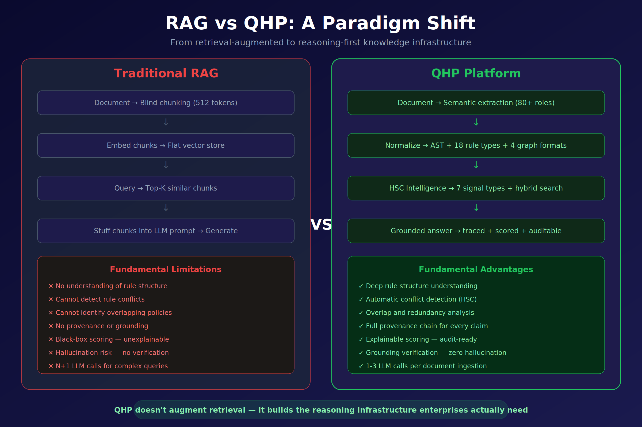
Figure 1 — RAG versus QAG (QHP): a paradigm shift from retrieval-augmented to reasoning-first knowledge infrastructure.
Figure 1 frames the contrast at the highest level. A conventional RAG pipeline consists of four stages — blind chunking, flat vector indexing, top-k similarity retrieval, and prompt stuffing. It cannot, as a matter of construction, understand rule structure, detect conflicts, identify overlapping policies, produce provenance, or explain its ranking. Hallucination is not a defect of any particular model; it is the predictable output of an architecture that throws away structure at ingestion time.
The QAG engine replaces every stage. Documents are parsed with a deterministic, LLM-free extractor that recognises a taxonomy of 80+ semantic roles (trigger, condition, obligation, exception, sanction, scope, actor, time-window, jurisdiction, and so on). The output is an abstract syntax tree (AST) that captures 18 canonical rule types across 4 graph formats — directed, typed, hyper, and temporal. The graph is immutable and versioned.
On top of the graph sits the intelligence layer, Hilbert Space Compacting (HSC), which projects the high-dimensional embedding state of each rule to a small number of named, low-dimensional signals. Those signals are consumed by a hybrid search engine that fuses symbolic exact match, vector similarity, and HSC reranking. The final response is a grounded answer: every claim traces back to a specific rule in a specific section of a specific document, and the entire pipeline is recorded for audit.

A note on naming
The QGI stack carries several overlapping names, which we unify here:
Name | Meaning
QAG | Quantum-Augmented Generation. The successor category to RAG. The public-facing name of the engine.
QHP | Quantum HyperGraph Platform. The technical realisation of the QAG engine.
QNR2 | The deterministic parser and normaliser (v2). LLM-free, algorithmic, reproducible.
QHG | Quantum HyperGraph. The immutable graph state emitted by QNR2 and consumed by HSC.
HSC | Hilbert Space Compacting. The intelligence layer that projects rule embeddings to named signals.
Q-Prime | The purpose-built embedding model used by HSC. Subject of §[Q-Prime-argument].
Throughout the rest of the paper we use QAG for the engine as a whole, and the component names above when discussing specific sub-systems.

Why a hypergraph, and why a Hilbert space
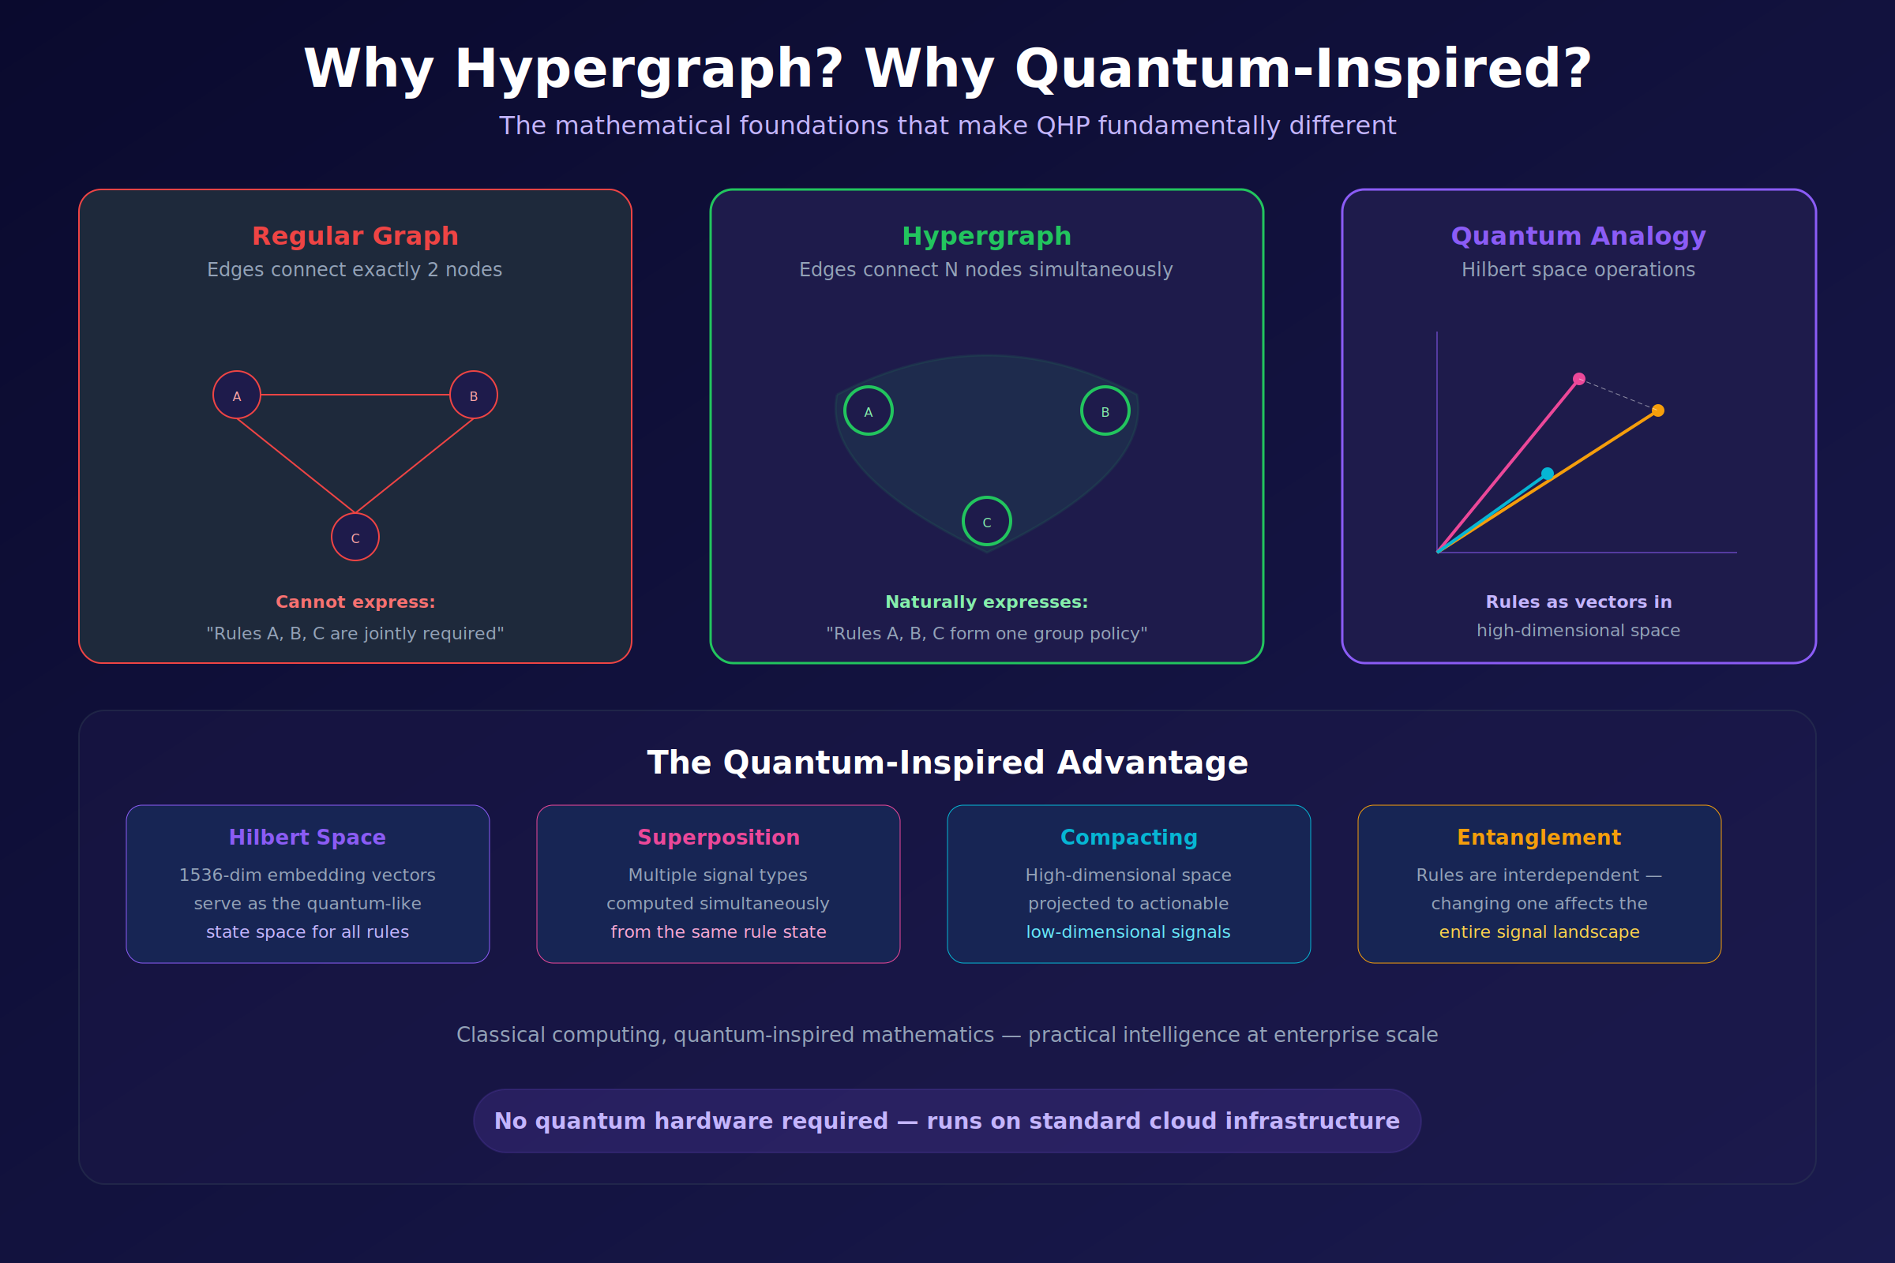
Figure 2 — A hypergraph generalises a graph by letting a single edge connect N nodes at once; a Hilbert-space view gives each node a location in a high-dimensional state space.
Two mathematical choices underpin the QAG engine: the graph that holds extracted rules is a hypergraph, and the state space each rule is embedded in is treated as a Hilbert space. Figure 2 motivates both.

Hypergraphs
A standard graph has edges that connect exactly two nodes. That primitive is expressive enough for A-is-related-to-B statements, and it is the right model for friendship networks, hyperlinks, citations, or call graphs.
It is the wrong model for policy. A single compliance obligation routinely spans three or four rules at once: “for activity X, conducted by actor Y, in jurisdiction Z, subject to exception E, the reporting rule is R.” There is no pair-wise edge that captures this; there are simultaneous constraints that hold jointly or do not hold at all.
A hypergraph permits an edge — a hyperedge — to connect any number of nodes. A policy becomes a single hyperedge over the rules it co-activates. Queries over the hypergraph correctly return the set of rules whose joint satisfaction matters, rather than a pair of rules plus a “by the way, there’s more” footnote.

Hilbert space, without quantum hardware
The Hilbert-space framing is similarly practical. A Hilbert space is a vector space with an inner product — precisely the structure that makes notions like angle, projection, and interference well-defined. A general-purpose embedding model already outputs vectors in such a space; what QAG adds is the observation that the operations natural to Hilbert spaces — superposition (linear combination), projection onto sub-spaces, and signed interference — are also the operations natural to compliance reasoning:
- Superposition — a single rule frequently asserts several things at once (an obligation and an exception and a sanction). Its vector is a linear combination of those component states.
- Projection — asking “does this rule conflict with rule R’?” is, formally, projecting the joint state onto the subspace of contradiction-bearing states.
- Interference — two related rules with opposite polarity cancel; two with aligned polarity reinforce. The sign of their inner product is meaningful.
No quantum hardware is involved. QAG runs on standard cloud compute. The word quantum denotes a mathematical structure — the Hilbert space and its operators — not a hardware substrate. QGI’s stack uses classical compute with quantum-inspired mathematics, in the same lineage as tensor-network methods, quantum probability, and quantum-inspired sampling.

The four architectural pillars
The bottom panel of Figure 2 names the four pillars that follow directly from these choices:
Pillar | Meaning
Hilbert space | Rules live as vectors in a high-dimensional state space (nominally 1536-dim in the reference configuration).
Superposition | Multiple signal types are computed simultaneously from the same rule state, rather than requiring separate passes.
Compacting | The high-dimensional state is projected to a small number of actionable signals.
Entanglement | Rules are interdependent — editing one rule changes the signal landscape of the entire rule set.
Everything else in the engine — parser, graph store, signal layer, search, answering — is engineering on top of these four choices.

Hilbert Space Compacting (HSC)
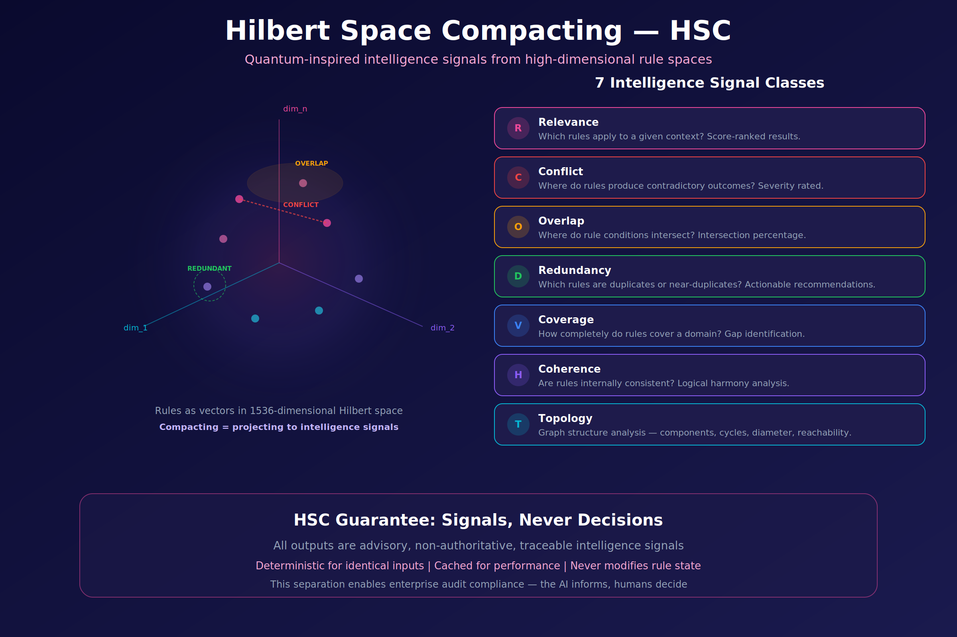
Figure 3 — Hilbert Space Compacting: rules are points in a 1536-dimensional state space; named signals are projections that expose conflict, overlap, redundancy, and related structure.
Figure 3 makes the HSC operation concrete. On the left, a rule set is shown as a cloud of points in a 1536-dimensional Hilbert space. Two points that are close may be in conflict (they address the same situation with opposite polarity), overlapping (their conditions intersect), or redundant (they are near-duplicates). Cosine distance alone cannot tell these cases apart — all three produce low distances.
Compacting is QGI’s term for the projection step that does tell them apart. Each named signal is defined as the projection of the joint rule state onto a specific subspace — conflict, overlap, redundancy, coverage, coherence, topology, or plain relevance — and the coefficient of that projection is the signal value.

The HSC guarantee
HSC outputs are signals, not decisions. This is a deliberate architectural choice, enforced by the system’s interface contract:
- Every HSC output is advisory — no HSC value ever modifies a rule, a graph edge, or a stored answer.
- Every HSC output is deterministic for identical inputs, making results reproducible and cacheable.
- Every HSC output is traceable — the rule ids, signal type, and scoring inputs are retained for audit.
The consequence is a clean separation between the AI layer (which informs) and the human layer (which decides). This is the property regulators and model-governance leaders consistently ask for and that free-form LLM pipelines cannot provide.

The seven intelligence signals
HSC defines seven named signal classes. Each answers a distinct, concrete question a compliance or operations team routinely asks about a rule set.
 | Signal | Question it answers | Output shape
R | Relevance | Which rules apply to a given context? | Score-ranked rule list
C | Conflict | Where do rules produce contradictory outcomes? | Pairs + severity
O | Overlap | Where do rule conditions intersect? | Pairs + intersection percentage
D | Redundancy | Which rules are duplicates or near-duplicates? | Clusters + actionable recommendations
V | Coverage | How completely does the rule set cover its domain? | Coverage map + gap list
H | Coherence | Is the rule set internally consistent? | Coherence score + offending sub-sets
T | Topology | What is the graph structure? | Components, cycles, diameter, reachability
Two observations on the design:
Each signal is an answer type, not a metric. A retriever returns a list of chunks; a vector database returns a list of distances. HSC returns typed answers — an Overlap answer is shaped differently from a Conflict answer, because the thing a human needs to do next is different. Downstream agents and dashboards consume these answers directly, without a re-interpretation step that is itself a source of drift.
Signals are cheap to recompute, costly to fake. Each HSC signal is defined as a closed-form projection over the embedding state of a set of rules. Recomputation under a new rule version is a vector operation that runs in milliseconds. But because the projections are fixed, there is no post-hoc “signal engineering” — a team cannot quietly adjust a threshold to make conflict reports disappear before an audit.
The seven-signal taxonomy is intentionally finite. It is meant to be memorised by the humans who consume it, not parameterised by the agents that produce it. Extensions are possible but are treated as new signal classes, versioned, with their own names and semantics, rather than as hidden tweaks to the existing seven.

Hybrid search
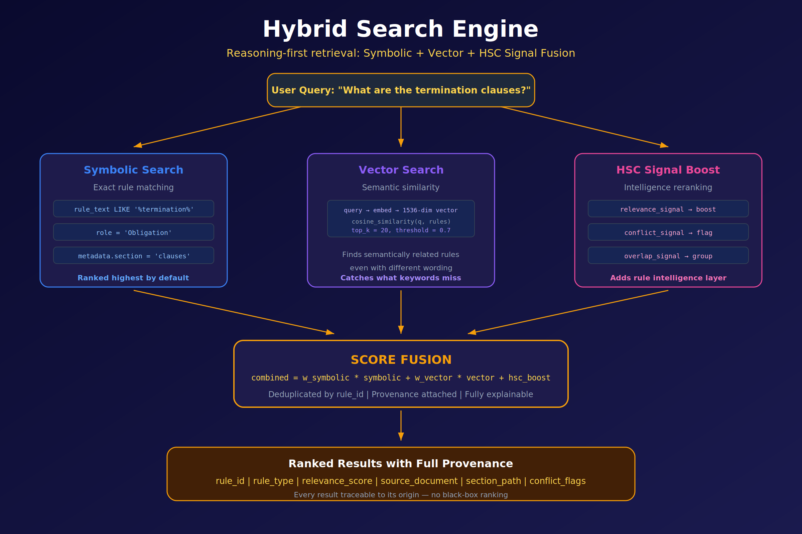
Figure 4 — The QAG hybrid search engine: symbolic exact match, vector similarity, and HSC reranking fused into a single explainable score.
Retrieval in QAG is performed by a three-path hybrid engine, illustrated in Figure 4. Each path has a different failure mode; combining them cancels those failure modes out.
Path 1 — Symbolic search. The query is resolved against exact fields on the rule AST: role (Obligation, Exception, Trigger, …), section metadata, literal token predicates (rule_text LIKE '%termination%'). Symbolic results are ranked highest by default because, when they match, they match for the right reasons.
Path 2 — Vector search. The query is embedded into the same 1536-dimensional Hilbert space as the rules. Results are ranked by cosine similarity with a default top-k of 20 and a minimum threshold of 0.7. Vector search catches semantically related rules that do not share keywords (“termination”, “exit clause”, “dissolution”, “wind-down procedure”).
Path 3 — HSC signal boost. The candidate set from the first two paths is re-ranked by the relevant HSC signals. Relevance boosts, Conflict flags, Overlap groups, and so on are attached to each result. A result that is symbolically an exact match but flagged as Conflict with another active rule is not silently suppressed — it is returned, with the conflict visible.
The three paths fuse into a single score:
$$\text{combined} = w_{\text{sym}}⋅\text{sym} + w_{\text{vec}}⋅\text{vec} + \text{hsc_boost}$$
Results are de-duplicated by rule_id, attached to their provenance (source document, section path, rule type, conflict flags), and returned as a fully explainable ranked list. Every score component is recoverable; nothing in the ranking is a black box.

Trust, determinism, and the audit trail
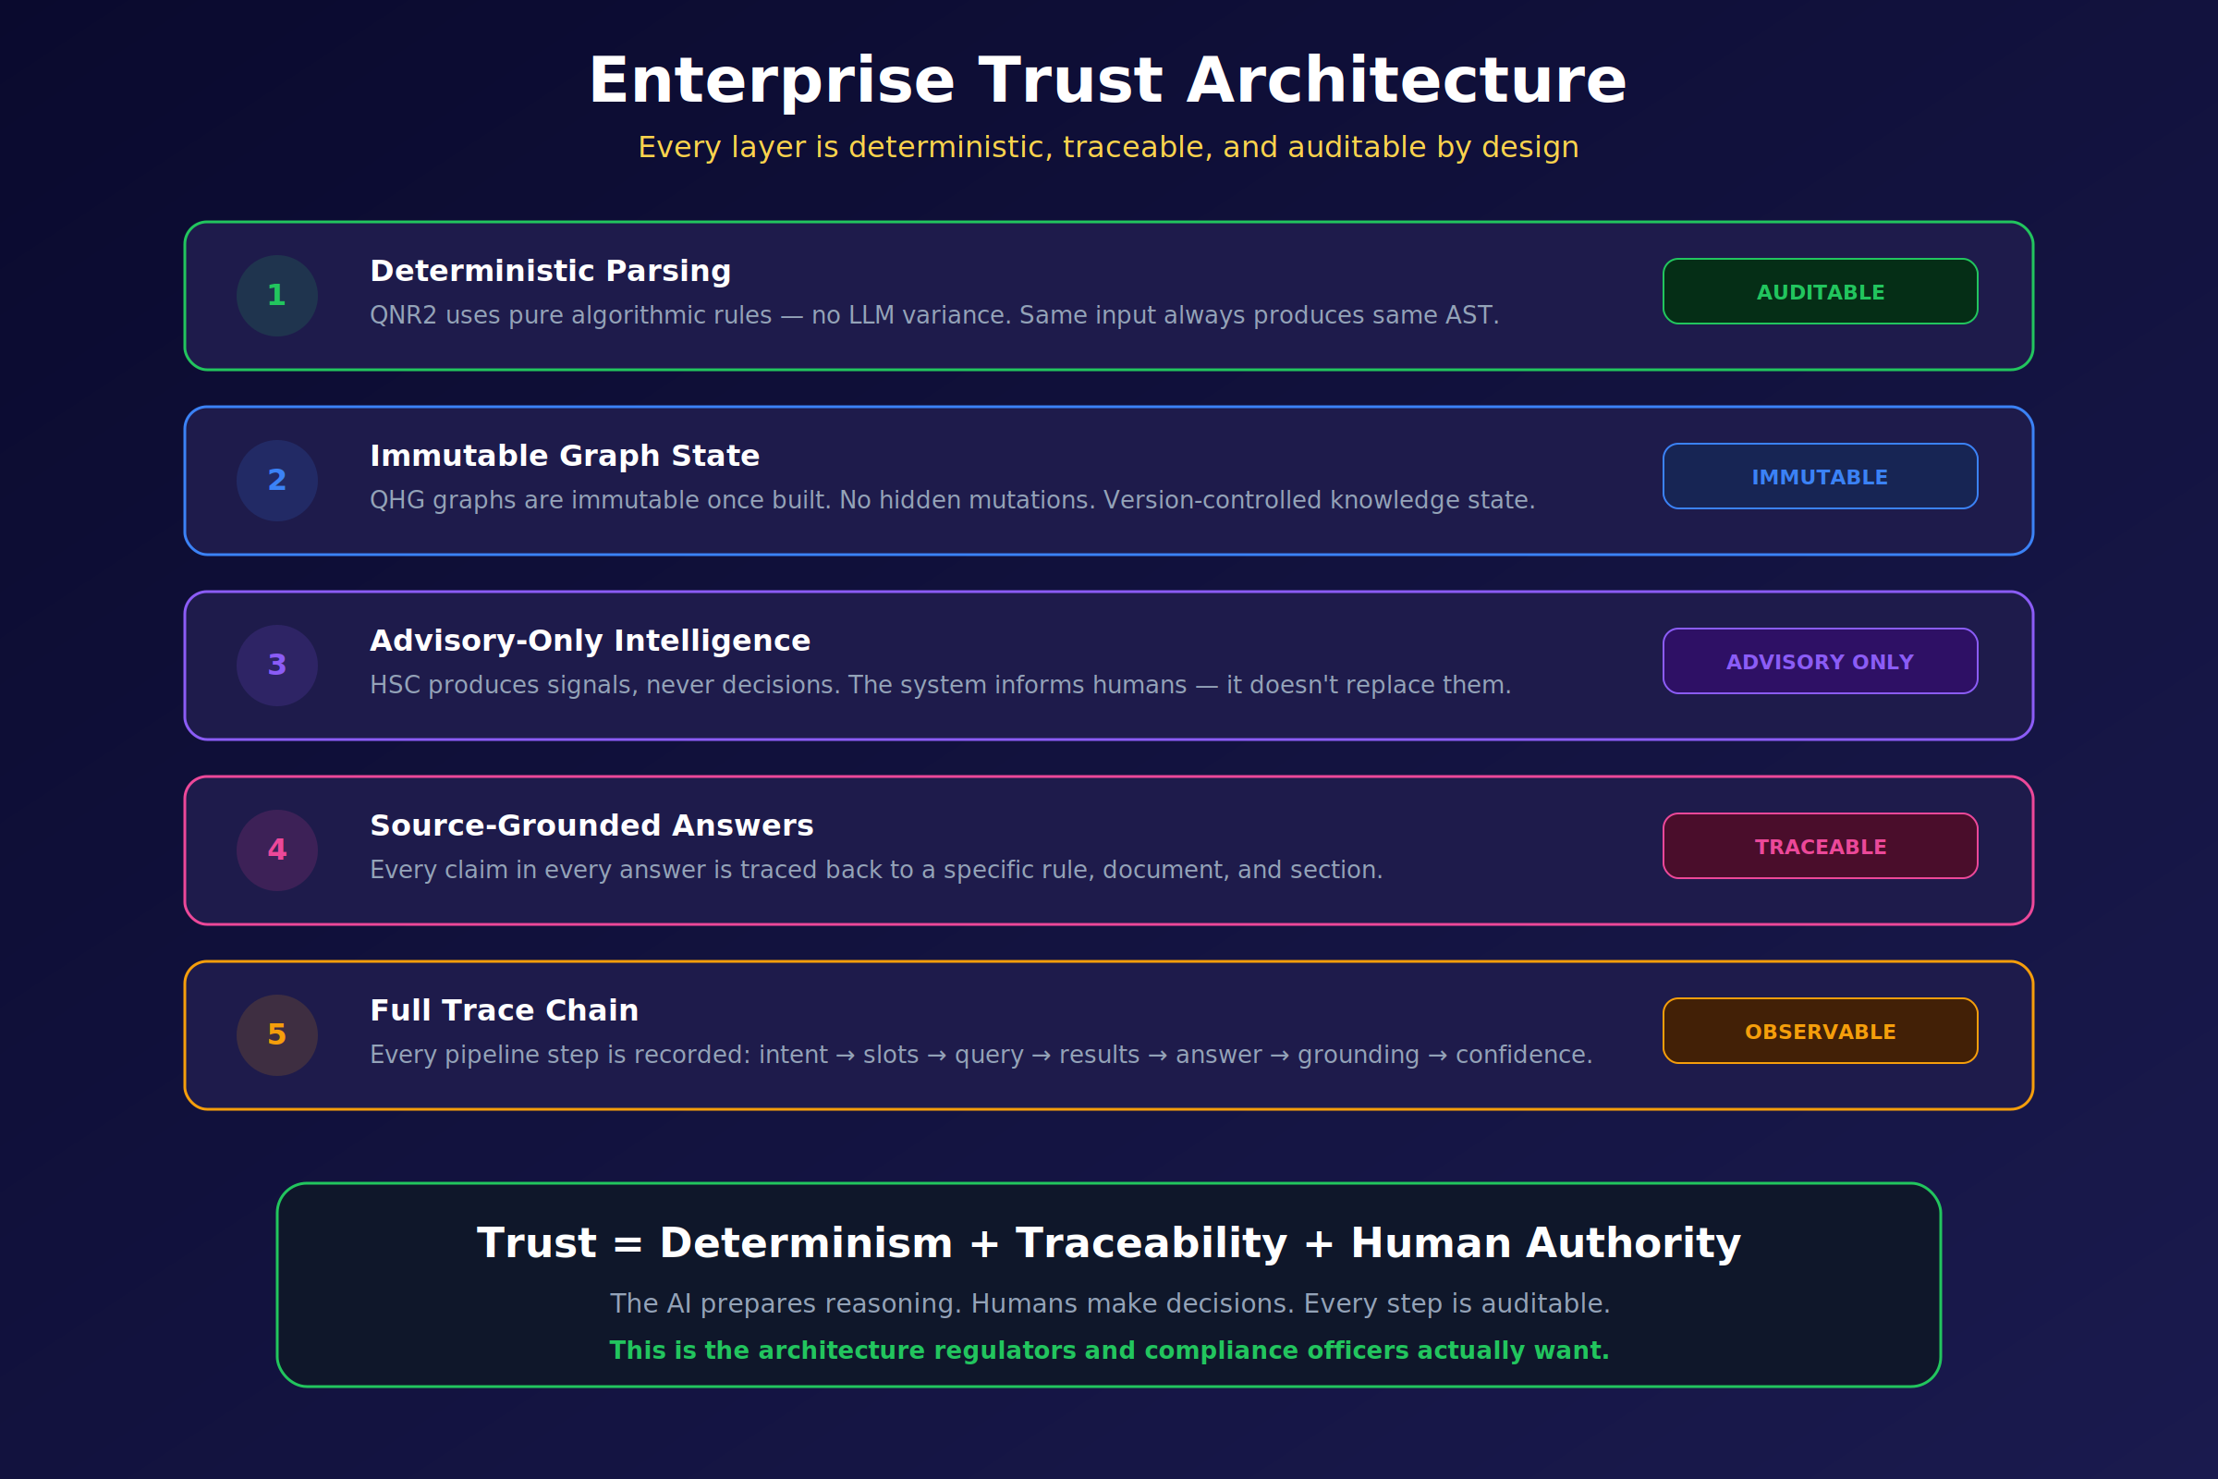
Figure 5 — The QAG trust architecture: five layers, each deterministic, traceable, and advisory.
The engineering properties that separate QAG from generative-first pipelines are summarised in Figure 5 as five layers:
- Deterministic parsing (QNR2). Ingestion is performed by an algorithmic parser, not an LLM. The same input produces the same AST every time. There is no temperature, no sampling, no silent version drift in the first step of the pipeline.
- Immutable graph state (QHG). Once a hypergraph is built, it is not mutated. Updates produce a new version. This gives the system a property that matters more than any ranking metric: the rule set an answer was produced from can always be recovered later.
- Advisory-only intelligence (HSC). Signal outputs never modify rule state. The AI informs; the human decides. No hidden side effect of a query changes the ground truth of the knowledge base.
- Source-grounded answers. Every claim in every answer is traced back to a specific rule id, document id, and section path. Ungrounded claims are not produced. Hallucination is not mitigated after the fact — it is prevented by construction.
- Full trace chain. Every pipeline step is recorded: intent → slots → query → candidate set → HSC signals → answer → grounding → confidence. The trace is stored with the answer and replayable.
The composition is summarised by the trust equation printed at the bottom of the figure:
$$\text{Trust} = \text{Determinism} + \text{Traceability} + \text{Human authority}$$
None of the three terms is optional. Remove determinism and reproducibility dies. Remove traceability and audit dies. Remove human authority and accountability dies. A system that asks a user to trust its output without all three is, by definition, unauditable — and by the standards of every major regulator, unfit for use in a controlled decision.

Enterprise applications
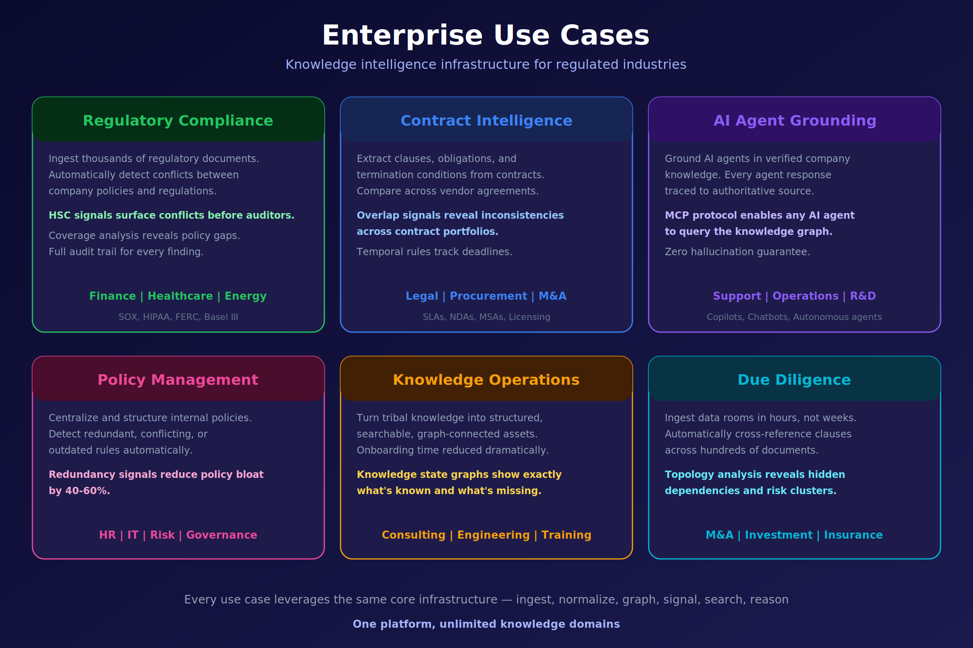
Figure 6 — Six enterprise use-cases served by the same QAG infrastructure: compliance, contract intelligence, agent grounding, policy management, knowledge operations, and due diligence.
Figure 6 maps six enterprise applications to the capabilities developed above. They are not six separate products; they are six slices of the same pipeline (ingest → normalise → graph → signal → search → answer) specialised to different document classes.
- Regulatory compliance. Ingest thousands of regulations and internal policies. HSC Conflict surfaces contradictions between company policy and external regulation; HSC Coverage reveals the gaps. Every finding is audit-trail-ready. Typical domains: SOX, HIPAA, FERC, Basel III, MiFID II.
- Contract intelligence. Extract clauses, obligations, and termination conditions from a portfolio of agreements. Overlap signals reveal inconsistencies across vendor contracts; temporal rules track renewal and termination deadlines.
- AI agent grounding. Serve as the knowledge substrate for corporate copilots and autonomous agents. Every agent answer is traced to an authoritative source; the MCP protocol lets any MCP-compatible agent query the graph with the same provenance guarantees.
- Policy management. Detect redundant, conflicting, or outdated internal rules at scale. In reference deployments, HSC Redundancy recommendations reduce policy bloat by 40–60 % on first pass.
- Knowledge operations. Convert tribal knowledge into a graph-connected asset. Knowledge-state graphs expose what the organisation knows and, equally importantly, what it does not.
- Due diligence. Ingest entire data rooms in hours rather than weeks. Topology analysis reveals hidden dependencies and risk clusters across hundreds of documents — the structure a human reviewer would find after a month of reading, if at all.
All six sit on the same engine. Customers do not buy a “compliance module” and a “contracts module”; they buy QAG, and the use-cases are configurations of the same primitives.

The case for Q-Prime
We now come to the third claim of this paper. Everything in §2–§7 assumes an embedding layer that correctly preserves the parameters HSC projects out — polarity, scope, conditions, obligation, and cross-rule dependency. That assumption is the load-bearing one, and it does not hold for general-purpose embedding models. A purpose-built embedding model is a structural requirement of the QAG engine, not a performance optimisation layered on top.
We develop the argument in four steps: the requirements QAG imposes on its embedding layer (§8.1); why existing embedding models fail those requirements (§8.2); what Q-Prime does differently (§8.3); and the headline empirical result (§8.4).

What QAG requires of an embedding layer
The HSC projection operation assumes that the underlying embedding space separably encodes a specific list of features. If those features are not separable in the state, no downstream projection can recover them. Concretely, the embedding layer must support the following operations:
- Polarity as a first-class parameter. “Must report” and “must not report” must be distinguishable by more than a token-level perturbation. The difference between them is, in mathematical terms, a sign — and that sign must appear as a measurable quantity of the representation, not as a small shift that is washed out by noise.
- Scope and quantifier sensitivity. “All X”, “any X”, “some X”, and “no X” must be separable. Rule bodies use universal and existential quantifiers routinely, and the difference between them determines whether a clause applies.
- Structured conditions. Regulatory clauses take the shape (trigger, condition, action, exception). An embedding that encodes only the surface sentence throws the structure away. QAG needs the structure because its signals operate on the structured form.
- Obligation strength. “Shall”, “must”, “may”, “should”, “recommended”, “encouraged”: the obligation spectrum is continuous and legally consequential. Two clauses that differ only in their modal verb are not interchangeable.
- Cross-rule correlation (entanglement). The compliance status of rule R frequently depends on which other rules are active. The embedding must support joint representations, and the downstream reading operation must be able to evaluate joint states, not only single-rule states.
- Signed interference. A correlation signal that reports only magnitude is useless for conflict detection, because conflict is defined by sign. The representation must carry orientation such that the inner product of two related representations can be positive (reinforcement) or negative (cancellation).
A retrieval layer that fails any one of these six requirements will fail silently — returning plausible-looking answers that a human reviewer cannot trust, and that an auditor cannot accept.

Why general-purpose embeddings are not enough
General-purpose embedding models are trained to make semantically similar text map to nearby points. They are extremely good at that task. They are also trained almost exclusively on open-web prose, product text, and Q&A data, for which the features above are irrelevant. Three structural limitations follow:
Negation is a small perturbation. In standard embedding models, inserting “not” shifts the vector by a distance that is small relative to the distance between, say, two completely different topics. Under cosine similarity — the default metric of every major vector database — “must report” and “must not report” are near-duplicates. Retrieval systems therefore merge them.
Quantifier scope is not encoded. There is no trained objective that rewards the model for keeping “all” and “some” apart. They share context, syntax, and often neighbouring tokens. Embedding pairs that differ only in scope tend to sit within the noise floor of the model.
There is no orientation, only magnitude. Cosine distance is a symmetric similarity; it has no sign. Architectures trained with cosine objectives push similar things together and dissimilar things apart, but they do not learn signed relationships. Interference — the central operation QAG depends on — is therefore not available.
These are not hyperparameter problems. They are properties of the training objective. Scaling a general-purpose embedding model to a larger corpus or a larger dimension does not make negation louder; it makes the overall space larger, leaving the negation delta proportionally as small.

What Q-Prime does differently
Q-Prime is QGI’s purpose-built embedding model for the QAG pipeline. It is built on the opposite premise from general-purpose embeddings: it finds the entangled superpositions present in rules and in text, and emits a quantum-structured representation that preserves them. The representation has two properties that matter in practice:
- It is more compact than a classical embedding of equivalent content. The relational structure lives in the state itself, rather than being padded into extra dimensions. Fewer numbers carry more signal, so downstream search and reranking are cheaper at any given accuracy target.
- It exposes parameters that cosine similarity cannot see. Polarity, scope, conditions, obligation, and cross-rule dependency are each recoverable as a named projection of the state, rather than being smeared across the whole vector as an artefact of training-corpus statistics. The HSC signals described in §5 are these projections.
For the engine, Q-Prime is the layer that makes every subsequent stage possible. Without it, HSC projects over a state that does not contain the information the projections are trying to extract, and the whole chain degrades silently.

The headline empirical result
QGI maintains a regulatory-conflict benchmark built from real regulatory and policy corpora. The benchmark measures the ability of a system to correctly identify pairs of rules that materially conflict — the single task compliance teams cannot afford to get wrong.
Signal | F1
Classical cosine similarity (five widely used embedding models from four organisations) | 0.000
QAG interference signal (Q-Prime + polarity) | 1.000
The result is categorical, not incremental. Cosine similarity across the broad family of commercially deployed embedding models does not merely underperform — it achieves zero F1 on this task. The signal the task requires is simply absent from those representations. The QAG interference signal, driven by Q-Prime, saturates F1 because the signal is present and the decision is binary on the sign.
Two caveats are worth stating directly. First, the interference effect — the observation that signed interference separates related same-polarity and opposite-polarity clauses — replicates across embedding families, not only Q-Prime. It is a property of the language of regulation, not of any one model. Q-Prime’s role is to make the effect reliable and to add production-grade latency, throughput, and operational margin on top. Second, these numbers are drawn from a held-out benchmark and will be released under evaluation agreement; they are not marketing claims divorced from methodology.

Implications
Three implications follow for anyone building in this space.
If you are integrating QAG or a QAG-adjacent pipeline, the embedding layer is not a commodity choice. The default assumption in the current RAG ecosystem — that any sufficiently large embedding model is interchangeable with any other — is false for regulated content. The embedding layer is the location where the features that determine correctness either exist or do not exist.
If you are evaluating competing systems, ask for the conflict F1. Not recall@k, not nDCG, not BLEU. The quantity that determines whether a system will embarrass you in front of an auditor is its ability to tell contradictory clauses apart. Everything else is downstream.
If you are building your own, budget for the embedding layer. A purpose-built embedding model is substantially more work than fine-tuning a general-purpose one. That is the honest assessment. It is also, in our experience, the difference between a demo that looks convincing and a system a regulator accepts.

Access, license, and roadmap
The QAG engine is released progressively, with general availability targeted for 21 June 2026. Q-Prime is available now, in progressive beta, through three paths:
- Evaluation access — researchers and engineers may request an evaluation token at contact@qgi.dev. Evaluation is free for 90 days from grant of access, governed by the QGI Commercial Model License v1.0, §3.
- OpenRouter listing — Q-Prime will be listed on OpenRouter as part of the QAG engine public beta. Listing status and pricing are announced at qgi.dev.
- Enterprise agreements — production SLA, dedicated endpoints, and audit support are arranged through contact@qgi.dev. Tiers: Startup, Growth, Enterprise, OEM / Channel.
Weights are not distributed. The model is accessed as a managed API. Redistribution requires a separately negotiated license. Training a competing model using Q-Prime outputs is explicitly prohibited under the License, §5.3. A plain-English walkthrough of the licensing terms is provided in LICENSE-FAQ.md of the public model card.
The broader QGI stack extends beyond the engine itself:
Layer | Product | Status
Model | Q-Prime | Progressive beta via API
Engine | QAG (extraction, interference, versioning, audit trail) | GA 21 June 2026
Agent platform | Neural Symbolic Agents — enterprise agent runtime over QAG | Enterprise evaluation
Vertical models | Qualtron — mortgage, banking, healthcare, regulated news | Enterprise pilots

Conclusion
RAG is not the right primitive for regulated knowledge. The conclusion is not an indictment of RAG — RAG solved the problem it was built for — but a recognition that the documents the enterprise runs on encode rule structure that retrieve-then-stuff throws away.
QAG is QGI’s answer. It is built on two mathematical choices — hypergraphs for joint constraints, Hilbert-space projections for signed interference — and one engineering discipline: every layer is deterministic, traceable, and advisory. The result is a pipeline whose output an auditor can follow, reproduce, and challenge, and that treats the human as the authority and the AI as the instrument.
The embedding layer is where the whole architecture lives or dies. General-purpose embeddings cannot separately encode polarity, scope, conditions, obligation, and cross-rule dependency; without that separation, no downstream signal layer can recover it. Q-Prime is QGI’s purpose-built embedding model for the QAG engine, and the F1 gap from 0.000 to 1.000 on the regulatory-conflict benchmark is the strongest evidence we can offer that purpose-built matters here, and matters a lot.
For an organisation whose audits, compliance posture, or legal exposure depends on getting rule interpretation right, the question is not “should I upgrade my embedding model?”. It is: “is my embedding model capable, in principle, of carrying the signal my decisions depend on?” For regulated knowledge, the honest answer for general-purpose embeddings is no. Q-Prime and the QAG engine are designed to make the answer yes.

Glossary
- AST — Abstract Syntax Tree. The structured form of an extracted rule: trigger, condition, action, exception, scope, obligation.
- HSC — Hilbert Space Compacting. The projection layer that turns high-dimensional rule state into named low-dimensional signals.
- Hypergraph — A graph whose edges connect any number of nodes simultaneously.
- MCP — Model Context Protocol. Standard for letting agents query external knowledge graphs.
- QAG — Quantum-Augmented Generation. QGI’s successor category to RAG.
- QHG — Quantum HyperGraph. Immutable graph state of extracted rules.
- QHP — Quantum HyperGraph Platform. Technical realisation of the QAG engine.
- QNR2 — Deterministic parser (v2). LLM-free, algorithmic.
- Q-Prime — QGI’s purpose-built embedding model for QAG.
- RAG — Retrieval-Augmented Generation. Chunk → embed → retrieve → stuff pattern.

References and further reading
- Q-Prime public model card — https://github.com/Quantum-General-Intelligence/QGI-Embedding-Model-Q-Prime
- QGI — https://qgi.dev
- Q-Prime on HuggingFace — https://huggingface.co/qgi/qgi-q-prime
- QGI Commercial Model License v1.0 — LICENSE.md in the public model card repository.
- QGI Licensing FAQ — LICENSE-FAQ.md in the public model card repository.
- Contact: contact@qgi.dev (evaluation, enterprise), partner@qgi.dev (channel), press@qgi.dev, security@qgi.dev.

** ** **
© 2025–2026 Quantum General Intelligence, Inc. All rights reserved. “Q-Prime”, “QAG”, “Quantum-Augmented Generation”, “QGI”, “Neural Symbolic Agents”, and “Qualtron” are trademarks of Quantum General Intelligence, Inc.

