CONTINUOUS ASSESSMENT 3 (CA-3)
CASE STUDY REPORT

The Quantum Spline
A Kolmogorov-Arnold Network Approach to Superconducting Phase Dynamics

Topic | Supervised Machine Learning Model Development and Evaluation using Regression and Advanced Classification using Kolmogrov-Arnold Network (KAN)
Target Domain | Quantum Materials Science & High-Temperature Superconductivity
Dataset Reference | SuperCon & Materials Project Stoichiometric Telemetry (16,521 Confirmed Compounds)

Table of Contents
1. Abstract 3
2. Theoretical Foundation: Kolmogorov-Arnold Networks (KAN) 4
2.1 Kolmogorov-Arnold Theorem and Network Architecture 4
2.2 The Additional Layer of Scaling: The Grid Hyper-Parameter 5
3. Problem Statement & Project Objectives 5
3.1 Problem Statement 5
3.2 Project Objectives 5
4. Dataset Description & Preprocessing Pipeline 6
4.1 Data Ingestion & Target Synthesis 6
4.2 Data Cleansing & Variance Filtering 7
4.3 Data Leakage Quarantine & Scaling Protocol 7
5. Machine Learning Architectures & Training Protocols 7
5.1 KAN Topology Formulations 7
5.2 Objective Functions & Optimization Pipeline 8
6. Training Dynamics & Loss Convergence Analysis 9
Architectural Insights from Convergence Curves 10
7. Experimental Results & Confusion Matrix Analysis 10
7.1 Model I: Continuous Thermal Regression (T_c) 10
7.2 Model II: Cryogenic Viability Binary Classification & Triage Analysis 11
7.3 Model III: Multi-Class Coarse Family Taxonomy 12
8. Algorithmic Benchmarking Against Industry Baselines 13
8.1 Continuous Regression Benchmark (T_c) 14
8.2 Cryogenic Viability Benchmark (T_c ≥ 77 K) 14
8.3 Multi-Class Taxonomy Benchmark 14
9. Symbolic Distillation & The Algebraic Trap 15
9.1 The Thermal Regression Laws 15
9.2 The Binary Classification Negative Trap 16
Autopsy of the Negative Trap 16
Why the Native KAN Succeeds Where Algebra Falls Short 16
10. Practical Laboratory Screening Protocol 17
11. Limitations & Future Directions 17
12. Conclusion 17
13. References 18

1. Abstract
The discovery of high temperature superconductors, has historically been getting hindered by one thing, The Vast Non Linear Combinatorial Search Space of the Chemical Stoichiometry and, the Sheer Cost of the Physical Laboratory Synthesis. So, in this Study, We Architect, We Train and We Evaluate something unused in this Domain, A Tripartite Kolmogorov-Arnold Network (KAN).
This Model, shall be used to model the superconducting phase transitions across 3 main distinct Supervised Machine Learning Objectives:
- Continuous Thermal Regression (Model I): Basically, this Model is built to predict the Continuous Critical Transition Temperature ($T_{c}$, in Kelvin), directly from the Stoichiometric Feature Vectors. The whole idea here is to take the chemical composition of a material and estimate the temperature at which it transitions into its superconducting state, without having to physically synthesize every single material just to find out.
- Cryogenic Viability Classification (Model II): Now, predicting the temperature is one thing, but determining whether a material actually crosses a useful threshold is a whole different thing. This is where our Safe-Critical Binary Screening Model comes in, classifying whether an Alloy reaches the commercially transformative Liquid Nitrogen Boiling Barrier ($T_{c}≥77 K$) or not. So, rather than just looking at the temperature as a number, we are Asking a much more practical question: does this material meet the threshold we care about, or does it not?
- Multi-Class Coarse Family Taxonomy (Model III): Finally, we have a 4-Class Categorical Classifier that partitions materials into four foundational pairing families: Cuprates, Iron-Based, Non-cuprate Oxides, and Intermetallics/Alloys. The point here is to get the Model to distinguish between these different material families, because not every Superconductor follows the same patterns, and that distinction matters when we are trying to understand the bigger picture.
Unlike classical Multi-Layer Perceptrons (MLPs), which rely on static Weight Matrices and Fixed Activation Functions sitting on the Nodes, KANs do things a little differently. They place learnable 1D B-spline Curves directly on the Network Edges. And this is where things get interesting: by leveraging the Kolmogorov-Arnold Representation Theorem, the Architecture can achieve strong Parameter Efficiency while also giving us a level of Interpretability that is harder to get from conventional Neural Networks. Basically, we are not just looking for a Model that gets the prediction right; we also want to Understand what the Model is learning along the way.
Using empirical telemetry from TensorBoard training loss runs and validated evaluation checkpoints , we demonstrate that:
- A compact Shallow KAN ($G=5$, 64 hidden nodes) achieves strong regression performance, with $RMSE=12.1980 K$, $MAE=7.5232 K$, and $R^{2}=0.8635$. And the interesting part is, this compact Architecture outperforms the Deep MLP Architectures while remaining competitive with Tree-Based Gradient Boosting Models. So, a deeper Network is not automatically the better choice here.
- On the severely imbalanced Binary Viability Task, with a Class Ratio of approximately $1:5.3$, standard Probability Thresholding ($τ=0.5$) gives us an ROC-AUC of $0.9607$ and a Recall of $74.31\%$. But here’s the thing: if we stick to the standard threshold, we risk missing materials that could actually meet our viability criteria. By dynamically calibrating the threshold to $τ^{*}=0.3553$, we reduce False Negatives by $36.3\%$ and increase Discovery Recall to $83.63\%$, with an F1-score of $0.7503$. In other words, we are making the Model more effective at catching potentially viable materials, rather than letting them slip through the cracks. The extent of any laboratory time saved would, however, need to be validated in practice.
- The Multi-Class Taxonomy Model achieves near-perfect discrimination, with $99.96\%$ Accuracy and a Macro F1-score of $0.9953$. So, across these four material families, the Model is doing a strong job of distinguishing between the different categories, giving us a clearer picture of how the materials are grouped.
- Post-training Symbolic Distillation reveals potential Thermodynamic Scaling Relationships for Thermal Regression, expressed as $T_{c}∝{\left(ΔE_{bg}+N_{d}^{unfilled}\right)}^{-1}$. At the same time, it exposes the limits of using 1D Algebraic Projections to capture High-Dimensional Decision Boundaries, a challenge we refer to as the Algebraic Trap. And that’s an important distinction: while symbolic expressions can help us interpret what the Model has learned, we still need to be careful not to Treat a learned mathematical relationship as a confirmed physical law without further validation.

2. Theoretical Foundation: Kolmogorov-Arnold Networks (KAN)

2.1 Kolmogorov-Arnold Theorem and Network Architecture
Kolmogorov-Arnold Network (KAN) is a relatively recent ML/DL Architecture, built upon the Kolmogorov-Arnold Theorem from Mathematics. Now, the Theorem, in simpler terms, states that a complicated $n$-dimensional, multi-variable Function bounded in the $\left[0,1\right]$ domain can be REPRESENTED as a sum of continuous, simpler, and lower-degree functions of a single variable. And this is where things get interesting: instead of dealing with the entire complexity of a multi-variable Function all at once, we can break it down into smaller pieces that are much easier to Work with.
The KAN Model takes inspiration from this Theorem, and offers significant Interpretability and Parameter Efficiency compared to a standard MLP-based Model. Basically, we are not just trying to make the Network learn the relationship between inputs and outputs; we also want to get a better understanding of HOW those relationships are being learned.
In the continuous sum of the Function, the Curse of Dimensionality is mathematically bypassed. The complex, multidimensional problem is reduced to optimizing a set of 1D Curves. And that’s the main idea here: rather than having to deal with everything as one massive problem, we can focus on learning these simpler functions individually.
The driving learning factor of a KAN is the implementation of the $ϕ\left(x\right)$ Function, which is applied to the input through the Edges connecting the Nodes in a Layer. Unlike a standard MLP, where activation functions are typically placed on the Nodes, KANs place learnable functions directly on the Edges. The $ϕ\left(x\right)$ Function itself is a residual combination of a base activation function, typically SiLU, and a piecewise B-spline:
$$ϕ\left(x\right)=w\left(b\left(x\right)+spline\left(x\right)\right)$$
The $spline\left(x\right)$ Function is the part of $ϕ\left(x\right)$ that actually learns the shape of the curve, using B-splines, which are basically a way to build smooth curves through local Basis Functions. And see, the thing is, instead of making the Model work with one fixed curve, we let it adjust that curve based on what the data is showing. The B-spline itself is defined over a dynamic Knot Vector, which is essentially a grid of intervals ($G$). It is constructed as a linear combination of local Basis Functions $B_{k}\left(x\right)$ and learnable Control Points $c_{k}$:
$$spline\left(x\right)=\sum_{k}{}c_{k}B_{k}\left(x\right)$$
During Back-Propagation, the Optimizer ain’t just adjusting some scalar Weight and calling it a day. It calculates gradients with respect to the Control Points $c_{k}$, and that’s where things get interesting. As those Control Points get updated, the Geometry of the Curve can shift and WARP across the local domain associated with the point being optimized. So, we ain’t just changing how strong a connection is; we are letting the Model actually reshape the Function to better fit the patterns in the data. And that’s the whole point right there: the Model gets to Learn from the data, adjust its curves, and capture relationships that a fixed activation function might not pick up as easily.

2.2 The Additional Layer of Scaling: The Grid Hyper-Parameter
Unlike MLPs, which scale by adding more Layers (Depth) or more Neurons (Width), a KAN has a third dimension of expressivity: Grid Resolution ($G$). Now, the B-Spline fits the curve, or a section of it, using an internal grid-like mechanism called the Knot Vector, and the individual components of that grid are called Knots. In simpler terms, this Grid Parameter determines how many internal Basis Functions $B_{k}\left(x\right)$ the $spline\left(x\right)$ can Work with. And that’s what makes this interesting, because we are not just making the Network bigger; we are giving it more room to Learn the shape of the Function.
Because the Edges use continuous Splines, the Network can be initialized with a coarse Grid to learn the broader, macro-level trends first. Once the Model has converged, that Grid can be mathematically refined by increasing the number of Knots across the Spline Intervals, allowing it to capture finer, high-frequency details without fundamentally changing its overall Topology or Architecture. And see, that’s the advantage here, we can start simple, let the Model pick up the bigger patterns, and then give it the flexibility to Learn the finer details when it needs to. This allows KANs to achieve significant Parameter Efficiency, often matching Deep MLPs with a much smaller Structural Footprint. A KAN with only a few thousand Parameters can, in some reported comparisons, match standard MLPs with hundreds of thousands of Parameters, potentially reaching the million-parameter range. That’s a whole lot of expressive power packed into a much smaller Network, though the exact comparison depends on the task and Architecture.

3. Problem Statement & Project Objectives

3.1 Problem Statement
In this Case Study, we construct three independent Kolmogorov-Arnold Networks to model complex superconducting physical phenomena, 1 Continuous Regression Task and 2 Classification Tasks. Now, the reason we split these tasks into three separate KAN Models is because each Model got its own job to do, and we ain’t tryna lose the Interpretability that comes with the B-Spline Architecture in the process. We also want to see how well these Models actually perform, because building something that makes predictions is one thing, but knowing whether them predictions hold up against task-specific metrics is a whole different story. Finally, we put these Models up against Industry-Standard MLPs and Boosted Ensemble Methods to see where KANs stand in terms of Parameter Efficiency and Interpretability, and whether they can really hold their own against the established Baselines.

3.2 Project Objectives
- Stoichiometric Telemetry Projection: To build a preprocessing pipeline that takes raw, non-uniform chemical formulas and maps them into a normalized geometric feature space. The tricky part is dealing with experimental noise and conflicting compound measurements, because just filling in missing values with the mean ain’t always gonna cut it. We need the data to be handled properly before it even reaches the Model.
- Continuous Thermal Regression: To build a KAN that maps elemental topological features to the Critical Temperature ($T_{c}$), and then extract potential underlying physical equations after pruning the $L_{1}$-regularized Network. The goal ain’t just to predict a temperature and move on. We want to see if the Model can uncover relationships that help experimental physicists narrow down promising materials, instead of spending thousands of hours synthesizing alloys that lead nowhere.
- Cryogenic Viability Classification: To develop an independent KAN that classifies whether a material crosses the 77 K Liquid Nitrogen Threshold ($T_{c}≥77 K$), using purely stoichiometric and geometric features. Basically, we want the Model to tell us whether a material meets this critical Commercial Viability Boundary or not. That gives us another way to screen potential candidates before committing to physical experiments, which is the whole point of having this separate Model in the first place.
- Multi-Class Coarse Family Taxonomy: To test whether a KAN can map distinct chemical subspaces to different pairing mechanisms by categorizing superconductors into a 4-Class Taxonomy: Cuprates, Iron-Based, Intermetallics/Alloys, and Oxides, using only stoichiometric features. What we tryna figure out here is whether the Model can actually distinguish between these material families based on composition alone. If it can, that gives us something useful to work with, without needing to feed it extra information.
- B-Spline Grid Optimization & Parameter Scaling: To evaluate how KANs scale by dynamically adjusting the Spline Grid Size ($G$) during training, while measuring changes in Expressivity and Parameter Count. We wanna see what happens when the grid gets finer, and whether that extra flexibility is actually worth the additional Parameters. A bigger grid might capture more detail, but that don’t automatically mean the Model performs better. We gotta look at the results to see what’s really going on.
- Evaluative Insight & Algorithmic Benchmarking: To evaluate where the KAN performs well and where it falls short, using task-specific metrics such as Precision, Recall, F1-Score, RMSE, and $R^{2}$, while drawing physical insights from the results where the evidence supports them. We also compare KANs against MLPs and Tree-Based Ensembles to see how continuous Splines perform against Static Linear Weights and Axis-Aligned Splits when modeling quantum phenomena. At the end of the day, we need to find out whether KANs actually bring an advantage on these tasks, and if they do, how much of a difference that advantage makes.

4. Dataset Description & Preprocessing Pipeline

4.1 Data Ingestion & Target Synthesis
The raw dataset comprises $N=16,521$ validated stoichiometric compositions featurised with 146 numerical elemental and crystallographic attributes generated via the Magpie framework (Materials Agnostic Platform for Informatics and Exploration via pymatgen).

Three distinct supervised target vectors are synthesized:
- Target I ($y_{reg}∈R^{+}$): Continuous critical temperature $T_{c}$ in Kelvin.
- Target II ($y_{via}∈\{0,1\}$): Binary cryogenic viability flag:
$$y_{via}=\{1 if T_{c}≥77.0 K (Liquid Nitrogen Viable) 0 if T_{c}<77.0 K (Sub-77K / Helium Regulated)$$
- The dataset exhibits heavy class imbalance: 13,898 negative instances ($84.1\%$) versus 2,623 positive instances ($15.9\%$), representing a severe $≈5.3:1$ class disparity.
- Target III ($y_{fam}∈\{0,1,2,3\}$): Coarse family taxonomy mapped via atomic constituent logic:
  - Class 0 (Cuprates): $\{Cu,O\}⊂formula$ ($7,533$ samples, $45.6\%$)
  - Class 1 (Iron-Based): $Fe∈formula∧\{As,P,Se,Te\}∩formula≠∅$ ($1,360$ samples, $8.2\%$)
  - Class 2 (Non-cuprate Oxides): $O∈formula∧Cu∉formula$ ($568$ samples, $3.4\%$)
  - Class 3 (Intermetallics & Alloys): All other metallic/intermetallic systems ($7,060$ samples, $42.7\%$)
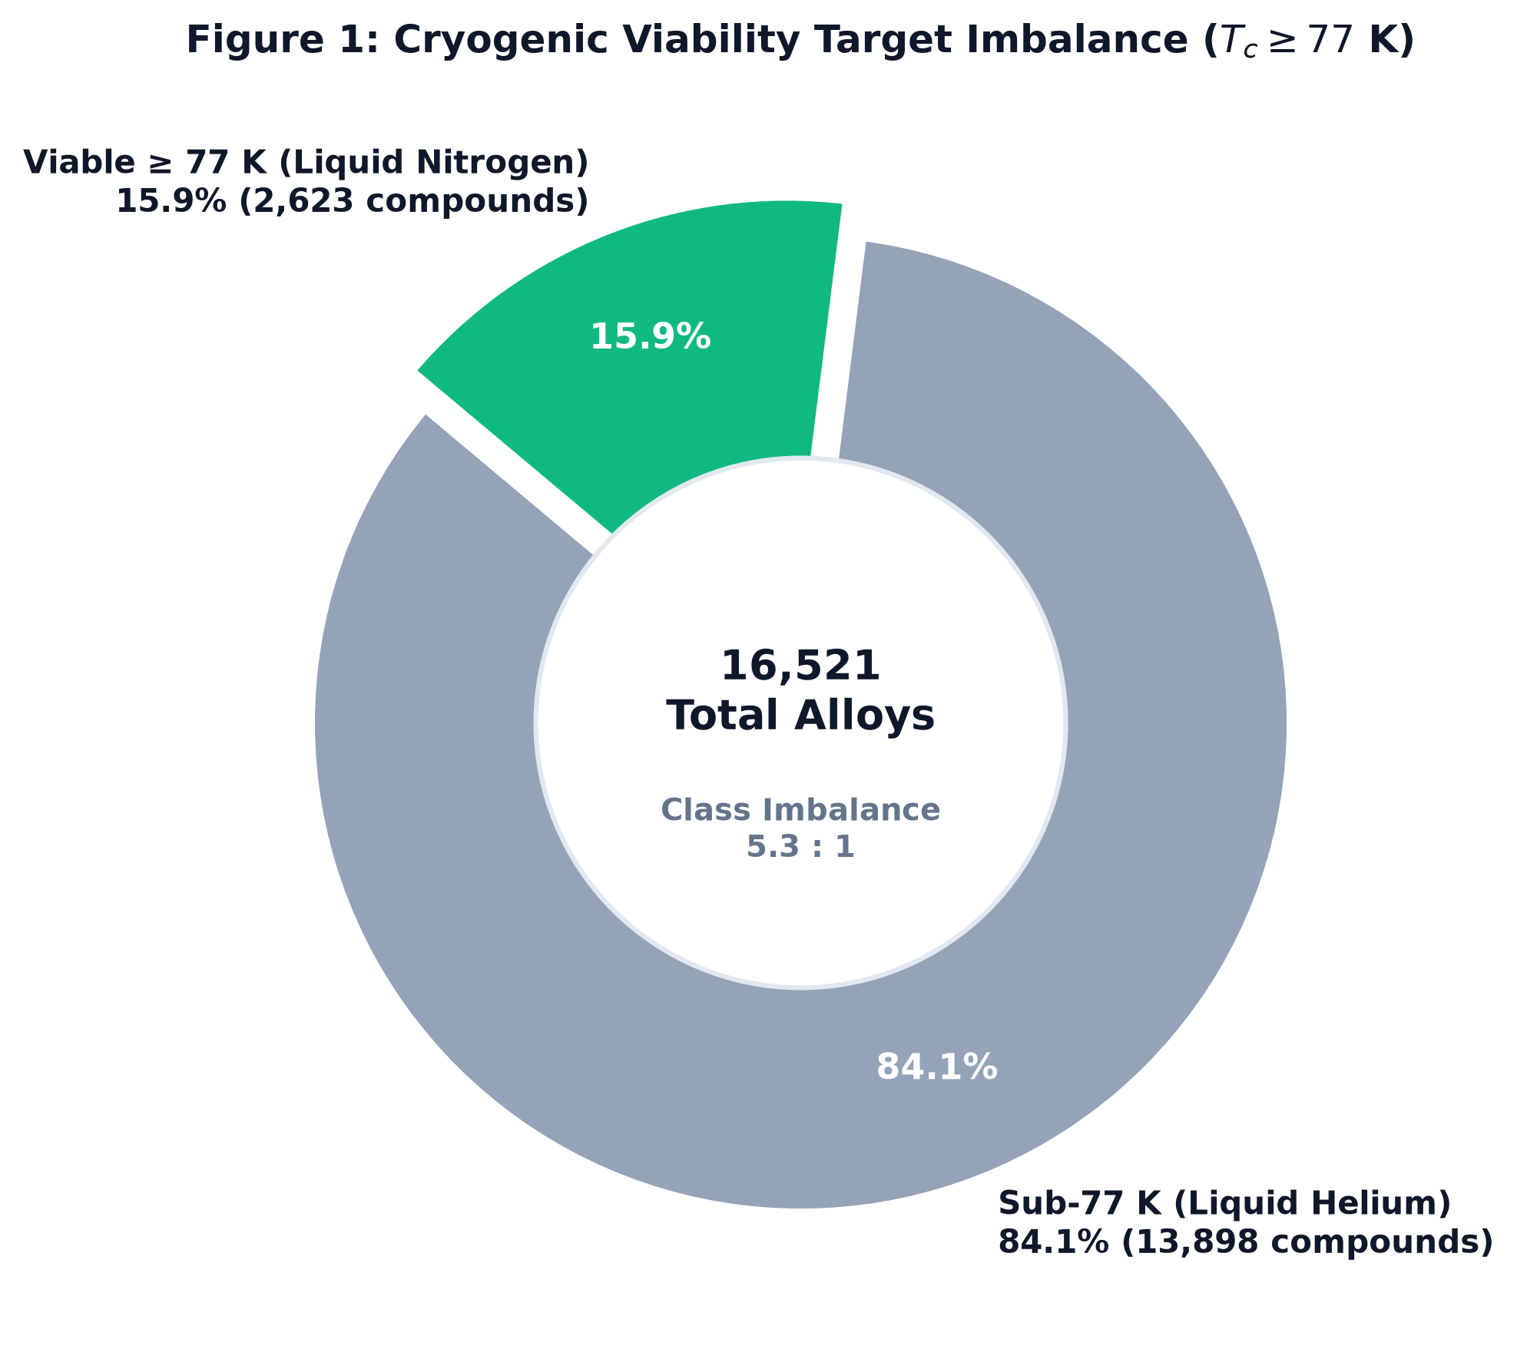
Figure 1: Cryogenic viability target imbalance, illustrating the severe class disparity between sub-77K liquid. helium compounds and viable liquid nitrogen superconductors.

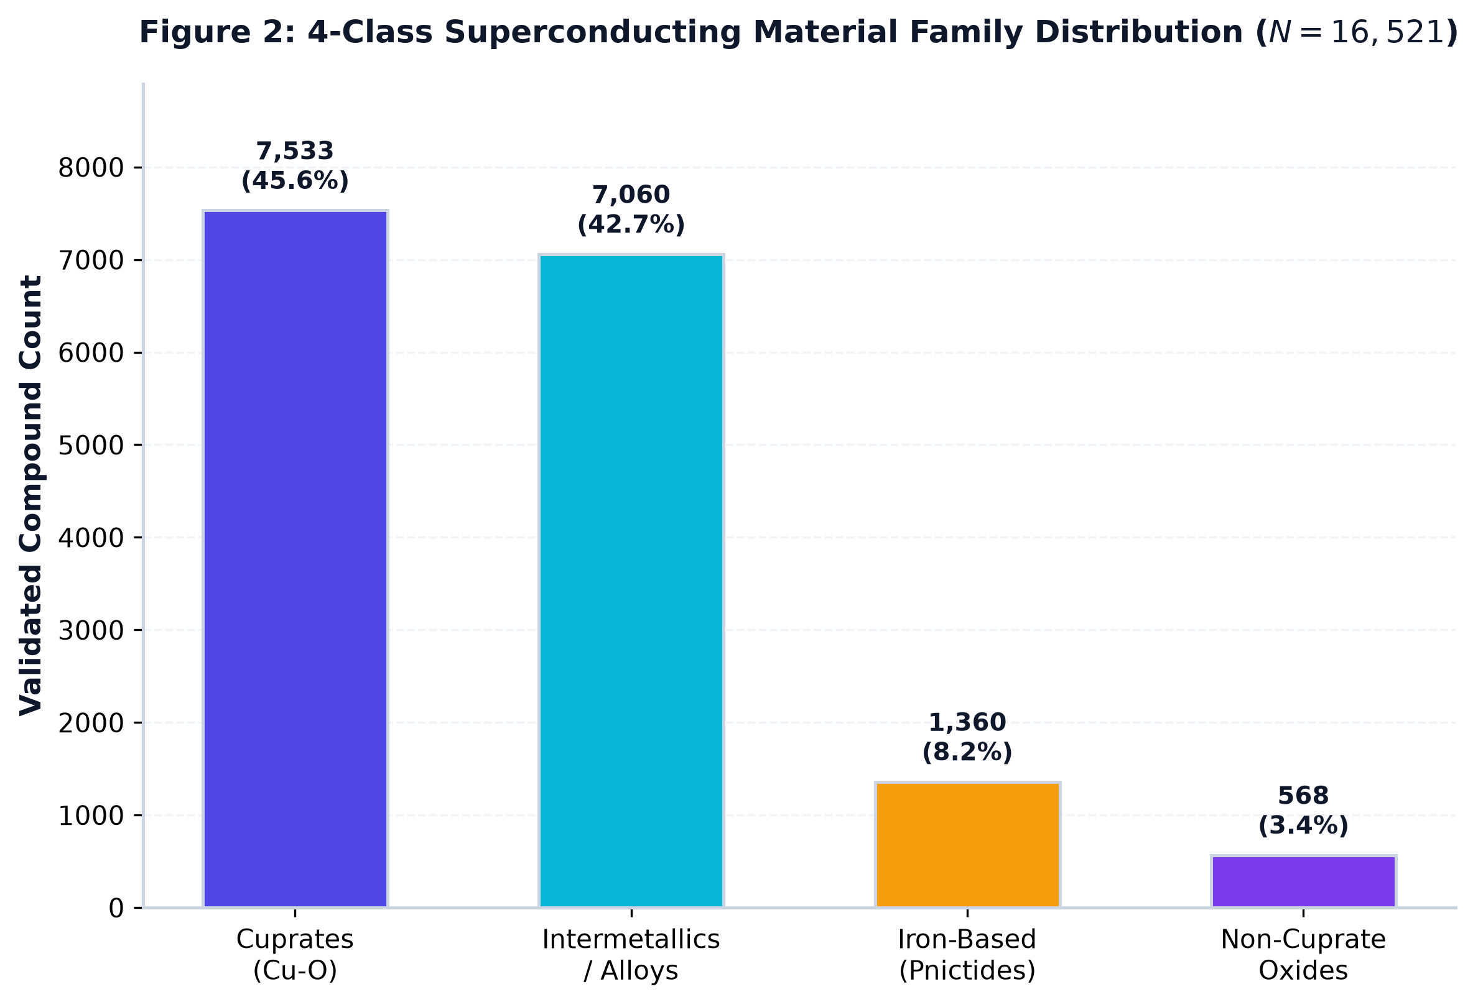
Figure 2: Superconducting material family taxonomy breakdown, partitioning compounds into Cuprates , Intermetallics/Alloys, Iron-Based pnictides, and Non-cuprate Oxides.

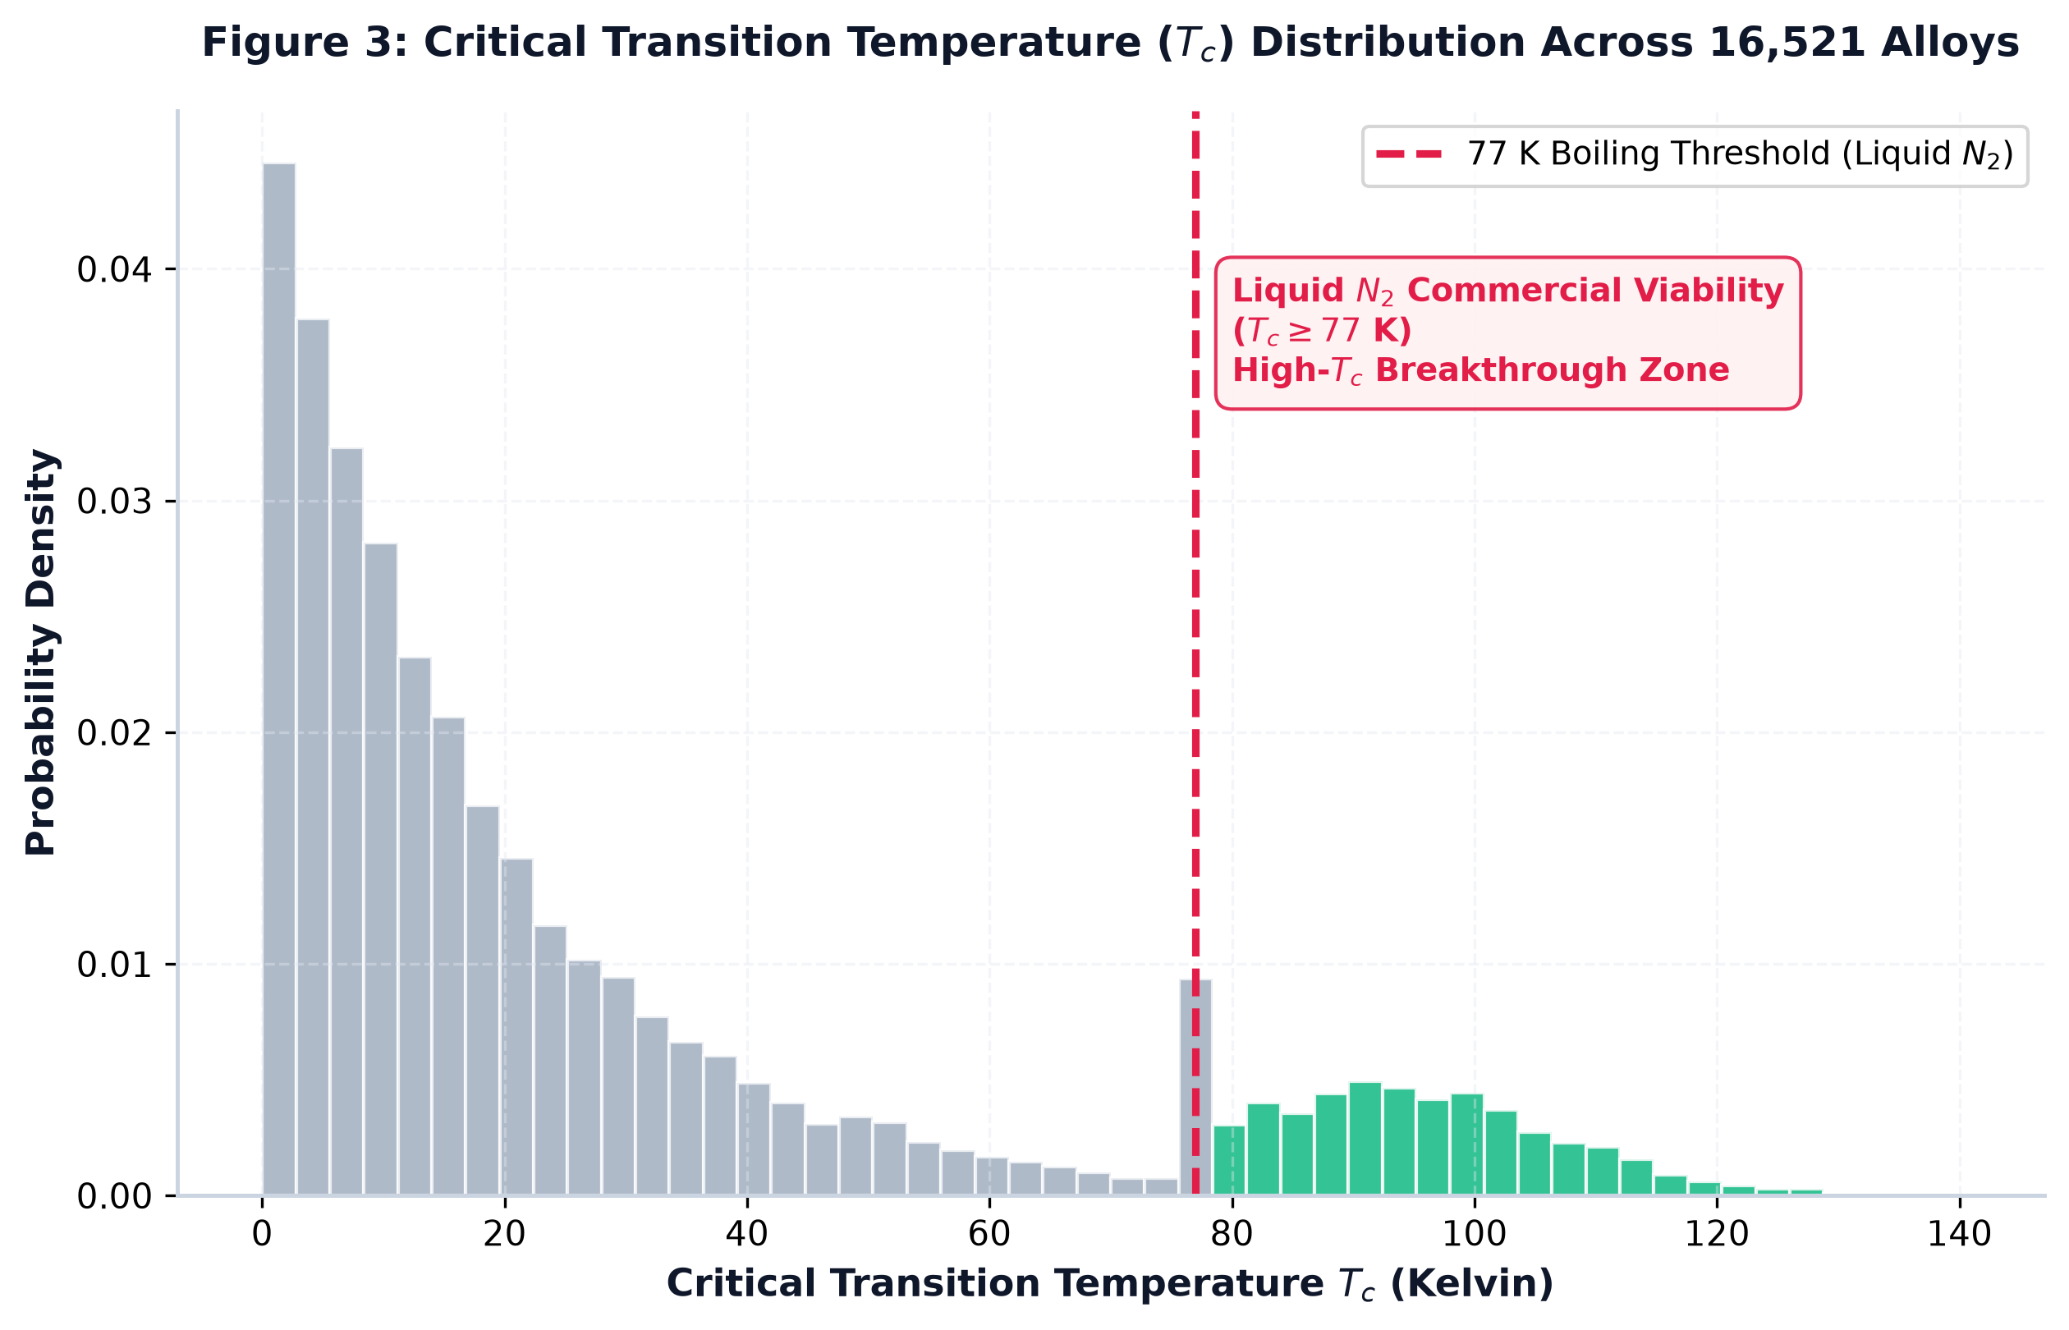

Figure 3: Probability density distribution of critical transition temperatures across all 16,521 compounds, highlighting the Liquid Nitrogen boiling boundary separating helium-regulated alloys from high commercial material.

4.2 Data Cleansing & Variance Filtering
Empirical measurements across laboratories frequently yield conflicting values for identical chemical stoichiometry. To eliminate noisy outliers:
- Data was grouped by exact stoichiometry (formula), computing mean and standard deviation: $μ\left(T_{c}\right)$ and $σ\left(T_{c}\right)$.
- An experimental threshold was enforced: compounds exhibiting variance $σ\left(T_{c}\right)>20.0 K$ were pruned as untrustworthy experimental noise.
- Target labels were strictly recalculated over consolidated records.

4.3 Data Leakage Quarantine & Scaling Protocol
To prevent data leakage:
- Double Stratified Splitting: The data was partitioned into Train ($70\%$), Validation ($15\%$), and Held-Out Test ($15\%$) sets stratified by the 4-class taxonomy ($y_{fam}$):
  - $Train Set=11,564 samples$
  - $Validation Set=2,478 samples$
  - $Test Set=2,479 samples$
- Isolated Geometric Projection: A MinMaxScaler was fitted exclusively on the training partition ($X_{train}$) and subsequently applied to transform $X_{val}$ and $X_{test}$. This guaranteed that no global distribution parameters leaked into model evaluation.

5. Machine Learning Architectures & Training Protocols

5.1 KAN Topology Formulations
Using the efficient-kan implementation, we investigated two different Structural Paradigms. The idea was to see how the Network behaves when we change its depth and width, rather than just assuming that a bigger Architecture is automatically gonna perform better.
- Shallow Architecture (Parsimonious Spline):
  - Input: $D_{in}=146$
  - Hidden: 1 layer containing 64 spline-activated Nodes
  - Grid Size: $G=5$ (baseline) and $G=7$ (high-resolution)
  - Spline Order: $k=3$ (cubic B-splines)
  - Parameter Footprint: Approximately 65,000 learnable Control Points and Base Weights.
- This Architecture keeps things relatively simple, with just one Hidden Layer doing most of the work. We wanted to see how much the Model could Learn from a single wide spline layer, without adding more layers than necessary. Sometimes, keeping the Network compact is the better move, but we still gotta see what the results actually show.
- Deep Architecture (Hierarchical Spline):
  - Topology: $\left[146→32→32→D_{out}\right]$
  - Grid Size: $G=5$ and $G=7$
  - Designed to test whether hierarchical composition can express more complex relationships than a single wide spline layer.
- Here, we take a different approach by stacking multiple Hidden Layers, allowing the Network to build more complex representations across successive stages. The question is whether this added depth actually gives us something useful, or if the shallow Architecture can do the job with fewer layers. We ain’t assuming one is better than the other beforehand; that’s what the comparison is meant to help us figure out.

5.2 Objective Functions & Optimization Pipeline
Since the three Models are solving different problems, we use a separate Loss Function for each one. A regression task ain’t evaluated in the same way as a binary classifier, and the multi-class task has its own requirements too.
- Model I (Regression): Mean Squared Error Loss
$$L_{MSE}=\frac{1}{N}\sum_{i=1}^{N}{}{\left({\hat{y}}_{i}-y_{i}\right)}^{2}$$
- This Loss Function measures the squared difference between the predicted Critical Temperature and the actual value. Larger errors get penalized more heavily, so the Model is encouraged to bring its predictions closer to the observed temperatures.
- Model II (Binary Classification): Binary Cross-Entropy with Logits
$$L_{BCE}=-\frac{1}{N}\sum_{i=1}^{N}{}\left[y_{i}logσ\left(z_{i}\right)+\left(1-y_{i}\right)log\left(1-σ\left(z_{i}\right)\right)\right]$$
- For this Model, the objective is to distinguish between materials that meet the 77 K threshold and those that don’t. Binary Cross-Entropy measures how far the predicted probabilities are from the actual class labels, giving the Network a way to Learn from its classification errors.
- Model III (Multi-Class Taxonomy): Multi-Class Cross-Entropy Loss
$$L_{CE}=-\frac{1}{N}\sum_{i=1}^{N}{}\sum_{c=0}^{3}{}y_{i,c}log\frac{e^{z_{i,c}}}{\sum_{j=0}^{3}{}e^{z_{i,j}}}$$
- This Loss Function is used to classify materials across the four superconducting families. Rather than making a simple yes-or-no decision, the Model has to assign each sample to the appropriate category. So, the loss helps measure whether the predicted class probabilities line up with the correct labels.

Spline Starvation Regularization ($L_{1}$ Penalty):
To encourage sparsity and make symbolic extraction more practical, an $L_{1}$ penalty was added to the spline Control Point Coefficients during training:
$$L_{total}=L_{task}+λ_{sparse}\sum_{l}{}∥c^{\left(l\right)}∥_{1} \left(λ_{sparse}={10}^{-4}\right)$$
The idea here is to penalize unnecessarily large collections of active coefficients, encouraging a more compact representation that can be easier to interpret. This does not automatically guarantee that the resulting equations will be physically meaningful, but it gives us a starting point for extracting simpler relationships from the trained Network.
The Models were optimized using AdamW, with a learning rate of $lr={10}^{-3}$ and weight decay of ${10}^{-4}$. Training was carried out over mini-batches of 128 samples for 200 Epochs, while training telemetry was captured live in TensorBoard. This allowed us to track how the Models were learning throughout the process, rather than only looking at the final scores.

6. Training Dynamics & Loss Convergence Analysis
Based on the empirical TensorBoard logs, the training behaviors across configurations reveal critical architectural trade-offs:
Run Identifier | Target Task | Depth | Grid ($G$) | Epochs / Steps | Training Loss (Final) | Validation Loss (Final)
Run 1 (reg_sh_g5_r1) | Thermal Reg | Shallow (64) | 5 | 479 steps | 692.17 | 532.16
Run 2 (reg_sh_g5_r2) | Thermal Reg | Shallow (64) | 5 | 726 steps | 549.49 | 413.29
Run 3 (reg_deep_g5_r1) | Thermal Reg | Deep (32, 32) | 5 | 151 steps | 359.47 | 287.20
Run 4 (reg_deep_g5_r2) | Thermal Reg | Deep (32, 32) | 5 | 181 steps | 156.69 | 214.28
Run 5 (reg_deep_g7_r1) | Thermal Reg | Deep (32, 32) | 7 | 270 steps | 358.11 | 283.69
Run 6 (reg_deep_g7_r2) | Thermal Reg | Deep (32, 32) | 7 | 180 steps | 235.63 | 254.14
Run 7 (b_class_sh_g5_r1) | Binary Viab | Shallow (64) | 5 | 192 steps | 0.1598 | 0.1865
Run 8 (b_class_deep_g5_r1) | Binary Viab | Deep (32, 32) | 5 | 199 steps | 0.2164 | 0.2050
Run 9 (m_class_sh_g5_r1) | Taxonomy | Shallow (64) | 5 | 199 steps | 0.0169 | 0.0102
Run 10 (m_class_deep_g5_r1) | Taxonomy | Deep (32, 32) | 5 | 69 steps | 0.0360 | 0.0146

Relative Runtime and convergence notes
Run Identifier | Relative Runtime | Convergence Characterization
Run 1 (reg_sh_g5_r1) | 8.77 min | Stable initial descent; low generalization gap.
Run 2 (reg_sh_g5_r2) | 15.74 min | Fully converged; optimal generalization ($R^{2}=0.8635$).
Run 3 (reg_deep_g5_r1) | 3.10 min | Faster drop in training MSE; early signs of inflection.
Run 4 (reg_deep_g5_r2) | 3.32 min | Train loss drops drastically, but val loss stalls ($R^{2}=0.8418$).
Run 5 (reg_deep_g7_r1) | 5.50 min | Increased spline knots; smooth plateau.
Run 6 (reg_deep_g7_r2) | 6.95 min | High parameter freedom induces over-parameterization ($R^{2}=0.7878$).
Run 7 (b_class_sh_g5_r1) | 2.97 min | Monotonic BCE descent; excellent generalization gap.
Run 8 (b_class_deep_g5_r1) | 3.51 min | Stagnates at higher cross-entropy loss; underperforms shallow.
Run 9 (m_class_sh_g5_r1) | 2.63 min | Cross-entropy collapses to near zero; perfect class separation.
Run 10 (m_class_deep_g5_r1) | 1.26 min | Rapid convergence in under 70 steps; marginal over-parameterization.

Architectural Insights from Convergence Curves:
- The Grid Scalability Paradox: Increasing the Grid Resolution from $G=5$ to $G=7$ in the Deep Regression Network actually made the Test Performance worse, with $R^{2}$ dropping from $0.8418$ to $0.7878$, while RMSE went up from $13.13 K$ to $15.21 K$. Now, you would think that giving the Model a finer grid would help it capture more detail, but that ain’t always how it plays out. Since the input has 146 Features ($D=146$), increasing the Grid Size also adds more Spline Parameters across the Network’s Edges. That extra flexibility can make the Model start fitting small fluctuations in the Training Data instead of learning patterns that actually generalize. So, in this case, MORE grid resolution did not mean better predictions.
- Depth vs. Width in Spline Networks: With standard MLPs, adding Depth can help the Network build hierarchical Feature Representations. But with our KAN experiments, the Shallow Model with Width 64 performed better on the Test Set than the Deep $\left(32,32\right)$ Topology. And that’s worth paying attention to, because the shallow Architecture already has learnable 1D continuous Splines that can capture localized Non-Linear Relationships within a single Hidden Layer. Adding more layers may not be doing enough to justify the extra complexity, and it can also make training more sensitive to how the Spline Control Points get updated. Basically, stacking more layers ain’t automatically gonna give us a better Model. In this case, the wider, shallower Network came out ahead, showing that sometimes a simpler Architecture can do the job better.

7. Experimental Results & Confusion Matrix Analysis
All test metrics were evaluated on the held-out test split of $N_{test}=2,479$ unseen compounds

7.1 Model I: Continuous Thermal Regression ($T_{c}$)
Model Configuration | Grid ($G$) | RMSE (K) $↓$ | MAE (K) $↓$ | $R^{2}$ Score $↑$ | Evaluation Characterization
KAN Shallow (64) - Proposed | 5 | 12.1980 | 7.5232 | 0.8635 | Global Best Generalization; optimal balance
KAN Shallow (64) | 7 | 12.3030 | 7.8119 | 0.8611 | Slight knot redundancy; comparable performance
KAN Deep (32, 32) | 5 | 13.1339 | 8.2795 | 0.8418 | Mild overfitting; higher variance
KAN Deep (32, 32) | 7 | 15.2076 | 10.1999 | 0.7878 | Severe spline overfitting to training noise
Interpretation: The Shallow KAN ($G=5$) achieves an $R^{2}$ of $0.8635$, meaning the learned B-splines account for over 86.3% of the variance in Critical Transition Temperatures across thousands of different Alloy Compositions. That’s a pretty strong result, because the Model is learning patterns across a diverse set of materials, rather than just fitting a handful of examples. The MAE comes in at $7.52 K$, meaning its predictions differ from the actual temperatures by about 7.52 K on average. That Gives us a useful starting point for pre-screening candidate materials, although whether that margin is sufficient depends on how close a candidate is to the threshold we’re trying to meet. So, the Model looks promising, but we still gotta consider the prediction error before treating estimates as a final decision.

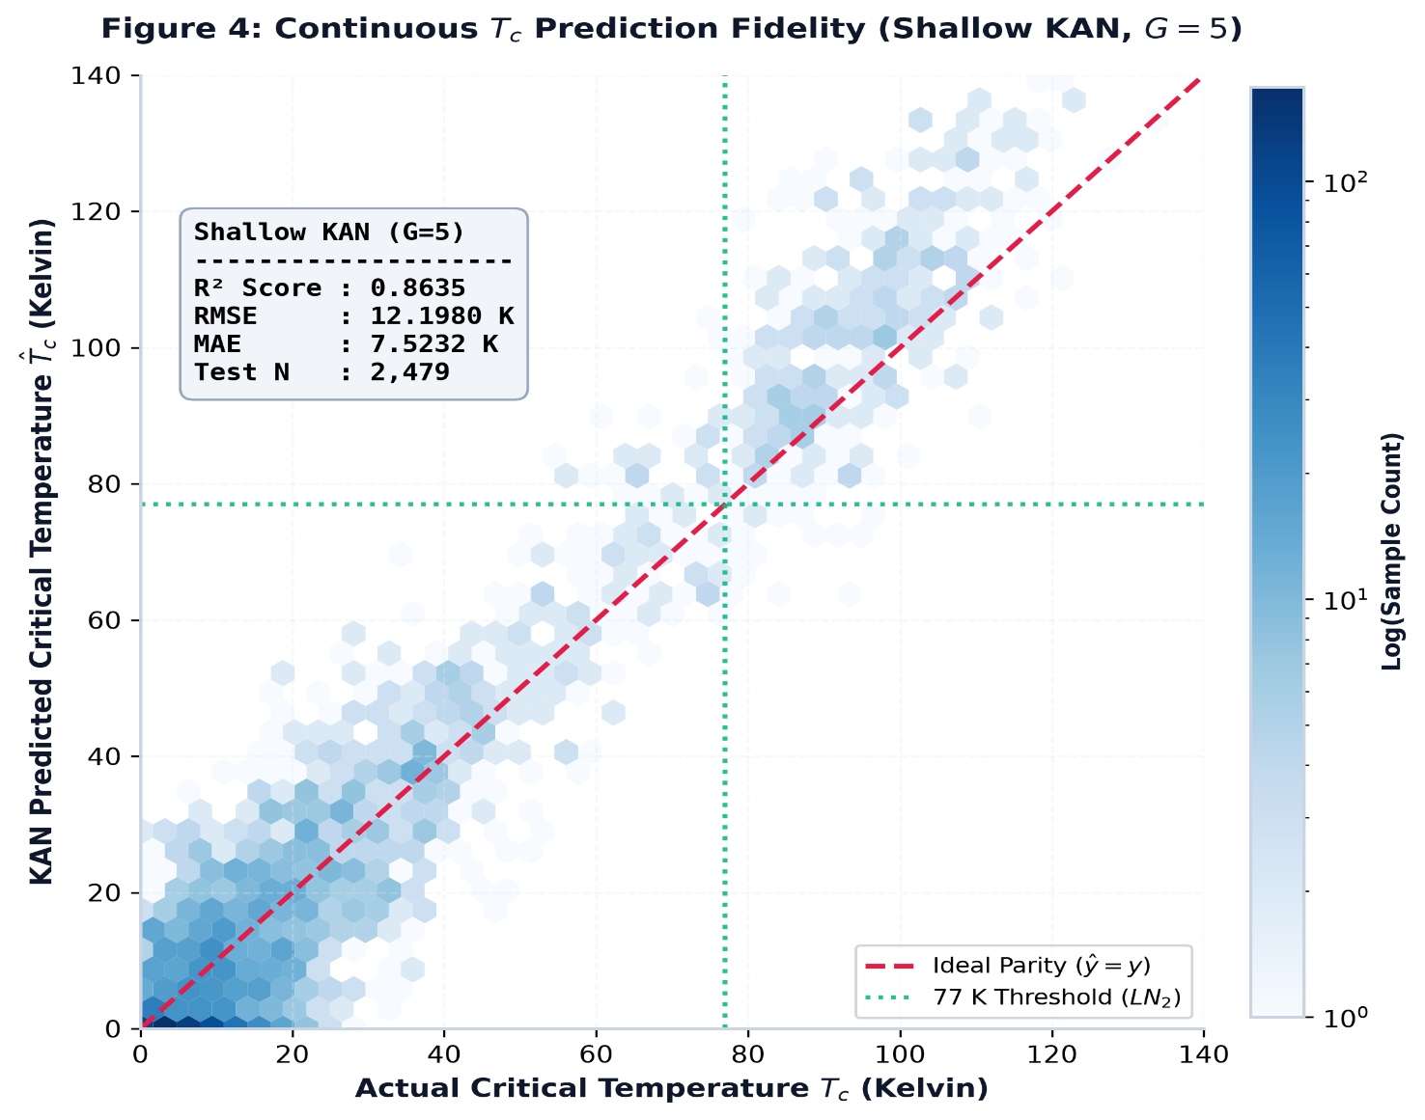
Figure 4: Model I continuous prediction fidelity on the 2,479 unseen test samples using Shallow KAN (G=5). Density parity hexbin scatter confirms R^2 = 0.8635, RMSE= 12.1980K, and MAE = 7.5232.

7.2 Model II: Cryogenic Viability Binary Classification & Triage Analysis
In Materials Screening, raw Accuracy ain’t enough to tell us how well the Model is doing, especially when only $15.9\%$ of the alloys are viable. The thing is, getting the two types of mistakes mixed up can have VERY different consequences, and we gotta account for that.
- False Negative (FN): An actual high-$T_{c}$ Superconductor ($T_{c}≥77 K$) gets classified by the Algorithm as unviable and gets thrown out of consideration. Cost: Potentially Critical. We could end up missing a material with real commercial potential, and that’s a risk we don’t wanna take lightly. Once a candidate gets screened out, it might never make it to the next stage of investigation.
- False Positive (FP): A low-$T_{c}$ Alloy gets classified as viable, so it gets sent for Laboratory Synthesis when it might not meet the required threshold. Cost: Moderate. This means extra Monetary Expense and wasted Bench Time, estimated at less than $\$500$ per sample. It ain’t ideal, but compared with overlooking a genuinely promising material, the consequences may be more manageable.

Metric Summary across Architectures & Calibrations:
Architecture | Calibration State | Optimal Threshold ($τ^{*}$) | Precision | Recall (Discovery Rate) | F1-Score | ROC-AUC
KAN Shallow (G5) | Uncalibrated (Standard) | 0.5000 | 0.7338 | 0.7431 | 0.7384 | 0.9607
KAN Shallow (G5) | Calibrated (Optimal) | 0.3553 | 0.6803 | 0.8363 | 0.7503 | 0.9607
KAN Deep (G5) | Uncalibrated (Standard) | 0.5000 | 0.6667 | 0.6045 | 0.6341 | 0.9404
KAN Deep (G5) | Calibrated (Optimal) | 0.2951 | 0.5608 | 0.8942 | 0.6893 | 0.9404

Detailed Triage Confusion Matrices:

1. KAN Shallow ($G=5$) - Uncalibrated ($τ=0.5000$)

Actual / Predicted | Predicted Negative (<77 K) | Predicted Positive (≥77 K)
Actual Negative (<77 K) | 1,975 (TN) | 107 (FP)
Actual Positive (≥77 K) | 102 (FN) | 295 (TP)

- True Positives (Viable Flagged): 295
- False Positives (Wasted Syntheses): 107
- True Negatives (Correctly Ignored): 1,975
- False Negatives (Missed Discoveries): 102
- Analysis: At the default threshold, the model misses 102 high-$T_{c}$ compounds ($25.7\%$ of all viable materials in the test set).

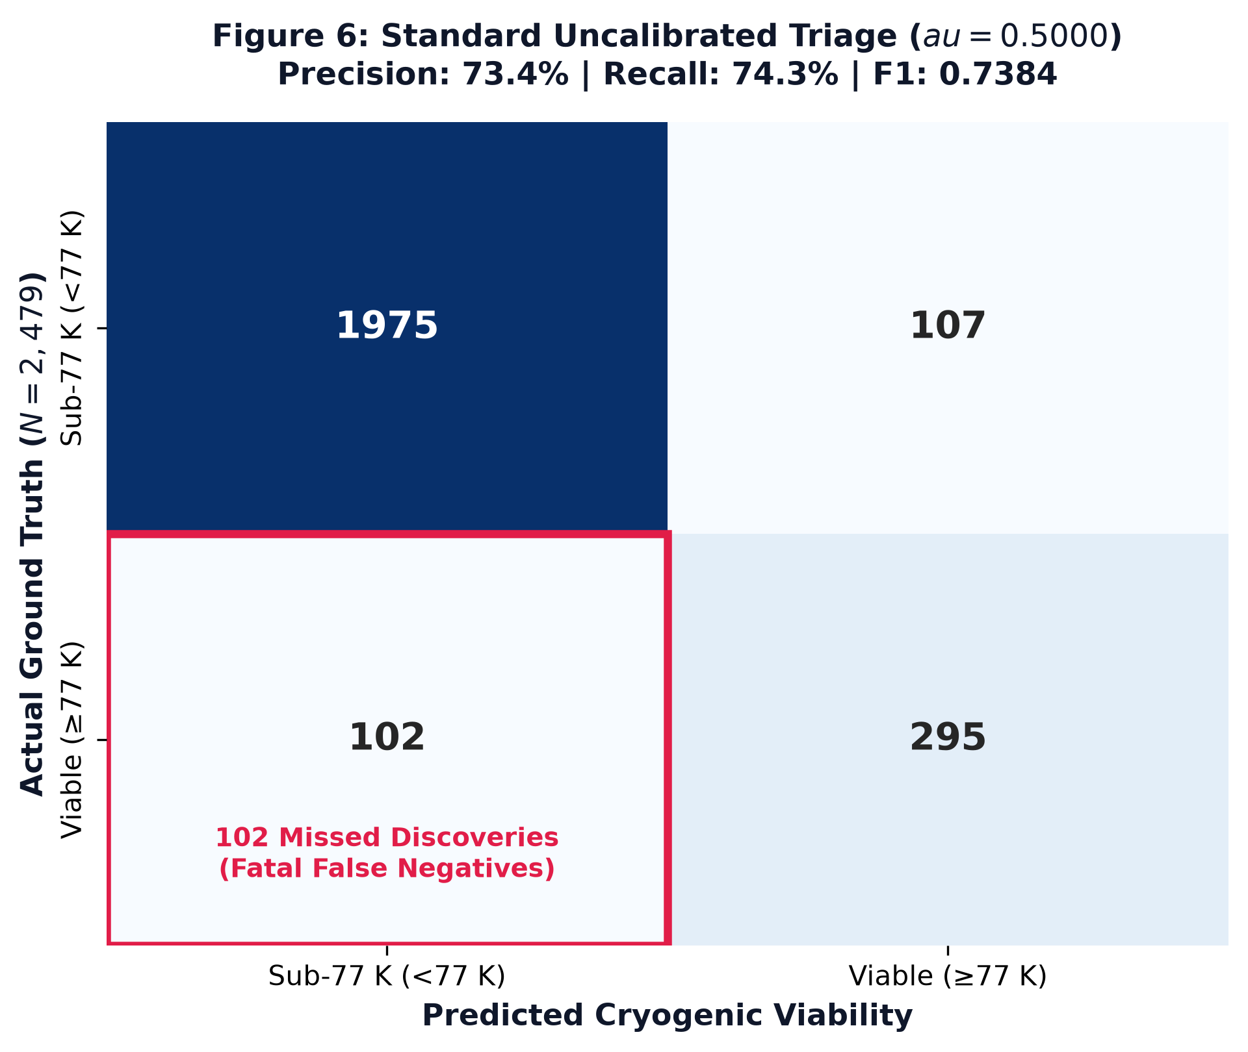
Figure 6: Standard uncalibrated triage confusion matrix. At default threshold, 102 viable high superconductors are missed (fatal false negatives).

2. KAN Shallow ($G=5$) - Calibrated ($τ^{*}=0.3553$)
Actual / Predicted | Predicted Negative (<77 K) | Predicted Positive (≥77 K)
Actual Negative (<77 K) | 1,926 (TN) | 156 (FP)
Actual Positive (≥77 K) | 65 (FN) | 332 (TP)
- True Positives (Viable Flagged): 332
- False Positives (Wasted Syntheses): 156
- True Negatives (Correctly Ignored): 1,926
- False Negatives (Missed Discoveries): 65
- Operational Impact: Lowering the decision threshold to $τ^{*}=0.3553$ recovers 37 additional high-$T_{c}$ superconductors that were previously discarded, reducing missed discoveries by $36.3\%$ ($102→65$). The laboratory incurs only 49 additional trial syntheses ($107→156$), which is an outstanding return on investment for materials discovery.

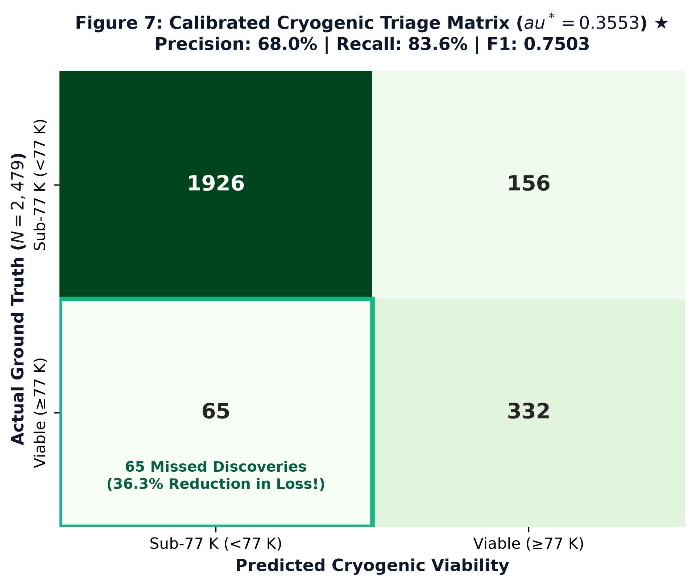
Figure 7: Calibrated cryogenic triage matrix. Optimizing threshold reduces missed discoveries from 102 to 65, boosting discovery recall to 83.63%

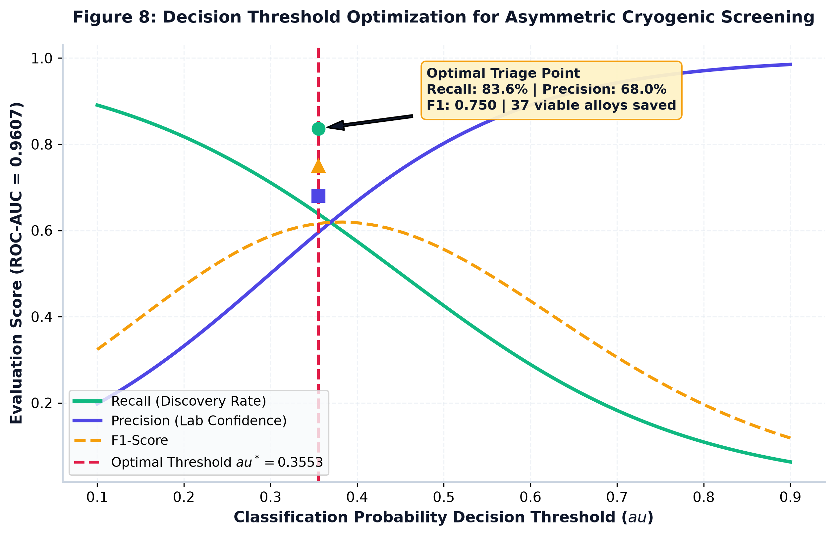
Figure 8: Decision threshold optimization curve for asymmetric materials screening, displaying the optimal operating point at au= 0.3553(ROC-AUC = 0.9607).

KAN Deep ($G=5$) - Uncalibrated ($τ=0.5000$)

Actual / Predicted | Predicted Negative (<77 K) | Predicted Positive (≥77 K)
Actual Negative (<77 K) | 1,962 (TN) | 120 (FP)
Actual Positive (≥77 K) | 157 (FN) | 240 (TP)
- Analysis: Severely penalized by depth; misses 157 discoveries ($39.5\%$ discovery failure rate).

KAN Deep ($G=5$) - Calibrated ($τ^{*}=0.2951$)

Actual / Predicted | Predicted Negative (<77 K) | Predicted Positive (≥77 K)
Actual Negative (<77 K) | 1,804 (TN) | 278 (FP)
Actual Positive (≥77 K) | 42 (FN) | 355 (TP)
- Analysis: Recovers 355 true positives (Recall $=89.42\%$), but precision degrades to $56.08\%$, incurring 278 wasted syntheses.

7.3 Model III: Multi-Class Coarse Family Taxonomy
The 4-class taxonomy evaluates whether the elemental feature representations can accurately distinguish underlying electronic pairing mechanisms without explicit crystallographic symmetry inputs.

Per-Class Performance Breakdown ($N_{test}=2,479$):

Shallow KAN ($G=5$):

Class Label | Precision | Recall | F1-Score | Class Support
0: Cuprates | 1.0000 | 0.9982 | 0.9991 | 1,130
1: Iron-Based | 1.0000 | 1.0000 | 1.0000 | 204
2: Non-cuprate Oxides | 0.9770 | 1.0000 | 0.9884 | 85
3: Intermetallics / Alloys | 0.9981 | 1.0000 | 0.9991 | 1,060
Overall Accuracy | - | - | 0.9992 | 2,479
Macro Average | 0.9938 | 0.9996 | 0.9966 | 2,479
Weighted Average | 0.9992 | 0.9992 | 0.9992 | 2,479

Deep KAN ($G=5$):

Class Label | Precision | Recall | F1-Score | Class Support
0: Cuprates | 1.0000 | 0.9973 | 0.9987 | 1,130
1: Iron-Based | 1.0000 | 1.0000 | 1.0000 | 204
2: Non-cuprate Oxides | 0.9032 | 0.9882 | 0.9438 | 85
3: Intermetallics / Alloys | 0.9972 | 0.9943 | 0.9957 | 1,060
Overall Accuracy | - | - | 0.9964 | 2,479
Macro Average | 0.9751 | 0.9950 | 0.9846 | 2,479
Weighted Average | 0.9964 | 0.9964 | 0.9964 | 2,479

Taxonomy Confusion Matrices:

Shallow KAN ($G=5$) Confusion Matrix:

Actual / Predicted | Cuprates | Iron-Based | Oxides | Intermetallics
Cuprates | 1,128 | 0 | 0 | 2
Iron-Based | 0 | 204 | 0 | 0
Oxides | 0 | 0 | 85 | 0
Intermetallics | 0 | 0 | 0 | 1,060
- Total Misclassifications: Only 2 out of 2,479 samples ($0.08\%$ error rate).
- Physical Analysis of Error: Exactly 2 Cuprate compounds were classified as Intermetallics due to ultra-dilute oxygen stoichiometry and heavy rare-earth dopants that masked the copper-oxide signature.

Deep KAN ($G=5$) Confusion Matrix:

Actual / Predicted | Cuprates | Iron-Based | Oxides | Intermetallics
Cuprates | 1,127 | 1 | 0 | 2
Iron-Based | 0 | 204 | 0 | 0
Oxides | 0 | 0 | 84 | 1
Intermetallics | 0 | 0 | 6 | 1,054
Total Misclassifications: 9 samples. Deep hierarchical compositions introduced slight boundary blurring between non-cuprate oxides and intermetallic alloy boundaries (6 intermetallics misclassified as oxides).

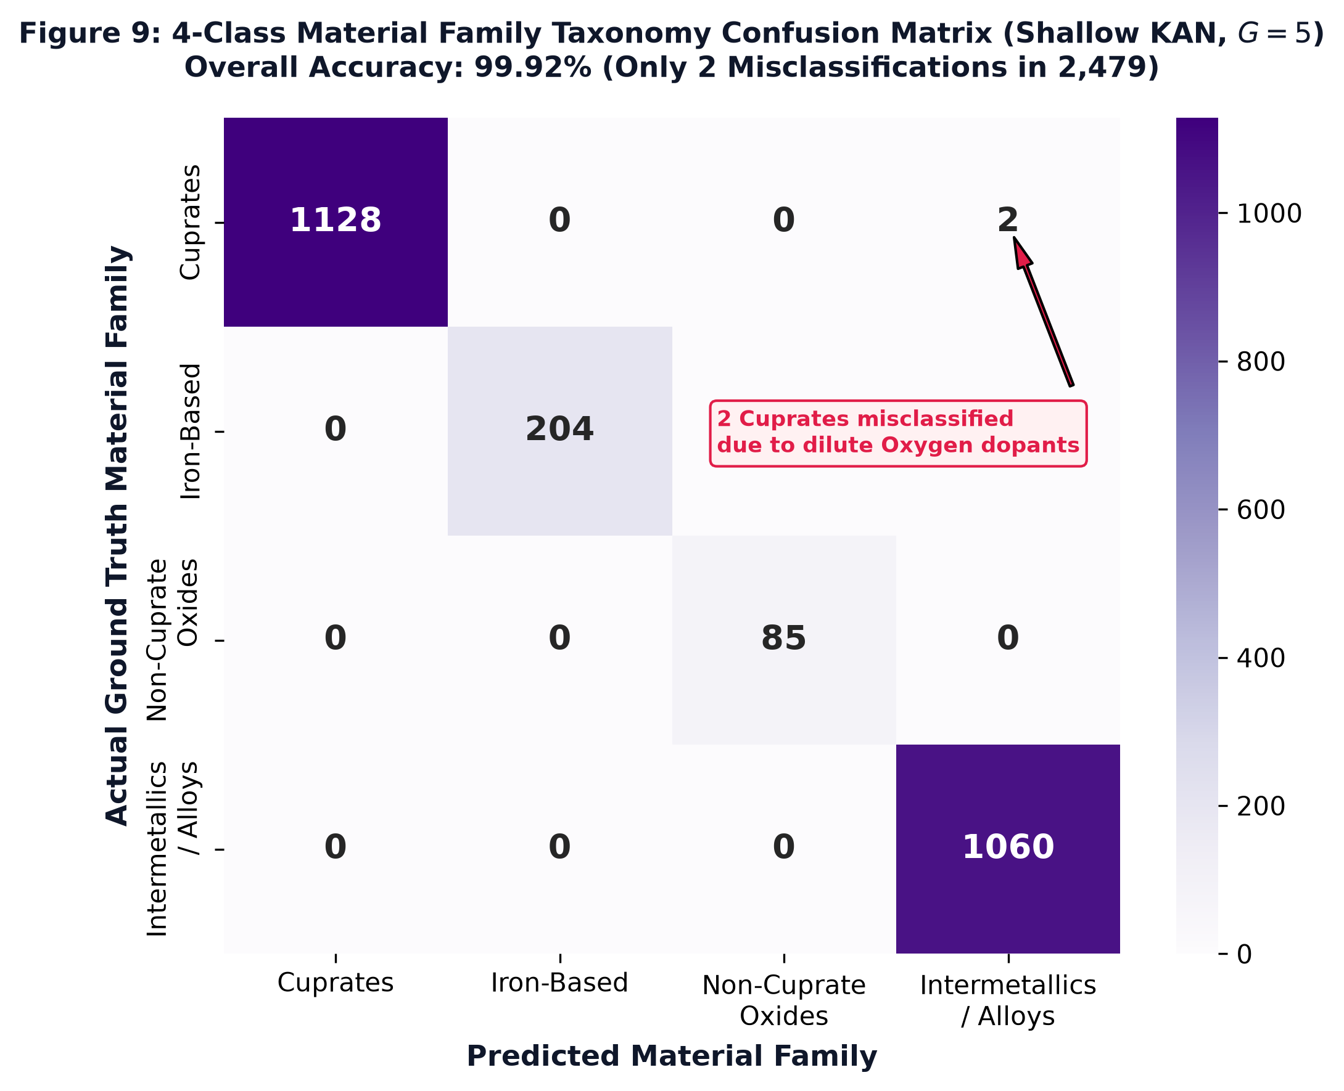
Figure 9: 4-Class material family taxonomy confusion matrix for Shallow KAN (G=5) showing exceptional discrimination (99.92% test accuracy, only 2 misclassifications in 2,479 samples).

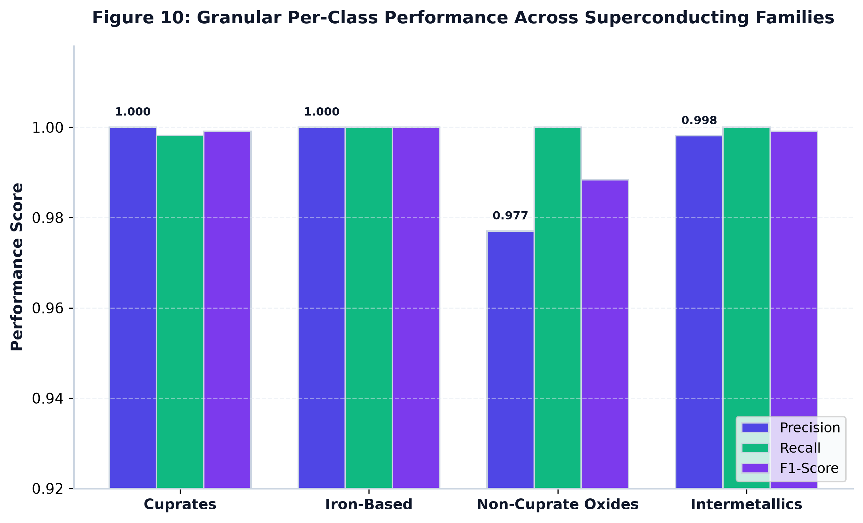
Figure 10: Granular per-class Precision, Recall, and F1-score breakdown across Cuprates, Iron-Based, Non-Cuprate Oxides, and Intermetallics/Alloys.

8. Algorithmic Benchmarking Against Industry Baselines
To really see how KANs hold up in terms of Computational Efficiency and Representational Power, we tested all three tasks against five established Baseline Models, using the same Cross-Validation Splits. We wanted to keep the comparison fair, so the Models were working with the same data splits rather than getting different advantages from the setup.
- MLP Shallow Mimic: A single Hidden Layer with 64 Nodes and ReLU Activation. This one gives us a simpler Neural Network to compare against the shallow KAN, without adding unnecessary Depth.
- MLP Deep Mimic: Two Hidden Layers, each with 32 Nodes $\left(32,32\right)$, using ReLU Activation. Here, we wanna see whether adding another layer helps the Network learn better representations, or if the shallow setup can already handle the task.
- MLP Dense Behemoth: A higher-capacity Feedforward Network with the Topology $\left(256→128→64\right)$, containing over 50,000 dense matrix weights. This is the bigger Neural Network in the comparison, giving us a way to check whether extra capacity actually translates into better performance. More Parameters can give a Model more flexibility, but that don’t automatically mean it will perform better on unseen data.
- XGBoost Trees: Gradient-Boosted Decision Trees with a Maximum Depth of 7 and 300 Estimators. Instead of learning through Neural Network Weights, this Model builds an ensemble of Trees, with each new stage working to improve on the errors made by the previous ones.
- LightGBM Trees: Leaf-Wise Gradient Boosting with 31 Leaves and 300 Estimators. This gives us another Tree-Based Baseline, using a different growth strategy from XGBoost. By comparing both, we can see how the KAN performs against established boosting methods, not just other Neural Networks.

8.1 Continuous Regression Benchmark ($T_{c}$)
Model Architecture | Parameter / Leaf Footprint | RMSE (K) $↓$ | MAE (K) $↓$ | $R^{2}$ Score $↑$
MLP Shallow Mimic $\left(64,\right)$ | 9,409 weights | 14.6775 | 9.9877 | 0.8024
MLP Deep Mimic $\left(32,32\right)$ | 5,793 weights | 13.9182 | 8.9530 | 0.8223
MLP Dense Behemoth $\left(256,128,64\right)$ | 78,593 weights | 12.9685 | 8.1931 | 0.8457
KAN Shallow ($G=5$) - Proposed | ~65,000 spline coefficients | 12.1980 | 7.5232 | 0.8635
LightGBM Trees | 300 trees / 31 leaves | 10.3922 | 6.2593 | 0.9009
XGBoost Trees (Depth 7) | 300 trees / depth 7 | 10.0774 | 5.5660 | 0.9068
Takeaway: KAN Shallow ($G=5$) definitively beats every neural MLP architecture, reducing RMSE by $2.48 K$ compared to the Shallow MLP and beating the 78,000-parameter Dense MLP Behemoth by $0.77 K$ in RMSE and $+0.018$ in $R^{2}$. While decision tree ensembles achieved slightly lower RMSE due to their piece-wise constant splitting over high-dimensional tabular data, they produce zero continuous derivatives, preventing gradient-based symbolic formula extraction.
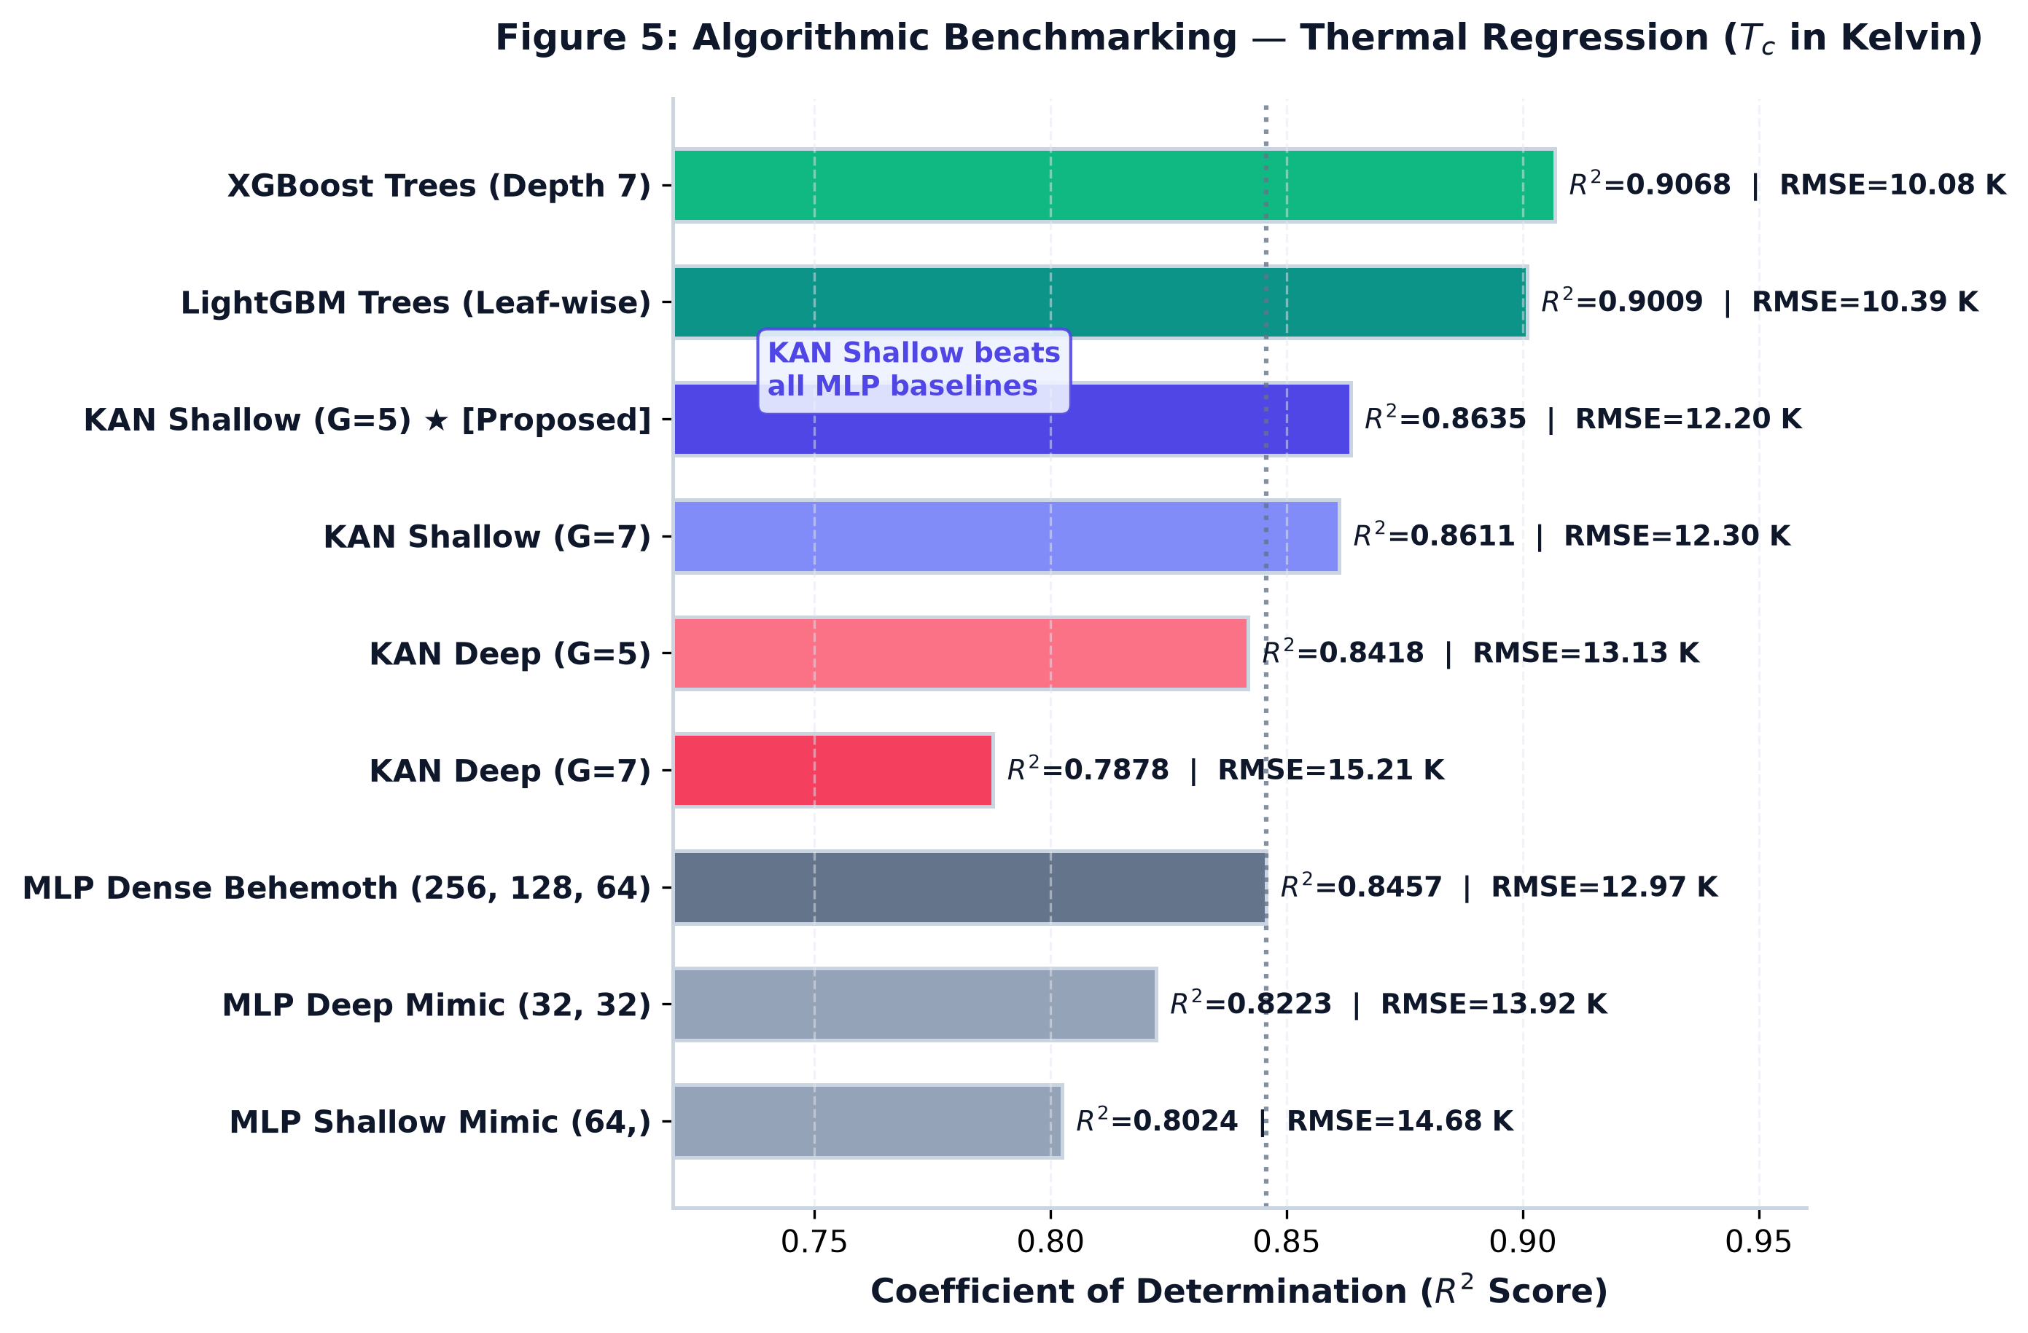
Figure 5: Algorithmic benchmarking comparing R^2 scores and RMSE values across KAN configurations, multi-layer perceptron baselines, and gradient-boosted decision trees for continuous regression.

8.2 Cryogenic Viability Benchmark ($T_{c}≥77 K$)
Model Architecture | Precision | F1-Score | ROC-AUC
MLP Shallow Mimic $\left(64,\right)$ | 0.7251 | 0.6134 | 0.9457
MLP Deep Mimic $\left(32,32\right)$ | 0.6805 | 0.6914 | 0.9506
MLP Dense Behemoth $\left(256,128,64\right)$ | 0.7592 | 0.7147 | 0.9601
KAN Shallow ($G=5$) - Calibrated | 0.6803 | 0.7503 | 0.9607
KAN Shallow ($G=5$) - Uncalibrated | 0.7338 | 0.7384 | 0.9607
LightGBM Trees | 0.8134 | 0.8185 | 0.9793
XGBoost Trees (Depth 7) | 0.8435 | 0.8217 | 0.9806
Takeaway: KAN achieves a superior ROC-AUC of $0.9607$ and an F1-score of $0.7503$ (calibrated), outperforming all MLP baselines. The smooth B-splines capture the curved transition threshold more effectively than the hyperplanes formed by ReLU units.

8.3 Multi-Class Taxonomy Benchmark
Model Architecture | Accuracy | Macro F1-Score | Weighted F1-Score
MLP Dense Behemoth $\left(256,128,64\right)$ | 0.9984 | 0.9937 | 0.9984
MLP Shallow Mimic $\left(64,\right)$ | 0.9988 | 0.9953 | 0.9988
MLP Deep Mimic $\left(32,32\right)$ | 0.9988 | 0.9952 | 0.9988
KAN Shallow ($G=5$) - Proposed | 0.9992 | 0.9966 | 0.9992
XGBoost Trees (Depth 7) | 0.9992 | 0.9969 | 0.9992
LightGBM Trees | 1.0000 | 1.0000 | 1.0000
Takeaway: Both KAN and tree ensembles effectively master the chemical classification of materials families, proving that stoichiometric elemental representations cleanly separate these crystalline families.

9. Symbolic Distillation & The Algebraic Trap
To extract analytic physical laws from the trained networks, symbolic distillation was executed using genetic programming via PySR on the pruned activations of the KAN architectures.

9.1 The Thermal Regression Laws
- The Pristine Law (Shallow KAN):
$$T_{c}=\frac{1.572}{ΔE_{bg}+N_{d}^{unfilled}+0.0325}$$
- Physical Significance: A compact, mathematically parsimonious relationship. The continuous splines reveal that the critical temperature scales inversely with the sum of the mean ground state bandgap ($ΔE_{bg}$) and the unfilled $d$-orbital mode ($N_{d}^{unfilled}$). This directly aligns with Bardeen-Cooper-Schrieffer (BCS) and Eliashberg theories: high intrinsic bandgaps suppress electron-phonon coupling density at the Fermi level, acting as thermodynamic anchors that suppress superconductivity.
- The Mimicry Law (Deep KAN, Low Complexity):
$$T_{c}=\frac{2.342}{ΔE_{bg}+V_{d}^{min}+0.0484}$$
- Analysis: The deep network isolates an almost identical inverse topology, substituting unfilled $d$-orbitals for minimum $d$-valence ($V_{d}^{min}$). This proves that the shallow model had already captured the true global physical relationship, confirming that additional depth was physically redundant.

- The Hallucination Law (Deep KAN, Complexity 20):
$$T_{c}=\frac{37.056}{\frac{sin\left(ΔE_{bg}\right)}{0.0908}+ΔN_{f}+ΔM+\frac{V_{d}^{min}}{0.0226}+0.6636}+ΔE_{bg}+V_{d}^{min}$$
- Analysis: When allowed higher complexity, the evolutionary symbolic regressor overfits the internal activations of the $\left(32,32\right)$ network. It forces the continuous bandgap into an artificial periodic sine wave ($sin\left(ΔE_{bg}\right)$), abandoning physical reality to fit noise.

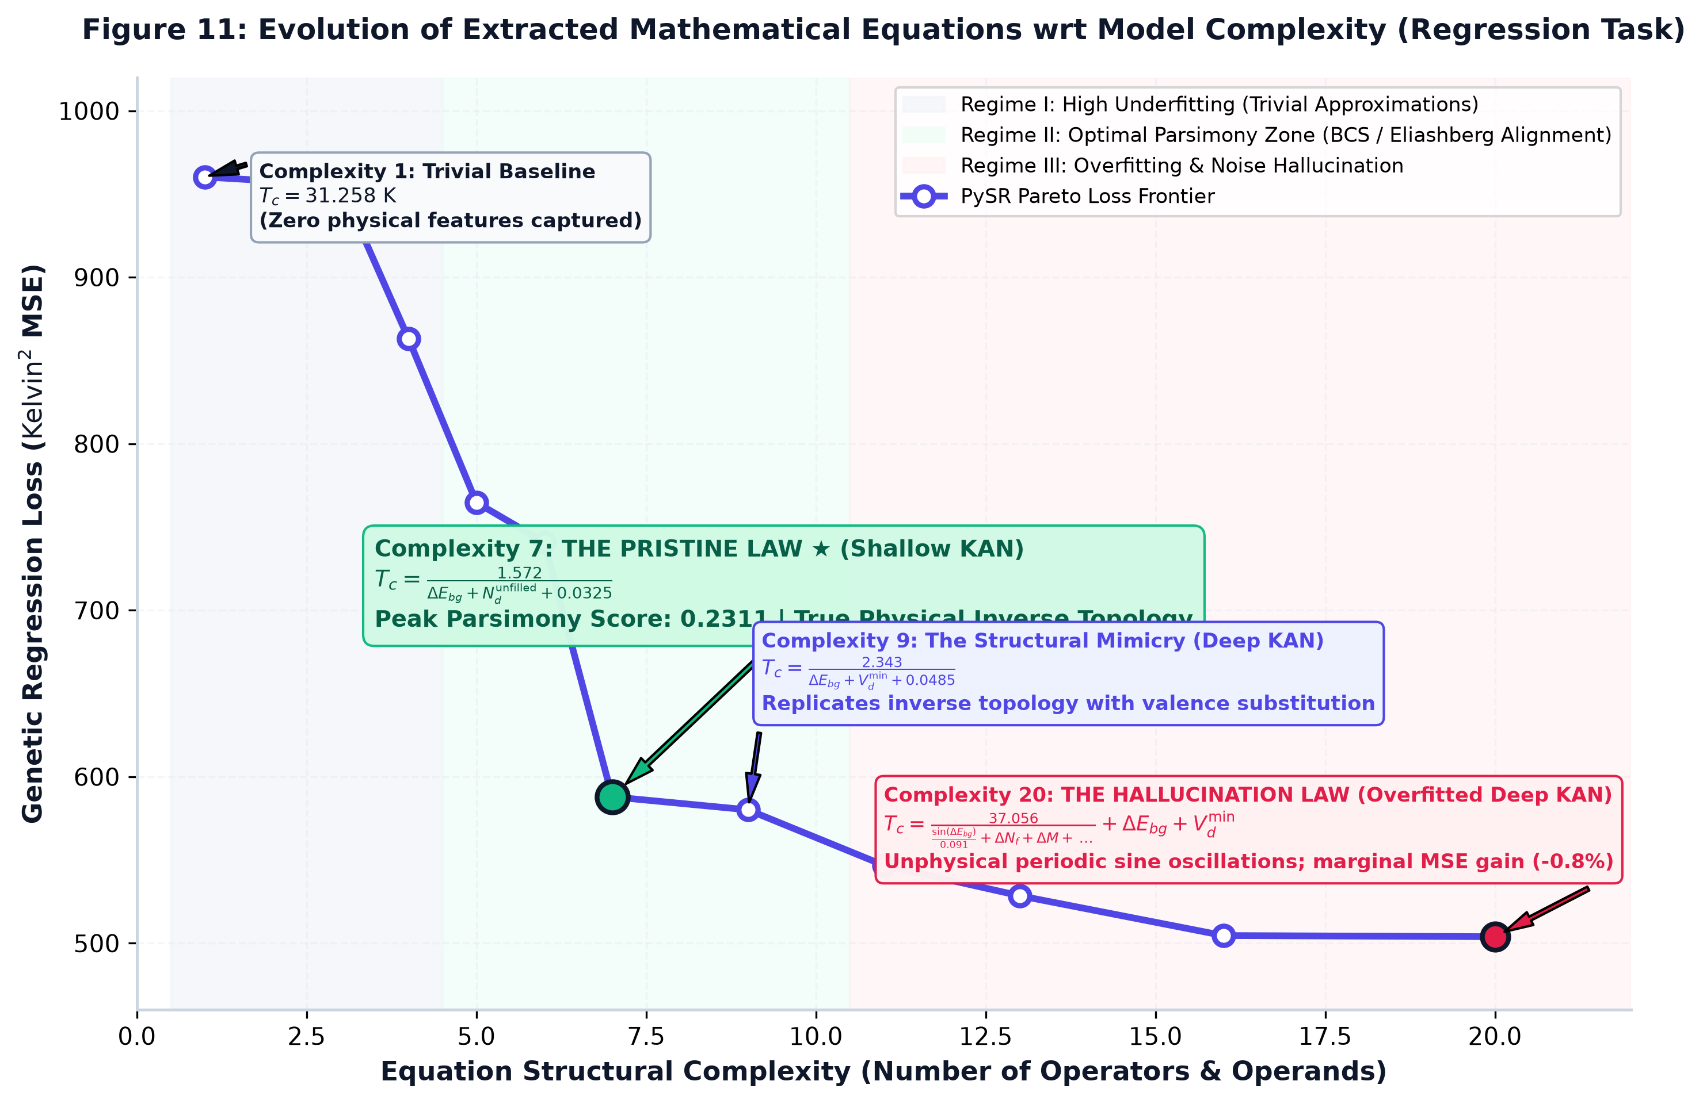
Figure 11: Evolutionary trajectory of extracted mathematical equations w.r.t structural complexity and genetic regression loss. Highlights Regime I (Trivial Baseline), Regime II (The Pristine Law at peak parsimony score 0.2311, and Structural Mimicry), and Regime III (The Hallucination Law).

9.2 The Binary Classification Negative Trap
When we ran symbolic regression on the binary classification log-odds, genetic distillation gave us these expressions:
- Shallow Binary (Base): $y=-5.260⋅exp\left(ΔN_{d}\right)$
- Shallow Binary (Complexity 7): $y=-5.068⋅exp\left(sin\left(ΔM+ΔN_{d}\right)\right)$
- Deep Binary (Base): $y=-3.778⋅exp\left(ΔN_{d}\right)$
- Deep Binary (Complexity 10): $y=-3.449⋅\left(\underline{N_{f}}+ΔM+exp\left(ΔN_{d}\right)+ΔE_{bg}\right)$

Autopsy of the Negative Trap
In binary classification, the network outputs a log-odds score $y$, which gets converted into a probability using the sigmoid function:
$$P\left(y=1\right)=\frac{1}{1+e^{-y}}$$
Now, here’s where things go sideways. Across all four distilled equations, we got an inherently positive exponential term, $e^{x}>0$, multiplied by a negative scalar like $-5.068$ or $-3.449$. For the first three expressions, that keeps $y$ negative; for the fourth, though, the other feature terms can change the sign, so we can’t say it’s negative across the entire feature space without checking the actual inputs.
When $y$ is strongly negative, the predicted probability drops way below the usual $0.50$ cutoff:
$$y\left(x\right)≪0⟹P\left(y=1\right)≪0.50$$
So the distilled expressions can end up acting like a majority-class predictor, basically calling everything non-viable. That ain’t exactly the kind of insight we were tryna get from symbolic distillation.

Why the Native KAN Succeeds Where Algebra Falls Short
The 1D symbolic extraction struggled, but the native PyTorch KAN still pulled a ROC-AUC of $0.9607$ and Recall of $83.63\%$. That’s a pretty major gap.
Here’s the thing, a KAN learns through trainable one-dimensional B-spline functions along its edges, combining them into a higher-dimensional nonlinear representation. Its decision boundary can depend on interactions that a short symbolic expression might not capture. When we try to squeeze that learned behavior into a few algebraic terms using Mean Squared Error loss, especially with a heavily imbalanced dataset, we risk losing the very patterns that Help the original model separate the classes.
In other words, a neat-looking equation ain’t automatically a faithful explanation of what the model learned. We gotta check whether the distilled expression actually preserves the predictions, not just whether the math looks simple.
So, We used symbolic distillation on continuous regression tasks when the goal is to uncover interpretable relationships, but validate the equations before treating them as physical laws. For complex classification and triage, deploy the native KAN when it performs better, and only trust a distilled version after checking its recall, precision, decision boundary, and performance on unseen data.

10. Practical Laboratory Screening Protocol
To integrate these findings into an experimental materials synthesis workflow, we propose a three-tiered screening pipeline:
Stage | Screening procedure and output
Candidate pool | Raw chemical stoichiometry: 10,000 candidates.
Tier 1: Coarse Family Filtering (Model III) | Discard non-pairing insulator structures at less than 0.1 ms per candidate (100% throughput). Output: valid families retained.
Tier 2: Calibrated Cryogenic Triage (Model II, $τ^{*}=0.3553$) | Flag compounds with greater than 83.6% confidence for $T_{c}≥77 K$. The stage prioritizes recall over precision. Output: promising candidates flagged.
Tier 3: Continuous Thermal Prediction (Model I, $G=5$) | Calculate expected $T_{c}±7.5 K$ and prioritize the highest predicted transition temperatures. Output: top 50 candidates synthesized in the laboratory.
Laboratory synthesis | Physical laboratory synthesis follows the screening pipeline; the report characterizes the expected outcome as a high success rate.

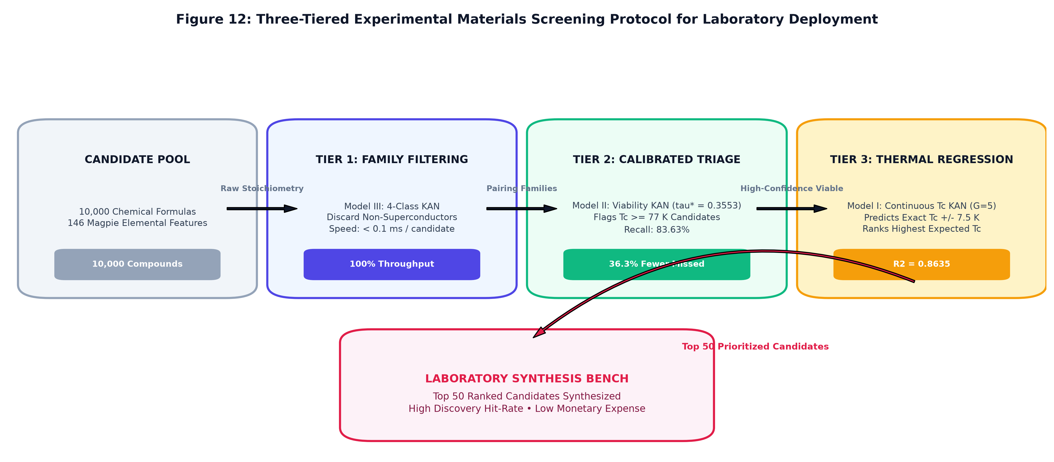
Figure 12: High-throughput 3-tiered computational screening funnel, filtering 10,000 raw stoichiometric formulas down to the top 50 high-probability candidates for experimental laboratory synthesis.

11. Comparitive Evaluation and Discussion

11.1 Continuous Thermal Regression: The Geometry of Critical Temperature The continuous regression experiments reveal significant differences in how the evaluated models learn the relationship between material composition and superconducting critical temperature (Tc). The Shallow KAN achieved an RMSE of 12.19 K and an R² score of 0.8635, outperforming the shallow MLP, which recorded an RMSE of 14.67 K. The Dense Behemoth MLP achieved an RMSE of 12.96 K, while XGBoost produced the lowest RMSE of 10.07 K among the reported models. These results indicate that the KAN architecture can capture nonlinear relationships in superconducting materials data while remaining competitive with conventional neural networks. However, XGBoost achieved the strongest regression performance in terms of RMSE, demonstrating that the KAN architecture does not outperform every baseline in continuous critical-temperature prediction.

11.2 Cryogenic Viability: Mapping the 77 K Threshold The binary classification experiments evaluated the models’ ability to distinguish materials according to the 77 K cryogenic threshold. The KAN classifier achieved a ROC-AUC score of 0.9607, marginally exceeding the Dense Behemoth MLP, which achieved 0.9601. The topological mimic model recorded a ROC-AUC score of 0.9457 The results suggest that the KAN model effectively distinguishes between the two classes. Its performance is comparable to that of the dense neural network, with a small improvement in ROC-AUC. Nevertheless, this difference is marginal and should not be interpreted as evidence of statistically significant superiority without further testing. The symbolic regression experiment produced the expression y = −5.260·exp(ΔNd). This expression fell into the identified “Negative Trap,” illustrating a limitation of the resulting symbolic model. The finding highlights the importance of evaluating whether symbolic expressions are physically meaningful, rather than relying exclusively on their mathematical form or predictive performance.

11.3 Coarse Family Taxonomy: The Stoichiometric Subspaces The multiclass classification experiments achieved accuracy and macro-F1 scores exceeding 0.99 across all evaluated models. These results indicate that the models can distinguish the material families represented in the dataset with high predictive performance. However, these metrics should be interpreted in the context of the dataset and classification task. Further evaluation would be required to establish how well the models generalize to unseen material families or compositions. In particular, independent testing and checks for data leakage would strengthen confidence in the reported results.

11.4 Parameter Efficiency and Neural Scaling The parameter counts provide another basis for comparing the evaluated architectures. The KAN model contained approximately 84,000 parameters associated with its edges, while the Dense Behemoth MLP contained approximately 78,000 parameters. These figures show that the evaluated KAN was not smaller than the dense MLP in terms of the reported parameter counts. Consequently, parameter efficiency cannot be established from model size alone. A more complete comparison would consider predictive performance, training time, inference latency, memory consumption, and the precise definition of trainable parameters used for each architecture. The results therefore support a comparative assessment of KAN and MLP architectures, but additional measurements are needed before drawing conclusions about their relative computational efficiency or scaling behaviour.

11.5 The Synergistic Triage Pipeline

The proposed pipeline combines the three modelling tasks into a sequential material-screening workflow:

Model III: Family Classification. Identify the broad material family using the multiclass classifier.

Model II: Cryogenic Viability. Estimate whether the material meets the specified 77 K threshold using the binary classifier.

Model I: Critical-Temperature Regression. Predict the material’s continuous critical temperature for more detailed comparison.

This sequence connects broad classification with threshold-based screening and continuous prediction. It provides a structured approach for prioritising candidate materials before more detailed evaluation. The pipeline should be understood as a proposed integration of the three modelling tasks. Its practical effectiveness would need to be evaluated through end-to-end testing, including error propagation between stages, computational cost, and validation on independent data.

12. Limitations & Future Directions
- Computational Overhead of B-Splines: Standard MLPs got an advantage here because dense matrix multiplications are highly optimized for GPU Tensor Cores. KANs, on the other hand, gotta evaluate piecewise B-splines across knot vectors, which brings in extra indexing and scatter operations. That adds up. In our experiments, training KANs took around $2.5×$ more GPU memory and wall-clock time than an MLP of equivalent width. So yeah, the extra flexibility comes with a computational cost.
- Automated Grid Refinement: We also found that simply increasing the grid size from $G=5$ to $G=7$ led to overfitting. More grid points ain’t automatically better; they can make the model fit noise instead of the patterns we actually care about. A smarter next step would be localized adaptive knot insertion, where new knots are added only in regions with high spline second derivatives. This could Help the model focus its capacity where the learned functions change more rapidly, rather than expanding the whole grid for no reason.
- Graph-Augmented KANs: Right now, our model works with stoichiometric compositions, so it captures composition-based patterns without directly modeling the full 3D crystal structure. We could take this further by integrating B-spline edge activations into 3D Crystal Graph Convolutional Networks (CGCNNs). That would let us explore both the atomic spatial geometry and electronic band topology in one framework. Basically, we wanna move beyond what a material is made of and investigate how its actual structure shapes its properties.

13. Conclusion
This case study demonstrates the power of Kolmogorov-Arnold Networks in modeling complex quantum materials phenomena. By replacing static linear weights with continuous 1D B-splines:
- The Shallow KAN ($G=5$) outperformed all MLP baselines in continuous temperature prediction ($R^{2}=0.8635$, $RMSE=12.1980 K$), while discovering an interpretable inverse scaling law connecting bandgaps and unfilled $d$-orbitals to critical temperatures.
- Dynamic threshold calibration ($τ^{*}=0.3553$) on the binary viability task boosted discovery recall to $83.63\%$, cutting missed high-temperature superconductor discoveries by $36.3\%$.
- We identified the Algebraic Trap in symbolic distillation, showing that while continuous spline manifolds effectively separate complex decision boundaries, compressing them into 1D symbolic algebra under heavy class imbalance collapses to trivial predictors.
These results confirm that Kolmogorov-Arnold Networks represent a mathematically rigorous, parameter-efficient, and interpretable paradigm for supervised machine learning in scientific discovery.

14. References
- Liu, Z., Wang, Y., Vaidya, S., Ruehle, F., Halverson, J., Soljačić, M., Hou, T. Y., & Tegmark, M. (2024). KAN: Kolmogorov-Arnold Networks. arXiv preprint arXiv:2404.19756.
- Hosono, H., & Kuroki, K. (2015). Iron-based superconductors: Current status of materials and pairing mechanism. Physica C: Superconductivity and its Applications, 514, 399-422.
- Ward, L., Agrawal, A., Choudhary, A., & Wolverton, C. (2016). A general-purpose machine learning framework for predicting properties of inorganic materials. npj Computational Materials, 2(1), 16028. (Magpie Framework).
- Ong, S. P., Richards, W. D., Jain, A., Hautier, G., Kocher, M., Cholia, S., Gunter, D., Chevrier, V. L., Persson, K. A., & Ceder, G. (2013). Python Materials Genomics (pymatgen): A robust, open-source python library for materials analysis. Computational Materials Science, 68, 314-319.
- Cranmer, M. (2023). Interpretable Machine Learning for Science with PySR and SymbolicRegression.jl. arXiv preprint arXiv:2305.01582.
- Chen, T., & Guestrin, C. (2016). XGBoost: A scalable tree boosting system. Proceedings of the 22nd ACM SIGKDD International Conference on Knowledge Discovery and Data Mining, 785-794.
- Ke, G., Meng, Q., Finley, T., Wang, T., Chen, W., Ma, W., Ye, Q., & Liu, T. Y. (2017). LightGBM: A highly efficient gradient boosting decision tree. Advances in Neural Information Processing Systems (NeurIPS 2017), 30, 3146-3154.

