Software for the Improvement of all Musical Performance (v0.8)

User’s Guide

Daniel Pinghero

Table of Contents

Introduction 2

Potential Uses 6

Installation 7

Description Of Interface 8

The Input Pane 9

Input Limits 10

The Definition Pane 10

The Accent Zone 10

The Beat Zone 11

The Hilarity Zone 13

Future Work 14

Missing Feature 1 14

Missing Feature 2 14

Missing Feature 3 14

# Introduction

Congratulations on your download of the ‘Software for the Improvement of all Musical Performance’! You have taken your first step on your journey to creating better music.

As you may know, the first mechanical Machine for the Improvement of all Musical Performance, called Metronome, was patented in 1815 by Johann Maelzel. He seems to have bald-facedly stolen the entire contraption from the Dutchman Dietrich Nikolaus Winkel, further cementing the superiority of the German race over their dubiously related retarded cousins.

In the heady days of early mechanical noise-makers, most metronomes consisted simply of an inverted pendulum with a sliding weight (figure 1).

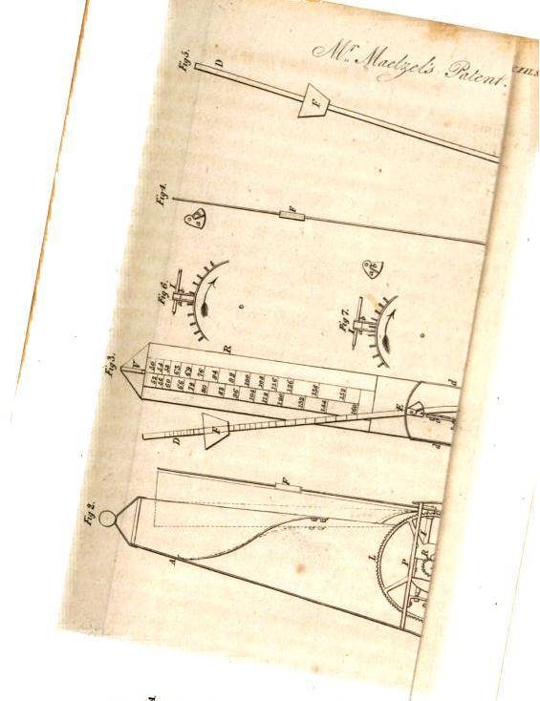

Figure 1 – Maelzel’s design documents from his original patent. It was the practice in those days to photocopy your notes shittily, in order to obscure your ideas and thus be ‘smart’

Pendula of this sort are very amenable to physical modelling. Consider the model pendulum in figure 2.

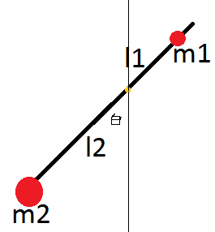

Figure 2 – Model Pendulum

As with nearly all mechanical metronomes, what appears to be an inverted pendulum is actually a double pendulum, with a large weight ($m_{2}$ in the diagram) hidden inside the metronome frame. Suppose $m_{2}≫m_{1}$, and the origin is centered about the pivot (golden dot) with positive, right handed sense. Applying the Lagrange equations of motion, with $θ$ as the angular coordinate and assuming a frictionless pivot with a massless support rod, the following equations can be written.

$$T=\frac{1}{2}m_{1}{\left(l_{1}{\dot{θ}}_{1}\right)}^{2}+\frac{1}{2}m_{2}(l_{2}{\dot{θ}}_{2})^2 \left[1\right]$$

$$V=m_{1}gl_{1}\cos\left(θ_{1}\right)-m_{2}gl_{2}\cos\left(θ_{2}\right) \left[2\right]$$

Noting that $θ_{1}=θ_{2}=θ$

$$L=T-V=\frac{1}{2}\left(m_{1}l_{1}^{2}{\dot{θ}}_{}^{2}+m_{2}l_{2}^{2}{\dot{θ}}_{}^{2}\right)-g\left(m_{1}l_{1}\cos\left(θ\right)-m_{2}l_{2}\cos\left(θ\right)\right) \left[3\right]$$

Applying the Euler-Lagrange Equation, $\frac{d}{dt}\left[\frac{dL}{d\dot{θ}}\right]=\frac{dL}{dθ}$, one obtains

$$\frac{d}{dt}\left[\left(m_{1}l_{1}^{2}+m_{2}l_{2}^{2}\right)\dot{θ}\right]= -g\left(m_{2}l_{2}\sin\left(θ\right)-m_{1}l_{1}\sin\left(θ\right)\right) [4]$$

Which ultimately yields

$$\left(m_{1}l_{1}^{2}+m_{2}l_{2}^{2}\right)\ddot{θ}= -g\left(m_{2}l_{2}-m_{1}l_{1}\right)\sin\left(θ\right) \left[5\right]$$

Denoting the left hand coefficient by $A$ and the right hand coefficient (less the $–g$) by $B$,

$$\ddot{θ}= -\frac{gB}{A}\sin\left(θ\right) \left[6\right]$$

Note that equation 6 closely mimics the usual form of a standard pendulum. In the limit that $m_{1}→0$, in fact, the equation perfectly reduces to the familiar

$$\ddot{θ}= -\frac{g}{l_{2}}\sin\left(θ\right) [7]$$

Appyling the standard small angle approximation to equation 6 (justified here in that the physical housing of the metronome enforces a limited range of motion anyway), an eminently solvable form is obtained, to wit

$$\ddot{θ}= -\frac{gB}{A}θ [8]$$

Which of course has the solution

$$θ\left(t\right)=C_{1}\sin\left(\sqrt{\frac{gB}{A}}θ\right)+C_{2}\cos\left(\sqrt{\frac{gB}{A}}θ\right) \left[9\right]$$

Assuming initial conditions $θ\left(0\right)=θ_{0}$ and $\dot{θ}\left(0\right)= 0,$

$$θ\left(t\right)= θ_{0}\cos\left(\sqrt{\frac{gB}{A} }θ\right) [10]$$

By inspection (or by passing familiarity with pendula), the period is of course

$$T=2π\sqrt{\frac{gB}{A}} \left[11\right]$$

In this type of pendulum, $m_{2},m_{1},$ and $l_{2}$ are all fixed, and changing $l_{1}$ (that is, sliding the weight up and down the pendulum) alters the period. Clearly, if $l_{1}$ is very small, the double pendulum again becomes a simple pendulum with just mass $m_{2}$. Setting sample numerical values for all parameters, a plot of period against $l_{1}$ is obtained.



Figure 3 – $T$ vs $l_{1}$

The numerical values are, of course, meaningless, as reasonable, unitless constants were selected for this plot. However, the trend agrees with the intuition of how a metronome should work – sliding the mass upward decreases the frequency of the pendulum (show in figure 3 as a decrease in period).

Luckily, this metronome is implemented in software, so no calculations of the previous sort are required at all. Instead, the desired beats per minute are simply typed into the program and the metronome creates the appropriate ticking noise.

# Potential Uses

The main use of the Software to Improve All Musical Performance is somewhat self-evident. Using this software is guaranteed to improve the musical performance skills of every single user, noticeably and without fail.

That being said, it is important to take careful note of the words used. This software will not allow the user to create or perform music worth listening too (this is of course, fundamentally impossible). It will merely improve the technical skills and facility with which the user is able to respond to mechanically precise tones of varying frequency and duration. While this seems utterly without point, many users are under the delusion that such ‘skills’ are interesting and desirable. Bowing to the inevitable pressures of someone vaguely asking you to sort of do something, this software has been developed and presented for those that wish to while away the hours with meaningless noise production.

Ultimately, this software will be transformed into a smartphone app, such that the practicing of musical techniques can be undertaken ‘on the road’, as it were, without requiring a laptop or similar device, or an internet connection.

# Installation

# Description Of Interface

Once the program is successfully installed, run it by []

Once it is finished loading, you will see the following screen (figure 4)

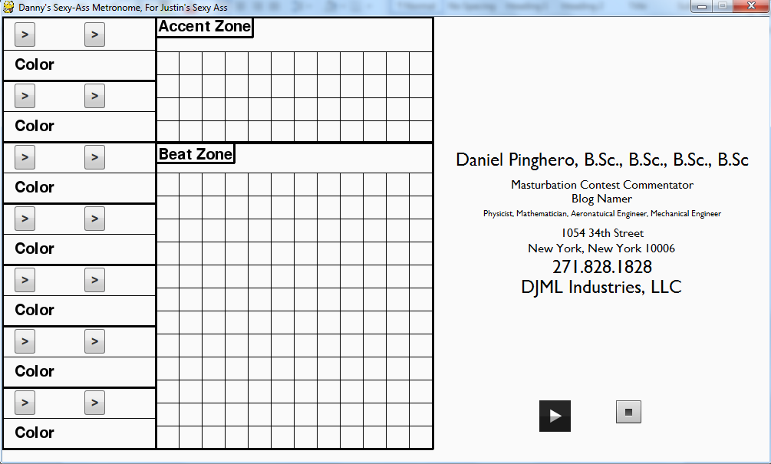

Figure 4 – Initial Metronome Screen

There are three main components of the main program window. In order from left to right they are: The Input Pane, The Definition Pane, and The Hilarity Zone. Typical usage of the program also flows from left to right.

## The Input Pane

The Input Pane is composed of 7 distinct rows, corresponding to the 7 unique metronome patterns that can be defined. Each row has two input buttons, two fields for displaying input text (blank in figure 4), and 1 color indicator box (initially blank, as in figure 4). It is here that the user enters the numerical constants that define the first part of the metronome’s pattern. To enter in data, simply click and input button and type in text. [Missing Feature 1] Once finished, press enter. Assuming valid input, the text will appear on the screen next to the appropriate input button (see figure 5).

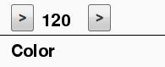

Figure 5 – Successful Input Echo

Input can be overridden at any time by simply clicking the input button again and retyping the data. Input can be cancelled by clicking anywhere on the screen. (Note – clicking another button will cancel current input but will not activate any buttons that were clicked. To enter input in a field after clicking on the wrong button, two clicks must be made. One to cancel current input, and one to initiate new input). Each input button can be clicked only if all buttons prior to it have been given input text at least once. (Button precedence proceeds left and then down. Each right button can be clicked only after the button directly to its left has been used. Each left button can only be clicked if the row above it has been fully filled out).

The two buttons on the Input Pane correspond to the Beats per Minute (BPM) and the Beats per Cycle (BPC. Also called Beats Per Measure, but that unhelpfully has the initials BPM as well) of the metronome pattern. The BPM setting controls how fast the metronome will tick. The BPC setting controls how many beats there will be in a measure. Later, these beats can be modified to accent some beats. Each beat lasts for 100 milliseconds, with the rests in between them being dependent on the BPM. The accented beats (or downbeats) will play the fifth above tuning A, and the unaccented beats will play an A.

Once both a BPM and a BPC are entered, a color will be assigned to the combination and appear below the two fields (see figure 6)

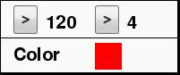

Figure 6 – This combination has been assigned the color red

Once a color is assigned, the square of color becomes an additional button on the input pane, as well as a reference used in the Definition Pane for this metronome pattern. Clicking the color allows you to edit the accented beats and the metronome play order in the Definition Pane. Once you select a color, that becomes the *active color* until a new color is clicked.

### Input Limits

The maximum frequency of the metronome is limited by the requirement that beats be distinct (ie, that there be a nonzero duration rest period between successive beats). Most physical metronomes, and as a consequence, most software metronomes, rarely allow for settings much above 208 BPM. After much experimentation, it was determined that the 100 millisecond duration is near to the shortest useful sound that can be perceived easily by an average human. As such, there is a hard limit to the BPM that can be played with this (or any) metronome. This can be easily calculated as follows:

$${\left(100\frac{ms}{beat}*\frac{1 s}{1000 ms}*\frac{1 \text{min}}{60 s}\right)}^{-1}={\left(\frac{1 \text{min}}{600 beat}\right)}^{-1}=600 BPM$$

Due to floating point rounding errors, the actual maximum of the metronome depends on implementation may vary slightly. Regardless, the metronome will not allow you to enter a BPM value that it cannot support. If one is entered, no input will appear and the user must click again in order to re-enter date [Missing Feature 2].

There is likewise a limit to the maximum BPC that can be entered. This limitation stems not from a mathematical fact, but a design choice. Due to graphical space constraints, the maximum BPC is limited to 48. This is a reasonably high value and it is not expected to be a large limitation in the use of the metronome. If a user absolutely needs more beats, there are two possible solutions. One is to adjust the BPM and change the working definition of what the metronome’s tick means (for example, instead of attempting to input a pattern of 64th notes, one could halve the BPM and set the metronome to play every other beat). The other is to use two patterns consecutively, effectively doubling the allowed BPC (see section on the Definition Pane for details on how to set patterns to play consecutively).

## The Definition Pane

The Definition Pane is comprised of two zones, the Accent Zone and the Beat Zone. It is here that the beats are accented and that the pattern of notes the metronome is to play is entered.

### The Accent Zone

The Accent Zone consists of a grid of 48 boxes, arranged in 4 rows of 12. The Accent Zone is only activated when at least one color has been assigned in the Input Pane (meaning that a BPM/BPC pattern has been designed). Clicking on the appropriate color indicator activates the Accent Zone. The active color will appear at the top of the Accent Zone (figure 7)



Figure 7 – The active color is red

Additionally, a number of grid squares will turn black. These are the notes in one measure, as defined by the BPC value for this color. Clicking on a black square will change it to the active color, and vice versa. Squares that remain the background color are inactive. Squares that are active colored are accented beats, and black squares are non-accented.

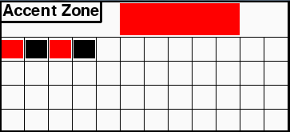

Figure 8 – Here, BPC was 4. The 1st and 3rd beats are accented

Clicking on a new color in the Input Pane will switch active colors and thus change out the entire Accent Zone. The pattern you entered is saved and can be returned to at any time by re-clicking the original color. The only time the pattern information will be lost is when the BPC is changed. Clicking on the color indicator will then reconfigure the Accent Zone to display a number of black squares equal to the new BPC. Changing the BPM has no effect on the Accent Zone.

### The Beat Zone

The Beat Zone is the lower half of the Definition Pane. It is composed of a 12x12 grid of 144 squares. Once the first BPM/BPC combo is entered in, the entire panel becomes active. Similar to the Accent Zone, the active color will appear near the Beat Zone header. Clicking a square will change it to the active color, regardless of its previous color. Clicking a square of the active color will set it back to being blank. When the play button is clicked (see Hilarity Zone), the metronome will play each color in sequence (scanning left to right and down). Squares that are background colored will simply be skipped.

In the following figure, red corresponds to 120 BPM, 4 BPC, 1st and 3rd accented, and green corresponds to 120 BPM, 3 BPC, 2nd accented.

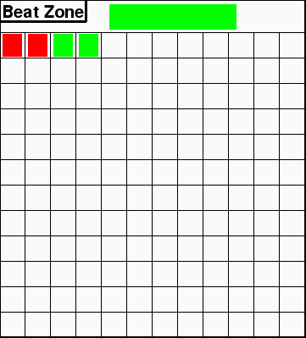

Figure 9 – The metronome will play 2 measures of red, and then 2 measures of green. Green is the active measure at the moment

To facilitate in the rapid definition of large stretches of the same color pattern, the beat zone will automatically fill in a swath of squares in the following manner: If a square is clicked, all the blank squares directly previous to it will be filled in the color of the active color. See figures 10-12 for an example.

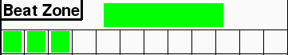

Figure 10 – The first three squares have been colored green, the active color

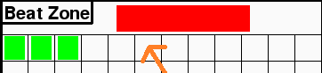

Figure 11 – The active color is changed to red by clicking on the red color indicator in the Input Pane.

Clicking on square 6 (indicated by arrow) will change the next three squares to red

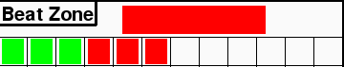

Figure 12 – The metronome will now play three measures of green and three measures of red

As there are only 144 boxes, only 144 measures can be played at any time. [Missing feature 3]

## The Hilarity Zone

The final interactive area is the aforementioned Hilarity Zone. Here are the start and stop buttons for the metronome, as well as an interesting and faithful description of the merits of the software author.

The play button can be clicked at any time there is at least one beat zone square filled in, causing the metronome to play whatever patterns are entered in the beat zone. At any time, the stop button can be clicked, halting the metronome. Note this is a stop and not a pause – pressing play again will start from the beginning of the pattern. Additionally, clicking any input button or input square will stop playback from the metronome. The only thing that can be clicked without disrupting the metronome are the color indicator squares in the Input Pane. Clicking them will display the appropriate boxes in the Accent Zone while allowing the metronome to continue playing (editing the Accent Zone itself will halt playback).

# Future Work

## Missing Feature 1

The primary missing feature, and also the most resistant to implementation solutions, is an active indicator of which textbox is awaiting input. Currently, clicking on a button signals the event handler to await keyboard input (while also allowing for quit events and mouse button down events to interrupt input collection), but no change is made to the screen until Enter is pressed. Future versions should have some sort of indicator in between clicking and pressing enter. Ultimately, real time character echoes are desired. As an intermediate measure, either highlighting the textbox currently gathering data, or printing a message to an information zone should indicate the active box. Unfortunately, this problem requires breaking the standard schema for screen updating. Normally, all updates are blitted to the background in place, but the screen is only flipped once per game loop. This would require earlier screen flipping prior to the major update. While this is distasteful from an architectural standpoint (though could possibly be refactored into a more consistent design), it should not be practically difficult. All efforts to implement such features up to this point have been met with unrelenting failure and an acute sense of shame. Planned for version 0.9.

## Missing Feature 2

Part of the Hilarity Zone is to be repurposed into a message center to report various data to the user. Ideally, this would serve as the primary error reporting center (for example, when a user enters a BPM value that is too high, a message would be displayed here, instead of the current silent rejection of input). Additionally, this area could be used as a staging ground for intermediate solutions to MF1. Planned for version 0.9

## Missing Feature 3

The third and final missing feature is also the simplest to implement. Currently the metronome plays the entire beat zone once and then ends. MF3 would implement a check box (or near analogue) offering the option to loop indefinitely. Potentially it could also include a number of repetitions input box, or a length of time for which to loop. Requires focus testing to determine user needs. Planned for version 1.0 (though)