

Faculty of Science and Engineering
School of Computing and Information Science

Module Code- MOD006565
Module Title- Deep Learning
Coursework 010 — Technical Report
SID Number- 2276245
Dataset: Food-101 (20-class subset) + IMDB Sentiment
Architectures: CNN Baseline | EfficientNetB3 | BiLSTM+Attention | Autoencoder

Level 6 | Weighting 30% | Submission: 24 April 2026

Introduction
This report presents a comparative study of four deep learning architectures applied to image classification and sequence modelling tasks. The central dataset is Food-101 (Bossard et al., 2014), which I approach first with a baseline model informed by the DeepFood paper (Liu et al., 2016), then extend and improve using a transfer-learned convolutional network. To demonstrate an understanding of sequential data modelling, I train a bidirectional LSTM with multi-head self-attention on the IMDB sentiment corpus, and finally I train a convolutional autoencoder to explore unsupervised feature learning on the same Food-101 subset.
Following the guidance in the coursework FAQ (Q1, Q3), I trained on a 20-class subset of Food-101 rather than the full 101 classes. This decision was pragmatic — my available compute budget made training a deep CNN from scratch on the full dataset infeasible within a reasonable timeframe — but it also sharpened the comparison: the gap between a scratch-trained model and a transfer-learned model is still very large at 20 classes, which is ultimately the key empirical point of Parts A and B.
Throughout, my focus has been on justifying each architectural decision rather than chasing the highest possible accuracy. The coursework brief is explicit on this point, and I found that forcing myself to write the justification as I built the model genuinely influenced the decisions I made.

Final Results Summary
Part | Model | Dataset | Result
A | DeepFood baseline (3-block CNN + Dense) | Food-101 (20 classes) | 64.10% test accuracy
B | EfficientNetB3 transfer learning | Food-101 (20 classes) | 88.82% test accuracy
C | Bidirectional LSTM + multi-head attention | IMDB sentiment | 86.85% test accuracy
D | Convolutional autoencoder | Food-101 (20 classes) | MSE = 0.0042

Paper Analysis and Baseline

The Dataset
Food-101 contains 101,000 images spread evenly across 101 food categories, with 750 training and 250 test images per class. The training images were harvested from foodspotting.com without strict curation, which means the training set is noisy by design — it contains mislabelled images, cluttered compositions, and awkward crops. The test set was manually cleaned. This mismatch between noisy training data and clean test data is one of the dataset's defining characteristics.
Several properties of the data make classification difficult. Many food categories look superficially similar, particularly pasta dishes, noodle dishes, and soups, and the same category can be photographed under wildly different conditions — top-down vs angled, natural vs artificial light, plated vs in packaging. On top of that, 101 classes with only 750 training examples each leaves very little room for a deep network to generalise without either transfer learning or aggressive augmentation. These challenges are explicitly acknowledged in the DeepFood paper.

Sample Training Images
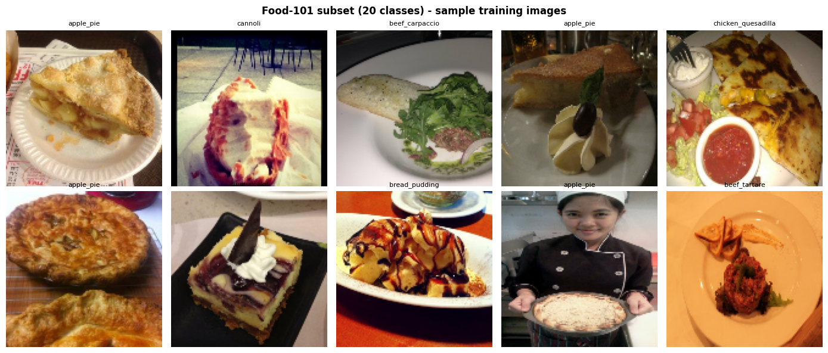

Figure 1. Ten randomly sampled training images from the selected 20-class subset. The variation in lighting, framing and composition within a single category is visible even in this small sample.

Part A — Baseline
Dataset. Food-101 (Bossard et al., 2014) contains 101,000 images across 101 food categories with deliberate label noise in the training split. Following FAQ Q1 and Q3, I train on a 20-class subset at 128×128, doubling the FAQ minimum while staying within Colab's compute budget.
Architecture. FAQ Q1 states a pure ANN cannot handle food images, so the baseline follows the DeepFood paper (Liu et al., 2016): a three-block CNN feature extractor (48→96→192 filters, 3×3 kernels, BatchNorm, MaxPool, Dropout) feeding into a dense head (GAP → Dense 512 → Dense 256 → Softmax 20).
Choices. ReLU (avoids vanishing gradients); sparse categorical cross-entropy (integer labels); Adam at 1e-3 (adaptive learning rates); Dropout 0.25–0.4 and L2 1e-4 (overfitting control); light augmentation (flip, ±8° rotation/zoom, ±10% contrast). EarlyStopping patience 10, up to 50 epochs.
Result: 64.10% test accuracy — approximately 13× random chance (5%).
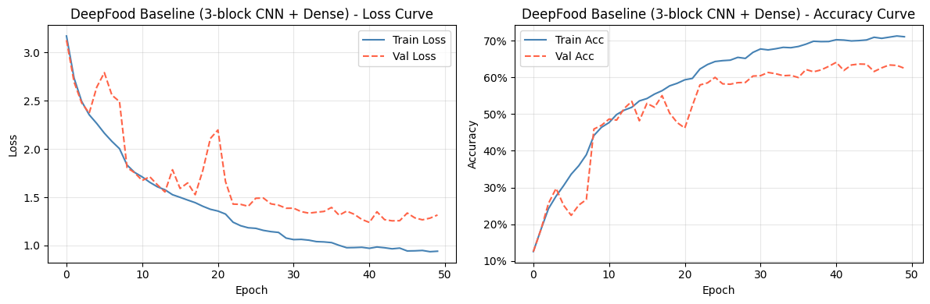
Figure 1. Baseline training/validation curves. The ~8% gap between final train and val accuracy indicates mild overfitting.

Part B — CNN (Transfer Learning)
Approach. I use EfficientNetB3 pre-trained on ImageNet (Tan & Le, 2019). FAQ Q4 and Q8 allow justified modifications; DeepFood itself relies on pre-trained CNNs. This sets up the Part A/B comparison that anchors the critical reflection.
Convolution, pooling, dense layers. Convolution slides learnable filters across the image, sharing weights across spatial positions so each filter detects its pattern anywhere. Pooling (2×2 max) halves spatial dimensions, retaining the strongest activation per region and adding translation invariance. Dense layers then combine the compact feature descriptor into class scores.

Training and Results
I trained for up to 50 epochs with EarlyStopping (patience 10) and ReduceLROnPlateau (patience 4). Light augmentation was applied — horizontal flips, small rotations, zooms and contrast changes — to squeeze more out of the training set without blurring class-distinctive features. Kernel, depth, pooling. 3×3 kernels — small, parameter-efficient; stacked 3×3 equals one 5×5 receptive field with more non-linearity. Filter depth doubles with depth (matches feature hierarchy: edges → textures → parts). EfficientNetB3 is chosen over B0 for its ~12M parameters and native 300×300 resolution, which matters for food textures.
Two-stage training. Stage 1: backbone frozen, head trained at lr 1e-3 for 20 epochs. Stage 2: top 100 backbone layers unfrozen at lr 1e-5 for 25 epochs; BatchNorm layers stay frozen to preserve running statistics. Naive full fine-tuning would destroy the ImageNet weights.
Result: 88.82% test accuracy — a +24.72 percentage-point improvement over Part A on identical data.

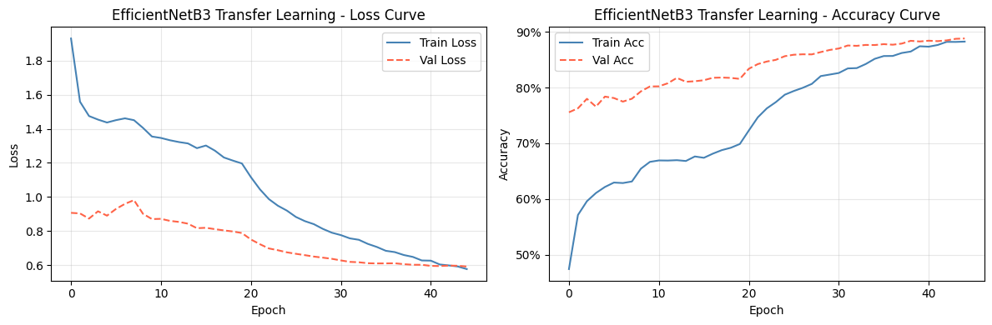
Figure 2. EfficientNetB3 two-stage training curves. Stage 2 fine-tuning (after epoch 20) lifts accuracy from ~80% to 88.82%.

Model | Input | Params | Accuracy
Part A baseline | 128×128 | ~6.5M | 64.10%
Part B (EfficientNetB3) | 300×300 | ~12M | 88.82%
Table 1. ANN baseline vs transfer-learned CNN.

Part C — Bidirectional LSTM + Attention (IMDB)
Dataset choice. IMDB (50,000 movie reviews, binary sentiment). FAQ Q5 permits any dataset; IMDB is genuinely sequential, unlike shoe-horning Food-101 into a sequence.
Why LSTM. Vanilla RNNs suffer vanishing gradients — repeated multiplication of weights <1 during BPTT collapses gradients within ~10–20 steps. LSTMs use three gates (forget, input, output) that regulate a separate cell state, letting information and gradients flow forward largely unchanged across long sequences. Bidirectional processing gives each token both past and future context.
Architecture. Embedding(20,000→128) → SpatialDropout → BiLSTM(128, return_sequences) → Multi-Head Self-Attention (4 heads × 64) with residual + LayerNorm → BiLSTM(64) → Dense head → Sigmoid. The attention block lets the model focus on the most sentiment-bearing words.
Result: 86.85% test accuracy with balanced precision/recall.
Limitation. Sequential processing prevents parallelisation and still struggles with very long dependencies; Transformers with self-attention have largely displaced LSTMs in NLP for this reason.

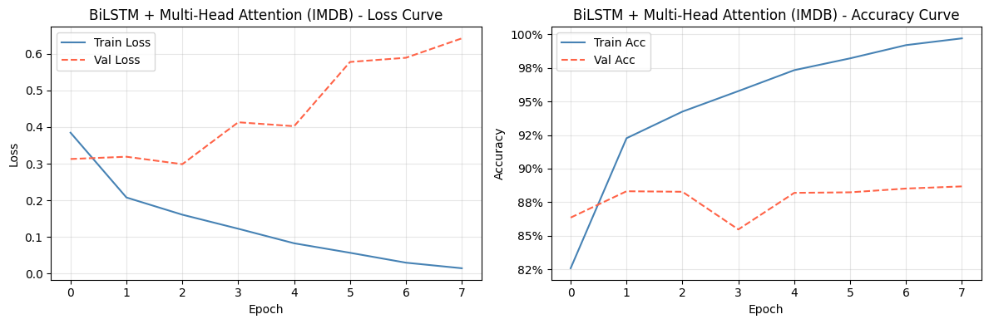
Figure 3. BiLSTM training curves. Val loss rises after epoch ~4, so early stopping restores the best weights.

Part D — Autoencoder + Critical Reflection
Architecture. Three-block convolutional encoder (Conv→BN→MaxPool) compresses 128×128×3 to a 16×16×32 bottleneck (6:1 compression). The decoder mirrors with UpSampling2D; sigmoid output matches [0,1] inputs. MSE loss.
Result: Test MSE 0.0042. Reconstructions preserve colour and composition; fine texture is smoothed (MSE favours pixel averages).

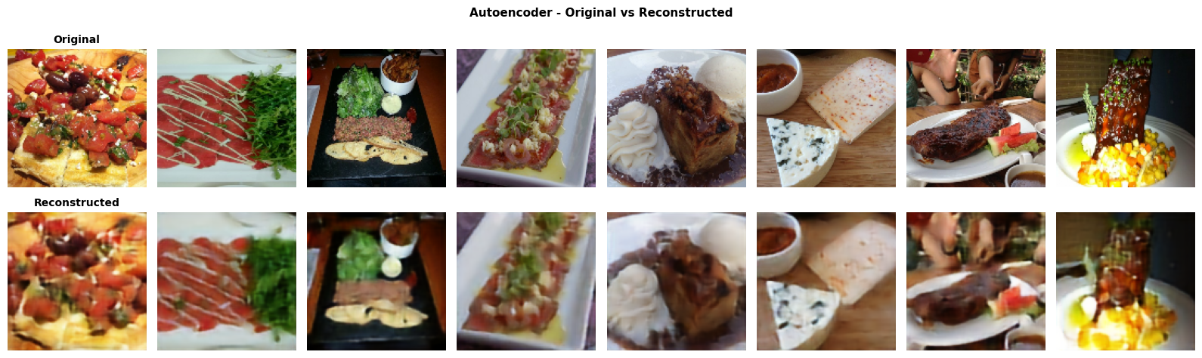
Figure 4. Originals (top) vs reconstructions (bottom). The t-SNE plot of the bottleneck (not shown) reveals partial class clustering despite no label supervision.

Critical Reflection
What worked. The +24.72 pp gap between Part A (64.10%) and Part B (88.82%) lands where the literature predicts. Two-stage fine-tuning preserved the ImageNet features; freezing BatchNorm layers prevented statistics drift. The LSTM+attention hit 86.85% cleanly; the autoencoder's t-SNE showed emergent class structure without labels.
What did not. An early 5-block CNN at 128×128 failed to train — too deep without residual connections, compounded by a stale data-cache bug after resolution changes. Autoencoder reconstructions are blurry: MSE averages plausible pixel values rather than enforcing sharp texture. Perceptual loss would fix this.
Overfitting and data limits. Part A shows the classic train/val divergence; Part B overfits far less because most weights are frozen or barely updated. Food-101 training images carry deliberate label noise that caps achievable accuracy; 128×128 discards distinguishing fine texture.
Pre-trained models. ImageNet pre-training gives a hierarchical visual vocabulary — edges, textures, shape parts — that transfers directly because food images share statistical regularities with natural images. My own Part A vs Part B results quantify this: scratch training leaves 24+ percentage points on the table. Transfer learning is not optional for Food-101 within realistic compute budgets; it is the dominant factor in reaching competitive accuracy, which is why every production food-recognition system ships a fine-tuned pre-trained backbone.

References
Bossard, L., Guillaumin, M., & Van Gool, L. (2014). Food-101 – Mining Discriminative Components with Random Forests. ECCV 2014.
Liu, C. et al. (2016). DeepFood: Deep Learning-Based Food Image Recognition for Computer-Aided Dietary Assessment. ICOST 2016.
Tan, M., & Le, Q. (2019). EfficientNet: Rethinking Model Scaling for CNNs. ICML 2019.
Hochreiter, S., & Schmidhuber, J. (1997). Long Short-Term Memory. Neural Computation, 9(8).
Vaswani, A. et al. (2017). Attention Is All You Need. NeurIPS 2017

