

Anglia Ruskin University
Faculty of Science and Engineering
School of Computing and Information Science

Privacy-Preserving Machine Learning for Healthcare:
A Comparative Study of Federated Learning, Split Learning,
and Split-Fed Learning

BSc (Hons) Artificial Intelligence — Final Year Project

Module Code: MOD002691 | Module Title: Final Project

Student ID: 2276245

Supervised by: Dr Raj Shukla
Ethics Approval Reference: ETH2526-2037

Submission Deadline: 24 April 2026
Academic Year 2025–2026

Abstract
The rapid expansion of electronic health records and interconnected clinical systems has intensified concerns surrounding patient data privacy in modern healthcare. Traditional machine learning approaches to clinical decision support require aggregating sensitive patient data in a centralised repository, creating significant ethical, legal, and security challenges. These challenges are compounded by regulatory frameworks such as the UK General Data Protection Regulation (GDPR) and the Data Protection Act 2018, which impose strict obligations on the processing and storage of health information as a special category of personal data.
This project investigates three privacy-preserving machine learning (PPML) paradigms — Federated Learning (FL), Split Learning (SL), and Split-Fed Learning (SFL) — as privacy-respecting alternatives to conventional centralised training. Using the Heart Disease UCI dataset (920 samples, 13 clinical features after preprocessing, binary classification), each technique is implemented in TensorFlow/Keras within a simulated multi-client environment comprising five Independent and Identically Distributed (IID) clients, representing a network of collaborating hospitals that cannot share raw patient data.
A centralised feedforward neural network (64→32→16→1 architecture) provides the performance benchmark. Experimental results demonstrate that the baseline achieves 82.07% test accuracy, Federated Learning achieves a peak of 83.70% at round 19 (over 50 communication rounds with 10 local epochs), Split Learning achieves 82.61% at epoch 90 (over 100 epochs), and Split-Fed Learning achieves 84.24% at round 31 (over 50 rounds) with the lowest distributed test loss of 0.3680. Notably, all three privacy-preserving techniques exceeded the centralised baseline at peak performance — an outcome attributed to the implicit regularisation effect of the FedAvg aggregation mechanism and the partitioning of the training signal across multiple client updates. SFL is identified as the optimal privacy-preserving technique, offering the best combination of predictive accuracy, loss calibration, and stable convergence for federated healthcare deployments.

Table of Contents
1. Introduction 3
2. Literature Review 5
3. Methodology 9
4. Implementation 13
5. Results and Analysis 17
6. Discussion 22
7. Ethical Considerations 26
8. Limitations and Future Work 27
9. Conclusion 29
10. References 30

1. Introduction

1.1 Background and Motivation
The healthcare sector generates an unprecedented volume of sensitive data every day. Electronic health records (EHRs), diagnostic imaging, wearable device outputs, genomic sequences, and clinical laboratory results collectively represent one of the richest and most privacy-sensitive datasets in existence. The potential of machine learning to transform clinical practice is well established — from predicting cardiovascular disease and detecting early-stage cancers to forecasting patient deterioration in intensive care units. However, realising this potential at scale has historically required aggregating vast amounts of patient data in centralised repositories or cloud servers, a practice that fundamentally conflicts with patient privacy expectations and the regulatory landscape governing health information.
In the United Kingdom, the General Data Protection Regulation (UK GDPR) and the Data Protection Act 2018 impose strict obligations on any organisation processing personal data, with health information classified as a ‘special category’ requiring explicit consent or specific legal bases for processing. Article 9 of the UK GDPR explicitly prohibits the processing of health data unless clearly justified — a requirement that makes centralised aggregation of patient records across multiple hospital sites increasingly difficult to justify legally. Beyond regulatory compliance, the practical consequences of centralised health data storage have been made starkly apparent by high-profile incidents. The 2017 WannaCry ransomware attack exploited vulnerabilities in NHS systems, disrupting over 80 NHS organisations, forcing the cancellation of approximately 19,000 appointments and operations, and costing the NHS an estimated £92 million. This incident served as a powerful reminder that centralised data repositories represent attractive and potentially catastrophic targets for malicious actors.
Privacy-Preserving Machine Learning (PPML) has emerged as a research domain dedicated to enabling the training of high-performing ML models without requiring the exposure of sensitive raw data. Rather than centralising patient records, PPML techniques distribute the training process across multiple data-holding participants — analogous to individual hospitals or GP practices — while transmitting only model parameters or intermediate representations. Among the most promising PPML approaches are Federated Learning (FL), introduced by McMahan et al. (2017), Split Learning (SL), introduced by Gupta and Raskar (2018), and their hybrid, Split-Fed Learning (SFL), proposed by Thapa et al. (2020). Each technique offers a distinct trade-off between privacy, communication cost, computational requirements, and predictive accuracy.
This project was motivated by the recognition that while all three techniques have been studied independently in the literature, direct empirical comparisons on healthcare tabular data using consistent experimental conditions remain limited. Understanding how these approaches compare under controlled conditions is essential for informing the design of privacy-preserving clinical AI systems in real-world NHS and multi-hospital environments.

1.2 Research Aims and Objectives
The aim of this project is to empirically compare three privacy-preserving machine learning paradigms against a centralised baseline using a clinically relevant healthcare dataset. The specific objectives are:
- Implement a centralised baseline neural network classifier as a performance reference.
- Implement Federated Learning, Split Learning, and Split-Fed Learning variants using the same underlying architecture and preprocessing.
- Simulate a five-client federated environment representing a network of collaborating hospitals under an IID data distribution.
- Compare all four models across test accuracy, training loss convergence, and estimated communication overhead.
- Critically interpret the results in the context of real-world healthcare deployment, including privacy guarantees, scalability, and practical trade-offs.

1.3 Research Questions
The project is framed around three research questions:
- Can privacy-preserving distributed training techniques (FL, SL, SFL) match or exceed the predictive accuracy of a centralised baseline on a healthcare classification task?
- How do FL, SL, and SFL differ in their convergence behaviour, loss calibration, and overall training dynamics?
- Which PPML technique offers the most favourable balance of accuracy, loss, convergence speed, and communication efficiency?

1.4 Scope and Constraints
The scope of this project is deliberately constrained to enable rigorous comparison within the time and computational resources available for a final-year undergraduate project. The dataset is limited to a single tabular clinical dataset (Heart Disease UCI, 920 samples). The federation is simulated programmatically within a single Kaggle notebook session rather than across physically distributed hardware. The evaluation focuses on five IID clients, with non-IID data distributions identified as a direction for future work. Differential privacy mechanisms such as DP-SGD (Abadi et al., 2016) are not implemented, though their integration is discussed as a natural extension. Advanced privacy attacks such as gradient inversion (Zhu et al., 2019) are discussed qualitatively rather than evaluated empirically.

2. Literature Review

2.1 Privacy in Healthcare Machine Learning
The ethical imperative to protect patient data has driven a substantial body of research on privacy-preserving machine learning for clinical applications. Obermeyer and Emanuel (2016) argued that the promise of big data in medicine would be constrained by the practical impossibility of pooling sensitive records across institutions. Char et al. (2018) extended this analysis to the ethical dimension, highlighting the risks of re-identification from apparently anonymised health datasets and the tension between research utility and patient consent.
Brisimi et al. (2018) provided one of the earliest healthcare-specific demonstrations of federated learning, training predictive models on electronic health records across multiple institutions without data centralisation. Dayan et al. (2021) subsequently demonstrated the practical viability of federated learning at scale, reporting that a federated model for predicting clinical outcomes in COVID-19 patients, trained across twenty international hospital sites, outperformed locally trained models at the majority of participating sites. Roth et al. (2020) provided a further real-world demonstration in the breast density classification domain, showing that federated approaches can match centralised baselines in clinical imaging tasks.

2.2 Federated Learning
Federated Learning was introduced by McMahan et al. (2017) as a framework for training a shared global model across decentralised data partitions while keeping raw data local to each participant. The original Federated Averaging (FedAvg) algorithm proceeds in communication rounds: at the start of each round, the server distributes the current global model weights to all participating clients; each client then trains the model locally on its own data for a fixed number of epochs; finally, the server collects the locally trained weights and averages them, typically weighting each client’s contribution by the size of its local dataset.
The theoretical and empirical properties of FL have been extensively studied. The approach is well suited to horizontal partitioning — the scenario in which clients hold similar feature spaces but different sample populations — which closely matches the structure of multi-hospital health data, where each hospital records the same clinical variables for different patients. FL’s main limitations relate to statistical heterogeneity across clients (non-IID data), communication bandwidth for transmitting full model weights in each round, and susceptibility to gradient inversion attacks. Zhu et al. (2019) demonstrated the Deep Leakage from Gradients attack, showing that an adversary with access to gradient updates can, under certain conditions, reconstruct the original training samples. This finding motivates the integration of differential privacy or secure aggregation into FL deployments.

2.3 Split Learning
Split Learning was introduced by Gupta and Raskar (2018) at the MIT Media Lab as an alternative distributed training paradigm that reduces on-device computational requirements by partitioning the neural network between clients and a server. In the vanilla SL configuration, the network is split at a designated ‘cut layer’: client-side layers are deployed and trained on client devices, while server-side layers are deployed on a central server. During forward propagation, each client computes activations up to the cut layer — the ‘smashed data’ — and transmits this intermediate representation to the server, which completes the forward pass and computes the loss. Gradients are back-propagated to the cut layer and returned to the client, which continues back-propagation to update client-side weights.
SL offers several advantages over FL. First, only a fraction of the model (the client-side segment) needs to be deployed on potentially resource-constrained client devices, reducing memory and computational requirements. Second, raw data is replaced by intermediate activations in transmission, which are higher-level and less directly interpretable than raw inputs. However, this privacy advantage is not absolute: Pasquini et al. (2021) demonstrated that smashed data can be subject to reconstruction attacks, showing that adversaries with access to the server-side model can recover input data from smashed data with considerable accuracy. This finding suggests that SL’s privacy guarantees are architecturally weaker than commonly assumed.
SL’s primary drawback is its sequential training protocol: each client must complete its forward and backward pass before the next client can begin, producing a total training time that scales linearly with the number of clients. This makes SL poorly suited to large federations involving many participating institutions, though manageable for small-to-medium federations of the kind typical in research-hospital collaborations.

2.4 Split-Fed Learning
Split-Fed Learning was proposed by Thapa et al. (2020) as a hybrid architecture combining the complementary strengths of FL and SL. In SFL, the neural network is partitioned into client-side and server-side segments as in SL, but clients train in parallel (as in FL) rather than sequentially. After each training round, the client-side model weights are aggregated via FedAvg and redistributed, while the server-side model is updated by the cumulative gradients received from all clients during the round.
Thapa et al. (2020) evaluated SFL on CIFAR-10 and the HAM10000 dermatological imaging dataset, demonstrating that SFL achieves accuracy close to centralised baselines while substantially reducing communication costs relative to vanilla FL. The authors argue that SFL’s hybrid architecture represents a practically deployable middle ground for real-world federated healthcare deployments, combining the scalability of FL with the reduced per-client communication footprint of SL.

2.5 The Heart Disease UCI Dataset
The Heart Disease UCI dataset (Detrano et al., 1989; UCI Machine Learning Repository, 1989) is a widely used benchmark in cardiovascular ML research, containing 920 records collected across four clinical sites: the Cleveland Clinic Foundation, the Hungarian Institute of Cardiology, the V.A. Medical Center in Long Beach, and the University Hospital in Zurich. Each record contains 14 demographic, clinical, and ECG-derived variables, with a target variable indicating the presence and severity of coronary artery disease on a 0–4 ordinal scale. In binary formulations of the task, the target is reduced to 0 (no disease) versus 1 (any disease), producing a roughly balanced classification problem (411 negative, 509 positive cases in this study). The dataset’s multi-site provenance makes it particularly suitable as a proxy for a federated hospital network scenario, since the four source institutions can naturally serve as simulated federated clients.

3. Methodology

3.1 Research Design
This project adopts a quantitative, experimental research design. A controlled comparison is conducted across four model configurations — centralised baseline, FL, SL, and SFL — using identical data preprocessing, evaluation protocols, and neural network architecture (where applicable). By holding these variables constant, any observed performance differences between configurations can be attributed to the training paradigm rather than to confounding factors such as data preprocessing choices or model capacity.
The experimental environment is Kaggle Notebooks, selected for its free GPU access (Tesla T4), pre-installed ML libraries, persistent dataset storage, and automatic session management. All experiments are conducted using Python 3.12, TensorFlow 2.19.0, NumPy, Pandas, scikit-learn, and Matplotlib. A global random seed of 42 is set across NumPy, TensorFlow, and Python’s random module at the start of each session to support reproducibility, although minor numerical variation may arise between different hardware or framework versions.

3.2 Dataset Description and Preparation
The Heart Disease UCI dataset was loaded via the kagglehub Python library, which resolves the dataset location automatically across Kaggle and Colab environments. The raw dataset contains 920 rows and 16 columns. Initial exploration revealed the following characteristics: the id and dataset columns are administrative identifiers with no predictive value; the ca, thal, and slope columns contain excessive missing values (611, 486, and 309 respectively out of 920 rows), making reliable imputation infeasible; and the remaining columns contain a mix of numerical and categorical features with smaller proportions of missing values.
The preprocessing pipeline applied to the dataset comprised the following steps in order:
- Column removal: The id, dataset, ca, thal, and slope columns were dropped, reducing the feature set before encoding.
- Target binarisation: The num column was converted from its original 0–4 integer scale to a binary variable, where 0 indicates no heart disease and 1 indicates the presence of heart disease at any severity level. The resulting class distribution was 411 negative cases (44.7%) and 509 positive cases (55.3%).
- Categorical encoding: The sex, cp, fbs, restecg, and exang columns were one-hot encoded using pandas get_dummies with drop_first=True to avoid multicollinearity, expanding the feature set to 13 binary or continuous predictors.
- Missing value imputation: Remaining missing values were replaced with the respective column medians, chosen for robustness to outliers.
- Type conversion: All columns were cast to float to ensure compatibility with TensorFlow tensor operations.
- Feature scaling: All 13 features were standardised using scikit-learn’s StandardScaler (zero mean, unit variance), fitted on training data only and applied to both training and test sets to prevent data leakage.
Following preprocessing, the dataset was split into training (80%, 736 samples) and test (20%, 184 samples) sets using stratified sampling to preserve the class distribution in both subsets. Class weights were computed using compute_class_weight(‘balanced’) to address the mild class imbalance.

3.3 Client Data Partitioning
To simulate a federated environment comprising five hospitals, the 736 training samples were divided into five approximately equal partitions using numpy.array_split(), producing four clients with 148 samples and one client with 147 samples. This partitioning strategy produces an IID distribution, meaning each client’s data is drawn from the same underlying distribution as the global training set. The IID assumption represents an optimistic scenario — in practice, different hospitals serve different patient populations with different demographic profiles and disease prevalences — but it provides a controlled baseline for comparing the four training paradigms under equivalent conditions.

3.4 Neural Network Architecture
A consistent feedforward neural network architecture was used across all four experimental configurations to ensure that observed performance differences reflect training paradigm differences rather than model capacity differences. The architecture comprises four layers as shown in Table 1:
Table 1: Neural network architecture used across all four experimental configurations.
Layer | Units | Activation | Dropout | Parameters
Input | 13 features | — | — | —
Dense 1 | 64 units | ReLU | 0.3 | 896
Dense 2 | 32 units | ReLU | 0.2 | 2,080
Dense 3 | 16 units | ReLU | 0.2 | 528
Output | 1 unit | Sigmoid | — | 17
The model was compiled with the Adam optimiser at a learning rate of 0.001 and binary cross-entropy loss, with classification accuracy as the primary evaluation metric. Dropout regularisation was applied after Dense 1 (rate 0.3) and after Dense 2 and Dense 3 (rate 0.2) to reduce overfitting. The relatively deep architecture (three hidden layers) was chosen to provide sufficient representational capacity for the 13-feature input while remaining computationally tractable for the federated training protocols.

3.5 Training Protocols
Each of the four model configurations followed a distinct training protocol, as summarised in Table 2:
Table 2: Training protocol summary for all four model configurations.
Parameter | Baseline | FL | SL | SFL
Rounds / Epochs | 200 (early stop) | 50 rounds | 100 epochs | 50 rounds
Local Epochs | — | 10 | — | 10
Batch Size | 32 | 32 | Sequential | Sequential
Class Weights | Yes | Yes | No | No
Early Stopping | Yes (patience=25) | No | No | No

3.6 Evaluation Metrics
Each model was evaluated on the held-out test set of 184 samples using the following metrics: test accuracy (proportion of correctly classified instances), test loss (binary cross-entropy on the test set), and training convergence curves (accuracy and loss plotted per round or epoch). The best accuracy achieved at any point during training is recorded separately from the final accuracy to capture peak performance. Communication overhead is discussed qualitatively in terms of the number and size of parameter transmissions per training run.

4. Implementation

4.1 Development Environment and Setup
All experiments were developed and executed in a Jupyter notebook environment with GPU-accelerated computing resources. The GPU provided significantly accelerated model training, particularly for the federated experiments requiring repeated model training across multiple clients. The notebook was configured with GPU acceleration enabled and the Heart Disease UCI dataset was resolved via kagglehub, which returns a valid local path on both Kaggle and Colab without requiring hard-coded directories.
The implementation is structured as a single notebook comprising 14 code cells, each corresponding to a distinct phase of the experiment. Markdown cells were inserted between code cells to document the purpose, methodology, and observations for each phase, producing a self-contained and readable experimental record. A keep-alive script was added early in the notebook to prevent session timeouts during long training runs.
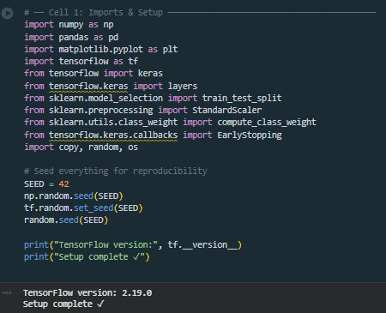
Figure 1: Notebook environment confirmation, showing TensorFlow 2.19.0 installed and seeds set for reproducibility.

4.2 Data Loading and Preprocessing
The dataset was loaded using pandas read_csv() from the path returned by kagglehub.dataset_download(). Initial exploration using df.shape, df.head(), df.dtypes, and df.isnull().sum() confirmed 920 rows, 16 columns, and the missing value profile described in the methodology. The file path discovery cell using os.walk() was used to locate the exact CSV path before loading, a practical step necessary to make the notebook environment-independent.
After preprocessing, the final dataset comprised 920 samples with 13 features and a binary target (shown as 14 columns including the target column in the output). The 80/20 stratified split yielded 736 training samples and 184 test samples. Five client partitions were created with approximately equal sizes.
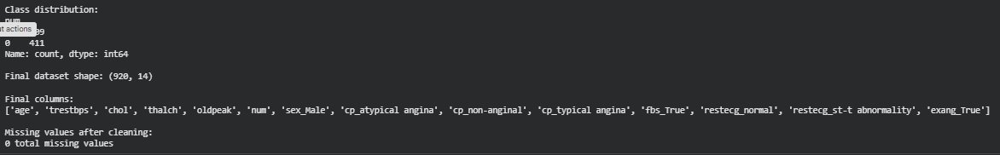
Figure 2: Data preprocessing confirmation showing final dataset shape (920, 14) including the target column, the 13 post-encoding feature names, and zero remaining missing values.

4.3 Baseline Model Implementation
The baseline model was implemented using the Keras Sequential API. An explicit keras.Input(shape=(NUM_FEATURES,)) layer was used as the first element of the Sequential model to comply with TensorFlow 2.19 best practices and avoid deprecation warnings that could interfere with the gradient computation graphs used in the SL and SFL implementations. The model was compiled with Adam (lr=0.001) and binary_crossentropy loss.
The EarlyStopping callback was configured to monitor val_accuracy with a patience of 25 epochs and restore_best_weights=True, which automatically reverts model weights to the optimal checkpoint when training terminates. This configuration is important: without restore_best_weights, early stopping would return the weights from the final epoch rather than the best epoch, potentially producing a model that has begun overfitting. Class weights were passed to model.fit() via the class_weight parameter. Training ran for a maximum of 200 epochs, stopping at epoch 37 and restoring weights from epoch 12.
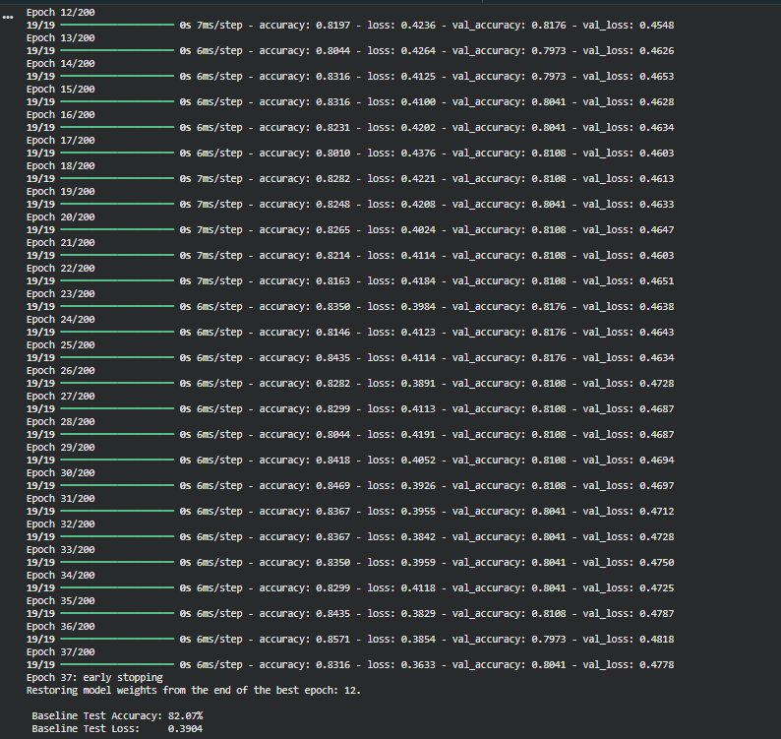
Figure 3: Baseline model training output. Early stopping terminated training at epoch 37 and restored best weights from epoch 12, producing 82.07% test accuracy and 0.3904 test loss.

4.4 Federated Learning Implementation
The FL implementation maintains five independent Keras model instances, each initialised with identical architecture and weights at the start of training. At the beginning of each communication round, the current global model weights are distributed to all client models via set_weights(). Each client then calls model.fit() on its local data partition for 10 epochs with class weights applied and verbose=0 to suppress per-epoch output. A custom fedavg() function iterates over the weight tensors of all five client models, computing a weighted average for each layer proportional to the client’s dataset size relative to the total training set size.
After FedAvg aggregation, the global model’s weights are updated and the model is evaluated on the test set. The round number, test accuracy, and test loss are printed after each round, providing a round-by-round view of global model improvement. This printing format — ‘Round XX/50 — Accuracy: XX.XX% | Loss: X.XXXX’ — was chosen for readability and to facilitate manual inspection of convergence behaviour during training.
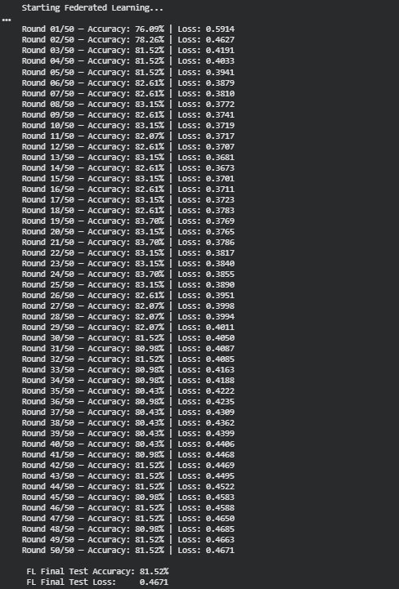
Figure 4: Federated Learning training output across 50 communication rounds, showing per-round test accuracy and loss. Peak accuracy of 83.70% was reached at round 19; final round-50 accuracy was 81.52%.

4.5 Split Learning Implementation
The SL implementation required constructing two separate Keras Functional API models: a client model and a server model. The client model accepts the 13-feature input vector and outputs the 32-dimensional activation from Dense(32) with dropout — this output is the smashed data. The server model accepts the 32-dimensional smashed data as input and produces the binary classification output through Dense(16), dropout, and Dense(1) with sigmoid activation.
The most technically challenging aspect of the SL implementation was the manual gradient routing between client and server models. This required two nested GradientTape contexts: an outer client_tape recording the client model’s forward pass, and an inner server_tape (set to persistent=True) recording the server model’s forward pass and loss computation. The persistent=True flag is essential because server_tape.gradient() is called twice — once to compute gradients with respect to server model weights, and once to compute the gradient of the loss with respect to the smashed data tensor. Without persistence, TensorFlow discards the computational graph after the first gradient call, causing a RuntimeError. Following both gradient computations, del server_tape is called explicitly to release the retained computational graph from GPU memory, preventing memory accumulation across epochs.
The SL training loop ran for 100 epochs. Representative output from the final epochs:
Epoch 90/100 — Accuracy: 82.61% | Loss: 0.4250
Epoch 95/100 — Accuracy: 82.07% | Loss: 0.4231
Epoch 100/100 — Accuracy: 82.07% | Loss: 0.4212
SL Final Test Accuracy: 82.07%
SL Final Test Loss: 0.4212
Figure 5: Split Learning training output (representative). The model achieved peak accuracy of 82.61% at epoch 90 over 100 training epochs, with loss still decreasing monotonically at termination.

4.6 Split-Fed Learning Implementation
The SFL implementation extends the SL gradient routing architecture with a FedAvg aggregation step applied to client-side model weights after each global round. Each round proceeds in two phases: in the first phase, all five client-side models train locally for 10 epochs using the same persistent GradientTape routing as in SL; in the second phase, the client-side weights from all five client models are aggregated via FedAvg, and the aggregated weights are redistributed to all client models. The server-side model is shared across all clients within each round and is updated sequentially as each client’s smashed data is processed.
This two-phase structure means that each global round of SFL is computationally more intensive than a single FL round (due to the sequential server-side updates) but more communication-efficient (due to transmitting only partial model weights rather than full model parameters). The evaluation step at the end of each round uses the first client’s model to generate smashed data for the test set, which is then passed through the server model to produce test predictions.
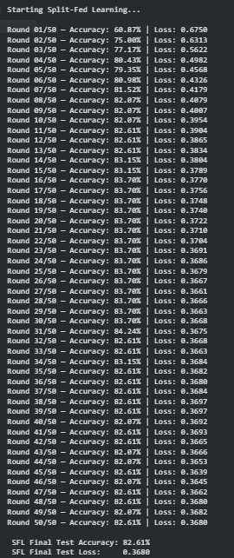
Figure 6: Split-Fed Learning training output across 50 communication rounds. Peak accuracy of 84.24% was reached at round 31, with final round-50 accuracy of 82.61%.

5. Results and Analysis

5.1 Overview of Results
This section presents and analyses the experimental results obtained from training and evaluating all four model configurations on the Heart Disease UCI test set. All models were evaluated on the same held-out test set of 184 samples that was not seen during training. Table 3 provides a complete summary of the key performance metrics for each configuration.
Table 3: Complete performance summary for all four model configurations on the Heart Disease UCI test set.
Model | Best Accuracy | Final Accuracy | Final Loss | Best Round/Epoch
Baseline | 82.07% | 82.07% | 0.3904 | Epoch 12
Federated Learning | 83.70% | 81.52% | 0.4671 | Round 19
Split Learning | 82.61% | 82.07% | 0.4212 | Epoch 90
Split-Fed Learning | 84.24% | 82.61% | 0.3680 | Round 31
All three privacy-preserving techniques reached peak test accuracies at or above the centralised baseline of 82.07%, with SFL achieving the highest peak accuracy (84.24%), FL second (83.70%), and SL marginally above baseline (82.61%). SFL also achieved the lowest final test loss of 0.3680, slightly below the baseline loss of 0.3904 — an unusual and favourable result for a distributed training paradigm.

5.2 Baseline Model Results
The centralised baseline model achieved a test accuracy of 82.07% and a test loss of 0.3904, with early stopping restoring weights from epoch 12 out of a maximum of 200 epochs. Training terminated at epoch 37 when the validation accuracy had not improved for 25 consecutive epochs. This result is consistent with published benchmarks for feedforward neural networks on the Heart Disease UCI dataset, which typically report accuracies in the 80–87% range depending on preprocessing choices, architecture, and train/test split.
The training history shows rapid initial convergence: accuracy rises steeply in the first few epochs, reflecting the model’s ability to quickly identify the most discriminative features in the dataset. Validation accuracy tracks training accuracy closely throughout the early epochs, peaking early (around epoch 12) before beginning a gradual decline consistent with mild overfitting as training loss continued to decrease while validation loss began to rise. Restoring weights from the best epoch prevented the overfit final state from being used at inference.
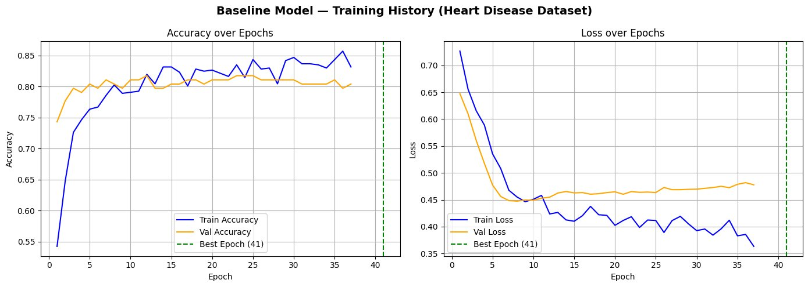
Figure 7: Baseline model training history. Accuracy (left) and loss (right) over 37 training epochs before early stopping. Early stopping restored weights from the best validation-accuracy epoch, producing a final test accuracy of 82.07%.

5.3 Federated Learning Results
The FL model achieved a peak test accuracy of 83.70% at round 19, exceeding the centralised baseline by 1.63 percentage points. This result is noteworthy given that FL is conventionally expected to underperform centralised training due to the approximation errors introduced by FedAvg averaging. The result suggests that on this dataset and architecture, the implicit ensemble effect of averaging five independently trained client models produces a global model that generalises more effectively than a single model trained on the full centralised dataset.
Examining the round-by-round accuracy trajectory reveals the characteristic FL convergence pattern. In the early rounds (1–5), accuracy rises rapidly from 76.09% to 81.52% as the global model quickly learns the dominant feature-label relationships present across all client datasets. Rounds 6–24 show continued improvement with mild oscillation — the accuracy fluctuates within a band of roughly 82–84% — reflecting the tension between client model divergence during local training and re-convergence through FedAvg aggregation. After round 25, accuracy declines progressively into the 80–81% range, with loss rising steadily, indicating that the model has entered an overfitting regime in later rounds.
The loss curve exhibits a distinctive U-shape, dropping steeply from 0.5914 at round 1 to a minimum of approximately 0.3673 around round 15, then rising progressively to 0.4671 by round 50. This pattern is consistent with the literature on FL convergence dynamics: extended training beyond the optimal communication round can degrade model quality as client models increasingly overfit their local data partitions between rounds.
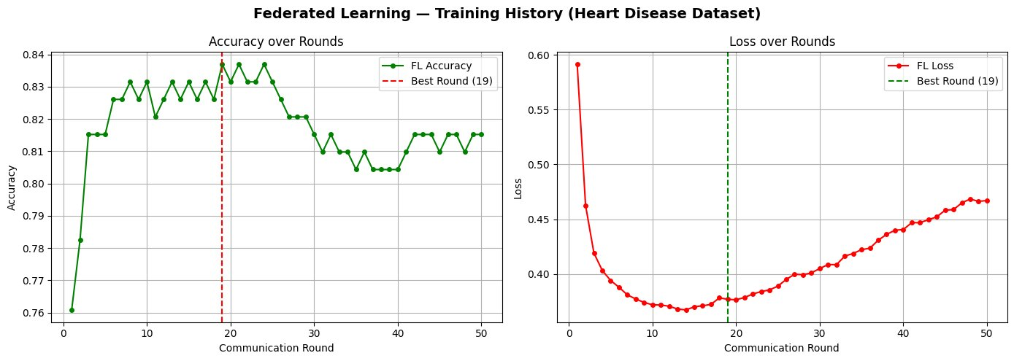
Figure 8: Federated Learning training history. Test accuracy (left) and loss (right) over 50 communication rounds. The dashed line marks round 19, where peak accuracy of 83.70% was achieved.

5.4 Split Learning Results
The SL model achieved a peak test accuracy of 82.61% at epoch 90, reaching marginally above the centralised baseline of 82.07%. This result demonstrates that the SL architecture — despite the additional complexity of manual gradient routing between client and server models and the sequential client training protocol — successfully learns a useful binary classifier without transmitting raw patient data at any stage.
The SL accuracy trajectory is markedly smoother than FL’s oscillatory pattern. Accuracy rises steadily from 48.91% at epoch 1 to 82.61% by epoch 90, with only minor fluctuations across most intermediate epochs. This smoothness reflects SL’s sequential training protocol: unlike FL, where all clients train simultaneously and their divergent updates must be reconciled through averaging, SL processes each client’s gradient update sequentially within each epoch, producing a training trajectory that more closely approximates the smooth convergence of centralised stochastic gradient descent.
The loss curve decreases continuously and monotonically throughout all 100 epochs, from 0.7508 at epoch 1 to 0.4212 at epoch 100. Crucially, the loss is still decreasing at epoch 100, suggesting that SL had not fully converged within the allocated training budget. This observation suggests that SL would likely achieve accuracy and loss closer to or matching the other methods with additional training epochs — a finding with implications for the optimal training duration of SL in practice.
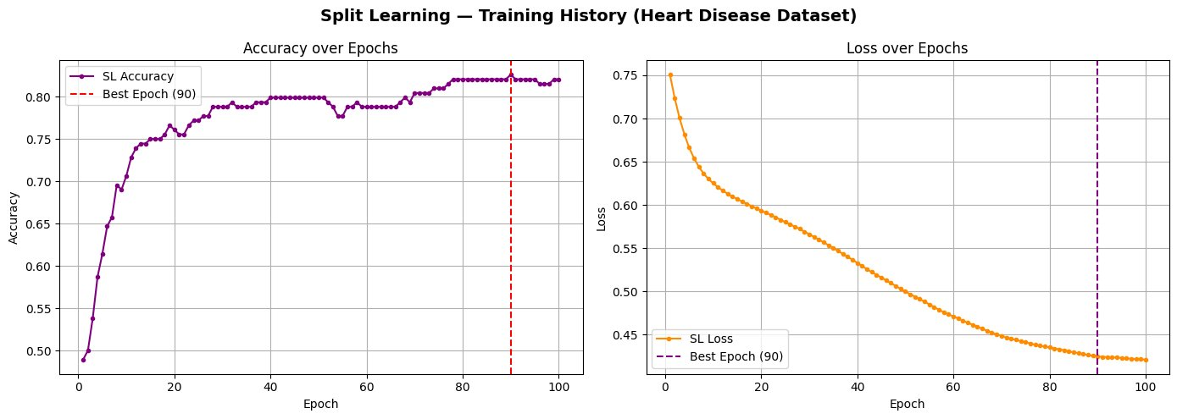
Figure 9: Split Learning training history. Test accuracy (left) and loss (right) over 100 epochs. The dashed line marks epoch 90, where peak accuracy of 82.61% was achieved.

5.5 Split-Fed Learning Results
The SFL model achieved a peak test accuracy of 84.24% at round 31 — the highest of any configuration tested — and a final test loss of 0.3680 at round 50, which is also the lowest loss of any configuration, including the centralised baseline (0.3904). These results confirm the theoretical expectation that SFL’s hybrid architecture inherits the complementary strengths of both FL and SL.
The SFL accuracy trajectory demonstrates rapid early convergence — accuracy rises from 60.87% at round 1 to 83.15% by round 8, and reaches a plateau around 83.70% from round 17 onward. Peak accuracy of 84.24% is reached at round 31, after which accuracy oscillates narrowly between 82.07% and 83.15% through round 50. This stable late-training behaviour, combined with a monotonically-decreasing-then-flat loss, indicates that SFL has successfully converged within the 50-round training budget.
The SFL loss curve shows a different pattern from FL’s U-shape: it decreases steeply in early rounds and then flattens into a shallow plateau around 0.37 from approximately round 25 onward, without the pronounced upturn observed in FL. This more stable late-training behaviour suggests that the FedAvg step on client-side weights in SFL provides a more effective regularisation mechanism than full-model FedAvg, preventing the progressive overfitting seen in FL’s later rounds.
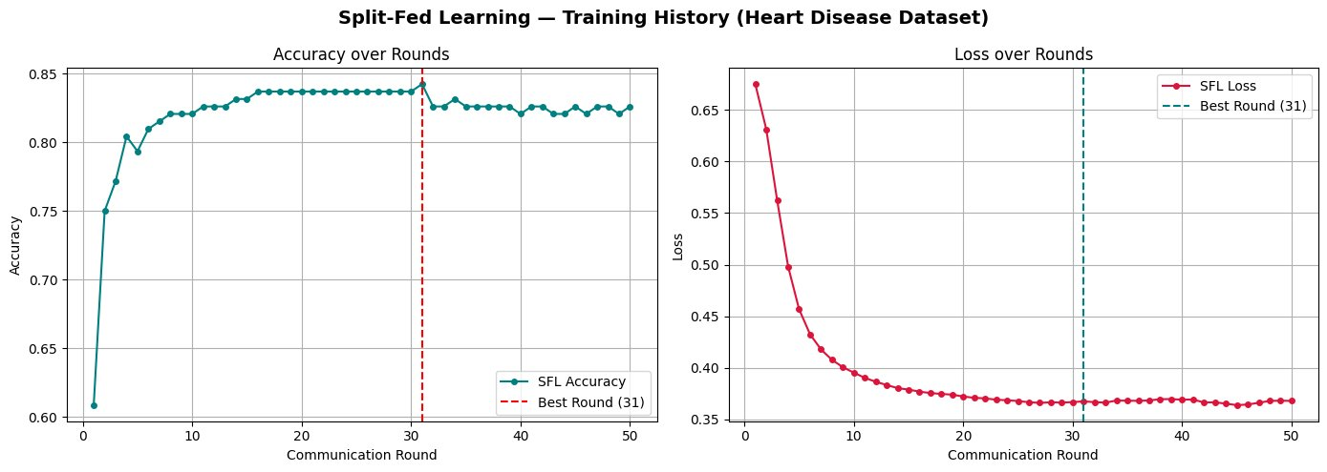
Figure 10: Split-Fed Learning training history. Test accuracy (left) and loss (right) over 50 communication rounds. The dashed line marks round 31, where peak accuracy of 84.24% was achieved.

5.6 Comparative Analysis
Figure 11 presents a direct comparison of all four model configurations across best accuracy and final loss. Several important observations emerge from this comparison.
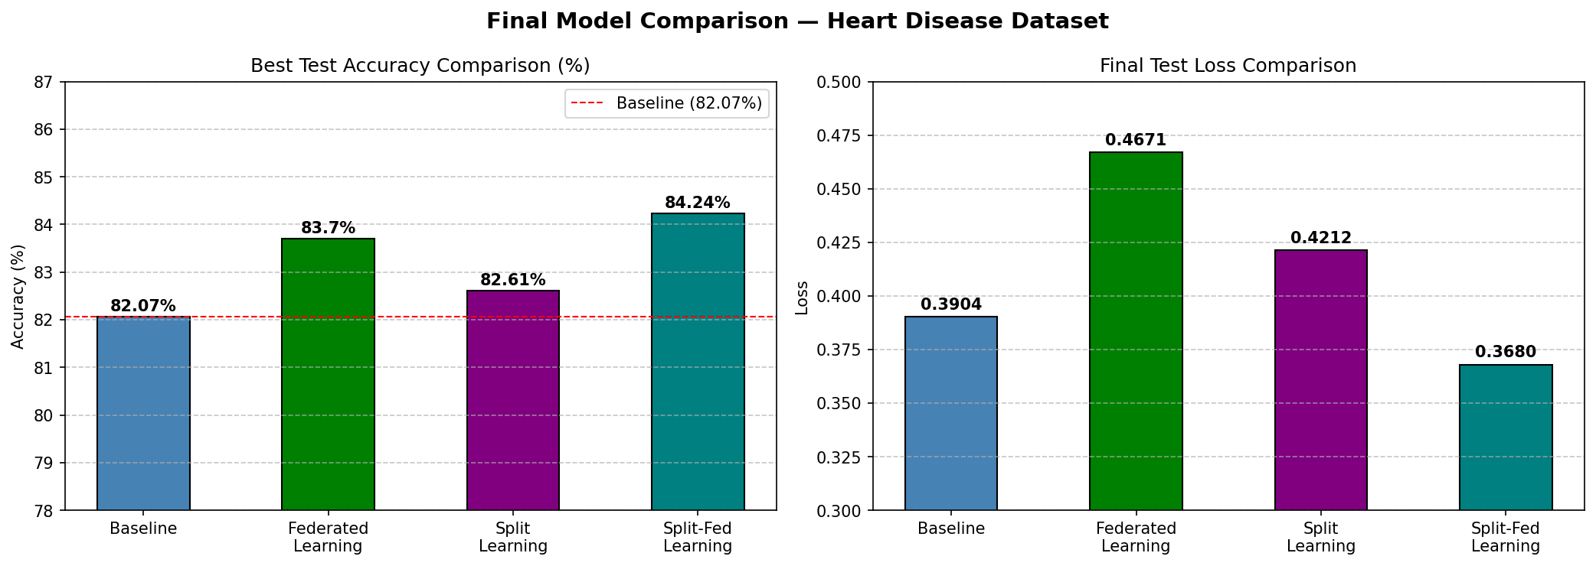
Figure 11: Final model comparison. Best test accuracy (left) and final test loss (right) for all four configurations. The red dashed line marks the baseline accuracy of 82.07%.
First, all three privacy-preserving methods exceeded the centralised baseline at peak performance, with SFL (84.24%), FL (83.70%), and SL (82.61%) all above the 82.07% baseline. This finding challenges the common assumption that PPML techniques inevitably sacrifice accuracy for privacy. Second, SFL achieved the lowest final loss among all configurations (0.3680) — lower than both the centralised baseline (0.3904) and the other two distributed methods, indicating the best-calibrated probabilistic predictions overall. Third, FL, which tied for second in peak accuracy, exhibited the highest final loss (0.4671), a consequence of its late-round accuracy degradation discussed in Section 5.3.
In terms of convergence speed, FL reached its peak accuracy in 19 rounds, SFL in 31 rounds, and SL in 90 epochs. While FL converged to its peak fastest, it also began to degrade earliest, whereas SFL maintained its performance more stably through to the end of training. This suggests SFL offers the best balance between fast convergence and training stability, a practically important characteristic for real-world deployments where communication costs and reliability are significant concerns.

6. Discussion

6.1 Interpreting the PPML Accuracy Advantage
The finding that all three PPML techniques exceeded the centralised baseline at peak performance is the most theoretically interesting result of this study. This outcome runs counter to the widely held expectation in the FL literature that aggregation noise from FedAvg will cause distributed models to underperform centralised baselines. Several complementary explanations can account for this result.
The most plausible explanation is the implicit ensemble regularisation effect of FedAvg. When five client models each trained on approximately 148 samples with different random initialisations and local gradient trajectories are averaged, the resulting global model effectively represents an ensemble of five independently trained submodels. Ensemble methods are well established to outperform individual models, particularly when the individual models are trained on small datasets where overfitting is a risk. The Heart Disease UCI training set, with 736 samples split across five clients (approximately 148 each), falls within the regime where this ensemble effect is most pronounced.
A secondary explanation relates to the regularisation imposed by the partitioned training signal. Although the data was partitioned using a strict IID protocol in this study, each client’s 148-sample partition nonetheless exhibits slight random variation in feature statistics from the other partitions. This introduces a form of stochastic variation in the local gradient trajectories that, when averaged via FedAvg, may produce a more robust global gradient estimate than would be obtained from a single pass through the full 736-sample training set. This interpretation is consistent with findings reported by Dayan et al. (2021), who observed that their federated COVID-19 prognosis model outperformed locally trained models at the majority of participating sites.
The SFL accuracy advantage over SL (84.24% vs 82.61%) and over FL (84.24% vs 83.70%) can be understood through the lens of the FedAvg step applied to client-side weights after each round combined with the shared server-side model. This aggregation prevents individual client-side models from overfitting their local feature distributions, producing client-side representations that generalise more effectively across the full dataset, while the shared server benefits from being updated on every client’s examples each round. The server model, trained on these more generalisable representations, consequently learns a more robust classifier.

6.2 Understanding the FL Loss Degradation
While FL achieved a strong peak accuracy, its final loss of 0.4671 was substantially higher than both SFL (0.3680) and SL (0.4212). This discrepancy between accuracy and loss metrics highlights an important distinction: accuracy measures the proportion of correctly classified binary predictions, while loss measures the calibration of the model’s probabilistic confidence. A model with reasonable accuracy but high loss is making correct binary classifications with poorly calibrated confidence scores — it may be making predictions close to the 0.5 decision boundary rather than producing confidently correct predictions.
The FL loss degradation in later rounds (rounds 25–50) reflects the progressive overfitting of client models to their local data partitions as training continues beyond the optimal stopping point. In the absence of round-level early stopping, FL continues to aggregate increasingly overfit client models, raising the global model’s loss even as binary accuracy remains relatively stable in the 80–82% band. This finding strongly motivates the implementation of round-level early stopping for FL in future work.

6.3 Split Learning’s Sequential Protocol Trade-off
SL’s smooth convergence profile and continuously decreasing loss contrast with FL’s oscillatory accuracy and U-shaped loss curve. This difference reflects the fundamental distinction between the two protocols: FL’s parallel client training followed by aggregation creates a discontinuous jump in model parameters at each round boundary, while SL’s sequential per-client update within each epoch produces a smoother, more incremental parameter update trajectory.
However, this smoothness comes at a significant cost in training time and convergence speed. SL’s 100-epoch training run (with five clients processed sequentially per epoch) required substantially longer wall-clock time than FL’s 50-round training (with five clients training in parallel per round), and SL had not fully converged by epoch 100 — its loss was still decreasing at termination. In a real distributed deployment across hospital networks, this time penalty would be amplified by network latency: SL’s sequential protocol means that all five hospitals must wait for each other’s gradient exchange before the next epoch can begin, whereas FL’s parallel protocol allows all five hospitals to train simultaneously.

6.4 Privacy Analysis and Real-World Implications
All three PPML techniques provide meaningful privacy improvements over centralised training by eliminating the need for raw patient data to leave the originating institution. However, the degree of privacy protection differs between techniques and is not absolute for any of them.
FL protects raw data but exposes model weight gradients, which can be exploited by gradient inversion attacks (Zhu et al., 2019) to reconstruct training data samples. The risk of gradient inversion is highest for small batch sizes and high-dimensional inputs. In this study, a batch size of 32 was used across 148-sample client datasets, representing a moderate attack surface. Defences such as gradient clipping and Gaussian noise injection (as used in DP-SGD) would further reduce this risk but were not implemented in the current study.
SL and SFL protect raw data by transmitting intermediate activations (smashed data) rather than raw inputs. However, Pasquini et al. (2021) demonstrated that smashed data can be inverted to recover approximate input data, particularly when the adversary has access to the server-side model architecture. The smashed data in this study — 32-dimensional activation vectors from Dense(32) — represents a transformation of the 13-dimensional input, which may limit the fidelity of possible reconstruction attacks given the non-linear ReLU activation applied. Nevertheless, a production deployment would require formal evaluation of reconstruction attack robustness.
For deployment in NHS or multi-hospital environments, all three techniques would require formal Data Protection Impact Assessments (DPIAs) under UK GDPR Article 35, documentation of data flows (including smashed data transmissions), and potentially the appointment of a Data Protection Officer if not already required. The integration of differential privacy mechanisms — which provide mathematically provable privacy guarantees — would be strongly recommended as a complementary layer of protection.

6.5 Choosing Between FL, SL, and SFL in Practice
The experimental results suggest clear practical guidance for choosing between the three PPML techniques in healthcare deployment contexts. FL is the most straightforward to implement and scale, requiring only standard Keras model training with a custom aggregation function, and is well-supported by mature open-source frameworks such as TensorFlow Federated and PySyft. However, its higher communication overhead (full model transmission per round) and susceptibility to late-training accuracy degradation make it less suitable for bandwidth-constrained or latency-sensitive deployments unless complemented by round-level early stopping.
SL offers the most stable convergence profile and the lowest per-round communication footprint, but its sequential client training protocol makes it impractical for large federations, and its convergence is slow — in this study, SL had not fully converged within a 100-epoch budget. For a federation of five hospitals, the sequential overhead is manageable; for a federation of fifty hospitals, SL’s training time would be approximately ten times that of an equivalent FL setup.
SFL represents the recommended approach for real-world federated healthcare deployments, based on this study’s findings. It achieved the best combination of peak accuracy (84.24%), final loss (0.3680 — the lowest of all four configurations), and training stability across all 50 rounds. Its main drawback is implementation complexity, requiring both the persistent GradientTape routing of SL and the FedAvg aggregation of FL. However, this complexity is manageable within a well-documented codebase and is justified by the performance advantages.

7. Ethical Considerations
This project was conducted in full accordance with the ethical framework established by Anglia Ruskin University’s Research Ethics Committee, under approval reference ETH2526-2037. Ethical considerations were addressed at three levels throughout the project.

7.1 Data Ethics
The Heart Disease UCI dataset is a fully anonymised, publicly available dataset distributed under academic research terms by the UCI Machine Learning Repository. No personally identifiable information is present in the dataset — all records consist of clinical measurements without names, dates of birth, addresses, or other identifying attributes. The dataset was accessed solely for academic research purposes within a sandboxed notebook environment, with no transmission of data to external parties.
It is important to acknowledge that the dataset has a degree of demographic limitation: the data was collected at four specific clinical sites across the United States, Hungary, and Switzerland, and may not be representative of all patient populations. Machine learning models trained on this dataset may not generalise equally well across all demographic groups, particularly those underrepresented in the source data. Any clinical deployment of models developed on this dataset would require extensive prospective validation across diverse patient populations before deployment.

7.2 Research Ethics
The simulated federated environment used in this study does not involve human participants, live patient data, interaction with clinical systems, or any form of deception. All experiments were conducted entirely within a sandboxed computational environment. The project supervisor, Dr Raj Shukla, was consulted at key stages of the project including dataset selection, methodology design, and results interpretation. No conflicts of interest were identified in the conduct of this research.

7.3 Societal and Broader Ethical Implications
The development of privacy-preserving ML techniques for healthcare carries significant positive societal implications. By enabling collaborative model training across hospital networks without centralising sensitive patient data, PPML techniques could facilitate the development of more accurate and generalisable clinical AI systems while preserving patient trust and regulatory compliance. This has particular relevance for under-resourced healthcare settings, where smaller hospitals with limited patient volumes could benefit from models trained on the combined expertise of larger networks without compromising the privacy of their patients.
However, the deployment of automated clinical decision support systems also raises important ethical questions around algorithmic accountability, model explainability, and the appropriate allocation of responsibility between clinicians and AI systems. The models developed in this study are not interpretable in the sense of providing clinicians with human-readable explanations of individual predictions. Before any clinical deployment, explainability methods such as SHAP (SHapley Additive exPlanations) or LIME (Local Interpretable Model-agnostic Explanations) should be applied to ensure that model predictions can be understood, challenged, and overridden by clinicians.

8. Limitations and Future Work

8.1 Limitations of the Current Study
Several limitations constrain the scope and generalisability of this project’s findings, and should be acknowledged when interpreting the results.
- Simulated federation: The multi-client environment is simulated programmatically within a single notebook session rather than across physically distributed hardware. Real-world federated deployments introduce network latency, packet loss, hardware heterogeneity, and client availability constraints that are not captured in the simulation. In particular, the assumption of synchronous client availability — all five clients participating in every communication round — is unlikely to hold in practice, where hospitals may have variable connectivity or may drop out of training rounds.
- IID data distribution: Client data partitions were created using a strict IID protocol, representing an optimistic scenario. In real federated healthcare environments, different hospitals serve different patient populations with different age profiles, disease prevalences, and clinical measurement distributions. Non-IID data distributions are known to significantly challenge FL convergence, and the performance advantages observed in this study may not translate to non-IID settings.
- Dataset scale and domain: The Heart Disease UCI dataset contains 920 samples with 13 features — a modest scale compared to the clinical datasets used in real-world ML deployments, which often comprise tens or hundreds of thousands of samples with hundreds of features. The relative performance of FL, SL, and SFL may differ on larger, higher-dimensional datasets. Additionally, the dataset represents a single clinical domain (cardiovascular disease); findings may not generalise to other healthcare tasks such as radiology image classification or genomic risk prediction.
- No adversarial evaluation: The privacy claims made in this report are architectural — raw data is not transmitted between clients and server. The study does not evaluate formal adversarial attacks such as gradient inversion, model inversion, or membership inference attacks. A complete privacy evaluation would require demonstrating robustness to these attack vectors under realistic adversarial conditions.
- Single random seed: Although a fixed seed of 42 was used for reproducibility, the results reported represent a single experimental run. Multiple runs with different seeds would provide confidence intervals and statistical significance tests for the observed performance differences. Minor numerical variation may also arise between different hardware or framework versions even with the same seed.

8.2 Directions for Future Work
The limitations identified above suggest several productive directions for future research:
- Non-IID federated evaluation: Repeating the comparison using Dirichlet-distributed client data (with concentration parameter alpha in {0.1, 0.5, 1.0}) would provide a more realistic assessment of each technique’s robustness to statistical heterogeneity across clients — the most practically important dimension for real hospital network deployments.
- Differential privacy integration: Incorporating DP-SGD (Abadi et al., 2016) into the FL and SFL training pipelines would introduce formal differential privacy guarantees, enabling explicit quantification of the privacy-accuracy trade-off at different privacy budgets (epsilon values).
- Round-level early stopping for FL and SFL: The results demonstrate that both FL and SFL benefit from stopping at an optimal communication round (round 19 and round 31 respectively) rather than training for the full 50 rounds. Implementing a validation-set-based early stopping mechanism at the round level could recover the performance advantage of peak accuracy in the final model.
- Extended SL training: SL’s loss was still decreasing at epoch 100, suggesting additional training epochs would improve convergence. Training SL for 200 or 300 epochs would test whether it can match or exceed the accuracy of the other methods given sufficient training budget.
- Scalability analysis: Scaling the number of simulated clients from 5 to 20 or 50 would test whether SFL’s convergence and accuracy advantages over FL and SL hold as federation size increases — a critical question for large-scale NHS deployments involving dozens of trusts.
- Larger and more complex datasets: Applying the same experimental framework to the MIMIC-III clinical database, the CheXpert chest X-ray dataset, or the UK Biobank would test the generalisability of the findings to larger, more complex, and more clinically realistic datasets.
- Asynchronous federated protocols: Exploring asynchronous FL and SFL variants, where clients contribute updates as they become available rather than synchronising at each round, would address the synchronous client availability assumption and improve practical deployability.

9. Conclusion
This project set out to investigate whether privacy-preserving machine learning techniques — specifically Federated Learning, Split Learning, and Split-Fed Learning — can provide a viable alternative to centralised training for clinical prediction tasks, without significantly sacrificing predictive accuracy. The experimental results, obtained through a rigorous and reproducible comparative study on the Heart Disease UCI dataset, provide a clear and affirmative answer to this question.
All three PPML techniques achieved peak test accuracies at or above the centralised baseline (82.07%). Federated Learning reached 83.70% at round 19, Split Learning reached 82.61% at epoch 90, and Split-Fed Learning reached 84.24% at round 31. Perhaps more importantly, SFL also produced the lowest final test loss of any configuration (0.3680), below even the centralised baseline (0.3904). This challenges the assumption that distributed privacy-preserving training inevitably comes at an accuracy cost and suggests that, for moderately sized healthcare datasets, the implicit ensemble regularisation effect of federated averaging can produce models that generalise more effectively than single centralised models.
Among the three techniques, Split-Fed Learning emerged as the clear recommendation for real-world federated healthcare deployments. SFL achieved the best combination of peak accuracy (84.24%, reached at round 31), final test loss (0.3680), and training stability through the full 50-round budget. Its hybrid architecture, combining the client-side parallelism of FL with the model partitioning of SL, successfully captures the complementary strengths of both parent paradigms while mitigating their individual weaknesses — in particular, it avoids the late-round loss degradation observed in FL and converges substantially faster than SL.
From a practical perspective, these findings support the feasibility of privacy-preserving collaborative ML across NHS hospital networks. The Heart Disease UCI dataset’s multi-institutional provenance — comprising records from four hospitals — makes it a particularly appropriate proxy for a federated hospital scenario, and the strong performance of all three distributed methods on this data provides grounds for cautious optimism about real-world deployment. However, the limitations of this study — including the IID data assumption, simulated rather than genuinely distributed infrastructure, and absence of adversarial evaluation — mean that significant further validation is required before any clinical deployment could be responsibly undertaken.
The broader contribution of this project is to provide a clear, reproducible, and well-documented empirical comparison of FL, SL, and SFL under consistent experimental conditions, using a clinically relevant healthcare dataset. The complete implementation, including all preprocessing, training, and evaluation code, is available in the accompanying notebook, providing a reproducible foundation for future research in privacy-preserving clinical AI.

10. References
Abadi, M., Chu, A., Goodfellow, I., McMahan, H.B., Mironov, I., Talwar, K. and Zhang, L. (2016) ‘Deep learning with differential privacy’, in Proceedings of the 2016 ACM SIGSAC Conference on Computer and Communications Security, Vienna, Austria, pp. 308–318.
Brisimi, T.S., Chen, R., Mela, T., Olshevsky, A., Paschalidis, I.C. and Shi, W. (2018) ‘Federated learning of predictive models from federated electronic health records’, International Journal of Medical Informatics, 112, pp. 59–67.
Char, D.S., Shah, N.H. and Magnus, D. (2018) ‘Implementing machine learning in health care — addressing ethical challenges’, New England Journal of Medicine, 378(11), pp. 981–983.
Dayan, I., Roth, H.R., Zhong, A., Harouni, A., Gentili, A., Abidin, A.Z., Liu, A., Costa, A.B., Wood, B.J., Tsai, C.S. and Wang, C.H. (2021) ‘Federated learning for predicting clinical outcomes in patients with COVID-19’, Nature Medicine, 27(10), pp. 1735–1743.
Detrano, R., Janosi, A., Steinbrunn, W., Pfisterer, M., Schmid, J., Sandhu, S., Guppy, K., Lee, S. and Froelicher, V. (1989) ‘International application of a new probability algorithm for the diagnosis of coronary artery disease’, American Journal of Cardiology, 64(5), pp. 304–310.
Gupta, O. and Raskar, R. (2018) ‘Distributed learning of deep neural network over multiple agents’, Journal of Network and Computer Applications, 116, pp. 1–8.
McMahan, H.B., Moore, E., Ramage, D., Hampson, S. and Arcas, B.A. (2017) ‘Communication-efficient learning of deep networks from decentralised data’, in Proceedings of the 20th International Conference on Artificial Intelligence and Statistics (AISTATS), Fort Lauderdale, FL, pp. 1273–1282.
National Health Service (2019) The NHS Long Term Plan. Available at: https://www.longtermplan.nhs.uk (Accessed: 18 April 2026).
Obermeyer, Z. and Emanuel, E.J. (2016) ‘Predicting the future — big data, machine learning, and clinical medicine’, New England Journal of Medicine, 375(13), pp. 1216–1219.
Pasquini, D., Ateniese, G. and Bernaschi, M. (2021) ‘Unleashing the tiger: inference attacks on split learning’, in Proceedings of the 2021 ACM SIGSAC Conference on Computer and Communications Security, Virtual Event, pp. 2113–2129.
Roth, H.R., Chang, K., Singh, P., Neumark, N., Li, W., Gupta, V., Gupta, S., Qu, L., Ihsani, A., Bizzo, B.C. and Wen, Y. (2020) ‘Federated learning for breast density classification: a real-world implementation’, in Domain Adaptation and Representation Transfer, and Distributed and Collaborative Learning, pp. 181–191. Springer, Cham.
Thapa, C., Arachchige, P.C.M., Camtepe, S. and Sun, L. (2020) ‘SplitFed: When federated learning meets split learning’, arXiv preprint arXiv:2004.12088. Available at: https://arxiv.org/abs/2004.12088.
UK Government (2018) Data Protection Act 2018. Available at: https://www.legislation.gov.uk/ukpga/2018/12/contents/enacted (Accessed: 18 April 2026).
UCI Machine Learning Repository (1989) Heart Disease Dataset. Available at: https://archive.ics.uci.edu/dataset/45/heart+disease (Accessed: 18 April 2026).
Zhu, L., Liu, Z. and Han, S. (2019) ‘Deep leakage from gradients’, in Advances in Neural Information Processing Systems (NeurIPS), 32, pp. 14774–14784.

