

Faculty of Science and Engineering
School of Computing and Information Science

Secure Door Access Management System

Module Code: MOD007361
Module Title: Embedded Computing
LIMITATION REPORT
SID NUMBER: 2276245

Platform: NUCLEO-G474RE | Mbed OS 6
Supervised by: Dr Oliver Faust
Assignment Deadline: 23 April 2026

1. System Overview
This report documents the limitations of the Secure Door Access Management System developed on the NUCLEO-G474RE microcontroller platform running Mbed OS 6. The system implements PIN-based authentication with a physical 4x4 matrix keypad, audio feedback through a passive piezo buzzer, LED-based door state indication, and a serial command interface accessible via UART.
Five limitations have been identified. Two have been addressed directly within the firmware implementation, while the remaining three are proposed as future work that would require additional hardware, extended development time, or secure infrastructure beyond the scope of this assignment.

1.1 Implemented Hardware Components
- NUCLEO-G474RE — ARM Cortex-M4 microcontroller development board
- 4x4 Matrix Membrane Keypad — physical PIN entry interface
- Passive Piezo Buzzer — PWM-driven audio feedback module (low-level trigger)
- Onboard LED (LD2) — visual door-state indicator
- Onboard Blue User Button (B1) — doorbell input with edge detection
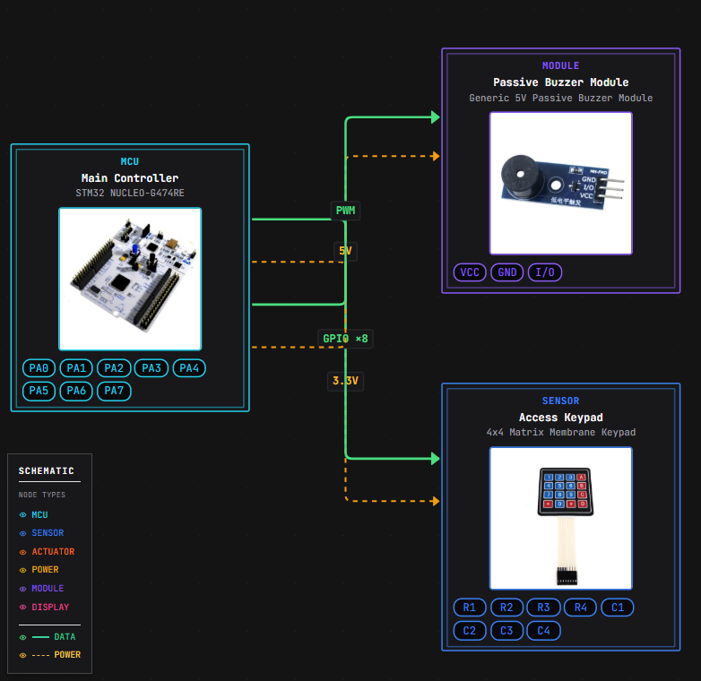

1.2 Flow diagram of given hardware’s Process

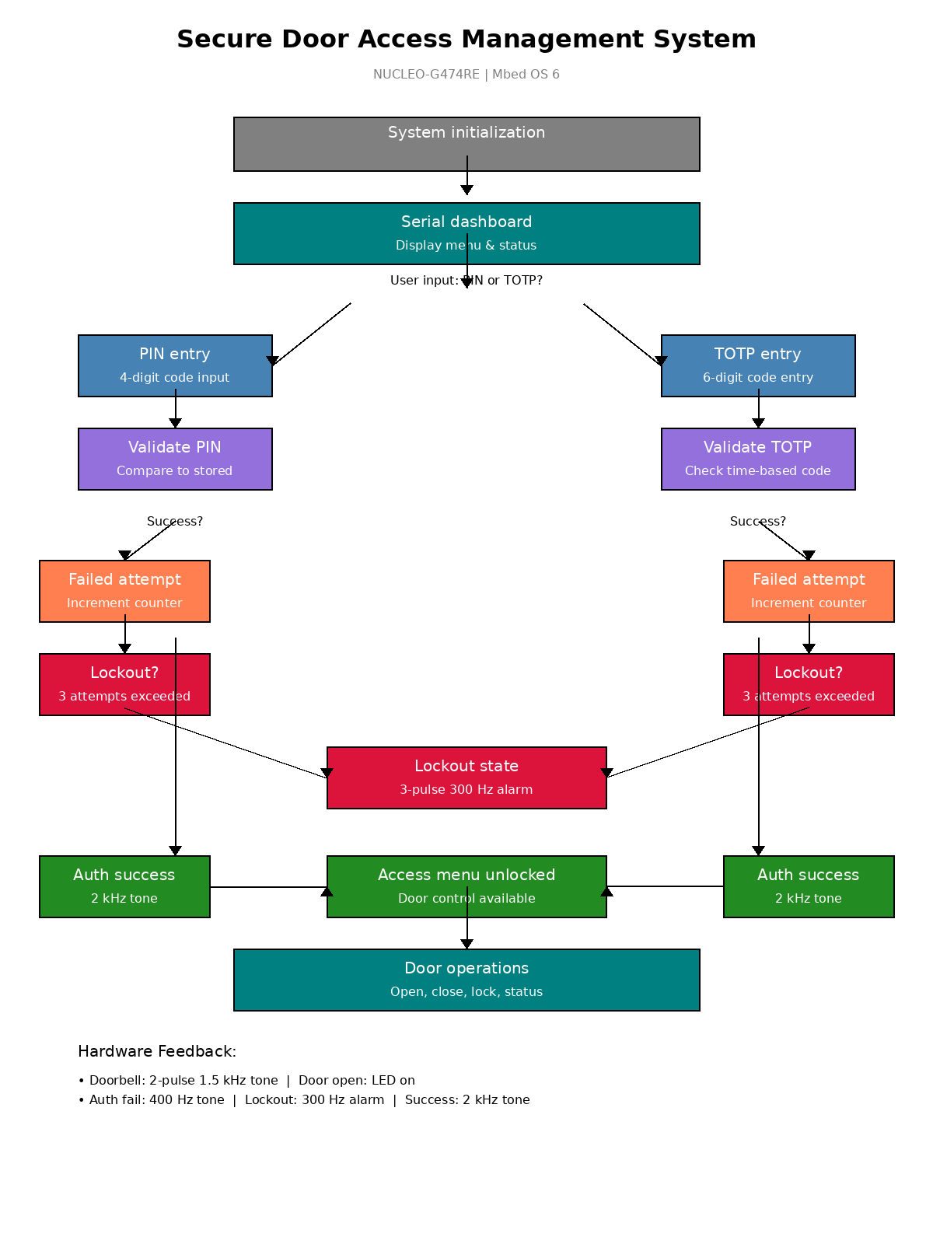

2. Addressed Limitations
The following two limitations of the minimal reference system have been directly addressed by design choices and implementation enhancements within the firmware and hardware setup provided.

Limitation 1 — Absence of User Authentication
Status: Addressed in firmware
The minimal reference system allows door operation without user verification, enabling unauthorized entry. This fundamental security flaw defeats the access control purpose.
This limitation was addressed through a four-digit PIN authentication mechanism accepting input from the physical keypad and serial terminal. The system incorporates a three-attempt lockout policy: after three incorrect entries, the firmware locks and triggers a 300 Hz alarm tone. On successful authentication, an access menu unlocks, and failed attempts are communicated via serial messages and auditory feedback.

Limitation 2 — Lack of Multi-Modal Feedback
Status: Addressed in hardware and firmware
The minimal design relies solely on an LED, providing no immediate response to user input. In realistic deployments, users expect both visual and auditory confirmation, especially in poor lighting or for accessibility.
This limitation was addressed by integrating a passive piezo buzzer with distinct audio signatures: 2 kHz for authentication success, 400 Hz for failure, two-pulse 1.5 kHz for doorbell, and three-pulse 300 Hz for lockout. Combined with the onboard LED and structured serial dashboard displaying authentication state, door status, and remaining attempts, the system now provides rich multi-modal feedback across auditory, visual, and text-based channels.

3. Limitations Proposed for Future Work
The following three limitations were identified during the development process but remain unaddressed in the present implementation. Each would require either additional hardware procurement, extended development time, or secure backend infrastructure beyond the scope of this assignment.

Limitation 3 — Single-Factor Authentication
Status: Future work
The current implementation relies solely on a static four-digit PIN, which is vulnerable to shoulder surfing, brute-force attacks, and social engineering. With only 10,000 possible combinations, a determined attacker could compromise the credentials through observation or systematic guessing, particularly as the PIN does not rotate and offers no resistance to physical inspection of key-press residue on the membrane keypad surface.
Future work could implement multi-factor authentication by adding a second independent factor, such as a time-based one-time password (TOTP) generated from an authenticator application or delivered to a registered mobile device, or a contactless RFID token read by an MFRC522 module over SPI. A TOTP approach would require implementing HMAC-SHA1 on the Cortex-M4 alongside an accurate real-time clock for synchronised time-step generation. Combining knowledge-based and possession-based factors would substantially harden the authentication surface against credential compromise.

Limitation 4 — No Persistent Access Audit Log
Status: Future work
The current system maintains no record of access events. Authentication attempts, door operations, lockout events, and doorbell activations are communicated to the serial console in real time but are lost when the serial session terminates or the system resets. This prevents post-incident forensic analysis, regulatory compliance audits, and pattern-of-use analytics, which are standard expectations for commercial access control systems.
Future work could integrate an external real-time clock (such as the DS3231) combined with non-volatile storage on an SD card or internal flash memory. Each event could be appended as a structured log entry containing timestamp, event type, user identifier, and authentication outcome. For enterprise deployment, logs could be transmitted to a central server using MQTT or HTTPS.

Limitation 5 — Physical Tampering and Firmware Extraction
Status: Future work
The prototype is constructed on an open development board with all GPIO lines, debug headers, power rails, and the SWD programming interface freely exposed. The PIN is stored as plaintext in the firmware, recoverable through the STLink debug interface. The keypad wiring, buzzer, and door-actuator LED can all be probed or bypassed.
Future work could address physical security through multiple layers: enabling STM32 Readout Protection Level 2 (RDP) prevents debug-port extraction; PIN material should be stored as salted SHA-256 hashes compared in constant time to resist timing attacks; a dedicated secure element such as the ATECC608A could store cryptographic keys in tamper-resistant hardware; mounting the board in a tamper-evident enclosure with a detection switch would trigger an alarm on intrusion.

4. Conclusion
The Secure Door Access Management System developed for this assignment implements a functional and demonstrable embedded access control solution on the NUCLEO-G474RE platform. Of the five limitations identified in the minimal reference design, two have been directly addressed through the implementation of PIN-based authentication with lockout protection and multi-modal audio-visual feedback. The remaining three limitations — single-factor authentication, absence of persistent audit logging, and physical tamper resistance — have been analysed and mapped to concrete, realisable technical solutions suitable for future development phases.
This layered approach, in which a minimal but functional core is progressively hardened against real-world threats, reflects standard industry practice for secure embedded systems and demonstrates the engineering trade-offs that govern the design of practical access control products.

