
Introduction
Welcome to the Pharmacy POS System User Manual.
This manual is designed to help pharmacy staff, including cashiers, managers, and administrators, effectively use the Pharmacy Billing and Inventory Management System. Developed to meet the specific needs of modern pharmacies, this system enhances operational efficiency, ensures accuracy in billing and inventory, and supports informed decision-making through robust reporting features.
In today’s fast-paced pharmaceutical environment, managing sales, stock, and supplier interactions with precision is crucial. Our POS system provides a secure, user-friendly interface to handle day-to-day pharmacy operations — from generating invoices and recording stock entries to managing products and generating insightful reports.
Whether you're processing a sale at the counter or reviewing inventory trends as an administrator, this manual offers step-by-step guidance to navigate the system’s features confidently and efficiently.
Who Should Use This Manual
- Cashiers handling billing and daily sales operations
- Pharmacy Managers overseeing stock, pricing, and supplier coordination
- System Administrators managing configurations, and reports
By following this guide, users will be able to:
- Log in and operate the cashier and admin panels
- Generate invoices
- Manage products, suppliers, and inventory through GRNs
- View and export detailed reports for audits and performance review
Let’s begin with an overview of how to get started.

Getting Started
Before using the Pharmacy POS System, it's important to understand how to access the platform and navigate the interface. This section covers system access, user roles, login procedures, and basic navigation for both the Cashier Panel and Admin Panel.

- System Access Requirements
To use the Pharmacy POS System, you’ll need:
- A desktop or laptop computer with Windows OS
- Java Runtime Environment (JRE) installed
- User credentials (provided by the system administrator)

- User Roles and Permissions
There are two main types of users in the system:
Role | Access Level
Cashier | Invoice generation, session start (login, petty cash), daily sales
Admin/Manager | Full access including product management, GRN, discounts, suppliers, and reports

- Launching the Application
- Double-click the Pharmacy POS System shortcut on your desktop.
- Wait for the application to initialize. You’ll see the login screen.

  - Log In Page
This is the main login screen for the Pharmacy POS system. Both cashiers and admin users use this screen to access their respective panels.
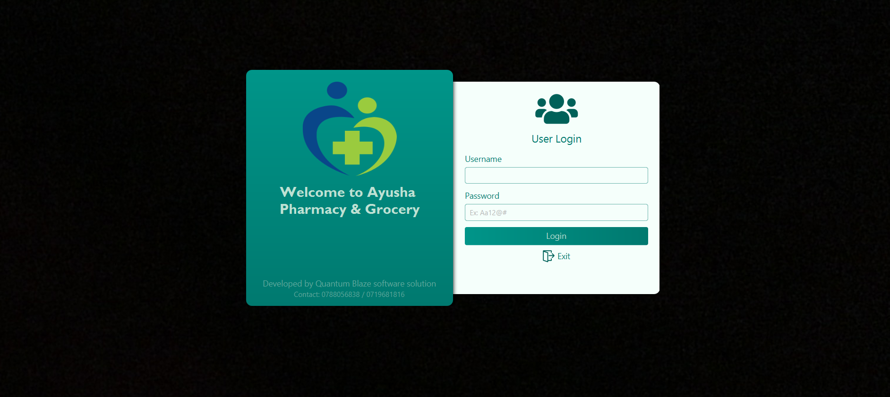

4.1. Elements Explained:
Username Field: Input the registered username of the cashier or admin.
Password Field: Input the secure password associated with the user account.
Login Button: After entering credentials, click this button to access the system.

- If you enter valid cashier credentials, the system redirects to the Cashier Panel.
- If you enter valid admin credentials, the system opens the Admin Panel.

⚠️ Make sure the username and password match exactly with the registered data. Incorrect credentials will show an error message like “Invalid Login Credentials”.

  - Cashier Dashboard
This is the cashier dashboard of this system.
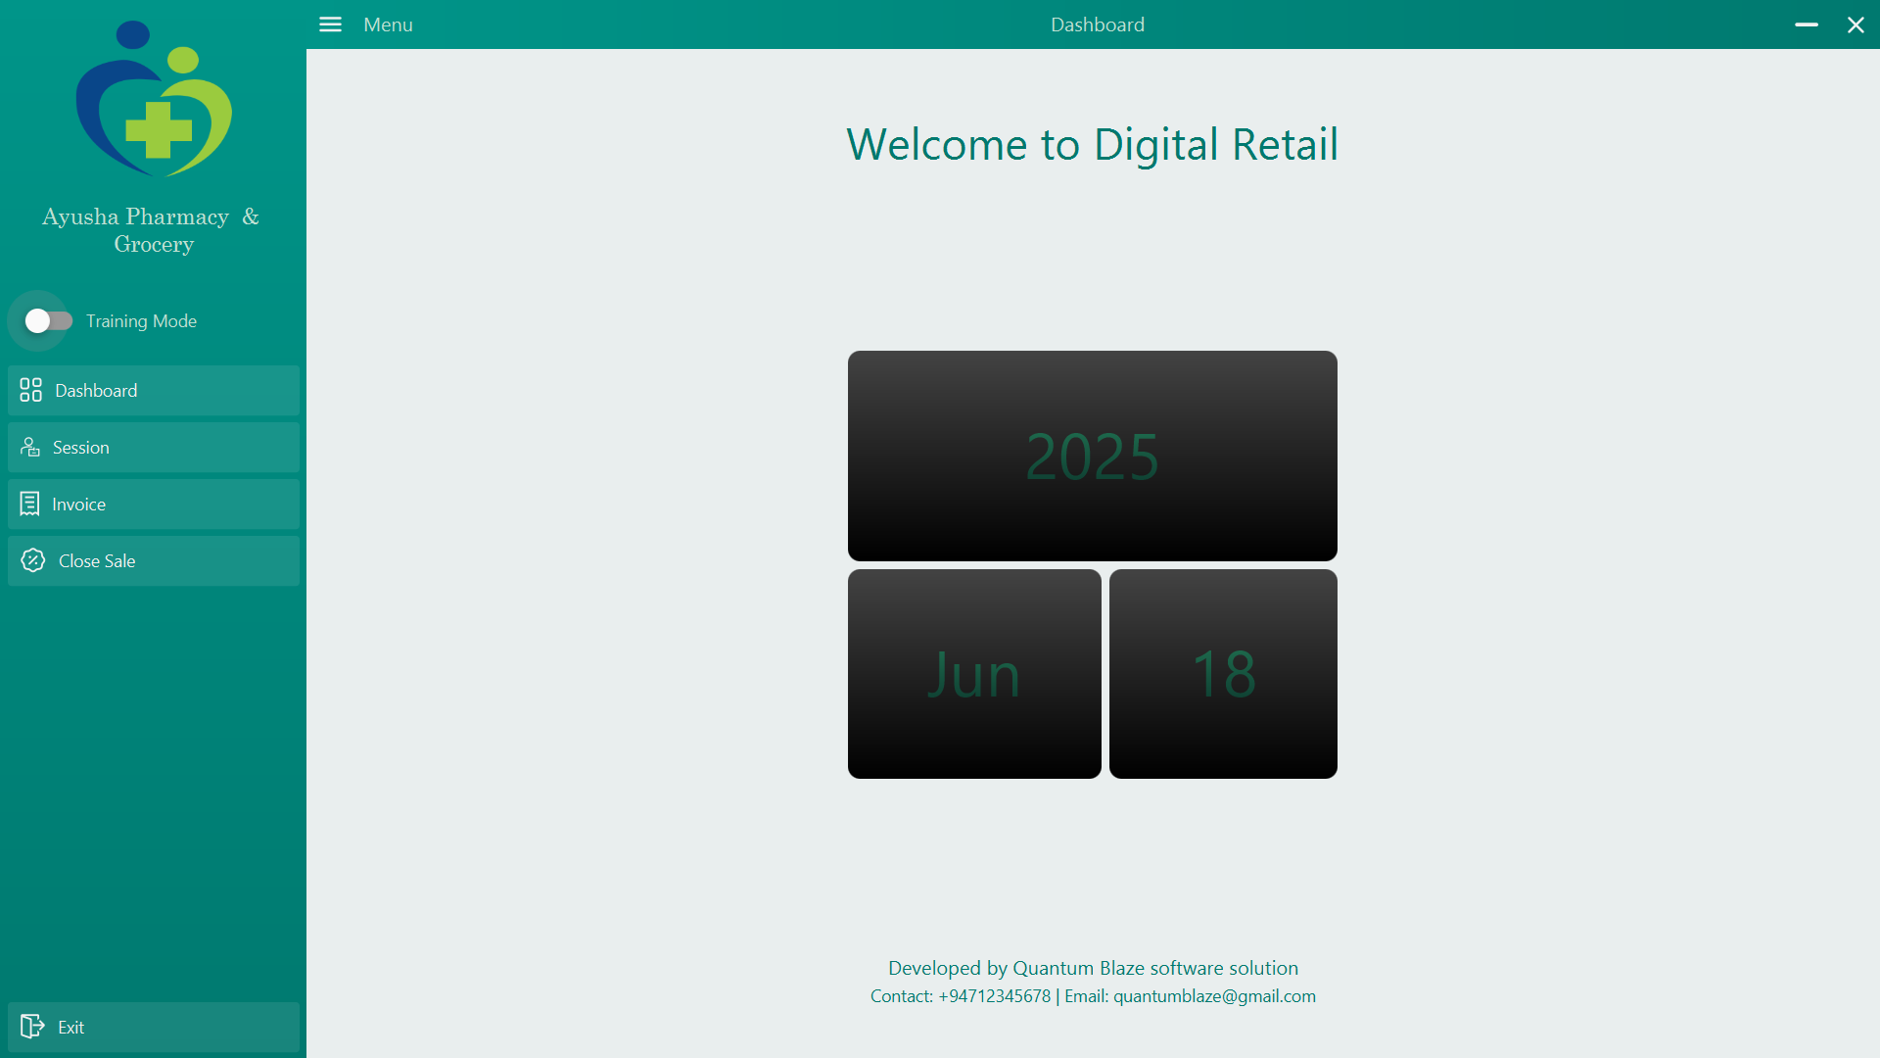

After coming to the dashboard, perform all the other processes. First, you need to go to the session page and start the session. For that, you need to switch to the session page.

  - Session
Session Start Panel: Enter petty cash at the beginning of a shift.
Session End Panel: Enter total cash collected and close the shift.
This dual-purpose screen ensures proper cash tracking and accountability during daily operations.
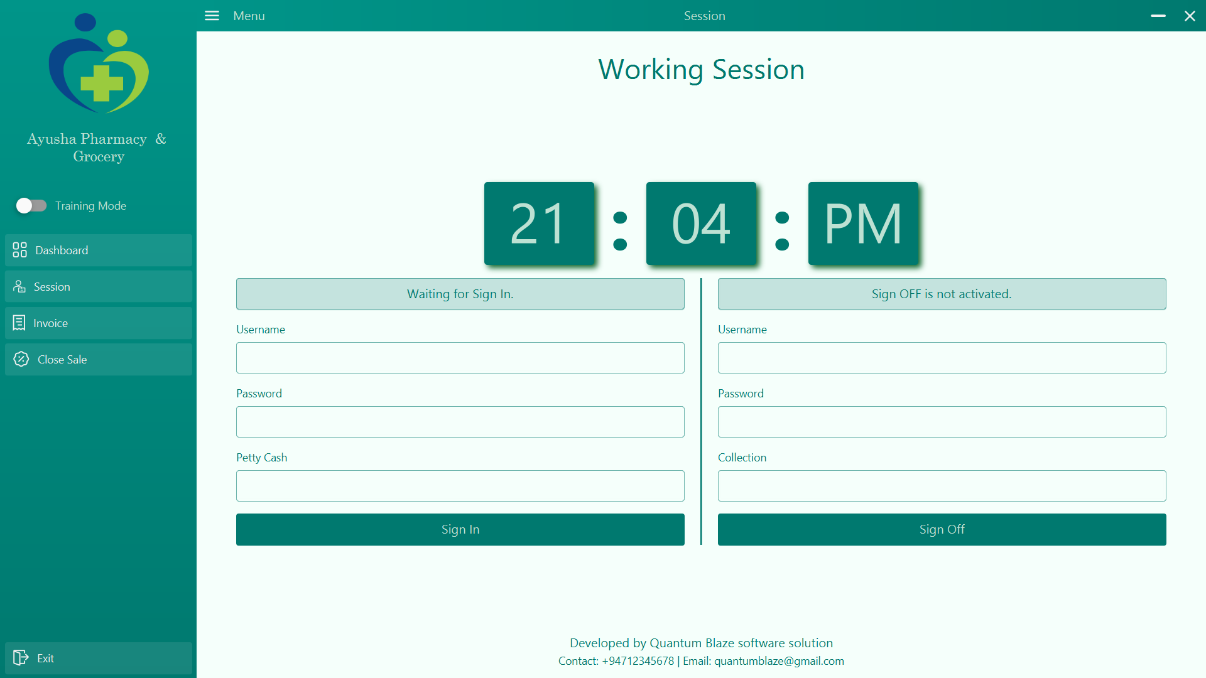

6.1 Start of Shift – Petty Cash Entry
When the cashier logs in and no session is currently active, the system shows the session start interface.
Fields and Actions:
- Petty Cash Field:
Input the starting cash in the drawer.
Example: RS.500.00
- Start Session / Sign in Button:
Records the session start with a timestamp and petty cash value.
Redirects to the Invoice Page after confirmation.
🔐 Once a session starts, the system prevents further login from the same account on other terminals (to ensure cash is traceable to one cashier).

6.2 End of Shift – Collection and Sign-off
At the end of the shift, when the cashier attempts to click "Sign Off", the system returns to the same screen, now transformed for a close sale.
Additional Fields at Session End:
Total Collection Field:
Cashier enters the actual cash collected (total cash in drawer) at the end of the shift.
End Session / Sign-off Button:
Completes the session.
- Saves the cash report
- Logs cashier out
- Locks terminal for the next user

  - Invoice
7.1 Invoice main working screen
Description:
This is the main working screen of the Cashier Panel, where day-to-day sales are conducted. Here, the cashier can add items to an invoice, collect payments, and print receipts.
The design focuses on speed, accuracy, and ease of use in a fast-paced retail pharmacy environment.
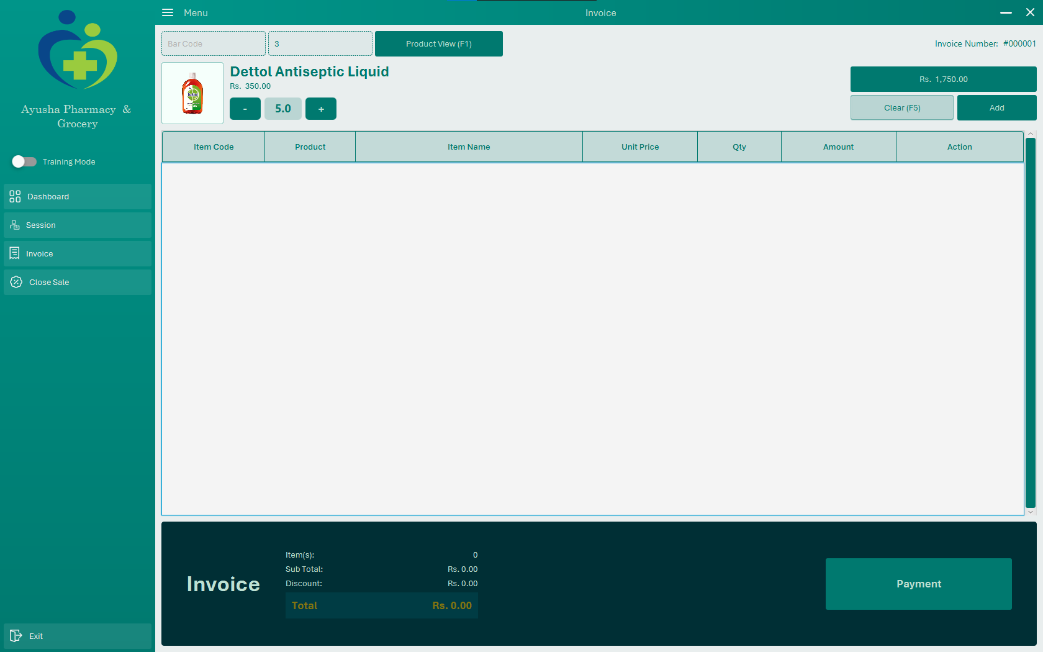
Elements Explained:
7.1.1 Item Entry
Item code / Search Field:
Manually type the product code. Upon selection, the product details are added to the invoice list.
- Double-click any product in the product view (opened via F1, Enter key or Product View button) to retrieve its product code
- Press the asterisk (*) key or the Enter key after entering a product code to load it into the preview section.
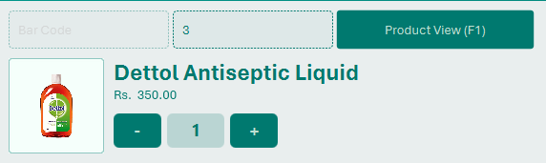
Quantity Field:
Sets how many units of the item are being purchased. Can be updated before adding to the invoice.
- Press Plus (+) or Minus (-) to modify item quantity before adding to the invoice.

Add to Invoice Button:
Adds the selected product to the current invoice.
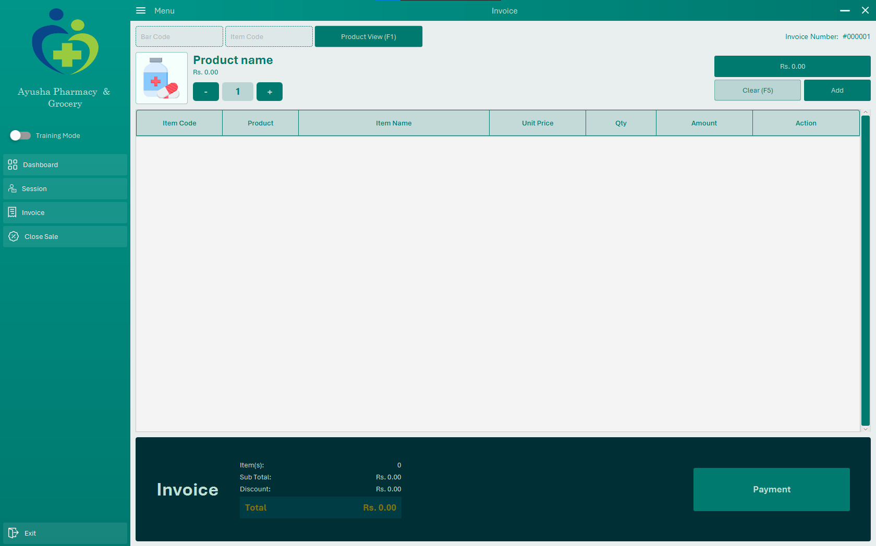
- Press the Enter Key or the Add button to add an item to the invoice.
7.1.2 Invoice Item List Table
Displays all products added to the current invoice in a structured list.
Columns typically include:
- Product Name
- Quantity
- Unit Price
- Discount (if applied)
- Total (per line item)
- Remove or Edit buttons for each item
Edit Item Button:
Adjust quantity if needed.
Delete Item Button:
Removes the selected item from the invoice.
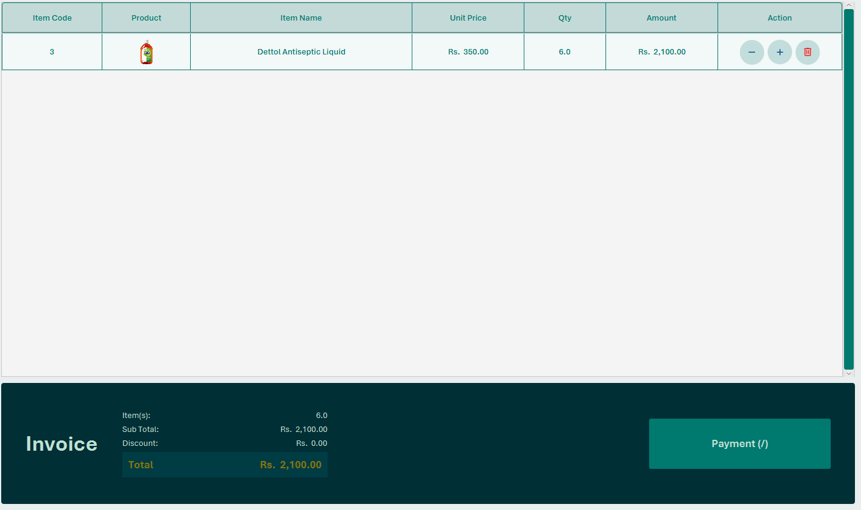
- Press Divide Key or the Payment button to move to the Payment section

7.2 Invoice Payment Popup (Cashier Panel – Finalize Payment)
Description:
This is the final step in the sales process. After all items are added to the invoice, this Invoice Payment Popup appears when the cashier clicks the "Payment" button.
This screen allows the cashier to select the payment method, enter amount received, and finalize the transaction.
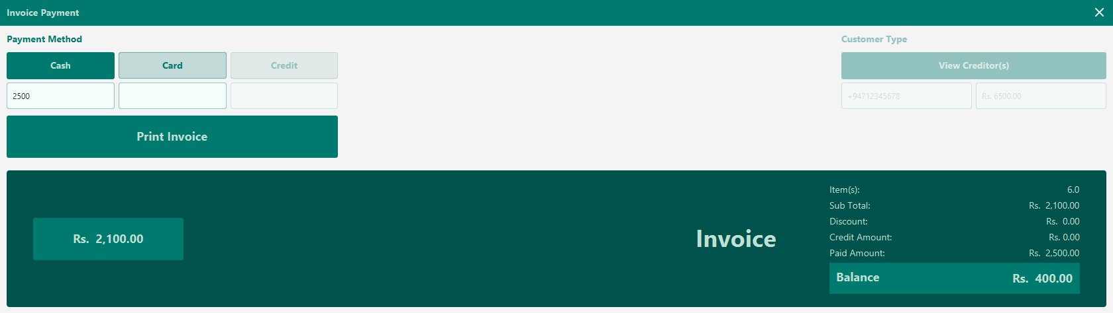
Elements Explained:
7.2.1. Payment Amount Section
Invoice Total / Payable Amount (Read-only):
Displays the final amount to be paid after discounts, and item totals.
Example: RS 2100.00
Amount Received Field:
Typically, the cashier selects the desired payment method and enters the amount tendered by the customer underneath.
Example: Customer gives RS 2500 → cashier enters 2500
Calculate the change:
- After entering the amount received and pressing the Enter key or clicking the "Calculate Invoice" button, the system will automatically calculate and display the change to be returned to the customer.
Example: Rs. 2500 received – Rs. 2100 = Rs. 400.00 change

Print Bill
By clicking the Print Invoice button here, you can print the bill related to the invoice
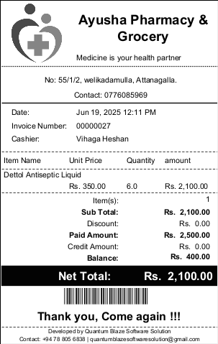
- After displaying the difference to be returned to the customer, press the Enter Key or click the “Print Invoice” button. The bill related to the invoice will be printed.
  - 8. Close Sale Page
Description:
The Close Sale Page is used at the end of a cashier’s shift to summarize the day’s cash collection. It allows the cashier to:
- Log out of the POS system
- Enter the number of each currency denomination collected
- Automatically calculate the total cash in hand
- Record DAY IN and DAY OFF timestamps for audit and reporting
- Ensure transparent cash handover to management or the next shift
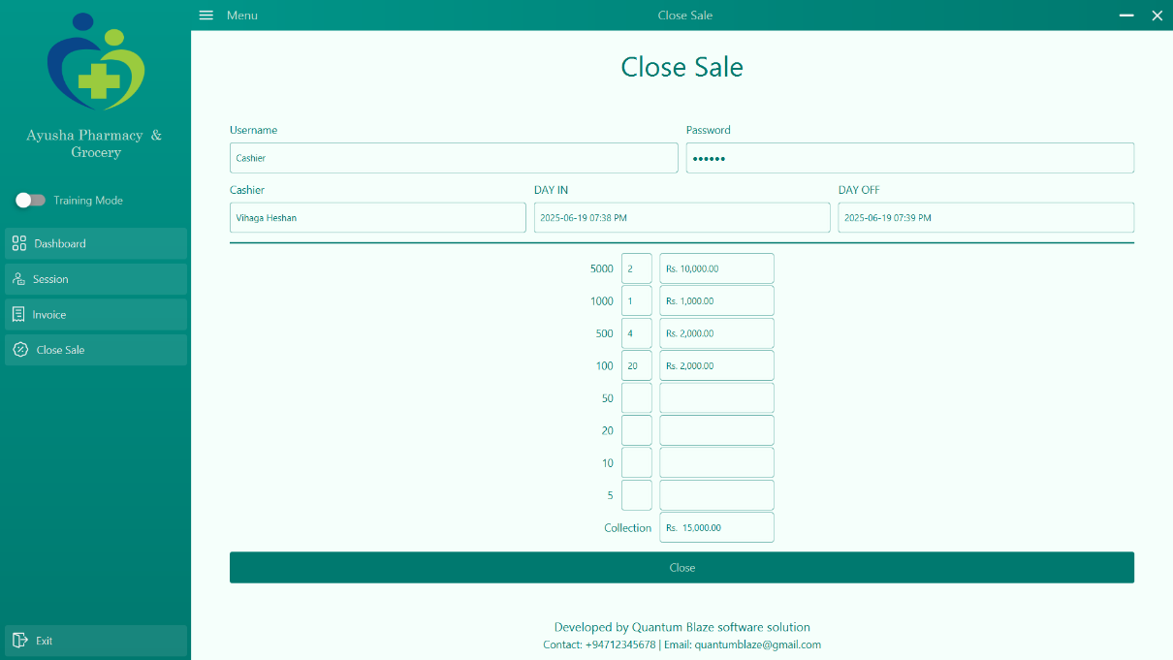

Key Components & Field-by-Field Explanation:
8.1. User Authentication
Username / Password Fields:
Required for cashier or supervisor to authorize the closing of the sale session.
Prevents unauthorized logout or manipulation of records.
8.2. Cashier Information
Cashier Name:
Auto-filled with the logged-in cashier’s name (e.g., Vihanga Heshan)
DAY IN:
Timestamp showing when the cashier started the session
Example: 2025-06-19 09:50 AM
DAY OFF:
Timestamp auto-filled at the moment of session closing
Example: 2025-06-19 04:48 PM
8.3. Cash Denomination Table
This section is for physically counting cash in hand and entering quantities of each note received during the shift.
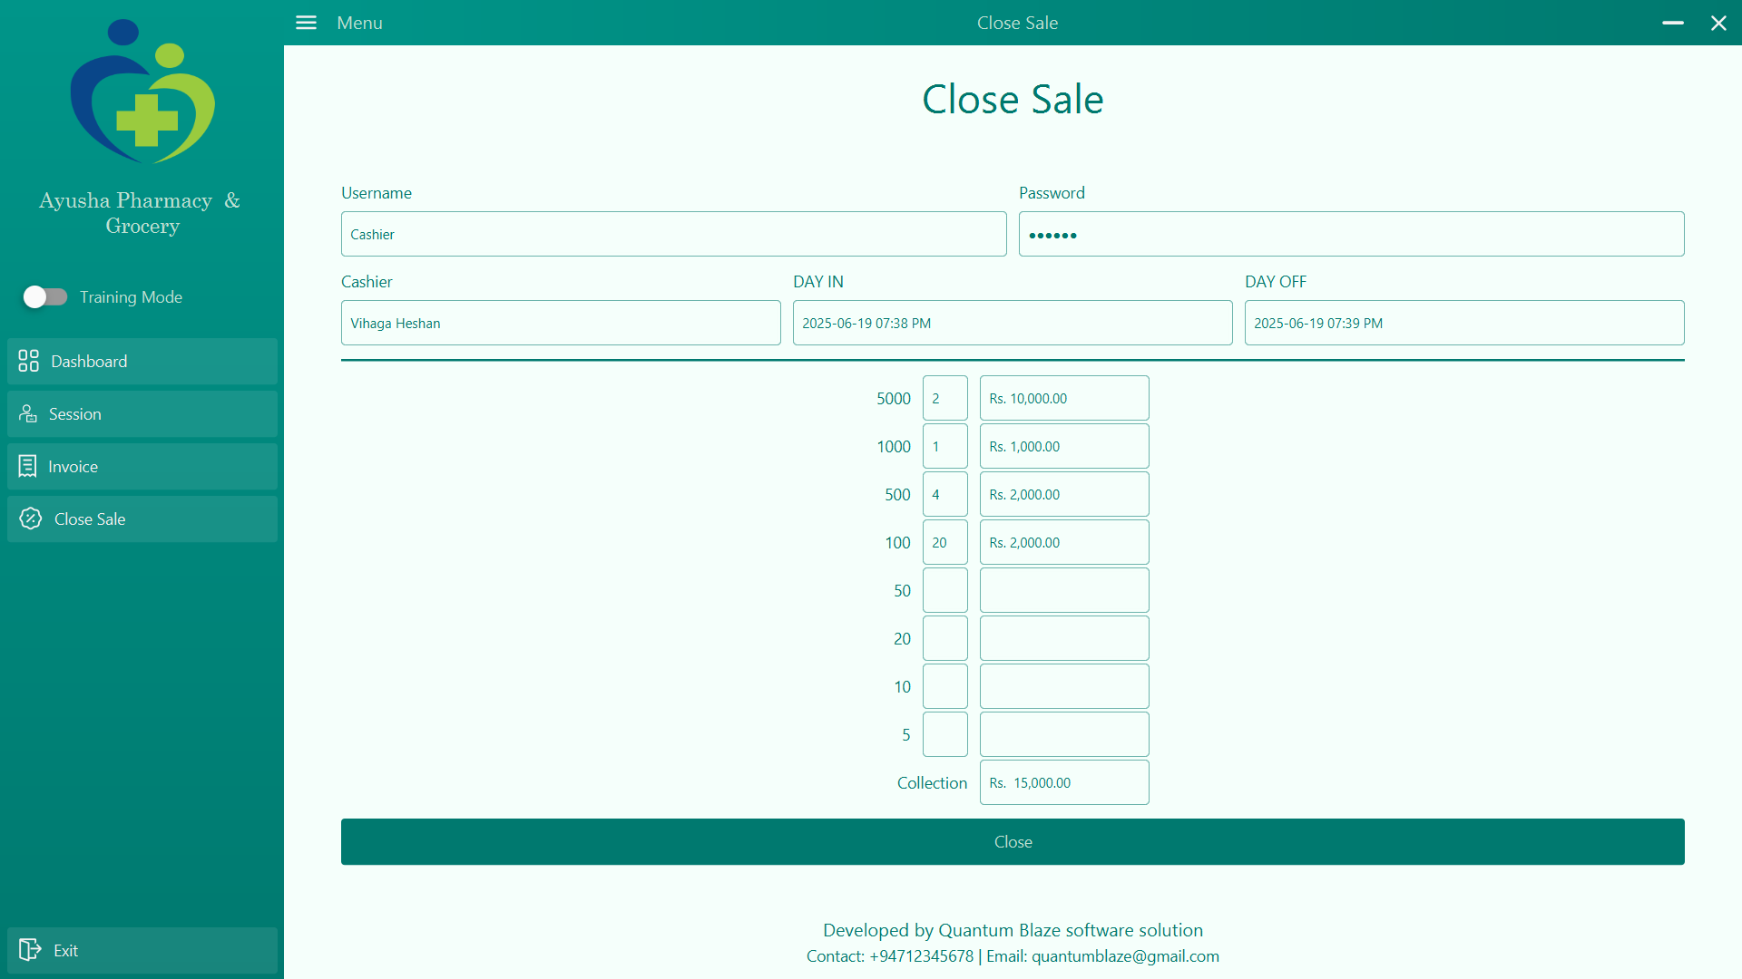

Collection (Total Cash in Drawer):
As the cashier types in the quantity for each denomination, the amount is auto-calculated in the adjacent column.
Example: Rs. 15,000.00
This figure should match the system’s expected cash balance based on sales.

Close Button:
- Finalizes the session
- Locks the cashier account until a new session is started
- Logs the data for audit and report

ADMIN
PANEL

  - Admin Verification
Description:
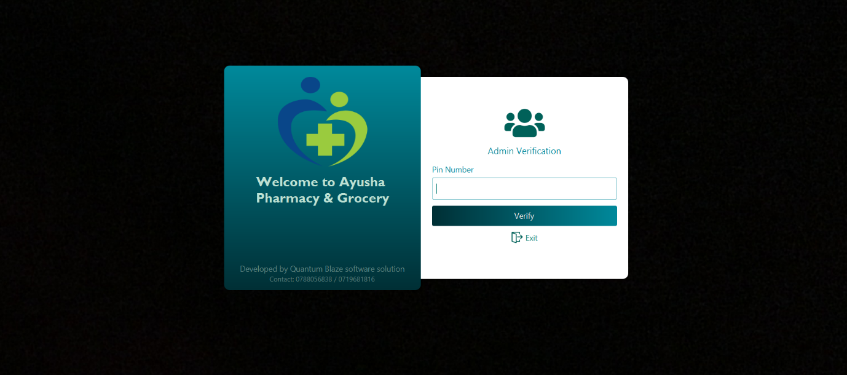
This is the login screen for the admin panel. Only authorized users (admins) can access the back-end system through this page.

Elements Explained:
Password
Secure field to input the password (characters are hidden).
Verify Button
Submits the Verify credentials for verification and grants access if valid.

- You can go to the Dashboard by adding the correct verification PIN and pressing the Enter key.

  - Admin Panel – Dashboard
The Admin Dashboard is the main landing page after a successful admin verification. It provides navigation to all core administrative features of the pharmacy POS system.
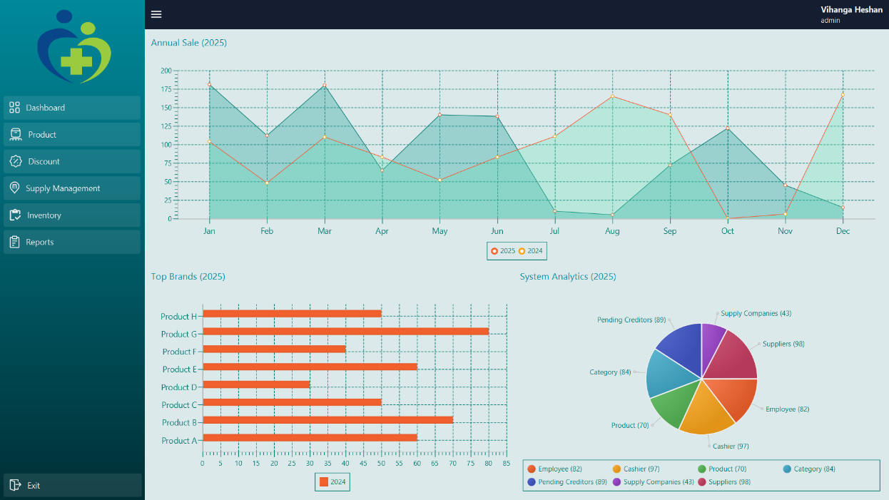
It acts as a control panel, giving the admin quick access to manage products, discounts, inventory, suppliers, and reports.

Elements Explained:
10.1 Admin Info
Displays the logged-in admin's name or ID. Confirms identity and provides access to profile or logout (if included in the header).
10.2 Dashboard Navigation Cards or Buttons
- Product Management: Navigate to product registration, Product Management, and department management.
- Discount: Manage item-specific discounts.
- Inventory (GRN): Access the Goods Received Note page for stock entries.
- Supplier Management: Register and manage supplier companies and suppliers.
- Reports: View reports on sales, GRNs, and current stock balance.
Displays system date and time for reference and audit tracking.

  - Admin Panel – Product Registration
Description:
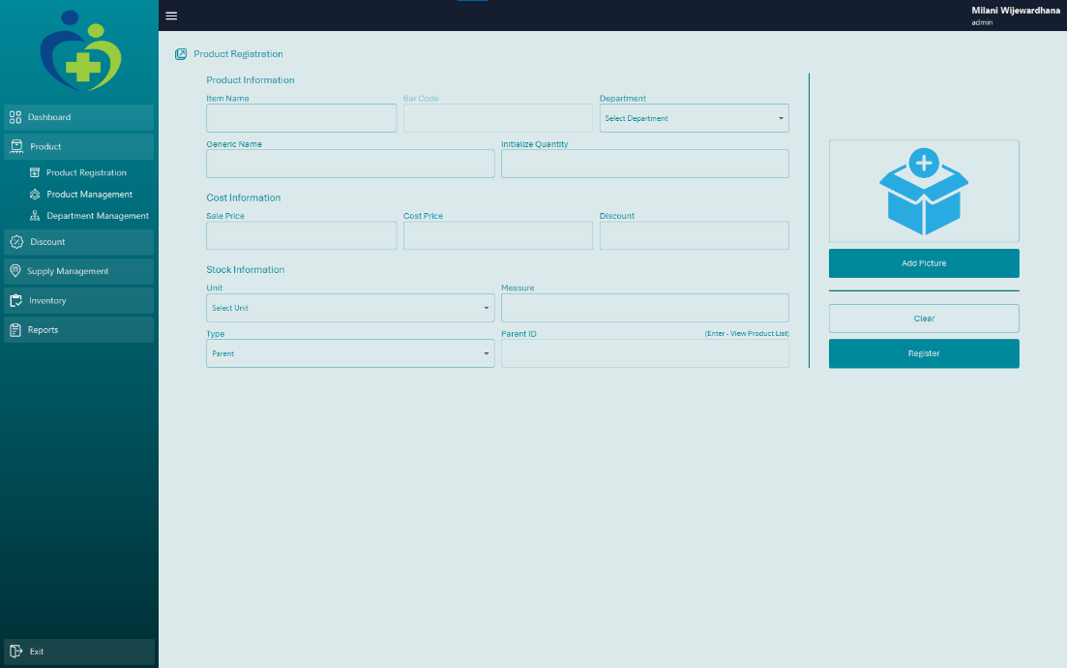
The Product Registration screen is used to register new pharmacy items into the POS system. It allows admins to define key product details such as name, department, cost information, and stock information. This ensures that every item sold is properly tracked in inventory, priced accurately, and can trigger restocking alerts.

Elements Explained:
11.1 Product Information
Product Item Name Field:
Enter the full name of the medicine or product (e.g., Paracetamol 500mg).
Department select Field:
Select the relevant department.
11.2 Cost Information
For cost information, you need to add Sales Price, Cost Price, and the discount required to be added to a product.
11.3 Stock Information
For stock information, first select the unit and type the measurement. Then, you must select the product type, either parent or child.
You can add a picture for the product by clicking the Add Picture button.
Register Button: Submits and saves the product details to the database.
Clear Button: Clears all fields to re-enter new product information (if available).
  - Admin Panel – Product Management
Description:
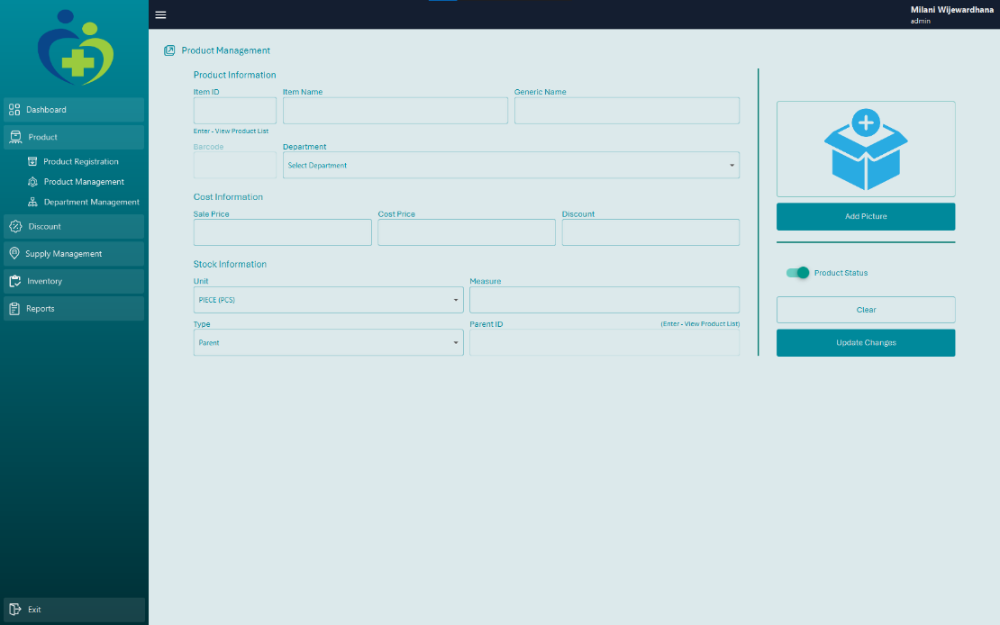
The Product Management screen allows the admin to view and update details of existing products in the system. It's designed for quick editing, price adjustments, and maintaining up-to-date inventory data. Admins can either select a product from a pop-up list or enter its ID directly to fetch and edit product details.

Elements Explained:
When the admin clicks on the Item ID field and presses the Enter key without typing anything, a pop-up appears showing a complete list of products in the system. This table lets the admin scroll through and select a product by simply clicking on its row. Once selected, all the product's details are automatically filled into the form on the page.
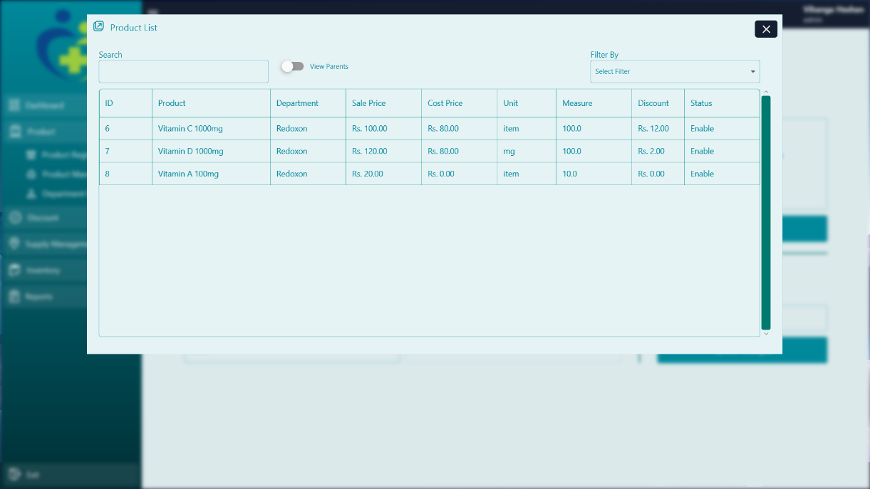
Alternatively, if the admin knows the specific Item ID, they can type it directly into the field and press the Enter key. The system will then auto-load the product information into the form, ready for editing.
After making the necessary changes, the admin clicks the Update Changes button to save the changes. If available, a Clear button allows them to clear the form and start over.

  - Admin Panel – Department Management
Description:
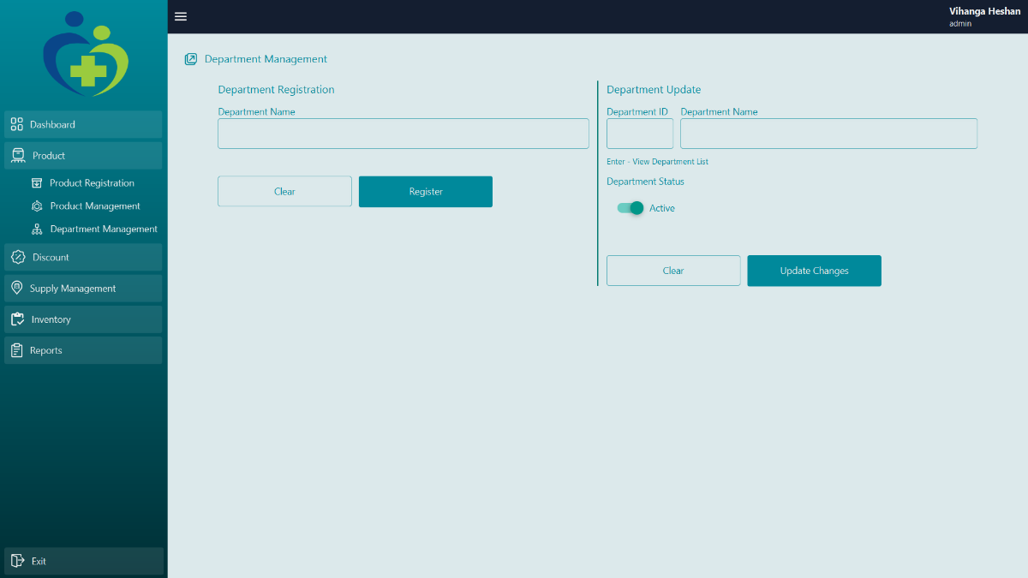
The Department Management screen allows the admin to register new product departments and update existing ones. These departments help organize products in the inventory and make it easier to filter or group items during billing, reporting, and stock control. This module ensures that products are properly categorized under their respective departments, such as Tablets, Syrups, Injections, etc.

13.1 Department Registration
To register a new department, the admin simply types the desired department name into the input field labeled for department entry. Once the name is entered, clicking the Register button will save it to the system. The new department then appears in the list of existing departments below.
13.2 Department Update
When the administrator clicks on the Department ID field and presses the Enter key without typing anything, a pop-up appears showing the complete list of departments in the system. This table allows the administrator to scroll through and select a department by clicking on its row. Once selected, the form on the department details page will be automatically populated.
Alternatively, if the administrator knows the specific department ID, they can type it directly into the field and press the Enter key. The system will then automatically populate the form with the department information, ready for editing.
A department can also be Active or inactive by toggling the toggle button next to it.
After editing the name, the administrator clicks the Update Changes button to save the changes.

  - Admin Panel – Discount Page
Description:
The Discount Page allows the admin to assign discounts to individual products. These discounts are applied automatically during sales, reducing the price of the specific product at checkout. The system does not support bill-level discounts — only product-level discounts can be set.
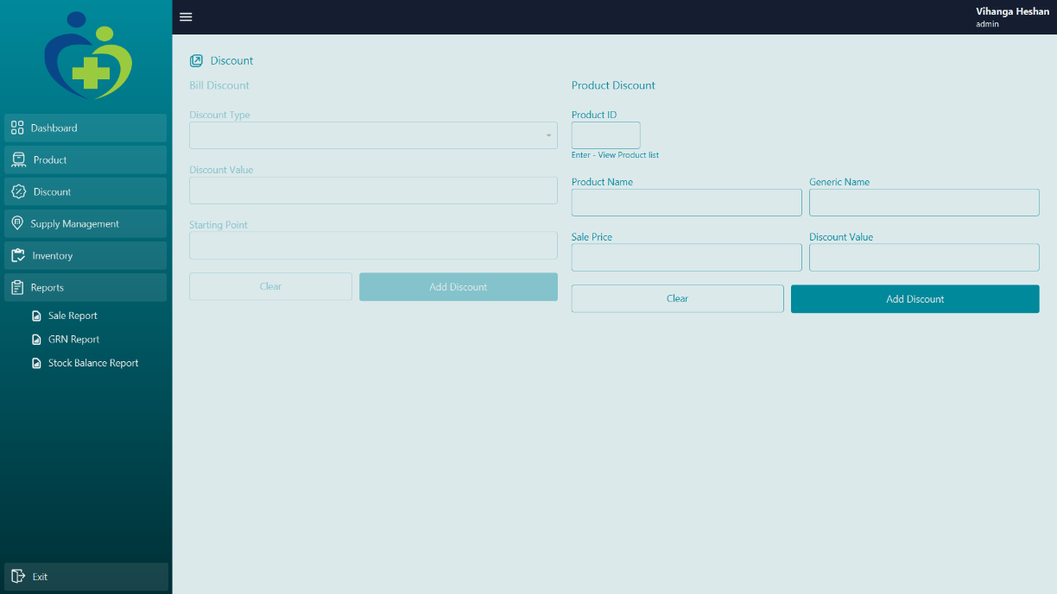
Product Discount Functionality:
Product ID Field:
Enter or search for the product’s unique ID. Press Enter to load the product details.
Product Details Auto-Load:
After selecting a product, its name and current selling price will appear automatically for confirmation.
Discount Field:
Enter the amount of discount to apply to that product. This value will be deducted from the selling price during sales.
Add Discount Button:
Click this to save the discount. The system applies the discount automatically when the product is billed.

  - Admin Panel – GRN (Goods Received Note)
Description:
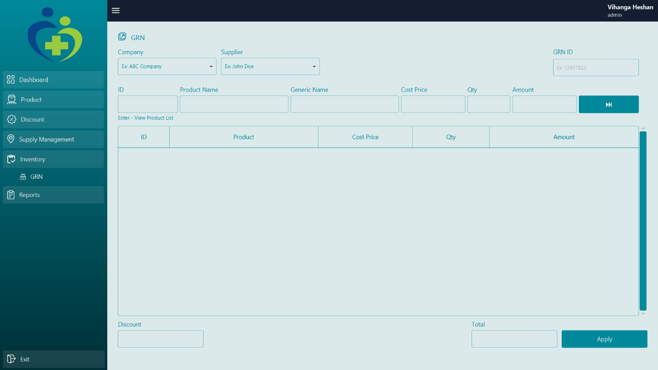
This GRN page is used by the admin to log new stock received from suppliers into the system. It captures key supplier details, product information, and pricing, which are essential for inventory accuracy and purchase tracking. It also allows loading past GRNs for reference or editing.

Elements Explained:
Company Dropdown (Ex: ABC Company)
A drop-down menu to select the supplier company delivering the goods. This ensures the stock received is correctly associated with the supplying organization.
Supplier Field (Ex: John Doe)
A field to select or search for the specific individual supplier or delivery representative related to the current stock receipt.
GRN ID Field (Ex: 12457823)
This field is used to either:
- View the GRN list (by pressing Enter), or load a previously saved GRN for review or editing.
- This feature is useful for referencing past entries.
Product Entry Section (Top Grid Inputs):
Here, the admin can enter the product information for each item received:
(Product ID, Product Name, Generic Name, Cost Price, Qty (Quantity), Amount)
Product List Table (Below Input Fields):
As products are entered, they appear in this list. This acts as a running record of all items included in the current GRN.
Delete Item:
To remove an unwanted item or correct a mistake
- Simply double-click on the item in the GRN table
Discount Field:
An optional field to apply a discount to the entire GRN total (e.g., if the supplier provided a bulk discount).
Total Field:
Automatically calculates the total value of all products received, minus any discounts.
Apply Button:
Finalizes the GRN entry. When clicked, the entered stock details are saved, and the inventory is updated accordingly.
This screen ensures:
- Proper tracking of incoming stock.
- Accountability by linking deliveries to suppliers.
- Accurate cost and inventory updates.
- A reference record for future reconciliation, stocktaking, or audits.

  - Admin Panel – Supplier Company Management
Description:
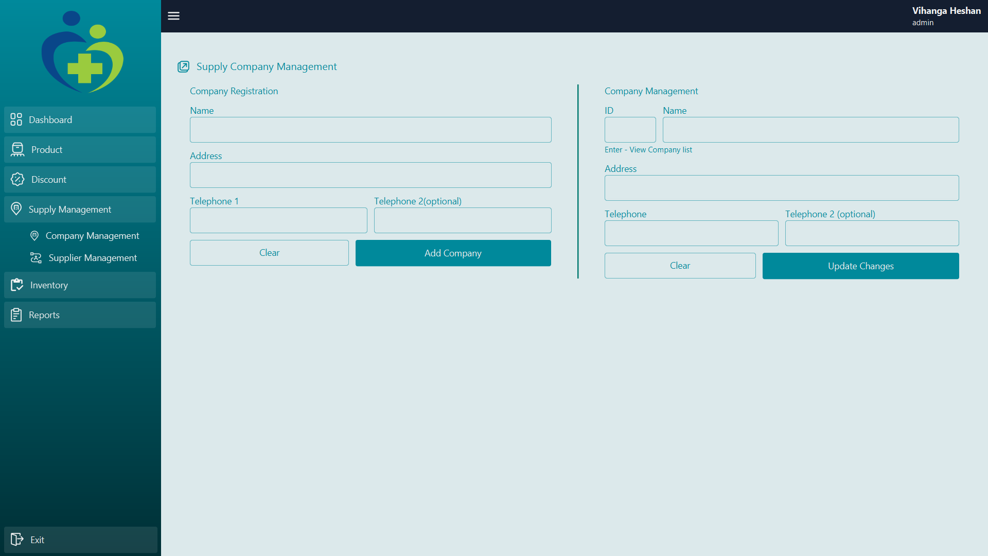
The Supplier Company Management screen allows the admin to register new supplier companies and manage existing ones. Supplier companies are the entities from which the pharmacy purchases stock. Maintaining this list ensures that inventory records are properly linked to their source and enables efficient supplier-related reporting and communication.

15.1. Company Register
This section is used to add new supplier companies to the system.
- The admin enters the company name into the input field.
- Additional optional fields may include contact numbers and address
- After entering the details, clicking the Add Company button saves the company to the database.
- The company becomes selectable in other modules, such as the GRN page and supplier linking.

15.2. Company Management
When the admin clicks on the ID field and presses the Enter key without typing anything, a pop-up appears showing an already registered Company list in the system. This table lets the admin scroll through and select a company by simply clicking on its row. Once selected, all the company's details are automatically filled into the form on the page.
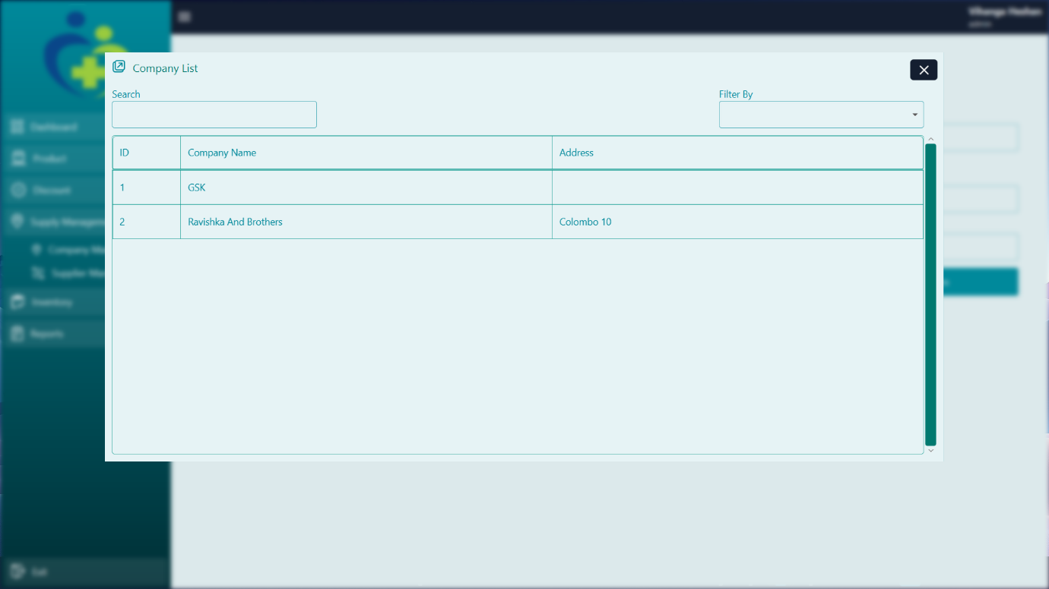
Alternatively, if the admin knows the specific Company ID, they can type it directly into the ID field and press the Enter key. The system will then auto-load the Company information into the form, ready for editing.
Edit allows the admin to correct the name or update the company’s contact details. Once edits are made, clicking the Update Changes button saves the changes.

  - Admin Panel – Supplier Management
Description:
The Supplier Management page is used to register and manage individual supplier representatives who are connected to supplier companies. These individuals are typically the sales agents or delivery personnel who handle transactions and logistics for stock deliveries.
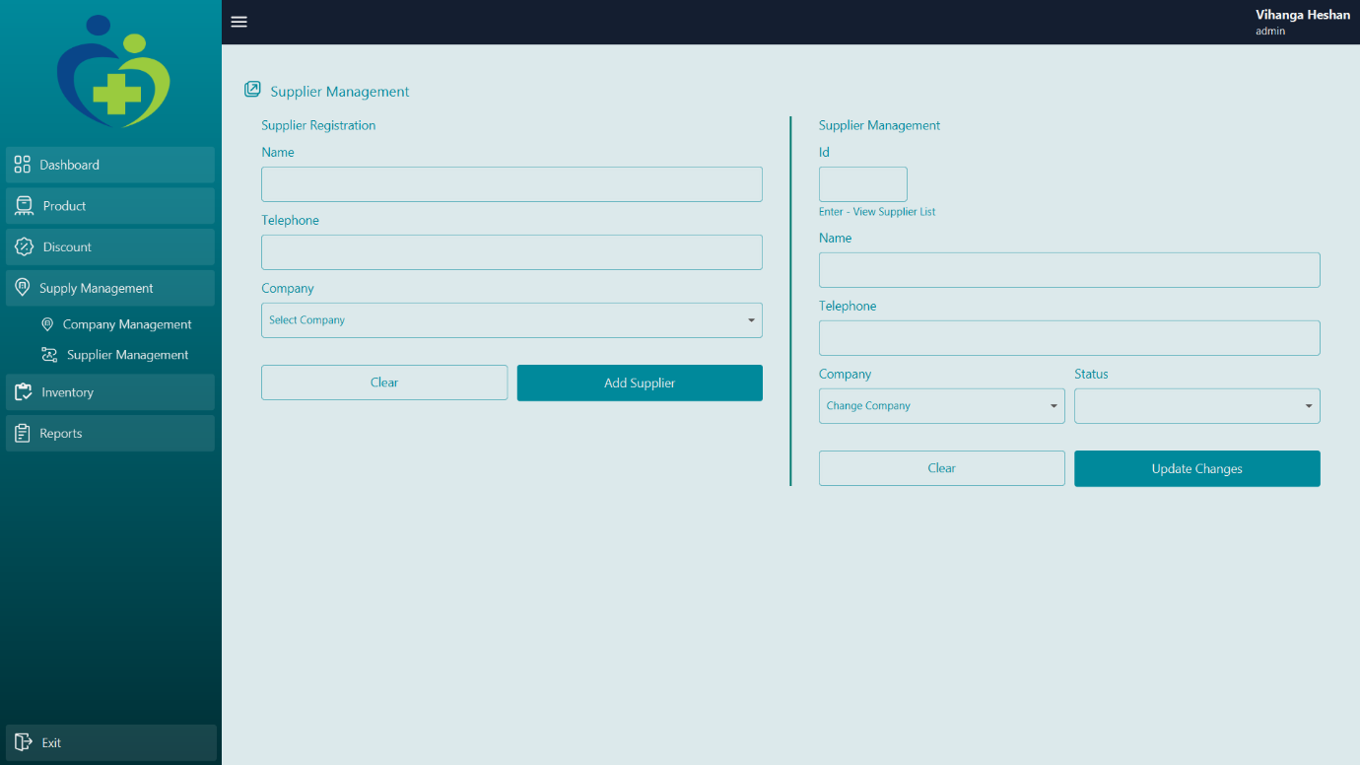
This page ensures that each supplier is linked to a registered supplier company and maintains clear contact details for communication and tracking.

16.1. Supplier Register
This section is used to add new supplier individuals to the system.
- The admin begins by selecting a Supplier Company from a dropdown list (previously registered in the Supplier Company Management screen).
- Then, the admin enters the Supplier Name, which is the full name of the representative (e.g., John Doe).
- Additional fields such as Contact Number, Address may be included.
- After entering the necessary details, clicking the Add Supplier button saves the supplier to the system and links them with the selected company.

16.2. Supplier Management
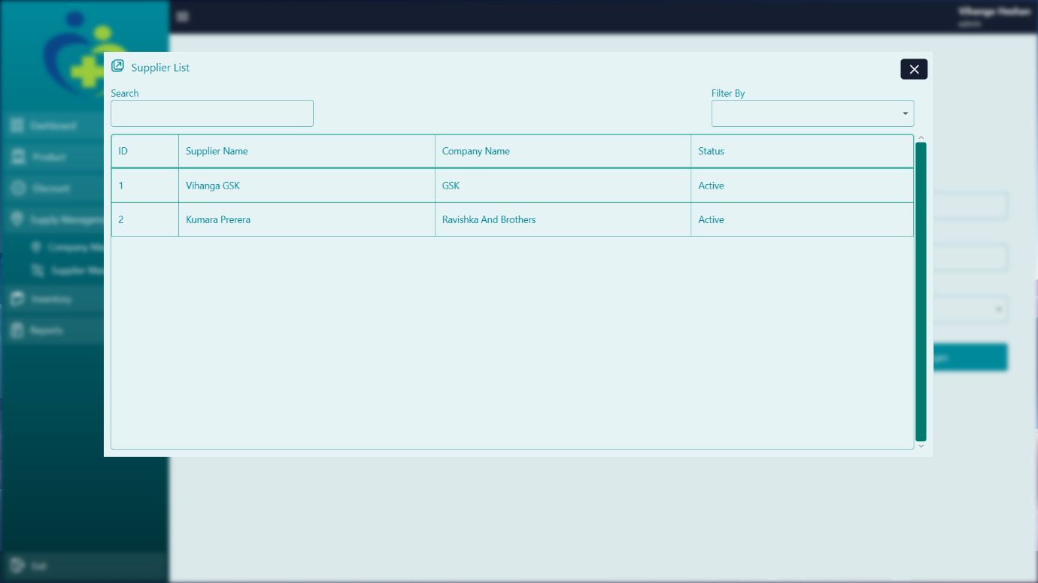
When the admin clicks on the ID field and presses the Enter key without typing anything, a pop-up appears showing an already registered Supplier list in the system. This table lets the admin scroll through and select a supplier by simply clicking on its row. Once selected, all the supplier's details are automatically filled into the form on the page.

Alternatively, if the admin knows the specific Supplier ID, they can type it directly into the ID field and press the Enter key. The system will then auto-load the Supplier information into the form, ready for editing.
The admin can update details such as name or phone number, and then click the Update Changes button to save.

  - Admin Panel – Sales Report
Description:
The Sales Report page provides detailed insights into the pharmacy's sales activities over a selected period. Admins use this screen to generate, view, and review invoice records. It helps with tracking performance, identifying trends, auditing cashier activity, and generating data for business analysis.
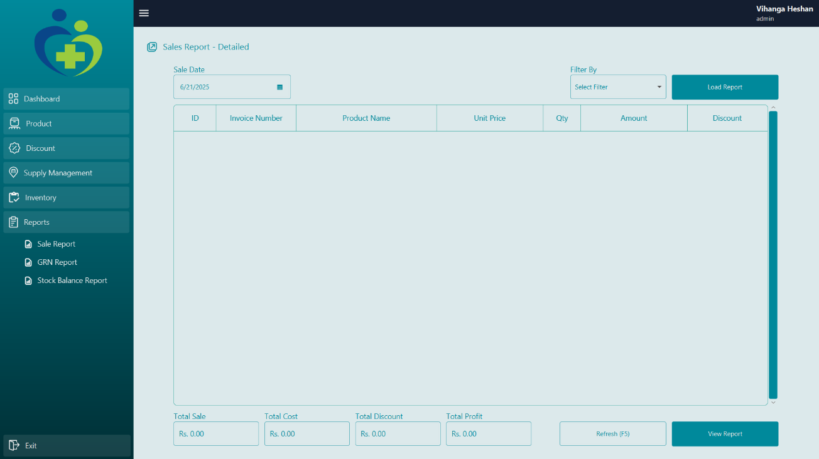
This report is essential for both daily monitoring and end-of-period financial summaries.

Elements Explained
When the admin opens the Sales Report screen, the following key elements are available:
Date Range Filter:
This allows you to select a date to filter by.
Next filter dropdown field:
The dropdown field allows you to filter by ID, Invoice Number, Product Number, and Quantity.
Report Table Display:
Add filters and, after clicking the Load Report button, load the sales report details to the table.
View Report Buttons: Optional features for exporting the report to PDF for printing, filing, or further analysis.

  - Admin Panel – GRN Report
Description:
The GRN Report page allows the admin to view and review all previously entered Goods Received Notes (GRNs). Each GRN record contains essential information about the stock received, including the supplier, products, quantities, and costs.
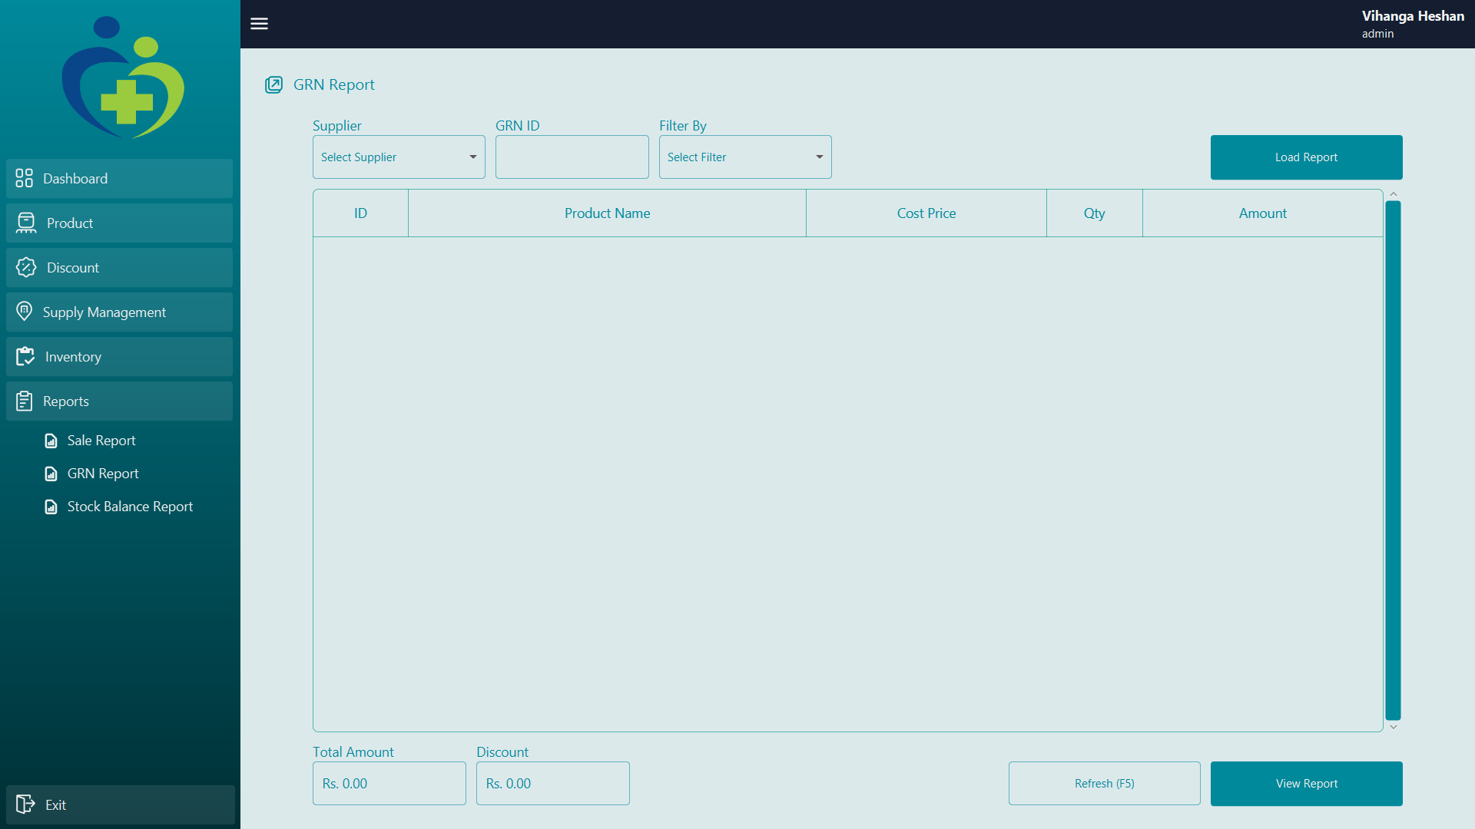
This report is used for inventory audits, purchase tracking, and verifying supplier deliveries. It is especially useful during stock reconciliation and financial reporting.

Elements Explained
Supplier Dropdown:
Let’s the admin filter GRNs by selecting a specific supplier. Only GRNs associated with the selected supplier will be shown in the results.
GRN ID Field:
Used to search for a specific GRN by its unique ID. This is helpful when reviewing or auditing a particular stock receipt.
Filter By Dropdown:
Provides additional filtering options such as by ID, Product Name, Quantity, and Cost Price. Helps narrow down report results based on specific criteria.
Load Report Button:
After selecting the filter options (supplier, GRN ID, etc.), clicking this button fetches the relevant GRN records and displays them in the table below.

Report Table (Below Filter Section):
Once the report is loaded, this table displays a list of products included in the selected GRNs.
The Total Amount field at the bottom left displays the combined value of all products listed in the GRN report. Next to it, the Discount field shows any discounts that were applied during the GRN entry, helping with accurate financial reconciliation and purchase tracking.
View Report Button:
Opens a detailed view or a printable version of the GRN report (depending on implementation). This may allow exporting or generating a summary.

  - Admin Panel – Stock Balance Report
Description:
The Stock Balance Report screen allows the admin to view the current inventory levels of all registered products. It is used to check available stock quantities, identify low-stock items, and monitor product availability based on departments.
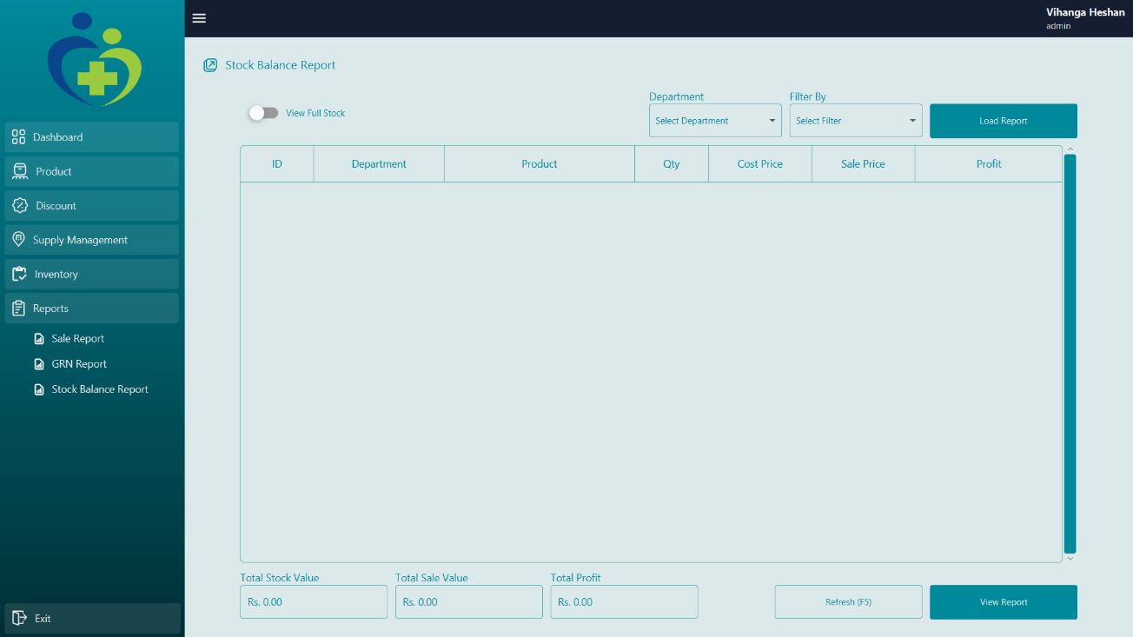
This report includes a toggle switch that changes how the data is loaded into the table.

Screen Functionality:
Toggle Button (View Full Stock):
When this switch is enabled (ticked), the system will ignore department filters and load the entire stock list across all departments once the Load Report button is clicked.
Department Dropdown:
When the toggle button is disabled (unticked), the admin must select a department from the dropdown menu. Clicking Load Report in this mode will display only the stock items related to the chosen department.
Load Report Button:
This button generates the report based on the toggle/department selection and loads the matching stock items into the report table below.
The Total Stock Value, Total Sale Value, and Total Profit fields show the overall cost, selling value, and profit of the current stock.
The Refresh button reloads the page, and View Report generates a detailed stock report.

Conclusion

Congratulations! You’ve now reached the end of the Pharmacy POS System User Manual. This guide has provided you with a comprehensive walkthrough of the system’s features, from cashier operations to advanced administrative controls.

By following this manual, you should now be able to:
- Efficiently process sales using the Cashier Panel.
- Manage inventory with Goods Received Notes (GRNs) and stock reports.
- Update product details, set discounts, and organize departments.
- Track suppliers and maintain accurate purchase records.
- Generate and analyze reports for sales, GRNs, and stock balance.

This system is designed to streamline pharmacy operations, reduce errors, and enhance productivity. Whether you’re handling daily transactions, restocking inventory, or reviewing business performance, the tools provided will help you maintain accuracy and efficiency.

Need Further Assistance?
If you encounter any issues or have questions not covered in this manual, please contact your system administrator or technical support team for help.

Final Notes
- Always log out after your session to ensure security.
- Regularly check reports to monitor sales trends and stock levels.
- Keep supplier and product details updated for smooth operations.

Thank you for using the Pharmacy POS System. We hope this tool enhances your workflow and contributes to your pharmacy’s success!

Happy Managing! 🚀💊

© 2025 Quantum Blaze Software Solution. All rights reserved.

