Assignment No.: 03  
Title: Exploring Flutter Widgets – Text, Button, Image, and Single Child Widgets  
Name: Harshit Raheja  
Class: D15B  
Roll Number: 45

**Aim:**  
To understand and implement basic Flutter widgets such as Text, Button, Image, and a custom widget using single-child layout.

**Theory:**  
Flutter provides rich pre-built widgets that are essential for building beautiful UIs. The fundamental ones include:

* Text: For displaying static or dynamic strings.
* ElevatedButton, TextButton: For user interaction.
* Image: For showing graphics from assets or networks.
* Container with styling: For custom single-child widget layout.

**1. Text Widget Example**

import 'package:flutter/material.dart';

void main() {

runApp(const MyApp());

}

class MyApp extends StatelessWidget {

const MyApp({Key? key}) : super(key: key);

@override

Widget build(BuildContext context) {

return MaterialApp(

home: Scaffold(

appBar: AppBar(title: const Text("Text Widget Example")),

body: const Center(

child: Text(

'Hello, ALL!',

textAlign: TextAlign.center,

style: TextStyle(fontWeight: FontWeight.bold, fontSize: 24),

),

),

),

);

}

}

**2. Button Widgets Example**

import 'package:flutter/material.dart';

void main() {

runApp(const MyApp());

}

class MyApp extends StatelessWidget {

const MyApp({Key? key}) : super(key: key);

@override

Widget build(BuildContext context) {

return MaterialApp(

home: Scaffold(

appBar: AppBar(title: const Text("Button Widget Example")),

body: Center(

child: Column(

mainAxisAlignment: MainAxisAlignment.center,

children: [

ElevatedButton(

onPressed: () {

print("Raised Button Clicked");

},

child: const Text("Click Me"),

),

TextButton(

onPressed: () {

print("Flat Button Clicked");

},

child: const Text("Click Here"),

),

],

),

),

),

);

}

}

**3. Image Widget Example**

import 'package:flutter/material.dart';

void main() {

runApp(const MyApp());

}

class MyApp extends StatelessWidget {

const MyApp({Key? key}) : super(key: key);

@override

Widget build(BuildContext context) {

return MaterialApp(

home: Scaffold(

appBar: AppBar(title: const Text("Image Widget Example")),

body: Center(

child: Image.network(

'https://via.placeholder.com/150',

),

),

),

);

}

}

**4. Single Child Custom Widget Example**

import 'package:flutter/material.dart';

void main() {

runApp(const MyApp());

}

class MyApp extends StatelessWidget {

const MyApp({Key? key}) : super(key: key);

@override

Widget build(BuildContext context) {

return MaterialApp(

home: Scaffold(

appBar: AppBar(title: const Text("Single Child Widget Example")),

body: Center(child: MyButton()),

),

);

}

}

class MyButton extends StatelessWidget {

const MyButton({Key? key}) : super(key: key);

@override

Widget build(BuildContext context) {

return Container(

decoration: const BoxDecoration(

border: Border(

top: BorderSide(width: 1.0, color: Color(0xFFFFFFFFFF)),

left: BorderSide(width: 1.0, color: Color(0xFFFFFFFFFF)),

right: BorderSide(width: 1.0, color: Color(0xFFFF000000)),

bottom: BorderSide(width: 1.0, color: Color(0xFFFF000000)),

),

),

child: Container(

padding: const EdgeInsets.symmetric(horizontal: 20.0, vertical: 2.0),

decoration: const BoxDecoration(

border: Border(

top: BorderSide(width: 1.0, color: Color(0xFFFFDFDFDF)),

left: BorderSide(width: 1.0, color: Color(0xFFFFDFDFDF)),

right: BorderSide(width: 1.0, color: Color(0xFFFF7F7F7F)),

bottom: BorderSide(width: 1.0, color: Color(0xFFFF7F7F7F)),

),

color: Colors.grey,

),

child: const Text(

'OK',

textAlign: TextAlign.center,

style: TextStyle(color: Colors.black),

),

),

);

}

}

**Output:**

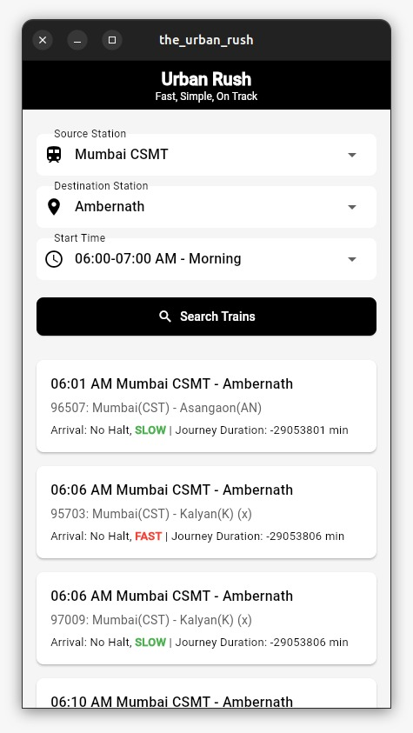

**Conclusion:**  
This assignment demonstrates practical usage of Flutter’s basic UI widgets. The Text, Button, and Image widgets offer essential building blocks, while the Container wrapped custom widget showcases single-child layout customization.