Assignment No.: 04  
Title: Creating an Interactive Form using Flutter Form Widget  
Name: Harshit Raheja  
Class: D15B  
Roll Number: 45

**Aim:**  
To create an interactive form using the Flutter Form widget, implementing validation and submission logic.

**Theory:**  
In Flutter, the Form widget combined with a GlobalKey<FormState> allows you to manage form validation and state efficiently. Forms typically consist of one or more TextFormFields, optional dropdowns or checkboxes, and a submit button. The FormState object provides methods like .validate() and .save() to process user input.

**Steps:**

1. Define a GlobalKey<FormState> to track form state.
2. Use TextFormField for inputs with built-in validation.
3. Add DropdownButtonFormField for selectable values.
4. Use a Checkbox for toggle options.
5. Use ElevatedButton to trigger validation and submission logic.

**Extracted Code Based on Urban Rush App Style:**

final _formKey = GlobalKey<FormState>();

String _name = '';

String _email = '';

String _selectedGender = 'Male';

bool _subscribeToNewsletter = false;

Form(

key: _formKey,

child: Column(

crossAxisAlignment: CrossAxisAlignment.start,

children: [

TextFormField(

decoration: InputDecoration(labelText: 'Name'),

validator: (value) {

if (value == null || value.isEmpty) {

return 'Please enter your name';

}

return null;

},

onSaved: (value) {

_name = value!;

},

),

SizedBox(height: 12),

TextFormField(

decoration: InputDecoration(labelText: 'Email'),

validator: (value) {

if (value == null || value.isEmpty || !value.contains('@')) {

return 'Please enter a valid email address';

}

return null;

},

onSaved: (value) {

_email = value!;

},

),

SizedBox(height: 12),

DropdownButtonFormField<String>(

decoration: InputDecoration(labelText: 'Gender'),

value: _selectedGender,

items: ['Male', 'Female', 'Other'].map((gender) {

return DropdownMenuItem(value: gender, child: Text(gender));

}).toList(),

onChanged: (value) {

_selectedGender = value!;

},

),

Row(

children: [

Checkbox(

value: _subscribeToNewsletter,

onChanged: (value) {

_subscribeToNewsletter = value ?? false;

},

),

Text('Subscribe to Newsletter'),

],

),

SizedBox(height: 16),

SizedBox(

width: double.infinity,

child: ElevatedButton(

onPressed: () {

if (_formKey.currentState!.validate()) {

_formKey.currentState!.save();

print('Name: $_name');

print('Email: $_email');

print('Gender: $_selectedGender');

print('Subscribe to Newsletter: $_subscribeToNewsletter');

}

},

child: Text('Submit'),

),

),

],

),

)

**Output:**

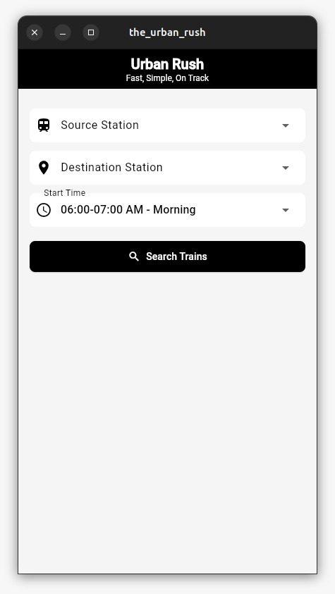

**Conclusion:**  
The form successfully collects and validates user input using TextFormField, DropdownButtonFormField, and Checkbox, with state handled by GlobalKey<FormState>. Upon submission, the entered data is processed, meeting all the outlined assignment requirements.