Assignment No.: 06  
Title: Setting Up Firebase with Flutter for iOS and Android Apps  
Name: Harshit Raheja  
Class: D15B  
Roll Number: 45

**Aim:**  
To learn how to integrate Firebase with a Flutter application for both Android and iOS platforms.

**Theory:**  
Firebase is a cloud-based backend solution that provides a range of services like authentication, database, storage, cloud functions, and analytics. Flutter supports Firebase through the official FlutterFire plugins. This setup allows seamless backend integration in cross-platform apps.

**Prerequisites:**

* Google account
* Flutter SDK installed
* Android Studio and/or Visual Studio Code
* Flutter and Dart plugins
* Xcode (for iOS development)

**Steps:**

**1. Creating a New Flutter Project:**

flutter create flutterfirebaseexample

cd flutterfirebaseexample

**2. Creating a New Firebase Project:**

* Go to [Firebase Console](https://firebase.google.com/)
* Click “Add Project” and follow the prompts
* Optionally disable Google Analytics

**3. Adding Android Support:**

* Click Android icon in Firebase dashboard
* Use your app’s package name (e.g., com.example.flutterfirebaseexample)
* Add this package name to android/app/build.gradle under applicationId

**4. Downloading the Config File:**

* Download google-services.json
* Place it inside android/app/

**5. Updating Gradle Files:**

**android/build.gradle:**

buildscript {

repositories {

google()

}

dependencies {

classpath 'com.google.gms:google-services:4.3.6'

}

}

**android/app/build.gradle:**

apply plugin: 'com.android.application'

apply plugin: 'com.google.gms.google-services'

dependencies {

implementation platform('com.google.firebase:firebase-bom:28.0.0')

// Add Firebase libraries as needed

}

**6. Adding iOS Support:**

* Click iOS icon in Firebase dashboard
* Use a valid iOS bundle ID (e.g., com.example.flutterfirebaseexample)
* Open ios/Runner.xcodeproj in Xcode
* Set the bundle identifier under the General tab
* Download GoogleService-Info.plist
* Add it to the Runner project in Xcode via drag and drop

**Screenshots:  
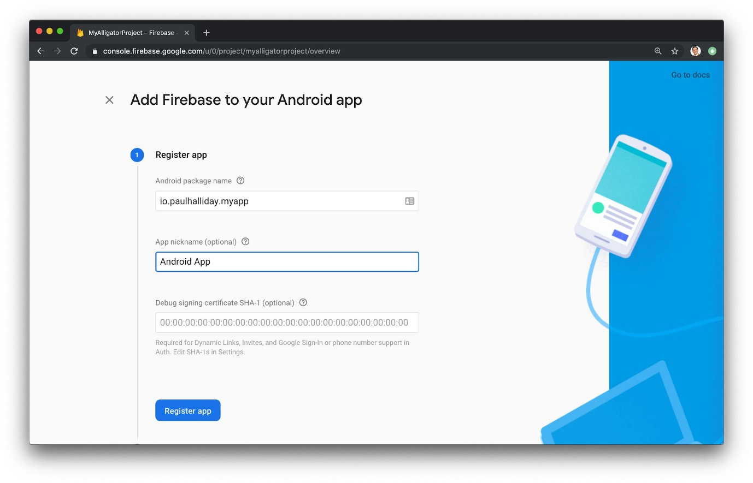**

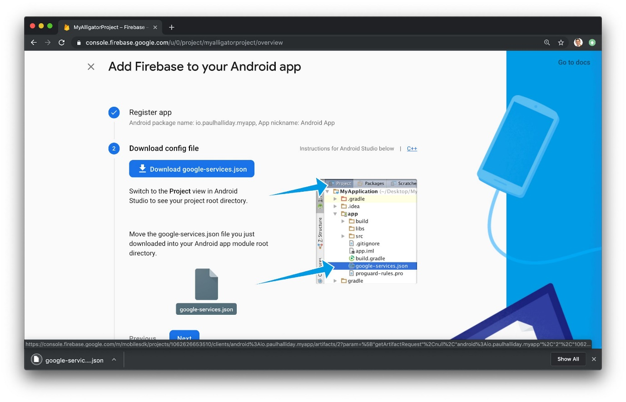

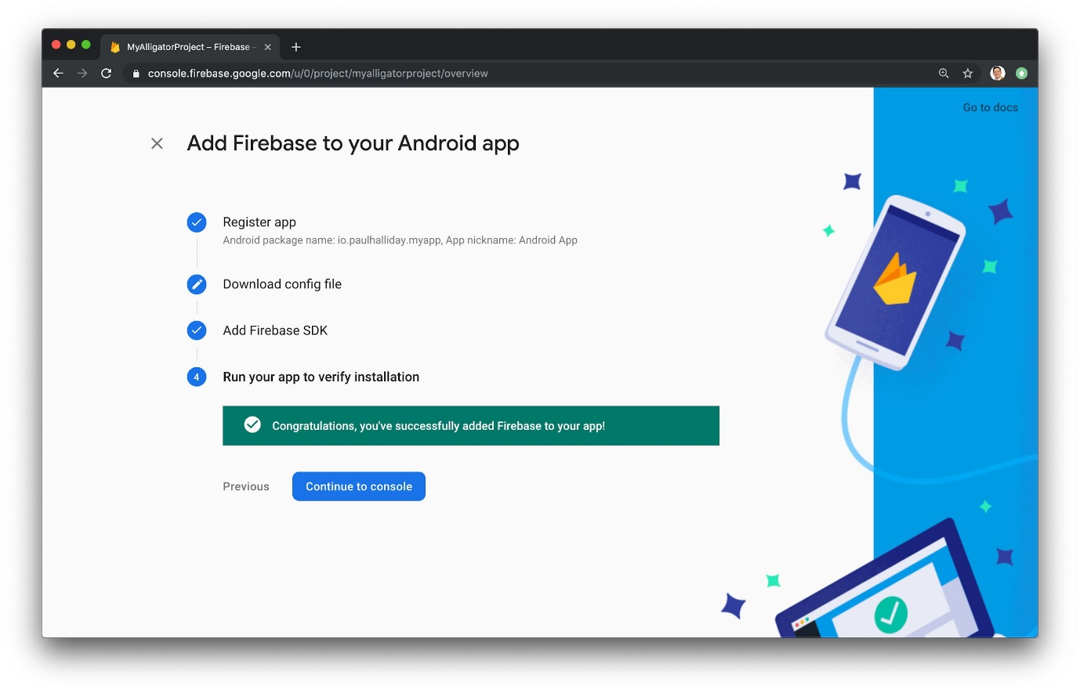

**Conclusion:**  
Firebase was successfully integrated into the Flutter app for both Android and iOS. The app can now leverage Firebase services like authentication, Firestore, and analytics via the FlutterFire plugin suite. This setup ensures scalability and real-time functionality for mobile app development.