Assignment No.: 09  
Title: Implementation of Fetch, Sync, and Push Events using Service Workers in E-commerce PWA  
Name: Harshit Raheja  
Class: D15B  
Roll Number: 45

**Aim:**  
To implement Service Worker events like fetch, sync, and push for the E-commerce PWA.

**Theory:**  
A Service Worker is a background script that works independently of the main web page, enabling features like offline access, background synchronization, and push notifications. Acting as a programmable network proxy, it enhances the reliability and performance of Progressive Web Apps (PWAs).

**Key Characteristics of Service Workers:**

* Only function over HTTPS or localhost (for development)
* Use Promises extensively for async operations
* Do not have access to the DOM (communicate via postMessage)
* Become idle when not in use and restart when needed

**Fetch Event:**  
The fetch event allows the Service Worker to intercept network requests.

* **Cache First Strategy:** If a cached response is available, return it. Otherwise, fetch from the network.
* **Network First Strategy:** Try to fetch from the network first; if it fails, fall back to the cache.

**Sync Event (Background Sync):**  
Enables delayed tasks to run when connectivity is restored.  
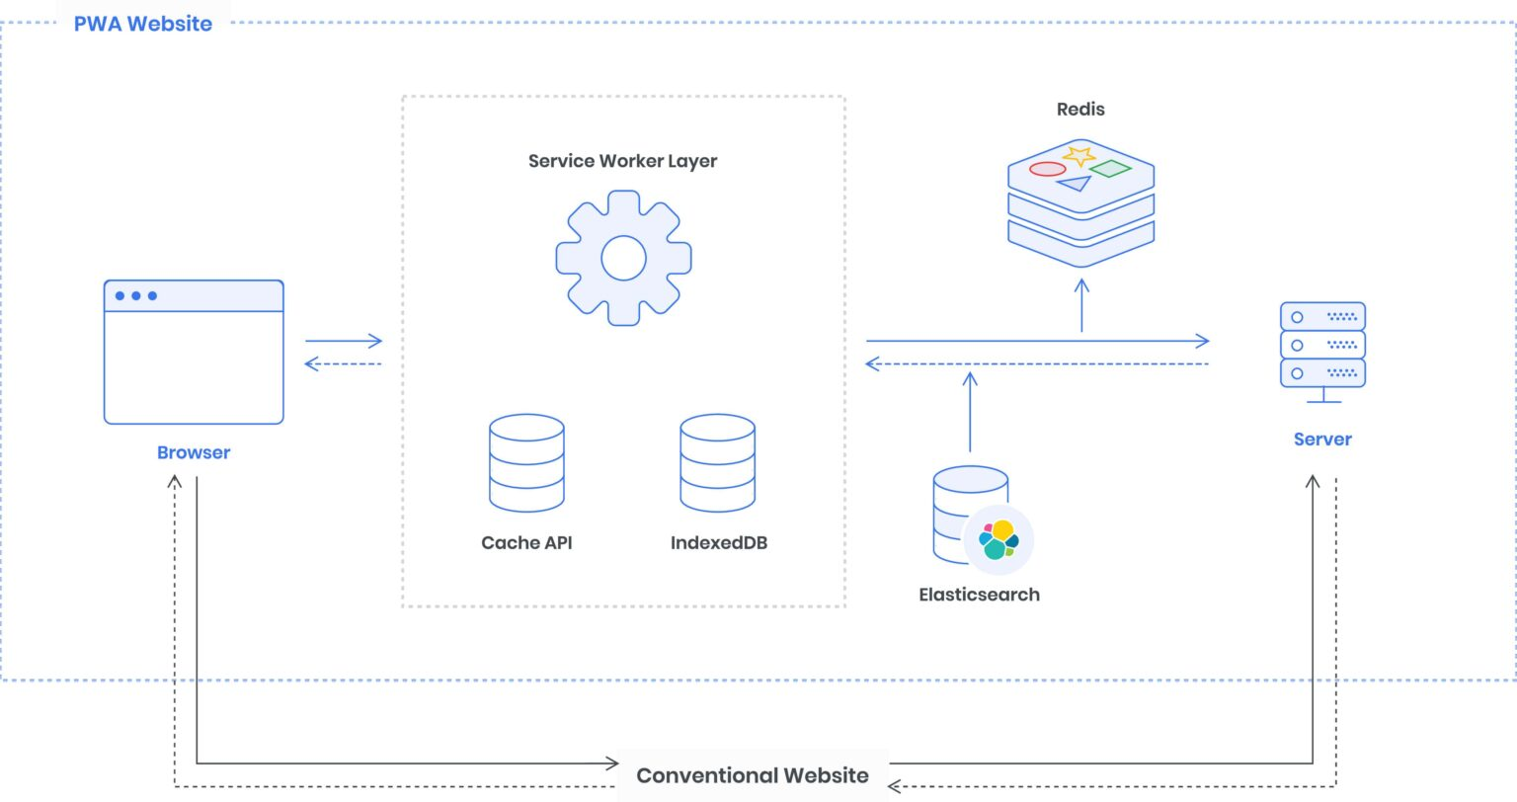  
**Example:**

1. Data (e.g., unsent emails) is saved to IndexedDB when offline.
2. Service Worker registers a sync event.
3. When the device goes online, the SW sends the stored data.

**Push Event:**  
Allows the app to receive push notifications even when it's not active.

* Requires user permission via Notification.requestPermission()
* Triggered using the push event in the service worker
* Displays notifications using self.registration.showNotification()

**Code (sw.js):**

var filesToCache = ['/', '/menu', '/contactUs', '/offline.html'];

var preLoad = function () {

return caches.open("offline").then(function (cache) {

return cache.addAll(filesToCache);

});

};

var checkResponse = function (request) {

return new Promise(function (fulfill, reject) {

fetch(request).then(function (response) {

if (response.status !== 404) {

fulfill(response);

} else {

reject();

}

}, reject);

});

};

self.addEventListener('fetch', function (event) {

event.respondWith(

checkResponse(event.request).catch(function () {

return caches.match(event.request);

})

);

});

self.addEventListener('sync', function (event) {

if (event.tag === 'sync-data') {

event.waitUntil(

// Logic to retrieve and send data from IndexedDB

console.log("Sync successful!")

);

}

});

self.addEventListener('push', function (event) {

if (event && event.data) {

var data = event.data.json();

if (data.method === "pushMessage") {

event.waitUntil(

self.registration.showNotification("Omkar Sweets Corner", {

body: data.message

})

);

}

}

});

**Output:**

* **Fetch:** Intercepts and responds with cached or network data
* **Sync:** Executes background tasks when network returns
* **Push:** Displays push notifications from the server