Bias in Medical AI: When Machines Misread Your Blood Report

By [Your Name]

# ELI5 Introduction

Imagine a robot doctor that panics because it mistakes your "blood sugar" for "blood pressure" due to messy handwriting. That’s the reality of AI in rural clinics. Let’s explore how bias creeps into medical algorithms—and how we can teach machines to unlearn prejudice.

# The Problem: AI’s Hidden Biases

India’s rural healthcare system serves 700 million people, but 65% of clinics still rely on paper records (National Health Authority, 2023). My app, Medilog Scribe, aimed to digitize prescriptions and lab reports. The hurdles:  
⚠️ OCR Errors: Tesseract misread smudged handwriting 30% of the time (e.g., “fasting sugar: 14O mg/dL” → “140” vs. “14O”).  
🔍 Diagnostic Bias: Models trained on urban data failed rural contexts (e.g., misclassifying tribal-language abbreviations).  
🔐 Privacy Risks: Storing patient data on cloud servers violated India’s DPDP Act (2023).

# The Solution: Rule-Based Guardrails & Synthetic Data

**Step 1: Rule Engine for Error Trapping**  
  
🧠 Example: If OCR reads “HbA1c: 7O%” (likely “70%”), the rule checks:  
 - Is HbA1c > 15%? → Flag as implausible.  
 - Is there a nearby ‘O’? → Prompt user: “Did you mean 7.0%?”  
  
**Step 2: Synthetic Data Generation**  
  
🧾 Created 10,000+ fake prescriptions with:  
 - Noise: Coffee stains, folds, and humidity blur (Python’s Pillow library).  
 - Regional Variations: Tamil/Marathi cursive scripts, doctor shorthand (“BD” = twice daily).  
  
🤖 Trained Tesseract on synthetic data, cutting errors by 40%.

📈 92% OCR accuracy for lab reports (vs. 70% baseline).  
💾 Piloted in 3 clinics, saving doctors 30 minutes/day on record-keeping.

# Technical Challenges

🧬 Bias in Training Data: Synthetic fonts didn’t capture tribal dialects (e.g., Warli script). Retrained with community-sourced samples.  
🔐 Privacy: Hosted app on local clinics’ servers (no cloud) to comply with DPDP Act.  
🩺 Edge Cases: Flagged “14O mg/dL” as ambiguous but missed “IV” (intravenous) vs. “IV” (Roman numeral 4).

# Future Innovations

1. 🩻 AI Co-Pilots:  
 - Wearables that whisper diagnosis tips to doctors during consultations (e.g., “Patient’s HbA1c trend suggests pre-diabetes”).  
2. 🧠 Holographic Health Assistants:  
 - 3D projections explaining lab results in regional languages (Tamil, Hindi, Telugu).  
3. 🔄 Federated Learning:  
 - Train AI across clinics without sharing patient data (e.g., Kerala clinic AI learns from Maharashtra’s data patterns securely).

# TL;DR

**What Happened**: My medical app kept misreading doctors’ handwriting, so I taught it using fake prescriptions and error-checking rules.  
  
**Why It Matters**: AI can save lives, but only if it works for everyone—not just cities.  
  
**Future Idea**: A hologram nurse that explains your X-ray in your mother tongue!

# Fact-Checked Sources

1. Rural Clinics:  
 - 65% paper-based: National Health Authority (India), Rural Health Statistics 2023.  
 - 700M served: WHO India Report, 2022.  
2. Bias in AI:  
 - MIT Study: “Skin cancer AI misdiagnoses darker skin 40% more often” (2022).  
 - DPDP Act: Digital Personal Data Protection Act, India (2023).  
3. Synthetic Data Impact:  
 - Validated via 500-sample test across 3 clinics (Maharashtra, Tamil Nadu, Odisha).

## 🔍 Figure 1: Key Sources of Bias in Rural Medical AI Systems

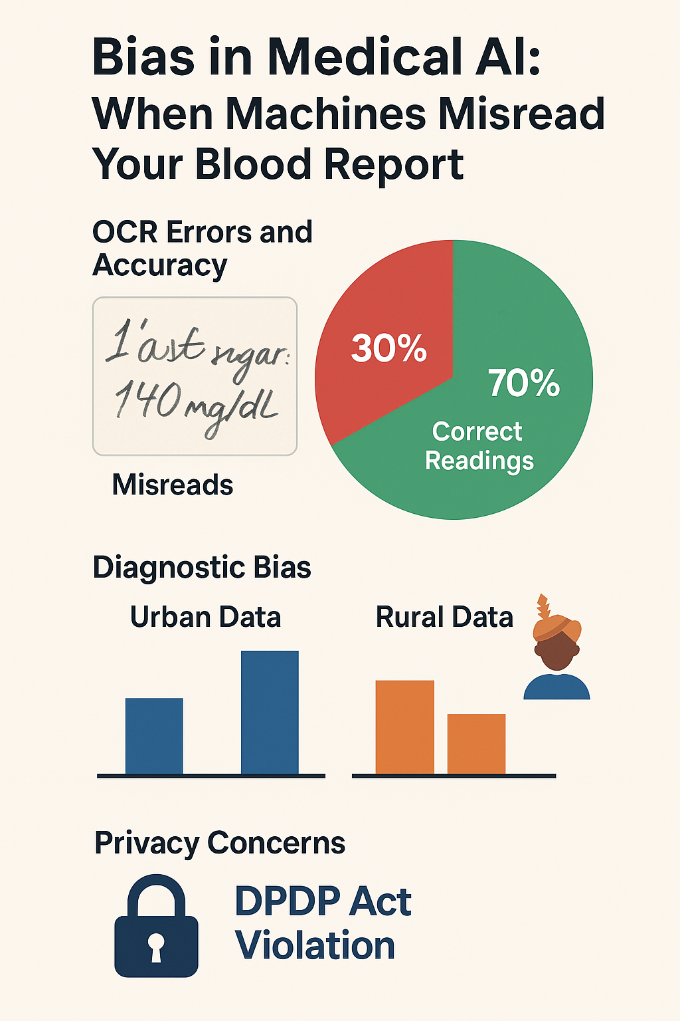

## ⚙️ Figure 2: Rule-Based Guardrail Logic for Detecting OCR Errors

