BURY and min cutrank comparison
  - Exactly balanced bipartitions on circuit and synthetic graphs
12 November 2026
Sampled sqrt-seeded BURY is a strong baseline on this circuit corpus, and annealing from its partitions gives lower median rank in most comparisons with random-start min-cutrank. With the tested ten-sweep schedule, sqrt BURY has lower native median rank on 32 of 43 fully completed circuit comparisons. At a 30-second budget, the sqrt BURY hybrid has lower median incumbent rank on 40 of all 45 circuit graphs, ties on four, and is higher on one. The longer-schedule sensitivity check changes some relative rankings, including two synthetic cases that favor random-start annealing.
The study uses identical exact floor/ceiling capacities on 45 circuit graphs, four grids, and 18 sparse random graphs. The primary measure is GF(2) cut rank. Random SA denotes the min-cutrank library with random initialization; hybrid methods use the same annealer initialized by BURY. Native results are final states after the schedule. Incumbents are the best valid states observed by the stated budget, including initialization.

Circuit rank comparisons
Table 1 Number of circuit graphs versus random SA under the same output policy
Method | Output policy | Lower | Tied | Higher | Unavailable
BURY | Native final | 15 | 3 | 25 | 2
Sqrt BURY | Native final | 32 | 6 | 5 | 2
BURY plus SA | Native final | 26 | 10 | 7 | 2
Sqrt plus SA | Native final | 38 | 3 | 2 | 2
BURY | 30 s incumbent | 16 | 3 | 26 | 0
Sqrt BURY | 30 s incumbent | 34 | 6 | 5 | 0
BURY plus SA | 30 s incumbent | 29 | 8 | 8 | 0
Sqrt plus SA | 30 s incumbent | 40 | 4 | 1 | 0

Ordinary BURY is less consistent: it has higher median rank on 25 of the 43 completed native comparisons. Sqrt BURY is lower than random SA on all 20 initial circuits, while reduced circuits and evolution stage 2 contain losses. These counterexamples and every circuit result are retained in the appendix.
Of 2,010 annealing runs, 1,950 completed and 60 reached the time limit; none errored. The 60 limits comprise every annealing run on evolution stages 4 and 5. All methods provide a valid incumbent by 30 seconds. Counts compare per-graph medians, with ten stochastic replicates and one deterministic BURY result. Ranges in figures are observed extrema, not confidence intervals.

Native results on circuit families
On the six GF multiplier graphs, ordinary BURY is lower than random SA on four, ties on one, and is higher on one; sqrt BURY is lower on five and ties on one. The Toffoli family is a counterexample for ordinary BURY: it is higher on all eight graphs. Sqrt BURY is lower on six Toffoli graphs and higher on two. Across eight Barenco graphs, sqrt BURY is lower on five and ties on three.
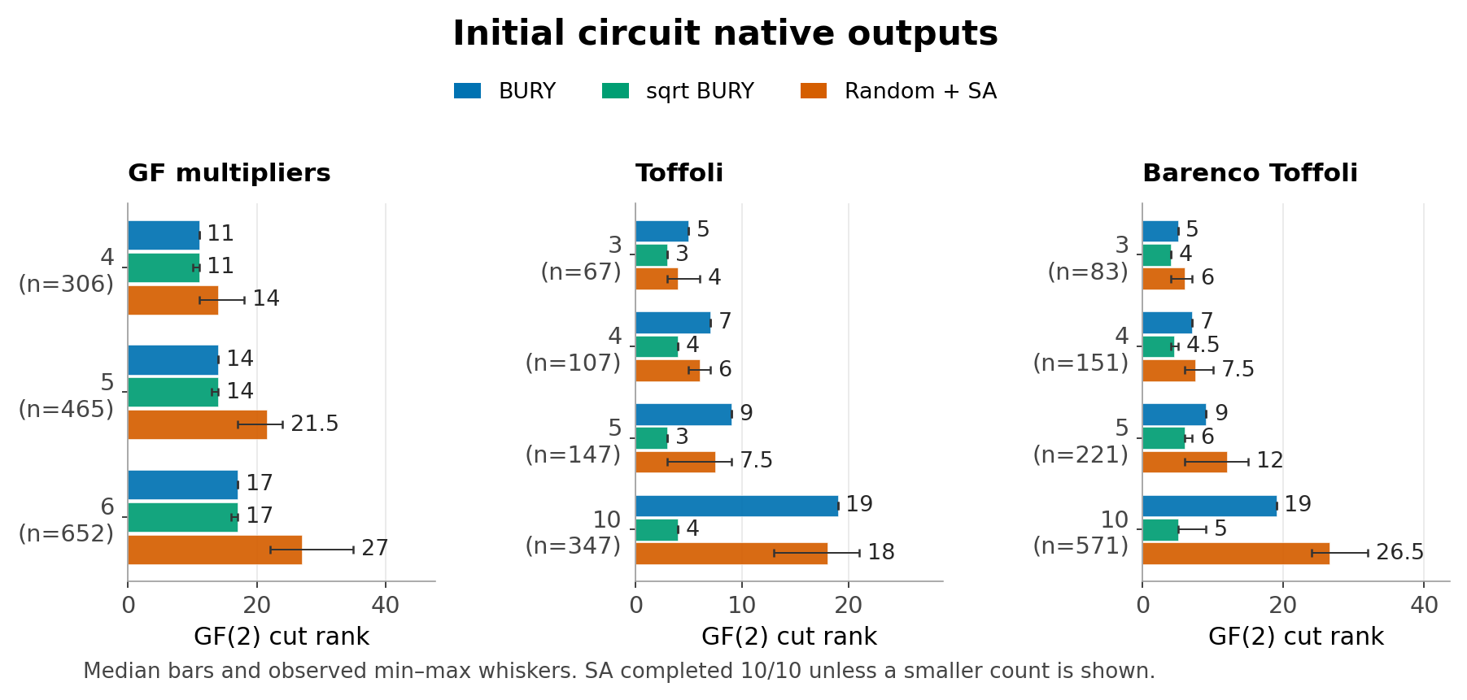
Figure 1 Initial circuit families. Native final ranks; all stochastic cases complete ten of ten runs. BURY uses one deterministic result.
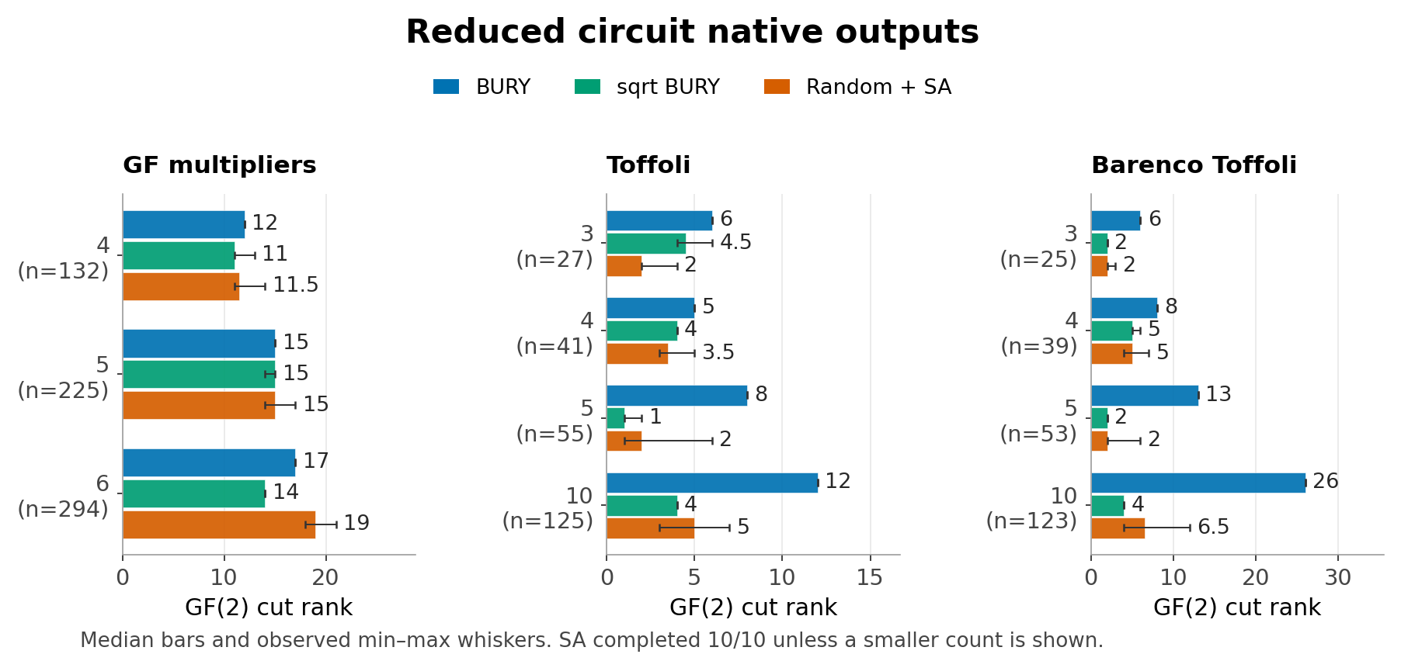
Figure 2 Reduced circuit families under the same policy. Median bars and observed minimum-to-maximum whiskers show seed variability.
The other nine circuit families contain 18 graphs. Sqrt BURY is lower on 15, ties on one, and is higher on two; ordinary BURY is lower on seven, ties on one, and is higher on ten. Whole-corpus counts therefore include more than the families illustrated above.

Annealing from BURY partitions
The sqrt hybrid improves median incumbent rank relative to its own initializer on 21 of 45 circuit graphs and ties on 24. Across individual runs it finds a strict rank improvement in 186 of 450 cases. The remaining 264 retain the initializer rank. Keeping the initializer makes a higher incumbent rank impossible by construction; the observed improvement counts measure the additional search benefit.
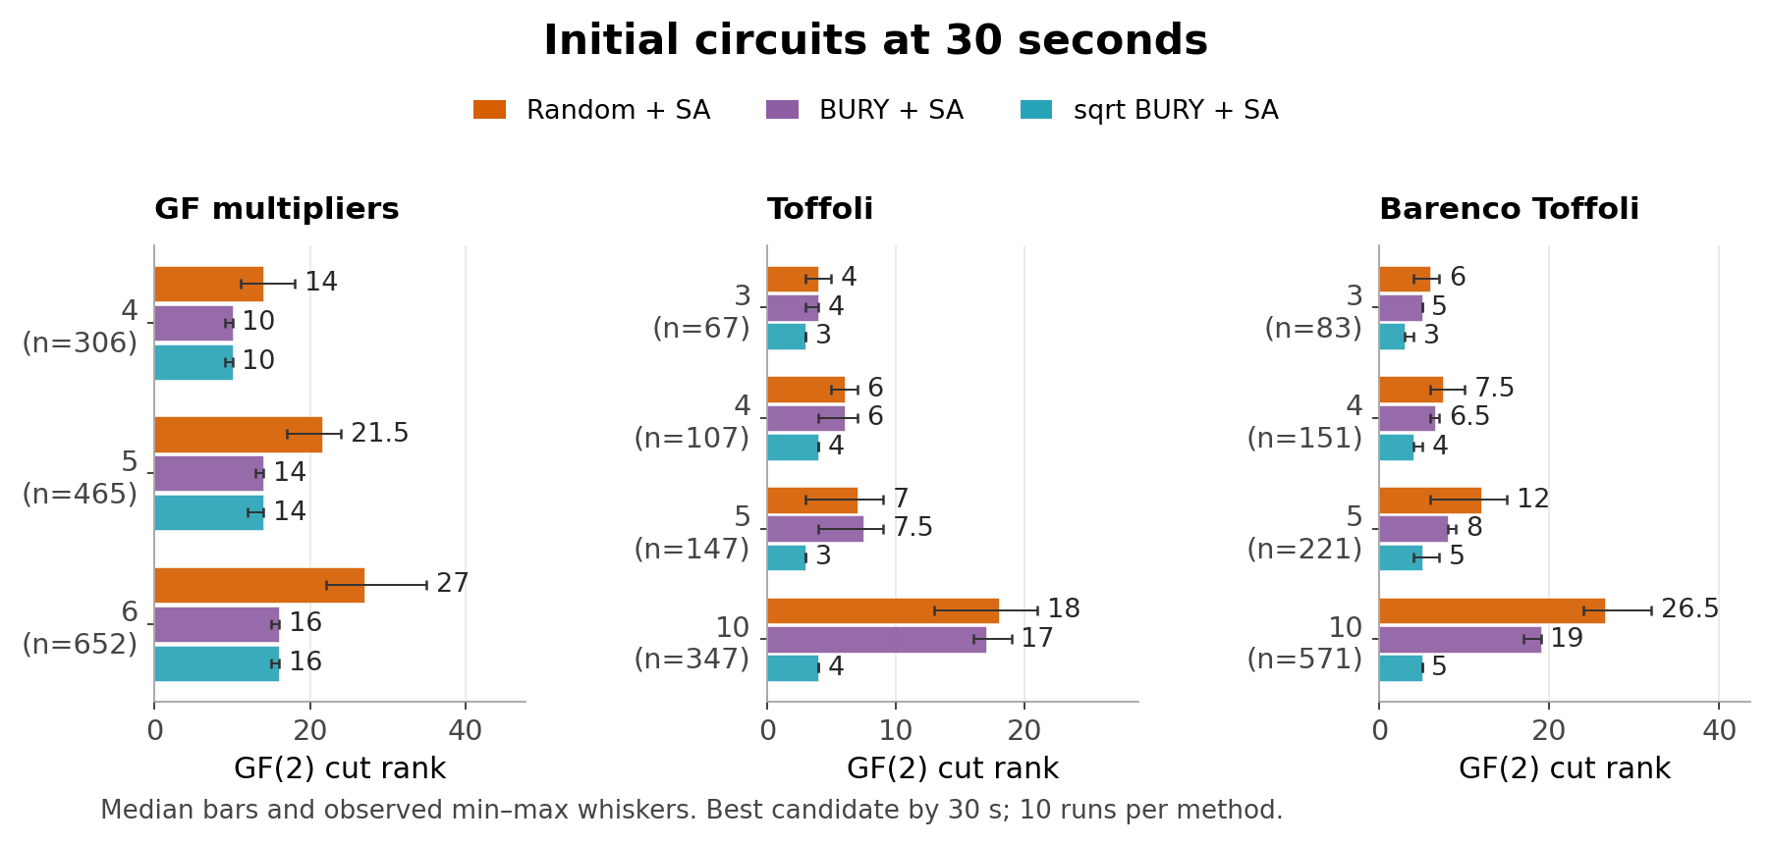
Figure 3 Initial circuit incumbents by 30 seconds. Each hybrid includes its separately measured complete BURY initializer charge.
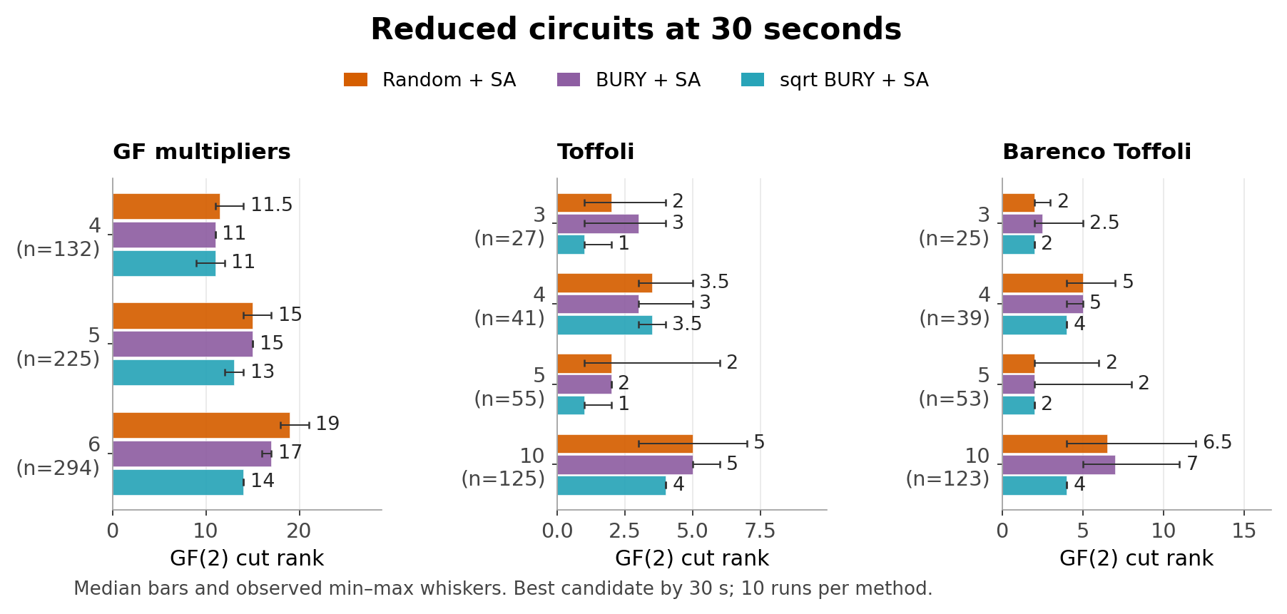
Figure 4 Reduced circuit incumbents. The first strictly lowest-rank observed state is retained, including the initializer.
The sole 30-second sqrt-hybrid loss is reduced vbe_adder_3: median rank 3.5 versus 3 for random SA. Native annealing can worsen its input: 71 of 430 completed circuit sqrt-hybrid runs end above their initializer rank, by up to four units. Across all methods, 236 of 1,950 completed native outputs are worse than their own recorded incumbent.

Evolution graphs
On stages 1 through 3, all annealers finish. Stages 4 and 5 have no completed native outputs, so their results support a time-budget comparison only. The sqrt hybrid ties random SA on stage 1 and has lower 30-second median incumbent rank on each later stage. Stage 2 illustrates why additional search matters: sqrt BURY alone has median rank 12 versus random SA 11.5; the sqrt hybrid reaches 6.
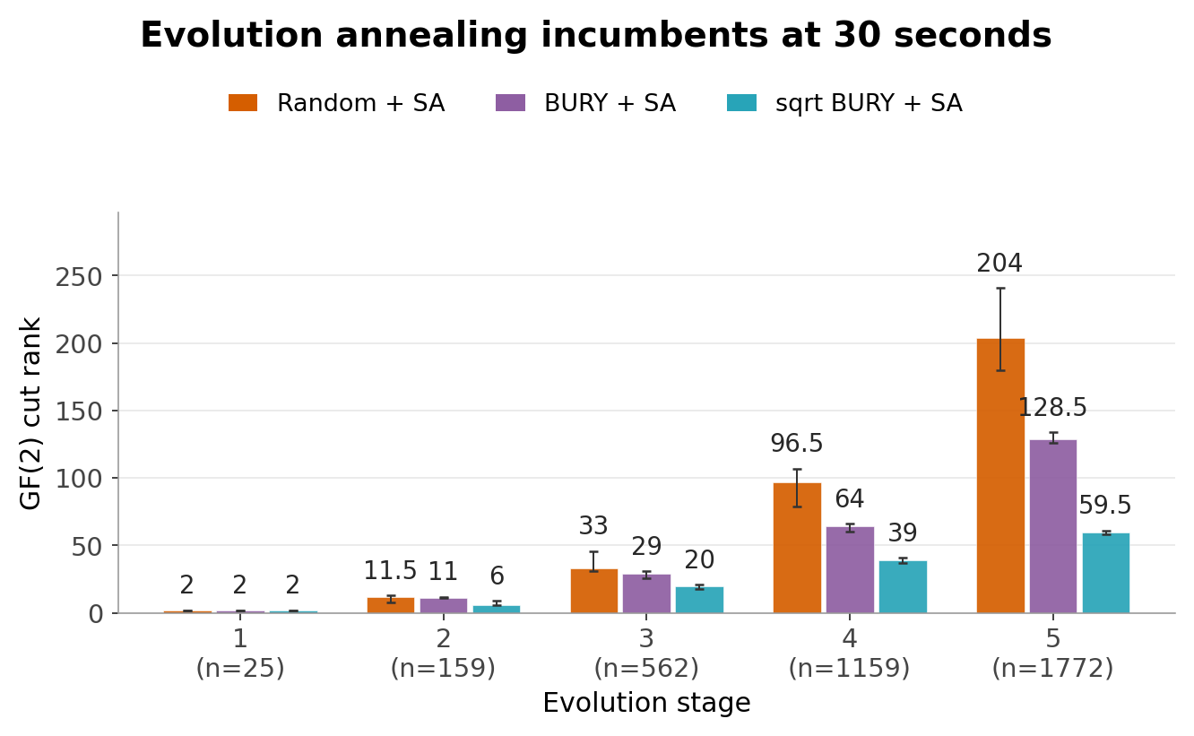
Figure 5 Incumbents available within 30 seconds. Stages 4 and 5 use valid states saved before their time limit, not fabricated native outputs.
Table 2 Evolution median ranks at 30 seconds
Stage | n | BURY | Sqrt BURY | Random SA | BURY plus SA | Sqrt plus SA
k1 | 25 | 2 | 2 | 2 | 2 | 2
k2 | 159 | 14 | 12 | 11.5 | 11 | 6
k3 | 562 | 46 | 25 | 33 | 29 | 20
k4 | 1159 | 99 | 65 | 96.5 | 64 | 39
k5 | 1772 | 153 | 85 | 204 | 128.5 | 59.5

On the largest graph, with 1,772 vertices, ordinary and sqrt BURY produce ranks 153 and median 85. At 30 seconds, random SA has median rank 204, BURY plus SA 128.5, and sqrt BURY plus SA 59.5. This is evidence about the declared budget and initialization policy; it does not establish the rank a completed longer random-start search would attain.

Rank available over elapsed time
The early-budget comparison measures which valid partition is available, including setup time and the complete BURY initializer charge. All methods have results for every replicate by one second. At 0.1 seconds, two sqrt BURY observations and their hybrid initializers are not yet eligible; this incomplete coverage is retained. A completed invocation keeps its incumbent at later budgets, rather than starting another search.
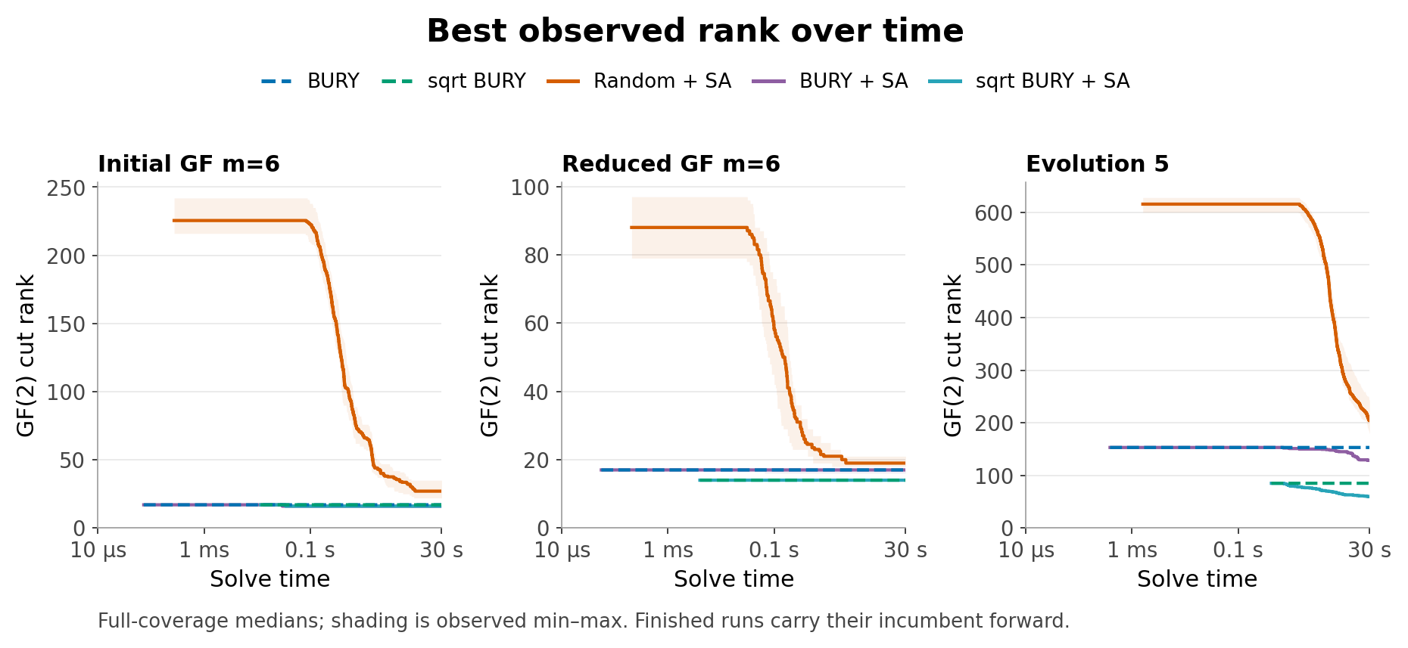
Figure 6 Selected circuit examples under the fixed schedule. Curves begin only when every required run has a candidate; shading spans observed run extrema. Completion and availability are distinct.
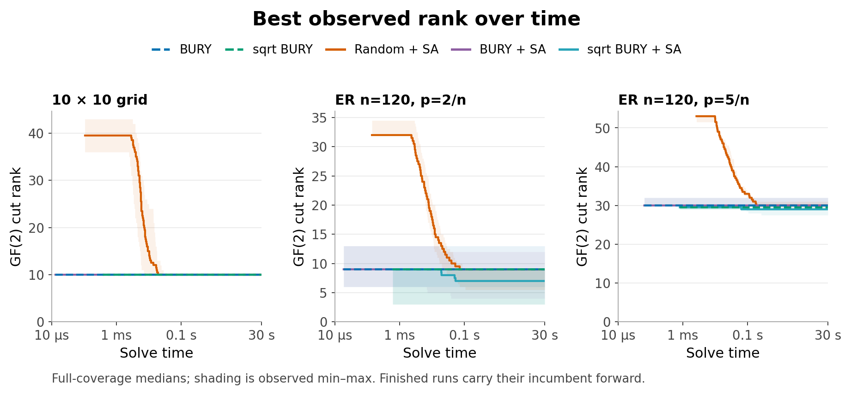
Figure 7 Synthetic examples. Grid curves show run medians and extrema. Sparse panels show the median of three graphwise run medians, with shading spanning those three medians. Each seed has one invocation.
Across the separate three-repeat timing measurements, per-key warmed medians range from 1.42 to 417.5 microseconds for ordinary BURY and from 0.0368 to 55.23 milliseconds for sqrt BURY. The Python search, dense workspace, language implementation, and scheduling costs differ substantially. These are machine-specific observations; no precise language-independent speedup is claimed.

Grids and sparse random graphs
Every native final output on the four grids has rank 4, 6, 8, and 10, respectively. On the 18 sparse random fixtures, sqrt BURY is lower than random SA on seven, ties on eight, and is higher on three. Sqrt BURY plus SA is lower on 12 and ties on six under both native and 30-second policies. This broader fixture set retains ordinary BURY losses and the three standalone sqrt losses.
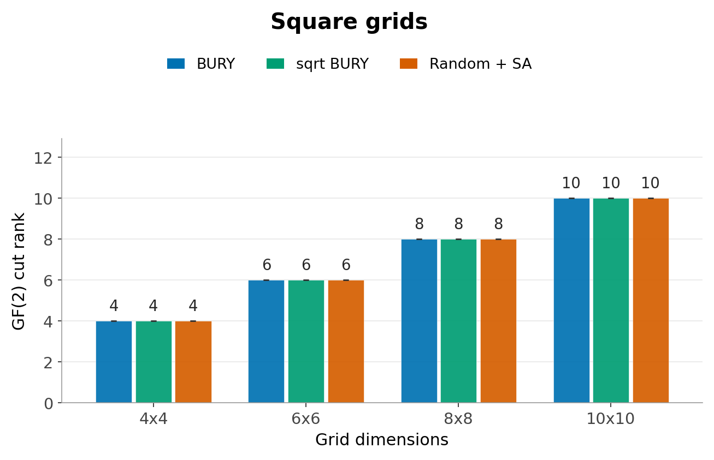
Figure 8 Native ranks on all four square grids. Every stochastic replicate has the displayed value; zero-width ranges are not omitted uncertainty estimates.
Table 3 Sparse graph counts versus random SA at 30 seconds
Graph family | Method | Lower | Tied | Higher
Sparse c = 2 | BURY | 0 | 3 | 6
Sparse c = 2 | Sqrt BURY | 3 | 6 | 0
Sparse c = 2 | BURY plus SA | 4 | 3 | 2
Sparse c = 2 | Sqrt plus SA | 6 | 3 | 0
Sparse c = 5 | BURY | 2 | 2 | 5
Sparse c = 5 | Sqrt BURY | 4 | 2 | 3
Sparse c = 5 | BURY plus SA | 3 | 3 | 3
Sparse c = 5 | Sqrt plus SA | 6 | 3 | 0

Each density has three graph seeds at each of n = 40, 80, and 120. Seeds are reused across sizes and densities; density pairs at a fixed size and seed are nested. These are 18 correlated fixtures, not 18 independent population samples. Disconnected instances are retained. Complete per-graph results and separate sparse-graph plots accompany this report.

Secondary costs and exact optimum checks
Lower GF(2) rank can coexist with more crossing edges. For initial tof_3, the sqrt hybrid at 30 seconds has median rank 3 versus random SA 4, but median edge cut 12 versus 7.5. Across the circuit corpus, its matching median is never higher than random SA, while edge cut is higher on four graphs.
Table 4 Lower / tied / higher medians versus random SA on 45 circuits at 30 seconds
Method | GF(2) rank | Matching | Edge cut
BURY | 16 / 3 / 26 | 21 / 5 / 19 | 16 / 1 / 28
Sqrt BURY | 34 / 6 / 5 | 39 / 4 / 2 | 40 / 1 / 4
BURY plus SA | 29 / 8 / 8 | 29 / 8 / 8 | 21 / 3 / 21
Sqrt plus SA | 40 / 4 / 1 | 42 / 3 / 0 | 40 / 1 / 4

All three costs are computed on the same returned memberships. These columns do not represent separate objective-specific searches. In particular, sqrt BURY retains its matching-selected inner seeds even when rank selects the outer target.

Exact gaps on small validation graphs
A separate sanity suite exhaustively enumerates 2,554 balanced subsets on ten small fixtures. It is excluded from the 67-graph study. The largest observed optimality gap is one rank unit.
Table 5 Exact balanced rank checks
Method | Runs at optimum | Runs above optimum | Maximum gap
BURY | 9 of 10 | 1 | 1
Sqrt BURY | 88 of 100 | 12 | 1
Random SA native | 99 of 100 | 1 | 1
Random SA incumbent | 100 of 100 | 0 | 0

The random12_seed333 fixture has optimum 4: ordinary BURY returns 5, sqrt BURY has median 5 with range 4 to 5, and every native annealing run returns 4. One annealing run on a nine-vertex path ends at rank 2 after visiting the optimum 1. The tiny suite uses one sequential initialization/search RNG stream; the main study separates them. No timing inference is drawn from the tiny suite. Independent enumeration also confirms optima 3 and 4 for the 3 by 3 and 4 by 4 grids. These checks do not certify optimality on large circuits.

Sensitivity to a longer schedule
A separate sensitivity study uses 100 linearly spaced temperatures from 1.0 to 0.1 under the same 30-second cap. It includes 11 structurally selected graphs: evolution stages 1 and 5, initial GF multiplier 6, reduced GF multiplier 4, the 10 by 10 grid, and all six n = 120 sparse fixtures. The selection was frozen during main collection and before these follow-up runs. It uses three seeds, 0 through 2, and compares only the identical graph, method, initializer, and seed keys from the ten-sweep study. Of 99 longer-schedule runs, 81 finish and 18 time out.
Table 6 Rank with 100 sweeps versus 10 sweeps on 33 matched runs per method
Method | Output policy | Lower | Tied | Higher | Unavailable
Random SA | Native final | 13 | 14 | 0 | 6
BURY plus SA | Native final | 8 | 19 | 0 | 6
Sqrt plus SA | Native final | 7 | 19 | 1 | 6
Random SA | 30 s incumbent | 18 | 13 | 2 | 0
BURY plus SA | 30 s incumbent | 9 | 22 | 2 | 0
Sqrt plus SA | 30 s incumbent | 6 | 25 | 2 | 0

More gradual cooling often lowers rank but does not dominate the shorter schedule. At 30 seconds, random SA improves in 18 of 33 paired runs, ties in 13, and is higher in two. The sqrt hybrid improves in six, ties in 25, and is higher in two. Relative method rankings also change: across the same 11 graph medians, the sqrt hybrid versus random SA changes from seven lower and four tied with ten sweeps to six lower, three tied, and two higher with 100 sweeps. The two longer-schedule losses are sparse n = 120, c = 2 graphs with seeds 1001 and 1002: sqrt-hybrid medians 9 and 4 versus random SA 8 and 3. The changed temperature sequence is a different trajectory, not a continuation of the ten-sweep run; the unchanged cap also censors long solves.

Interpretation and limits
The strongest measured pattern is the value of sampled sqrt BURY as a fast initializer on these fixtures. Its existing matching-selected seed policy already produces low rank, and the annealer sometimes improves it further. Ordinary BURY is less reliable on reduced circuits and Toffoli graphs. A longer schedule can change the comparison, and the current capped schedule cannot establish what a fully converged search would return.
METIS is not included in this strict-capacity contest. The older GraphML study used its default 3 percent imbalance tolerance. Filtering that historical study to its balanced outcomes would yield a selected subset, not an equivalent partitioning policy. These results concern bipartitions only; no recursive multipartition extension is evaluated.
Related circuit sizes, initial/reduced pairs, evolution stages, and reused synthetic RNG streams are correlated. The study reports complete fixture coverage and seed variability, without population-level significance claims. The incumbent policy guarantees retention of a good initializer; only strict improvements quantify new search benefit.

Methods and objective definitions
Every accepted partition has side sizes equal to the floor and ceiling of half the vertex count. The score is the rank over the binary field GF(2) of the adjacency block crossing the partition. On two parts this is exactly QuantumHamlets pairwise_cut_rank. Matching is the cardinality of a maximum matching in the same cut graph; edge cut counts the edges crossing it. Vertex attributes, phases, layouts, and edge-type attributes are ignored in this unweighted topology comparison.
Table 7 Algorithms and initializers
Method | Initial partition | Search and output
BURY | Ordinary heap BURY | Rank selects floor or ceiling candidate
Sqrt BURY | Sampled sqrt seeds | Matching selects inner seed; rank selects target
Random SA | Random fixed-size partition | Upstream row-formula annealing
BURY plus SA | Saved BURY partition | Same annealing schedule
Sqrt BURY plus SA | Saved replicate of sqrt BURY | Same annealing schedule

Ordinary BURY runs independently at the floor and ceiling targets, with one target on even graphs and two on odd graphs. The outer rank objective chooses between generated candidates and keeps the later target on ties. It does not change the greedy construction. Sampled sqrt BURY draws the ceiling of the square root of the vertex count in seeds with replacement, uses matching cost to choose the first best inner seed, and reruns that seed. Its outer target selector uses rank. This is the existing bipartition policy, distinct from the deterministic minimum-degree seeder used by the multipartition driver.
The annealer is the pinned upstream cut_rank_annealing_row_formula implementation. For each row vertex it evaluates exchanges with the other side, chooses among the minimum-rank exchanges, and uses the temperature to decide whether to accept an uphill move. Accepted operations exchange one vertex from each side. The main schedule contains ten linearly spaced temperatures from 1.0 to 0.1. Before annealing, BURY membership is complemented when necessary so the row side always has the floor of half the vertices. This preserves the cut and all symmetric costs while fixing a search-orientation policy.
There are ten algorithm seeds, 0 through 9. Random initial partitions use separate Python streams with seeds 100000 through 100009. Annealing then resets the global Python stream to the corresponding algorithm seed. Sqrt BURY uses Julia seeds 0 through 9. Equal integer seeds across Julia and Python do not define common random choices. Ordinary BURY is deterministic and is stored once per graph.

Budgets and input protocol
The native annealing output is the final state after the complete ten-temperature schedule. It can be worse than a state visited earlier. The native result is unavailable when the run reaches the time limit before finishing. Native median comparisons require all planned replicates of both methods to finish; incomplete cases retain completion counts but do not enter lower or higher totals.
A separate observation wrapper records the first strictly lowest rank encountered, including the initializer. The wrapper does not change proposals or consume random numbers. This incumbent is evaluated at elapsed budgets of 0.1, 1, 5, and 30 seconds. A saved candidate is eligible only when its recorded availability timestamp is no later than the budget. If the run finishes early, its incumbent remains available at later budgets. There is one invocation per replicate; the protocol does not use unlimited restarts to fill a budget.
Each solve has a 30-second elapsed-wall-time cap and a 75-second subprocess watchdog. An interrupted mutable upstream workspace is discarded. Only completed, copied, independently validated memberships can be reported as incumbents. A hybrid can retain its BURY initializer before annealing setup finishes. A timeout is recorded as a timeout, never assigned an invented final rank.
The solve timer excludes imports, topology-file loading, post-solve validation, and output serialization. It includes dense adjacency conversion, workspace construction, observer overhead, and initial rank evaluation for a random start. Hybrids also charge the measured complete Julia initializer solve, including both odd targets and the full sqrt seed search. Python CPU time is recorded separately and excludes that Julia charge; hybrid elapsed time includes it. The hybrid total is a composition of a separately measured Julia initialization and the measured Python phase, not the duration of a newly executed integrated pipeline.
The main collection uses at most two Python workers, with task order shuffled by seed 20261112. The sensitivity collection uses order seed 20261113. Wall times include scheduling effects. Hybrids charge the original warmed Julia solves. A separate three-repeat study verifies memberships and records wall time, compilation, garbage collection, and allocations without replacing those charges. These are practical implementation measurements, not language-independent algorithmic speedups.
The host is an Apple M1 Pro with 16 GiB RAM and 10 logical CPUs, running macOS 14.8.9. Julia uses one thread. Allocated Julia bytes and peak process RSS measure different quantities. Fresh-process memory probes include runtime and loading costs; Python peak RSS includes imports and post-validation. Neither is interpreted as solver-only memory.

Inputs and selection
The corpus contains 20 initial graphs, 20 reduced graphs, and five evolution stages, with 25 to 1,772 vertices. XML declaration order defines the shared dense vertex mapping. Synthetic inputs are square grids of side 4, 6, 8, and 10 and 18 Erdos-Renyi graphs: n = 40, 80, 120; edge probability c/n for c = 2, 5; and graph seeds 1000 through 1002. Disconnected samples are retained. Each saved topology is shared across methods. Reused seeds make density pairs nested and cross-size streams correlated. The main corpus and settings were fixed before collection; an excluded calibration pilot set the resource cap without quality-based tuning.

Validation and reproducibility
The upstream checker passed 345,652 assertions, including 9262 swap predictions and reverse-update pairs and 195 fixed-RNG direct-versus-incremental trajectory comparisons. It covers all labeled simple graphs with two through four vertices and all nonempty row sets, plus 240 seeded fixtures with five through sixteen vertices. The independent baseline audit passed 6,301 assertions over 67 graphs and 737 BURY memberships; all 495 prior circuit rank observations were reproduced. The separate timing study checked 2,948 saved memberships across warm and timed solves.
The main task audit passed 394,451 assertions over all 2,010 annealing runs and 34,756 saved membership records. The final table audit passed 115,717 assertions. Every one of the 3,563 distinct published memberships was independently rescored by QuantumHamlets for GF(2) rank, cardinality matching, and edge cut. Actual capacities, vertex mappings, topology hashes, seeds, completion status, and timestamp eligibility were checked. The longer-schedule audit passed 53,313 assertions over 99 runs and 2,236 saved memberships, including nine uninstrumented upstream replays. Julia also cross-checked ranks on all 211 distinct published sensitivity memberships.
The experiment pins QuantumHamlets commit 3513432ff18f26148aa7248f1d7cbb00d0f9174a and min-cutrank commit 86c1d8ff5d9b901983d9ad2254c8df0651e0219d. It uses Julia 1.12.6, Graphs 1.14.0, GraphIO 0.7.1, EzXML 1.2.3, Python 3.12.14, and NumPy 2.3.5 on an Apple M1 Pro with 16 GiB RAM and macOS 14.8.9. Production library code and the pinned upstream source were unchanged. Figures use the separately recorded Python 3.10.6, NumPy 2.2.6, and Matplotlib 3.10.9 environment; those versions are not the solver runtime.
Inputs, memberships, logs, figures, and source hashes are retained in experiments/min_cutrank_comparison/run_20261112T161827Z. The protocol fixes capacities, seeds, schedules, budgets, and timing rules. Tables include 13,735 derived score observations spanning native outputs and four budgets; these are not 13,735 independent trials. Separate tables contain 1,675 summaries and graph- and family-level comparisons. Scripts and the reproduction README are in experiments/min_cutrank_comparison/. Plots and this document are generated from saved data without rerunning partitioners.

Sources
Incremental row formula annealing implementation
Partition workspace and swap updates
Upstream baseline temperature configuration
Effective Partitioning for Distributed Measurement Based Quantum Computing

All circuit graph results
Entries are median GF(2) rank of the incumbent available by 30 seconds. Ordinary BURY has one result; each other method has ten. I denotes initial graphs, R reduced graphs, and E evolution stages. These complete-budget results include all 45 circuits. Native output tables separately retain the two evolution graphs where every annealing replicate times out.
Table A1 Every circuit graph under the 30 second incumbent policy
Circuit graph | n | BURY | Sqrt BURY | Random SA | BURY plus SA | Sqrt plus SA
I barenco_tof_10 | 571 | 19 | 5 | 26.5 | 19 | 5
I barenco_tof_3 | 83 | 5 | 4 | 6 | 5 | 3
I barenco_tof_4 | 151 | 7 | 4.5 | 7.5 | 6.5 | 4
I barenco_tof_5 | 221 | 9 | 6 | 12 | 8 | 5
I csla_mux_3 | 239 | 10 | 4 | 11.5 | 8 | 3
I csum_mux_9 | 622 | 14 | 6 | 19.5 | 11 | 6
I gf2^4_mult | 306 | 11 | 11 | 14 | 10 | 10
I gf2^5_mult | 465 | 14 | 14 | 21.5 | 14 | 14
I gf2^6_mult | 652 | 17 | 17 | 27 | 16 | 16
I hwb6 | 325 | 7 | 6 | 12.5 | 7 | 6
I mod_mult_55 | 167 | 9 | 6.5 | 8 | 7 | 6
I mod_red_21 | 355 | 11 | 9 | 13 | 11 | 9
I qcla_com_7 | 605 | 24 | 4 | 25.5 | 23.5 | 4
I qft_4 | 143 | 5 | 5 | 7 | 5 | 4.5
I rc_adder_6 | 262 | 14 | 6 | 14 | 12 | 6
I tof_10 | 347 | 19 | 4 | 18 | 17 | 4
I tof_3 | 67 | 5 | 3 | 4 | 4 | 3
I tof_4 | 107 | 7 | 4 | 6 | 6 | 4
I tof_5 | 147 | 9 | 3 | 7 | 7.5 | 3
I vbe_adder_3 | 200 | 10 | 4 | 9 | 8.5 | 4
R barenco_tof_10 | 123 | 26 | 4 | 6.5 | 7 | 4
R barenco_tof_3 | 25 | 6 | 2 | 2 | 2.5 | 2
R barenco_tof_4 | 39 | 8 | 5 | 5 | 5 | 4
R barenco_tof_5 | 53 | 13 | 2 | 2 | 2 | 2
R csla_mux_3 | 111 | 8 | 4 | 9.5 | 8 | 4
R csum_mux_9 | 166 | 21 | 7 | 8.5 | 11 | 3
R gf2^4_mult | 132 | 12 | 11 | 11.5 | 11 | 11
R gf2^5_mult | 225 | 15 | 15 | 15 | 15 | 13
R gf2^6_mult | 294 | 17 | 14 | 19 | 17 | 14
R hwb6 | 137 | 19 | 12 | 12 | 13.5 | 8
R mod_mult_55 | 73 | 9 | 7 | 8 | 5 | 4
R mod_red_21 | 133 | 10 | 6 | 9 | 4 | 6
R qcla_com_7 | 169 | 14 | 2 | 9 | 2 | 2
R qft_4 | 87 | 8 | 5 | 6 | 4 | 5
R rc_adder_6 | 106 | 19 | 6 | 3.5 | 6 | 3
R tof_10 | 125 | 12 | 4 | 5 | 5 | 4
R tof_3 | 27 | 6 | 4.5 | 2 | 3 | 1
R tof_4 | 41 | 5 | 4 | 3.5 | 3 | 3.5
R tof_5 | 55 | 8 | 1 | 2 | 2 | 1
R vbe_adder_3 | 44 | 11 | 5 | 3 | 3.5 | 3.5
E k1 | 25 | 2 | 2 | 2 | 2 | 2
E k2 | 159 | 14 | 12 | 11.5 | 11 | 6
E k3 | 562 | 46 | 25 | 33 | 29 | 20
E k4 | 1159 | 99 | 65 | 96.5 | 64 | 39
E k5 | 1772 | 153 | 85 | 204 | 128.5 | 59.5

