TESTING INDIVIDIAL DOCKERIZED SERVICES
EUREKA
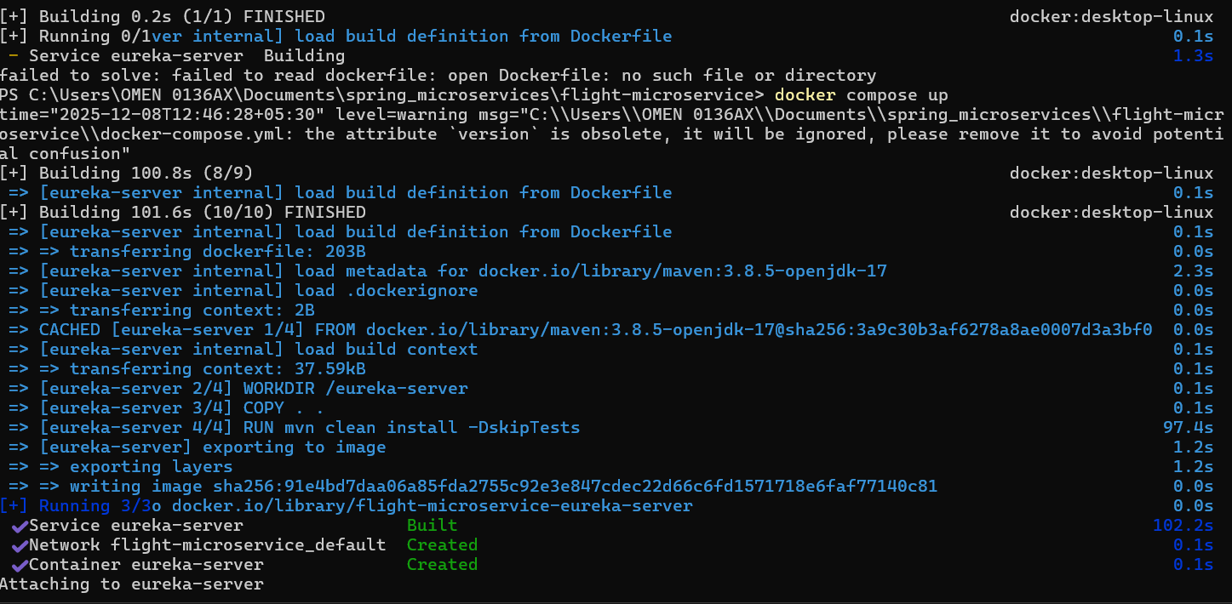
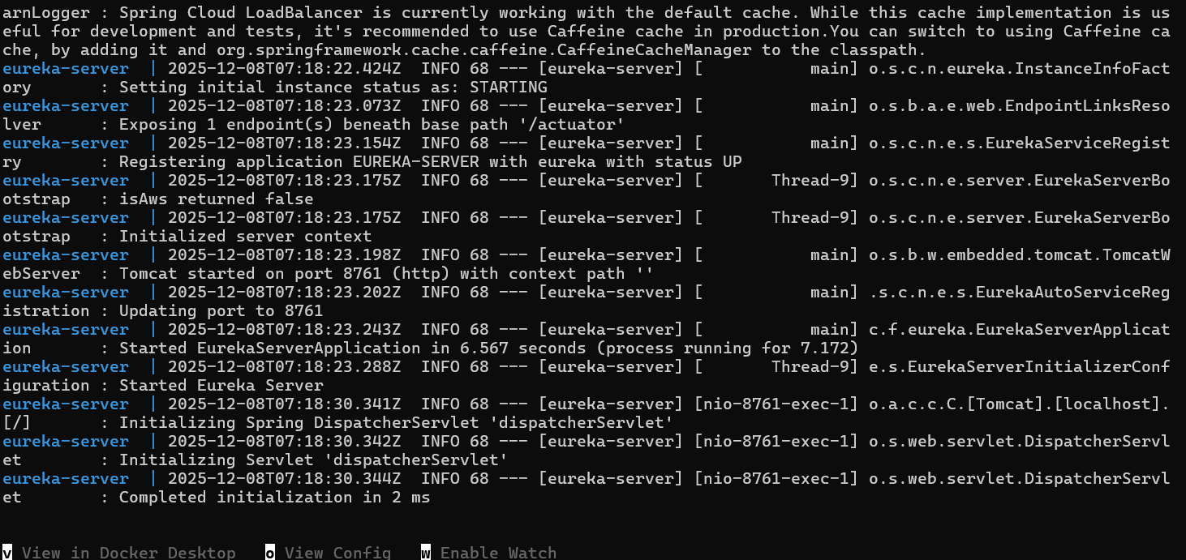
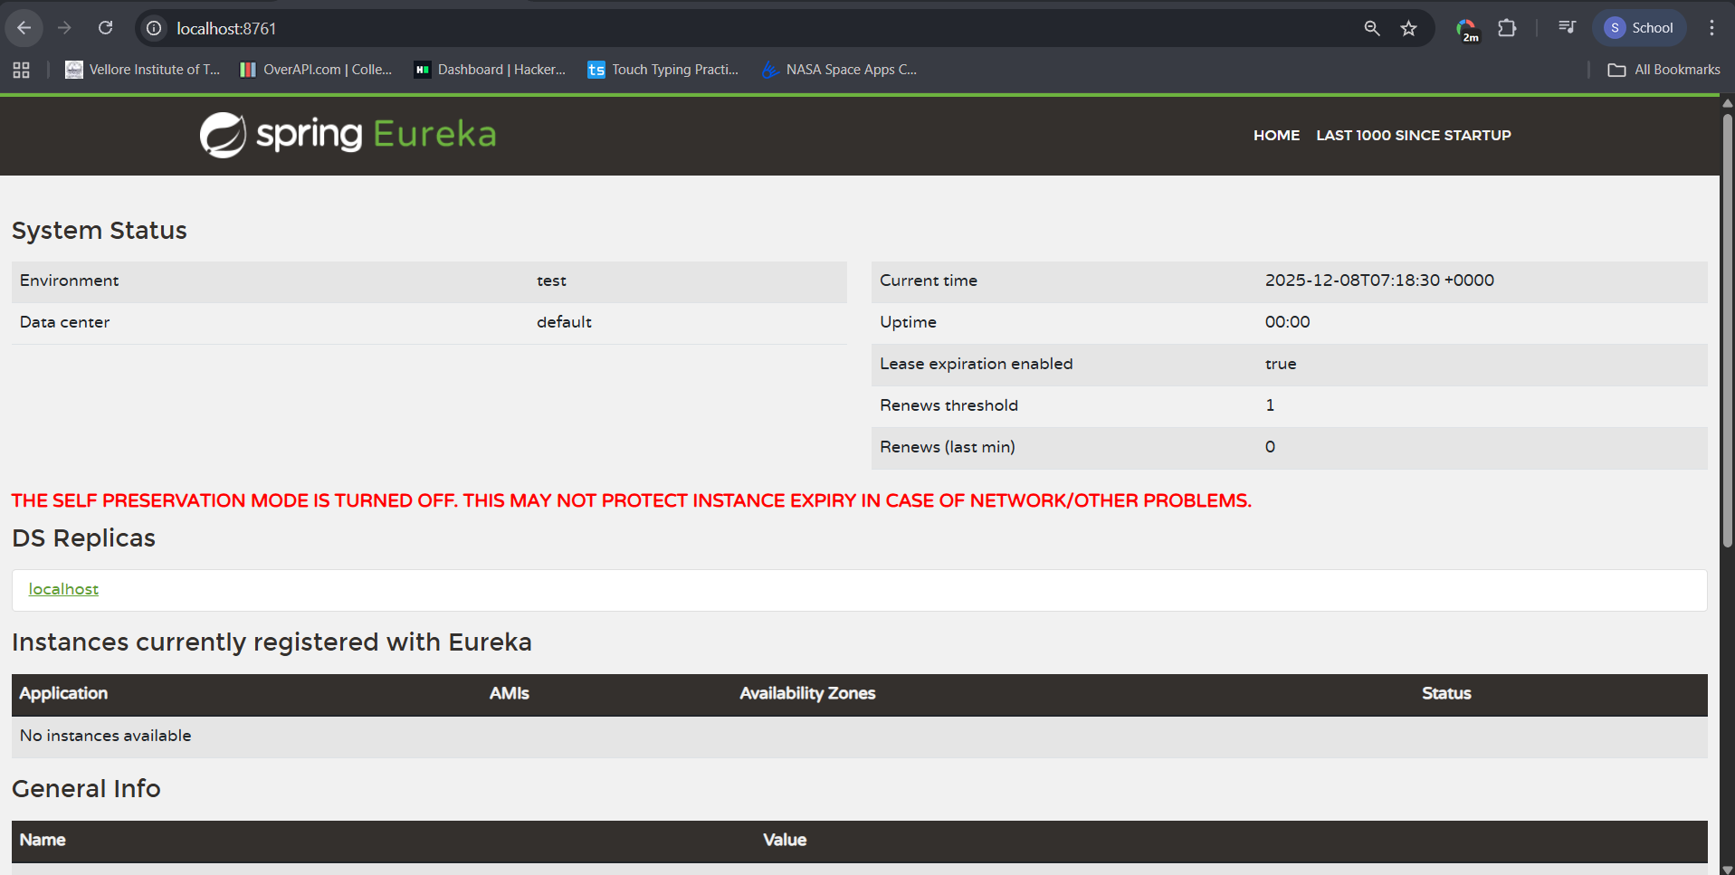

ADDING FLIGHT SERVICE AND TESTING
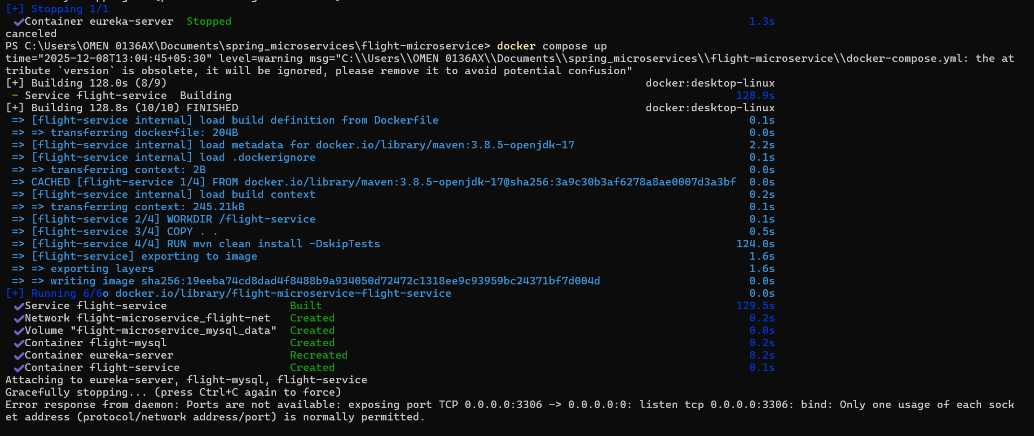
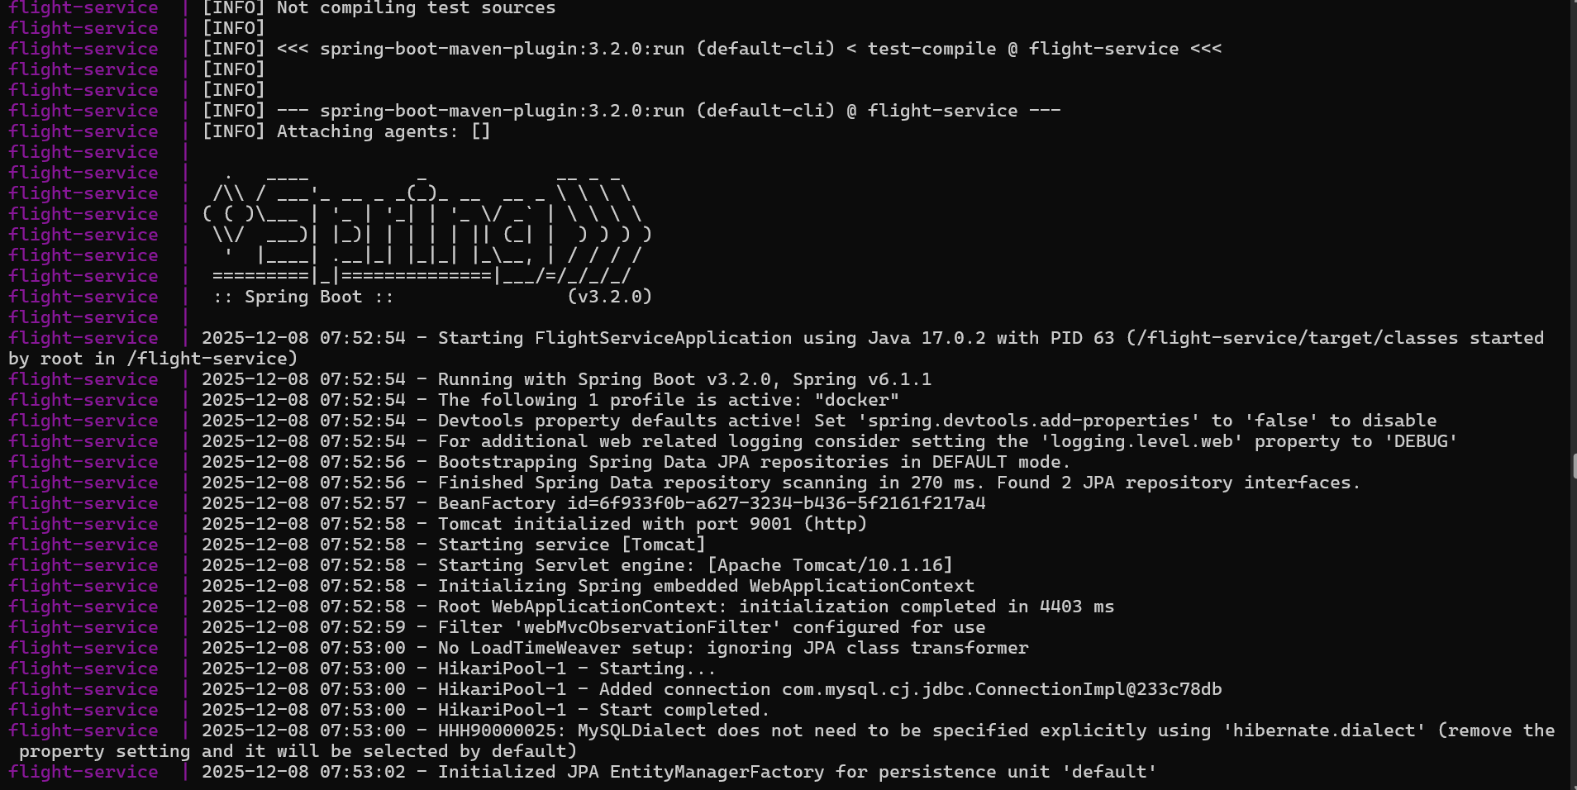
FLIGHT SERVICE REGISTERED IN EUREKA AND WORKING
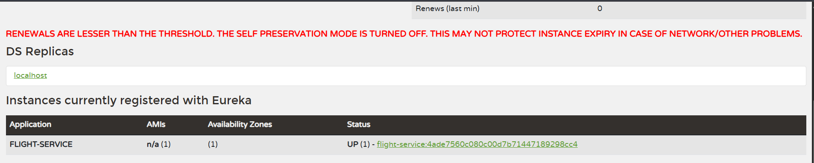

DOCKERIZED BOOKING SERVICE
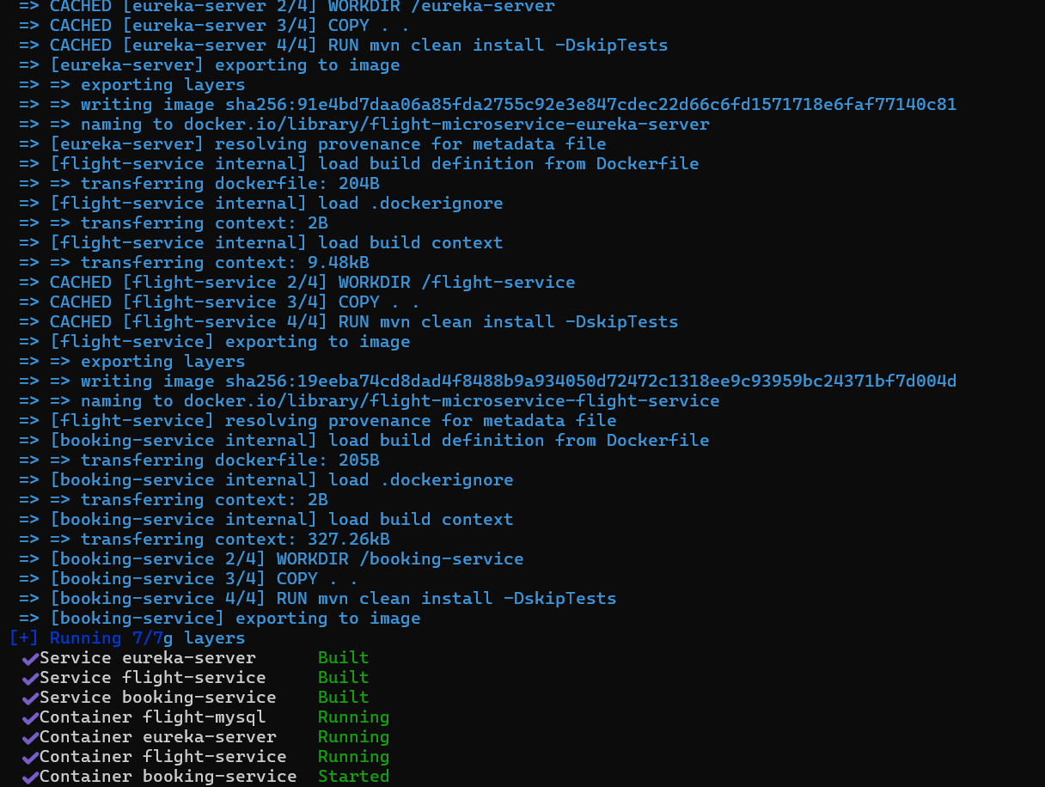

BOOKING SERVICE DOCKERIZED AND REGISTERED IN EUREKA
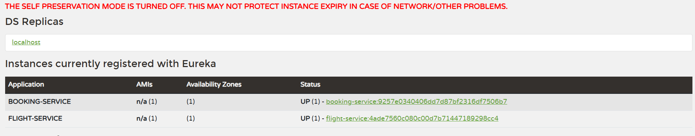

JWT token and Spring Auth Microservice docker output
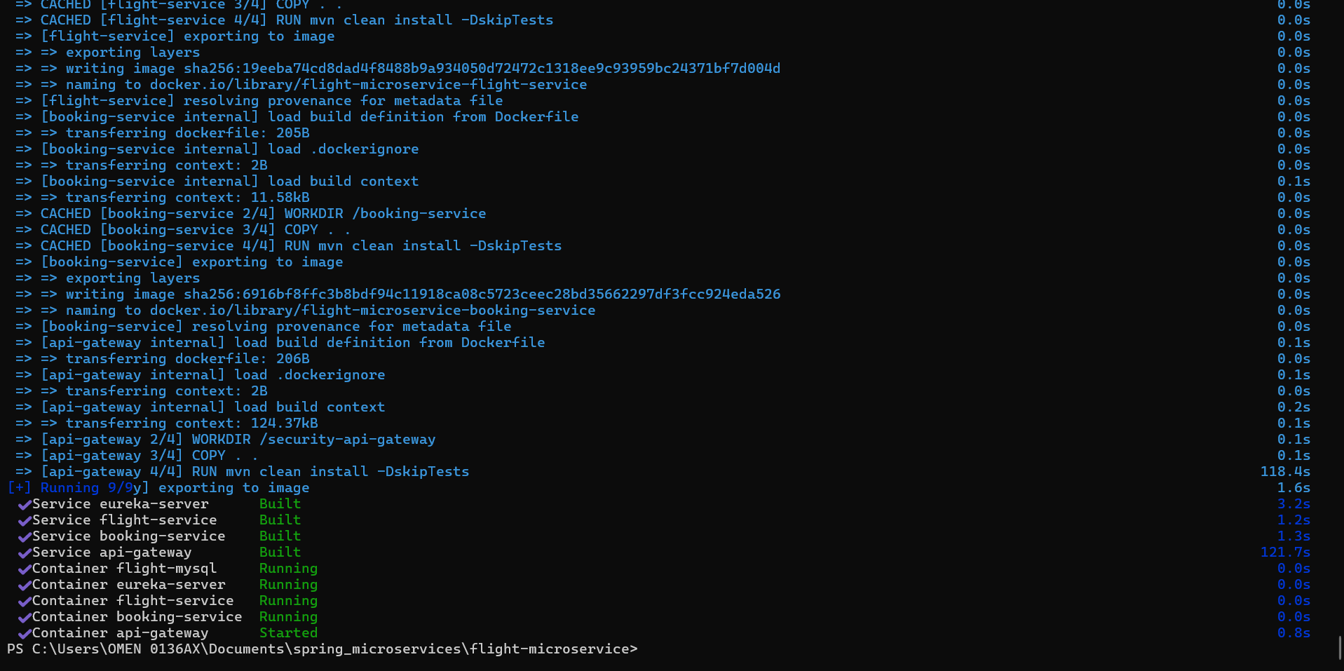
EUREKA DISCOVERY SERVER LISTS API GATEWAY
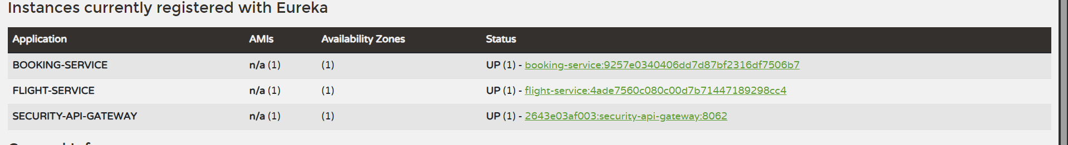

RUNNING EVERYTHING NOW
