MODULE 2 DBMS
10 Marks
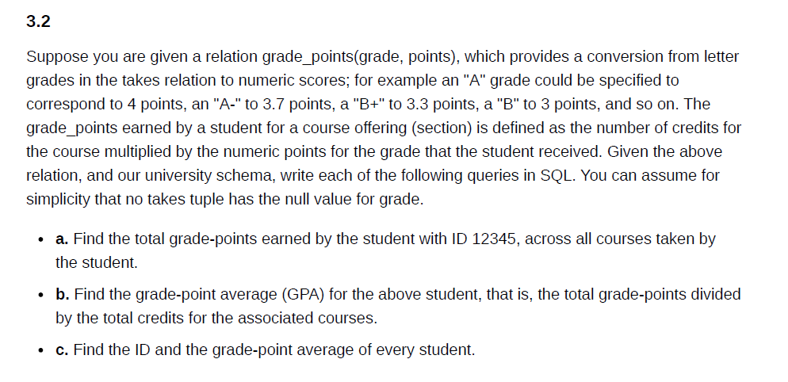
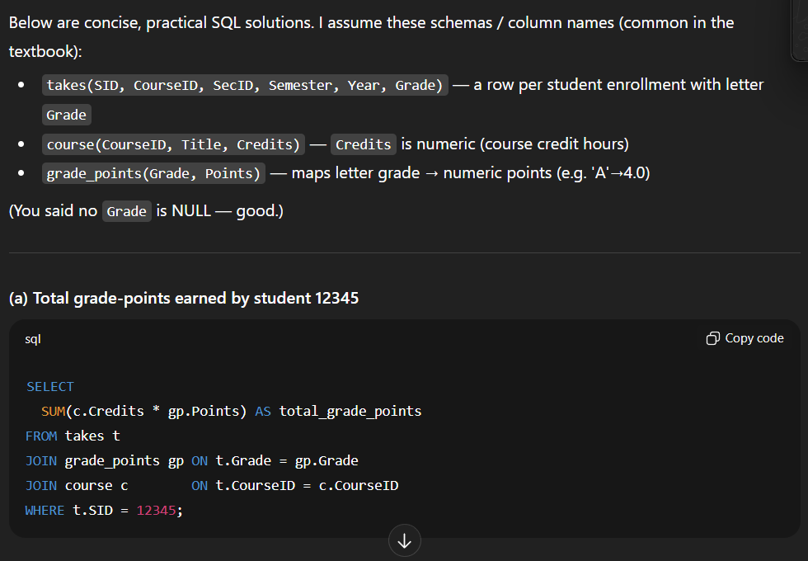
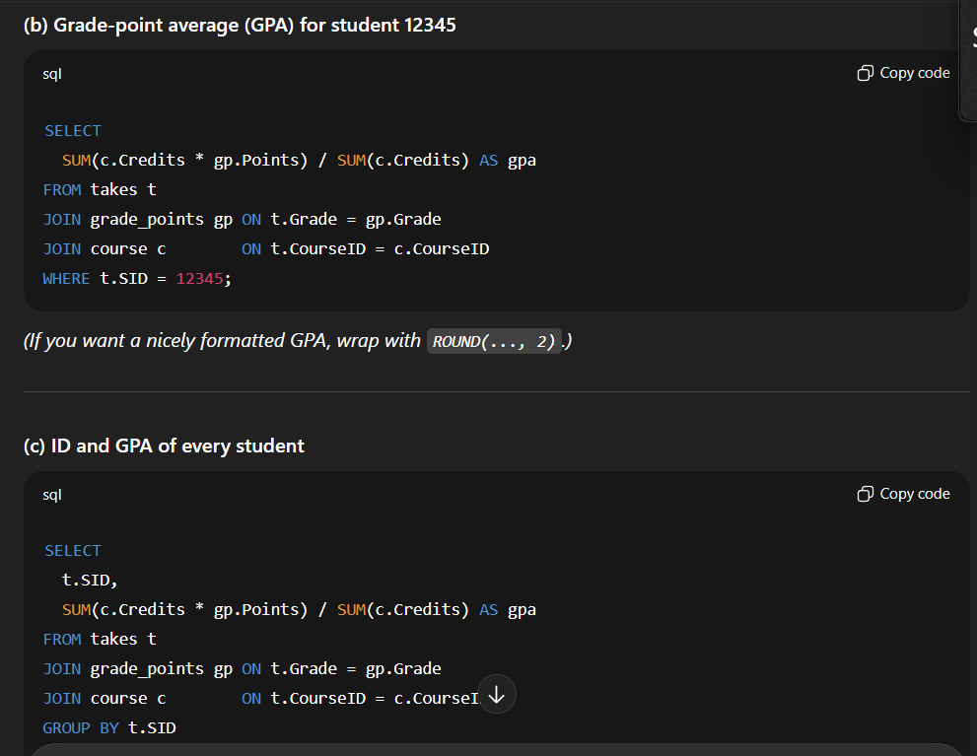
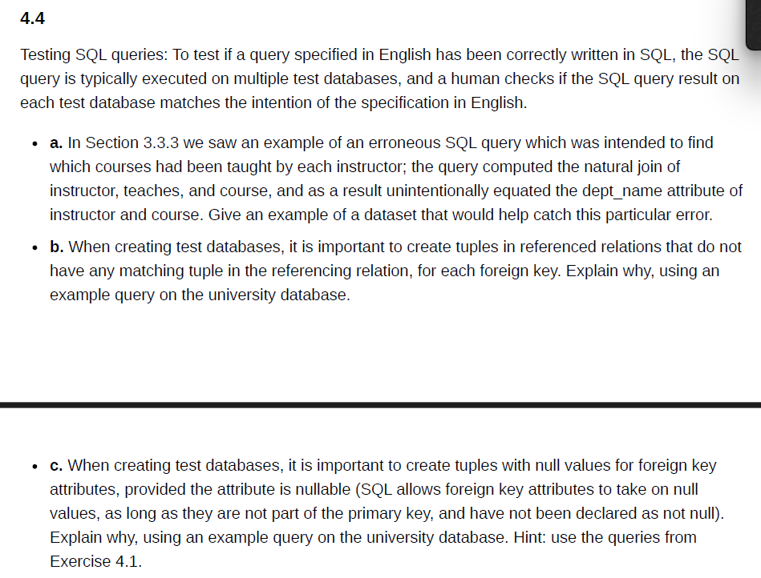
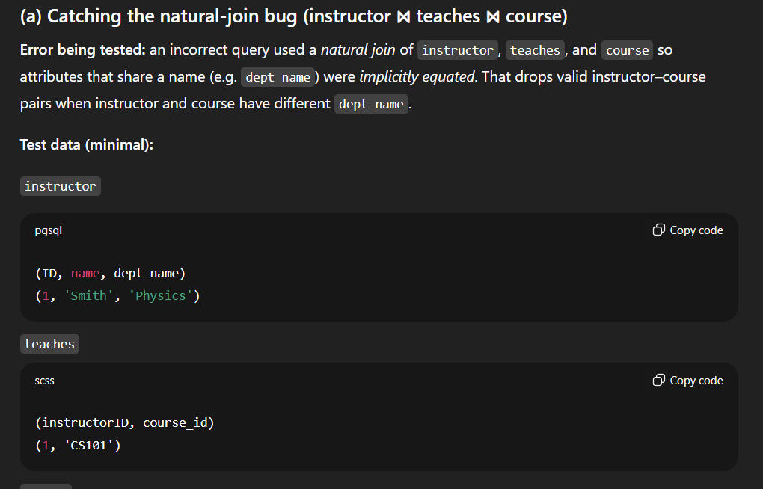
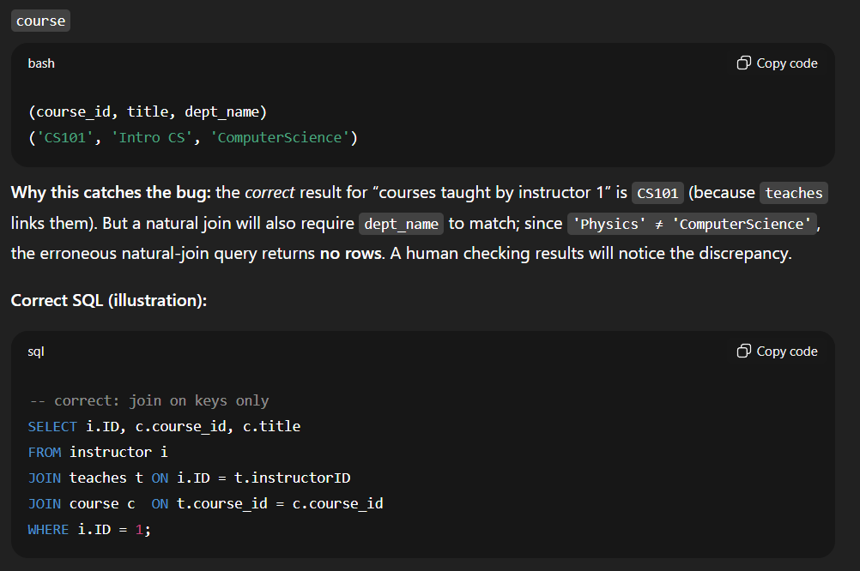
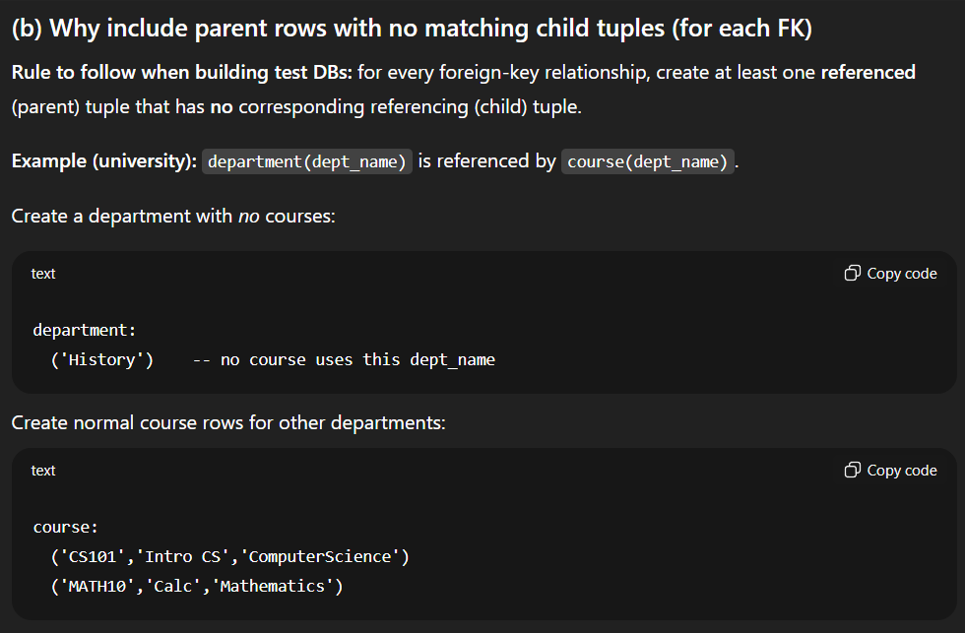
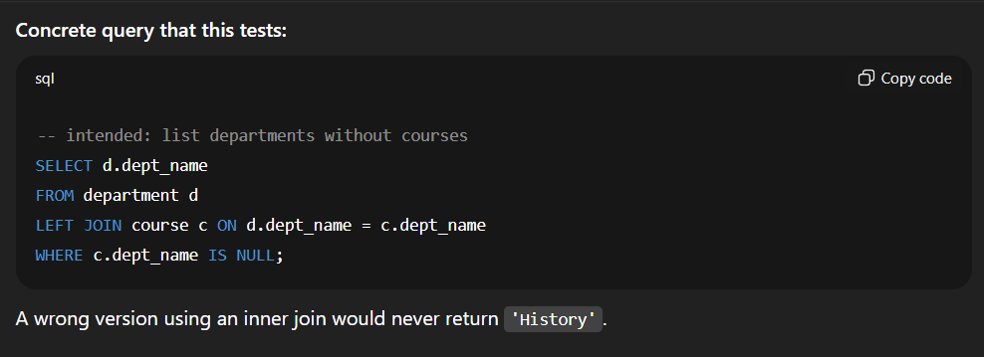
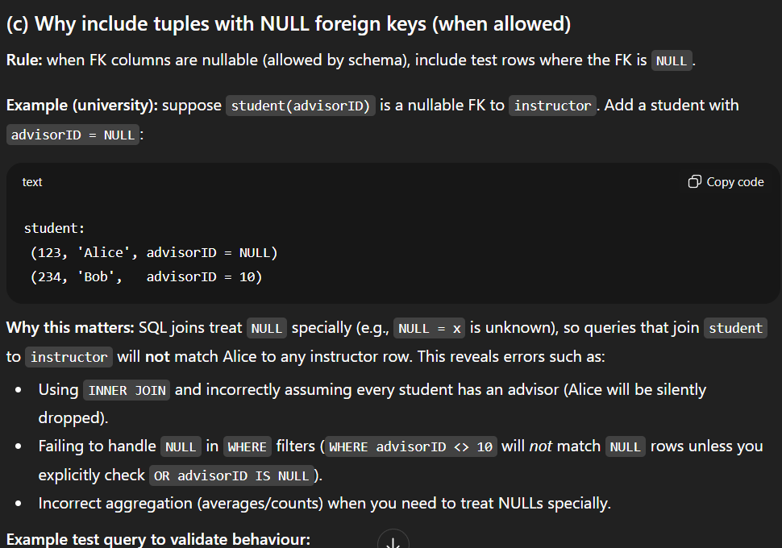
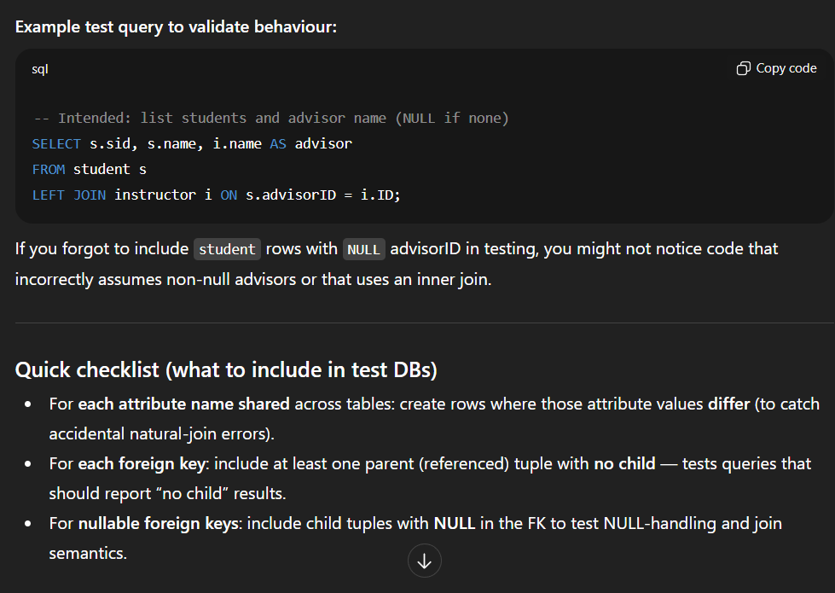
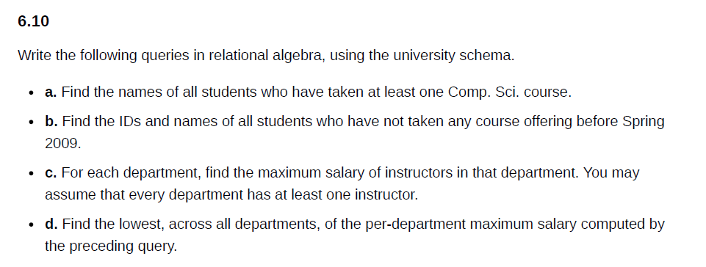
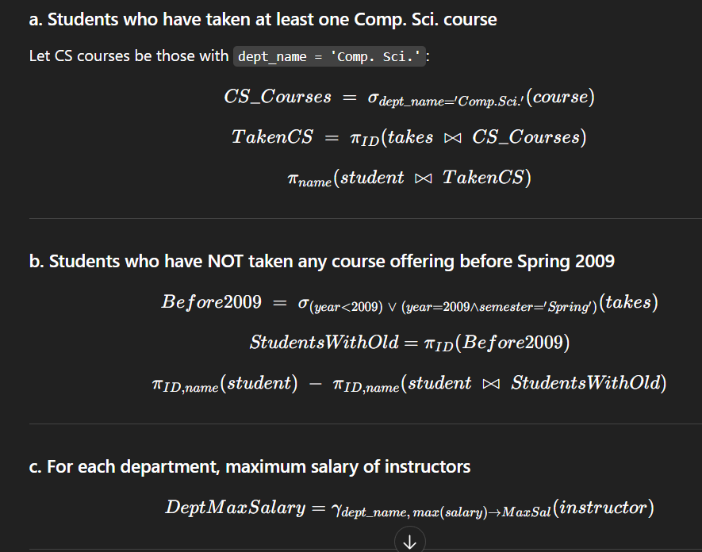

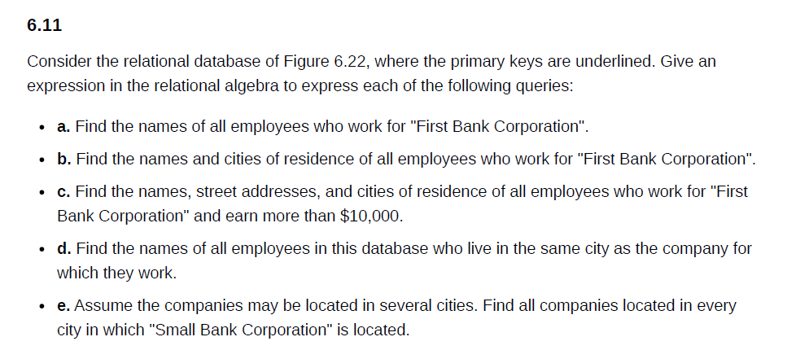
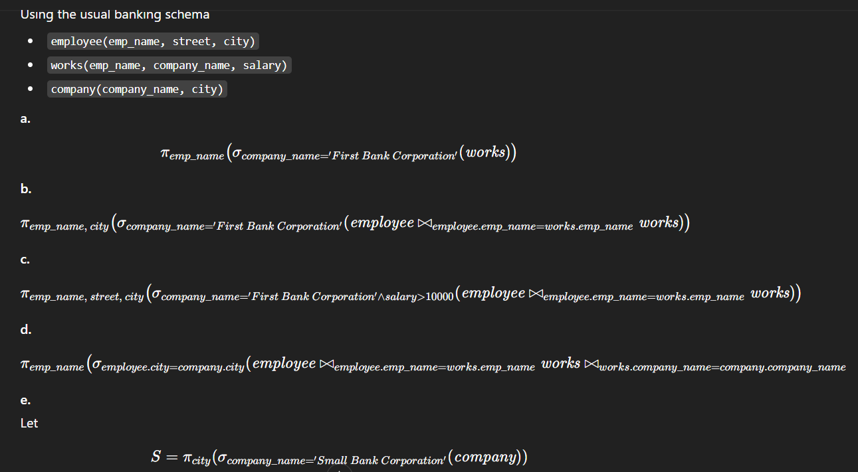
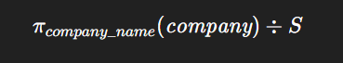
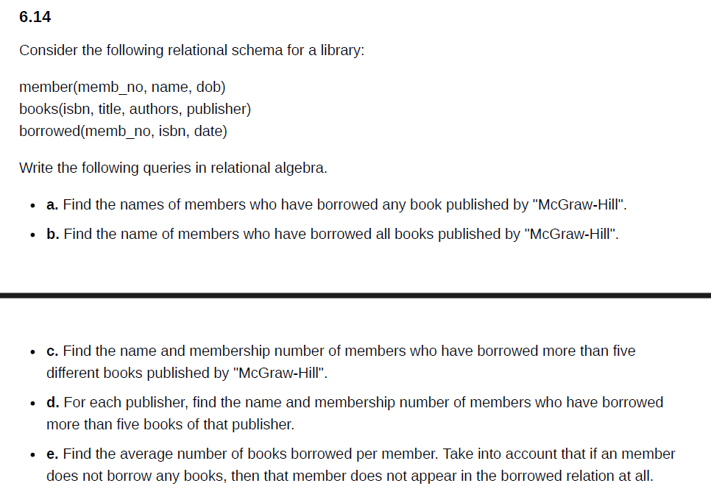
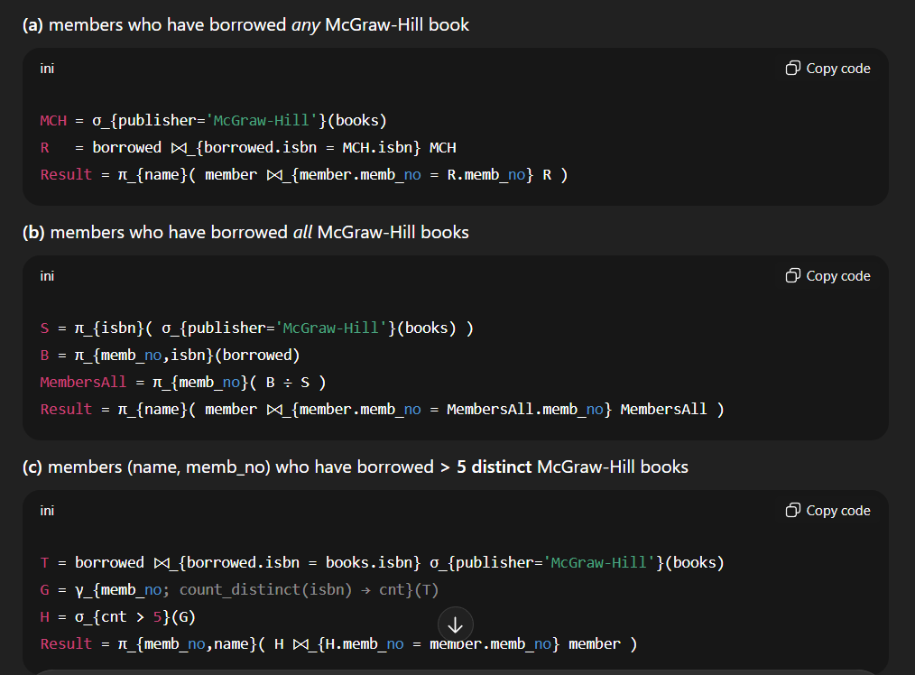
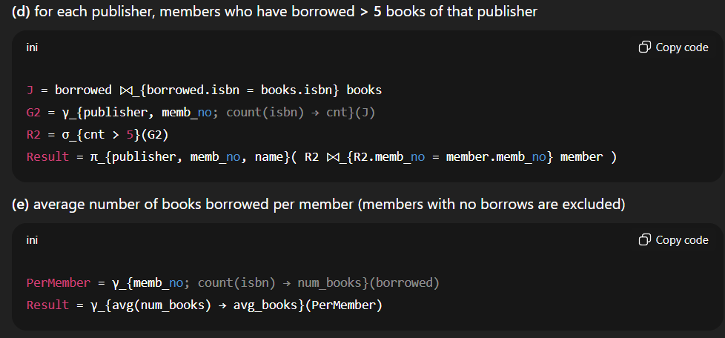
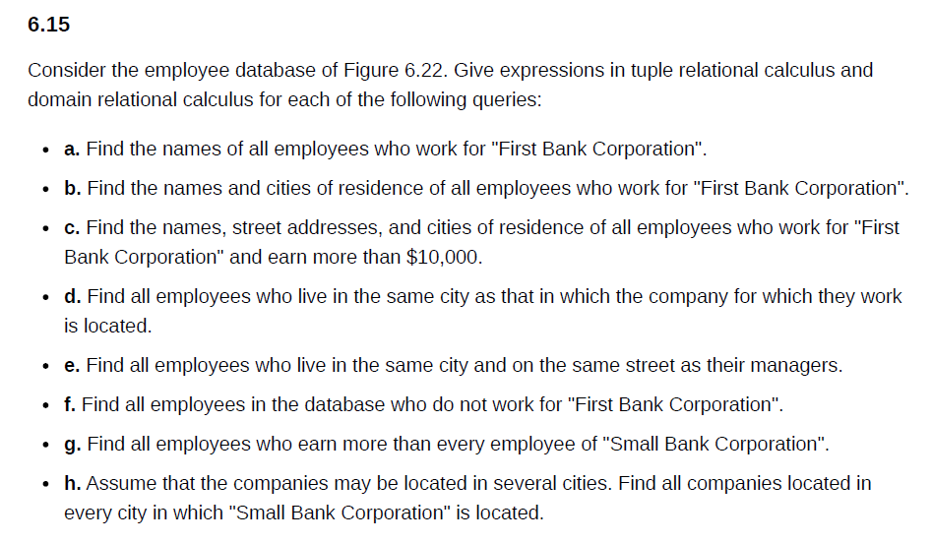
Below are concise answers: for each query (a → h) I give one tuple relational-calculus (TRC) expression and one domain relational-calculus (DRC) expression.
Schema assumed (usual Figure 6.22):
- Employee(Name, Street, City)
- Works(EmpName, CompanyName, Salary)
- Company(CompanyName, City)
- Manages(EmpName, ManagerName) (used in e)
Use Employee(e) to mean tuple variable e ranges over Employee, etc.

(a) Names of all employees who work for "First Bank Corporation"
TRC
{ e.Name | Employee(e) ∧ ∃w (Works(w) ∧ w.EmpName = e.Name ∧ w.CompanyName = 'First Bank Corporation') }
DRC
{ <n> | ∃s,ct (Employee(n,s,ct) ∧ ∃c,sal (Works(n,'First Bank Corporation',sal))) }

(b) Names and cities of employees who work for "First Bank Corporation"
TRC
{ <e.Name, e.City> | Employee(e) ∧ ∃w (Works(w) ∧ w.EmpName = e.Name ∧ w.CompanyName = 'First Bank Corporation') }
DRC
{ <n, city> | ∃street (Employee(n,street,city) ∧ ∃c,sal (Works(n,'First Bank Corporation',sal))) }

(c) Names, street addresses, and cities of employees who work for "First Bank Corporation" and earn > 10000
TRC
{ <e.Name, e.Street, e.City> |
Employee(e) ∧ ∃w (Works(w) ∧ w.EmpName = e.Name ∧ w.CompanyName = 'First Bank Corporation' ∧ w.Salary > 10000)
}
DRC
{ <n, s, city> |
Employee(n,s,city) ∧ ∃c,sal (Works(n,'First Bank Corporation',sal) ∧ sal > 10000)
}

(d) Names of employees who live in the same city as the company for which they work
TRC
{ e.Name |
Employee(e) ∧ ∃w (Works(w) ∧ w.EmpName = e.Name ∧ ∃co (Company(co) ∧ co.CompanyName = w.CompanyName ∧ co.City = e.City))
}
DRC
{ <n> |
∃s,city (Employee(n,s,city) ∧ ∃comp,sal (Works(n,comp,sal) ∧ ∃cname (Company(comp, city))))
}
(second line uses Company(comp,city) with same city variable)

(e) Employees who live in the same city and on the same street as their managers
TRC
{ e.Name |
Employee(e) ∧ ∃m (Manages(m) ∧ m.EmpName = e.Name ∧
∃mgr (Employee(mgr) ∧ mgr.Name = m.ManagerName ∧ mgr.City = e.City ∧ mgr.Street = e.Street))
}
DRC
{ <n> |
∃s,city (Employee(n,s,city) ∧ ∃mgr (Manages(n,mgr) ∧ ∃s2,city2 (Employee(mgr,s2,city2) ∧ s2 = s ∧ city2 = city)))
}

(f) All employees who do not work for "First Bank Corporation"
TRC
{ e.Name |
Employee(e) ∧ ¬∃w (Works(w) ∧ w.EmpName = e.Name ∧ w.CompanyName = 'First Bank Corporation')
}
DRC
{ <n> |
∃s,city (Employee(n,s,city) ∧ ¬∃sal (Works(n,'First Bank Corporation',sal)))
}

(g) Employees who earn more than every employee of "Small Bank Corporation"
TRC
{ e.Name |
∃w (Works(w) ∧ w.EmpName = e.Name ∧
∀w2 (Works(w2) ∧ w2.CompanyName = 'Small Bank Corporation' → w.Salary > w2.Salary))
}
DRC
{ <n> |
∃s,city,sal (Employee(n,s,city) ∧ Works(n,co,sal) ∧
∀n2,s2,c2,sal2 (Works(n2,'Small Bank Corporation',sal2) → sal > sal2) )
}

(h) All companies located in every city in which "Small Bank Corporation" is located
TRC
{ c.CompanyName |
Company(c) ∧ ∀x (Company(x) ∧ x.CompanyName = 'Small Bank Corporation' →
∃y (Company(y) ∧ y.CompanyName = c.CompanyName ∧ y.City = x.City))
}
DRC (using division-style formulation; let S be cities of Small Bank)
Let S = { city | ∃_ (Company('Small Bank Corporation', city)) }.

{ <comp> |
Company(comp, _) ∧ ∀city ( (∃_ (Company('Small Bank Corporation', city))) → ∃_ (Company(comp, city)) )
}
(Equivalently expressible with relational-division: π_company(Company) ÷ π_city(σ_company='Small Bank Corporation'(Company)).)

If you want any of these written with different attribute names or adjusted to the exact notation you prefer, I can substitute quickly.
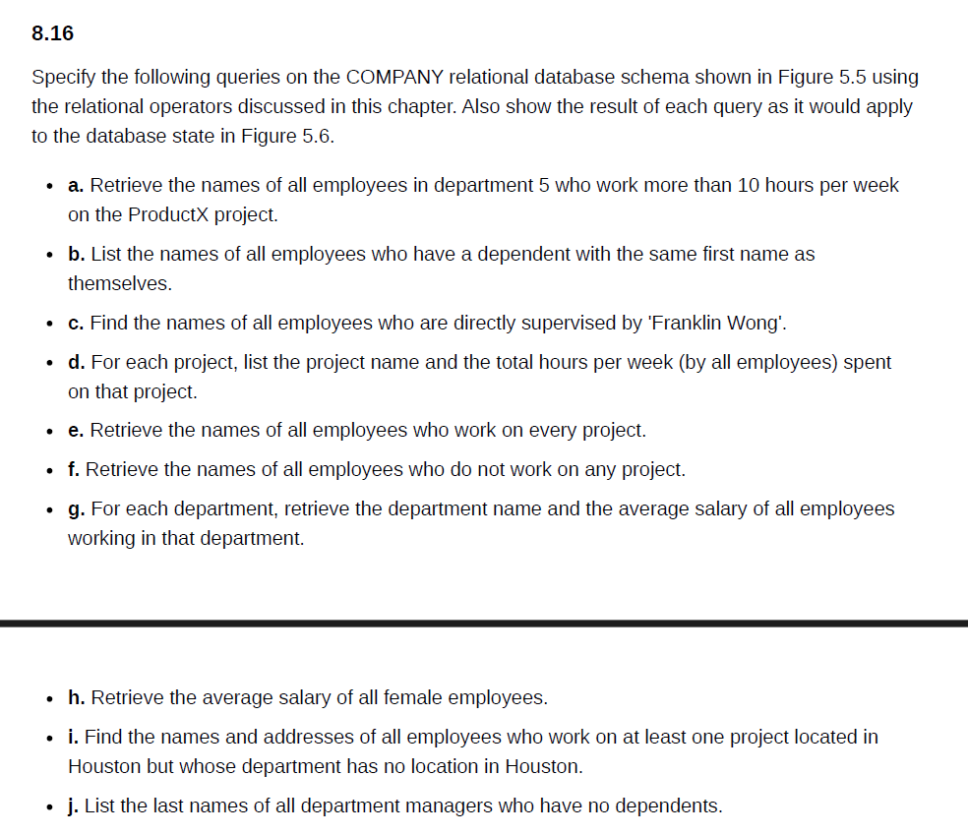
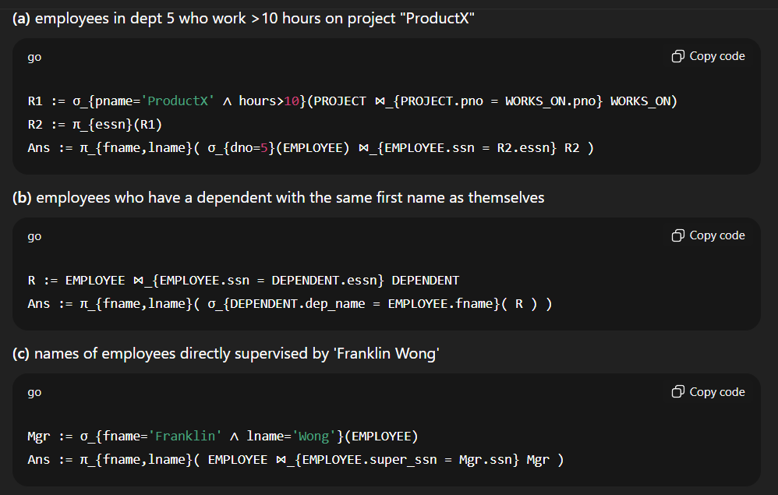
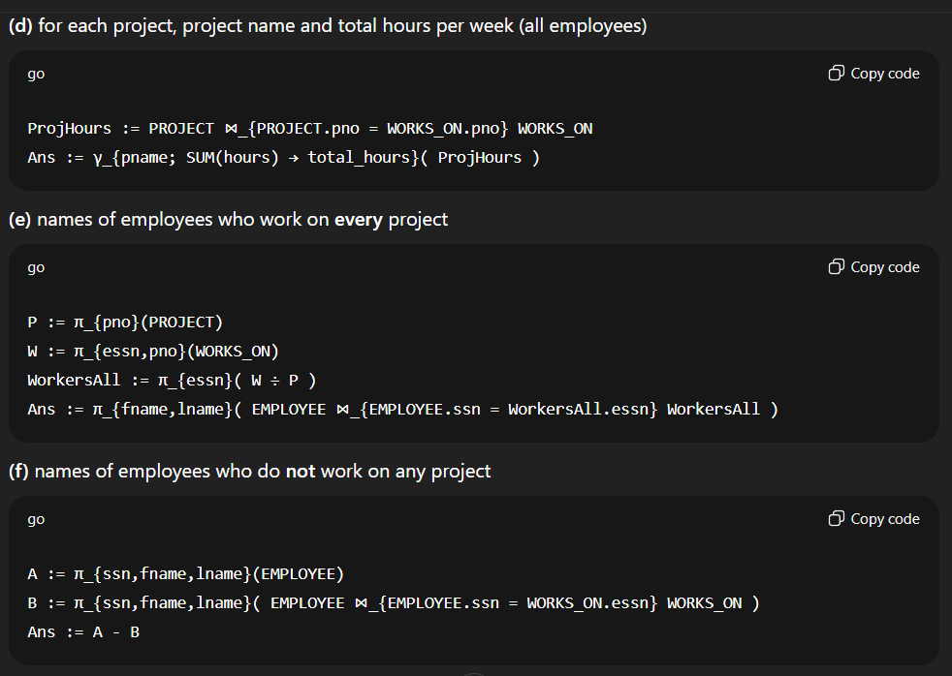
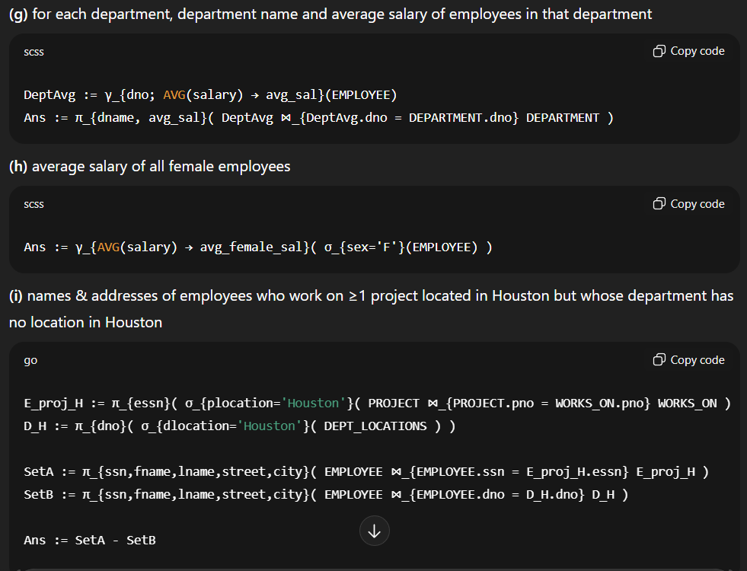
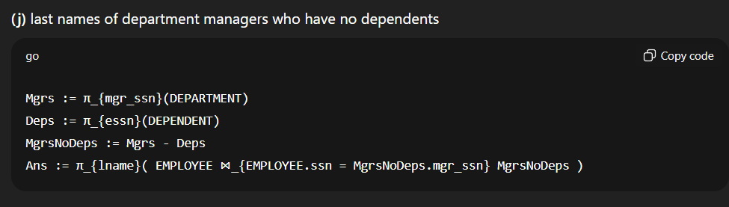
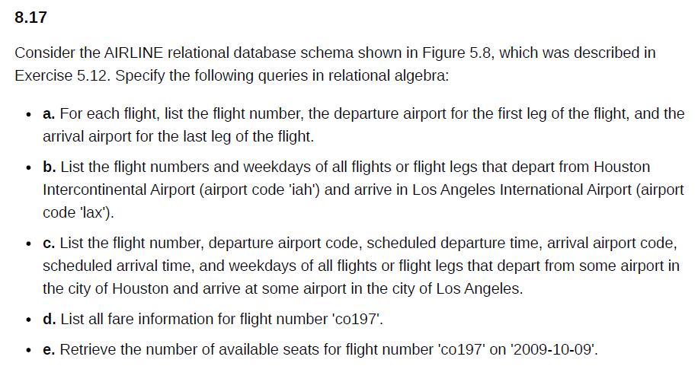
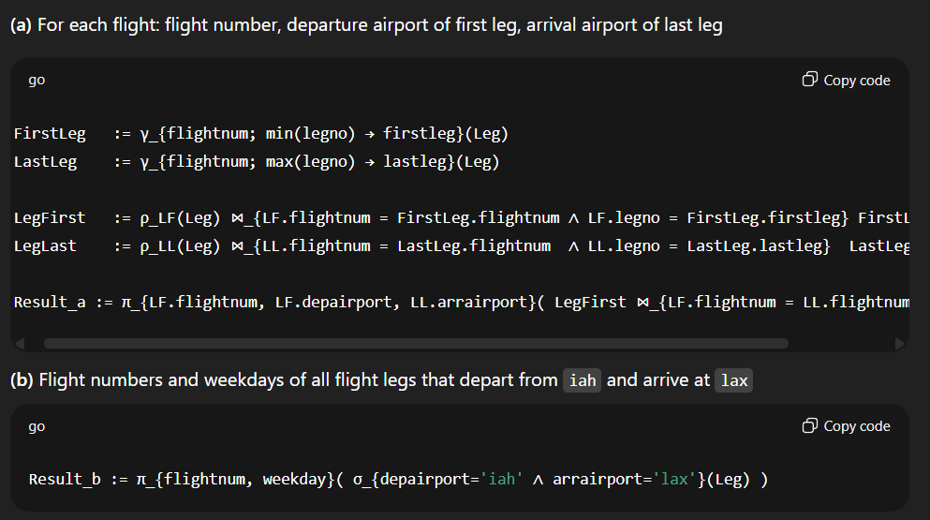
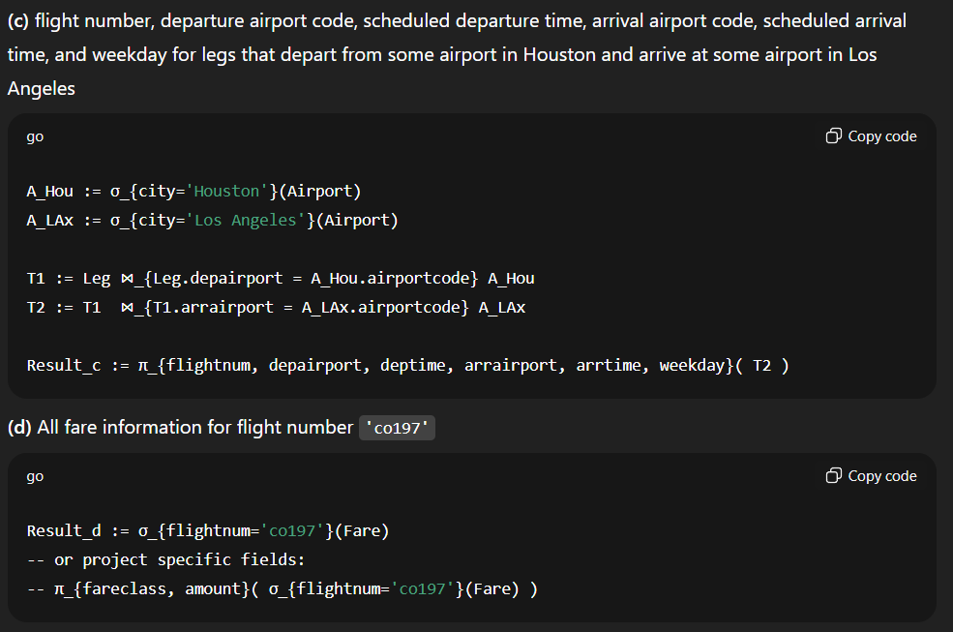
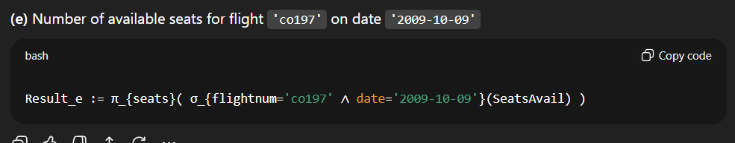
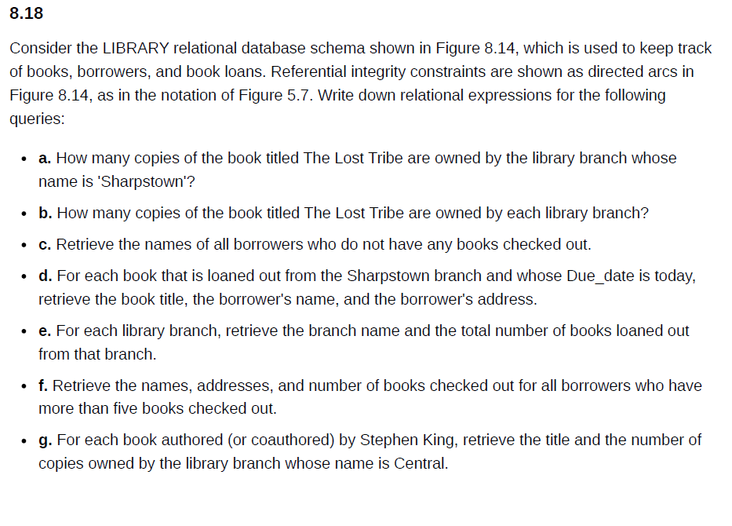
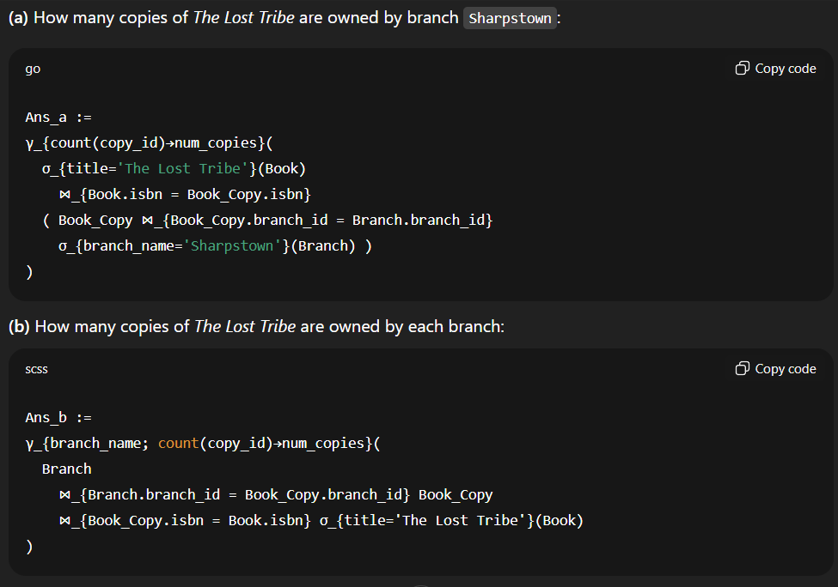
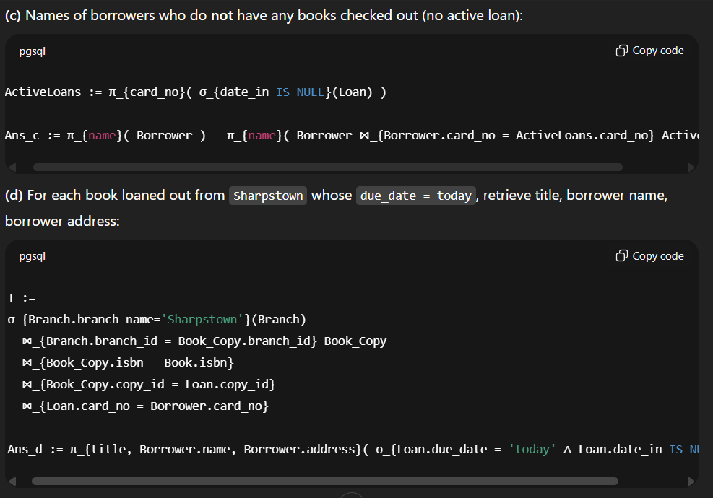
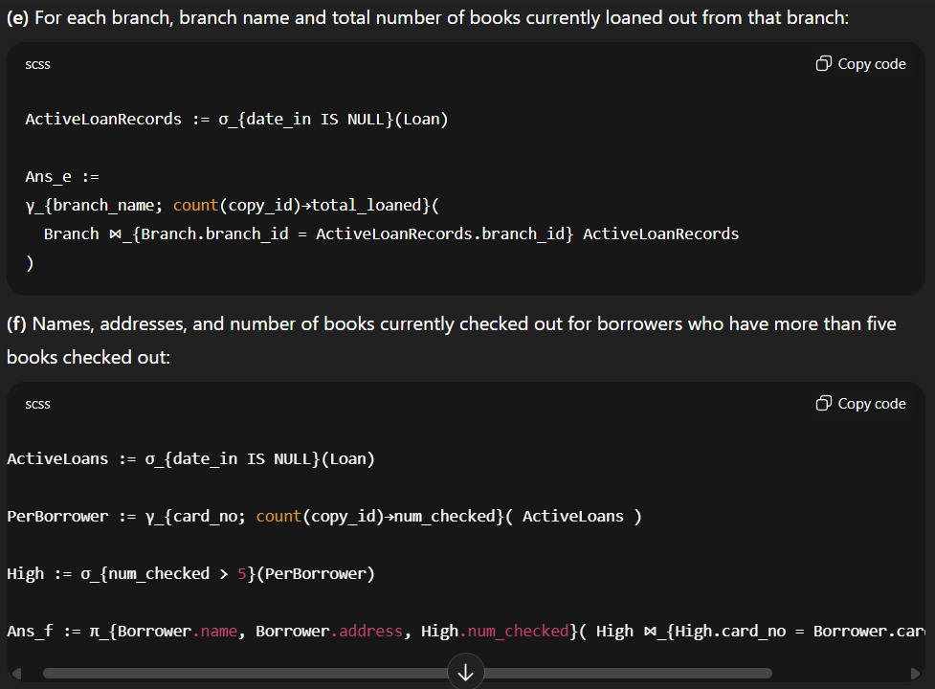
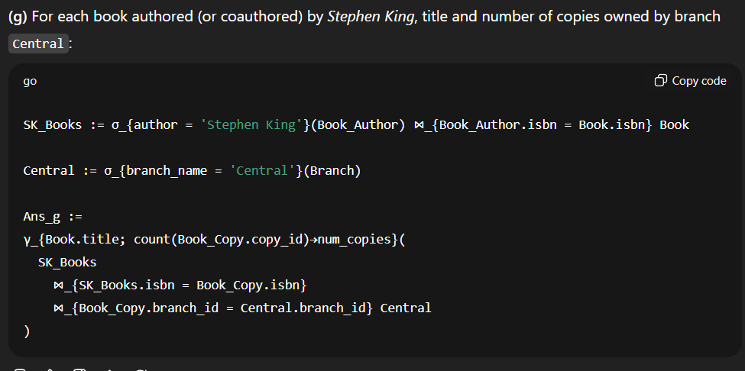
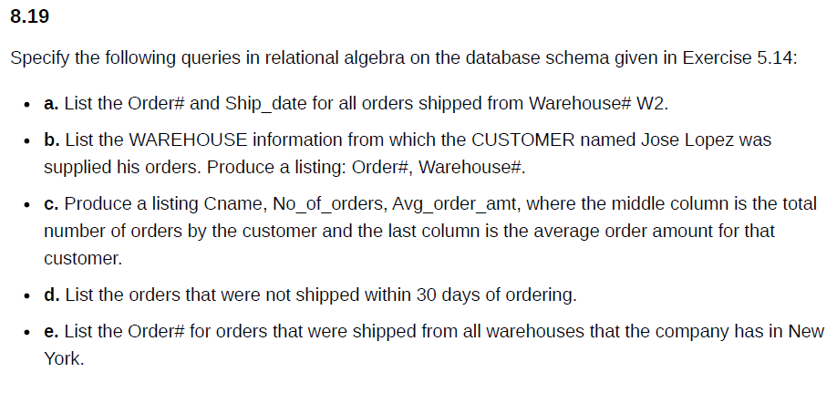
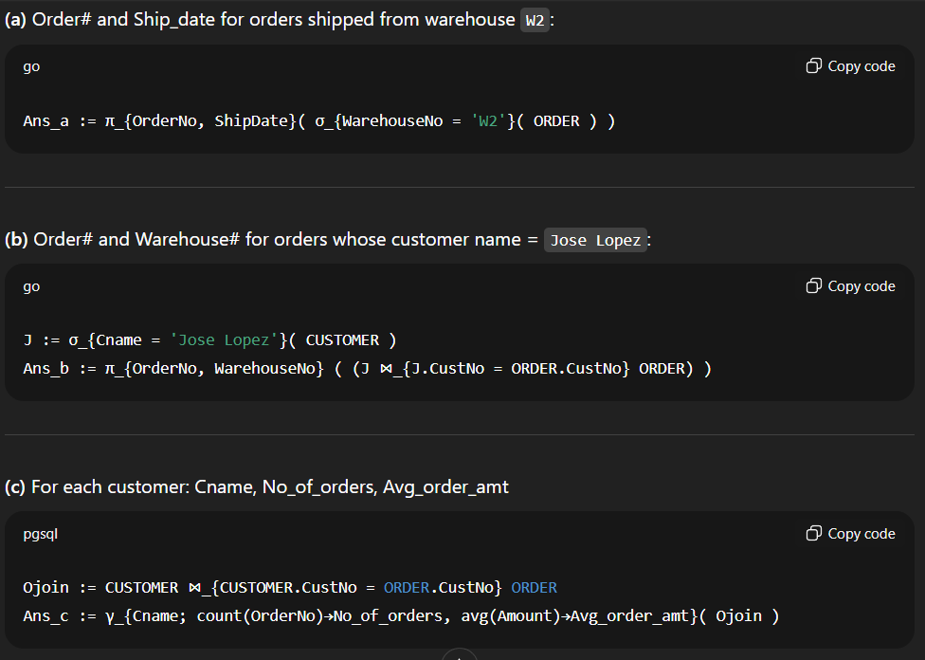
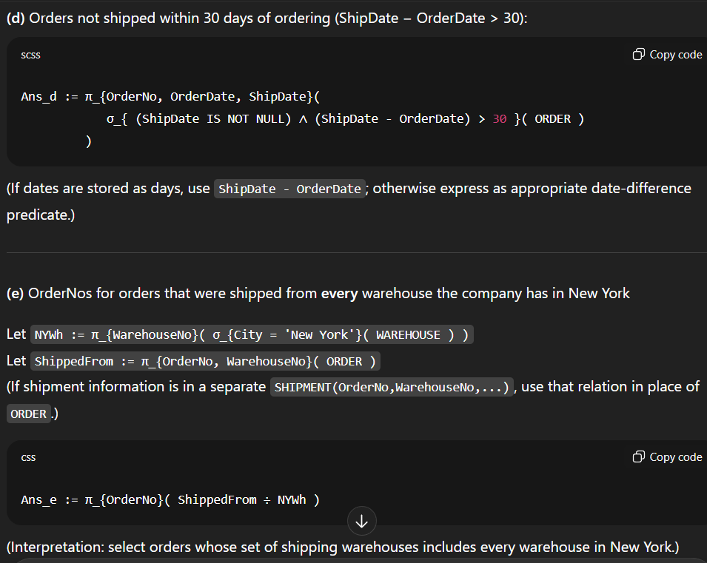
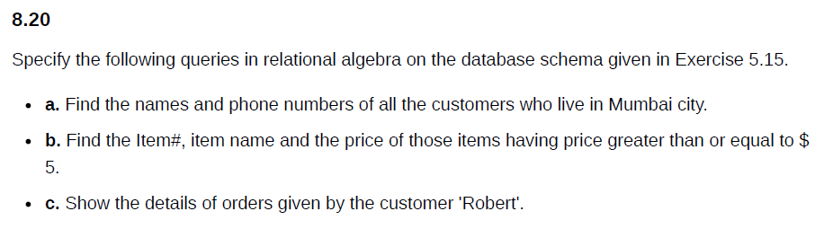
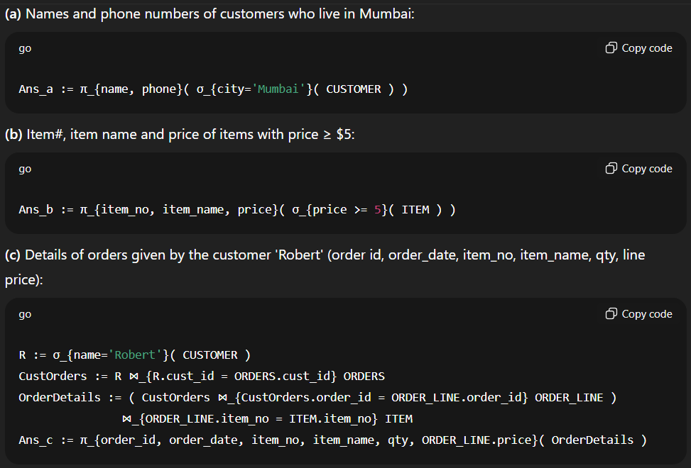
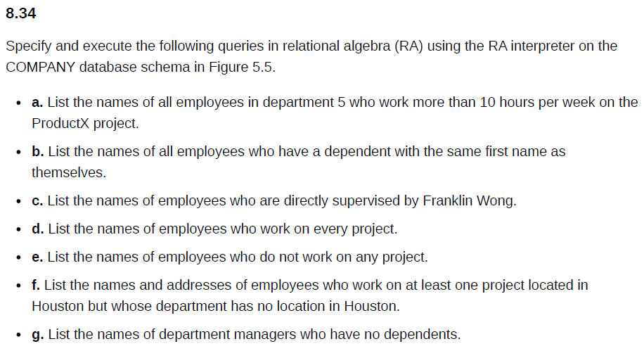
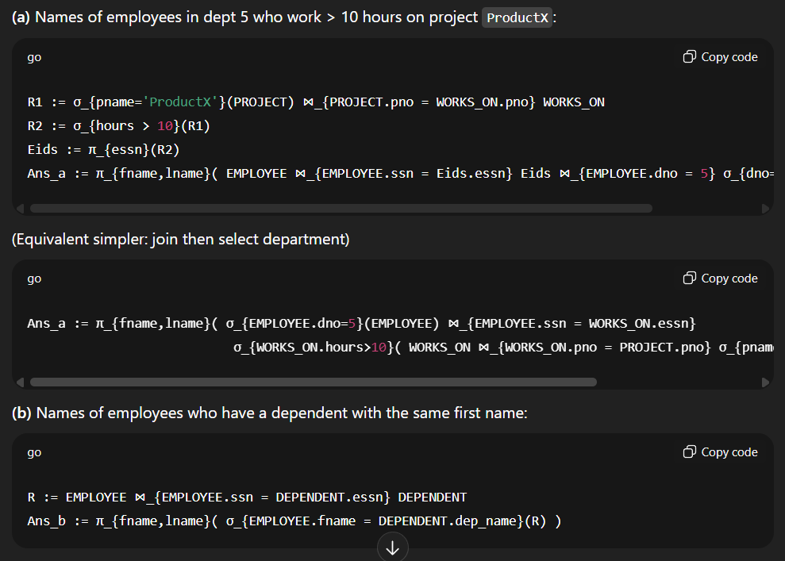
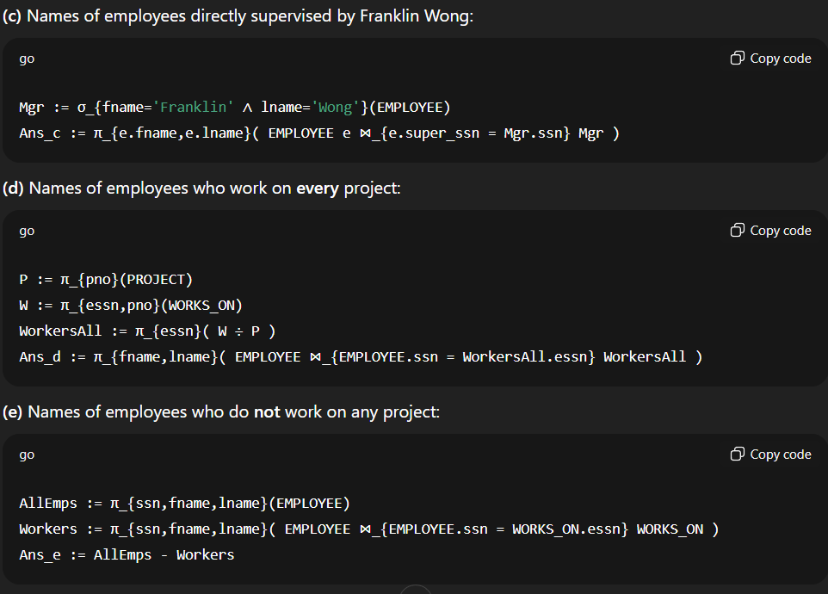
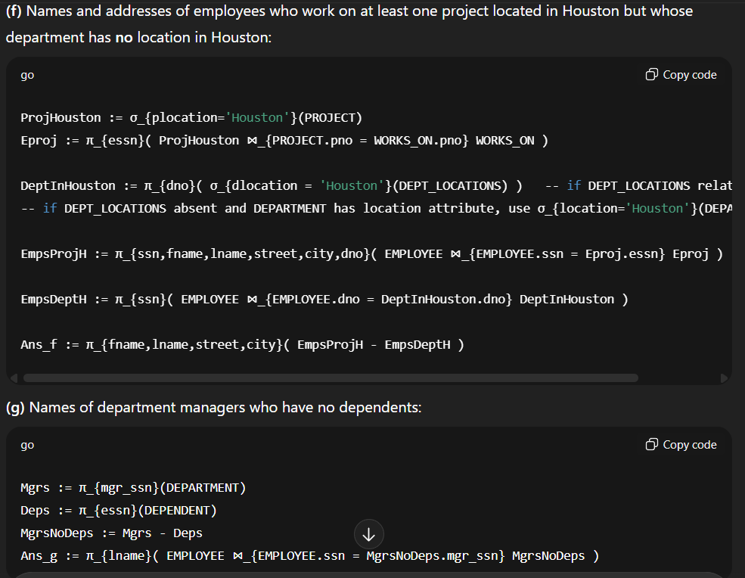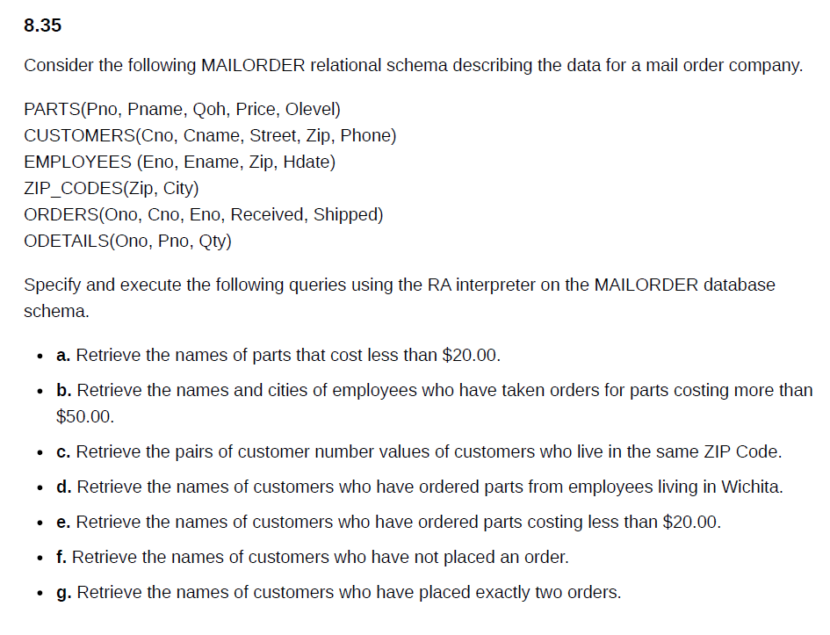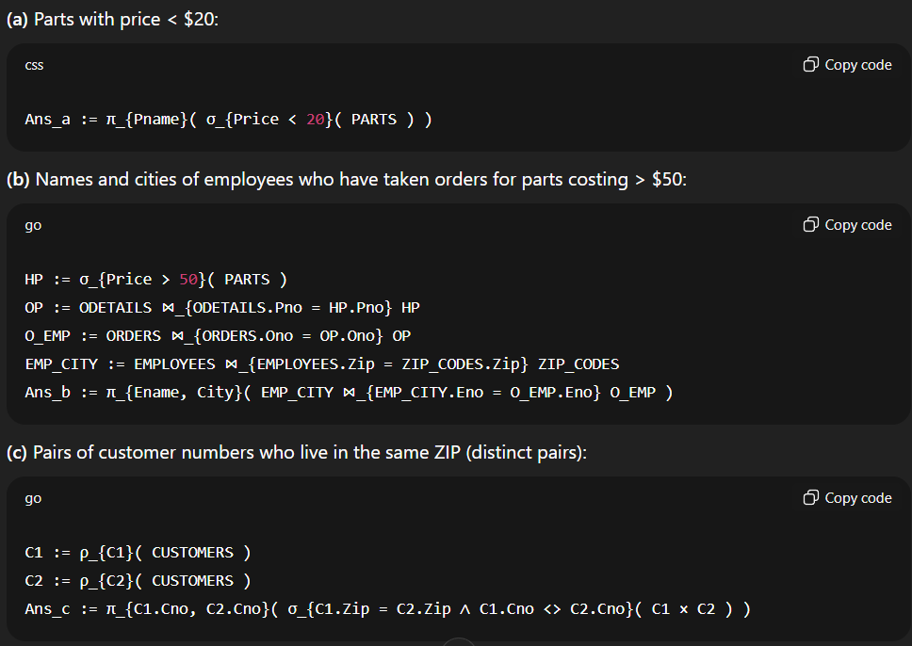
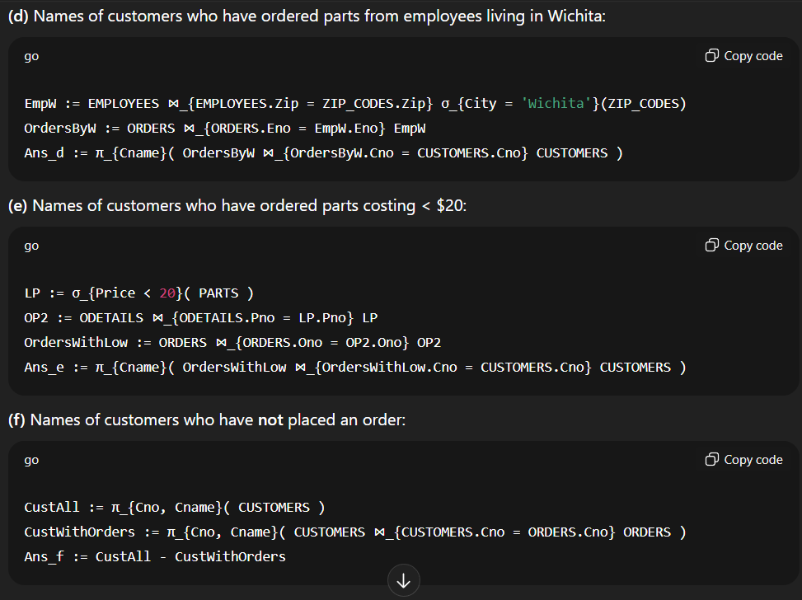
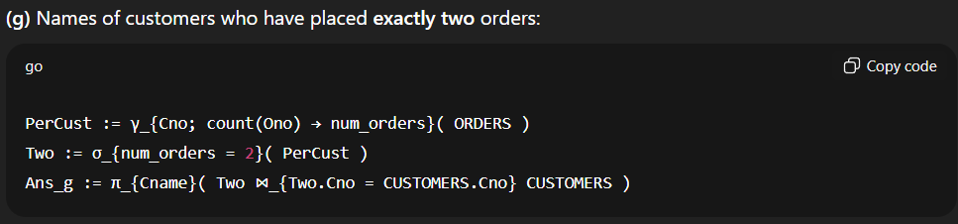
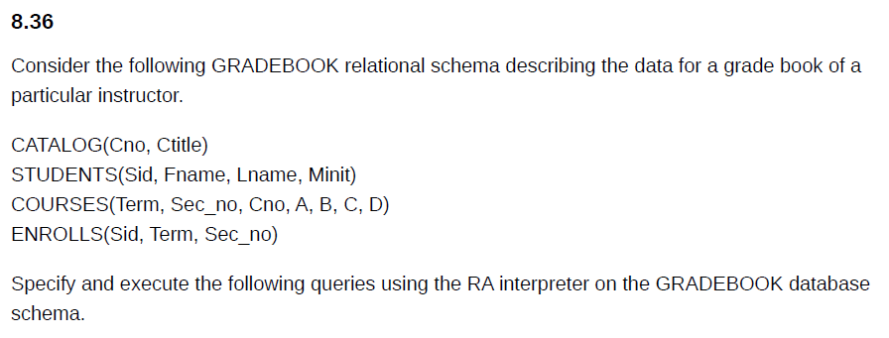
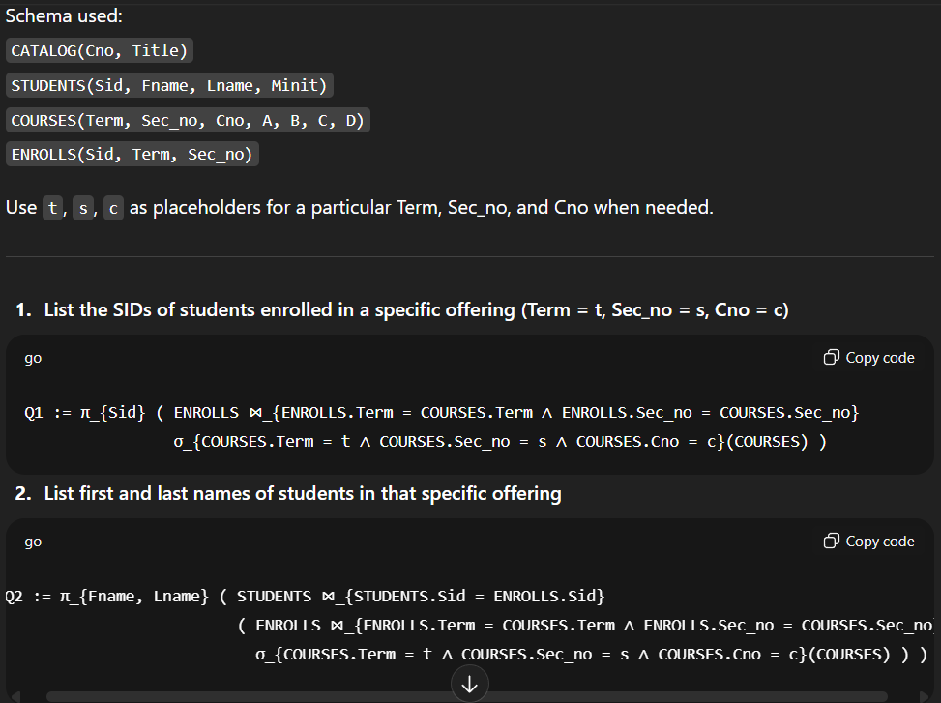
Q3 := γ_{Term, Sec_no, Cno; count(Sid) → NumStudents} ( ENROLLS )
-- or join with COURSES first if you want only valid offerings:
-- Q3 := γ_{COURSES.Term, COURSES.Sec_no, COURSES.Cno; count(ENROLLS.Sid)→NumStudents} ( COURSES ⋈ ENROLLS )
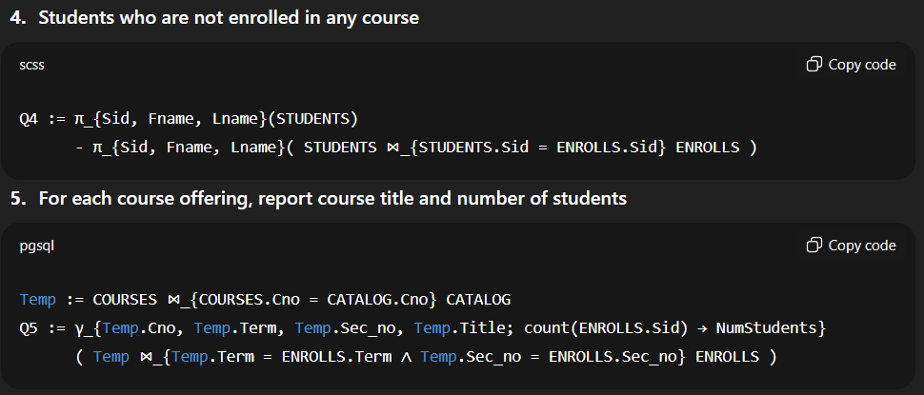
Q6 := π_{Sid, Term, Sec_no} ( ENROLLS )
-- or with course code:
Q6b := π_{Sid, COURSES.Cno, ENROLLS.Term, ENROLLS.Sec_no} ( ENROLLS ⋈_{ENROLLS.Term = COURSES.Term ∧ ENROLLS.Sec_no = COURSES.Sec_no} COURSES )
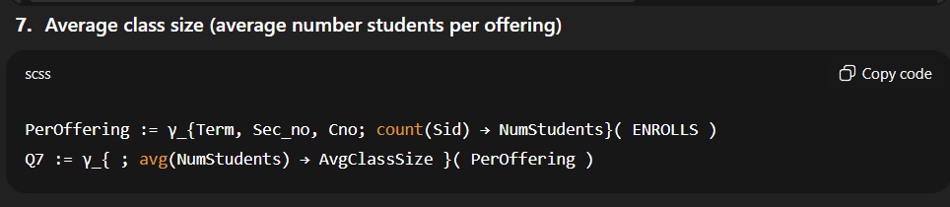
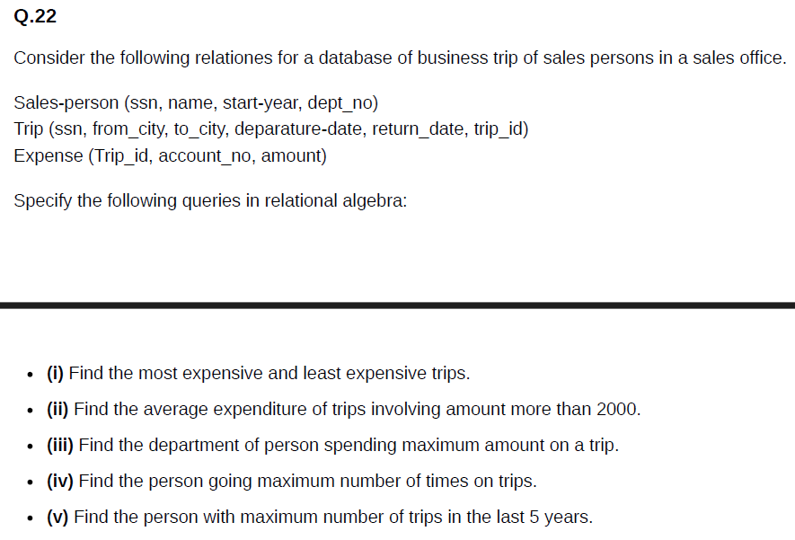
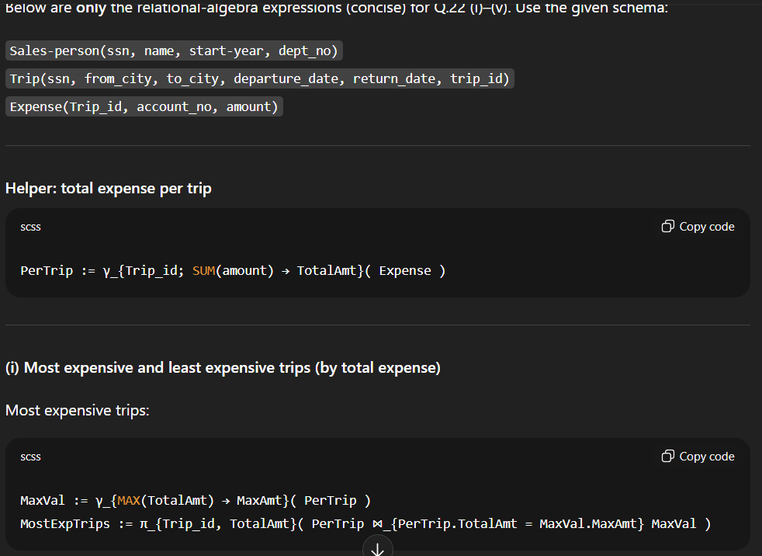
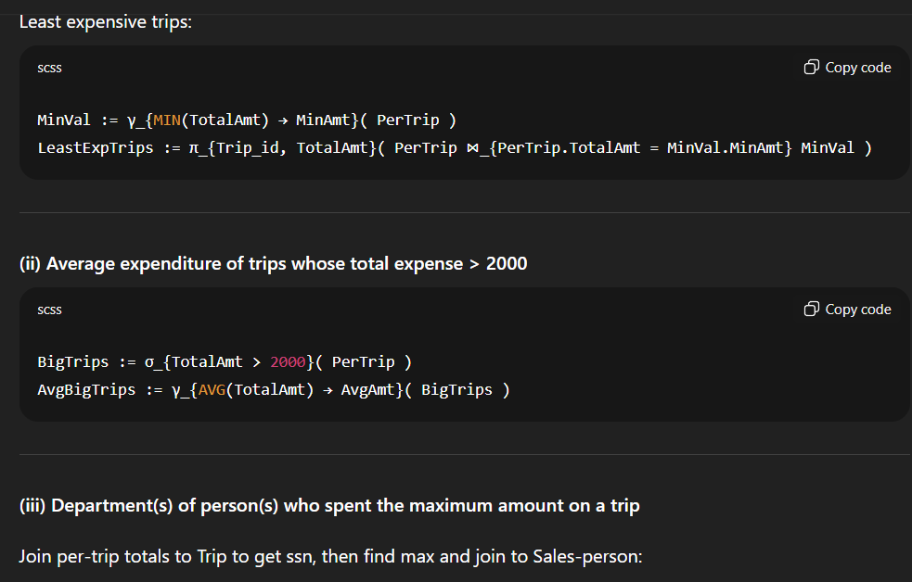
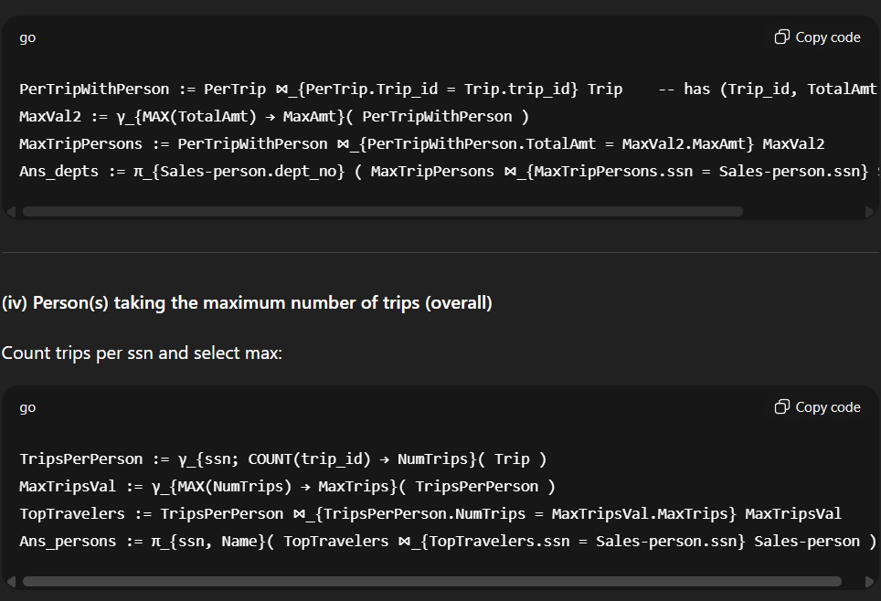

RecentTrips := σ_{departure_date >= (TODAY - INTERVAL '5' YEAR)}( Trip ) -- replace predicate with your DB date test
RecentCount := γ_{ssn; COUNT(trip_id) → NumRecent}( RecentTrips )
MaxRecent := γ_{MAX(NumRecent) → MaxNumRecent}( RecentCount )
TopRecentPersons := RecentCount ⋈_{RecentCount.NumRecent = MaxRecent.MaxNumRecent} MaxRecent
Ans_recent := π_{ssn, name}( TopRecentPersons ⋈_{TopRecentPersons.ssn = Sales-person.ssn} Sales-person )

