Decoding the network rhythms of Zebra finch auditory LFP

Mike Schachter, Julie Elie, Fritz Sommer, Frederic Theunissen

**SUMMARY**

A detailed understanding of the local field potential (LFP) will dramatically elucidate how information flows in neural networks and enhance the performance of brain-machine interfaces. Zebra finches are an exceptional model for studying fundamental neural computations in the auditory system, due to their gregarious nature and complex, meaningful vocalizations. Here we describe how acoustic information can be decoded from the multi-electrode LFP of the Zebra finch auditory network and how that information is spatio-temporally distributed. First we show that the spectral properties of syllables can be decoded from gamma band (15-80 Hz) LFP, and that the decoders take advantage of the spatio-temporal patterns of network activity. Then we show that the thalamorecipient region L2 and neighboring regions CM and L1 form a tightly interconnected primary auditory area in the low gamma range (15-45 Hz).

We trained decoders to predict acoustic features of syllables from multi-electrode LFP power spectra. Analysis by frequency showed the gamma band primarily contains information about spectral envelope and amplitude, while higher frequencies (> 80Hz) contain temporal envelope properties such as mean onset and spread. Narrowing focus to the low gamma band, we found that power was highly correlated with population spike rate, during both stimulus evoked and spontaneous activity. Some neurons showed phase preferences for gamma during spontaneous activity, and lost that preference during stimulus evoked activity, most notably in thalamorecipient region L2. Fitting a coupled oscillator model to the multi-electrode activity and analyzing the coupling strengths, we found that low gamma band coupling is strongest between regions L2, CM, and L1. Coupling strength is significantly distance-dependent, decaying quickly within 500um, but thick-tailed. Taken together, these results portray the L2/CM/L1 complex as a functional network connected with secondary region NCM; the entire network rich in acoustic information accessible via the gamma band LFP.

**ADDITIONAL DETAILS**

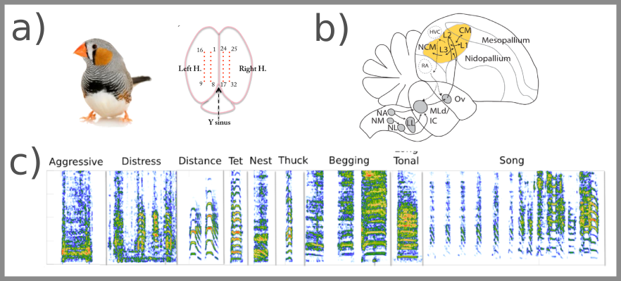

**Figure 1: Experiment**

(a) Julie Elie performed dual hemi- sphere multi electrode recordings from anaesthetized Zebra Finch.

(b) 8x2 electrode arrays were placed perpendicular to primary and secondary auditory areas, shown in yellow.

(c) Examples from the vocal repertoire of Zebra finches played during recording.

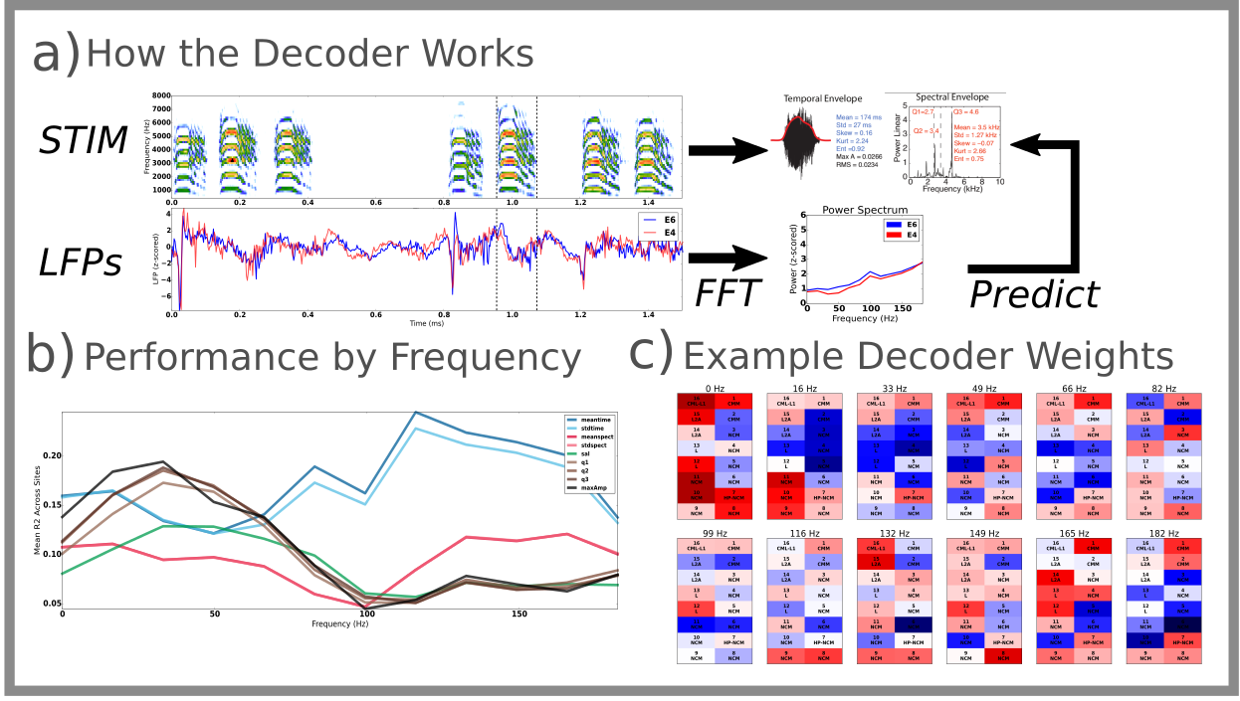

**Figure 2, The Decoder**

(a) A series of distance calls are played (STIM) while the LFP is recorded simultaneously from the electrode array (LFPs). Two electrodes are shown. A syllable is isolated (dashed lines) and the acoustic properties of that syllable are extracted. The power spectrum of each LFP conditioned on the syllable is computed and zscored. The decoder utilized regularized linear regression with 10-fold cross validation to optimally predict each acoustic feature. (b) A performance plot for decoders trained on individual frequency bands. Each trace shows the decoding performance for a different acoustic feature, by frequency. Brown and black traces, representing quantiles of the spectral envelope and amplitude, respectively, dominate decoding performance for the gamma frequency band (15-80 Hz). (c) The weights for a decoder trained on all electrodes and frequency bands shows that predictions are obtained by a weighted combination of power across frequency and space.

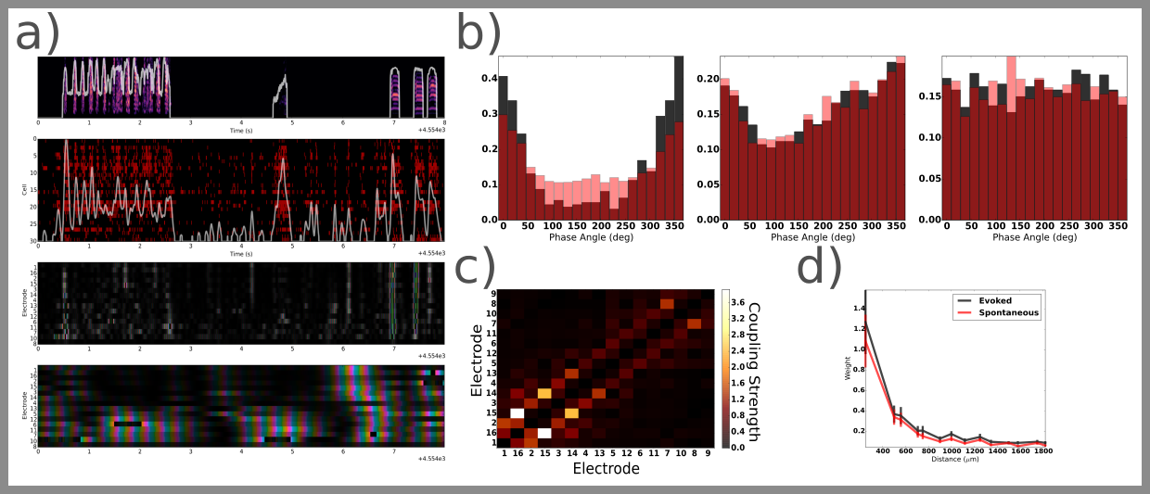

**Figure 3, Low Gamma in Space:** (a) A plot of the vocalizations played to the bird during recording (top), the spike raster recorded on one hemisphere (2nd row), the multielectrode gamma phase and amplitude (color and brightness, 3rd row), and the multielectrode delta (0-5Hz) phase and amplitude on the bottom row. (b) The phase preferences of three different neurons. Histograms of phase during spontaneous spikes (black) are overlaid with phase histograms during evoked spikes (red). The histograms go from high preference (left) to no preference (right). (c) A coupling matrix from one recording array. Element i,j shows the coupling between electrodes i and j. Electrodes on the lower left quadrant are in Field L, CM, and L1, neurons on the upper right are in NCM. (d) Coupling strength as a function of distance, for evoked (gray) and spontaneous (red) activity. Coupling weights strengthen during evoked activity over long distances.