Supplementary information

“Detection of Large Thermal Vibration for Cu Atoms in Tetrahedrite by High Angle Annular Dark Field Imaging”

Tara Prasad Mishra¹ , Mikio Koyano² and Yoshifumi Oshima^{2*}
1 Dept. Materials Engineering, Indian Institute of Science, Bangalore 560012, India
2 School of Materials Science, Japan Advanced Institute of Science and Technology,
1-1, Asahidai, Nomi, 923-1292, Japan
E-mail: oshima@jaist.ac.jp

Figure S1
A relatively low magnification HAADF image. Atomic resolved HAADF images were taken around the edge of the wedged shape specimen.

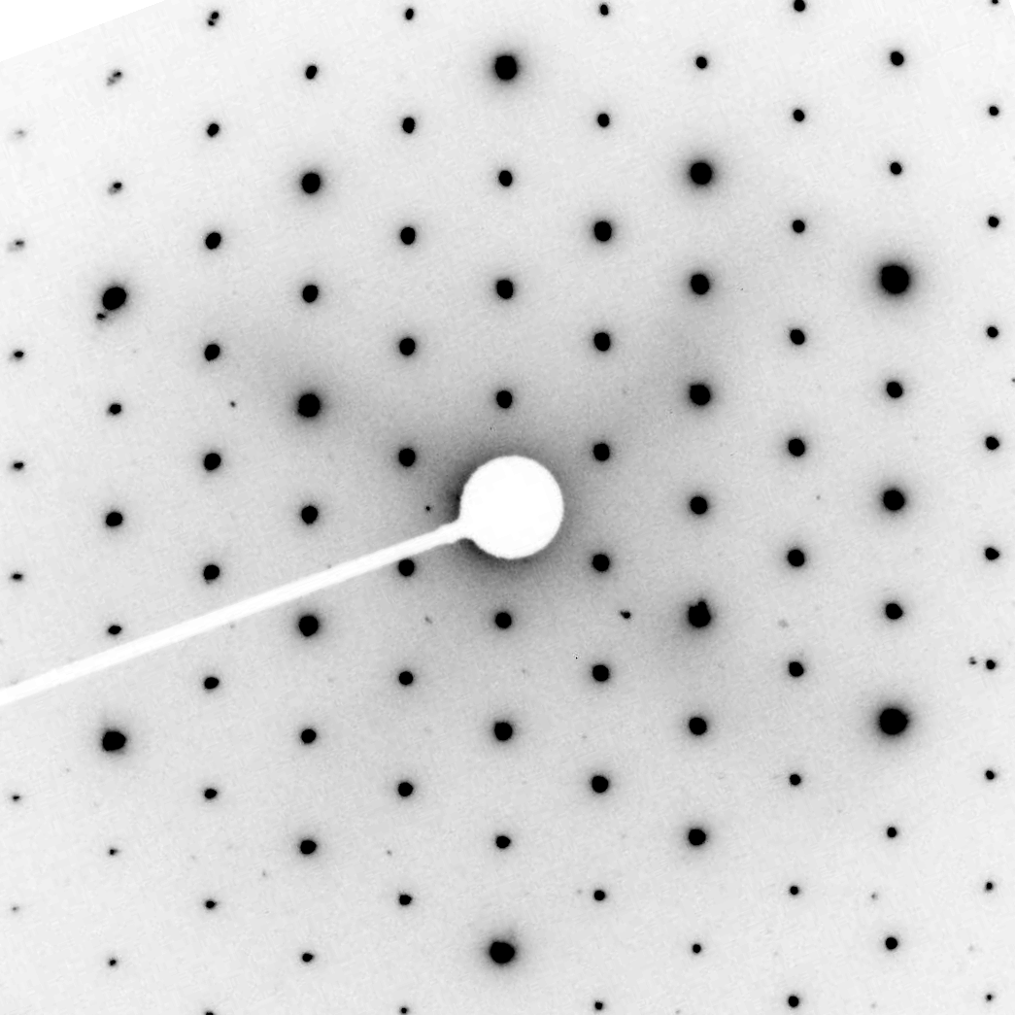
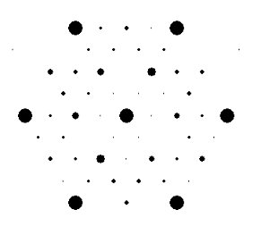
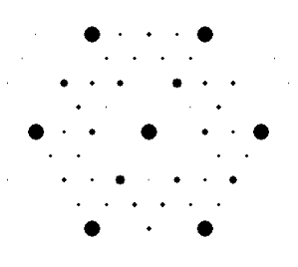
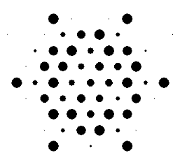
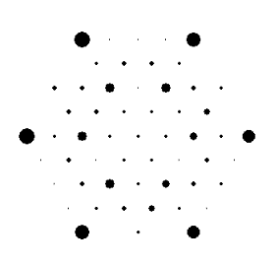
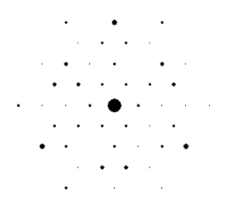
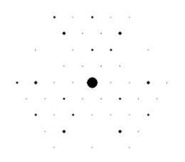
(a)
(b)
t=6 nm
t=8 nm
t=10 nm
t=12 nm
t=20 nm
t=30 nm
{440}
{220}
{422}

Figure S2
(a) A transmission electron diffraction (TED) pattern taken from the area where the HAADF image was taken. (b) Simulated TED patterns obtained by multi-slice calculation. The area of each spot is in proportion to the calculated intensity at the diffracted spot. The value of t indicates thickness. By comparing with the experimental TED pattern, the thickness of the specimen was estimated to be about 10 nm.

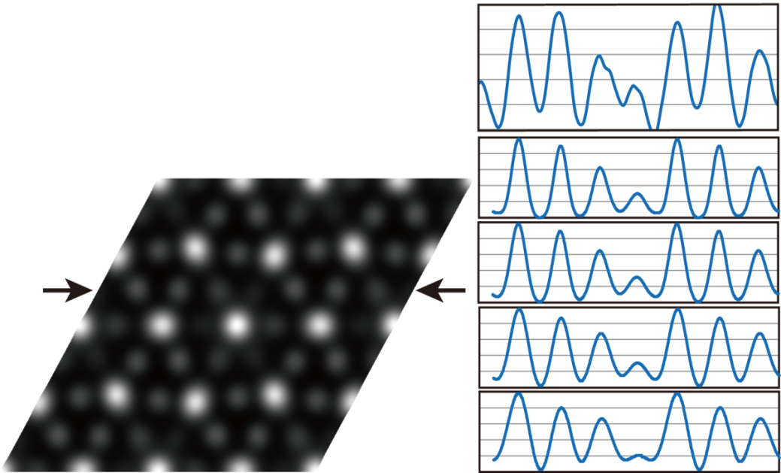
Exp.
50pm
100pm
150pm
0pm
Cu2+S
Cu2
Cu1+S

Figure S3
A simulated HAADF image of tetrahedrite crystal viewed frome the [111] direction. The HAADF images were convolved with different Gaussian blur functions, since the effect of finite source size should be taken into account. In this calculation, the source sizes of 50, 100 and 150 pm were assumed. The right column shows the intensity profiles along the line indicated by arrows with different finite effective source size.

Figure S4
A graph of TDS cross section for Cu atom as a function of scattering angle. TDS cross section ($σ_{i}$) is defined by $σ_{i}∼f^{2}\left(s\right)[1-exp⁡(-2Ms^{2})]$, where $f\left(s\right)$ is the atomic form factor for elastic scatterings, $s$ is the scattering vector, and $M$ is thermal factor, which is in proportional to atomic displacement parameters (ADP). The value indicated inside the graph corresponds to ADP. TDS cross section increases with increasing the ADP value below 50 mrad, while it is almost constant above 50 mrad.

